Python import issue

The line that is triggering, “module not found” from gps_odom.py

# Import geonav tranformation module
import geonav_transform.geonav_conversions as gc

$ rospack find is successful
tractor@tractor-HP-ProBook-645-G1:~$ rospack find geonav_transform
/home/tractor/catkin_ws/src/geonav_transform
tractor@tractor-HP-ProBook-645-G1:~$

python import statement does not accept “/”
SyntaxError: invalid syntax
>>> import home/tractor/catkin_ws/src/geonav_transform.geonav_conversions as gc
File "<stdin>", line 1
import home/tractor/catkin_ws/src/geonav_transform.geonav_conversions as gc
^
SyntaxError: invalid syntax
>>>

tractor@tractor-HP-ProBook-645-G1:~$ python3
Python 3.8.10 (default, Jun 22 2022, 20:18:18)
[GCC 9.4.0] on linux
Type "help", "copyright", "credits" or "license" for more information.
>>> import sys
>>> sys.path
['', '/home/tractor/catkin_ws/devel/lib/python3/dist-packages', '/opt/ros/noetic/lib/python3/dist-packages', '/usr/lib/python38.zip', '/usr/lib/python3.8', '/usr/lib/python3.8/lib-dynload', '/home/tractor/.local/lib/python3.8/site-packages', '/usr/local/lib/python3.8/dist-packages', '/usr/lib/python3/dist-packages']
>>> quit()
tractor@tractor-HP-ProBook-645-G1:~$

ref: https://stackoverflow.com/questions/4383571/importing-files-from-different-folder
sys.path.insert(1, '/path/to/application/app/folder')
home/tractor/catkin_ws/src/
sys.path.insert(1, '/home/tractor/catkin_ws/src/')
sys.path.insert(1, '/home/tractor/catkin_ws/src/geonav_transform/src/geonav_transform')

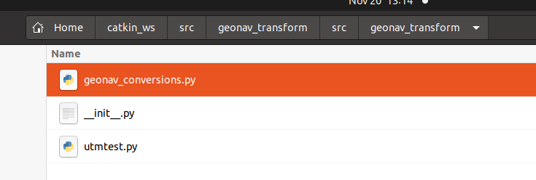

moving geonav_conversions.py to /home/tractor/catkin_ws/src/geonav_transform/src/
and then including the statement below in gps_odom.py helped find the module
sys.path.append('/home/tractor/catkin_ws/src/geonav_transform/src/')

Now the statement below fails
reload(gc)

rosrun beginner_tutorials gps_odom.py

tractor@tractor-HP-ProBook-645-G1:~$ rosrun beginner_tutorials gps_odom.py
Traceback (most recent call last):
File "/home/tractor/catkin_ws/src/beginner_tutorials/scripts/gps_odom.py", line 15, in <module>
reload(gc)
NameError: name 'reload' is not defined
tractor@tractor-HP-ProBook-645-G1:~$

So to use reload in Python 3, you'd have to write imp.reload(moduleName) and not just reload(moduleName).

11/21/22 -
- Goal – get a “heading” and feed it into gps_odom.py and see if that solves the “tuple” issue
  - The topic “/imu/data” from the Chip Robotics is able to be read in
  - Issue #1: It appears to need to be reset
  - Issue #2: The range goes from West(+3.14) to North(1.57) to East (0) to South(-1.57) to West(-3.14)

Ref to angular velocity (might be helpful later) https://www.engineeringtoolbox.com/radian-d_942.html

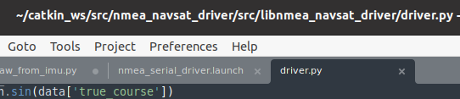

elif 'HDT' in parsed_sentence:
data = parsed_sentence['HDT']
if data['heading']:
current_heading = QuaternionStamped()
current_heading.header.stamp = current_time
current_heading.header.frame_id = frame_id
q = quaternion_from_euler(0, 0, math.radians(data['heading']))
current_heading.quaternion.x = q[0]
current_heading.quaternion.y = q[1]
current_heading.quaternion.z = q[2]
current_heading.quaternion.w = q[3]
self.heading_pub.publish(current_heading)
From ros_yaw_from_imu.py
orientation_q = msg.orientation
orientation_list = [orientation_q.x, orientation_q.y, orientation_q.z, orientation_q.w]
Matt’s gps_odom.py
nmea_navsat_driver/src/libnmea_navsat_driver/driver.py
if 'HDT' not in parsed_sentence:
current_heading = QuaternionStamped()
current_heading.header.stamp = current_time
current_heading.header.frame_id = frame_id
q = quaternion_from_euler(0, 0, data['true_course'])
current_heading.quaternion.x = q[0]
current_heading.quaternion.y = q[1]
current_heading.quaternion.z = q[2]
current_heading.quaternion.w = q[3]
self.heading_pub.publish(current_heading)
I want to publish a heading from the IMU because getting the heading from the GPS when there is no movement and possibly no RTK fix, the heading will be wrong.
I’m thinking:
orientation_q = msg.orientation
orientation_list = [orientation_q.x, orientation_q.y, orientation_q.z, orientation_q.w]
current_heading = QuaternionStamped()
current_heading.header.stamp = current_time
current_heading.header.frame_id = frame_id
q = quaternion_from_euler(0, 0, data['true_course'])
current_heading.quaternion.x = orientation_q.x
current_heading.quaternion.y = orientation_q.y
current_heading.quaternion.z = orientation_q.z
current_heading.quaternion.w = orientation_q.w
self.heading_pub.publish(current_heading)
“elif 'GST' in parsed_sentence:” - appears in line 317
What seems to be operating above it is
elif 'RMC' in parsed_sentence:
Matt’s
if data['fix_valid']:
current_vel = TwistStamped()
current_vel.header.stamp = current_time
current_vel.header.frame_id = frame_id
current_vel.twist.linear.x = data['speed'] * \
math.sin(data['true_course'])
current_vel.twist.linear.y = data['speed'] * \
math.cos(data['true_course'])
self.vel_pub.publish(current_vel)

self.speed_pub.publish(data['speed'])

if 'HDT' not in parsed_sentence:
current_heading = QuaternionStamped()
current_heading.header.stamp = current_time
current_heading.header.frame_id = frame_id
q = quaternion_from_euler(0, 0, data['true_course'])
current_heading.quaternion.x = q[0]
current_heading.quaternion.y = q[1]
current_heading.quaternion.z = q[2]
current_heading.quaternion.w = q[3]
self.heading_pub.publish(current_heading)

elif 'GST' in parsed_sentence:
Current
if data['fix_valid']:
current_vel = TwistStamped()
current_vel.header.stamp = current_time
current_vel.header.frame_id = frame_id
current_vel.twist.linear.x = data['speed'] * \
math.sin(data['true_course'])
current_vel.twist.linear.y = data['speed'] * \
math.cos(data['true_course'])
self.vel_pub.publish(current_vel)

