Python import issue

The line that is triggering, “module not found” from gps_odom.py

# Import geonav tranformation module
import geonav_transform.geonav_conversions as gc

$ rospack find is successful
tractor@tractor-HP-ProBook-645-G1:~$ rospack find geonav_transform
/home/tractor/catkin_ws/src/geonav_transform
tractor@tractor-HP-ProBook-645-G1:~$

python import statement does not accept “/”
SyntaxError: invalid syntax
>>> import home/tractor/catkin_ws/src/geonav_transform.geonav_conversions as gc
File "<stdin>", line 1
import home/tractor/catkin_ws/src/geonav_transform.geonav_conversions as gc
^
SyntaxError: invalid syntax
>>>

tractor@tractor-HP-ProBook-645-G1:~$ python3
Python 3.8.10 (default, Jun 22 2022, 20:18:18)
[GCC 9.4.0] on linux
Type "help", "copyright", "credits" or "license" for more information.
>>> import sys
>>> sys.path
['', '/home/tractor/catkin_ws/devel/lib/python3/dist-packages', '/opt/ros/noetic/lib/python3/dist-packages', '/usr/lib/python38.zip', '/usr/lib/python3.8', '/usr/lib/python3.8/lib-dynload', '/home/tractor/.local/lib/python3.8/site-packages', '/usr/local/lib/python3.8/dist-packages', '/usr/lib/python3/dist-packages']
>>> quit()
tractor@tractor-HP-ProBook-645-G1:~$

ref: https://stackoverflow.com/questions/4383571/importing-files-from-different-folder
sys.path.insert(1, '/path/to/application/app/folder')
home/tractor/catkin_ws/src/
sys.path.insert(1, '/home/tractor/catkin_ws/src/')
sys.path.insert(1, '/home/tractor/catkin_ws/src/geonav_transform/src/geonav_transform')

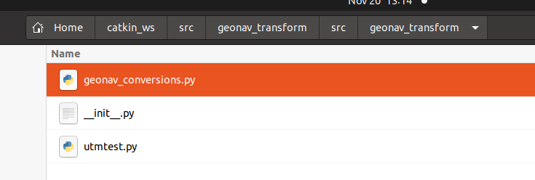

moving geonav_conversions.py to /home/tractor/catkin_ws/src/geonav_transform/src/
and then including the statement below in gps_odom.py helped find the module
sys.path.append('/home/tractor/catkin_ws/src/geonav_transform/src/')

Now the statement below fails
reload(gc)

rosrun beginner_tutorials gps_odom.py

tractor@tractor-HP-ProBook-645-G1:~$ rosrun beginner_tutorials gps_odom.py
Traceback (most recent call last):
File "/home/tractor/catkin_ws/src/beginner_tutorials/scripts/gps_odom.py", line 15, in <module>
reload(gc)
NameError: name 'reload' is not defined
tractor@tractor-HP-ProBook-645-G1:~$

So to use reload in Python 3, you'd have to write imp.reload(moduleName) and not just reload(moduleName).

