**Mueller Center Class Signups**

**Web Science Spring 2018**

**The A-Team:**

Collin Jones

Jason Lee

Yarden Ne’eman

Sydney Ruzicka

Kamil Szmyd

The focus of this project is to streamline the process of signing up for classes through the Mueller Center. As it stands now, the Mueller Center has a generally disorganized and paper-based system that could be greatly improved upon. Our project would allow interested parties to sign up for classes and events online, as well as providing the instructors with an easy way to contact the members of their class. Depending on the viability, we may also extend this to include bursar and credit card payments.

**Project Team: The A-Team**

Collin Jones is a junior Information Technology & Web Science (ITWS) and Computer Science dual major with a concentration in Web Technologies. His primary role will be Backend Developer due to his extensive experience with object-oriented languages and database work through internships and other coursework.

Jason Lee is a junior Computer Science and ITWS dual major with a concentration in Web Technologies. He will be focusing on interaction between the project’s frontend and backend, as well as the editing of project reports.

Yarden Ne’eman is a senior Computer Science and ITWS dual major with a concentration in Web Technologies. Yarden will serve as the Project Manager for this project due to her prior experience with project management. She will also work on Frontend Development for the application due to her previous experience working with frontend technologies.

Sydney Ruzicka is a junior ITWS and Business Management dual major. Her main role in the project will be Frontend Developer.

Kamil Szmyd is a senior ITWS major. He will be focusing on the Backend Development. Kamil has experience working on database systems through various projects which will help create a solid backbone for the project at hand.

**Problem Statement**

RPI currently offers a variety of classes through the Mueller Center ranging from self-defence courses to fitness classes to quilting. These classes can be used as a supplement for students to learn new life skills, stay healthy, and acquire knowledge in an area that interests them. Classes are offered to both RPI students and the local community and they are taught in the classrooms and the gym area of the Mueller Center. The issue the team has identified is the outdated sign up system which still uses paper sign up sheets which makes it easy for mistakes to occur and hard to keep track of who has registered for classes. Another issue caused by the current system is the difficulty with communication between instructors and the students participating in the classes as there is no single method for that to take place. The team has decided to come up with a new solution to create an easy and streamlined way for anyone to sign up for new classes and for instructors to keep track of everyone that will be attending the course. The system will also include a way for instructors to be able to easily get a hold of the students participating in a particular course.

**Problem Solution**

We will be working together to create a web portal solution to manage the signup process for various classes at the Mueller Center. As the classes offered vary in size, scope, and audience, the resulting system must be scalable and easy to use in order to adapt to the increasing numbers of classes and students. In addition, shortly after classes start, the Mueller Center collects payment from registered students in a multitude of ways. As such, this system also has to account for the many ways that class participants can choose to pay for instruction.

The service relies on a persistent data store, as it must be able to help with maintaining class rosters and assignment of instructors. To facilitate the transfer of feedback between student and instructor, collaboration between different users of the service must be made possible.

Additional features include the ability for instructors to send mass emails to class lists, and the option to pay via a third-party service.

**Candidate Technologies**

For this project, we are leaning heavily towards using the MEAN stack (MongoDB, Express, AngularJS, and NodeJS). We will also be using HTML5, CSS3, and JavaScript for the front-end user experience, as well as frameworks such as jQuery and Bootstrap. If viable, we will use Stripe as an online payment method to handle credit cards.

Moreover, since classes are open to the community, usage of the campus Central Authentication System (CAS), which only authenticates RPI students, faculty, and staff, is not sufficient for the portal’s projected user base. Instead, a more traditional login and authentication system will be deployed.

**Technical Requirements**

The project requirements outline the necessary functionality in the following scopes: process, people, usability, database, and security. There are three groups of people that would utilize this application and each type of person would follow their own process. Mueller Center employees would serve as Admins for the project, keeping track of payments and editing the list of classes offered. Instructors would have access to a list of the students signed up for their class as well as the ability to send mass emails to their students. Finally, any student or community member would be able to view the available classes and sign up for them. The website will highlight usability with a clean and consistent user interface that would be accessible to users of all ages. Furthermore, the application will also be mobile responsive to ensure that sign-ups can be accessible to web and mobile users. In order to maintain user permissions, a database is required to keep track of all of the types of users. Furthermore, a database will be required to store information about courses so that they can be maintained throughout the semester. Since personal information about students and instructors will be stored, the database and website will be secured with user authentication and script injections will be prevented.

**Wireframes**

[Class Information Page](https://wireframe.cc/Q3n81A) - Below is a wireframe to illustrate the interface to browse the currently available classes. The left panel will feature a list of all of the classes being offered and upon clicking on the more info button, the right panel will be populated with more detailed information about the selected class.

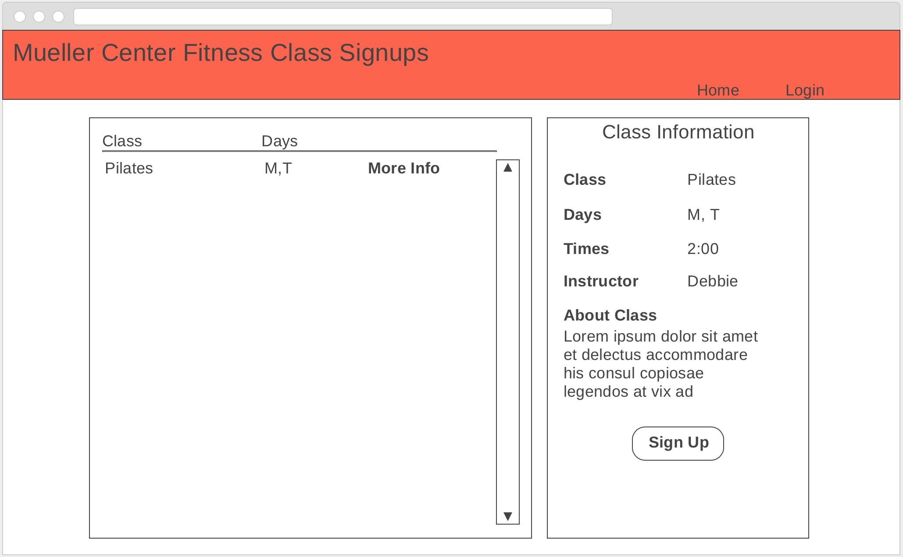

[Class Sign Up Page](https://wireframe.cc/6dusKa) - Below is a wireframe to illustrate what a student or community member would see upon signing up for a class. The only requirements to register is name, email, RIN (if affiliated with RPI) and the payment method. Actual payment may or may not be implemented, but the proposed solution would keep track of the intended payment type.

