Digital Sensors Alert Outputs
Set 3 Set 2
North South
N D N D N D N D
e i e i e i e i
a s a s a s a s Alert Set
r t r t r t r t 1 0
D9D8D7D6D5D4D3D2 D13D12D11D10 +5 G G VIN
⓿❶❷❸❹❺❻❼
V block
⓿❶❷❸❹❺❻❼
Digital block

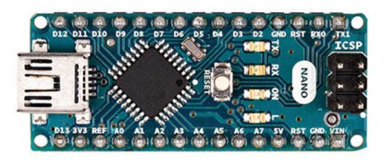


10K Ω
Black – Ground
Red - +5 volts
Green – sensor inputs
Yellow – VIN
Blue – output to alert
⓿❶❷❸❹❺❻❼
S1 block
⓿❶❷❸❹❺❻❼
S0 block

A0A1A2A3 ---+5--- ---+5--- A4A5A6A7
Set 0 Set 1
D N D N D N D N
i e i e i e i e
s a s a s a s a
t r t r t r t r
Analog Sensors (phototransistors, photoresistors)
Relay board:
Com Common
NC Normally closed
NO Normally open

C C
o N N o N N
m C O m C O
⓿❶❷❸
S0 block
⓿❶❷❸
S1 block

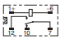

LED LED

S S
e e G
t t n
0 1 d
⓿❶❷❸
Input block

