Jordan Jones

Module Seven: Project 3

08-14-2025

Documentation- GrocerList Class

**Class Definition**

**File**: GrocerList.h  
**Header Guard**: GROCERLIST_H  
**Dependencies**:

* <iostream> for input/output operations
* <fstream> for file handling
* <unordered_map> for storing item frequencies
* <string> for string manipulation

**Member Functions**

**void ReadItems()**

* **Description**: Reads grocery items from the file grocer_list.txt and increments their frequency in the itemFrequency map.
* **Parameters**: None
* **Return**: None
* **Behavior**:
  + Opens grocer_list.txt for reading.
  + If the file cannot be opened, outputs an error message and aborts.
  + Reads each item (string) from the file and increments its count in the itemFrequency map.

**void DataBackup()**

* **Description**: Writes the contents of the itemFrequency map to a file named frequency.dat.
* **Parameters**: None
* **Return**: None
* **Behavior**:
  + Opens frequency.dat for writing.
  + If the file cannot be opened, outputs an error message and aborts.
  + Writes each item and its frequency in the format item: frequency to the file.
  + Closes the file after writing.

**void DisplaySpecific(string item)**

* **Description**: Displays the frequency of a specific item.
* **Parameters**:
  + item (string): The grocery item to query.
* **Return**: None
* **Behavior**: Outputs the item and its frequency from the itemFrequency map in the format item: frequency.

**void DisplayAll()**

* **Description**: Displays the frequency of all items in the itemFrequency map.
* **Parameters**: None
* **Return**: None
* **Behavior**: Iterates through the itemFrequency map and outputs each item and its frequency in the format item: frequency.

**void DisplayHistogram()**

* **Description**: Displays a histogram of item frequencies using asterisks (*) to represent counts.
* **Parameters**: None
* **Return**: None
* **Behavior**: For each item in the itemFrequency map, outputs the item name followed by a number of asterisks corresponding to its frequency.

**void PrintMenu()**

* **Description**: Displays an interactive menu and handles user input to call other member functions.
* **Parameters**: None
* **Return**: None
* **Behavior**:
  + Displays a menu with options:
    1. Enter an item to view its frequency.
    2. View the frequency for all items.
    3. View a histogram of frequencies for all items.
    4. Exit the program.
  + Reads user input and calls the corresponding function (DisplaySpecific, DisplayAll, or DisplayHistogram) until the user selects option 4 to exit.

**Main.cpp**

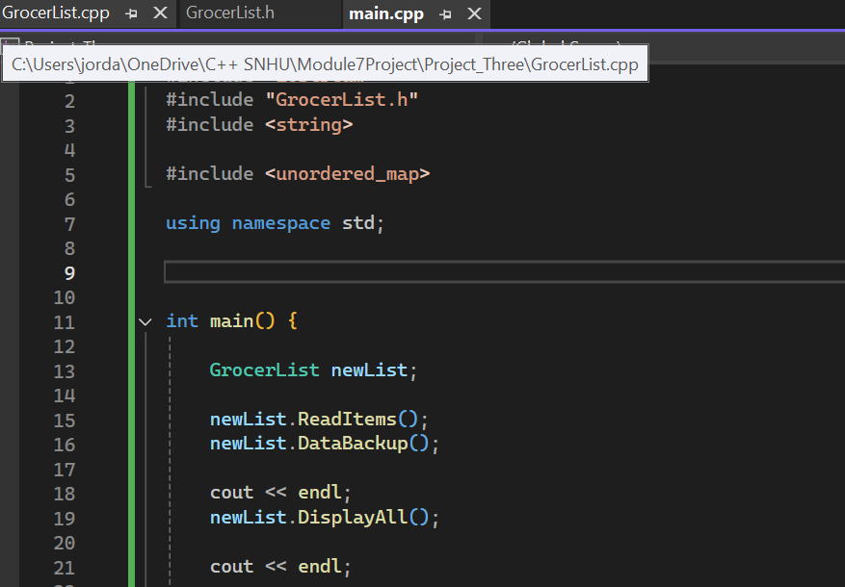

Create new object of type GrocerList

Read data from specified input file

Write data to output file

Call member functions on class object

**Example Input File (grocer_list.txt)**

Yams

Cranberries

Limes

Onions

**Example Output File (frequency.dat)**

Yams: 5

Cranberries: 2

Limes: 1

Onions: 6