First off: The top finisher for each rank goes to the Golden Eagle Finals, Saturday February 6 at New Mark Middle School (515 NE 106th Street, KC, MO 64155). Those are:
Tiger: Jacob Caylor – Wild Kratt
WEBELOS I: Benji Mitchell – Blue Burrito
WEBELOS II: Jacob Laake – The Outstanding Squirrel

Ok, now on to the race info. First off, the last Run of the Cub Primaries had to be rerun due to odd results. I wanted to understand what went wrong, in case there was a problem with my program (spoiler – procedural issue). Looking at the 13 results logged during the cub primary races (should be 12).... It didn't take long to spot the problem. Look at the times on the highlighted row, below. All 9+ seconds. Once the track timer exceeds 9.999 seconds, it keeps showing 9's. I *think* it just keeps rolling over from 9.999 to 9.0, not sure. The point is, these cars have been running between 2.8 and 4.1 seconds, not 9+!! The only way for this to happen is if we started a Run when the red light on the laser gate was not lit:
1) Track timer reset after prior run. This turns on the red light at the start laser gate.
2) Laser was broken prior to the start of the run, starting the track timer and turning off the red light at the start laser gate.
3) Some time later, the run was started, finishing 10+ seconds after the laser was first tripped.
4) Computer receives track results after the last lane detects a car at the finish line.

Side note: I just noticed I'm logging the date/time twice. The part the track sends back to the computer starts with “A=...”.

2016-01-23 18:16:46,709 2016-01-23 18:16:46.709231:A=3.119 B=2.850! C=2.999 D=4.031 E=3.019 F=2.968
2016-01-23 18:20:05,927 2016-01-23 18:20:05.927623:A=2.919! B=3.373 C: =2.926 D=3.594 E=3.047 F=3.371
2016-01-23 18:22:06,996 2016-01-23 18:22:06.996520:A=3.031 B=3.350 C=2.951 D=3.020 E=2.894! F=3.165
2016-01-23 18:24:45,867 2016-01-23 18:24:45.866897:A=3.085 B=3.077 C=3.311 D=2.961! E=3.623 F=3.082
2016-01-23 18:27:38,076 2016-01-23 18:27:38.076766:A=2.825! B=2.913 C=3.185 D=2.917 E=3.459 F=2.960
2016-01-23 18:29:32,201 2016-01-23 18:29:32.201140:A=3.472 B=2.914! C=3.113 D=3.281 E=2.980 F=2.978
2016-01-23 18:30:42,799 2016-01-23 18:30:42.799517:A=3.564 B=3.297 C=2.897! D=3.124 E=2.920 F=3.097
2016-01-23 18:34:19,690 2016-01-23 18:34:19.690575:A=3.000 B=3.262 C=3.033 D=3.122 E=2.923! F=2.979
2016-01-23 18:36:30,082 2016-01-23 18:36:30.081894:A=3.007! B=3.144 C=3.104 D=3.026 E=3.375 F=3.459
2016-01-23 18:38:35,371 2016-01-23 18:38:35.371240:A=2.980 B=3.009 C=2.957! D=3.017 E=3.176 F=3.736
2016-01-23 18:40:10,071 2016-01-23 18:40:10.071798:A=3.385 B=3.127! C=3.503 D=3.156 E=3.195 F=3.155
2016-01-23 18:41:24,756 2016-01-23 18:41:24.756774:A=9.968 B=9.954 C=9.906 D=9.987! E=9.991 F=9.971
2016-01-23 18:43:34,609 2016-01-23 18:43:34.609032:A=3.391 B=3.159 C=3.758 D=2.979! E=3.054 F=3.036

I also confirmed the problem result's timestamp is the one not recorded in the Run times (good!), because we overwrote it with the next run (18:43) when we re-ran the Run.

select id, race_id, run_seq, run_completed, stamp from runner_run where race_id=2 order by stamp
3 2 1 1 2016-01-23 18:16:46.709231
4 2 2 1 2016-01-23 18:20:05.927623
5 2 3 1 2016-01-23 18:22:06.996520
6 2 4 1 2016-01-23 18:24:45.866897
7 2 5 1 2016-01-23 18:27:38.076766
8 2 6 1 2016-01-23 18:29:32.201140
9 2 7 1 2016-01-23 18:30:42.799517
10 2 8 1 2016-01-23 18:34:19.690575
11 2 9 1 2016-01-23 18:36:30.081894
12 2 10 1 2016-01-23 18:38:35.371240
13 2 11 1 2016-01-23 18:40:10.071798
14 2 12 1 2016-01-23 18:43:34.609032

Okay, now that that is settled (whew!), here are the race results. Race-level info first, then farther down are individual stats (by Race). Prepare thyself for information overload!
Race: Cub Primaries - Pack 4180's 2016 Pinewood Derby
Lanes in use: 6
Number of race participants: 12
Overall race stats:
Fastest run time: 2.825 seconds
Fastest run speed: 346 MPH
Average run time: 3.151 seconds
Average run speed: 313 MPH
Slowest run time: 4.031 seconds
Slowest run speed: 244 MPH

Standings + Racer averages:
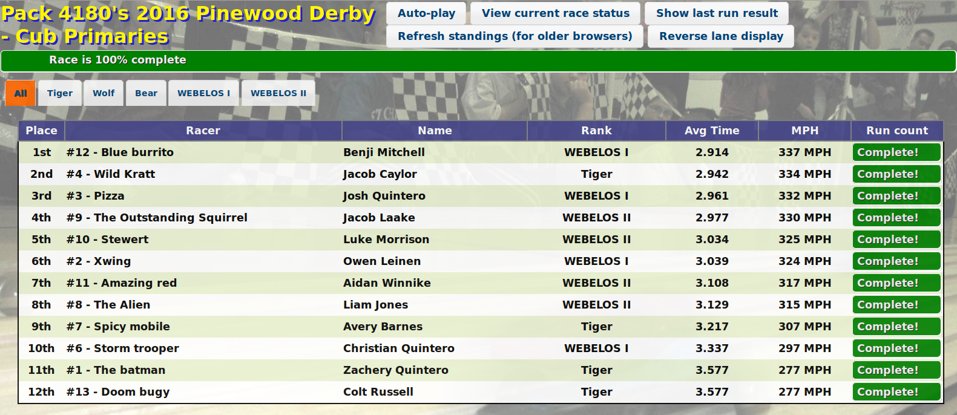
This matrix shows which lane each Racer ran on for each Run in the Cub Primaries Race. Next year we may run everyone on each lane twice. This is what district does for their finals. And on that note, the first place finisher in each rank will represent our pack in the Golden Eagle District finals. Note our old district (North Star) changed this year to Golden Eagle. They split up Clay and Platte counties into their own district.

Cub Primaries
Cub Primaries Racer Group
racer_ids=[1, 2, 3, 4, 6, 7, 8, 9, 10, 11, 12, 13]
0 0 0 0 0 0 0 0 1 1 1 1
Racer ID: 1 2 3 4 6 7 8 9 0 1 2 3
------------------------
Run # 1c> - 3 - 6 - - 1 - 5 - 2 4
Run # 2c> 4 - 3 - 6 - - 1 - 5 - 2
Run # 3c> 2 4 - 3 - 6 - - 1 - 5 -
Run # 4c> - 2 4 - 3 - 6 - - 1 - 5
Run # 5c> 5 - 2 4 - 3 - 6 - - 1 -
Run # 6c> - 5 - 2 4 - 3 - 6 - - 1
Run # 7c> 1 - 5 - 2 4 - 3 - 6 - -
Run # 8c> - 1 - 5 - 2 4 - 3 - 6 -
Run # 9c> - - 1 - 5 - 2 4 - 3 - 6
Run #10c> 6 - - 1 - 5 - 2 4 - 3 -
Run #11c> - 6 - - 1 - 5 - 2 4 - 3
Run #12c> 3 - 6 - - 1 - 5 - 2 4 -

Lane-to-Run Result Matrix.
Race: Pack 4180's 2016 Pinewood Derby - Cub Primaries

Lane # 1 2 3 4 5 6
---------- ---------- ---------- ---------- ---------- ----------
Run # 1: 8: 3.119 12: 2.85 2: 2.999 13: 4.031 10: 3.019 4: 2.968
Run # 2: 9: 2.919 13: 3.373 3: 2.926 1: 3.594 11: 3.047 6: 3.371
Run # 3: 10: 3.031 1: 3.35 4: 2.951 2: 3.02 12: 2.894 7: 3.165
Run # 4: 11: 3.085 2: 3.077 6: 3.311 3: 2.961 13: 3.623 8: 3.082
Run # 5: 12: 2.825 3: 2.913 7: 3.185 4: 2.917 1: 3.459 9: 2.96
Run # 6: 13: 3.472 4: 2.914 8: 3.113 6: 3.281 2: 2.98 10: 2.978
Run # 7: 1: 3.564 6: 3.297 9: 2.897 7: 3.124 3: 2.92 11: 3.097
Run # 8: 2: 3.0 7: 3.262 10: 3.033 8: 3.122 4: 2.923 12: 2.979
Run # 9: 3: 3.007 8: 3.144 11: 3.104 9: 3.026 6: 3.375 13: 3.459
Run # 10: 4: 2.98 9: 3.009 12: 2.957 10: 3.017 7: 3.176 1: 3.736
Run # 11: 6: 3.385 10: 3.127 13: 3.503 11: 3.156 8: 3.195 2: 3.155
Run # 12: 7: 3.391 11: 3.159 1: 3.758 12: 2.979 9: 3.054 3: 3.036
---------- ---------- ---------- ---------- ---------- ----------
Min: 2.825 2.850 2.897 2.917 2.894 2.960
Avg: 3.148 3.123 3.145 3.186 3.139 3.166
Max: 3.564 3.373 3.758 4.031 3.623 3.736
Race: Wildcard Races - Pack 4180's 2016 Pinewood Derby
Lanes in use: 3
Number of race participants: 3
Overall race stats:
Fastest run time: 2.911 seconds
Fastest run speed: 337 MPH
Average run time: 3.053 seconds
Average run speed: 322 MPH
Slowest run time: 3.341 seconds
Slowest run speed: 296 MPH

Standings + Racer averages:
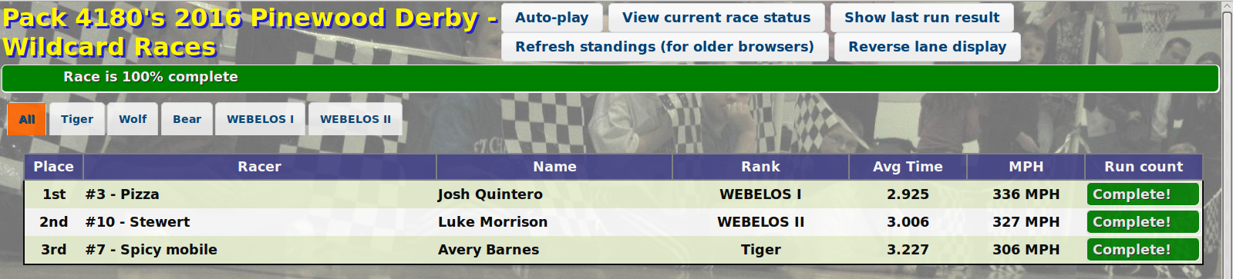

Matrix entries are the lane numbers (just like above). Only 3 lanes used, since we had only 3 Racers:
Wildcard Races
Wildcard Racer Group
racer_ids=[3, 7, 10]
0 0 1
Racer ID: 3 7 0
------
Run # 1c> 1 3 2
Run # 2c> 2 1 3
Run # 3c> 3 2 1

Lane-to-Run Result Matrix. Matrix entries are “Car #: time(seconds)”
Race: Pack 4180's 2016 Pinewood Derby - Wildcard Races

Lane # 1 2 3
---------- ---------- ----------
Run # 1: 3: 2.923 10: 3.025 7: 3.172
Run # 2: 7: 3.169 3: 2.94 10: 2.919
Run # 3: 10: 3.074 7: 3.341 3: 2.911
---------- ---------- ----------
Min: 2.923 2.940 2.911
Avg: 3.055 3.102 3.001
Max: 3.169 3.341 3.172

Race: Pack Finals - Pack 4180's 2016 Pinewood Derby
Lanes in use: 4
Number of race participants: 4
Overall race stats:
Fastest run time: 2.855 seconds
Fastest run speed: 343 MPH
Average run time: 2.905 seconds
Average run speed: 337 MPH
Slowest run time: 2.981 seconds
Slowest run speed: 329 MPH

The difference between first and second place was four thousandths of a second!!
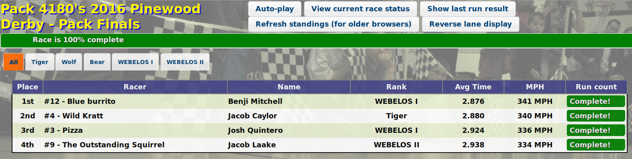
Matrix entries are lane numbers. Lanes 5 & 6 were not used, since Racer count was just 4.
Pack Finals
Pack Finals Group
racer_ids=[3, 4, 9, 12]
0 0 0 1
Racer ID: 3 4 9 2
--------
Run # 1c> 3 1 2 4
Run # 2c> 4 3 1 2
Run # 3c> 2 4 3 1
Run # 4c> 1 2 4 3

Lane-to-Run Result Matrix.
Race: Pack 4180's 2016 Pinewood Derby - Pack Finals

Lane # 1 2 3 4
---------- ---------- ---------- ----------
Run # 1: 4: 2.855 9: 2.981 3: 2.949 12: 2.879
Run # 2: 9: 2.947 12: 2.885 4: 2.855 3: 2.98
Run # 3: 12: 2.862 3: 2.9 9: 2.906 4: 2.871
Run # 4: 3: 2.867 4: 2.94 12: 2.877 9: 2.92
---------- ---------- ---------- ----------
Min: 2.855 2.885 2.855 2.871
Avg: 2.883 2.926 2.897 2.913
Max: 2.947 2.981 2.949 2.980
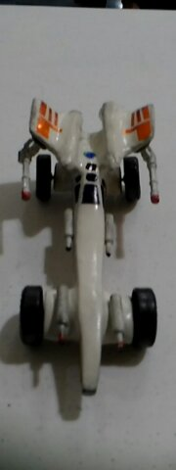
Here is a picture of the car voted Best In Show. I don't have the ballot tally, but I do know this was the overwhelming favorite. Great job Owen Leinen!

Here are some pictures I took during the event.
https://www.flickr.com/photos/joneser005/albums/72157663329671880

