The below graph shows the average survival rate at each cancer stage for Bladder, Breast, Colorectal, Kidney, Lung, Melanoma, Ovary, Prostate and Uterus cancers for the years 2012 to 2014 in England for adults aged 15-99. 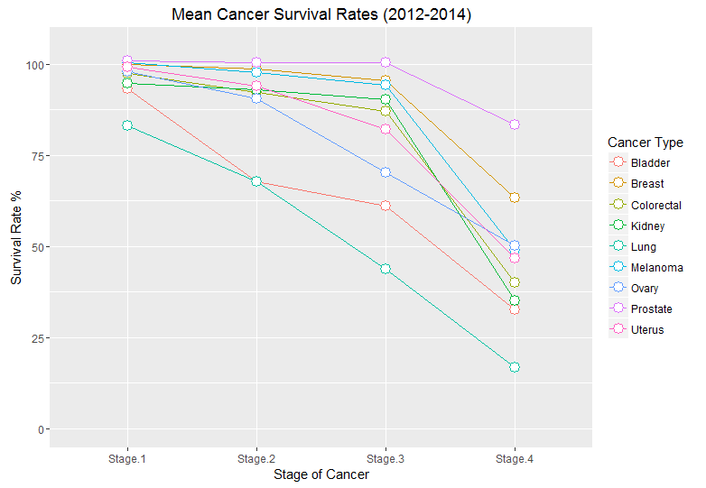

The graph clearly shows that for most cancers (other than lung and bladder) there isn’t much deterioration between stage one and stage two, with the highest difference being in ovary cancer with a difference in average survival rate of around 7.5%. Only one of these cancers, again being ovary cancer, drops below 80% at stage three. Both bladder and lung cancers are already below this point at stage two, with both having an average survival rate of 67.7%.

Even though the difference in bladder cancer average survival rate from stage one to two is greater than lung (25.6% difference compared to 15.3% in lung), lung cancer average survival rate drops steadily and more rapidly across the next two stages unlike bladder cancer. All the cancers shown on the graph suffer rapid differences in average survival rates between stage three and four.

Lung cancer suffers the greatest drop in average survival rates from stage one to four, with an overall difference of 66.3%, with the next being bladder and kidney cancers with overall differences of 60.7% and 59.6% respectively.

In summary, lung cancer average survival rates suffer steady but rapid drops through stage one to four with an overall drop greater than any of the other cancers shown, whereas most of the other cancers only see a rapid drop from stage three to four. It also shows that lung cancer has a lower or almost equal average survival rate at stage one compared to all cancers shown (other than bladder and ovary) in stage three and stage four in prostate cancer.