Hardy Jones
999397426
Prof. Nitta
ECS 154A
Homework #3

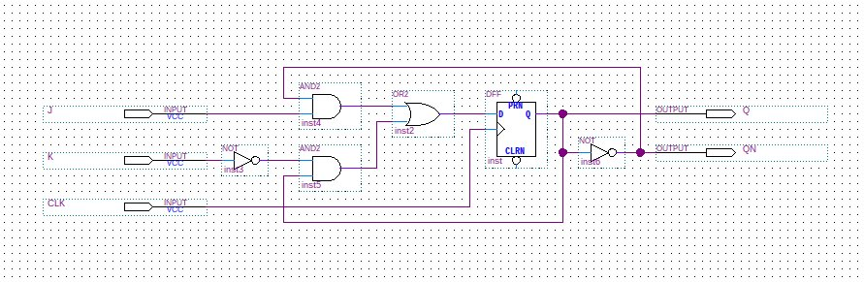
1.

2.

3.
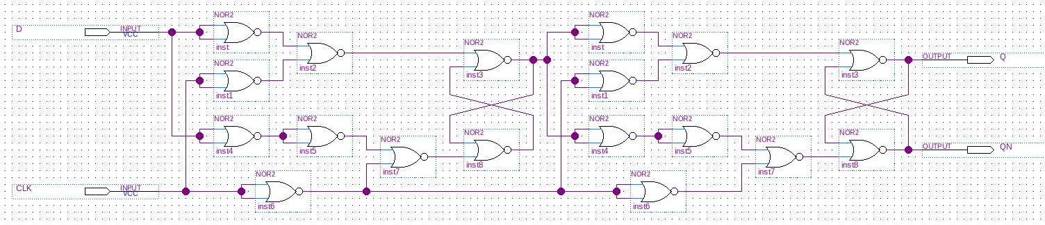
4.
