Holistic Cognition is More Flexible in Thinking Processes than Analytic Cognition

Having a particular thinking process that incorporates the whole picture, may allow the individual to be more relatable to emotions, while having a thinking process that narrowly focuses on a specific object may prevent the individual to relate to emotions as well. A study conducted by Masuda et al. (2008) theorized that an individual with a thinking process that incorporates the whole picture relates to emotions better. This type of thinking process is known as *holistic cognition,* a type of attention that focuses on the entire perceptual field, especially relations among objects and events, and associating the cause and effect of things based on the context (Na et al., 2010). On the other hand, a study done by Varnum et al. (2010) hypothesized that individuals with a thinking process that narrowly focuses on an object allows them to have an advantage in visual attention and better formal logic in reasoning. This type of thinking process is known as *analytic cognition*, a type of attention that focuses on a specific object in the perceptual field, categorizing objects by type, and associating cause and effect to the object itself (Na et al., 2010). Thus, possessing analytic cognition may interfere with the ability in relating to other people’s emotions and making incorrect associations. For example, if Bob has analytic cognition, he might think that Sally is a happy person because she is always happy, attributing it to a personality trait. He neglected the fact that it may be due to other factors, such as that she might have received a raise on a job recently. However, individuals possessing a holistic cognition may think otherwise. They are more likely to think that Sally is happy based on the situation, such as that she received a raise than thinking that it was due to her always-happy personality. Having a holistic cognition may help individuals relate to emotions better and making more accurate attributions, while analytic cognition may hinder that ability to do so.

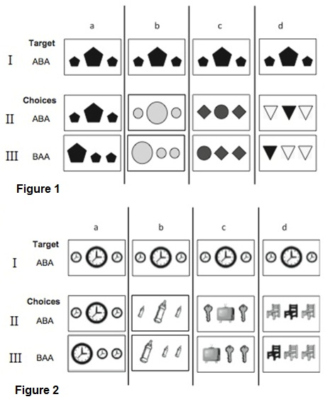Past research theorized that cognitive differences in individuals may have stemmed from cultural influences. The cultural influence led researchers to categorize thinking processes into two main types: analytic cognition and holistic cognition. Based on these two types of cognition, Professor Graf-Estes in the Department of Cognitive Psychology at UC Davis states that “different cultures will benefit each category”, as there is no true winner in all critera by possessing a specific type of cognition. As discussed previously, analytic cognition focuses more on objects, whereas holistic cognition focuses more on the entire picture. For example, upon examining an aquarium, holistic individuals would look at the whole aquarium such as the plants, fish, and house, whereas analytic individuals would only focus on the fish. These differences in cognition in adults were also tested similarly in different studies involving children. One study by Kuwabara et al. (2012) examined relational structure in children to see if they understand the relationships of objects presented as stimuli to them, where different trials ranged from least abstract to most abstract. This procedure was done in a *match-to-standard* process, in which the subjects had to match the choices given to them to the correct target picture. For instance, referring to Figure 1aI, children were given the target picture of small hexagon-big hexagon-small hexagon or small clock-big clock-small clock, and they had to choose what was the closest choice to the target picture between Figure 1aII and Figure 1aIII. Figure 1aII was the only correct answer out of the two choices. The other choice, Figure 1aIII, carries the incorrect choice. This study was designed to measure whether individuals with holistic cognition will do better in object and abstract relations by matching correctly the choicies to the target picture, and whether this abstract relational matching will hurt the performance of individuals with analytic thinking.

The study required children to perform a match-to-standard procedure which is measured in two different ways. Children were either assigned to simply or richly detailed conditions. In Figure 1, it represents a simple detailed condition that involved different sizes, colors, and geometric shapes such as circles and triangles. In contrast, Figure 2 presents a richly detailed condition that involved every everyday objects such as clocks and chairs. Children were required to match the choices given to the target picture of either hexagons or clocks. All the target pictures followed the standard of ABA with choices that has a standard of either ABA (symmetrical standard) or BAA (asymmetrical standard). Referring to Figure 1I, the target had a standard of ABA, a symmetrical standard of how the objects are oriented. For example, Figure 1aI represents little hexagon-big hexagon-little hexagon. The choices were either in ABA (little hexagon-big hexagon-little hexagon) or BAA (big hexagon-little hexagon-little hexagon). In terms of testing for abstractness, Figures 1 and 2, columns a, were the trials that contained the same elements as the target standard, the least abstract. Those two trials were the easiest trials, as it was also an identity matching trial. For example, Figure 1aII is exactly the same as Figure 1aI. Figure 1 and 2, columns b contained different objects in the choices compared to the objects in the target, but had the same small-big-small size or big-small-small pattern. Regardless, it still had a relevant relationship and size. The trials became more abstract as each trial was conducted across the columns. Figures 1 and 2, columns c, requires children to pinpoint the difference in shape of the object, as the sizes all look the same. Lastly, Figures 1 and 2, columns d, requires children to point out the color of the choices that’s most similar to the target. These trials eliminated identity, size, and shape but focused on the color. After testing, individuals with analytic cognition tend to do poorly in rich condition than simple condition, whereas individuals with a holistic cognition tend to do the same in both rich condition and simple condition. Overall, individuals with holistic cognition are generally better in making relational and abstract matches.

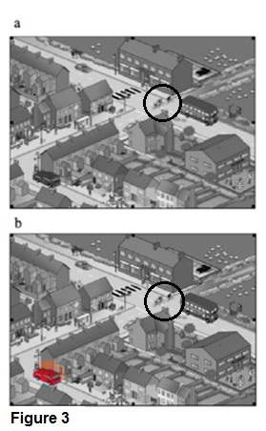 Another study, also by Kuwabara et al. (2012), examined whether or not individuals with analytic cognition or holistic cognition will do better when they have to pinpoint an object in a whole picture. Referring to Figure 3, the study required individuals to find an object, which is the bicyclist in this case, in a whole relatable context, which is a snapshot of a street. The bicyclist was not circled during testing when it was presented to study subjects. This studied was conducted in two conditions: less distraction in Figure 3a, and more distraction in Figure 3b. In the distraction condition, the red car was highlighted to test whether or not it will slow the target objective, which was the bicyclist. Individuals with either type of thinking process were measured on the speed in which they were able to find the bicyclist. Results indicated that individuals with holistic cognition is slower in pinpointing the bicyclist in the less distraction condition, and even slower in the more distraction condition. In constrast, individuals with analytic cognition were faster in pinpointing the bicyclist in either conditions, regardless of the more distracting red car. Individuals with analytic cognition with faster reactions has to due with their greater visual attention in a context of relatable objects (Grossmann et al., 2011). These various standards lead to the question of which type of cognition provides more flexibility in thoughts and judgments. Although holistic cognition is better in relating to abstract objects, analytic cognition is better at pinpointing an object in a whole picture. However, holistic cognition can relate to emotions more accurately, which overall may provide more flexibility in an individual’s thinking.

**Relating to Abstract Objects**

Individuals with holistic cognition are better at relating to abstract objects than individuals with analytic cognition. For example, Joe, who has holistic cognition, might be better in making a connection with a red ball-blue ball-red ball to a cupcake-cookie-cupcake combination. Possessing this type of cognition may allow individuals to better understand relationships, especially in the abstract setting. The study done by Kuwabara et al. (2012) tested individuals with either holistic or analytic cognition on the basis of finding out which group will perform better in a match-to-standard task involving objects with increasing abstractness. Will the individuals be able to match the correct choices to the target picture? Results indicated that individuals with holistic cognition performed about equally well in simple and rich conditions, with simple condition at 76.79% correct and rich condition at 72.32% correct (Kuwabara et al. 2012). On the other hand, individuals with analytic cognition performed more poorly in both conditions, with simple condition at 71.65% correct and rich condition at a significantly lower accuracy, at 56.70% correct (Kuwabara et al. 2012). Overall, individuals with holistic cognition performed better than individuals with analytic cognition, which can mean that they are generally better at making relational matches of abstractness with both simple and rich conditions.

**Finding an Object in a Relatable Context**

As for individuals with analytic cognition, they tend to be faster at pinpointing an object in a relatable context than individuals with holistic cognition. For example, individuals with analytic cognition do better if they were asked to find a specific car on the street as they would focus on finding that car, while individuals with holistic cognition will look at buildings and street lights, which may hinder them in finding a car on the street efficiently. Moreover, if a distracting object was placed on the street, let’s say, a pink convertible, and their objective was to find a bicyclist, individuals with analytic cognition will still do better and not be affected by a salient object. Analytic cognition may allow the individual to focus better at a target object and paying greater attention to small details. The study done by Kuwabara et al. (2012) examined individuals with either holistic or analytic cognition on the speed of pinpointing a specific object in a relatable context. Subjects were tested in two different conditions, one with less distractions and one with more distractions. Individuals with holistic cognition did not fare as well as individuals with analytic cognition. Referring back to Figure 3, when individuals with holistic cognition were asked to pinpoint the bicyclist on the street, they took longer to spot it in both conditions with a time of 6.53 seconds. In comparison, individuals with analytic cognition, on average, were faster in both conditions with a time of approximately 5.30 seconds (Kuwabara et al. 2012). Generally speaking, individuals with analytic cognition are able to focus and spot a specific object, regardless of salient distractions posed upon them.

**Relating to Emotions**

Individuals with holistic cognition can relate to other people’s emotions more accurately, by means of attributing their feelings to the person’s surrounding context. However, individuals with analytic cognition have a different way in interpreting other people’s emotions. Individuals with analytic cognition are not as likely to make attributions of a certain emotion due to context, since they believe that an individual’s feelings are part of their personality trait (Masuda et al., 2008). For example, Andy always appears to be sad, and Pat, who’s an analytic thinker, may interpret Andy as a person that’s always sad. Moreover, if individuals with analytic cognition are focused on one person versus people in the background, they are less aware of the emotions of the surrounding people (Masuda et al., 2012). The study conducted by Masuda et al. (2012) showed that individuals with analytic cognition attended to the people in the background’s emotional context less, at 1154.17 milliseconds. In contrast, individuals with holistic cognition attribute a person’s emotions to the surrounding context that the person is in, and actively incorporates the feelings of the background people (Masuda et al., 2012). For example, Marge, who’s a holistic thinker, may think Andy is sad because the people surrounding him were also sad. The study by Masuda et al. 2012 revealed that individuals with holistic cognition attended to the people in the background’s emotional context more, at 1568.19 milliseconds. They are more aware of the surrounding people’s emotions, along with making accurate assumptions of an individual’s feelings. Overall, individuals with holistic cognition take in the context of the surrounding factors that may cause an individual to have a certain emotion, such as being happy or sad. This in turn, allows them to have more flexibility in noticing and understanding other’s feelings as well as making more accurate assumptions of a person’s emotions.

**Bibliography**

Grossmann, I. & Varnum, M. (2011). Social Class, Culture, and Cognition. *Social Psychological & Personality Science*, *2,* 81-89.

Graf-Estes, K. Assistant Professor in the Department of Psychology, 102J Young Hall, kgrafestes@ucdavis.edu. Personal interview. May 14, 2013.

Kuwabara, M. & Smith, L. B. (2012). Cross-cultural differences in cognitive development: Attention to relations and objects. *Journal of Experimental Child Psychology, 113,* 20-35.

Masuda, T., Mesquita, B., Tanida, S., Ellsworth, P. C., Leu, J., & de Veerdonk, E. V. (2008). Placing the Face In Context: Cultural Differences in the Perception of Facial Emotion. *Frontiers in Integrative Neuroscience*.

Masuda, T., Wang, H., Ishii, K., & Ito, K. (2012). Do surrounding figures’ emotions affect judgment of the target figure’s emotion? Comparing the eye-movement patterns of European Canadians, Asian Canadians, Asian International Students, and Japanese. *Frontiers in Integrative Neuroscience, 72,* 1-9.

Varnum, M., Grossmann, I., Kitayama, S., & Nisbett, R. E. (2010). The Origin of Cultural Differences in Cognition: The Social Orientation Hypothesis. *Psychological Science*, 1-5.