The goal of cancer treatment is to eradicate cancer cells within the body and to stop growth of cancer cells. Current medicine stops the division of cancer cells through drugs that will enter the cancerous cell and cause toxic effects to the cell. The drugs are designed to enter the cell and cause some sort of damage to the cell so that they do not continue to differentiate. The toxicity of the drug on the cell is either cause automated cell death, which is called apoptosis, or DNA damage. Thus, how drugs or even nanoparticles enter the cell play a huge role to whether they will be toxic towards the cell. The targeted region of the cell for entrance of drugs or nanoparticles is at the plasma membrane of the cell, or rather the outer layer of the cell. Entrance at this region is rather selective due to the nature of the plasma membrane. It is made up of a lipid bilayer, which acts as a barrier from the intracellular portion of the cell and the extracellular portion. The lipid bilayer is selective because it is made up of two layered membranes, which have a hydrophilic and a hydrophobic tails. The hydrophilic heads, also termed the “water-loving” portion of the layer is on the outside and the hydrophobic tails, also termed water-fearing” portion, are layered on the inside of the cell. This design is important towards the overall structure of the cell to retain is shape, since only enough water is kept within the cell. Furthermore, the surface of the cell at the plasma membrane has a negative surface charge. The negative surface charge has negative ions, which act as electric charge resting on the surface. Effectiveness of drug delivery depends on such properties of the plasma membrane and there are various methods of entrance to the intracellular area.

One primitive method of entrance into the intracellular area is passive diffusion. Point 1 in Figure 1 depicts that during passive diffusion, particles are able to cross the plasma membrane simply by fusing with the membrane and then moving towards the intracellular space. Diffusion of a particle may occur due to certain properties of the particle such as size. Because the membrane is 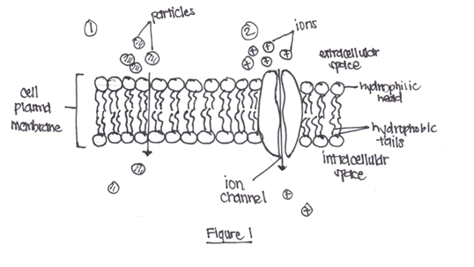constantly oscillating in place, there are chances for a small particle to slip through the hydrophilic heads and hydrophobic tails. For example, nanoparticles are sometimes able to fit through the small openings of the plasma membrane. However, this occurrence often relies on chance and is not the best for targeted drug delivery. Furthermore, diffusion is driven by a concentration gradient of salts within the cell. Figure 1 shows that there is a higher concentration of salt particles outside of the cell than inside of the cell. Therefore, movement of the particles will be driven into the cell. This concentration gradient controls how much is taken up and therefore diffusion across the cell membrane is purely random.

While diffusion is a random movement of particles in and out of the cell, the ion transport channel is a more selective towards what may enter the cell. In the plasma membrane, proteins may be imbedded within and may have an ion transport channel for which particles are able to move into the cell membrane. However, only particles with a certain charge are able to pass through the membrane making an electrochemical gradient. The negative surface charge of the cell membrane may also apply to the ion transport channel, in which is the driving force for how particles may enter. As shown in Figure 1, point 2 positive ions may enter through the ion transport channel, but only upon opening of the electrochemical gates to the channel. The gates of the channel only open when the positive charge meets the negative surface charge. Furthermore, certain ion channels may be selective to the type of ion that accumulates. For example, perhaps a sodium ion may pass through the channel, but a potassium ion may not. Both are positively charged, yet the ion channel is element-specific. This may be favorable for some drug interactions, yet the drug must target the ion channels of a cell. However, like diffusion, a particle crossing the cell membrane through this method has low probability due to the high selectivity of the channel and size limitations from the pore of the channel.

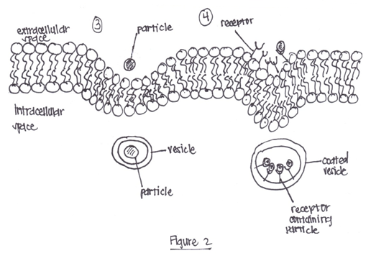 On the other hand, endocytosis does not have as many limitations and drug design for chemotherapy or nanomedicine more often targets this cellular uptake method. Two types of endocytosis are pinocytosis or receptor-mediated mechanism. During pinocytosis, as shown in point 3 of Figure 2, a particle rests at the surface of the plasma membrane. The plasma membrane surrounds the particle causing it to be engulfed and sealed by the plasma membrane. This creates a vesicle of for the particle and then is pinched off into the cell as seen in the intracellular space of point 3 of Figure 2. The particle is able to be pinocytosized only if it is made up of polar molecules, which are influence by the electronegativity of the particles. Pinocytosis is particle-specific yet, drug synthesis may modify a particle to allow it to be more polar and influence uptake. For example, a gold nanoparticle itself may not be significantly taken up by a cell, but if coated with a more polar substance, uptake is more successful. Furthermore, point 4 of Figure 2 shows the receptor-mediated mechanism, which is like pinocytosis, yet there are receptors that only bind to specific particles with a certain connector. Cancer drugs may be modified by adding ligands, or added molecules that fit the receptor. Thus, this allows for an easier way to influence uptake of a drug into the cell.