Cats have invaded most of the world since the 1500s when they started traveling with ships during the “Age of Discovery”. Cats were kept on board as a mean of rodent control, a sort of guardian for the crew’s food. However, even though cats are considered domesticated, they were not the most loyal companions. As a result, many cats chose to stay behind on islands as their ships sailed away. Over the past centuries, cats have established colonies and populations on islands humans introduced them too. They had become a recognized threat to island ecology and native species. These cats are *feral,* meaning that they are just like our domesticated pet cats, but they don’t depend on humans for survival. In short, these cats belonged to nobody.

Scientists are especially concerned about the presence of feral cats on islands for several reasons. Island environment encourages species to evolve because there are usually a lot of niches to fill on an island due to their accessibility difficulty. The species reached the islands are likely to have little competition, leaving them a lot of room for evolving and specializing. However, native island species don’t usually include large predators because finding enough food to survive as a big animal on a very small island is hard.

This makes islands the perfect place for cats. These cats flourish since there are no natural enemy or competition standing in their way and an island worth of food. Feral cats eat native seabirds, amphibians, small mammals, etc. – species that are special to an island and might not exist elsewhere. The fact that feral cats have hunted some native birds and small mammal species to extinction is proven. For this reason, a lot of island ecologists and authorities consider performing complete eradication of feral cat populations on their islands. This sounds very straightforward – cats are the problem, let’s get rid of cats. The reality is much more complicated than that. Unpredicted trophic cascade is a serious risk of this feral cat control method. A *trophic cascade* is a phenomenon in which changes in one species’ abundance (in this case, feral cats) effects multiple other links in the food web. From here we will take a look at the ideal outcome 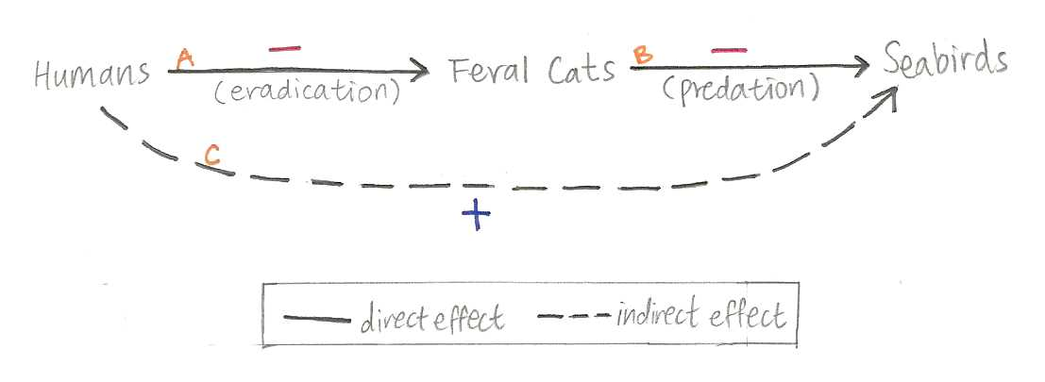of eradication and work out way through possible, undesirable consequences.

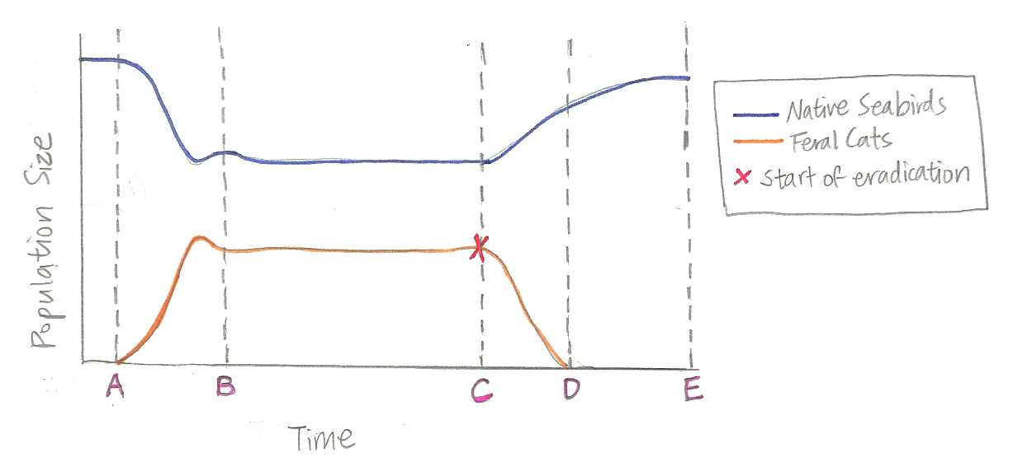 Ecologists often use interaction maps to show the relationships between players in the ecosystem. Figure1 represents the most simplified ecological interactions between feral cats, native seabirds, and humans. Organisms in nature interact *directly (*between two organisms only*)* and *indirectly (*through other intermediates*)*, and these interactions could be either negative or positive (as indicated by the + and - signs). In an ideal scenario, we assume that feral cats have a negative effect on seabird population (arrow B) and eradication will have a negative effect on feral cats populations (arrow A). The addition of these two relationships is arrow C. Arrow C is positive because multiplying a negative to another negative yields a positive. If all goes according to this picture, we would expect the involved populations to respond as they are drawn in Figure 2.

Figure2. Population response to eradication under ideal scenario

Figure1. Ideal Scenario of Cat Eradication

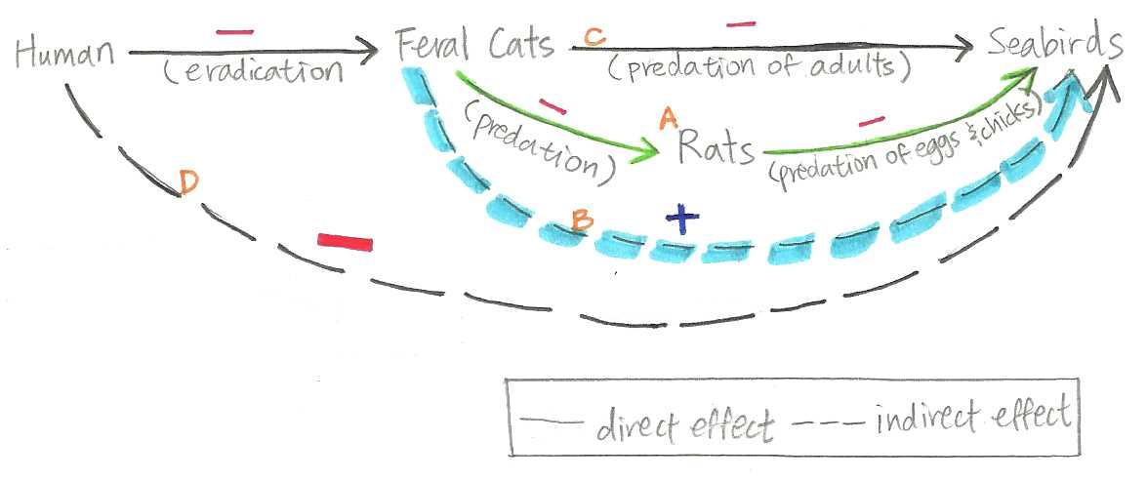 But wait! It would be naïve of us to assume that feral cats only interact with one species on an island. Trophic cascade becomes a very apparent risk when you expand the food web to include just one more species. In Figure3 we include the rats’ interaction with feral cats into the interaction map.

The green arrows show that feral cats have a negative effect on rats through predation and that the rats also have a negative effect on seabirds through predation. This relationship add together to make arrow B. What arrow B tells us is that feral cats actually has an indirect positive inpact on the seabird population. You might be wondering, why does arrow B outweigh arrow C? The reason is that rats proliferate much faster than cats. Therefore, we disregard arrow C. Incorporating the interactions further, humans, by eradicating cats, might have a negative impact on seabird populations (arrow D). If eradication is – and we multiply that by the + indirect effect feral cats have on seabirds, we yeild a negative result in our efforts. This phenomenon is called the *Mesopredator Release,* in which populations of the middle predators (mesopredators, in this case, the rats) rapidly increase in ecosystems after the removal of top predators (cats). Because rats proliferate so 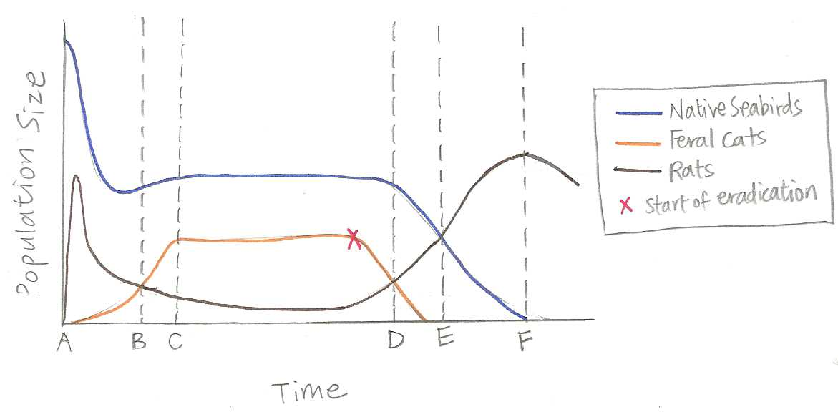quickly, mesopredator release of the rat population can be very detrimental to the bird populations. The population trends of this release is presented in Figure 4.

Figure3. Interaction map including Rats

Figure4. Population trends when mesopredator release occurs

Borrowed Visual

Original Visual 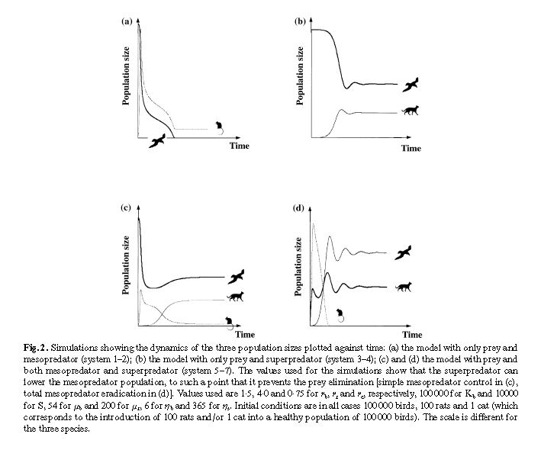

Source:

Courchamp, F. et al. (1999) Cats protecting birds: modeling the mesopredator release effect. J. Anim. Ecol. 68, 282–292

Revision:

I borrowed (b) from the original for Figure2. I extended the scenario to incorporate what was predicted to happen after feral cat eradication when no mesopredators were taken into account. I borrowed and combined (a) and (c) for Figure4 to show population trends in a mesopredator release scenario. I modeled Figure4 to (c) for the part before feral cat eradication and to (a) for the part after (when the superpredator – feral cats – were removed). I also added markers along the trends so I can explain what interaction caused what change in which population.