The thrill of algebraic effects, the agony of monad transformers

Hardy Jones

Reasoning about programs is hard, and our current techniques are not very composable. In most programming languages any *computational effect* – like input/output (I/O), non-determinism or optional values – can happen at any time. Explicitly enumerating which computational effects happen within a program allows you to more easily reason about what a program actually does. We can use *monads* to describe any computational effects. Monads are just data types that have an operation that embeds a value within it and an operation to chain computations together [2]. But monads do not compose without losing expressive power, so recently work has been done to develop the theory of *algebraic effects* – where operations describe introduction, composition and removal of computational effects [1,3] – which compose while keeping their expressive power.

A computational effect is a side effect of producing a pure computation. For instance, if you are computing the division of two numbers, this computation may fail if the divisor is 0. Failure is the computational effect in this example while division is the pure computation. A popular method of describing computations in a functional language is through the use of monads. Some well known monads are: the optional value monad (called *Maybe* or *Option*) depicting a computation that has exactly 0 or 1 value; the non-determinism monad (can be represented as *List*) for computations which have 0 or more values; and the *State* monad, which describes computations with some globally accessible values that can be read from or written to. Continuing with the example, we could use either the Maybe monad or the List monad to encode the result of division. If it failed, we would have *None* or an empty list. And if it succeeded, we would have *Some value* or a list with one element.

Ifwe want to specify a computation with more than one monad, we may attempt to compose them together. Unfortunately, the composition of two monads (like the Maybe monad and the List monad) directly does not necessarily give a new monad. The composition may become some weaker structure that cannot describe all computational effects. However, we can still formalize the composition of certain monads by implementing a *monad transformer* [2]. A monad transformer requires an additional operation – usually named *lift* or *prod –* that gives the implementation for embedding a computation from one monad to the other. For instance, if you were to combine Maybe over List (so the effect is optional non-deterministic values), then you would have to provide some way to pull the non-deterministic effect from List into the optional effect from Maybe. The monad transformer construction allows us to describe the composition of different computational effects.

Algebraic effects are a relatively new method of describing computational effects. In fact, algebraic effects are so recent that very few programming languages have an implementation available, and most languages lack the expressive power to properly encode the concept. This formalization arose specifically as a way of generically describing the composition of effects. So by construction, composing two algebraic effects is always still an algebraic effect. Composing Maybe with List doesn't imply that you need an ad-hoc way to move effects around or any general structure on the program.

Both of these formalizations are pretty heady. It can help to think of the difference between the two as the difference between a tube of potato chips (like Pringles) and a bag of potato chips (like Lay's or Ruffles), where we are concerned with inserting and removing chips from the container. Monad transformers are the Pringles in this situation. In order to get at a specific chip, you have to remove any other chips above it. Algebraic effects are the Lay's; you can reach into the bag and choose any specific chip. We will see how these metaphors help to show that monad transformers are more powerful than algebraic effects, but algebraic effects are more fine-grained and composable.

**Monad transformers: Computational effects in disguise**

Since monad transformers are just compositions of monads, and monads can describe any computational effect, monad transformers can be used to describe any computational effect as well [2]. We could use monads to fully describe every computational effect that any program had, but decomposing a program to his level of granularity is not done in practice, for reasons to be shown later. The story is different for algebraic effects. It is not immediately obvious which computational effects can be described by algebraic effects. *Continuations* – where the programmer states explicitly what the next action is rather than relying on implicit control – cannot be encoded by algebraic effects [3]. It can be shown that the continuation monad can actually describe all other monads (and thus all computational effects) [4]. Since we cannot represent continuations with algebraic effects, they must necessarily be a weaker construct than monads and their transformer compositions.

**With our effects combined... we are algebraic effects!**

If we already have monads – and monad transformers for composing them – you might be inclined to ask what the motivation is behind creating a weaker abstraction like algebraic effects. There are two important distinctions: creating a new composition from smaller pieces, and accessing the data type that describes the effect. The distinctions arise from the way each composes. Monad transformers create a linear stack based composition, while algebraic effects create a flatter graph based composition.

Let’s say that we have a computation that has the following effects: I/O, State, and Randomness. If our monad transformer stack is as shown in Figure 1, then we can perform I/O with a state of random values, and that is the only computational effect we can perform. We do not have the option to perform I/O with a random state of values or use random state to perform I/O. If some different computational effect is required, then the entire monad transformer stack must be changed to reflect this. To continue with the potato chip metaphor, we have only one way to get to the 5th chip in the tube, we have to remove the four chips above it. The unwieldiness of monad transformers also shows up when we want an additional computational effect.

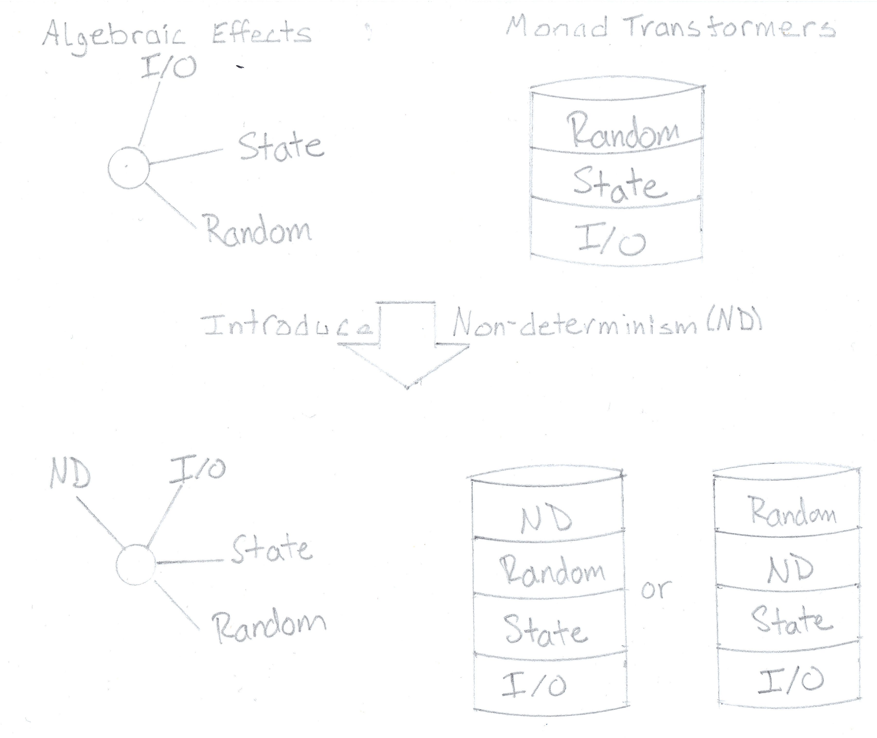

Figure 1

If we wanted to introduce non-determinism into our program, we have some options as to where that effect will take place. On the one hand, if we put the non-determinism at the top of the monad transformer stack, then we have a computation that can perform I/O with a state of random non-deterministic values. On the other hand, if we introduce non-determinism between the randomness and the state, then we have a computation that can perform I/O with a state of non-deterministic random values. Introducing an effect is like adding a chip into the tube. When we choose where we want to put the new chip, we have also decided how to remove this chip at a later time. Deciding to place the new chip 3rd from the top means we must remove two chips in order to get to it. These options are only two of many, but with each they lock down the computational effects that the program can now perform.

With algebraic effects, each effect is at the same level as the others as shown in Figure 1. This flatness means that if you wanted to introduce non-determinism to the effects we already have, it does not matter where you introduce the non-determinism. The computation started out as being able to perform I/O, read/write to state or generate random values. For example, we can perform I/O with randomly generated state values, we can perform I/O with a state of randomly generated values, or we can just generate random values. Algebraic effects allow us to perform any of these computations (and many more) without changing the structure of the program. If we wanted a specific chip from a bag of Lay's, we can look into the bag for that particular chip and pick out just that one without having to remove others.

If we again wanted to introduce non-determinism, we end up having an easier time with it than we did with monad transformers. Introducing a new effect is similar to throwing a new chip into the bag. We have not affected the chips that were already in the bag, nor have we made it more complex to remove the newly added chip. We can still look for the chip we want and pull it out by itself. After we add this new effect, the computation can now perform I/O, read/write to state, generate random values, and do all of this non-deterministically. This method of composition means we can now perform I/O with a non-deterministic state of random values, non-deterministically perform I/O, or simply generate random values still. It does not matter which additional effects are added, the previous behavior is still valid and new combinations are just as valid.

**Like sands through the hourglass, so are the algebraic effects of our program**

Since monad transformers compose in a linear stack fashion, each effect we want to describe must be inserted in a specific order. If the stack is created as the first part of Figure 1, then we need to *lift* an I/O operation twice (once to bring it up to state and again to bring it up to Random) when we want to use it. And when we introduce a new effect, we have to go through our program and update all the I/O *lift*s to be called three times instead of two. This same transformation has to be done for each effect we have in our stack depending on where the new effect is placed. Forcing changes like this dictates designs where different computational effects are lumped together if they share some similarities in order to decrease the amount of *lift*s necessary to use the transformer.

I/O is a perfect example of computational effects that are lumped together to make programming easier to write. It is much easier to state that all things which interact with the real world happen in the I/O effect. But I/O can be much more granular than that. Reading from a database is not the same computational effect as writing to a database. Writing to a file handle is not the same computational effect as getting the current time. However, each of these effects is usually lumped into I/O in practice. So, when you see that a program is using an I/O effect, you do not necessarily know what the program is actually doing. It could be something as mundane as sending a file to the printer, or it could be as catastrophic as launching missiles!

Algebraic effects also allow for a more fine grained approach to describing computations. As there is no order to how effects are accessed, it makes no difference when you add a new effect. In practice, the flatness of effects means that there is less burden to divide kinds of effects up. We can more easily state that a program only reads from a database and writes to a file. We do not need to carry around implicit information about possible computations a program can have. We instead state exactly what a program can compute. We can use this when we compose smaller programs into larger ones.

If we have the option of choosing between two programs A and B, to use within program C (all using fine grained algebraic effects), and we see that A and B share the same effects, but B also introduces a missile launching effect, then we can make a better decision about which of A or B to use. Whereas if we were using the lumpier monad transformer style, then we would just assume A and B were equivalent programs (because the missile launching effect would be lumped into I/O) and choose one to use arbitrarily. Our choice could end up with a more dramatic result than we intended. The granularity of algebraic effects allows us to reason more effectively about the programs we create.

Creative addition: My creative addition is the titles and subtitles. They are tag lines or similar from television shows: *Wide World of Sports*, *Transformers*, *Captain Planet*, *Days of Our Lives* respectively.

References

1. Oleg Kiselyov, Amr Sabry, and Cameron Swords. 2013. Extensible effects: an alternative to monad transformers. SIGPLAN Not. 48, 12 (September 2013), 59-70. DOI=10.1145/2578854.2503791 <http://doi.acm.org/10.1145/2578854.2503791>
2. Sheng Liang, Paul Hudak, and Mark Jones. 1995. Monad transformers and modular interpreters. In Proceedings of the 22nd ACM SIGPLAN-SIGACT symposium on Principles of programming languages (POPL '95). ACM, New York, NY, USA, 333-343. DOI=10.1145/199448.199528 <http://doi.acm.org/10.1145/199448.199528>
3. G. Plotkin and M. Pretnar. Handlers of algebraic effects. In ESOP ’09, pages 80–94, Berlin, Heidelberg, 2009. Springer-Verlag.
4. D. Piponi. (2008, Dec 24) The Mother of all Monads. Retrieved from <http://blog.sigfpe.com/2008/12/mother-of-all-monads.html>

Hello, Hardy.

Please take a few minutes to read the comments I’ve added to your paper. In the margins above, you’ll find comments that apply to specific areas of the text, while in the comments below I try to summarize the most important issues that came up for me as I read and evaluated your work.

* A title like the one you’ve crafted might not work for everyday readers. Would they understand the jargon used there at a glance? Remember to draw in readers with the very first impression you make, and replace jargon with metaphors, simpler language, or examples (while still meeting the other criteria for a good comparison title).
* What is the losing side’s greatest loss? Try to develop an opening hook sentence around that loss. Remember that the criterion you bring up in the hook should match the criterion in the thesis lite and the final point of the comparison thesis, as well as being the final point the paper addresses.
* The thesis lite should state the way the winner wins the most—in the final criterion the paper addresses, which should be the same criterion the hook names. I can’t see that the thesis lite doing that quite yet.
* Nice job on the development of a comparison thesis. The options and evaluative criteria were clear.
* I like your introduction of the potato chip metaphor. It made the essay much more accessible and understandable. However, I would have been grateful to see it in the introductory paragraph as well as some of the body paragraphs towards the beginning of the comparison part of the paper. It did save the two final criteria.
* Rearrange the order in which the options are addressed in this body paragraphs so you always go from monad transformers two algebraic effects. If you name one option first under the first criterion, the same option should be named first under all the other criteria. This kind of consistency adds a little extra organization, clarity, and predictability to a formal comparison.
* Elbow passives are still fairly pervasive here. You might consider reviewing the PowerPoint on passive voice (particularly the elbow constructions) and running a few sentences by me if you're unsure whether they are passive or not.
* Overall, you should continue to focus more attention on translating terms for everyday readers. I often felt lost as I read your paper, unable to understand the jargon that you're assuming I can figure out or I already know. Again, the potato chip metaphor was quite useful and could have been used a little more often in criterion one in the body of the argument as well as the first paragraph of the essay. That metaphor was a great idea.

As always, if you need elaboration on my comments, please get in touch (during class, office hours, or via email) and I'm more than happy to explain what I mean so you can continue to improve the effectiveness of your writing.

**Grade: B**

Don