SDA connects to Pin 24.
SCK connects to Pin 23.
MOSI connects to Pin 19.
MISO connects to Pin 21.
GND connects to Pin 6.
RST connects to Pin 22.
3.3v connects to Pin 1.

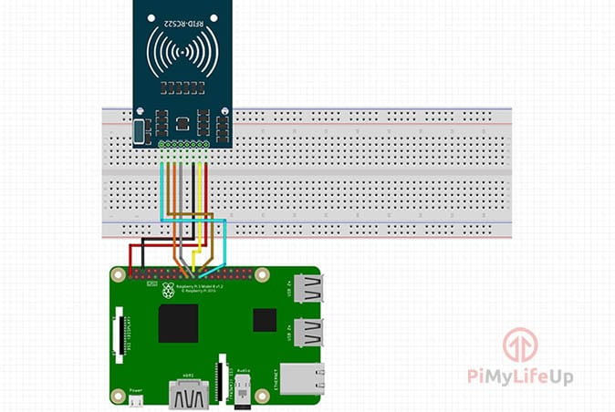

sudo raspi-config

>5.advanced options
>SPI enable
>yes >enter
exit

sudo reboot

lsmod | grep spi

sudo apt-get install python2.7-dev

cd ~
git clone https://github.com/lthiery/SPI-Py.git

cd ~/SPI-Py

sudo python setup.py install

cd ~/MFRC522-python

sudo nano Reading.py

import RPi.GPIO as GPIO
import SimpleMFRC522
import urllib2
import time
reader = SimpleMFRC522.SimpleMFRC522()
while True:
try:
id, text = reader.read()
print(id)
if id == 962079459598 :
print ("jones")
urllib2.urlopen("http://mycampus365.com/farmvilla/update.php?id=1").read()
time.sleep(1)
elif id == 344960107451 :
print ("arun")
urllib2.urlopen("http://mycampus365.com/farmvilla/update.php?id=2").read()
time.sleep(1)

else:
print ("invalid")
urllib2.urlopen("http://mycampus365.com/farmvilla/update.php?id=0").read()
time.sleep(1)
finally:
GPIO.cleanup()

ref: https://pimylifeup.com/raspberry-pi-rfid-rc522/

