**School Closures’ Potential Effects on COVID-19 Deaths**

**Original paper:**

[**https://www.bsg.ox.ac.uk/sites/default/files/2020-04/BSG-WP-2020-031-v4.0_0.pdf**](https://www.bsg.ox.ac.uk/sites/default/files/2020-04/BSG-WP-2020-031-v4.0_0.pdf)

**Data:**

[**https://covidtracker.bsg.ox.ac.uk/**](https://covidtracker.bsg.ox.ac.uk/)

**Full code:**

[**https://colab.research.google.com/drive/1z_9obvCFl2gAxk3ckVRC-ncMwexVz0Hl**](https://colab.research.google.com/drive/1z_9obvCFl2gAxk3ckVRC-ncMwexVz0Hl)

**Introduction**

Researchers Hale, Petherick, Phillips, and Webster at the Blavatnik School of Government, University of Oxford, have gathered daily data on 147 countries’ government responses to the COVID-19 pandemic since January 1, 2020. They measure “common policy responses” in 13 areas, including limits on various types of public gatherings, fiscal measures, and coronavirus testing; they also note whether certain measures are targeted or general.

The researchers then issue an overall stringency index for each country’s response, provided enough data has been collected. Their publication has focused on tracking and plotting this overall stringency index related to the number of confirmed coronavirus cases and deaths in certain countries (<https://covidtracker.bsg.ox.ac.uk/stringency-scatter>).

|  |  |  |
| --- | --- | --- |
| S1 School Closing | 0 - No measures  1 - Recommend closing  2 - Require closing | 0 - Targeted  1- General |
| S2 Workplace closing | 0 - No measures  1 - recommend closing  2 - require closing | 0 - Targeted  1- General |
| S3 Cancel public events | 0 - No measures  1 - recommend closing  2 - require closing | 0 - Targeted  1- General |
| S4 Close public transport | 0 - No measures  1 - recommend closing  2 - require closing | 0 - Targeted  1- General |
| S5 Public info campaigns | 0 -No COVID-19 public information campaign  1 - COVID-19 public information campaign | 0 - Targeted  1- General |
| S6 Restrictions on internal movement | 0 - No measures  1 - recommend movement restriction  2 - restrict movement | 0 - Targeted  1- General |
| S7 International travel controls | 0 - No measures  1 - Screening  2 - Quarantine on high-risk regions  3 - Ban on high-risk regions |  |
| S8 Fiscal stimuli | Value of fiscal stimuli, including spending or tax cuts |  |
| S9 Monetary policy interventions | Value of interest rate |  |
| S10 Emergency investment in healthcare | Value of new short-term spending on health |  |
| S11 Investment in vaccines | Value of investment |  |
| S12 Testing policy | 0 - No testing policy  1 - only testing those who both (a) have symptoms, and (b) meet specific criteria (eg key workers, admitted to hospital, came into contact with a known case, returned from overseas)  2 - testing of anyone showing COVID19 symptoms  3 - open public testing (eg “drive through” testing available to asymptomatic people) |  |
| S13 Contact tracing | 0 - no contact tracing  1 - limited contact tracing – not done for all cases  2 - comprehensive contact tracing |  |

The researchers have not, however, published any statistics about the relationships of individual categories of policy responses and the numbers of COVID-19 cases or deaths.

Because the [original Imperial College study](https://www.imperial.ac.uk/media/imperial-college/medicine/sph/ide/gida-fellowships/Imperial-College-COVID19-NPI-modelling-16-03-2020.pdf) of social distancing measures indicates on page 10 that the lowest number of critical cases would result from social distancing measures in combination with schools remaining open, not closed, I explored the relationship between the measures taken by governments around school closures (S1) and the number of coronavirus deaths.

The timing is early in the pandemic, fewer than 200 days, so like the Oxford researchers, I have not been able to draw sweeping conclusions from statistical analysis of the data. As new data is gathered daily, this same research may yield more conclusive results over time.

**Hypotheses**

Ho: Nations with strict school closure policies and those with no school closures do not have significantly different coronavirus death rates.

Ha: Different school closure policies are correlated with different coronavirus death rates.

**Data and Methods**

To begin, I reformatted and added to the data provided by the researchers so that the school data was summarized in a single column entitled school_stringency, as follows:

|  |  |
| --- | --- |
| No measures | 0 |
| Recommend closing, targeted | 1 |
| Recommend closing, general | 2 |
| Require closing, targeted | 3 |
| Require closing, general | 4 |

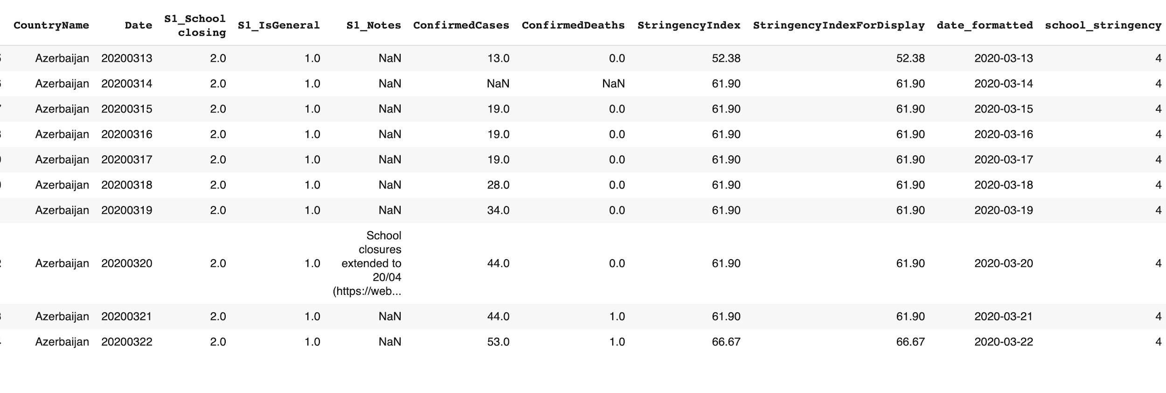

I added population statistics (total population and density) from the [UN’s Department of Economic and Social Affairs](https://population.un.org/wpp/Download/Standard/CSV/), and I calculated the death rate per 100,000 population for each country.

I plotted the death rate over time alongside the pattern of school stringency for several nations:

I then isolated all the data from April 6, the last day that a large majority of nations provided information to Oxford, resulting in a dataframe with 122 countries. Looking at plots like those above, I realized most nations settled into a certain school stringency level, some after an initial period, and they have held this school stringency level until the present. I therefore broke the dataframe down into four subgroups based on whether the nation had settled into level 0, 2, 3, or 4 school stringency as of April 6. (There were no nations practicing level 1 stringency as of April 6.)

Group 0 contains the following countries:

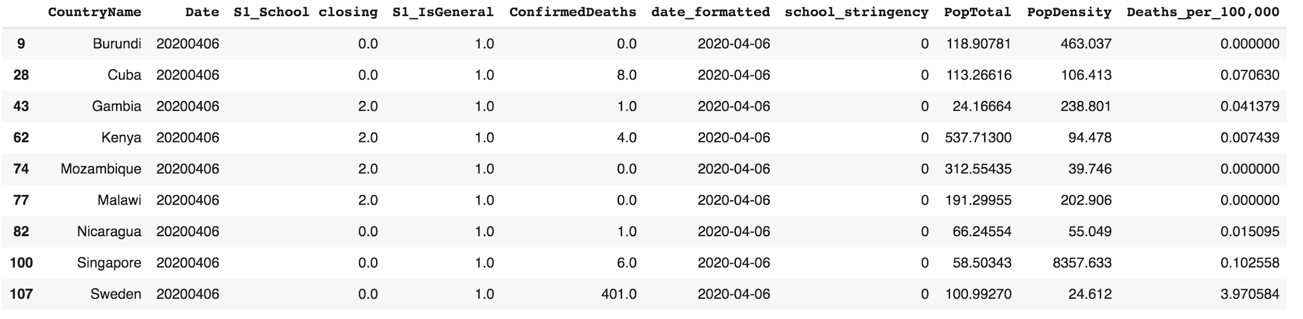

Group 2:



Group 3:

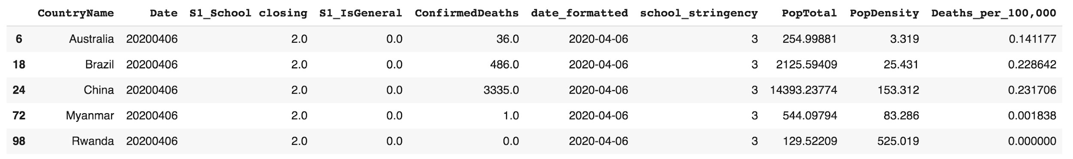

The remaining 106 countries fall into the group having school stringency level 4.

Finally, I used the Kruskal-Wallis test for non-normally-distributed data to test for significant differences between the confirmed deaths per 100,000 population of the groups.

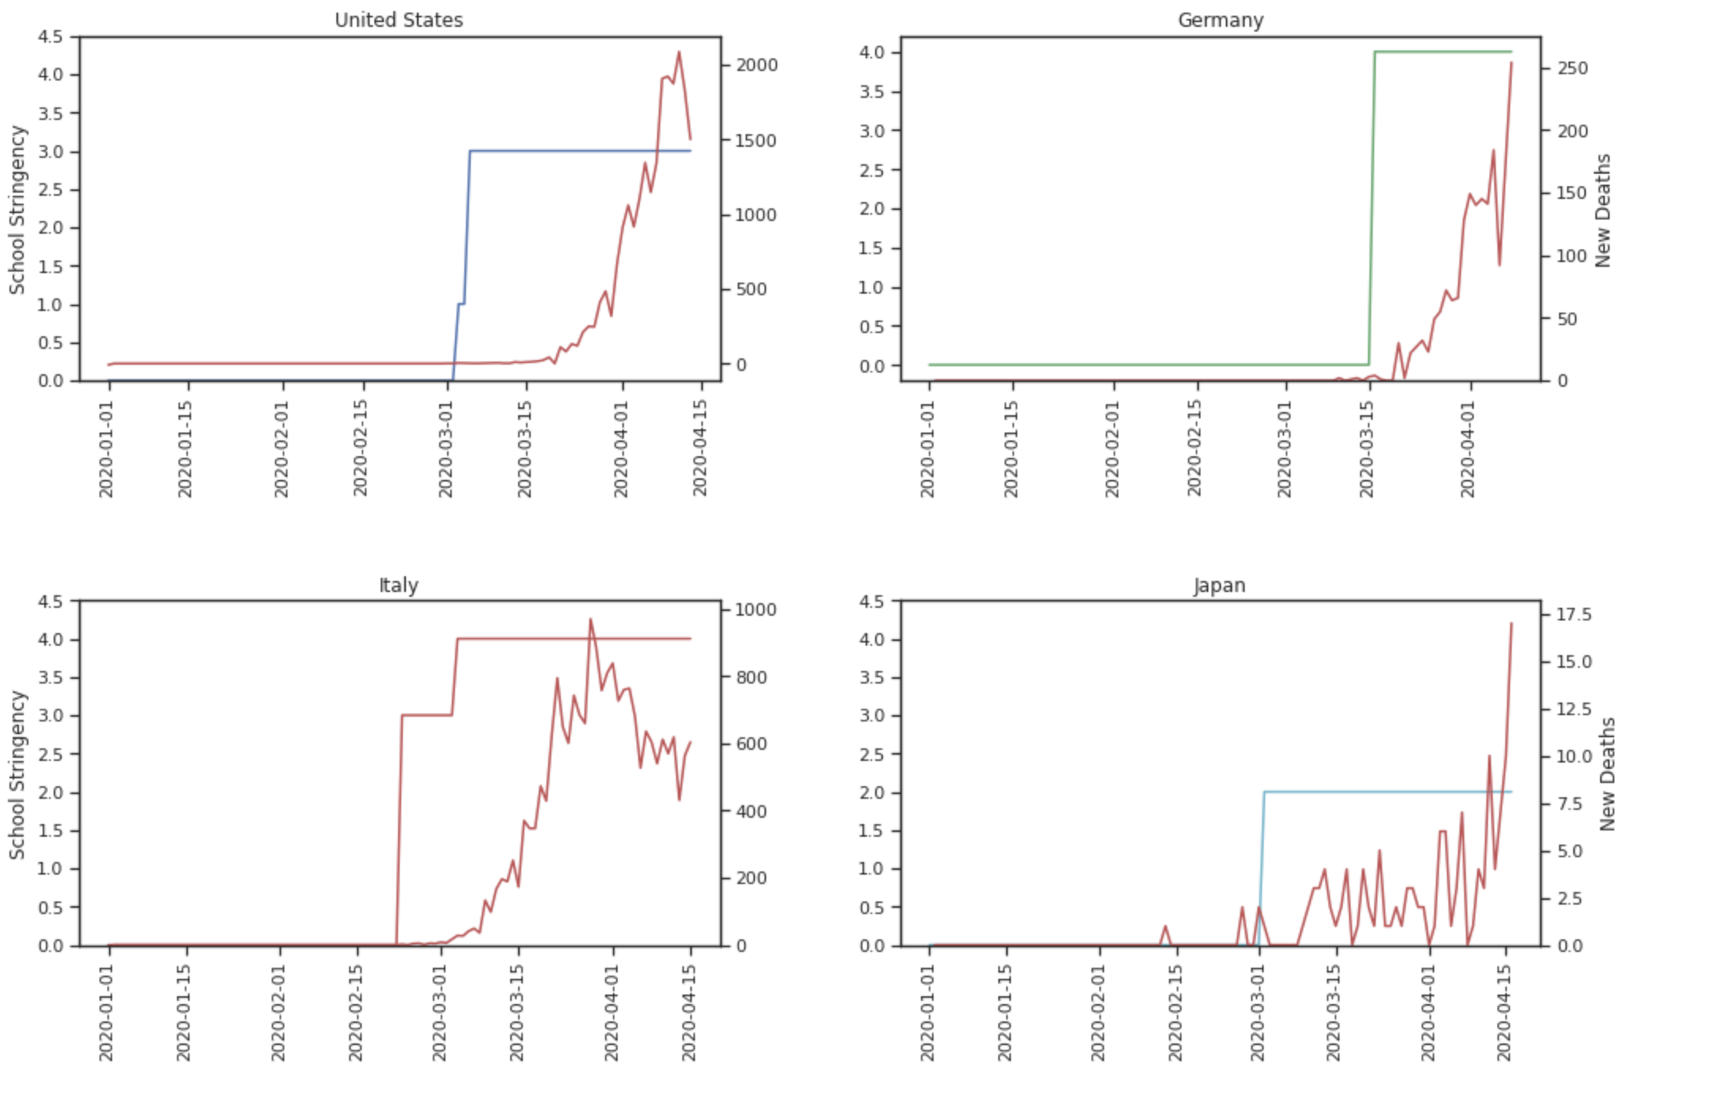

**Results**

The resulting p-value of 0.179 is too high to indicate a significant difference in the distributions of death rates based on the stringency of school closure. This means that, as of April 6, there is no significant difference in coronavirus death rates between nations who have no school closure vs complete school closure. However, this is a very narrow slice of data and a very complex issue, and many more tests could be conducted to study the relationships between school closure and coronavirus death rates, particularly as time goes on.

**Discussion & Recommendations**

There are many more factors that could be studied relative to school closures and coronavirus deaths. First, the same test should be run regularly over the next months as more data is collected and sample sizes become larger. Second, rather than grouping the data by day and by school stringency measures, date from first death and date from implementation of stringency measures could be taken into account. Population density could be included in calculations. Urban and rural areas could be separated; where available, the ages of those dying from coronavirus could be studied.

The measures leading to any change in coronavirus deaths over time are complex, as partially reflected in the thirteen measures used by the Oxford researchers in their study and incorporated into a more general Stringency Index. As the pandemic progresses, this research may become more useful as part of a larger effort which includes analyzing all thirteen measured factors against new coronavirus deaths, probably with more complex statistical methods. That might lead to more comprehensive data-driven recommendations for governments during future viral outbreaks.