The fitness landscape
Based on: http://academic.evergreen.edu/m/mcavityd/NetLogo/Fitness_Landscape.html

How the model works
The NetLogo program “Fitness_lanscape” (Fitness_landscape.nlogo) is a simulation model of evolution based on movement through a fitness landscape.
This landscape can be thought of as a 2-dimensional map of the “phenotypic world”, with fitness being indicated by the colour of the background – white = high fitness, black = low fitness. Animals (“turtles”) are placed on this fitness surface and those that sit on high fitness areas do well and reproduce while those that are on dark areas are likely to die without reproducing. You can think of the x- and y-axes as representing two variables that specify the phenotype of the turtles (e.g. beak length and body size).
The landscape in the model is generated by randomly assigning fitness values to points across the landscape and then smoothing the landscape using the smoothness slider in the user interface. The range variable on the interface specifies the difference between the maximum fitness and minimum fitness -- this effectively sets the steepness of the fitness slopes.
Using another slider, you specify a number of turtles, which will appear in a small circle near the center of the landscape. The radius of the circle represents the initial variation of the phenotypic variables The turtles age by one each time step and have a probability of dying that depends on their age and their fitness (which is determined by the patch they are on). As they age they are more likely to die, but if they have high fitness they are less likely to die. Thus, through time the population evolves.
The population is at carrying capacity, so if population is reduced due to death turtles are selected at random to reproduce until the population recovers. The new turtles are hatched a small distance from the parent in the fitness landscape -- this distance represents a slight mutation in the phenotypic variables of the parent. The amount of mutation can be varied with the slider.
There is an option to have the landscape change slowly in time (changing-landscape?) and the rate of this change can be varied with the landscape-change-rate slider. The effect in the model is that the fitness peaks gradually move around over time. In the natural world the fitness corresponding to particular phenotypes change over time, because of changes in the environment. For example, the pollution of the industrial revolution altered the relative fitness of the black/white morphs of the peppered moths (Biston betularia).
Finally, there is also an option to include a feedback mechanism where the fitness of individuals is reduced if there are too many other individuals with the same, or similar genome. The result of this type of feedback is speciation so the button to activate this is called “speciation?”. We will ignore that in this practical.
The default settings are:
Smoothness = 14 [how uniform or heterogeneous is the fitness landscape?]
Range = 100 [what is the difference between lowest and highest fitness?]
Number = 1196 [how many turtles?]
Mutation = 1 [how far from a parent can a baby turtle appear?]
Changing-landscape = On [does the environment/landscape change in time?]
Landscape-change-rate = 60 [how fast does the landscape change?]
Speciation = On [can speciation happen]

What to do…
- Set range to be 0, and landscape-change-rate to 10. Click setup. This will set up a fitness landscape with no variation. Click go. You should notice that although every turtle has the same fitness they still move around the fitness landscape as their offspring are born with mutations that allow their phenotypes to vary. They are showing neutral evolution (aka genetic drift).
- Move the mutation slider to reduce mutation to 0. You should see that now, offspring keep the same phenotype as the parents so the turtles do not move around the landscape.
- Move the mutation slider back up to 1.0.
- Now observe what happens as you gradually increase the range back up towards 100. Your landscape will now become heterogeneous with “blobs” of high and low fitness areas. You should see that the turtles move to the high fitness areas. This is because they are not successful in low fitness areas. Observe how the average fitness of your turtles increases with time.
- In some simulations you end up with “islands” of high fitness areas separated by “seas” of low fitness. In these you should see that your turtles become separated from each other. Isolated populations on this fitness landscape have distinct phenotypes. Gene flow can be limited between these separated populations and this is a precursor for speciation.
- With the model running, try clicking setup start new simulations. You should be able to see that turtles consistently migrate towards high fitness areas. Their phenotypes are evolving to maximise fitness. In some circumstances they can get “stuck” on islands so that even though they could be fitter, they cannot get there (see figure below).
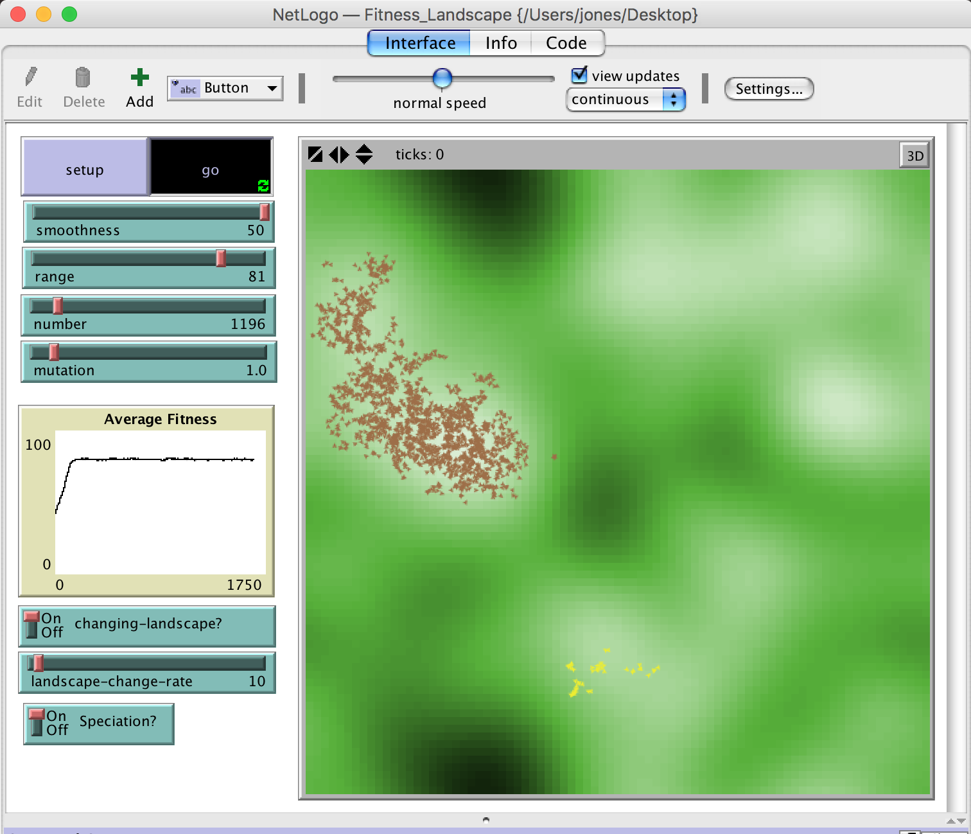

Things to notice
With a non-changing, or slowly changing landscape, the first thing to notice is that the population of turtles does gradually drift up the fitness landscape to local fitness peaks, although there are frequently groups of turtles that survive for a time away from the peaks. These are less than optimally fit subgroups who survive by random chance. The graph will show average fitness increasing, but with some fluctuations.
You will notice that the initial turtle population is randomly coloured. but after some time one color comes to dominate. The colours represent different genotypes, but there is no selection on genotype (i.e. it has no effect on fitness). The fact that one colour ends up dominating is a result of genetic drift. If two species are equally fit in an environment with limited resources, then over time, due to random fluctuations in population size one species will end up taking over. Sometimes you will see genetic drift acting when the population splits into two groups, one will die out, even if both groups have similar fitness. (Indeed occasionally a "fitter" but smaller group will die out for the same reason.)

Try the following (we’ll discuss it in the last part of the class)
- Try to get a simulation model running where there are unoccupied fitness peaks. While the model is running, try increasing mutation rate. What happens? What do you think this means?
- Start with a simulation with a heterogeneous but non-changing landscape, and a low mutation rate (0.5). Allow the turtles to move to the fitness peak(s), and look at the average fitness graph as it does so. Now allow the landscape to change rapidly. Observe what happens to average fitness. How this might relate to climatic or other rapid environmental change? How does mutation rate affect the ability to track environmental change?

