Intuition on quantitative genetics – continuous traits from discrete genes.

Owen Jones (jones@biology.sdu.dk)

You can get a simple intuitive view of how quantitative traits are influenced by many genes by considering flipping a coin.

If you flip a single coin you can get heads or tails -- a binary result.

Now consider a system where genes operate like switches and can be “on” or “off”. We could code this as 0 or 1.

Some traits are determined by sets of many genes and these traits are called quantitative traits. For example height, level of aggression, strength, milk yield in cows etc. are quantitative traits. Most of the time, if we measure these traits in a population, we see that they have a normal distribution.

So how can these so-called quantitative traits with continuous normal distributions be produced by simple on/off genes?

The answer is, in theory, pretty simple –

- Genes being on or off can lead to positive or no effects on a trait.

- We can simulate this by flipping coins here in the classroom. Imagine that each student represents a gene that can have a positive/negative effect.

- Let’s assume first that our baseline trait value is, say 50 (an arbitrary number). If person A, gets heads, then we add 1 to this value, but if they get tails, we add nothing. We do the same thing for person, B, C and D and so on. You can see that sometimes there’s a positive effect and sometimes no effect. The result is that the trait value for this particular individual animal would be approximately 50 + half the number of students.

- Now, if we repeated this process for the next individual we’re likely to get a similar value, but not the same. If we repeated this many times, to represent say 100 individuals, you should find that we get a normal distribution.

Excel exercise.

We can simulate this process using Excel.

In the Worksheet there are 3 areas: blue, red and green.
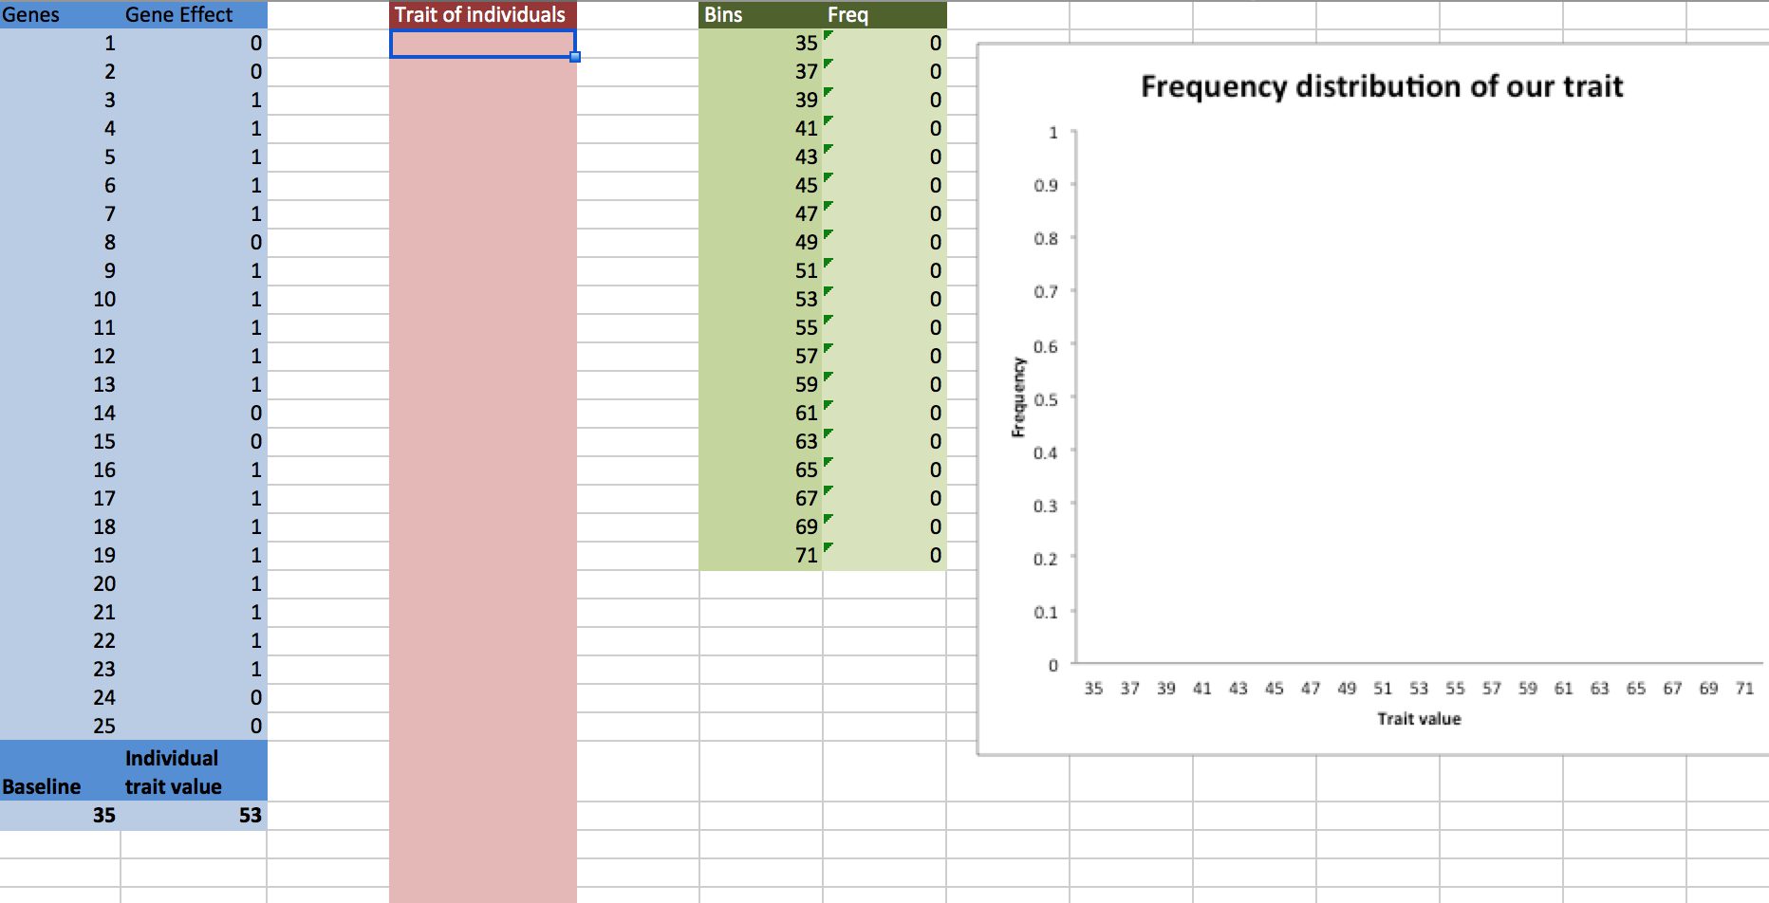

The blue area represents 25 genes, which are randomly either on (1) or off (0).

The 25 genes work together (additively) to influence the trait value, along with some arbitrary “baseline” value (in this case, 35). Thus, in this simulation, if there are ten genes “on”, and 15 genes “off”, the resulting trait value of the individual is 35 + 10 = 45.

The Excel sheet is set up so that every time you make a change, the gene effects are re-randomised, to give you the trait value of another individual.

To see the development of a normal distribution from this simple set up do the following.

- In the red area, type in the value given at the lower right-hand side of the blue area (in the figure above, this is 53. Then hit the Return/Enter key.
- You should notice that the green area, which will give a frequency distribution of the developing population, changes. A bar should also appear in the graph.

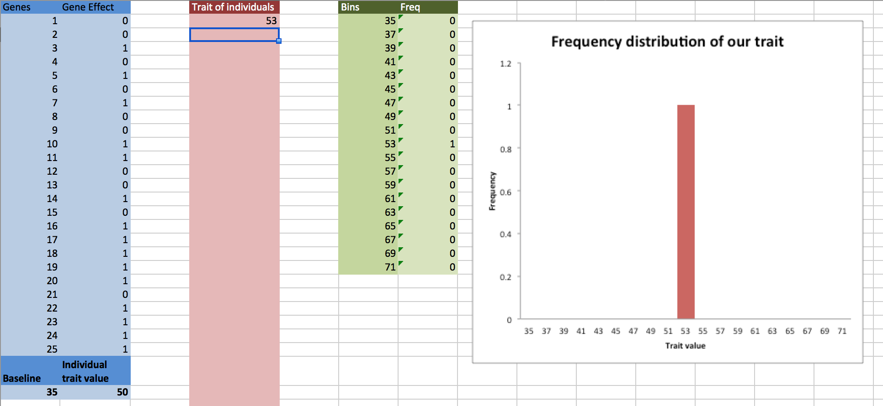

- You should also notice that when you hit the Return/Enter key, the genes are re-randomized, giving a new trait value for another individual. Type this in, and hit enter again.
- Repeat this process and observe how the distribution develops. You should see that, with time, a normal distribution develops. You will need a sample size of >30 for this.

