Supplementary Materials
  - When does sampling uncertainty matter in matrix population models? Evidence from published projection matrices
Table of Contents

Supplementary Methods

S1.1 Sampling-distribution workflow used for each MPM
For each focal matrix population model (MPM), we reconstructed transition-level sampling distributions from reported transition counts (or equivalent sample-size information). We then generated 2,000 parametric bootstrap draws per MPM by sampling each transition from its likelihood (multinomial for survival/growth/retrogression transitions and Poisson for recruitment transitions), rebuilding the full MPM for each draw, and recalculating each derived demographic quantity from that draw.
This produced a sampling distribution for each derived quantity used downstream (e.g. life expectancy, shape, log population growth rate). Point estimates in the manuscript correspond to values derived directly from the reported matrix entries; uncertainty-aware summaries correspond to moments of these bootstrap distributions.

S1.2 Age-from-stage derivation, truncation, and shape metric
Life expectancy and shape were derived from survivorship trajectories obtained using age-from-stage methods, starting from the first reproductive stage. Shape was calculated using the pace-shape framework metric (Baudisch and Stott 2019). Because stage-based survivorship can converge to an artefactual mortality plateau, shape was calculated on truncated trajectories up to quasi-stable convergence (distance threshold 1%).

S1.3 Pooled and mean MPM handling
Where population-level pooled MPMs were available, they were used; otherwise, mean MPMs were used. For uncertainty propagation in pooled or mean matrices, stage-specific sample sizes were pooled across years before bootstrap simulation. This captures within-year sampling variation but does not fully represent between-year process variation, so the resulting uncertainty should be interpreted conservatively.

S1.4 Bayesian model priors and fitting settings
Stan models and priors are defined in models/*.stan. For the two main analyses:
- Analysis 1 models use weakly informative normal priors for location/slope terms and normal priors for scale terms (see models/regress_hier.stan and models/regress_hier_error.stan).
- Analysis 2 uses two models with Gaussian-process regression forms and normal priors on GP hyperparameters and coefficients (see models/movbeta_gprc.stan and models/movbeta_gprc_err.stan).
Fitting settings used in scripts:
- Analysis 1 (scripts/S07_case_study_1_analysis.R): chains = 2, iter = 4000, warmup = 2000-3000, seed = 5654.
- Analysis 2 (scripts/S12_case_study_2.R): iter = 5000 for key models, seed = 5654, with additional control settings for GP fits.

S1.5 Variance-component summary (sampling-to-other ratio)
For each parameter, the total observed variance was partitioned into:
- sampling component: mean within-MPM sampling variance from bootstrap draws;
- residual component: remaining variance among populations/species.
The reported summary is Eq. (1):
$$\text{ratio}=\frac{σ_{\text{sampling}}^{2}}{σ_{\text{residual}}^{2}} \left(1\right)$$
Ratios above 1 indicate that sampling uncertainty exceeds residual biological variation for that parameter.

S1.6 Simplified spring-temperature model (analysis 2)
In addition to the monthly-lagged GP model, we fit a simplified spring summary model with mean spring temperature deviation as the predictor, under both point-estimate and uncertainty-aware formulations. The contrasts reported in the manuscript use posterior medians and 95% interval widths from these paired models.
For the stage-specific survival panel in analysis 2 (Fig. 5C), we derived annual stage-specific survival as the column sums of the $U$ matrix for each year and stage, then compared two logit-scale models per stage: (i) an SSD-weighted quasibinomial point-estimate model, $\text{surv}∼\text{tmp}$, where weights are the stable stage distribution from each annual $U$ matrix; and (ii) a binomial count model, $\text{cbind}\left(n_{\text{surv}},n_{\text{fail}}\right)∼\text{tmp}$, where $n_{\text{surv}}$ and $n_{\text{fail}}$ are survived and non-survived counts implied by stage sample size and $U$-column survival probability.

S1.7 Reporting recommendations for future MPM studies
To support uncertainty propagation in secondary analyses, primary studies should report (at a minimum):
- transition-level sample sizes for each matrix element (or reconstructable transition count tables);
- clear identification of pooled/mean matrices and pooling rules;
- uncertainty estimates on model-appropriate scales (e.g. linear predictor where relevant);
- explicit projection interval, stage definitions, and treatment filters used to derive published matrices.
These items are usually sufficient for parametric uncertainty reconstruction in compiled databases.

S1.8 Study and species identities in analysis 1
Analysis 1 used 67 population-level entries representing 26 species. Study-level and species-level identities (including COMPADRE SpeciesAuthor labels) are provided in Table S6.

S1.9 Multi-site extension for analysis 3 (Astragalus scaphoides)
To evaluate whether inference robustness in analysis 2 generalised across populations, we repeated the same paired modelling framework for all available Astragalus scaphoides sites with sufficient annual coverage. For each site, we fit (i) a point-estimate model and (ii) a sampling-uncertainty model for recruitment-temperature relationships, using both the monthly-lag Gaussian-process specification and the simplified spring-temperature specification. We then compared posterior medians and 95% intervals between model formulations within site. This design isolates the contribution of uncertainty propagation while preserving site-specific ecological context.
For stage-specific survival in analysis 3, we used the same matched pair as in analysis 2: an SSD-weighted quasibinomial point-estimate model ($\text{surv}∼\text{tmp}$, weights from the stable stage distribution of each annual $U$ matrix) and a binomial count model ($\text{cbind}\left(n_{\text{surv}},n_{\text{fail}}\right)∼\text{tmp}$). This keeps the linear predictor and response scale aligned across formulations, differing only in whether survival is treated as a plug-in proportion or as counts with explicit sampling uncertainty.
For sensitivity analyses intended to mimic database-only use (no access to true stage sample sizes), we re-fit stage-specific point-estimate models under two alternatives: (i) no weighting and (ii) stable-stage-distribution (SSD) weighting derived from each annual $U$ matrix.

Supplementary Results

S2.1 Sensitivity to point-estimate weighting choice
Across estimable stages in analysis 2, switching from no weighting to SSD weighting changed temperature-coefficient medians by at most 0.142 on the logit scale, with interval widths changing by -0.045 to 0.614 (Table S9).
Across estimable site-stage combinations in analysis 3, the corresponding maximum absolute median shift was 0.311, and interval-width differences ranged from -0.347 to 0.366 (Table S10). These sensitivity checks show how weighting assumptions alter point-estimate uncertainty when true stage sample sizes are unavailable.

Supplementary Tables
Table S1. Single-MPM derived-parameter summary for the focal Agrimonia eupatoria example. Reported values are point estimates and uncertainty intervals from parametric bootstrap sampling distributions, showing substantial uncertainty for several derived demographic quantities.
Parameter | Median | Lower 95% | Upper 95% | Point estimate
Pop. growth rate (λ) | 0.943 | 0.826 | 1.010 | 0.956
Damping ratio (ρ) | 1.440 | 1.110 | 2.200 | 1.310
Reproductive value (vegetative stage) | 2.800 | 0.803 | 15.000
Elasticity | 0.345 | 0.145 | 0.558
Generation time (T) | 25.900 | 15.300 | 58.100 | 31.500
Life expectancy (l₀) | 6.650 | 3.600 | 17.900 | 7.840

Table S2. Mean-MPM derived-parameter summary for the focal Agrimonia eupatoria example (population B). Point estimates are compared with sampling-distribution summaries to show how pooling/averaging changes central tendency and uncertainty relative to the single-MPM case.
Parameter | Median | Lower 95% | Upper 95% | Point estimate
Life expectancy (l₀) | 1.920 | 1.700 | 2.18 | 1.930
Pop. growth rate (λ) | 0.929 | 0.826 | 1.03 | 0.958
Damping ratio (ρ) | 1.430 | 1.250 | 1.66 | 1.370

Table S3. Analysis 1 posterior summary for the slope parameter (β) in the life expectancy-shape model. The uncertainty-aware model shows greater posterior support for β > 0 than the point-estimate model.
Model | Median beta | Lower 95% | Upper 95% | P(beta > 0)
Model of point estimates | -0.012 | -0.048 | 0.022 | 0.258
Model with sampling uncertainty | 0.004 | -0.020 | 0.031 | 0.646

Table S4. Analysis 2 Gaussian-process regression coefficients (monthly lags) for recruitment responses to temperature anomalies. Lag-specific posterior summaries are similar between point-estimate and uncertainty-aware model formulations.
Lag | Model | Median beta | Lower 95% | Upper 95%
1 | Point estimates | -0.251 | -0.659 | 0.154
2 | Point estimates | -0.135 | -0.472 | 0.223
3 | Point estimates | -0.030 | -0.358 | 0.282
4 | Point estimates | 0.078 | -0.261 | 0.396
5 | Point estimates | 0.155 | -0.196 | 0.474
6 | Point estimates | 0.207 | -0.156 | 0.507
7 | Point estimates | 0.272 | -0.040 | 0.563
8 | Point estimates | 0.331 | 0.055 | 0.608
9 | Point estimates | 0.320 | 0.054 | 0.538
10 | Point estimates | 0.245 | -0.068 | 0.482
11 | Point estimates | 0.200 | -0.154 | 0.460
12 | Point estimates | 0.145 | -0.151 | 0.416
13 | Point estimates | 0.111 | -0.154 | 0.407
14 | Point estimates | 0.049 | -0.195 | 0.411
15 | Point estimates | -0.003 | -0.251 | 0.421
16 | Point estimates | -0.091 | -0.333 | 0.197
17 | Point estimates | -0.182 | -0.464 | 0.084
18 | Point estimates | -0.203 | -0.543 | 0.046
19 | Point estimates | -0.203 | -0.494 | 0.044
20 | Point estimates | -0.159 | -0.393 | 0.062
21 | Point estimates | -0.082 | -0.306 | 0.181
22 | Point estimates | -0.009 | -0.278 | 0.291
23 | Point estimates | 0.018 | -0.317 | 0.361
24 | Point estimates | -0.002 | -0.451 | 0.414
1 | Sampling uncertainty | -0.274 | -0.735 | 0.189
2 | Sampling uncertainty | -0.163 | -0.551 | 0.236
3 | Sampling uncertainty | -0.035 | -0.402 | 0.329
4 | Sampling uncertainty | 0.079 | -0.265 | 0.464
5 | Sampling uncertainty | 0.162 | -0.197 | 0.517
6 | Sampling uncertainty | 0.225 | -0.136 | 0.554
7 | Sampling uncertainty | 0.295 | -0.038 | 0.615
8 | Sampling uncertainty | 0.348 | 0.061 | 0.631
9 | Sampling uncertainty | 0.342 | 0.078 | 0.571
10 | Sampling uncertainty | 0.277 | -0.068 | 0.543
11 | Sampling uncertainty | 0.216 | -0.161 | 0.497
12 | Sampling uncertainty | 0.155 | -0.204 | 0.456
13 | Sampling uncertainty | 0.117 | -0.168 | 0.401
14 | Sampling uncertainty | 0.053 | -0.215 | 0.448
15 | Sampling uncertainty | -0.004 | -0.270 | 0.406
16 | Sampling uncertainty | -0.100 | -0.338 | 0.207
17 | Sampling uncertainty | -0.182 | -0.473 | 0.068
18 | Sampling uncertainty | -0.226 | -0.568 | 0.069
19 | Sampling uncertainty | -0.226 | -0.548 | 0.043
20 | Sampling uncertainty | -0.193 | -0.413 | 0.054
21 | Sampling uncertainty | -0.112 | -0.356 | 0.183
22 | Sampling uncertainty | -0.043 | -0.333 | 0.335
23 | Sampling uncertainty | -0.020 | -0.376 | 0.362
24 | Sampling uncertainty | -0.013 | -0.456 | 0.416

Table S5. Analysis 2 posterior summary for the spring-temperature coefficient. Point-estimate and uncertainty-aware models yield similar medians and interval widths, indicating limited effect of uncertainty propagation on this coefficient.
Model | Median | Lower 95% | Upper 95%
Point estimates | 1.12 | 0.135 | 2.10
Sampling uncertainty | 1.21 | 0.151 | 2.33

Table S6. Primary studies represented in the analysis subset, as identified in COMPADRE. For matrix-level metadata and source-link details beyond this summary, refer to the COMPADRE database record for each study.
Authors | Year | Journal | DOI | Species (COMPADRE label)
Andrello | 2010 | PhD thesis |  | Dracocephalum_austriacum
Dangremond; Knight | 2010 | Ecology | 10.1890/09-0418.1 | Lupinus_tidestromii
Gaoue; Ticktin | 2010 | Cons Biol | 10.1111/j.1523-1739.2009.01345.x | Khaya_senegalensis
Jacquemyns; Brys; Jongejans | 2010 | Ecology | 10.1890/08-2321.1 | Orchis_purpurea
Picard; Mortier; Chagneau | 2010 | Ecol Model | 10.1016/j.ecolmodel.2010.06.010 | Dicorynia_guianensis
Sampaio; Scariot | 2010 | J Trop Ecol | 10.1017/S0266467409990599 | Geonoma_schottiana
Sletvold; Øien; Moen | 2010 | Biol Cons | 10.1016/j.biocon.2009.12.017 | Dactylorhiza_lapponica
Toräng; Ehrlén; Ågren | 2010 | Oecologia | 10.1007/s00442-009-1552-1 | Primula_farinosa_4
Csergő; Molnár; Garcia | 2011 | Popul Ecol | 10.1007/s10144-010-0249-y | Saponaria_bellidifolia
Dominguez Lozano; Moreno Saiz; Schwartz | 2011 | J Nat Cons | 10.1016/j.jnc.2011.05.005 | Vella_pseudocytisus_subsp._paui_2
Evju; Halvorsen; Rydgren; Austrheim; Mysterud | 2011 | Plant Ecol | 10.1007/s11258-011-9906-2 | Geranium_sylvaticum_2
Navarro; Galeano; Bernal | 2011 | Trop Cons Sci | 10.1177/19400829110040010 | Lepidocaryum_tenue
Norghauer; Newbery | 2011 | Ecol Monog | 10.1890/10-2268.1 | Microberlinia_bisulcata; Tetraberlinia_bifoliolata
Thorpe; Stanley; Kayne; Latham | 2011 | Report |  | Cypripedium_fasciculatum
Andrello; Bizoux; Barbet-Massin; Gaudeul; Nicolè; Till-Bottraud | 2012 | Biol Cons | 10.1016/j.biocon.2011.12.012 | Eryngium_alpinum
Ellis | 2012 | Ecology | 10.1890/11-1052.1 | Liatris_scariosa
Ellis; Williams; Lesica; Bell; Bierzychudek; Bowles; Crone; Doak; Ehrlén; Ellis-Adam; McEachern; Ganesan; Latham; Luijten; Kaye; Knight; Menges; Morris; Den Nijs; Oostermeijer; Quintana-Ascencio; Shelly; Stanley; Thorpe; Ticktin; Valverde; Weekley | 2012 | Ecology | 10.1890/11-1052.1 | Cirsium_pitcheri_4
Groenendijk; Eshete; Sterck; Zuidema; Bongers | 2012 | J Appl Ecol | 10.1111/j.1365-2664.2011.02078.x | Boswellia_papyrifera
Scanga; Leopold | 2012 | Biol Cons | 10.1016/j.biocon.2012.01.061 | Trollius_laxus
Ticktin; Ganesan; Paramesha; Setty | 2012 | J Appl Ecol | 10.1111/j.1365-2664.2012.02156.x | Phyllanthus_emblica_2; Phyllanthus_indofischeri
Burns; Pardini; Schutzenhofer; Chung; Seidler; Knight | 2013 | Ecology | 10.1890/12-1310.1 | Iris_germanica; Lonicera_maackii; Rosa_multiflora; Taraxacum_erythrospermum; Taraxacum_officinale_2
Gornish | 2013 | PhD thesis |  | Pityopsis_aspera
Maines; Knochel; Seastedt | 2013 | Ecosphere | 10.1890/ES13-00094.1 | Centaurea_stoebe_2
Matlaga; Davis | 2013 | J Appl Ecol | 10.1111/1365-2664.12057 | Miscanthus_giganteus
Osunkoya; Perrett; Fernando; Clark; Raghu | 2013 | Popul Ecol | 10.1007/s10144-013-0364-7 | Lantana_camara
Villellas; Morris; Garcia | 2013 | Ecography | 10.1111/j.1600-0587.2012.07425.x | Plantago_coronopus_2
Scanga | 2014 | Plant Ecol | 10.1007/s11258-014-0344-9 | Trollius_laxus_2
Baldauf; Correa; Ferreira; Santos | 2015 | Forest Ecol Manag | 10.1016/j.foreco.2015.06.022 | Himatanthus_drasticus
Gibert; Magda; Hazard | 2015 | PLoS ONE | 10.1371/journal.pone.0139919 | Festuca_eskia
Haridas; Keeler; Tenhumberg | 2015 | Ecology | 10.1890/13-1984.1 | Opuntia_macrorhiza_2

Table S7. Analysis 3 site coverage and spring-temperature effect summaries for Astragalus scaphoides. Point-estimate and sampling-uncertainty models give similar spring-temperature coefficients within each site, showing that between-site heterogeneity is larger than within-site method differences.
Site | Years (total) | Years (modelled) | Years excluded | Spring beta (point) | Spring beta (sampling)
Haynes Creek | 11 | 8 | 3 | -0.441 | -0.424
Sheep Corral Gulch | 11 | 10 | 1 | 0.244 | 0.258
McDevitt Creek | 9 | 9 | 0 | -0.238 | -0.212

Table S8. Analysis 3 posterior summary for the spring-temperature coefficient by site and model formulation. Across all sites, 95% intervals overlap zero under both formulations, showing similar uncertainty conclusions with and without explicit sampling-uncertainty propagation.
Site | Model | Median | Lower 95% | Upper 95%
Haynes Creek | Point-estimate model | -0.441 | -1.76 | 0.899
Haynes Creek | Sampling-uncertainty model | -0.424 | -1.74 | 0.872
McDevitt Creek | Point-estimate model | -0.238 | -1.45 | 1.110
McDevitt Creek | Sampling-uncertainty model | -0.212 | -1.52 | 1.160
Sheep Corral Gulch | Point-estimate model | 0.244 | -1.69 | 2.100
Sheep Corral Gulch | Sampling-uncertainty model | 0.258 | -1.51 | 2.080

Table S9. Analysis 2 stage-specific survival-temperature coefficients under two point-estimate weighting scenarios. “No weights” treats annual stage-specific survival proportions equally, whereas “SSD weights” applies stable-stage-distribution weights from the annual $U$ matrix.
Stage | Weighting | Years used | Median | Lower 95% | Upper 95%
Stage 1 | No weights | 4
Stage 1 | SSD weights | 4
Stage 2 | No weights | 12 | 0.235 | -0.221 | 0.691
Stage 2 | SSD weights | 12 | 0.093 | -0.670 | 0.856
Stage 3 | No weights | 12 | 0.238 | -0.315 | 0.791
Stage 3 | SSD weights | 12 | 0.178 | -0.353 | 0.708
Stage 4 | No weights | 12
Stage 4 | SSD weights | 12

Table S10. Analysis 3 stage-specific survival-temperature coefficients under two point-estimate weighting scenarios across sites. The comparison shows how coefficient estimates and interval widths change when no stage sample-size information is used and SSD weights are substituted.
Site | Stage | Weighting | Years used | Median | Lower 95% | Upper 95%
Haynes Creek | Stage 1 | No weights | 31
Haynes Creek | Stage 1 | SSD weights | 31
Haynes Creek | Stage 2 | No weights | 31 | 0.190 | -0.093 | 0.474
Haynes Creek | Stage 2 | SSD weights | 31 | -0.121 | -0.443 | 0.202
Haynes Creek | Stage 3 | No weights | 31 | 0.017 | -0.224 | 0.258
Haynes Creek | Stage 3 | SSD weights | 31 | -0.137 | -0.443 | 0.168
Haynes Creek | Stage 4 | No weights | 30 | -0.135 | -0.298 | 0.028
Haynes Creek | Stage 4 | SSD weights | 30 | 0.123 | -0.084 | 0.331
Haynes Creek | Stage 5 | No weights | 30 | 0.021 | -0.334 | 0.375
Haynes Creek | Stage 5 | SSD weights | 30 | 0.092 | -0.089 | 0.273
Sheep Corral Gulch | Stage 1 | No weights | 31
Sheep Corral Gulch | Stage 1 | SSD weights | 31
Sheep Corral Gulch | Stage 2 | No weights | 31 | -0.090 | -0.293 | 0.113
Sheep Corral Gulch | Stage 2 | SSD weights | 31 | -0.230 | -0.420 | -0.040
Sheep Corral Gulch | Stage 3 | No weights | 31 | 0.074 | -0.204 | 0.351
Sheep Corral Gulch | Stage 3 | SSD weights | 31 | 0.236 | -0.071 | 0.543
Sheep Corral Gulch | Stage 4 | No weights | 30 | 0.122 | -0.402 | 0.645
Sheep Corral Gulch | Stage 4 | SSD weights | 30 | 0.091 | -0.560 | 0.742
Sheep Corral Gulch | Stage 5 | No weights | 30 | -0.535 | -0.879 | -0.192
Sheep Corral Gulch | Stage 5 | SSD weights | 30 | -0.295 | -0.646 | 0.056
McDevitt Creek | Stage 1 | No weights | 27 | 0.090 | -0.100 | 0.281
McDevitt Creek | Stage 1 | SSD weights | 27 | 0.145 | -0.199 | 0.489
McDevitt Creek | Stage 2 | No weights | 27 | 0.020 | -0.295 | 0.335
McDevitt Creek | Stage 2 | SSD weights | 27 | 0.100 | -0.398 | 0.598
McDevitt Creek | Stage 3 | No weights | 27 | 0.080 | -0.274 | 0.433
McDevitt Creek | Stage 3 | SSD weights | 27 | -0.143 | -0.565 | 0.279
McDevitt Creek | Stage 4 | No weights | 27 | 0.035 | -0.172 | 0.243
McDevitt Creek | Stage 4 | SSD weights | 27 | 0.024 | -0.324 | 0.372
McDevitt Creek | Stage 5 | No weights | 26 | 0.114 | -0.339 | 0.567
McDevitt Creek | Stage 5 | SSD weights | 26 | 0.118 | -0.200 | 0.436

Supplementary Figures
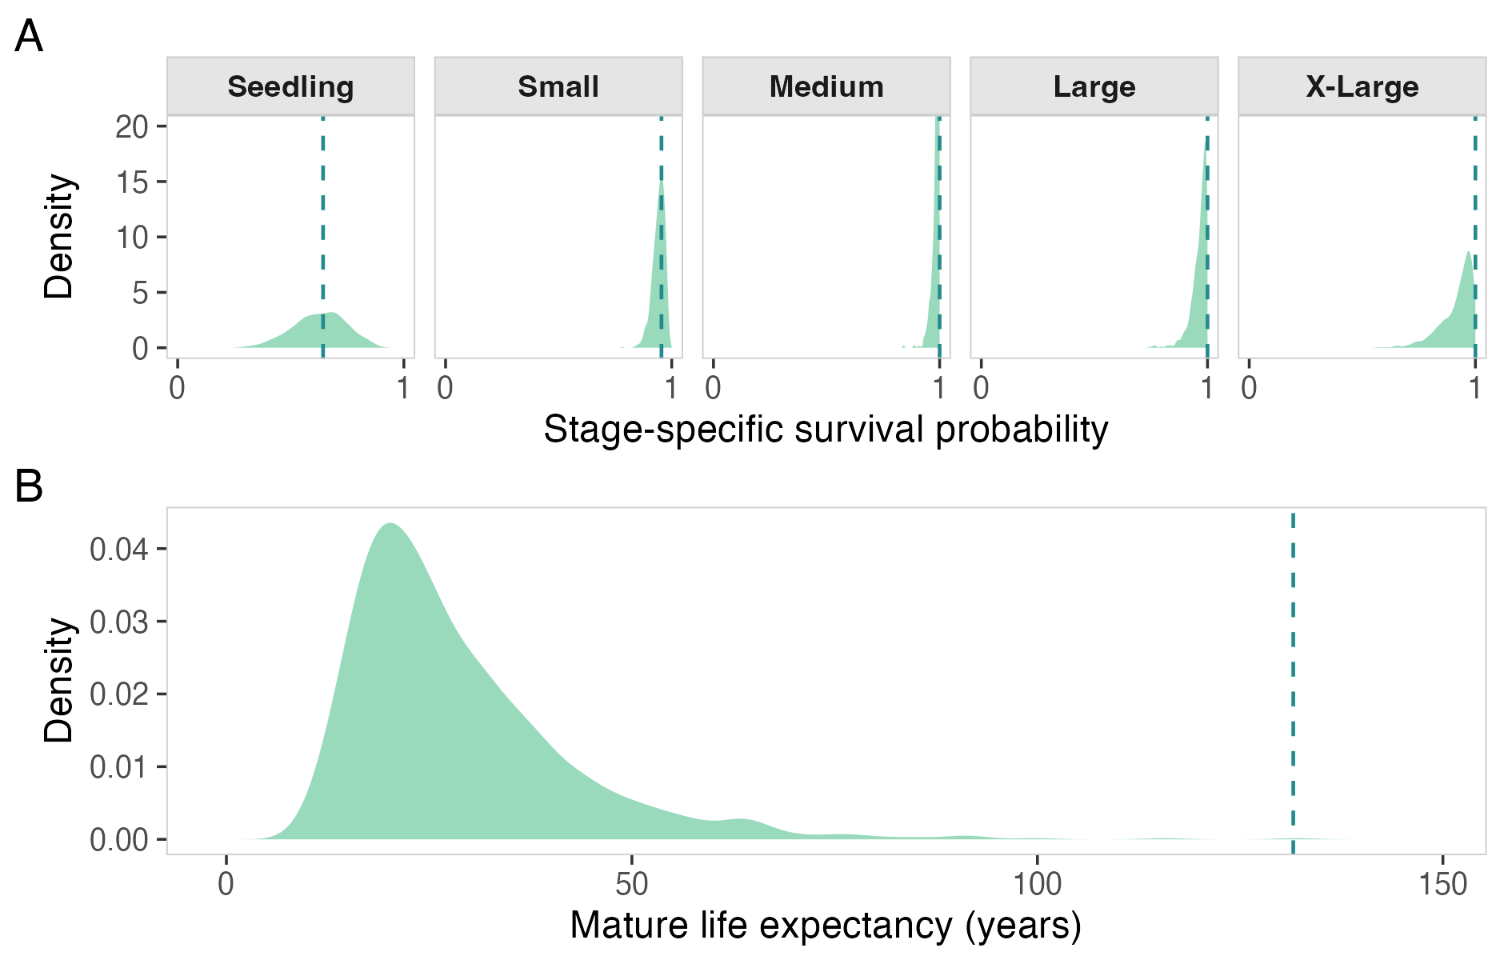
Figure 1: Boundary-estimate diagnostic. When stage-specific survival estimates are near 0 or 1, derived-parameter sampling distributions can be displaced relative to point estimates, indicating potential inferential fragility.

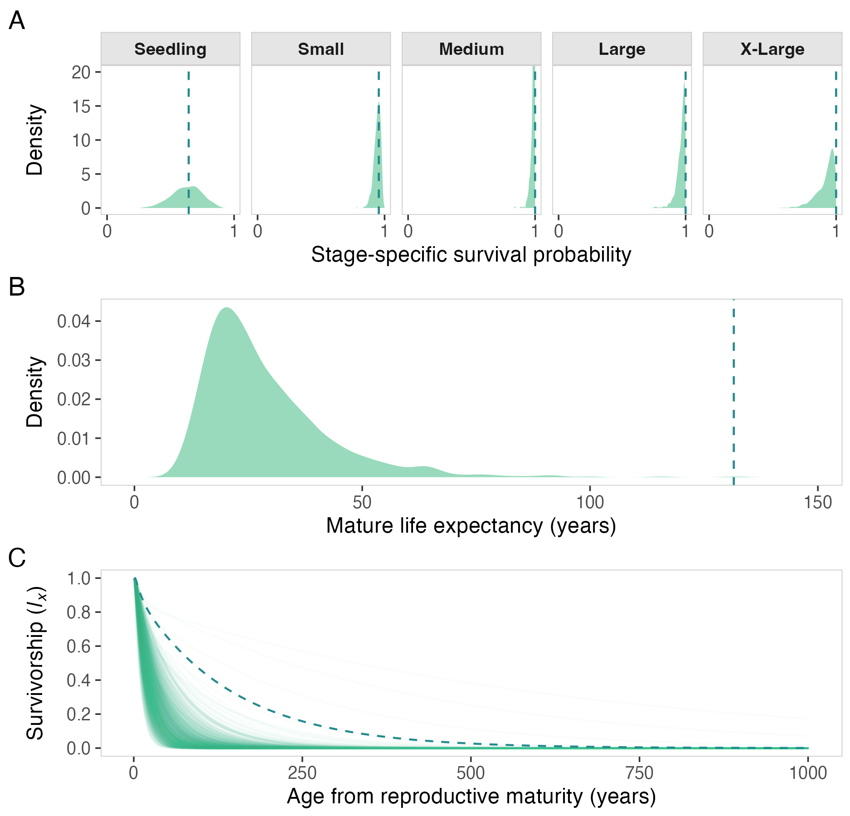
Figure 2: Illustration of survivorship trajectories under boundary survival transitions. These cases can induce artefactual trajectory shapes and help explain mismatches between point estimates and uncertainty-aware summaries.

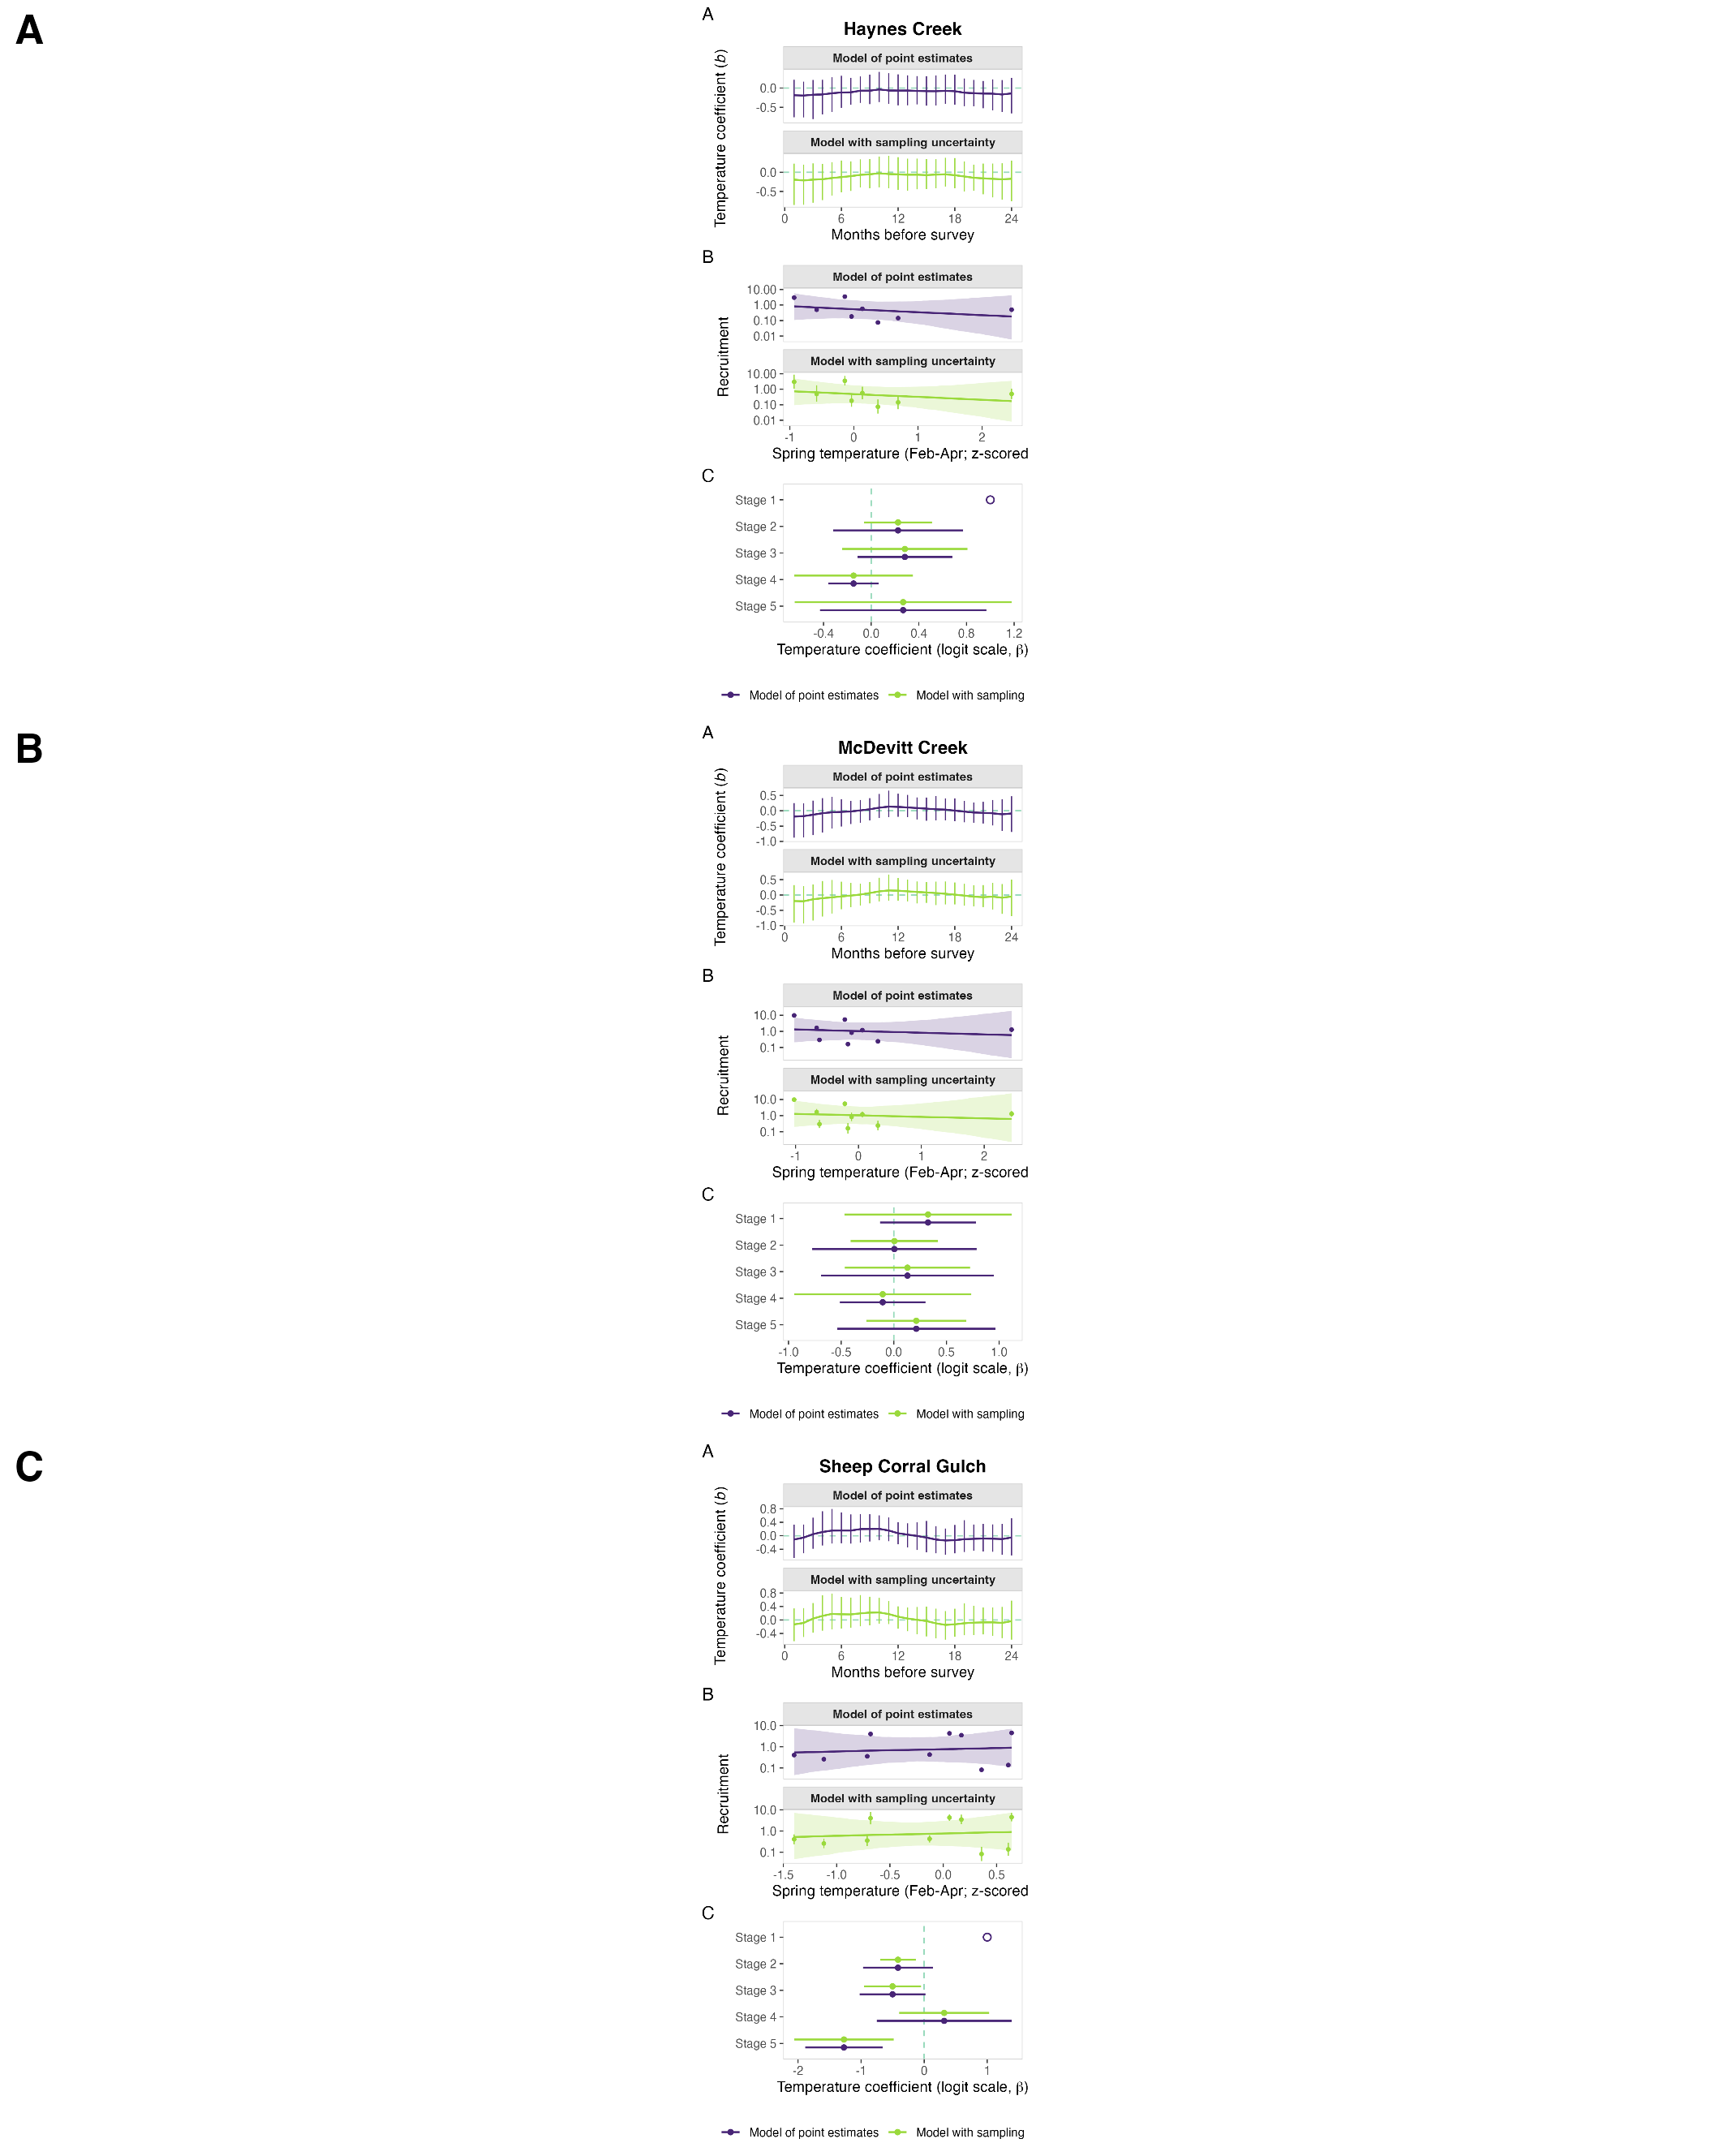
Figure 3: Analysis 3 multisite climate-demography comparison for Astragalus scaphoides. Panel A (Haynes Creek), panel B (McDevitt Creek), and panel C (Sheep Corral Gulch) each show monthly lag coefficients, recruitment fits, and stage-specific survival coefficients for point-estimate and sampling-uncertainty formulations. Across sites, the two formulations remain closely aligned, showing limited sensitivity to sampling-uncertainty propagation relative to among-site ecological differences.

