Supplementary Materials
  - When does sampling uncertainty matter in matrix population models? Evidence from published projection matrices

Authors
Owen R. Jones*^{1,2}, Patrick Barks¹, Emily G. Simmonds²

Affiliations
¹ Department of Biology, University of Southern Denmark, Odense, Denmark
² Institute of Ecology and Evolution, School of Biological Sciences, University of Edinburgh, Edinburgh, UK

Corresponding author
- Owen R. Jones, jones@biology.sdu.dk

Supplementary Tables
Table 1: Single-MPM derived-parameter summary for the focal *Agrimonia eupatoria* example. Reported values are point estimates and uncertainty intervals from bootstrap sampling distributions, showing substantial uncertainty for several derived demographic quantities.
Parameter | Median | Lower 95% | Upper 95% | Point estimate
Pop.~growth~rate~(italic(lambda)) | 0.942 | 0.828 | 1.010 | 0.956
Damping~ratio~(italic(rho)) | 1.460 | 1.110 | 2.170 | 1.310
Repro.~value~(Veg.) | 2.740 | 0.800 | 13.800
Elasticity | 0.335 | 0.135 | 0.553
Generation~time~(italic(T)) | 25.500 | 15.100 | 60.800 | 31.500
Life~expectancy~(italic(l[0])) | 6.800 | 3.510 | 17.700 | 7.840

Table 2: Mean-MPM derived-parameter summary for the focal example. Point estimates are compared with sampling-distribution summaries to show how pooling/averaging changes central tendency and uncertainty relative to the single-MPM case.
Parameter | Median | Lower 95% | Upper 95% | Point estimate
Life~expectancy~(italic(l[0])) | 1.920 | 1.700 | 2.18 | 1.930
Pop.~growth~rate~(italic(lambda)) | 0.929 | 0.826 | 1.03 | 0.958
Damping~ratio~(italic(rho)) | 1.430 | 1.250 | 1.66 | 1.370

Table 3: Case study 1 posterior summary for the slope parameter (β) in the life expectancy-shape model. The uncertainty-aware model shows greater posterior support for β > 0 than the point-estimate model.
Model | Median beta | Lower 95% | Upper 95% | P(beta > 0)
Model of point estimates | -0.013 | -0.045 | 0.022 | 0.250
Model with sampling uncertainty | 0.006 | -0.021 | 0.030 | 0.685

Table 4: Case study 2 Gaussian-process regression coefficients (monthly lags) for recruitment responses to temperature anomalies. Lag-specific posterior summaries are similar between point-estimate and uncertainty-aware model formulations.
Lag | Model | Median beta | Lower 95% | Upper 95%
1 | Model of point estimates | -0.224 | -0.630 | 0.169
2 | Model of point estimates | -0.122 | -0.451 | 0.213
3 | Model of point estimates | -0.023 | -0.334 | 0.257
4 | Model of point estimates | 0.088 | -0.217 | 0.392
5 | Model of point estimates | 0.161 | -0.156 | 0.493
6 | Model of point estimates | 0.225 | -0.103 | 0.506
7 | Model of point estimates | 0.290 | 0.000 | 0.544
8 | Model of point estimates | 0.336 | 0.089 | 0.590
9 | Model of point estimates | 0.329 | 0.090 | 0.535
10 | Model of point estimates | 0.257 | -0.040 | 0.466
11 | Model of point estimates | 0.202 | -0.174 | 0.435
12 | Model of point estimates | 0.144 | -0.188 | 0.392
13 | Model of point estimates | 0.101 | -0.157 | 0.396
14 | Model of point estimates | 0.039 | -0.199 | 0.378
15 | Model of point estimates | -0.023 | -0.253 | 0.367
16 | Model of point estimates | -0.101 | -0.335 | 0.174
17 | Model of point estimates | -0.177 | -0.428 | 0.072
18 | Model of point estimates | -0.202 | -0.480 | 0.040
19 | Model of point estimates | -0.196 | -0.479 | 0.033
20 | Model of point estimates | -0.154 | -0.392 | 0.052
21 | Model of point estimates | -0.082 | -0.294 | 0.149
22 | Model of point estimates | 0.000 | -0.276 | 0.304
23 | Model of point estimates | 0.028 | -0.316 | 0.355
24 | Model of point estimates | 0.006 | -0.423 | 0.400
1 | Model with sampling uncertainty | -0.282 | -0.730 | 0.165
2 | Model with sampling uncertainty | -0.166 | -0.544 | 0.235
3 | Model with sampling uncertainty | -0.045 | -0.394 | 0.306
4 | Model with sampling uncertainty | 0.083 | -0.283 | 0.485
5 | Model with sampling uncertainty | 0.161 | -0.175 | 0.544
6 | Model with sampling uncertainty | 0.228 | -0.114 | 0.583
7 | Model with sampling uncertainty | 0.296 | -0.027 | 0.596
8 | Model with sampling uncertainty | 0.351 | 0.064 | 0.629
9 | Model with sampling uncertainty | 0.340 | 0.056 | 0.568
10 | Model with sampling uncertainty | 0.277 | -0.038 | 0.511
11 | Model with sampling uncertainty | 0.217 | -0.162 | 0.485
12 | Model with sampling uncertainty | 0.155 | -0.198 | 0.423
13 | Model with sampling uncertainty | 0.106 | -0.162 | 0.412
14 | Model with sampling uncertainty | 0.055 | -0.205 | 0.386
15 | Model with sampling uncertainty | 0.005 | -0.262 | 0.379
16 | Model with sampling uncertainty | -0.082 | -0.331 | 0.197
17 | Model with sampling uncertainty | -0.179 | -0.463 | 0.082
18 | Model with sampling uncertainty | -0.220 | -0.555 | 0.061
19 | Model with sampling uncertainty | -0.218 | -0.514 | 0.056
20 | Model with sampling uncertainty | -0.185 | -0.439 | 0.074
21 | Model with sampling uncertainty | -0.101 | -0.371 | 0.157
22 | Model with sampling uncertainty | -0.026 | -0.333 | 0.338
23 | Model with sampling uncertainty | 0.008 | -0.373 | 0.395
24 | Model with sampling uncertainty | 0.005 | -0.439 | 0.474

Table 5: Case study 2 posterior summary for the spring-temperature coefficient. Point-estimate and uncertainty-aware models yield similar medians and interval widths, indicating limited effect of uncertainty propagation on this coefficient.
Model | Median | Lower 95% | Upper 95%
err | 1.22 | 0.159 | 2.24
reg | 1.15 | 0.207 | 2.09

Table 6: Studies for which additional source materials were used to recover transition-level sample-size information. This table documents provenance for non-standard inputs that contributed directly to the analysis dataset.
Authors | Year | DOI | Additional source/material
Andrello | 2,010 |  | Andrello Dracocephalum austriacum 2012; Andrello Cons Biol 2012b
Andrello; Bizoux; Barbet-Massin; Gaudeul; Nicolè; Till-Bottraud | 2,012 | 10.1016/j.biocon.2011.12.012 | Andrello Biol Cons 2012.xls; Tymen Independent Project 2008 (PDF)
Baldauf; Correa; Ferreira; Santos | 2,015 | 10.1016/j.foreco.2015.06.022 | Baldauf Forest Ecol Manag 2015 Appendix
Burns; Pardini; Schutzenhofer; Chung; Seidler; Knight | 2,013 | 10.1890/12-1310.1 | Burns Ecol 2013 – Pers. comm.
Csergő; Molnár; Garcia | 2,011 | 10.1007/s10144-010-0249-y | Csergo Popul Ecol 2011 Stage structure.xls; Csergo Popul Ecol 2011 Transition matrices.xls
Dangremond; Knight | 2,010 | 10.1890/09-0418.1 | Dangremond et al. ESA 2008 (PDF)
Dominguez Lozano; Moreno Saiz; Schwartz | 2,011 | 10.1016/j.jnc.2011.05.005 | Iriondo Book 2009
Ellis | 2,012 | 10.1890/11-1052.1 | Crone Cons Biol 2013
Ellis; Williams; Lesica; Bell; Bierzychudek; Bowles; Crone; Doak; Ehrlén; Ellis-Adam; McEachern; Ganesan; Latham; Luijten; Kaye; Knight; Menges; Morris; Den Nijs; Oostermeijer; Quintana-Ascencio; Shelly; Stanley; Thorpe; Ticktin; Valverde; Weekley | 2,012 | 10.1890/11-1052.1 | Bell Book 2003.pdf
Evju; Halvorsen; Rydgren; Austrheim; Mysterud | 2,011 | 10.1007/s11258-011-9906-2 | Evju Plant Ecol 2011 Appendix
Gaoue; Ticktin | 2,010 | 10.1111/j.1523-1739.2009.01345.x | Gaoue PhD thesis 2008.pdf
Gibert; Magda; Hazard | 2,015 | 10.1371/journal.pone.0139919 | Gibert; Magda; Hazard Oikos 2013
Gornish | 2,013 |  | Gornish AoB Plants Adv Adc 2013
Groenendijk; Eshete; Sterck; Zuidema; Bongers | 2,012 | 10.1111/j.1365-2664.2011.02078.x | MSc thesis 2010
Haridas; Keeler; Tenhumberg | 2,015 | 10.1890/13-1984.1 | Keeler SW Nat 2011
Jacquemyns; Brys; Jongejans | 2,010 | 10.1890/08-2321.1 | Jacquemyn Ecol 2010 A2.html; Jacquemyn J Ecol 2010
Maines; Knochel; Seastedt | 2,013 | 10.1890/ES13-00094.1 | Maines Master Thesis 2013
Matlaga; Davis | 2,013 | 10.1111/1365-2664.12057 | Matlaga J Appl Ecol 2013 Appendix
Navarro; Galeano; Bernal | 2,011 |  | Warren PhD thesis 2008
Norghauer; Newbery | 2,011 | 10.1890/10-2268.1 | Norghauer Ecol Monog 2011 Appendix L.htm
Osunkoya; Perrett; Fernando; Clark; Raghu | 2,013 | 10.1007/s10144-013-0364-7 | Osunkoya Popul Ecol 2013 Supplementary material.pdf; Raghu Basic Appl Ecol 2014.pdf
Picard; Mortier; Chagneau | 2,010 | 10.1016/j.ecolmodel.2010.06.010 | Picard Ecol Model 2010 (PDF)
Sampaio; Scariot | 2,010 | 10.1017/S0266467409990599 | Portela Biodiv; Cons 2010 (PDF)
Scanga | 2,014 | 10.1007/s11258-014-0344-9 | Scanga PhD thesis 2009
Scanga; Leopold | 2,012 | 10.1016/j.biocon.2012.01.061 | Scanga Biol Cons 2012 Appendix.doc; Scanga Plant Ecol 2014
Sletvold; Øien; Moen | 2,010 | 10.1016/j.biocon.2009.12.017 | Sletvold GCB 2013
Thorpe; Stanley; Kayne; Latham | 2,011 |  | Ellis Ecol 2012; Crone Cons Biol 2013
Ticktin; Ganesan; Paramesha; Setty | 2,012 | 10.1111/j.1365-2664.2012.02156.x | Ellis Ecol 2012; Crone Cons Biol 2013; Ticktin J Appl Ecol 2014
Toräng; Ehrlén; Ågren | 2,010 | 10.1007/s00442-009-1552-1 | Toräng Oecologia 2010 Appendix
Villellas; Morris; Garcia | 2,013 |  | Villellas Ecol 2013

Supplementary Figures

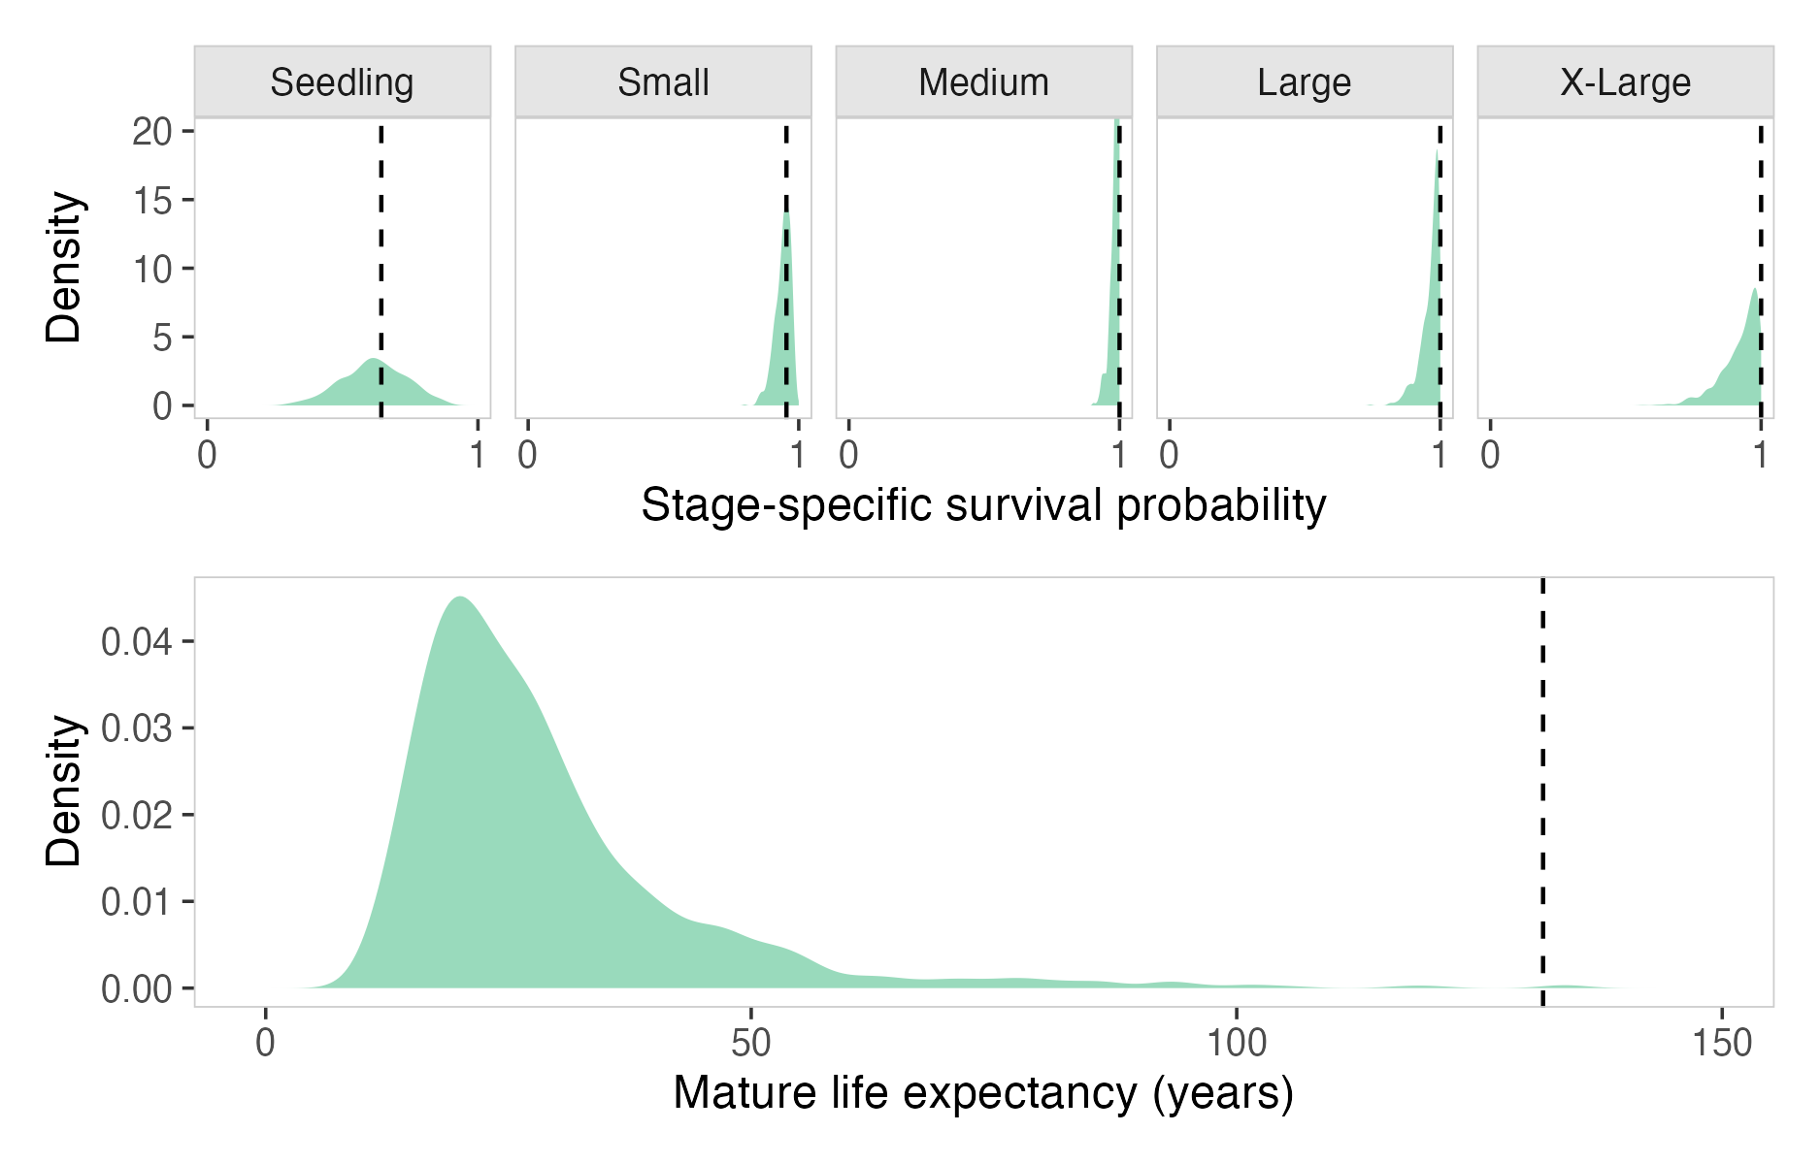
Figure 1: Boundary-estimate diagnostic. When stage-specific survival estimates are near 0 or 1, derived-parameter sampling distributions can be displaced relative to point estimates, indicating potential inferential fragility.

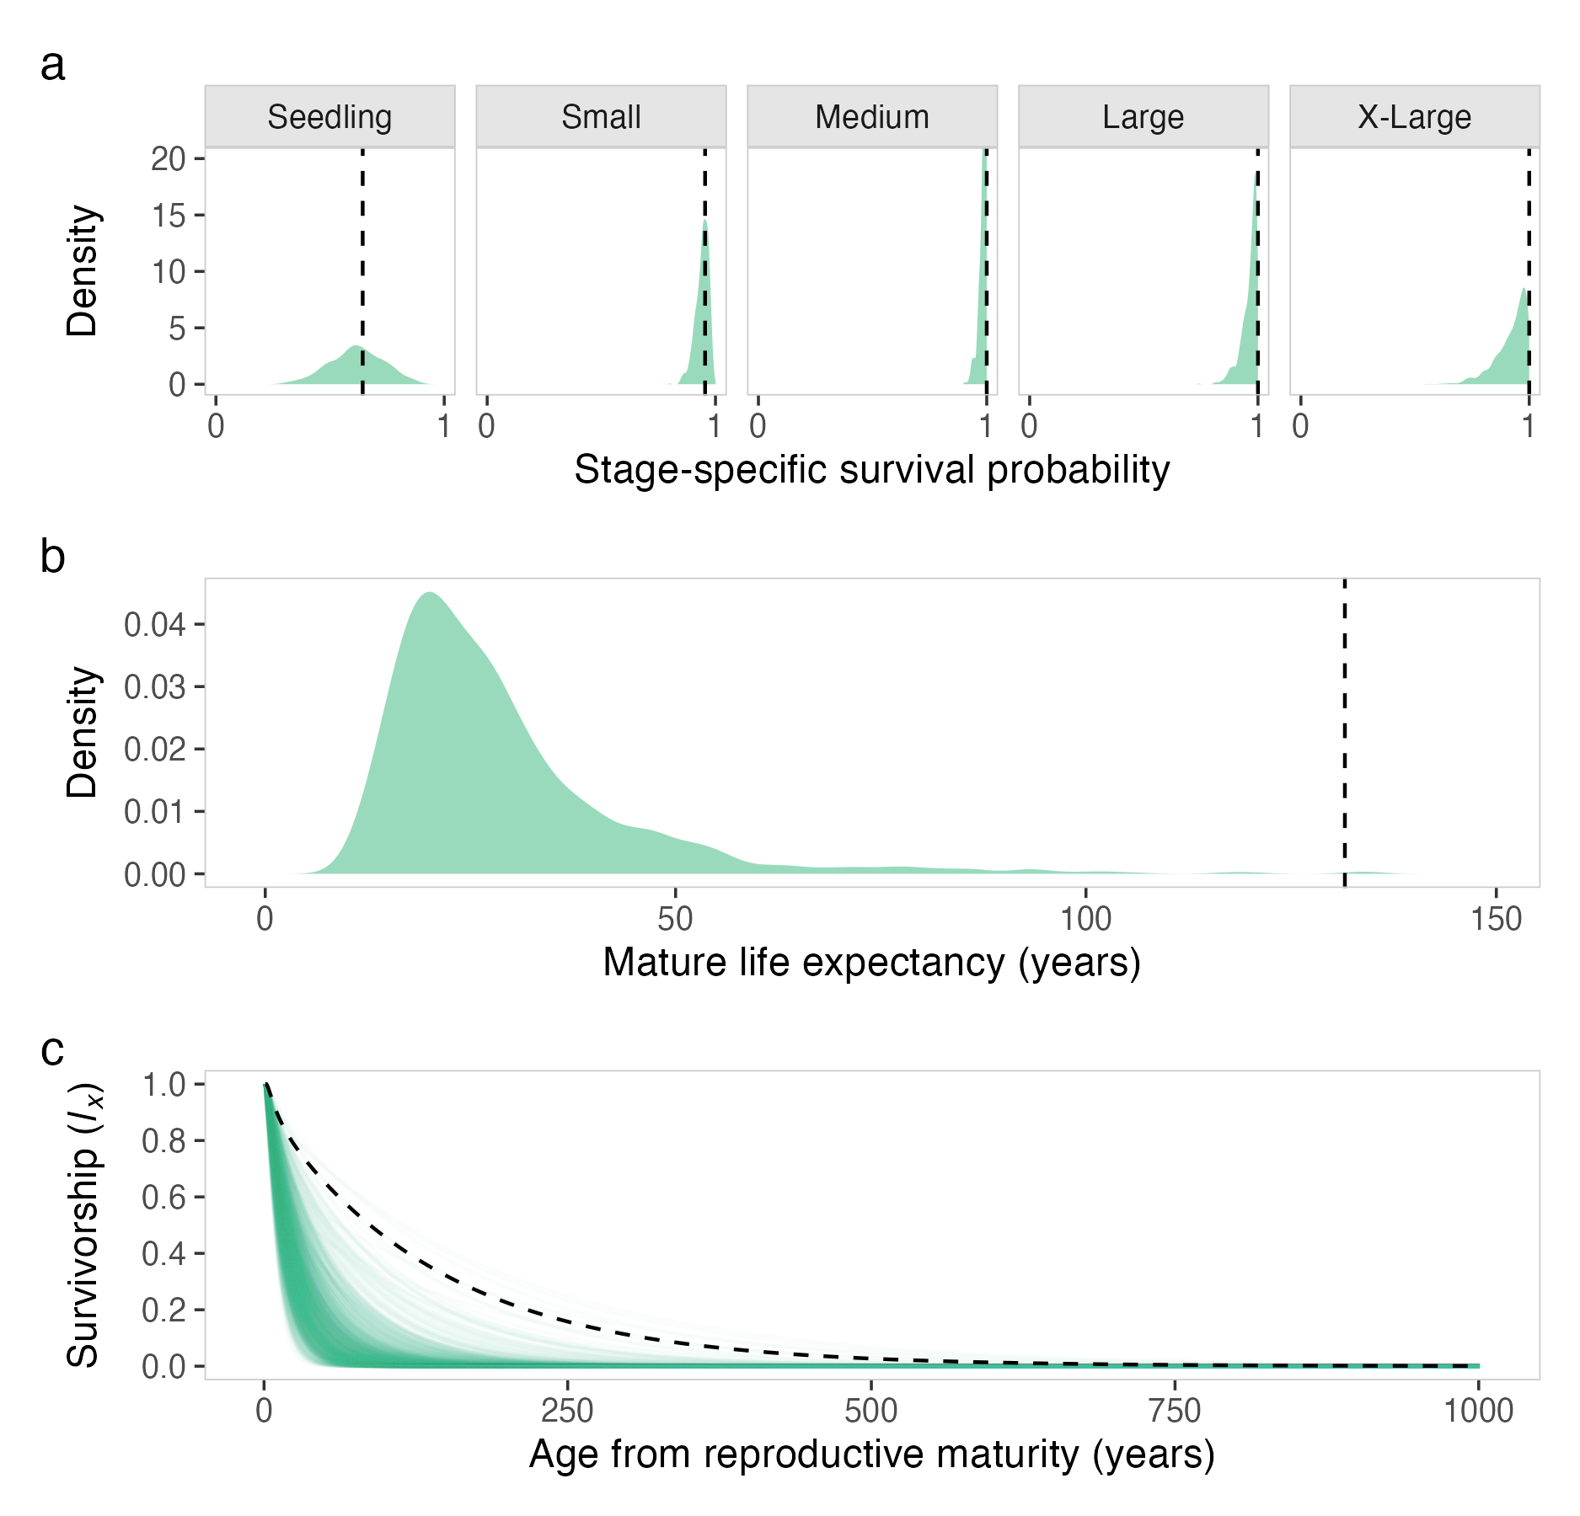
Figure 2: Illustration of survivorship trajectories under boundary survival transitions. These cases can induce artefactual trajectory shapes and help explain mismatches between point estimates and uncertainty-aware summaries.

