Supplementary Materials
  - When does sampling uncertainty matter in matrix population models? Evidence from published projection matrices
Table of Contents

Supplementary Methods

S1.1 Sampling-distribution workflow used for each MPM
We reconstructed transition-rate uncertainty by direct conjugate posterior sampling, using 2,000 draws per MPM for the illustrative example and 1,000 for Analysis 1. For each origin-stage column of $U$, allowed living transitions and death were drawn jointly from $Dirichlet(k_{1}+1,…,k_{m}+1)$, corresponding to a multinomial likelihood and a $Dirichlet(1,…,1)$ prior. Counts $k_{m}$ were reconstructed as transition rates multiplied by stage sample size, after rescaling any $U$ column whose sum exceeded 1. These reconstructed counts may be fractional for rounded or averaged matrix entries. Each allowed reproductive rate was drawn from $Gamma(1+k,\text{rate}=n)$, where $k=nF_{ij}$, corresponding to a Poisson likelihood and an improper flat prior on the non-negative rate scale. These are posterior parameter draws, not bootstrap resamples of observations. We rebuilt each MPM and recalculated derived quantities for every draw.
Allowed-transition masks default to positive entries in the focal matrix; where masks are constructed across matrices, an entry is allowed if positive in any contributing matrix. Other entries remain zero. Death is included even when its reconstructed count is zero, provided the column has an allowed living transition. This does not establish that excluded zero-valued transitions are biologically impossible. A missing sample size leaves its column unchanged; a sample size of zero produces a missing simulated column. Neither case supplies a posterior uncertainty estimate for that column. Figure 1C displays normalised marginal binomial or Poisson likelihood curves under flat priors over the plotted range; these are distinct from the joint Dirichlet draws used for derived quantities.
Point estimates correspond to values derived directly from the reported matrix entries; uncertainty-aware summaries describe the reconstructed posterior distributions.

S1.2 Age-from-stage derivation, truncation, and shape metric
Life expectancy and shape were derived from survivorship trajectories obtained using age-from-stage methods, starting from the first reproductive stage. Shape was calculated using the pace-shape framework metric (Baudisch and Stott 2019). Because stage-based survivorship can converge to an artefactual mortality plateau, shape was calculated on truncated trajectories up to quasi-stable convergence (distance threshold 1%).

S1.3 Pooled and mean MPM handling
Analysis 1 used one population-level MPM per population. Where a pooled population MPM was available, it was used; otherwise, a mean population MPM was used; if neither was available, a population-level matrix was constructed as the element-wise mean of the available annual individual MPMs. When COMPADRE included both site-specific population rows and aggregate rows that combined multiple populations, only the site-specific population rows were retained, so that each population contributed a single analysis unit. For uncertainty propagation in pooled or mean matrices, stage-specific sample sizes were pooled across years before posterior sampling. This captures within-year sampling variation but does not fully represent between-year process variation, so the resulting uncertainty should be interpreted conservatively.

S1.4 Bayesian model priors and fitting settings
Stan models and priors are defined in models/*.stan. For the three main analyses:
- Analysis 1 models use normal priors for location/slope terms and half-normal priors for positive scale terms (see models/regress_hier.stan and models/regress_hier_error.stan).
- Analysis 2 uses Gaussian-process recruitment models with normal priors on GP hyperparameters and coefficients (models/movbeta_gprc.stan and models/movbeta_gprc_err.stan), plus spring-temperature models (models/regress.stan and models/regress_log_err.stan).
- Analysis 3 fits its model with year-specific process variation using models/poisson_climate_latent.stan: the intercept and climate coefficient have $\text{Normal}(0,2)$ and $\text{Normal}(0,1)$ priors, respectively; the process standard deviation has an $\text{Exponential}(1)$ prior, and the standardised year effects have $\text{Normal}(0,1)$ priors. Its Gaussian and Poisson point-estimate models use stats::glm() and have no Bayesian priors.
- The multisite Astragalus scaphoides robustness analysis uses the same Gaussian-process recruitment model pair as Analysis 2 (models/movbeta_gprc.stan and models/movbeta_gprc_err.stan) together with a simpler spring-temperature regression pair using weakly informative normal priors on regression coefficients and scale terms (models/regress.stan and models/regress_log_err.stan).
Fitting settings used in scripts:
- Analysis 1 (scripts/S07_case_study_1_analysis.R): chains = 2, iter = 4000, warmup = 2000-3000, seed = 5654.
- Analysis 2 (scripts/S12_case_study_2.R): iter = 5000 for key models, seed = 5654, with additional control settings for GP fits.
- Analysis 3 (scripts/S16_analysis_3_simulation.R): chains = 4, iter = 3000, warmup = 1500, and a separate reproducible seed for each simulated time series.
- Multisite Astragalus scaphoides robustness analysis (scripts/S14_case_study_3_astragalus.R): iter = 5000, seed = 5654, using the same GP control settings as Analysis 2 for recruitment models and matched regression settings for the simplified spring-temperature models.

S1.5 Comparison of point-estimate and posterior-mean variance
For each parameter, we compared variance across population-level MPM entries using:
- the value derived from each matrix point estimate, ${\hat{θ}}_{p}$;
- the mean of its reconstructed posterior distribution, ${\overset{‾}{θ}}_{p}$.
For population-level entries $p$, the reported ratio is Eq. (1):
$$\text{ratio}=\frac{{Var}_{p}({\hat{θ}}_{p})}{{Var}_{p}({\overset{‾}{θ}}_{p})}. (1)$$
Ratios above 1 indicate that point estimates are more dispersed than posterior means. We obtained 95% intervals by resampling population-level entries with replacement 2,000 times, keeping each point estimate paired with its posterior mean. This descriptive ratio does not say how much of that spread is due to sampling noise rather than genuine biological differences.

S1.6 Simplified spring-temperature model (Analysis 2)
In addition to the monthly-lagged GP model, we fit a simplified spring summary model with mean spring temperature deviation as the predictor, under both point-estimate and uncertainty-aware formulations. The contrasts reported in the manuscript use posterior medians and 95% interval widths from these paired models.
For the stage-specific survival panel in Analysis 2 (Fig. 5C), we derived annual stage-specific survival as the column sums of the $U$ matrix for each year and stage, then compared two logit-scale models per stage: (i) a stable-stage distribution (SSD)-weighted quasibinomial point-estimate model, $\text{surv}∼\text{tmp}$, where weights are the stable stage distribution from each annual $U$ matrix; and (ii) a binomial count model, $\text{cbind}(n_{\text{surv}},n_{\text{fail}})∼\text{tmp}$, where $n_{\text{surv}}$ and $n_{\text{fail}}$ are survived and non-survived counts implied by stage sample size and $U$-column survival probability. The quasibinomial model estimates dispersion, whereas the binomial model fixes it at 1; together with the different weights, this prevents attributing interval-width differences solely to sampling uncertainty. Intervals are coefficient estimates ± 1.96 standard errors (95% Wald confidence intervals). Stages failing the fitting criteria (at least five usable years, variation in temperature, and both survivors and deaths) are labelled as not estimable.

S1.7 Reporting recommendations for future MPM studies
To support uncertainty propagation in secondary analyses, primary studies should report (at a minimum):
- transition-level sample sizes for each matrix element (or reconstructable transition count tables);
- clear identification of pooled/mean matrices and pooling rules;
- uncertainty estimates on model-appropriate scales (e.g. linear predictor where relevant);
- explicit projection interval, stage definitions, and treatment filters used to derive published matrices.
These items are usually sufficient for parametric uncertainty reconstruction in compiled databases.

S1.8 Included versus excluded studies in the current target-study screen
To assess whether the studies retained for uncertainty analysis differed systematically from those screened but not retained, we compared the 23 post-2010 studies in the final dataset that still fall within the current reproducible COMPADRE screen against the remaining 69 screened studies. For each study, we summarized mean matrix dimension, mean stage-specific survival (the average of $U$-column survival probabilities across matrices), and the proportions of stage-specific survival estimates equal to 0, equal to 1, or at either boundary. Dominant life form was defined as the modal OrganismType among a study’s matrices. Three additional post-2010 studies in the final dataset do not fall within the current screen under COMPADRE version 6.26.3.0 (created Mar_11_2026) (Paeonia officinalis, Tillandsia butzii, Lantana camara), and five further studies were pre-2010 additions assembled on the basis of temporal replication (at least four annual matrices); these eight studies were excluded from this screen-based comparison. The requirement of at least four annual matrices applied only to those five pre-2010 studies, which were added to support the time-series analyses; it was not a selection criterion for the full 31-study dataset used across all analyses.

S1.9 Study and species identities in Analysis 1
The Analysis 1 life expectancy-shape models used 68 population-level matrix entries representing 25 species. This is a different subset from the boundary/small-sample audit in section S1.11. Study-level and species-level identities (including COMPADRE SpeciesAuthor labels) are provided in Table S6.

S1.10 Multisite robustness extension of Analysis 2 (Astragalus scaphoides)
To evaluate whether the Analysis 2 conclusions generalised across populations, we repeated the same paired modelling framework for all available Astragalus scaphoides sites with sufficient annual coverage as a supplementary robustness analysis. For each site, we fit (i) a point-estimate model and (ii) a sampling-uncertainty model for recruitment-temperature relationships, using both the monthly-lag Gaussian-process specification and the simplified spring-temperature specification. We then compared posterior medians and 95% intervals between model formulations within site. This design compares model formulations within each site rather than isolating the contribution of uncertainty propagation.
For stage-specific survival in this supplementary robustness analysis, we used the same pair of formulations as in Analysis 2: an SSD-weighted quasibinomial point-estimate model ($\text{surv}∼\text{tmp}$, weights from the stable stage distribution of each annual $U$ matrix) and a binomial count model ($\text{cbind}(n_{\text{surv}},n_{\text{fail}})∼\text{tmp}$). The linear predictor and logit link are shared, but weighting and dispersion assumptions also differ, as described in section S1.6; the comparison therefore does not isolate sampling uncertainty.
For sensitivity analyses intended to mimic database-only use (no access to true stage sample sizes), we re-fit stage-specific point-estimate models under two alternatives: (i) no weighting and (ii) SSD weighting derived from each annual $U$ matrix.

S1.11 Boundary survival estimates and small stage-specific sample sizes in Analysis 1
To assess whether the conditions most likely to distort point estimates were concentrated in particular parts of the Analysis 1 dataset, we summarized a separate set of 68 population-level entries from 28 species with recovered stage counts by COMPADRE OrganismType (used here as the available life-form grouping) and by broad matrix-dimension class (3-5 versus 6+ stages). For each population-level matrix, we recorded whether any stage-specific survival estimate lay exactly on the boundary (0 or 1), whether any stage had $N<20$ or $N<50$, and the minimum stage-specific sample size. This audit used unscaled $U$ matrices, with exactly 100% survival in 22/68 entries, rather than the rescaled matrices and model subset described in the main Discussion. These summaries are descriptive and intended to identify where potentially fragile point estimates are concentrated in the analysed subset.

S1.12 Displacement magnitude versus boundary survival structure
To examine factors associated with point-estimate displacement in Analysis 1, we compared each population-level point estimate to the median of its sampling distribution for mature life expectancy and shape. We defined displacement magnitude as the absolute difference between the point estimate and the sampling-distribution median; for life expectancy, this was calculated on the $\log_{10}$ scale to reflect multiplicative discrepancies. We then related displacement magnitude to two predictors derived from the same population-level matrix: (i) the number of stage-specific survival estimates at the boundary (0 or 1), and (ii) the proportion of observed individuals belonging to boundary-survival stages, calculated from the recovered stage-specific sample sizes. We summarized these relationships with simple linear regressions and visualized them with scatter plots and fitted lines.

S1.13 Sensitivity to the quasi-stable-distribution truncation threshold
To assess whether the shape metric was sensitive to the truncation rule used to avoid artefactual mortality plateaus, we repeated the Analysis 1 shape calculation using quasi-stable-distribution convergence thresholds of 0.5% and 5%, alongside the 1% threshold used in the main analysis. For each population-level MPM that remained estimable under all three thresholds, we recalculated the point estimate of shape and the posterior uncertainty summary using the threshold-specific truncation age $q$. We then compared the resulting shape estimates to the 1% baseline using pairwise correlations, absolute differences, sign changes around zero, and shifts in $q$.

Supplementary Results

S2.1 Sensitivity to point-estimate weighting choice
Across estimable stages in Analysis 2, switching from no weighting to SSD weighting changed temperature-coefficient medians by at most 0.142 on the logit scale, with interval widths changing by -0.045 to 0.614 (Table S9).
Across estimable site-stage combinations in the Astragalus robustness analysis, the corresponding maximum absolute median shift was 0.912, and interval-width differences ranged from -0.512 to 1.526 (Table S10). These sensitivity checks show how weighting assumptions alter point-estimate uncertainty when true stage sample sizes are unavailable.

S2.2 Where do boundary estimates and small stage counts occur?
Among the 68 Analysis 1 population-level entries with recovered stage counts, 42.6% contained at least one boundary survival estimate and 30.9% contained at least one stage estimated from fewer than 20 individuals. These conditions tended to co-occur: the population-level proportion of boundary survival estimates was positively correlated with the proportion of stages having $N<20$ ($r=0.35$).
By life form, herbaceous perennials made up most of the analysed subset and showed the highest frequency among the well-represented categories, with 45.3% of entries containing at least one boundary survival estimate and 34.0% containing at least one stage with $N<20$. Succulents showed lower corresponding values (22.2% and 22.2%, respectively). Woody life forms were too sparsely represented in the final subset for strong conclusions. By matrix dimension, both features were more common in 6+-stage matrices than in 3-5-stage matrices (61.1% versus 36.0% for any boundary estimate; 44.4% versus 26.0% for any stage with $N<20$; Table S12).
Boundary survival estimates can arise from finite sampling of discrete stage classes. Finer stage classes do not necessarily reduce these estimates and may leave fewer observations per class. Information sharing in fitted vital-rate models, such as those used to construct integral projection models, may reduce boundary estimates through smoothing rather than finer discretisation alone.

S2.3 Does displacement increase with boundary survival structure?
Displacement magnitude increased with both measures of boundary-survival structure (Figure S3; Table S13). For shape, the absolute difference between the point estimate and the sampling-distribution median increased with the number of boundary survival stages (slope = 0.010, 95% CI [0.005, 0.016]) and with the proportion of individuals in boundary-survival stages (slope = 0.093, 95% CI [0.043, 0.143]). For mature life expectancy, the same pattern was evident on the $\log_{10}$ scale (number of boundary stages: slope = 0.062, 95% CI [0.029, 0.095]; proportion of individuals in boundary-survival stages: slope = 0.672, 95% CI [0.370, 0.974]). The fitted models explained a modest but non-trivial share of the among-matrix variation in displacement magnitude ($R^{2}=0.176−0.242$). These associations are consistent with the proposed mechanism, but do not establish causality.

S2.4 How sensitive are shape estimates to the truncation threshold?
In the 65 population-level entries for which shape was estimable under all three thresholds, the shape metric was highly stable to the quasi-stable-distribution truncation rule (Table S14; Figure S4). Relative to the 1% threshold used in the main analysis, the 0.5% threshold changed point estimates by a median absolute amount of 0.002 and sampling-distribution medians by 0.001. The more permissive 5% threshold produced somewhat larger but still modest shifts (median absolute changes 0.004 and 0.003, respectively), with only 2 point estimates changing sign relative to the 1% baseline. Those sign changes occurred only for populations whose baseline shape estimates were already very close to zero. These results indicate that shape estimates were generally stable across the thresholds tested. We did not refit the downstream regressions, so their sensitivity to threshold choice remains untested.

S2.5 Multisite robustness analysis in Astragalus scaphoides
For recruitment, applying the Analysis 2 framework to three Astragalus scaphoides populations yielded the same overall pattern: point-estimate and sampling-uncertainty models were closely aligned within site, while differences among sites were more pronounced than differences between model formulations (Figure S5). Across sites, we had 9-11 years of annual demographic records, with 8-10 years retained for model fitting after filtering (0-3 years excluded; Table S7).
For spring-temperature models, posterior medians differed only slightly between formulations (maximum absolute within-site difference: 0.026 on the linear predictor scale), and 95% interval widths changed by only -5.3% to 4.7% across sites (Table S8). Monthly-lag coefficient profiles were likewise highly concordant between formulations, with within-site correlations of posterior medians ranging from 0.992 to 0.997 and a maximum lag-specific median difference of 0.042 (Figure S5). These results support the main-text conclusion from Analysis 2 that climate-effect inference can be robust to transition-rate sampling uncertainty in this empirical setting.

Supplementary Tables
Table S1. Single-MPM derived-parameter summary for the focal Agrimonia eupatoria example. Reported values are point estimates and 95% credible intervals from reconstructed posterior distributions, showing substantial uncertainty for several derived demographic quantities.
Parameter | Median | Lower 95% | Upper 95% | Point estimate
Pop. growth rate (λ) | 0.943 | 0.826 | 1.010 | 0.956
Damping ratio (ρ) | 1.440 | 1.110 | 2.200 | 1.310
Reproductive value (vegetative stage) | 2.800 | 0.803 | 15.000
Elasticity | 0.345 | 0.145 | 0.558
Generation time (T) | 25.900 | 15.300 | 58.100 | 31.500
Life expectancy (l₀) | 6.650 | 3.600 | 17.900 | 7.840

Table S2. Mean-MPM derived-parameter summary for the focal Agrimonia eupatoria example (population B). Point estimates are compared with sampling-distribution summaries to show how pooling/averaging changes central tendency and uncertainty relative to the single-MPM case.
Parameter | Median | Lower 95% | Upper 95% | Point estimate
Life expectancy (l₀) | 1.920 | 1.69 | 2.16 | 1.930
Pop. growth rate (λ) | 0.929 | 0.82 | 1.03 | 0.958
Damping ratio (ρ) | 1.430 | 1.25 | 1.68 | 1.370

Table S3. Analysis 1 posterior summary for the slope parameter (β) in the life expectancy-shape model. The uncertainty-aware model shows greater posterior support for β > 0 than the point-estimate model.
Model | Median beta | Lower 95% | Upper 95% | P(beta > 0)
Model using point estimates | -0.016 | -0.052 | 0.023 | 0.206
Model with sampling uncertainty | 0.011 | -0.017 | 0.038 | 0.770

Table S4. Analysis 2 Gaussian-process regression coefficients (monthly lags) for recruitment responses to temperature anomalies. Lag-specific posterior summaries are similar between point-estimate and uncertainty-aware model formulations.
Lag | Model | Median beta | Lower 95% | Upper 95% | lag_err
1 | Point estimates | -0.251 | -0.659 | 0.154 | 0.82
2 | Point estimates | -0.135 | -0.472 | 0.223 | 1.82
3 | Point estimates | -0.030 | -0.358 | 0.282 | 2.82
4 | Point estimates | 0.078 | -0.261 | 0.396 | 3.82
5 | Point estimates | 0.155 | -0.196 | 0.474 | 4.82
6 | Point estimates | 0.207 | -0.156 | 0.507 | 5.82
7 | Point estimates | 0.272 | -0.040 | 0.563 | 6.82
8 | Point estimates | 0.331 | 0.055 | 0.608 | 7.82
9 | Point estimates | 0.320 | 0.054 | 0.538 | 8.82
10 | Point estimates | 0.245 | -0.068 | 0.482 | 9.82
11 | Point estimates | 0.200 | -0.154 | 0.460 | 10.80
12 | Point estimates | 0.145 | -0.151 | 0.416 | 11.80
13 | Point estimates | 0.111 | -0.154 | 0.407 | 12.80
14 | Point estimates | 0.049 | -0.195 | 0.411 | 13.80
15 | Point estimates | -0.003 | -0.251 | 0.421 | 14.80
16 | Point estimates | -0.091 | -0.333 | 0.197 | 15.80
17 | Point estimates | -0.182 | -0.464 | 0.084 | 16.80
18 | Point estimates | -0.203 | -0.543 | 0.046 | 17.80
19 | Point estimates | -0.203 | -0.494 | 0.044 | 18.80
20 | Point estimates | -0.159 | -0.393 | 0.062 | 19.80
21 | Point estimates | -0.082 | -0.306 | 0.181 | 20.80
22 | Point estimates | -0.009 | -0.278 | 0.291 | 21.80
23 | Point estimates | 0.018 | -0.317 | 0.361 | 22.80
24 | Point estimates | -0.002 | -0.451 | 0.414 | 23.80
1 | Sampling uncertainty | -0.274 | -0.735 | 0.189 | 1.18
2 | Sampling uncertainty | -0.163 | -0.551 | 0.236 | 2.18
3 | Sampling uncertainty | -0.035 | -0.402 | 0.329 | 3.18
4 | Sampling uncertainty | 0.079 | -0.265 | 0.464 | 4.18
5 | Sampling uncertainty | 0.162 | -0.197 | 0.517 | 5.18
6 | Sampling uncertainty | 0.225 | -0.136 | 0.554 | 6.18
7 | Sampling uncertainty | 0.295 | -0.038 | 0.615 | 7.18
8 | Sampling uncertainty | 0.348 | 0.061 | 0.631 | 8.18
9 | Sampling uncertainty | 0.342 | 0.078 | 0.571 | 9.18
10 | Sampling uncertainty | 0.277 | -0.068 | 0.543 | 10.20
11 | Sampling uncertainty | 0.216 | -0.161 | 0.497 | 11.20
12 | Sampling uncertainty | 0.155 | -0.204 | 0.456 | 12.20
13 | Sampling uncertainty | 0.117 | -0.168 | 0.401 | 13.20
14 | Sampling uncertainty | 0.053 | -0.215 | 0.448 | 14.20
15 | Sampling uncertainty | -0.004 | -0.270 | 0.406 | 15.20
16 | Sampling uncertainty | -0.100 | -0.338 | 0.207 | 16.20
17 | Sampling uncertainty | -0.182 | -0.473 | 0.068 | 17.20
18 | Sampling uncertainty | -0.226 | -0.568 | 0.069 | 18.20
19 | Sampling uncertainty | -0.226 | -0.548 | 0.043 | 19.20
20 | Sampling uncertainty | -0.193 | -0.413 | 0.054 | 20.20
21 | Sampling uncertainty | -0.112 | -0.356 | 0.183 | 21.20
22 | Sampling uncertainty | -0.043 | -0.333 | 0.335 | 22.20
23 | Sampling uncertainty | -0.020 | -0.376 | 0.362 | 23.20
24 | Sampling uncertainty | -0.013 | -0.456 | 0.416 | 24.20

Table S5. Analysis 2 posterior summary for the spring-temperature coefficient. Point-estimate and uncertainty-aware models yield similar medians and interval widths, indicating limited effect of uncertainty propagation on this coefficient.
Model | Median | Lower 95% | Upper 95%
Point estimates | 1.12 | 0.135 | 2.10
Sampling uncertainty | 1.21 | 0.151 | 2.33

Table S6. Primary studies represented in the analysis subset, as identified in COMPADRE. For matrix-level metadata and source-link details beyond this summary, refer to the COMPADRE database record for each study.
Authors | Year | Journal | DOI | Species (COMPADRE label)
Andrello | 2010 |  |  | Dracocephalum_austriacum
Dangremond; Knight | 2010 | Ecology | 10.1890/09-0418.1 | Lupinus_tidestromii
Davison; Jacquemyn; Adriaens; Honnay; de Kroon; Tuljapurkar | 2010 | J Ecol | 10.1111/j.1365-2745.2009.01611.x | Anthyllis_vulneraria
Fortini; Zarin | 2010 | Forest Ecol Manag | 10.1016/j.foreco.2010.11.007 | Callycophyllum_spruceanum; Carapa_guianensis; Licania_heteromorpha; Licaria_mahuba; Mora_paraensis; Platymiscium_filipes; Virola_surinamensis
Gaoue; Ticktin | 2010 | Conserv Biol | 10.1111/j.1523-1739.2009.01345.x | Khaya_senegalensis
Jacquemyns; Brys; Jongejans | 2010 | Ecology | 10.1890/08-2321.1 | Orchis_purpurea
Picard; Mortier; Chagneau | 2010 | Ecol Model | 10.1016/j.ecolmodel.2010.06.010 | Dicorynia_guianensis
Sampaio; Scariot | 2010 | J Trop Ecol | 10.1017/S0266467409990599 | Geonoma_schottiana
Sletvold; Øien; Moen | 2010 | Biol Conserv | 10.1016/j.biocon.2009.12.017 | Dactylorhiza_lapponica
Bullock; White; Prudhomme; Tansey; Perea; Hooftman | 2011 | J Ecol | 10.1111/j.1365-2745.2011.01910.x | Cirsium_acaule_2
Che-Castaldo; Inouye | 2011 | Ecosphere | 10.1890/ES11-00263.1 | Frasera_speciosa_2
Chen; Visser; Jongejans; van Breugel; Zuidema; Kassim; de Kroon | 2011 | J Ecol | 10.1111/j.1365-2745.2011.01825.x | Shorea_leprosula
Csergő; Molnár; García | 2011 | Popul Ecol | 10.1007/s10144-010-0249-y | Saponaria_bellidifolia
Dominguez Lozano; Moreno Saiz; Schwartz | 2011 | J Nat Conserv | 10.1016/j.jnc.2011.05.005 | Vella_pseudocytisus_subsp._paui_2
Navarro; Galeano; Bernal | 2011 | Trop Conserv Sci | 10.1177/194008291100400104 | Lepidocaryum_tenue
Norghauer; Newbery | 2011 | Ecol Monogr | 10.1890/10-2268.1 | Microberlinia_bisulcata; Tetraberlinia_bifoliolata
Thorpe; Stanley; Kayne; Latham | 2011 |  |  | Cypripedium_fasciculatum
Andrello; Bizoux; Barbet-Massin; Gaudeul; Nicolè; Till-Bottraud | 2012 | Biol Conserv | 10.1016/j.biocon.2011.12.012 | Eryngium_alpinum
Ellis | 2012 | Ecology | 10.1890/11-1052.1 | Liatris_scariosa
Ellis; Williams; Lesica; Bell; Bierzychudek; Bowles; Crone; Doak; Ehrlén; Ellis-Adam; McEachern; Ganesan; Latham; Luijten; Kaye; Knight; Menges; Morris; den Nijs; Oostermeijer; Quintana-Ascencio; Shelly; Stanley; Thorpe; Ticktin; Valverde; Weekley | 2012 | Ecology | 10.1890/11-1052.1 | Cirsium_pitcheri_4; Phyllanthus_emblica_3
Groenendijk; Eshete; Sterck; Zuidema; Bongers | 2012 | J Appl Ecol | 10.1111/j.1365-2664.2011.02078.x | Boswellia_papyrifera
Scanga; Leopold | 2012 | Biol Conserv | 10.1016/j.biocon.2012.01.061 | Trollius_laxus
Ticktin; Ganesan; Paramesha; Setty | 2012 | J Appl Ecol | 10.1111/j.1365-2664.2012.02156.x | Phyllanthus_emblica_2; Phyllanthus_indofischeri
Gornish | 2013 |  |  | Pityopsis_aspera
Matlaga; Davis | 2013 | J Appl Ecol | 10.1111/1365-2664.12057 | Miscanthus_giganteus
Osunkoya; Perrett; Fernando; Clark; Raghu | 2013 | Popul Ecol | 10.1007/s10144-013-0364-7 | Lantana_camara
Villellas; Ehrlén; Olesen; Braza; García | 2013 | Ecography | 10.1111/j.1600-0587.2012.07425.x | Plantago_coronopus_2
Scanga | 2014 | Plant Ecol | 10.1007/s11258-014-0344-9 | Trollius_laxus_2
Baldauf; Correa; Ferreira; Santos | 2015 | Forest Ecol Manag | 10.1016/j.foreco.2015.06.022 | Himatanthus_drasticus
Gibert; Magda; Hazard | 2015 | PLOS ONE | 10.1371/journal.pone.0139919 | Festuca_eskia
Berry; Natalie L Cleavitt | 2021 | Popul Ecol | 10.1002/1438-390X.12092 | Platanthera_macrophylla_; Platanthera_orbiculata_

Table S7. Multisite robustness-analysis site coverage and spring-temperature effect summaries for Astragalus scaphoides. Point-estimate and sampling-uncertainty models give similar spring-temperature coefficients within each site, showing that between-site heterogeneity is larger than within-site method differences.
Site | Years (total) | Years (modelled) | Years excluded | Spring beta (point) | Spring beta (sampling)
Haynes Creek | 11 | 8 | 3 | -0.441 | -0.424
Sheep Corral Gulch | 11 | 10 | 1 | 0.244 | 0.258
McDevitt Creek | 9 | 9 | 0 | -0.238 | -0.212

Table S8. Multisite robustness-analysis posterior summary for the spring-temperature coefficient by site and model formulation. Across all sites, 95% intervals overlap zero under both formulations, showing similar uncertainty conclusions with and without explicit sampling-uncertainty propagation.
Site | Model | Median | Lower 95% | Upper 95%
Haynes Creek | Point-estimate model | -0.441 | -1.76 | 0.899
Haynes Creek | Sampling-uncertainty model | -0.424 | -1.74 | 0.872
McDevitt Creek | Point-estimate model | -0.238 | -1.45 | 1.110
McDevitt Creek | Sampling-uncertainty model | -0.212 | -1.52 | 1.160
Sheep Corral Gulch | Point-estimate model | 0.244 | -1.69 | 2.100
Sheep Corral Gulch | Sampling-uncertainty model | 0.258 | -1.51 | 2.080

Table S9. Analysis 2 stage-specific survival-temperature coefficients under two point-estimate weighting scenarios. “No weights” treats annual stage-specific survival proportions equally, whereas “SSD weights” applies stable-stage-distribution weights from the annual $U$ matrix.
Stage | Weighting | Years used | Median | Lower 95% | Upper 95%
Stage 1 | No weights | 4
Stage 1 | SSD weights | 4
Stage 2 | No weights | 12 | 0.235 | -0.221 | 0.691
Stage 2 | SSD weights | 12 | 0.093 | -0.670 | 0.856
Stage 3 | No weights | 12 | 0.238 | -0.315 | 0.791
Stage 3 | SSD weights | 12 | 0.178 | -0.353 | 0.708
Stage 4 | No weights | 12
Stage 4 | SSD weights | 12

Table S10. Multisite robustness-analysis stage-specific survival-temperature coefficients under two point-estimate weighting scenarios across sites. The comparison shows how coefficient estimates and interval widths change when no stage sample-size information is used and SSD weights are substituted.
Site | Stage | Weighting | Years used | Median | Lower 95% | Upper 95%
Haynes Creek | Stage 1 | No weights | 8
Haynes Creek | Stage 1 | SSD weights | 8
Haynes Creek | Stage 2 | No weights | 8 | 0.180 | -0.401 | 0.761
Haynes Creek | Stage 2 | SSD weights | 8 | -0.103 | -0.748 | 0.542
Haynes Creek | Stage 3 | No weights | 8 | 0.232 | -0.207 | 0.670
Haynes Creek | Stage 3 | SSD weights | 8 | 0.232 | -0.369 | 0.833
Haynes Creek | Stage 4 | No weights | 7 | -0.210 | -0.625 | 0.206
Haynes Creek | Stage 4 | SSD weights | 7 | -0.093 | -0.745 | 0.559
Haynes Creek | Stage 5 | No weights | 8 | 0.028 | -0.702 | 0.759
Haynes Creek | Stage 5 | SSD weights | 8 | 0.102 | -0.372 | 0.577
McDevitt Creek | Stage 1 | No weights | 9 | 0.120 | -0.485 | 0.725
McDevitt Creek | Stage 1 | SSD weights | 9 | 0.164 | -1.030 | 1.350
McDevitt Creek | Stage 2 | No weights | 9 | 0.020 | -0.601 | 0.642
McDevitt Creek | Stage 2 | SSD weights | 9 | 0.104 | -0.881 | 1.090
McDevitt Creek | Stage 3 | No weights | 9 | 0.086 | -0.605 | 0.777
McDevitt Creek | Stage 3 | SSD weights | 9 | -0.152 | -0.982 | 0.678
McDevitt Creek | Stage 4 | No weights | 9 | -0.211 | -0.608 | 0.186
McDevitt Creek | Stage 4 | SSD weights | 9 | -0.152 | -0.953 | 0.648
McDevitt Creek | Stage 5 | No weights | 9 | 0.283 | -0.371 | 0.937
McDevitt Creek | Stage 5 | SSD weights | 9 | 0.248 | -0.160 | 0.657
Sheep Corral Gulch | Stage 1 | No weights | 10
Sheep Corral Gulch | Stage 1 | SSD weights | 10
Sheep Corral Gulch | Stage 2 | No weights | 10 | -0.317 | -0.889 | 0.255
Sheep Corral Gulch | Stage 2 | SSD weights | 10 | -0.513 | -0.938 | -0.089
Sheep Corral Gulch | Stage 3 | No weights | 10 | -0.460 | -1.010 | 0.092
Sheep Corral Gulch | Stage 3 | SSD weights | 10 | -0.247 | -0.892 | 0.398
Sheep Corral Gulch | Stage 4 | No weights | 10 | 0.329 | -0.877 | 1.530
Sheep Corral Gulch | Stage 4 | SSD weights | 10 | 0.520 | -1.050 | 2.090
Sheep Corral Gulch | Stage 5 | No weights | 10 | -1.010 | -2.220 | 0.204
Sheep Corral Gulch | Stage 5 | SSD weights | 10 | -0.098 | -2.070 | 1.880

Table S11. Comparison of screened target studies that were included versus excluded under the current reproducible COMPADRE-based screen. Numeric entries are study-level means ± SD; life-form entries are numbers of studies with percentages in parentheses. Included studies have a higher mean proportion of boundary survival estimates, especially estimates of exactly 1.
Characteristic | Included | Excluded
Studies, n | 23 | 69
Mean matrix dimension | 5.92 ± 2.75 | 6.68 ± 5.05
Mean stage-specific survival | 0.74 ± 0.14 | 0.76 ± 0.15
Proportion of survival estimates equal to 0 | 0.05 ± 0.10 | 0.03 ± 0.09
Proportion of survival estimates equal to 1 | 0.17 ± 0.17 | 0.08 ± 0.15
Proportion of survival estimates at the boundary (0 or 1) | 0.23 ± 0.18 | 0.11 ± 0.17
Dominant life form: Herbaceous perennial | 14 (60.9%) | 40 (58.0%)
Dominant life form: Succulent | 5 (21.7%) | 8 (11.6%)
Dominant life form: Shrub | 0 (0.0%) | 4 (5.8%)
Dominant life form: Tree | 2 (8.7%) | 13 (18.8%)
Dominant life form: Palm | 2 (8.7%) | 4 (5.8%)

Table S12. Distribution of boundary survival estimates and small stage-specific sample sizes across Analysis 1 population-level MPM entries, grouped by the COMPADRE life-form categories available for these studies and by broad matrix-dimension class. Percentages give the share of population entries with at least one boundary survival estimate or at least one stage with sample size below the stated threshold. Woody life-form categories are included for completeness but are sparsely represented in this subset.
Group | Category | Population entries, n | Any boundary survival estimate (%) | Any stage with N < 20 (%) | Any stage with N < 50 (%) | Mean minimum stage N
Life form | Epiphyte | 1 | 0.0 | 0.0 | 100.0 | 29.0
Life form | Herbaceous perennial | 53 | 45.3 | 34.0 | 58.5 | 66.3
Life form | Palm | 3 | 33.3 | 0.0 | 33.3 | 144.7
Life form | Shrub | 1 | 100.0 | 0.0 | 0.0 | 190.0
Life form | Succulent | 9 | 22.2 | 22.2 | 33.3 | 85.4
Life form | Tree | 1 | 100.0 | 100.0 | 100.0 | 8.0
Matrix dimension | 3-5 stages | 50 | 36.0 | 26.0 | 50.0 | 83.2
Matrix dimension | 6+ stages | 18 | 61.1 | 44.4 | 66.7 | 43.6

Table S13. Linear models relating displacement magnitude in Analysis 1 to boundary-survival predictors. Displacement is defined as the absolute difference between the point estimate and the median of the sampling distribution; life expectancy displacement is modelled on the log10 scale. Positive slopes indicate greater point-estimate displacement in matrices with more boundary survival structure.
Response | Predictor | Population entries, n | Slope | 95% CI | P value | R²
Shape displacement |point - median| | Number of boundary survival stages | 68 | 0.010 | [0.005, 0.016] | 0.00037 | 0.176
Shape displacement |point - median| | Proportion of individuals in boundary-survival stages | 64 | 0.093 | [0.043, 0.143] | 0.00045 | 0.181
Life expectancy displacement |log10(point) - log10(median)| | Number of boundary survival stages | 68 | 0.062 | [0.029, 0.095] | 0.00035 | 0.177
Life expectancy displacement |log10(point) - log10(median)| | Proportion of individuals in boundary-survival stages | 64 | 0.672 | [0.370, 0.974] | < 1e-04 | 0.242

Table S14. Sensitivity of Analysis 1 shape estimates to the quasi-stable-distribution truncation threshold used when calculating the shape metric. Comparisons are against the 1% threshold used in the main analysis, summarising the stability of shape estimates across the thresholds tested; downstream regressions were not refitted.
Comparison | Population entries, n | Correlation of point estimates | Median |ΔS| (point estimate) | 95th percentile |ΔS| (point estimate) | Max |ΔS| (point estimate) | Median |ΔS| (sampling median) | Sign changes in S | Median Δq | Range of Δq
0.5% vs 1% | 65 | 0.997 | 0.002 | 0.016 | 0.026 | 0.001 | 0 | 1 | 0 to 54
5% vs 1% | 65 | 0.981 | 0.004 | 0.050 | 0.064 | 0.003 | 2 | -3 | -126 to 0

Supplementary Figures
Figure S1. Boundary-estimate diagnostic. Purple lines indicate point-estimate-derived quantities and green densities indicate uncertainty-aware summaries from sampling distributions. When stage-specific survival estimates are near 0 or 1, derived-parameter sampling distributions can be displaced relative to point estimates, indicating potential inferential fragility.
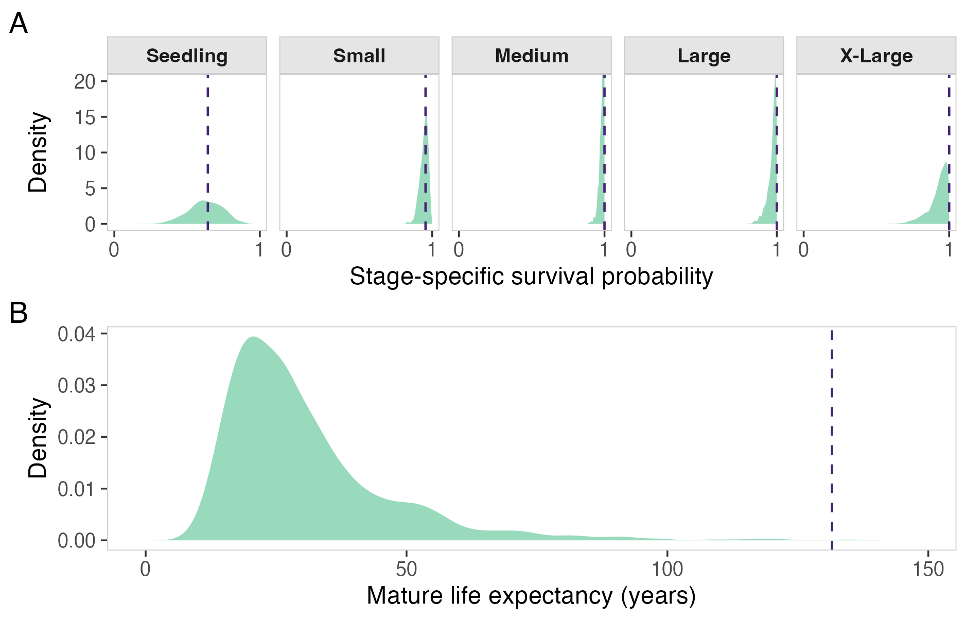

Figure S2. Illustration of survivorship trajectories under boundary survival transitions. Age/time is shown in years. These cases can induce artefactual trajectory shapes and help explain mismatches between point estimates and uncertainty-aware summaries.
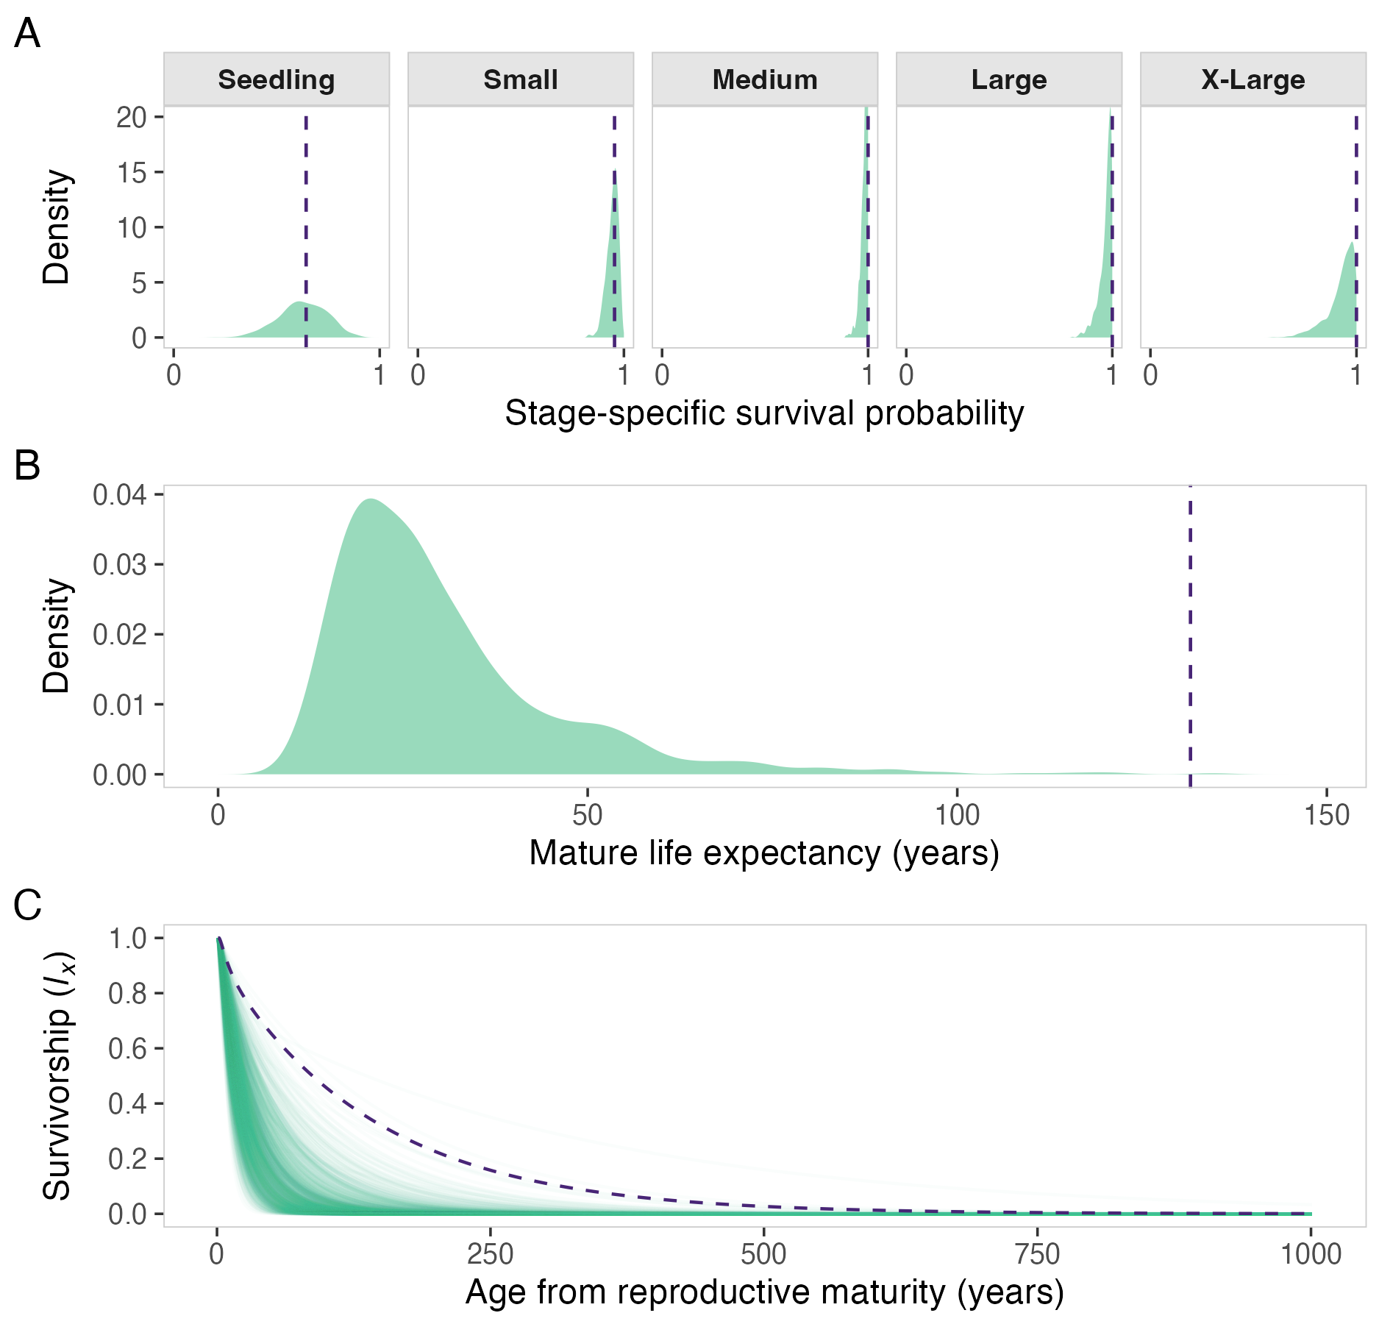

Figure S3. Displacement magnitude in Analysis 1 increases with boundary-survival structure. Each point is a population-level matrix. Panels compare the absolute difference between the point estimate and the sampling-distribution median against the number of boundary survival stages and the proportion of sampled individuals in those boundary stages, showing that matrices with more boundary-survival structure tend to have larger point-estimate displacement.
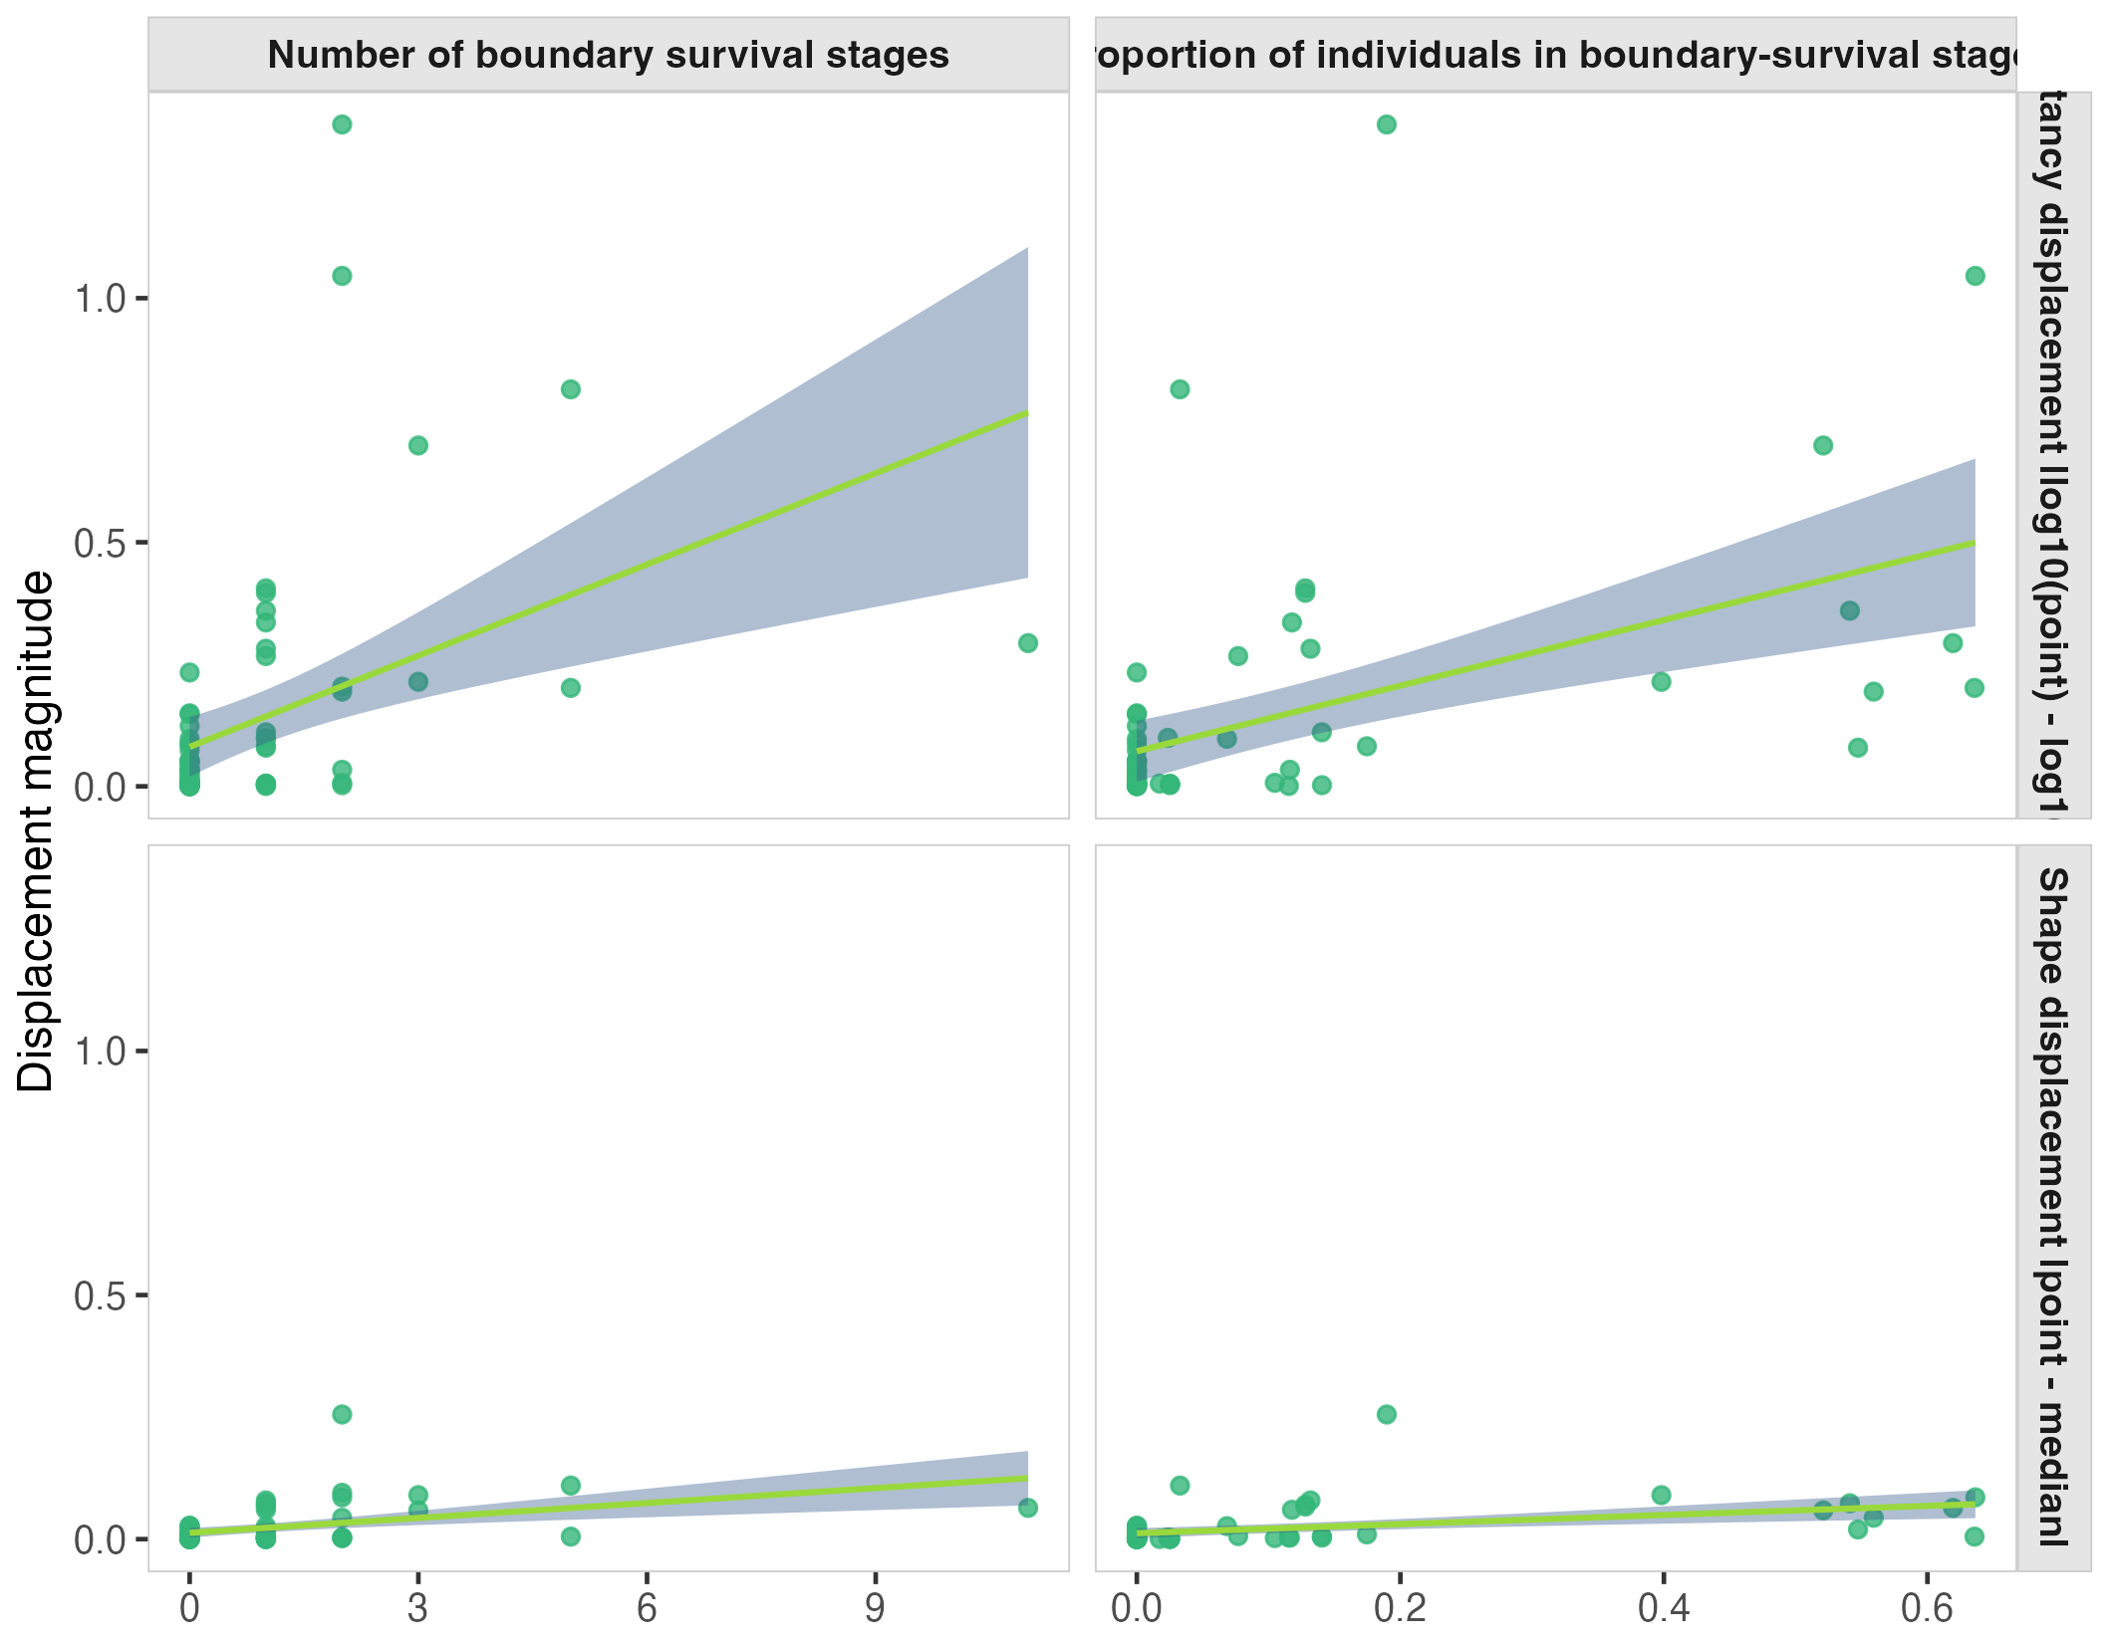

Figure S4. Sensitivity of Analysis 1 point estimates of mortality-trajectory shape to the quasi-stable-distribution truncation threshold. Point estimates calculated with 0.5% and 5% thresholds are plotted against the 1% threshold used in the main analysis, showing that most values lie close to the 1:1 line and that threshold choice makes little difference except for a small number of near-zero cases.
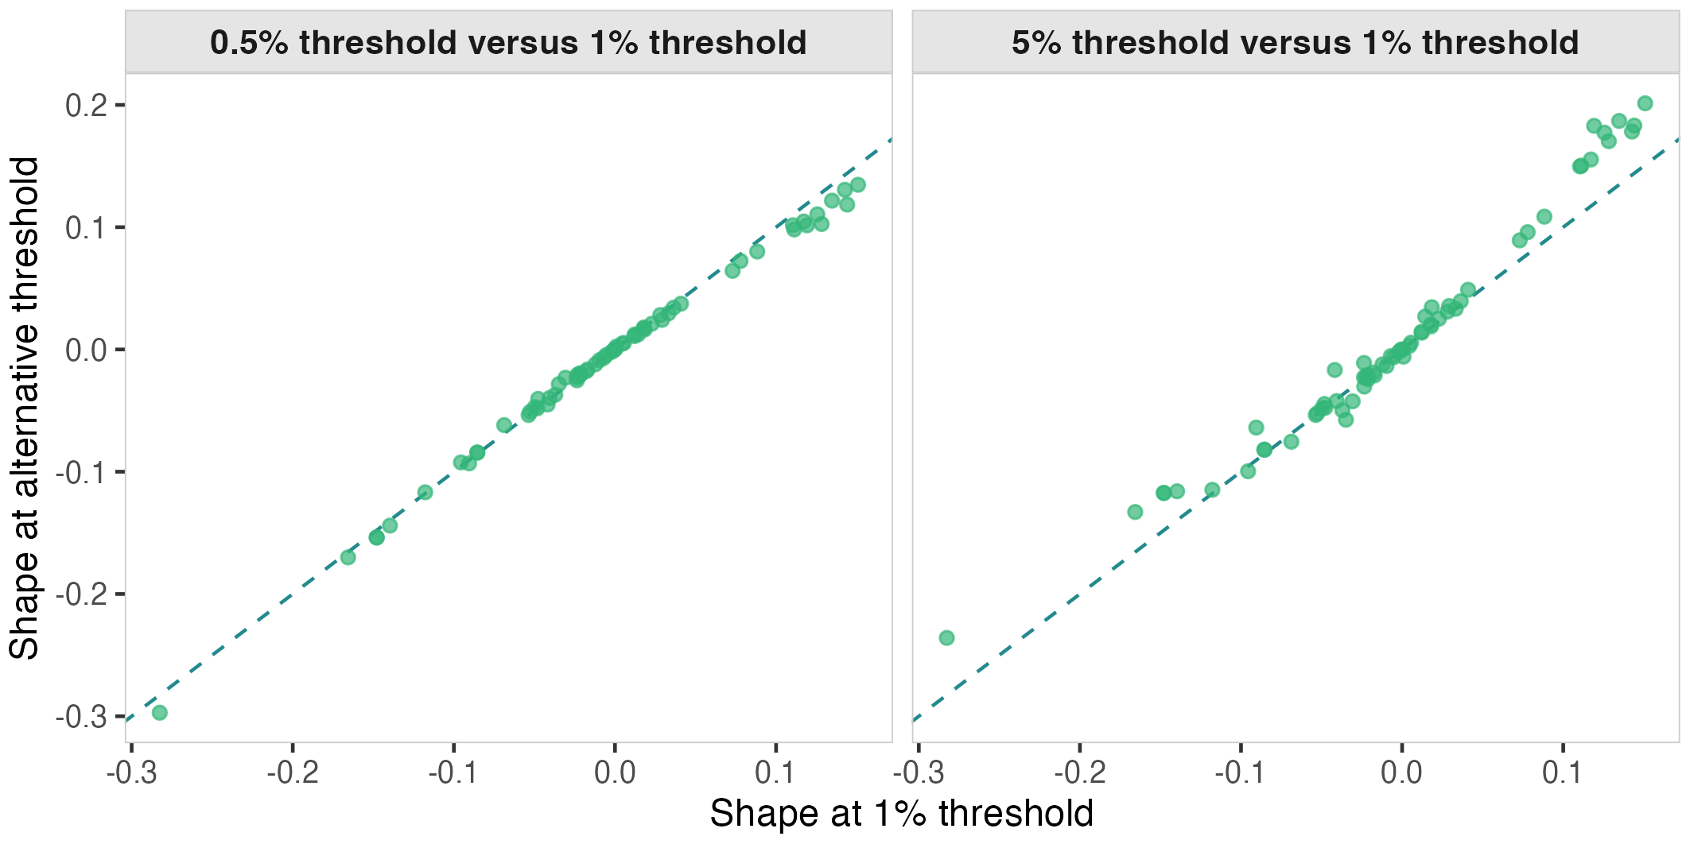

Figure S5. Multisite robustness analysis for Astragalus scaphoides. Columns show Haynes Creek (A, D, G), McDevitt Creek (B, E, H), and Sheep Corral Gulch (C, F, I). Rows show monthly-lag temperature coefficients (A-C), recruitment-temperature fits (D-F), and stage-specific survival-temperature coefficients (G-I) for point-estimate (purple) and uncertainty-aware (green) formulations. Recruitment is seedlings per reproductive plant, and stage-specific survival coefficients are on the logit scale (β). Survival intervals are 95% Wald confidence intervals; non-estimable stages are labelled rather than plotted. Differences between survival models reflect weighting and dispersion assumptions as well as the use of sample sizes. Recruitment results are closely aligned between formulations within sites.
