Abstract
- The collation of thousands of population projection matrices in the COM(P)ADRE Matrix Databases has enabled large-scale comparative analyses in ecology, evolution, and demography. A persistent challenge is that transition rates are estimated from finite samples, yet the resulting sampling uncertainty is rarely reported and typically ignored in downstream analyses. Although sampling uncertainty is well recognised, it remains unclear when it affects demographic inference.
- Using a subset of studies from the COMPADRE Plant Matrix Database for which transition-specific sample sizes could be obtained, we reconstructed sampling distributions for transition rates and derived demographic parameters, and conducted three related analyses: (i) a multi-species comparative analysis of life expectancy-shape relationships, (ii) a single-species time-series analysis of climate-demography effects, and (iii) a simulation study with known truth that compares how models account for count sampling and year-to-year variation.
- The effects of sampling uncertainty were strongly trait-dependent. Accounting for sampling uncertainty barely shifted integrated metrics such as population growth rate, but substantially displaced traits related to mortality trajectories, particularly the shape of the mortality distribution. In these cases, point estimates were often systematically displaced from their underlying sampling distributions due to boundary estimates of stage-specific survival (i.e. survival probabilities near 0 or 1), which are common in published matrices. By contrast, inference in a within-species analysis of weather effects on vital rates was largely unaffected, whereas the simulation study showed that point-estimate count models can become overconfident even when bias remains low.
- Together, these analyses show that ignoring sampling uncertainty does not universally compromise inference from published projection matrices, but can yield fragile or biased conclusions for certain demographic traits; the simulation also shows that omitting year-to-year variation can produce overconfident interval estimates in count-based models. We identify structural features of MPMs and analyses that may indicate heightened sensitivity to sampling uncertainty, and discuss implications for researchers using compiled demographic databases.
Keywords: age-from-stage methods; estimation bias; parameter uncertainty; stage-structured models; sensitivity analysis; plant demography; life history traits

Introduction
Sampling uncertainty is a widely recognised, inherent component of demographic analyses (Caswell 2001). This uncertainty, stemming from the sampling of the population of interest, proliferates across almost all estimates of individual demographic rates (e.g. survival and reproduction), through studies based on raw data and single species, up to large comparative studies.
The collation of published demographic data in databases such as PanTHERIA (Jones et al. 2009), AnAge (de Magalhães and Costa 2009), Myhrvold et al.’s (2015) amniote life-history database, and COM(P)ADRE (Salguero-Gómez et al. 2015, Salguero-Gómez et al. 2016a) has enabled fascinating comparative analyses in ecology, evolution, and demography (e.g. Garratt et al. 2013, Adler et al. 2014, Healy et al. 2014, Fristoe et al. 2017). By leveraging open-source databases that aggregate data from hundreds of individual studies, researchers can test hypotheses of interest across taxonomic, spatial, and temporal scales that would otherwise be impossible. However, analyses based on published demographic results rather than underlying raw data also present their own challenges.
One challenge in working with large collections of published data is understanding and modelling the sources of underlying uncertainty. For instance, the demographic parameters reported in the databases noted above have almost always been estimated from a sample of individuals drawn from a larger population of interest, and therefore carry inherent sampling uncertainty. However, parameter-specific sample sizes and standard errors are rarely available and are often difficult to obtain even from the original data sources. These original studies, which produce the parameter estimates later compiled in demographic databases, usually account for sampling uncertainty in their own analyses, but uncertainty is often not reported in a form that can be propagated from the published matrices. Therefore, studies that subsequently analyse parameter estimates compiled in demographic databases rarely incorporate this uncertainty, raising questions about the robustness of resulting inferences (Caswell 2001, Ch. 12; Biggs et al. 2009).
Despite widespread recognition that sampling uncertainty is inherent in demographic estimates (Caswell 2001), a key unresolved question concerns when this uncertainty materially affects inference from compiled databases. Comparative analyses using projection matrices rely on a diverse set of derived demographic traits: population- or species-level quantities computed from matrix population models (MPMs). These span life-history traits such as generation time, transient descriptors such as reactivity, and integrated metrics such as population growth rate, through to traits governed by long-term survivorship or tail behaviour, such as life expectancy and the shape of mortality trajectories. Whether these different classes of traits are equally sensitive to sampling uncertainty under typical data regimes remains poorly understood.
Recent work has reviewed the importance of uncertainty propagation in matrix population models and outlined best-practice guidelines for addressing it (Simmonds and Jones 2024). That paper focused on methodology and characterised the sources of uncertainty, the available propagation techniques, and recommendations for practice, but did not empirically quantify the consequences of ignoring uncertainty across a range of real analyses and demographic traits. Here, we address that complementary question directly: not how uncertainty should be handled, but when handling it actually changes the conclusions researchers draw from published projection matrices.
Large comparative analyses are not the only analysis that can be impacted by omission of sampling uncertainty. Another key area where sampling uncertainty could have a substantial impact is in linking demographic rates to abiotic drivers. When incorporating drivers, such as climate, in MPM studies researchers typically regress an annual demographic rate (e.g. recruitment) against a climate variable (e.g. spring temperature) to estimate how strongly climate drives dynamics. A key challenge with this approach is that the vital rate estimates in the regression are themselves noisy. In linear regression, independent, additive, mean-zero error in the response reduces precision but does not itself bias the slope towards zero. Its effects in models of demographic rates depend on the error structure and model formulation; whether explicitly accounting for sampling uncertainty materially changes climate-response inference is therefore an empirical question, which we address here.
We investigate sampling uncertainty in the COMPADRE Plant Matrix Database (Salguero-Gómez et al. 2015; www.compadre-db.org), which currently contains over 9,000 matrix population models (i.e. projection matrices, hereafter MPMs) drawn from more than 650 studies. Over the course of its development, researchers have used COMPADRE (and the sister animal matrix database COMADRE; Salguero-Gómez et al. 2016a) to address diverse topics in ecology, evolution, and demography, including studies of the structuring of life-history variation (Franco and Silvertown 1996, Salguero-Gómez et al. 2016b), comparative analyses of ageing (Baudisch et al. 2013, Jones et al. 2014), tests of the demographic buffering hypothesis (McDonald et al. 2017), and analyses of the impact of climate on population dynamics (Coutts et al. 2016, Csergő et al. 2017). In practice, these analyses involve deriving parameters from a set of MPMs in COMPADRE (e.g. equilibrium population growth rate λ, elasticities of λ, reproductive values, mean vital rates, generation time, life expectancy), and then using these parameter estimates, which themselves carry sampling uncertainty inherited from the underlying transition rates, or further derivations of them, as inputs to a statistical model that tests the relationship of interest. Uncertainty must therefore propagate along a chain, from the sampled transition rates, through the derived parameters, to the final inference.
Our aim is to examine how sampling uncertainty in published projection matrices propagates to specific MPM-derived quantities and to explore when point estimates are robust or fragile. We expect sensitivity to vary systematically across traits, reflecting a spectrum from highly integrated metrics — such as population growth rate, which averages over many transitions and should be buffered against uncertainty in any single element — to traits that depend on long-term survivorship inferred indirectly via age-from-stage methods, such as life expectancy and mortality shape, where small errors in late-stage survival can amplify into large errors in derived quantities. We combine a comparative analysis of lifetime-integrating traits across populations and species (Analysis 1), a within-species analysis of climate effects on demographic rates (Analysis 2), and a simulation assessing estimation bias and interval coverage against known climate effects (Analysis 3). A multisite extension of Analysis 2 using Astragalus scaphoides provides a supplementary robustness check. The focal quantities are mature life expectancy, the shape of the mortality trajectory, log population growth rate, and recruitment-climate regression coefficients. Because COMPADRE does not routinely include transition-level sample sizes, our empirical analyses are restricted to the subset for which these data could be assembled (695 MPMs from 31 studies; details in Methods). We use these analyses to identify diagnostic features that help researchers assess robustness in their own work. We also provide a practical diagnostic checklist for COMPADRE users.

Methods

Background on the COMPADRE Plant Matrix Database
The COMPADRE database includes MPMs and associated metadata from published studies dating back to 1966 (Salguero-Gómez et al. 2015). Where possible, MPMs are decomposed into component processes of survival, growth, and retrogression (the U matrix), sexual reproduction (F), and clonal reproduction (C). The database provides a range of metadata for each MPM, including the relevant time period, geographic coordinates of the study site, population or site identifiers, and treatment conditions. From a given source study, COMPADRE often contains multiple MPMs reflecting different sites, time periods, and/or treatment conditions, as well as one or more “mean MPM” calculated as an element-by-element arithmetic mean across multiple years and/or sites.

Target studies
We used COMPADRE to identify candidate studies for data collection, with the following criteria: published from 2010 onwards; common perennial growth forms (herbaceous, shrub, tree, palm, and succulent); wild populations not subjected to experimental treatments; and MPMs with three or more stage classes and a one-year projection interval. This yielded a dataset of 31 studies, representing 695 MPMs for 132 populations of 30 species, including a small number added under separate criteria (Supplementary Methods section S1.8). Studies were most often excluded because transition-specific sample sizes were insufficiently reported, with a few using estimation methods incompatible with our uncertainty-reconstruction approach (e.g. mark-recapture or multi-stage vital-rate products). We compared the included studies with the other studies that met the same criteria but lacked usable sample sizes, and found them broadly similar in matrix dimension, life form, and mean stage-specific survival, although our included studies had a higher proportion of boundary survival estimates, especially survival of exactly 1 (Table S11). This over-representation may favour detection of boundary-related sensitivity and limits generalisation to all MPM studies.

Typical construction of matrix population models
A matrix population model $A$ is a square projection matrix whose elements $A_{ij}$ represent estimated transition rates from stage class $j$ to stage class $i$ over one projection interval (typically one year). Transitions may reflect the passage of individuals from one stage to another through survival, growth, or retrogression (the $U$ component), or the production of new individuals via reproduction (the $F$ component); $A=U+F$. Sometimes the reproductive transitions are further split into sexual and clonal contributions.
The methodology for estimating transition rates varies across studies. In plant MPM studies, survival-related transitions are often estimated from observed stage transitions of marked individuals between censuses, as in Eq. (1); in other systems, especially mobile animals, transition and survival estimation more commonly uses models that explicitly account for imperfect detection.
$$U_{ij,t}=\frac{\text{number transitioned from stage }j\text{ in year }t-1\text{ to stage }i\text{ in year }t}{\text{number in stage }j\text{ in year }t-1}. (1)$$
Reproductive transitions are sometimes estimated directly from counts of new recruits at time $t$ per reproductive individual at time $t-1$, as in Eq. (2),
$$F_{sr,t}=\frac{\text{number in recruit stage }s\text{ in year }t}{\text{number in reproductive stage }r\text{ in year }t-1}. (2)$$
The demographic interpretation of $F$ depends on census timing and stage definitions (e.g. pre-breeding vs post-breeding formulations). Here, Eq. (2) is a count-based estimator of the recruit transition across one projection interval and we use the published matrix entries as represented in COMPADRE rather than reparameterising each study to a single census convention.
Alternatively, reproductive transitions may be decomposed into lower-level vital rates (e.g. flowers per plant, seeds per fruit, and germination probability) estimated from separate samples, or transition rates may be fitted with models that partially pool estimates across stage classes, sites, or years, as in hierarchical vital-rate models and integral projection models (IPMs). Uncertainty in such models can differ from the simple count-based setting considered here: partial pooling often reduces the variance of weakly informed estimates but can induce stronger correlations across transitions, so uncertainty should ideally be propagated from the joint posterior of the fitted model. Our reconstructions therefore approximate the uncertainty available to a secondary user of the published matrix and its sample-size information, rather than the full joint uncertainty from the original fitted model.

Sampling distribution for a single MPM
Techniques for estimating sampling uncertainty in transition rates and derived parameters are reviewed in Caswell (2001, Ch. 12). We reconstruct uncertainty using direct draws from conjugate posterior distributions: 2,000 draws per MPM for the illustrative example and 1,000 for Analysis 1. Hereafter, “sampling distributions” refers to these reconstructed posterior uncertainty distributions. Survival-related transitions are drawn jointly within each origin-stage column using a Dirichlet prior with all concentration parameters equal to 1, including death; reproductive rates use independent flat priors on the non-negative rate scale (Supplementary Methods section S1.1). For example, if $U_{ij}$ is a survival-related transition from stage $j$ to $i$, estimated from the observation that $k$ out of the $n$ individuals in stage $j$ survived and transitioned to stage $i$ (and the remaining $n-k$ died), we can model the $U_{ij}$ transition as a binomial sample with $k$ successes in $n$ trials. We could equivalently use a multinomial likelihood here (given observed counts $x_{m}$ of each possible outcome $m$), which flexibly scales to instances with more than two possible outcomes (e.g. an individual from stage $j$ might die, survive and remain in stage $j$, or survive and grow to stage $j+1$). For reproductive transitions, we use a Poisson likelihood to model the number of recruits $k$ produced by a given number of reproductive individuals $n$. Use of a Poisson distribution for fecundity might under-capture overdispersion in species with highly variable fecundity.
Because it draws from the posterior rather than resampling the reported estimate, this approach assigns uncertainty to allowed outcomes that were not observed, including death when all sampled individuals survived, so it does not force every draw to reproduce boundary point estimates. The resulting uncertainty depends on the priors and on the allowed-transition structure, which we defined per population; it may be understated for transitions that are biologically possible but never observed for a population, and columns with missing or zero recorded sample sizes contribute no reconstructed uncertainty (Supplementary Methods section S1.1).

Analyses

Illustrative example
We illustrate with an MPM for the perennial forb Agrimonia eupatoria (Rosaceae) from a study carried out in southern Sweden (Kiviniemi 2002) (Population ‘B’; projection interval 1997-1998). The full matrix is
$$A=\left[\begin{matrix}0 & 0 & 0 & 0.19 \\ 0.86 & 0.78 & 0 & 0 \\ 0.06 & 0.67 & 0.28 & 0 \\ 0 & 0 & 0.22 & 0.70\end{matrix}\right].$$
Decomposed into survival/growth ($U$) and reproduction ($F$) components:
$$U=\left[\begin{matrix}0 & 0 & 0 & 0 \\ 0.86 & 0.78 & 0 & 0 \\ 0.06 & 0.67 & 0.28 & 0 \\ 0 & 0 & 0.22 & 0.70\end{matrix}\right], F=\left[\begin{matrix}0 & 0 & 0 & 0.19 \\ 0 & 0 & 0 & 0 \\ 0 & 0 & 0 & 0 \\ 0 & 0 & 0 & 0\end{matrix}\right].$$
In that study, ~80 plants were monitored each year in a population estimated at ~1000 individuals. Mirroring the $A=U+F$ decomposition above, the observed transition frequencies can be written as:
$$N_{U}=\left[\begin{matrix}0 & 0 & 0 & 0 \\ 12/14 & 14/18 & 0 & 0 \\ 0 & 1/18 & 6/9 & 13/47 \\ 0 & 0 & 2/9 & 33/47 \\ 2/14 & 3/18 & 1/9 & 1/47\end{matrix}\right],$$
$$N_{F}=\left[\begin{matrix}0 & 0 & 0 & 9/47 \\ 0 & 0 & 0 & 0 \\ 0 & 0 & 0 & 0 \\ 0 & 0 & 0 & 0\end{matrix}\right].$$
Here, columns index origin stage $j$; rows 1-4 in $N_{U}$ index destination stages, and the extra row $d$ is death. In the posterior sampling, death probability is drawn jointly with the living-transition probabilities in each $U$-column, but only the living-stage components are written back into the simulated $U$ matrix. The $N_{F}$ matrix remains $4×4$ and contains only reproductive transitions. The count likelihoods used to reconstruct transition-rate uncertainty are:
$$(12,2)∼\text{Multinomial}(U_{21},U_{d1}),$$
$$(14,1,3)∼\text{Multinomial}(U_{22},U_{32},U_{d2}),$$
$$(6,2,1)∼\text{Multinomial}(U_{33},U_{43},U_{d3}),$$
$$(13,33,1)∼\text{Multinomial}(U_{34},U_{44},U_{d4}),$$
$$9∼\text{Poisson}​\left(47F_{14}\right).$$
To create a sampling distribution for the focal MPM, we take 2,000 independent draws from the posterior distributions obtained using these likelihoods and the priors described above (see Supplementary Methods section S1.1 for a full workflow description). At each iteration, we arrange the drawn transition rates into the form of our MPM and then use that MPM draw to calculate our derived parameter(s) of interest. After 2,000 iterations, we therefore have 2,000 independent draws from the sampling distribution of each transition rate and derived parameter.
The modest sample sizes underpinning this MPM (9-47 plants per stage class) result in relatively high sampling uncertainty in the transition rates (Fig. 1). For instance, the sample estimate for the vegetative-reproductive growth transition is 0.22 (2/9), but the upper bound of the 95% credible interval suggests this transition rate could plausibly be as high as 0.45 in the population at large. Correspondingly, there is substantial sampling uncertainty in some derived parameters (Fig. 2). Based on the 95% credible interval bounds, the equilibrium population growth rate could be as low as –17% per year or as high as +1% per year; life expectancy could be as low as 3.5 years or as high as 18.2 years; and the reproductive value of the vegetative stage class could be 22% lower than that of the seedling stage or 1460% higher.
We chose three analyses to examine contrasting settings where sampling uncertainty may matter. Analysis 1 is a comparative analysis across many species and populations, in which derived traits depend heavily on long-term survivorship inferred indirectly from stage-structured matrices, precisely the setting in which sampling uncertainty might compound. Analysis 2, by contrast, is a within-species time-series analysis in which the response variable is a directly observed count, the statistical model is closely tied to the raw data, and the question concerns an environmental driver rather than a demographic trait itself. Analysis 3 is a simulation study with a known truth, designed to test whether these models perform well when year-to-year process variation is present across a range of effect sizes and sample sizes. Together, the three analyses cover a broad range of typical uses of published MPMs and examine how modelled sources of uncertainty affect inference in different contexts.

Analysis 1: Comparative analysis of mortality trajectories
The analysis we focus on here tests the relationship between mature life expectancy and the “shape” of the mortality distribution (sensu Baudisch 2011), where shape denotes the extent to which mortality rates increase with age after reproductive maturity. Evolutionary biologists have long been interested in variation in mortality trajectories within evolutionary theories of senescence, but previous metrics used to compare rates of senescence may have conflated variation in the shape of mortality trajectories with variation in the average level of mortality (i.e. the inverse of life expectancy). Measures of shape proposed by Baudisch and colleagues (Baudisch 2011, Baudisch et al. 2013, Wrycza et al. 2015) are mathematically independent of life expectancy and therefore well-suited for comparative analyses. Whether shape is biologically independent of life expectancy is a separate question, and an analysis by Baudisch et al. (2013) (based on MPMs for 290 angiosperm species) found a positive relationship between life expectancy and the shape of mortality trajectories. In addition to that analysis, several other studies have used estimates of life expectancy and shape derived from MPMs in COM(P)ADRE, primarily in studies of life-history variation (e.g. Salguero-Gómez et al. 2016b; Healy et al. 2019).
To estimate mature life expectancy ($L$) and shape ($S$), we first used age-from-stage methods (Cochran and Ellner 1992, Caswell 2001 Sec. 5.3) to derive a survivorship trajectory from each MPM, starting from the first stage class(es) with positive reproduction (see Supplementary Methods section S1.2 for details). We then estimated mature life expectancy by summing over the survivorship trajectory, as in Eq. (3),
L=x​lx, (3)
where $l_{x}$ is the proportion of a cohort surviving from reproductive maturity to age $x$. To estimate shape, we used a metric proposed by Baudisch and Stott (2019), which compares the area under a survivorship trajectory to that under a reference trajectory assuming constant mortality with age. The metric can take any continuous value between –0.5 (maximal negative senescence; all individuals die at the age of maturity) and +0.5 (maximal senescence; all individuals die at the age of maximum longevity), with a value of 0 indicating a constant mortality rate (negligible senescence). Values of shape greater than, equal to, or less than zero correspond to Type I, II, and III survivorship curves, respectively. Thus, more positive values indicate that mortality is concentrated later in adult life, whereas more negative values indicate that mortality is concentrated earlier in adult life. When deriving a survivorship trajectory from an MPM, the apparent mortality rate necessarily flattens as the stage distribution approaches equilibrium (Horvitz and Tuljapurkar 2008). To avoid bias from artefactual mortality plateaus, we calculated shape from truncated survivorship trajectories, limited to the period before a cohort reaches its quasi-stable distribution (based on a distance threshold of 1%; see Supplementary Methods sections S1.2 and S1.13).
We calculated life expectancy and shape at the population level, using one population-level MPM per population. For populations with temporal replication, we used a pooled population MPM if available (i.e. a matrix constructed by pooling individual-level demographic information across periods and/or populations); otherwise, we used a population mean MPM if available (i.e. an element-by-element arithmetic mean across annual matrices); if neither was available, we constructed a population-level matrix by taking the element-wise mean of the available annual Individual matrices in COMPADRE. When database records included both site-specific populations and aggregate population labels (e.g. combined multi-site entries), we retained the site-specific populations and excluded the aggregate rows to avoid double counting. To model sampling uncertainty for pooled or mean population-level MPMs, we pooled stage-specific sample sizes across years (see Supplementary Methods section S1.3). This approach ignores uncertainty arising from temporal variation in transition rates and therefore underestimates overall uncertainty in the pooled estimates. The degree of underestimation depends on how much transition rates vary across years relative to within-year sampling error; for species with high interannual variability, the bias could be substantial. Results should therefore be interpreted conservatively with respect to the influence of sampling uncertainty.
Our uncertainty calculations used the per-stage or per-transition sample sizes we could recover. The total estimated population size was not consistently reported across the included studies, so we did not use it. For 5 of the population matrices (one population each), we could not recover even the per-stage sample sizes, so we had no basis for estimating their uncertainty. Where these matrices were kept, the affected columns were held at their published values rather than given reconstructed sampling uncertainty.
To model the relationship between point estimates of mature life expectancy and shape, we used a linear model with random intercepts at the species level (to account for non-independence among populations of the same species), as in Eq. (4),
$$y_{ij}∼\text{Normal}(α_{j}+βx_{ij},σ^{2}), (4)$$
where $x_{ij}$ and $y_{ij}$ represent point estimates of life expectancy and shape, respectively, for population $i$ and species $j$, $α_{j}$ represent species-specific intercepts, $β$ is the slope of the relationship between $S$ and $L$, and $σ^{2}$ is residual variance. Species-level intercept variation is modelled as $α_{j}∼\text{Normal}(μ_{α},τ^{2})$, where $τ^{2}$ is the among-species intercept variance (i.e., variance of random intercepts; distinct from residual variance $σ^{2}$). To incorporate sampling uncertainty, we used a measurement error model (based on McElreath 2020, sec. 14.1.2) where latent $x_{ij}$ and $y_{ij}$ are linked to sampling-distribution means (${\overset{‾}{x}}_{ij}$ and ${\overset{‾}{y}}_{ij}$) and variances ($σ_{x,ij}^{2}$ and $σ_{y,ij}^{2}$) derived as described in the sampling-distribution section above, as in Eqs. (5), (6), and (7).
The structural form of the model is unchanged when sampling uncertainty is incorporated; Eqs. (5)-(7) restate the outcome model and add explicit sub-models for the true latent values of $x_{ij}$ and $y_{ij}$, which are now treated as unknown quantities estimated from their reconstructed posterior distributions rather than as fixed point estimates:
$$y_{ij}∼\text{Normal}(α_{j}+βx_{ij},σ^{2}), (5)$$
$${\overset{‾}{x}}_{ij}∼\text{Normal}(x_{ij},σ_{x,ij}^{2}), (6)$$
$${\overset{‾}{y}}_{ij}∼\text{Normal}(y_{ij},σ_{y,ij}^{2}). (7)$$
For these models, we used priors and settings as described in Supplementary Methods section S1.4.
In supplementary analyses, for each derived parameter we compared how much its point estimates varied across population-level MPM entries with how much its posterior means varied. A ratio greater than 1 means the point estimates are more spread out than the posterior means. It does not tell us how much of that spread comes from sampling noise and how much from genuine biological differences among populations. We obtained 95% intervals by paired bootstrap resampling of entries (Supplementary Methods section S1.5; Table 1).

Analysis 2: The impact of weather on demographic traits
We focus on a 12-year MPM time-series for Silene spaldingii (Lesica and Crone 2007), a perennial herb found in semi-arid grasslands of western North America. We selected this case because it provides a rare combination of multi-year temporal replication, recoverable transition-level sample sizes, and matched local climate covariates (PRISM data extracted at the geographic coordinates of the study population and matched in time to the demographic observations), making it well suited for testing uncertainty propagation in a climate-response context. In that study, transition rates were estimated using the methods described above, as ratios of two integers (Eqs. (1) and (2)), and the corresponding stage-specific sample sizes are reported in Ellis et al. (2012). Eight of the MPMs in the 12-year time-series were non-ergodic due to missing estimates for the “rosette” stage class (i.e. no rosettes were observed in the sample plots). Instead of examining variation in population growth rates (which assumes ergodicity), we focus on the reproductive transition (hereafter ‘recruitment’, the number of seedlings in year $t$ per reproductive plant in year $t-1$), and survival. We note that recruitment estimated in this way is a relatively aggregated transition whose behaviour under sampling uncertainty may differ substantially from that of survival transitions, which are estimated from smaller stage-specific samples and are more prone to boundary estimates. Any robustness in this analysis would therefore reflect properties of aggregate reproductive transitions under moderate sample sizes, and should not be taken to imply that within-species analyses are always insensitive to sampling uncertainty.
We examined the effect of monthly temperature deviations, derived from PRISM monthly temperature rasters extracted at the study population coordinates (Daly et al. 2008; PRISM Group, Oregon State University 2026; Supplementary Methods section S1.6), on annual recruitment using a similar approach to Teller et al. (2016), in which we model separate slope coefficients for a series of $K$ monthly lags (going back in time from the end of each transition interval), smoothing coefficients across neighbouring lags. The smoothing model is a Gaussian process with an exponential covariance function, as in Eq. (8),
log(yt)∼Normal​α+k​bkxtk,σ2, (8)
with the monthly-coefficient prior and covariance structure given in Eqs. (9) and (10),
$$b∼\text{MVN}(μ_{b},K), (9)$$
and
$$K_{i,j}=η^{2}exp​\left(-0.5 ρ^{2}(j-i)^{2}\right), (10)$$
respectively, where $y_{t}$ is annual recruitment in year $t$, and $x_{tk}$ is the temperature deviation for year $t$ at monthly lag $k$. Model parameters include the intercept ($α$), residual variance ($σ^{2}$), vector of monthly temperature coefficients ($b$), mean of the distribution of $b$ ($μ_{b}$), covariance matrix ($K$), maximum covariance for the $b$ distribution ($η^{2}$), and the rate of decay in covariance with time ($ρ^{2}$).
In the model above, $y_{t}$ represents a point estimate of annual recruitment derived from the relevant MPM. Recall that these values were initially calculated as the number of seedlings in year $t$ divided by the number of reproductive adults in year $t-1$. To propagate sampling uncertainty, we model the raw seedling counts directly with a Poisson likelihood (Eq. (11)) and include $log(N_{t-1})$ as an offset via the year-specific intercept model in Eq. (12), so expected counts scale with the number of reproductive plants sampled. Note that the two formulations also differ in model structure: the point-estimate model uses a Gaussian likelihood on log per-capita recruitment, whereas the uncertainty-aware model uses a Poisson likelihood on raw counts with a log-offset. Observed differences between formulations therefore reflect both structural change and uncertainty propagation, though in practice the two are virtually identical. Accordingly, we model seedling counts as
Yt∼Poisson​exp​αt+k​bkxtk, (11)
and year-specific intercepts as
$$α_{t}∼\text{Normal}​\left(μ_{α}+log(N_{t-1}),σ_{α}^{2}\right). (12)$$
This implies that uncertainty in per-capita recruitment declines with sample size: if ${\hat{r}}_{t}=Y_{t}/N_{t-1}$, then $Var({\hat{r}}_{t})$ scales as $1/N_{t-1}$ for fixed underlying recruitment intensity.
We used the same coefficient prior and covariance structure as for the point-estimate model (Eqs. (9) and (10)), where the response variable $Y_{t}$ is the number of seedlings in year $t$, and $N_{t-1}$ is the sample size of reproductive adults in year $t-1$. The model is otherwise similar to the point estimates model, except that we use year-specific intercepts ($α_{t}$) to incorporate the Poisson offset ($N_{t-1}$), rather than a single model intercept as before. We fit the above-described models again, with priors and settings as described in Supplementary Methods section S1.4.
For the stage-specific survival comparison shown in the climate figures, we derived annual stage-specific survival probabilities as column sums of $U$ (survive and transition to any living stage). We then estimated temperature effects for each stage under two formulations on the logit scale: an SSD-weighted quasibinomial GLM for point estimates ($\text{surv}∼\text{tmp}$, with weights from the stable stage distribution of each annual $U$ matrix) and a binomial count model for uncertainty propagation ($\text{cbind}(n_{\text{surv}},n_{\text{fail}})∼\text{tmp}$). The two formulations also differ in how they weight the data, handle dispersion, and use sample sizes, so comparing them does not single out the effect of sampling uncertainty. Full implementation details are provided in Supplementary Methods sections S1.6 and S1.10. We also applied this approach to a multi-site dataset of three Astragalus scaphoides populations as a robustness check (Supplementary Methods section S1.10; Supplementary Results section S2.5).

Analysis 3: Simulation study of climate effects on fecundity
To evaluate the effect of sampling uncertainty where the true climate effect is known, we simulated annual recruitment time series from a realistic four-stage Lefkovitch MPM generated with mpmsim::rand_lefko_mpm() (archetype 2). We kept a baseline matrix with population growth rate close to equilibrium ($λ≈1$). We then imposed a climate effect on a single fecundity entry, $F_{1,4}$, over $T=15$ annual time steps. In each simulated year, the climate covariate was drawn as $x_{t}∼\text{Normal}(0,1)$, and true fecundity followed
$$log(F_{1,4,t})=log(F_{1,4})+β_{\text{true}}x_{t}+z_{t}, (13)$$
where $β_{\text{true}}$ was set to 0.1, 0.3, or 0.5, and $z_{t}∼\text{Normal}(0,{0.2}^{2})$ represented additional year-to-year biological variation not explained by climate. For each year we then simulated observed seedling counts from finite samples of reproductive individuals, using stage sample sizes of 10, 20, 50, or 100 per year. We analysed 200 replicate time series for each effect-size and sample-size combination.
For each simulated dataset, we fitted three models to estimate the climate effect on recruitment: (i) a Gaussian regression with a log link on annual point estimates of fecundity, (ii) a Poisson count model using observed seedling counts and an offset for the number of reproductive individuals, and (iii) a Poisson uncertainty-aware model that additionally included a latent year-specific process term analogous to $z_{t}$. All three models target the same log-scale climate effect; the Gaussian model uses untransformed rates as its response and assumes constant residual variance. Its 95% intervals are the usual coefficient estimate ± t × standard error. We then compared the models in terms of bias and 95% interval coverage (the proportion of replicate datasets in which the 95% interval contained the true effect $β_{\text{true}}$; a well-calibrated model achieves coverage close to the nominal 0.95). Both Poisson models allow for the sampling variation in counts; their comparison tests the effect of additionally modelling year-to-year process variation.
Priors and fitting settings for the simulation model are given in Supplementary Methods section S1.4.
All analyses were run in R (4.6.1) using RStan (2.32.7), with data handling and plotting in tidyverse packages.

Results

Analysis 1: Comparative analysis of mortality trajectories
We first look, across all derived traits, at how much more spread out the point estimates are than their posterior means across every population-level entry (Table 1). We then ask whether that extra spread is large enough to change the conclusions of a particular comparative analysis.
For life expectancy and shape, across-entry variance of point estimates was 1.93 and 3.31 times the variance of posterior means, respectively (Table 1). These ratios describe how much more spread out the point estimates are, not how much of that spread comes from sampling noise rather than genuine biological differences among populations. Point estimates of life expectancy and shape often deviated from their respective sampling distributions (Fig. 3). For shape, the most extreme positive and negative point estimates tended to have sampling distributions shifted much closer to zero, whereas for mature life expectancy, many point estimates were skewed upward from the median of the sampling distribution. The mismatches between point estimates and sampling distributions usually coincided with a boundary estimate of stage-specific survival (i.e. a point estimate approaching either 0% or 100%). Supplementary analyses suggest that these boundary estimates can skew a point estimate of life expectancy or shape away from the majority of its sampling distribution (see Supplementary Figure S1 and Supplementary Figure S2).
Despite the mismatch between point estimates and sampling distributions, accounting for sampling uncertainty in our test of the relationship between life expectancy and shape did not impact the overall conclusion (Fig. 4; Supplementary Table S3). While the posterior distribution of the slope parameter β from the point-estimate model was centred slightly to the left of zero (P[β > 0] = 0.206), the corresponding posterior from the sampling-uncertainty model was shifted somewhat to the right (P[β > 0] = 0.770). The posterior median of the slope therefore changed sign between the two models. This shift is not trivial, but because both posteriors span zero the overall conclusion, that there is no strong effect, is unchanged.
Counterintuitively, there was less posterior uncertainty in β in the sampling-uncertainty model than in the point-estimate model. The reason is largely that a regression slope is harder to estimate precisely when the predictor is very spread out, since many slopes then fit the data about equally well. Boundary-survival estimates push some shape point estimates to extreme values, artificially inflating that spread; replacing them with their sampling distributions, which cluster much closer to zero (Figure 4A), pulls the predictor back in and tightens the slope. Posterior width also depends on the model’s assumptions and treatment of uncertainty.

Analysis 2: The impact of weather on demographic traits
Despite the relatively small sample sizes underlying some recruitment estimates (the three smallest sample sizes of reproductive individuals were 8, 12, and 13, respectively), results from the point-estimate model and the sampling-uncertainty model were virtually identical (Fig. 5). Both models identified temperature deviations in monthly lags 7-9 (February-April, prior to the start of the transition interval in July) as having a positive effect on recruitment. If we simplify our model and consider only the relationship between recruitment and mean spring temperature deviations (see Supplementary Methods section S1.6 and Supplementary Table S5), we again find that the point-estimate model is similar to the model incorporating sampling uncertainty (Fig. 5). The estimate of the temperature coefficient $β$ was 8.0% higher, and the 95% interval width for that estimate was 10.9% higher, in the model incorporating sampling uncertainty compared with the point-estimate model. A difference of this magnitude is unlikely to qualitatively change any inferences drawn from a model. In the stage-specific survival panel (Fig. 5C), temperature coefficients were estimable for stages 2 and 3; stages 1 and 4 are labelled as not estimable because stage 1 has only four usable years and stage 4 has 100% survival in all usable years. The narrower intervals in the count model should be interpreted in light of the different likelihood and weighting assumptions, rather than attributed to uncertainty propagation alone. A supplementary multisite robustness analysis based on three Astragalus scaphoides populations reached the same qualitative conclusion: climate-effect inference was similar with and without explicit uncertainty propagation in that empirical setting (Supplementary Results section S2.5; Figure S5; Tables S7-S10).

Analysis 3: Simulation study of climate effects on fecundity
The simulation study showed that accounting for year-to-year process variation improved the intervals’ coverage without much increasing the average error (Fig. 6). Across all effect sizes and sample sizes, the uncertainty-aware Poisson model achieved coverage close to the nominal 95% (0.951), whereas the simpler Poisson point-estimate model’s intervals fell well short (0.757). The two Poisson models were about equally accurate on average (RMSE 0.086 versus 0.087). Modelling this process variation therefore mainly improved how often the intervals contained the true effect, rather than the accuracy of the estimate itself.
The Poisson point-estimate model’s intervals missed the true effect more and more often as sample size increased. Averaged across true effect sizes, its intervals contained the true effect in 0.897 of cases at sample size 10, falling to 0.593 at sample size 100, whereas the uncertainty-aware model stayed near 0.95 over the same range (0.955 to 0.952; Fig. 6). Larger samples shrink the sampling noise in each year’s estimate, so the point-estimate model treats its estimate as increasingly precise and its intervals narrow. But the simulated truth also varies from year to year for reasons unrelated to climate, and this variation does not shrink with sample size. The point-estimate model ignores it, so its intervals become too narrow to capture the true effect, increasingly so as samples grow, whereas the uncertainty-aware model includes a term for it and keeps its intervals about the right width. This year-to-year variation is a different source of uncertainty from the sampling noise in the transition rates that we examined in Analyses 1 and 2.
On average, all three models estimated the climate effect with little systematic error (Fig. 6). For the Gaussian log-link model, the average estimate of the strongest effect ($β_{\text{true}}=0.5$) was off by only -0.005, but its 95% intervals contained the true effect only 0.915 of the time, below the intended 0.95. The uncertainty-aware model therefore gives both an accurate estimate and intervals that contain the true effect close to 0.95 of the time.

Discussion

When does transition-rate sampling uncertainty materially affect inference from published MPMs?
Sampling uncertainty in the transition rates underlying matrix population models can, in principle, propagate into substantial uncertainty in the demographic traits derived from those models. However, our results show that the impact of sampling uncertainty on inference from published MPMs is strongly trait-dependent. In our analyses, accounting for transition-rate sampling uncertainty moderately affected inference in a comparative analysis of mortality trajectories, but had little impact on a within-species analysis of weather effects on recruitment. The simulation analysis clarifies that this apparent robustness does not imply that point-estimate count models are generally well calibrated: when unmodelled year-to-year biological variation is present, they can remain nearly unbiased yet still become overconfident. It is important to note that the within-species result pertains specifically to an aggregate reproductive transition (seedlings per reproductive adult) rather than to stage-specific survival transitions, which are more commonly affected by boundary estimates. The contrast between analyses 1 and 2, together with the simulation result, therefore reflects both the type of trait analysed and the type of transition underlying it.
We use “materially affects inference” to mean a difference large enough to change a qualitative conclusion, for instance, by shifting the direction of an estimated effect, moving a credible interval from largely overlapping to largely excluding zero, or substantially altering the rank order of populations. This is a judgment call rather than a formal threshold, and readers with different tolerances for uncertainty may draw the lines differently. This contrast illustrates that ignoring sampling uncertainty does not universally compromise inference from published projection matrices, but that its consequences depend on the traits being analysed and the structure of the underlying models.
Point estimates were far more dispersed relative to their posterior means for mortality-trajectory traits, particularly shape, than for integrated metrics such as population growth rate (λ) and generation time (Table 1). This greater dispersion, together with the displacements shown in Figure 3, indicates that mortality-trajectory traits are more sensitive to sampling uncertainty than the directly observed recruitment response in the climate analysis.

Why are some MPM-derived traits particularly sensitive to sampling uncertainty, and what are the practical implications?
The sensitivity of mortality-trajectory traits has a clear mechanistic basis. Life expectancy and shape are inferred via age-from-stage methods, which project a cohort forward through repeated matrix multiplication, so errors in late-stage survival are not simply carried forward but compounded across projection steps, amplifying small transition-rate uncertainties into large uncertainties in long-term survivorship. Integrated metrics such as population growth rate are buffered against this, because they average over many transitions where errors tend to partially cancel, although they are not wholly immune to sampling uncertainty.
Several structural features of published matrices may exacerbate this. In our Analysis 1 life expectancy-shape set (68 population-level matrix entries from 25 species), 47% (32/68) contain only a single reproductive stage class, 69% (47/68) reach their quasi-stable distribution in less than one life expectancy, and 46% (31/68) contain at least one stage-specific survival estimate of 100% after rescaling any $U$ columns whose sums exceeded 1 (allowing for floating-point rounding). These are not rare edge cases; they are common features in our dataset that may contribute to displacement of derived trait estimates from the centre of their sampling distributions.
Consistent with this explanation, within the Analysis 1 dataset displacement magnitude increases with both the number of boundary survival stages and the proportion of sampled individuals occupying those stages (Supplementary Methods section S1.12; Table S13; Figure S3).

Practical implications for users of compiled demographic databases
These structural constraints have practical implications. Highly aggregated demographic metrics, such as population growth rate and generation time, were among the least sensitive in our dataset, so analyses focused on them will often be robust to sampling uncertainty. Analyses of ageing, longevity, or mortality trajectories were more sensitive and warrant particular caution.
Generalisability is also conditioned by taxonomic representation. Relative to the full current COMPADRE plant database, our final 31-study subset is enriched for herbaceous perennials (64.5% of studies in our subset versus 49.1% in COMPADRE overall) and succulents (16.1% versus 7.8%), while trees (6.5% versus 15.4%) and shrubs (3.2% versus 9.0%) are under-represented; annuals and several less common plant life forms are absent entirely. This skew mirrors a documented bias in plant demographic data more broadly, towards short-term studies of temperate-region herbaceous perennials (Römer et al. 2024). Our conclusions should therefore be interpreted most directly for perennial herb and succulent systems, and more cautiously for woody or otherwise under-represented life forms.
Within the analysed subset, the warning signs most relevant to uncertainty propagation were also unevenly distributed. Boundary survival estimates and very small stage counts were concentrated mainly in herbaceous perennial systems and in larger matrices: among 6+-stage population-level entries, 61.1% contained at least one boundary survival estimate and 44.4% had at least one stage with $N<20$, compared with 36.0% and 26.0%, respectively, for 3-5-stage entries (Table S12). This pattern is consistent with the practical intuition that more weakly observed stage classes create more opportunities for boundary estimates, although woody life forms remain too sparse in our final subset for a strong life-form-specific comparison (Supplementary Methods section S1.11).
As provisional screening heuristics, analyses warrant particular caution when: any stage has survival >0.95 or <0.05, or is estimated from fewer than 20 individuals; the matrix has only a single reproductive stage class; or the time to quasi-stable distribution is less than one life expectancy. Conversely, analyses may be less sensitive when survival estimates are well away from boundaries, key transitions are estimated from >50 individuals, and the focal metric is highly integrated (e.g. population growth rate, generation time). The absence of a detectable uncertainty effect (as in our climate-recruitment analysis) should not be taken as general evidence that propagation is unnecessary; robustness is trait- and context-specific.
Our analyses used count-based, stage-structured (Lefkovitch) matrices, and the consequences of sampling uncertainty may differ for other widely used demographic model types. In age-based (Leslie) models, vital rates are indexed by age rather than stage, so the age-from-stage reconstruction that amplifies late-stage survival errors in our Analysis 1 does not arise in the same way, but uncertainty can still accumulate when survival is projected across ages. Analyses built directly from individual-level data, such as integral projection models or capture-recapture survival models, typically estimate vital rates by sharing information across ages or sizes; such partial pooling tends to reduce the variance of weakly informed rates but can induce correlations among them, altering both the magnitude and the structure of the uncertainty that propagates to derived quantities. In those settings, propagating uncertainty from the joint posterior of the fitted vital-rate model, rather than treating rate estimates as independent, would be the natural extension of our approach.

Sampling uncertainty versus demographic stochasticity
It is important to emphasise that our analysis of sampling uncertainty is distinct from demographic stochasticity, a distinction that is sometimes blurred in the literature (Kendall 1998). In the current study, we assume that the parameter of interest is the population mean of a demographic trait and focus exclusively on uncertainty arising from finite sampling of that mean. In addition, individuals within a population are likely to exhibit genuine variation around the population mean in demographic rates, giving rise to demographic stochasticity. Both sources of uncertainty can have important implications for applications such as population viability analyses, where failing to account for either demographic stochasticity or sampling uncertainty can lead to biased estimates of extinction risk (Kendall and Fox 2002, McGowan et al. 2011). Distinguishing between these sources of uncertainty is therefore essential for appropriate interpretation.

Data limitations and reporting considerations
Incorporating transition-rate sampling uncertainty into analyses of published MPMs remains challenging, primarily because the data required to reconstruct sampling distributions are rarely reported. In our own screening, most otherwise-eligible studies had to be excluded for exactly this reason. Improved reporting of transition-specific sample sizes or standard errors, particularly on the scale of the linear predictor, would greatly enhance future researchers’ ability to assess robustness and propagate uncertainty where necessary (see Supplementary Methods section S1.7 for detailed recommendations). At the same time, the absence of a single, universally “correct” approach to modelling transition rates should not deter progress. Even partial information can be sufficient to identify cases where inference is likely to be robust or fragile, and recognising the limits of inference is often as important as refining point estimates. Viewed in this light, accounting for sampling uncertainty is not simply a technical exercise but a means of understanding when demographic inference from compiled databases can be trusted and when it should be treated with caution.

Conclusions
Our analyses show that the consequences of transition-rate sampling uncertainty in published matrix population models are highly trait-dependent. For integrated metrics such as population growth rate and generation time, point estimates were only modestly more dispersed than their posterior means, whereas for mortality-trajectory traits, including life expectancy and especially the shape of the mortality distribution, they were much more dispersed and more sensitive to sampling uncertainty. In these cases, point estimates can be displaced from the centres of their posterior distributions by boundary estimates of stage-specific survival.
These results indicate that accounting for sampling uncertainty will not universally alter conclusions drawn from analyses of published MPMs, but that its importance depends critically on the demographic traits being analysed and on features of model structure and data availability. Although our study examined only a subset of MPM-derived parameters and a limited fraction of the matrices available in COMPADRE, it highlights specific conditions under which inference is likely to be fragile and provides practical guidance for assessing robustness in comparative and time-series analyses.
More broadly, the growing availability of large, compiled demographic databases presents both new opportunities and new challenges. The data underlying these databases were collected for diverse purposes, using heterogeneous sampling designs and statistical approaches, resulting in variation not only in sampling uncertainty but also in underlying assumptions and context. Recognising and accounting for these limitations through improved reporting in primary studies and careful, trait-specific interpretation in secondary analyses will be essential to ensure that comparative demography based on published projection matrices yields reliable and biologically meaningful inferences.

Acknowledgements
[removed for anonymous review]

Author contributions
[removed for anonymous review]

Conflict of interest
The authors declare no conflict of interest.

Data availability
Data and code required to reproduce our analyses are provided for review in a zip archive. They will be archived in a publicly accessible repository upon manuscript acceptance.

Supplementary Materials
The supplementary materials include the following items:
- Supplementary Methods S1.1: Sampling-distribution workflow used for each MPM.
- Supplementary Methods S1.2: Age-from-stage derivation, truncation, and shape metric.
- Supplementary Methods S1.3: Pooled and mean MPM handling.
- Supplementary Methods S1.4: Bayesian model priors and fitting settings.
- Supplementary Methods S1.5: Comparison of point-estimate and posterior-mean variance.
- Supplementary Methods S1.6: Simplified spring-temperature model (Analysis 2).
- Supplementary Methods S1.7: Reporting recommendations for future MPM studies.
- Supplementary Methods S1.8: Included versus excluded studies in the current target-study screen.
- Supplementary Methods S1.9: Species identities in Analysis 1.
- Supplementary Methods S1.10: Multisite robustness extension of Analysis 2 (Astragalus scaphoides).
- Supplementary Methods S1.11: Boundary survival estimates and small stage-specific sample sizes in Analysis 1.
- Supplementary Methods S1.12: Displacement magnitude versus boundary survival structure.
- Supplementary Methods S1.13: Sensitivity to the quasi-stable-distribution truncation threshold.
- Supplementary Results S2.1: Sensitivity to point-estimate weighting choice (no weights vs SSD weights).
- Supplementary Results S2.2: Where do boundary estimates and small stage counts occur?
- Supplementary Results S2.3: Does displacement increase with boundary survival structure?
- Supplementary Results S2.4: Sensitivity of shape estimates to the truncation threshold.
- Supplementary Results S2.5: Multisite robustness analysis in Astragalus scaphoides.
- Table S1: Single-MPM derived-parameter summary for the focal Agrimonia eupatoria example.
- Table S2: Mean-MPM derived-parameter summary for the focal Agrimonia eupatoria example (population B).
- Table S3: Analysis 1 posterior summary for the slope parameter (β) in the life expectancy-shape model.
- Table S4: Analysis 2 Gaussian-process regression coefficients (monthly lags) for recruitment responses to temperature anomalies.
- Table S5: Analysis 2 posterior summary for the spring-temperature coefficient.
- Table S6: Primary studies represented in the analysis subset, as identified in COMPADRE.
- Table S7: Multisite robustness-analysis site coverage and spring-temperature effect summaries for Astragalus scaphoides.
- Table S8: Multisite robustness-analysis posterior summary for the spring-temperature coefficient by site and model formulation.
- Table S9: Analysis 2 stage-specific survival-temperature coefficients under no weights and SSD weights.
- Table S10: Multisite robustness-analysis stage-specific survival-temperature coefficients under no weights and SSD weights.
- Table S11: Comparison of screened target studies that were included versus excluded under the current reproducible COMPADRE-based screen.
- Table S12: Distribution of boundary survival estimates and small stage-specific sample sizes across Analysis 1 population-level MPM entries.
- Table S13: Linear models relating displacement magnitude in Analysis 1 to boundary-survival predictors.
- Table S14: Sensitivity of Analysis 1 shape estimates to the quasi-stable-distribution truncation threshold.
- Figure S1: Boundary-estimate diagnostic.
- Figure S2: Illustration of survivorship trajectories under boundary survival transitions.
- Figure S3: Displacement magnitude in Analysis 1 versus boundary-survival structure.
- Figure S4: Sensitivity of Analysis 1 shape estimates to the quasi-stable-distribution truncation threshold.
- Figure S5: Multisite robustness analysis for Astragalus scaphoides.

References
Adler, P. B., Salguero-Gómez, R., Compagnoni, A., Hsu, J. S., Ray-Mukherjee, J., Mbeau-Ache, C., and Franco, M. (2014) Functional traits explain variation in plant life history strategies. Proceedings of the National Academy of Sciences, 111, 740-745. https://doi.org/10.1073/pnas.1315179111
Baudisch, A. (2011) The pace and shape of ageing. Methods in Ecology and Evolution, 2, 375-382. https://doi.org/10.1111/j.2041-210X.2010.00087.x
Baudisch, A., Salguero-Gómez, R., Jones, O. R., Wrycza, T., Mbeau-Ache, C., Franco, M., and Colchero, F. (2013) The pace and shape of senescence in angiosperms. Journal of Ecology, 101, 596-606. https://doi.org/10.1111/1365-2745.12084
Biggs, R., Carpenter, S. R., and Brock, W. A. (2009) Spurious certainty: how ignoring measurement error and environmental heterogeneity may contribute to environmental controversies. BioScience, 59, 65-76. https://doi.org/10.1525/bio.2009.59.1.10
Caswell, H. (2001) Matrix population models: construction, analysis, and interpretation, 2nd ed. Sinauer, Sunderland, MA.
Cochran, M. E., and Ellner, S. (1992) Simple Methods for Calculating age-based life history parameters for stage-structured populations. Ecological Monographs, 62, 345-364. https://doi.org/10.2307/2937115
Coutts, S. R., Salguero-Gómez, R., Csergő, A. M., and Buckley, Y. M. (2016) Extrapolating demography with climate, proximity and phylogeny: approach with caution. Ecology Letters, 19, 1429-1438. https://doi.org/10.1111/ele.12691
Crone, E.E. and Lesica, P. (2004) Causes of synchronous flowering in Astragalus scaphoides, an iteroparous perennial plant. Ecology, 85: 1944-1954. https://doi.org/10.1890/03-0256
Csergő, A. M., Salguero-Gómez, R., Broennimann, O., Coutts, S. R., Guisan, A., Angert, A. L., Welk, E., Stott, I., Enquist, B. J., McGill, B., Svenning, J. C., Violle, C., and Buckley, Y. M. (2017) Less favourable climates constrain demographic strategies in plants. Ecology Letters, 20, 969-980. https://doi.org/10.1111/ele.12794
Daly, C., Halbleib, M., Smith, J. I., Gibson, W. P., Doggett, M. K., Taylor, G. H., Curtis, J., and Pasteris, P. A. (2008) Physiographically sensitive mapping of climatological temperature and precipitation across the conterminous United States. International Journal of Climatology, 28, 2031-2064. https://doi.org/10.1002/joc.1688
de Magalhães, J. P., and Costa, J. (2009) A database of vertebrate longevity records and their relation to other life-history traits. Journal of Evolutionary Biology, 22, 1770-1774. https://doi.org/10.1111/j.1420-9101.2009.01783.x
Ellis, M. M., Williams, J. L., Lesica, P., Bell, T. J., Bierzychudek, P., Bowles, M., Crone, E. E., Doak, D. F., Ehrlén, J., Ellis-Adam, A., McEachern, K., Ganesan, R., Latham, P., Luijten, S., Kaye, T. N., Knight, T. M., Menges, E. S., Morris, W. F., den Nijs, H., Oostermeijer, G., Quintana-Ascencio, P. F., Shelly, J. S., Stanley, A., Thorpe, A., Ticktin, T., Valverde, T., Weekley, C. W. (2012) Matrix population models from 20 studies of perennial plant populations. Ecology, 93, 951-951. https://doi.org/10.1890/11-1052.1
Franco, M., and Silvertown, J. (1996) Life history variation in plants: an exploration of the fast-slow continuum hypothesis. Philosophical Transactions of the Royal Society of London B, 351, 1341-1348. https://doi.org/10.1098/rstb.1996.0117
Fristoe, T. S., Iwaniuk, A. N., and Botero, C. A. (2017) Big brains stabilize populations and facilitate colonization of variable habitats in birds. Nature Ecology & Evolution, 1, 1706. https://doi.org/10.1038/s41559-017-0316-2
Garratt, M., Gaillard, J.-M., Brooks, R. C., and Lemaître, J.-F. (2013) Diversification of the eutherian placenta is associated with changes in the pace of life. Proceedings of the National Academy of Sciences, 110, 7760-7765. https://doi.org/10.1073/pnas.1305018110
Healy, K., Guillerme, T., Finlay, S., Kane, A., Kelly, S. B. A., McClean, D., Kelly, D. J., Donohue, I., Jackson, A. L., and Cooper, N. (2014) Ecology and mode-of-life explain lifespan variation in birds and mammals. Proceedings of the Royal Society B: Biological Sciences, 281, 20140298. https://doi.org/10.1098/rspb.2014.0298
Healy, K., Ezard, T. H. G., Jones, O. R., Salguero-Gómez, R., and Buckley, Y. M. (2019) Animal life history is shaped by the pace of life and the distribution of age-specific mortality and reproduction. Nature Ecology & Evolution, 3, 1217-1224. https://doi.org/10.1038/s41559-019-0938-7
Horvitz, C. C., and Tuljapurkar, S. (2008) Stage dynamics, period survival, and mortality plateaus. The American Naturalist, 172, 203-215. https://doi.org/10.1086/589453
Jones, K. E., Bielby, J., Cardillo, M., Fritz, S. A., O’Dell, J., Orme, C. D. L., Safi, K., Sechrest, W., Boakes, E. H., Carbone, C., Connolly, C., Cutts, M. J., Foster, J. K., Grenyer, R., Habib, M., Plaster, C. A., Price, S. A., Rigby, E. A., Rist, J., Teacher, A., Bininda-Emonds, O. R. P., Gittleman, J. L., Mace, G. M., and Purvis, A. (2009) PanTHERIA: a species-level database of life history, ecology, and geography of extant and recently extinct mammals. Ecology, 90, 2648-2648. https://doi.org/10.1890/08-1494.1
Jones, O. R., Scheuerlein, A., Salguero-Gómez, R., Camarda, C. G., Schaible, R., Casper, B. B., Dahlgren, J. P., Ehrlén, J., García, M. B., Menges, E. S., Quintana-Ascencio, P. F., Caswell, H., Baudisch, A., and Vaupel, J. W. (2014) Diversity of ageing across the tree of life. Nature, 505, 169-173. https://doi.org/10.1038/nature12789
Kendall, B. E. (1998) Estimating the magnitude of environmental stochasticity in survivorship data. Ecological Applications, 8, 184-193. https://doi.org/10.1890/1051-0761(1998)008[0184:ETMOES]2.0.CO;2
Kendall, B. E., and Fox, G. A. (2002) Variation among individuals and reduced demographic stochasticity. Conservation Biology, 16, 109-116. https://doi.org/10.1046/j.1523-1739.2002.00036.x
Kiviniemi, K. (2002) Population dynamics of Agrimonia eupatoria and Geum rivale, two perennial grassland species. Plant Ecology, 159, 153-169. https://doi.org/10.1023/A:1015506019670
Lesica, P., and Crone, E. E. (2007) Causes and consequences of prolonged dormancy for an iteroparous geophyte, Silene spaldingii. Journal of Ecology, 95, 1360-1369. https://doi.org/10.1111/j.1365-2745.2007.01291.x
McDonald, J. L., Franco, M., Townley, S., Ezard, T. H., Jelbert, K., and Hodgson, D. J. (2017) Divergent demographic strategies of plants in variable environments. Nature Ecology & Evolution, 1, 0029. https://doi.org/10.1038/s41559-016-0029
McElreath, R. (2020) Statistical rethinking: A Bayesian course with examples in R and Stan, 2nd ed. Chapman and Hall/CRC. https://doi.org/10.1201/9780429029608
McGowan, C. P., Runge, M. C., and Larson, M. A. (2011) Incorporating parametric uncertainty into population viability analysis models. Biological Conservation, 144, 1400-1408. https://doi.org/10.1016/j.biocon.2011.01.005
Myhrvold, N. P., Baldridge, E., Chan, B., Sivam, D., Freeman, D. L., and Ernest, S. M. (2015) An amniote life-history database to perform comparative analyses with birds, mammals, and reptiles. Ecology, 96, 3109-3109. https://doi.org/10.1890/15-0846R.1
PRISM Group, Oregon State University (2026) PRISM Climate Data. https://prism.oregonstate.edu. Data created 04 Feb 2026, accessed 28 Feb 2026.
Römer, G., Dahlgren, J. P., Salguero-Gómez, R., Stott, I. M., and Jones, O. R. (2024) Plant demographic knowledge is biased towards short-term studies of temperate-region herbaceous perennials. Oikos, 2024, e10250. https://doi.org/10.1111/oik.10250
Salguero-Gómez, R., Jones, O. R., Archer, C. R., Buckley, Y. M., Che-Castaldo, J., Caswell, H., Hodgson, D., Scheuerlein, A., Conde, D. A., Brinks, E., de Buhr, H., Farack, C., Gottschalk, F., Hartmann, A., Henning, A., Hoppe, G., Römer, G., Runge, J., Ruoff, T., Wille, J., Zeh, S., Davison, R., Vieregg, D., Baudisch, A., Altwegg, R., Colchero, F., Dong, M., de Kroon, H., Lebreton, J.-D., Metcalf, C. J. E., Neel, M. M., Parker, I. M., Takada, T., Valverde, T., Vélez-Espino, L. A., Wardle, G. M., Franco, M., and Vaupel, J. W. (2015) The COMPADRE Plant Matrix Database: an open online repository for plant demography. Journal of Ecology, 103, 202-218. https://doi.org/10.1111/1365-2745.12334
Salguero-Gómez, R., Jones, O. R., Archer, C. R., Bein, C., de Buhr, H., Farack, C., Gottschalk, F., Hartmann, A., Henning, A., Hoppe, G., Romer, G., Ruoff, T., Sommer, V., Wille, J., Voigt, J., Zeh, S., Vieregg, D., Buckley, Y. M., Che-Castaldo, J., Hodgson, D., Scheuerlein, A., Caswell, H., and Vaupel, J. W. (2016a) COMADRE: a global data base of animal demography. Journal of Animal Ecology, 85, 371-384. https://doi.org/10.1111/1365-2656.12482
Salguero-Gómez, R., Jones, O. R., Jongejans, E., Blomberg, S. P., Hodgson, D. J., Mbeau-Ache, C., Zuidema, P. A., de Kroon, H., and Buckley, Y. M. (2016b) Fast–slow continuum and reproductive strategies structure plant life-history variation worldwide. Proceedings of the National Academy of Sciences, 113, 230-235. https://doi.org/10.1073/pnas.1506215112
Baudisch, A., and Stott, I. (2019) A pace and shape perspective on fertility. Methods in Ecology and Evolution, 10, 1941-1951. https://doi.org/10.1111/2041-210X.13289
Carpenter, B., Gelman, A., Hoffman, M. D., Lee, D., Goodrich, B., Betancourt, M., Brubaker, M., Guo, J., Li, P., and Riddell, A. (2017) Stan: A probabilistic programming language. Journal of Statistical Software, 76, 1-32. https://doi.org/10.18637/jss.v076.i01
Simmonds, E. G., and Jones, O. R. (2024) Uncertainty propagation in matrix population models: gaps, importance and guidelines. Methods in Ecology and Evolution, 15, 427-438. https://doi.org/10.1111/2041-210X.14276
Stan Development Team (2025) RStan: the R interface to Stan. R package version 2.32.7. https://mc-stan.org/ https://doi.org/10.32614/CRAN.package.rstan
Teller, B. J., Adler, P. B., Edwards, C. B., Hooker, G., and Ellner, S. P. (2016) Linking demography with drivers: climate and competition. Methods in Ecology and Evolution, 7, 171-183. https://doi.org/10.1111/2041-210X.12486
Wrycza, T. F., Missov, T. I., and Baudisch, A. (2015) Quantifying the shape of aging. PLOS ONE, 10, e0119163. https://doi.org/10.1371/journal.pone.0119163

Tables
Table 1: Across-entry variance ratios for key demographic parameters in Analysis 1, with 95% intervals from paired bootstrap resampling of population-level entries. Each ratio is the variance of matrix point estimates divided by the variance of reconstructed posterior means across the same entries; values above 1 indicate that point estimates are more spread out than posterior means, not how much of that spread is due to sampling noise rather than genuine biological differences. The ratio is highest for shape, intermediate for life expectancy, and lowest for log population growth rate.
Parameter | Variance ratio | 95% interval
Shape | 3.31 | [2.26, 5.06]
Life expectancy | 1.93 | [1.48, 2.55]
Log population growth rate | 1.01 | [0.99, 1.15]
Damping ratio | 1.12 | [1.01, 1.29]
Generation time | 1.63 | [1.20, 2.22]
Probability of reaching maturity | 1.62 | [1.08, 2.59]

Figures
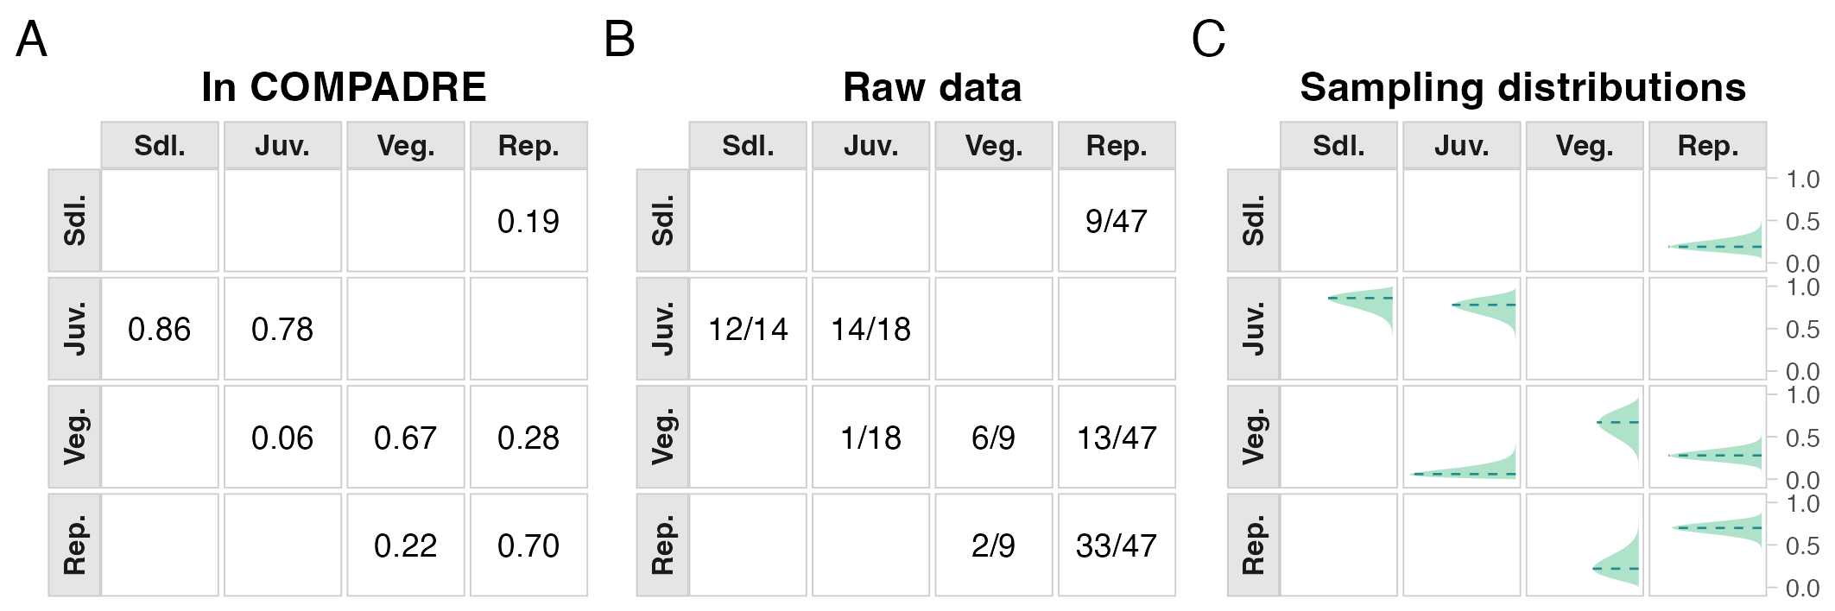
Figure 1: Sampling distributions of transition rates for the focal single-MPM example (Agrimonia eupatoria, population B), showing transition rates as reported in COMPADRE (A), the underlying transition counts used for estimation (B), and posterior uncertainty distributions (C). In panel C, pale green densities show transition-rate sampling distributions, and teal dashed horizontal lines mark point estimates. Survival-related transitions are probabilities; the reproductive transition gives recruits per reproductive plant. Together, these panels show that several matrix elements are weakly estimated from finite samples.

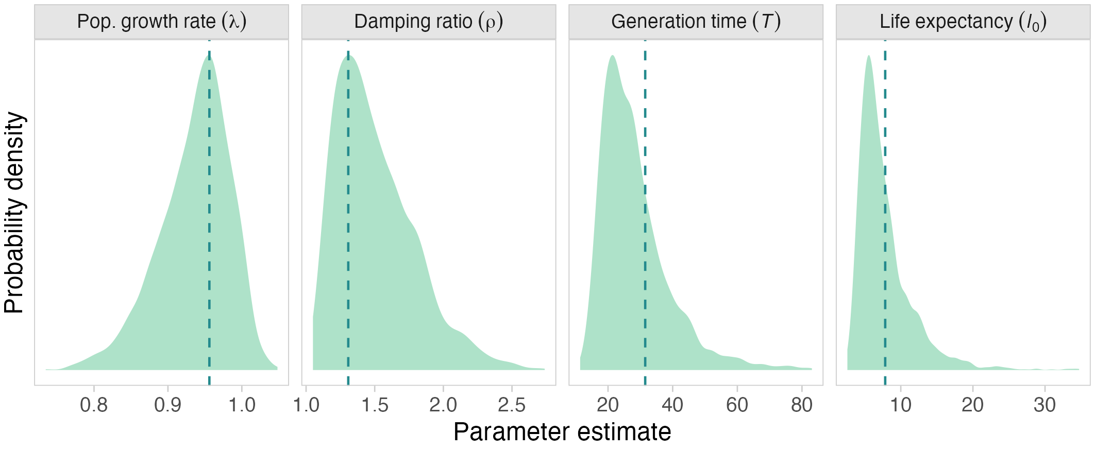
Figure 2: Sampling distributions of demographic quantities derived from the focal single MPM, including population growth rate (λ), damping ratio (ρ), generation time (T), and life expectancy (l₀). Pale green densities show derived-quantity sampling distributions, and teal dashed vertical lines mark point estimates. Quantities are shown on their natural scales (T and l₀ are in years). Uncertainty in transition rates propagates to substantial uncertainty in these derived parameters, with the largest spread in quantities that depend on long-term survivorship and reproduction.

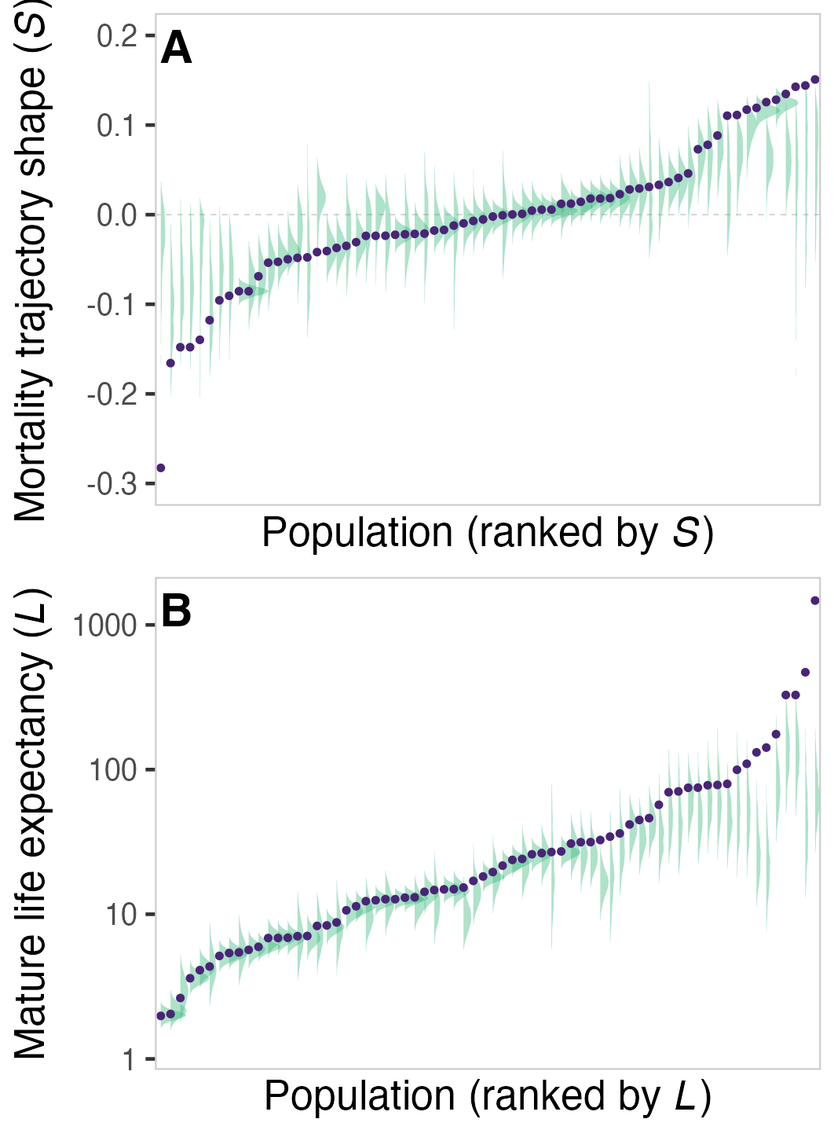
Figure 3: Analysis 1 comparison of point estimates versus sampling-distribution summaries for population-level life expectancy and shape. Panel A shows mortality-trajectory shape, and panel B shows mature life expectancy (years). Purple points show estimates derived directly from the matrix point estimates, whereas green distributions show uncertainty-aware summaries from transition-rate sampling distributions. The figure shows systematic shifts and shrinkage in extreme values when sampling uncertainty is propagated.

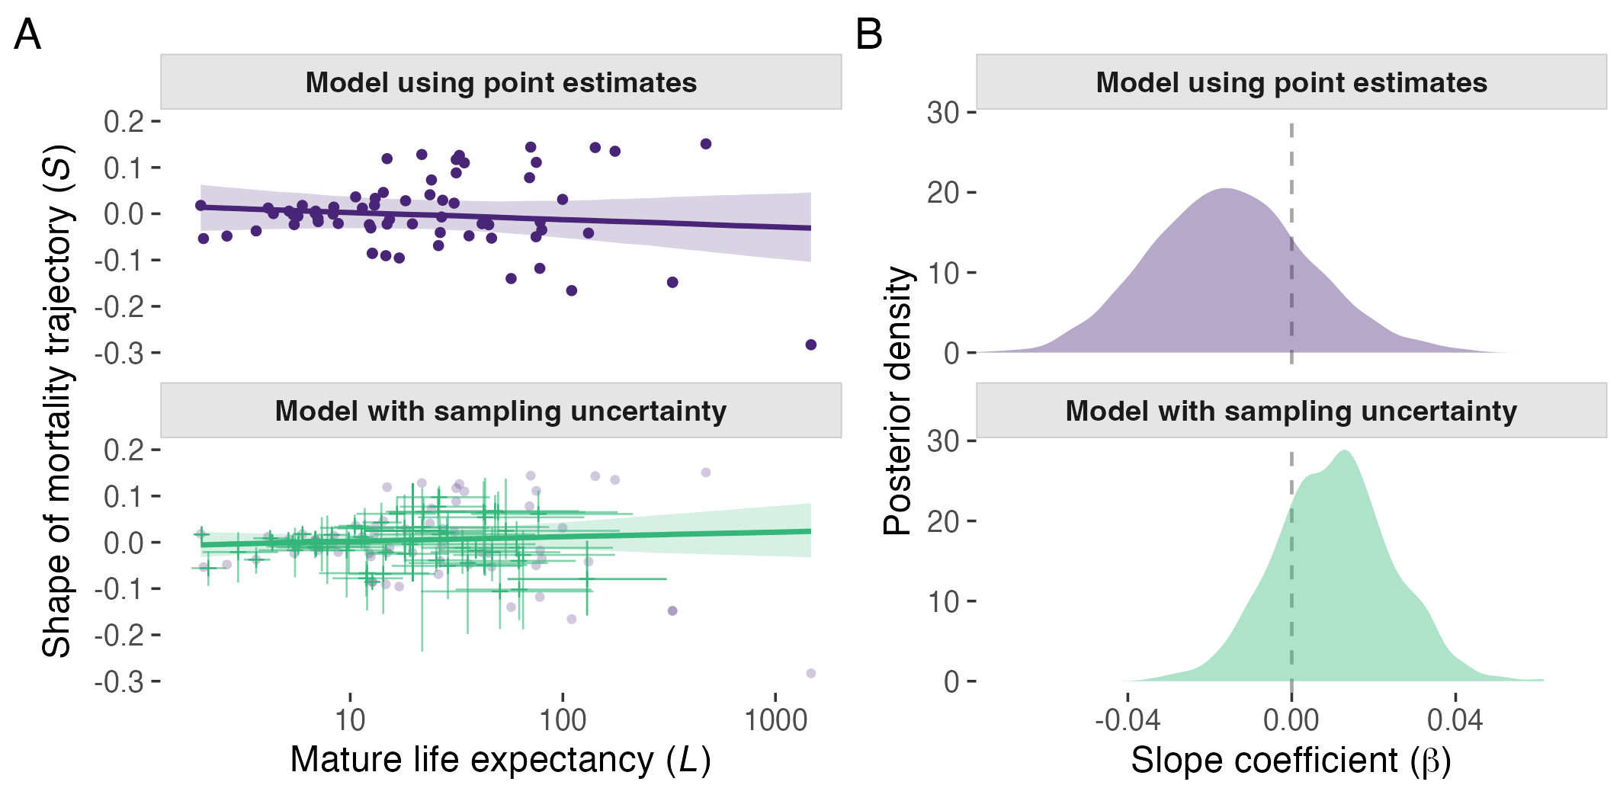
Figure 4: Accounting for sampling uncertainty shifts the estimated life expectancy-shape relationship and narrows its posterior interval, although both models retain substantial uncertainty about the direction of the relationship. Analysis 1 relationship between life expectancy and shape under models with and without sampling uncertainty propagation. In panel A, purple points, line, and ribbon show the model using point estimates. Green crosses, line, and ribbon show the uncertainty-aware model; crosses are centred on sampling-distribution medians with horizontal and vertical bars showing 95% intervals. The displacement between faint reference points and crosses indicates that propagated sampling distributions can shift central tendency away from point estimates, consistent with the offsets between dashed lines and density peaks in Figure 2. Axes are mature life expectancy (years, log scale) and mortality-trajectory shape. Panel B shows posterior densities for the slope parameter β (unit change in shape per unit change in log life expectancy), with purple for the point-estimate model and green for the uncertainty-aware model.

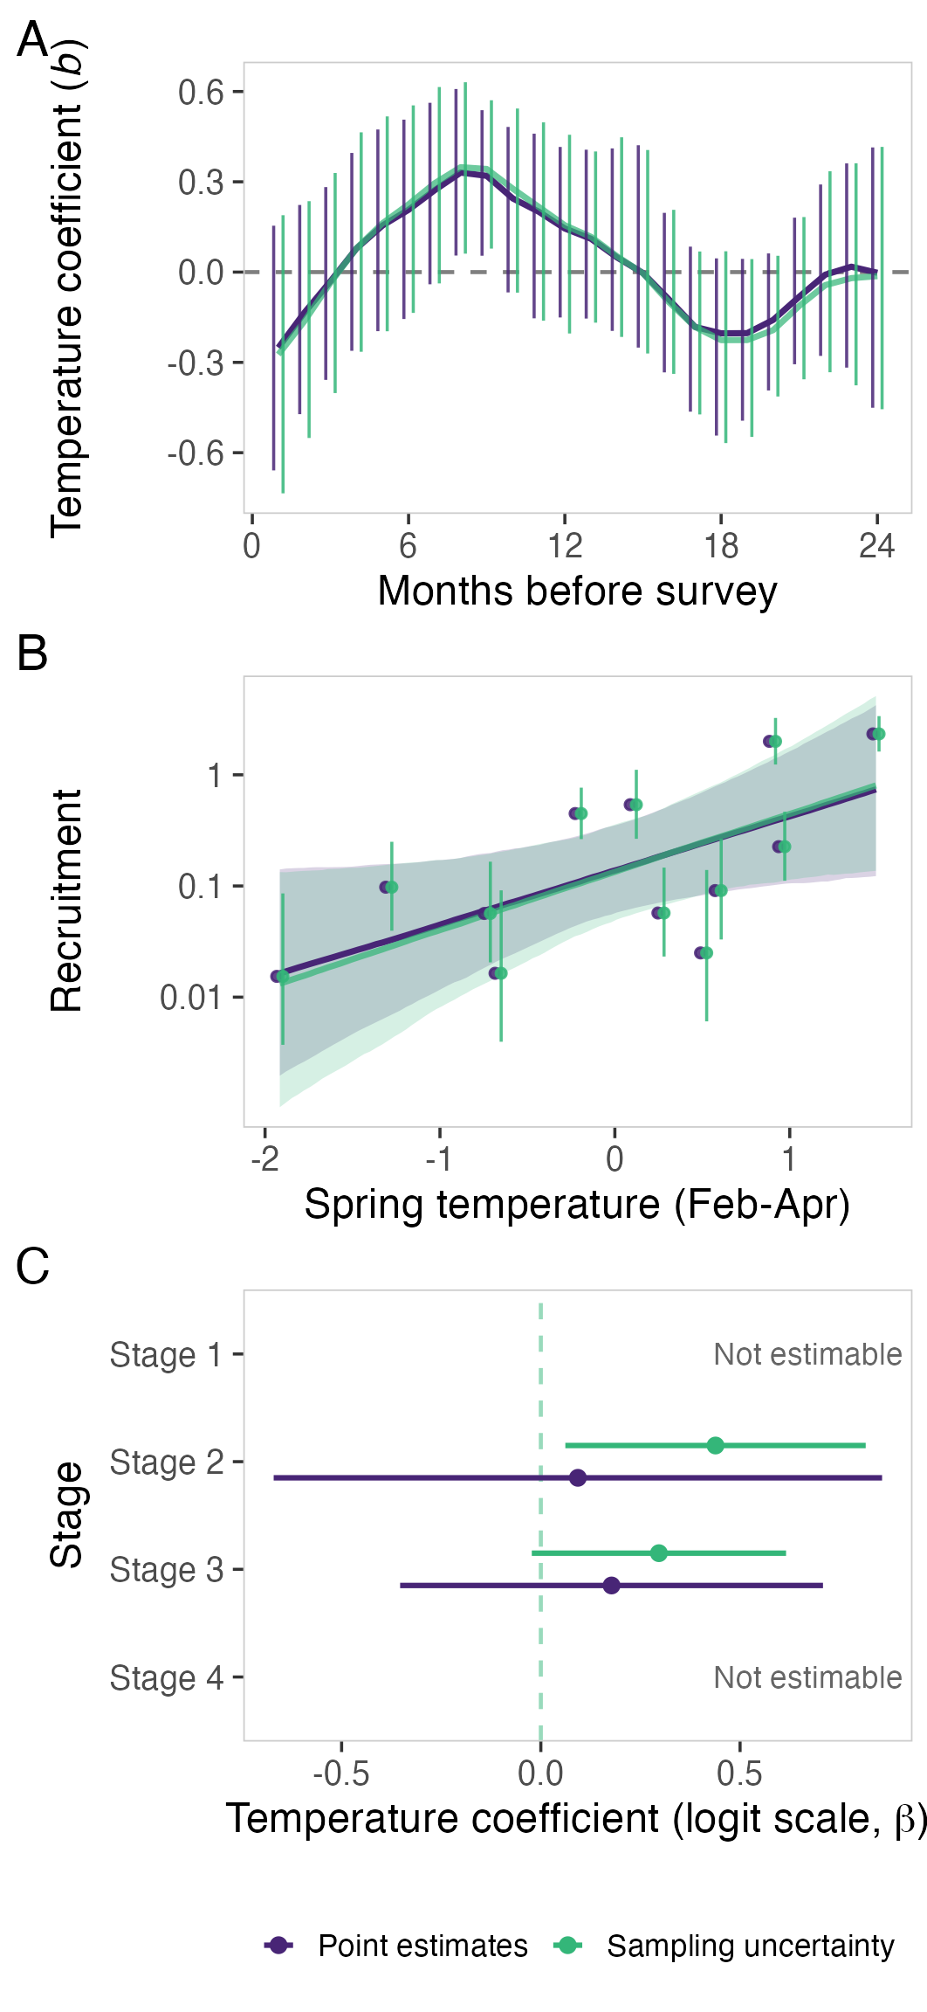
Figure 5: Analysis 2 climate effects on recruitment and stage-specific survival in Silene spaldingii. Panels A-B show monthly-lag and spring-temperature recruitment models for point-estimate (purple) and uncertainty-aware (green) formulations, with similar posterior coefficient estimates and interval widths. In panel A, y-values are temperature coefficients b for monthly temperature deviations (months before survey on the x-axis). In panel B, recruitment is seedlings per reproductive plant and spring temperature is February-April temperature deviation. Panel C shows stage-specific survival-temperature coefficients on the logit scale (β) where estimable (stages 2-3), again with purple for the point-estimate model and green for the uncertainty-aware model. Panel C intervals are 95% Wald confidence intervals; differences reflect weighting and dispersion assumptions as well as the use of sample sizes. Stages 1 and 4 are labelled as not estimable (only four usable years and 100% survival in all usable years, respectively).

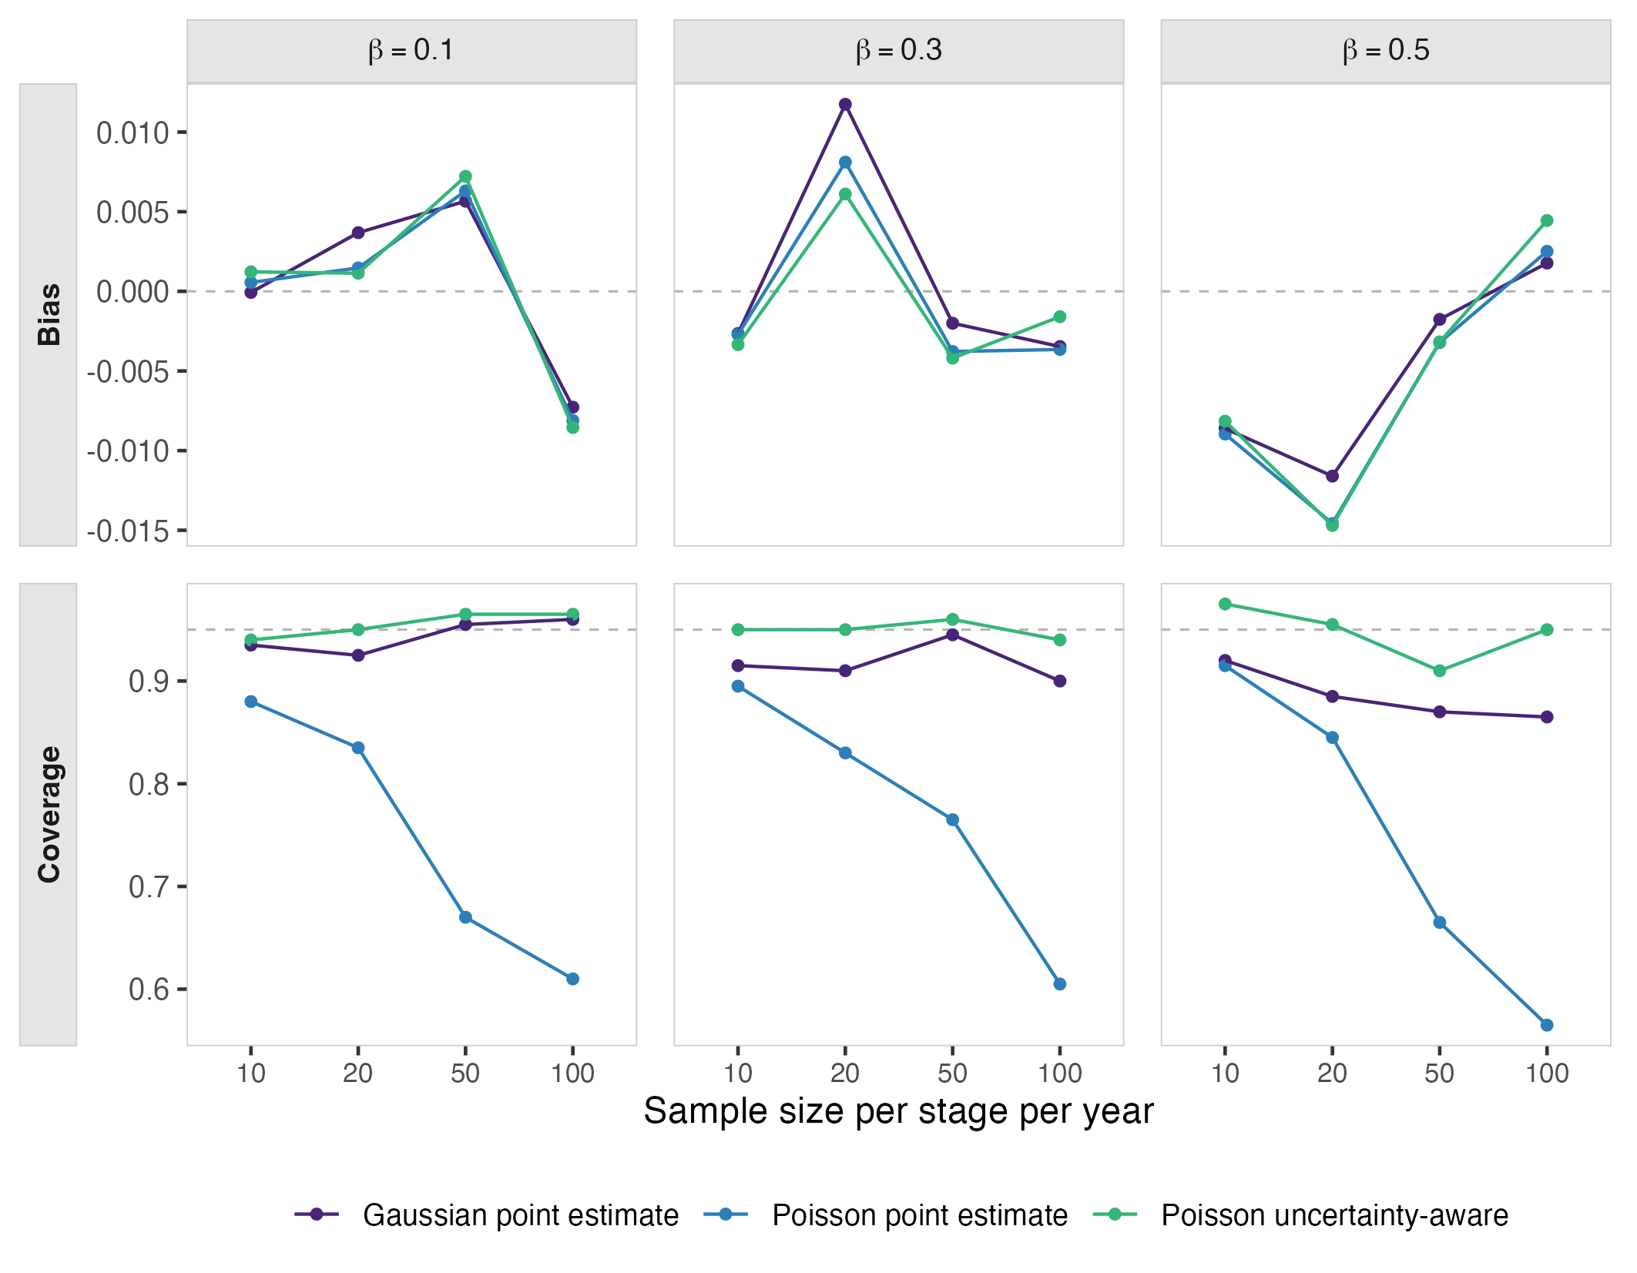
Figure 6: Simulation analysis of climate effects on fecundity, showing that modelling year-to-year process variation improves interval performance while keeping bias low. The upper row shows bias, and the lower row shows 95% interval coverage, across four sample sizes and three true effect sizes (beta = 0.1, 0.3, and 0.5). The Gaussian log-link point-estimate model (purple) has little average bias but its intervals are too narrow, especially at stronger climate effects. The Poisson point-estimate model (blue) is nearly unbiased but its intervals miss the true effect too often, especially at larger sample sizes. The uncertainty-aware Poisson model (green) keeps coverage close to the expected 95% level across the full design.

