# Task8-批次執行跨伺服器資料表匯出檔案。

## 目的：完成此任務你將學習到

1. 建立資料庫連線設定
2. 匯出時選擇新建立資料庫連線
3. 自訂SQL語法查詢遠端資料表

## 劇本

1. 資料來源：dbo.tb_job_exec_log
2. 匯出欄位規格
   1. 所有欄位
3. 檔案內文格式
   1. 逗號(,)為分隔符號
   2. Big5
4. 檔案名稱：
   1. C:\IBS\OUT\tb_job_exec_log_yyyyMMdd{三碼流水號}.csv。
      1. 例如:tb_job_exec_log_20190506001.csv
5. 作業編號：Task8_job
6. 作業名稱：任務8檔案匯出作業

## 實作

1. 本Task，先在本機先建立一個SBP_SRC資料庫，然後建立一個資料表，並將測試資料匯入，先執行底下語法建立測試資料

|  |
| --- |
| CREATE DATABASE [SBP_SRC]  CONTAINMENT = NONE  ON PRIMARY  ( NAME = N'SBP_SRC', FILENAME = N'C:\Program Files\Microsoft SQL Server\MSSQL11.MSSQLSERVER\MSSQL\DATA\SBP_SRC.mdf' , SIZE = 5120KB , FILEGROWTH = 1024KB )  LOG ON  ( NAME = N'SBP_SRC_log', FILENAME = N'C:\Program Files\Microsoft SQL Server\MSSQL11.MSSQLSERVER\MSSQL\LOG\SBP_SRC_log.ldf' , SIZE = 2048KB , FILEGROWTH = 10%)  GO  USE [SBP_SRC]  GO  CREATE USER [sbp_user] FOR LOGIN [sbp_user]  GO  USE [SBP_SRC]  GO  ALTER ROLE [db_datareader] ADD MEMBER [sbp_user]  GO  CREATE TABLE [dbo].[tb_job_exec_log](  [job_log_seq] [bigint] NOT NULL,  [batch_log_seq] [bigint] NOT NULL,  [ssis_job_no] [varchar](30) NOT NULL,  [exec_status_key] [varchar](10) NOT NULL,  [creator] [varchar](255) NOT NULL,  [create_time] [datetime2](7) NOT NULL,  [modifier] [varchar](255) NULL,  [last_update_time] [datetime2](7) NULL,  CONSTRAINT [PK_tb_job_exec_log] PRIMARY KEY CLUSTERED  (  [job_log_seq] ASC  )WITH (PAD_INDEX = OFF, STATISTICS_NORECOMPUTE = OFF, IGNORE_DUP_KEY = OFF, ALLOW_ROW_LOCKS = ON, ALLOW_PAGE_LOCKS = ON) ON [PRIMARY]  ) ON [PRIMARY]  GO  INSERT INTO dbo.tb_job_exec_log with(tablock)  (batch_log_seq,ssis_job_no,exec_status_key,creator,create_time,modifier,last_update_time)  select 113,'Task7_job','012|S','sys',cast('2019-06-09 16:09:24.6420026' as datetime2),'sys',cast('2019-06-09 16:09:25.2923182' as datetime2)  union all  select 109,'Task7_job','012|S','sys',cast('2019-06-09 16:00:16.1739914' as datetime2),'sys',cast('2019-06-09 16:00:17.1164849' as datetime2)  union all  select 105,'Task6_job','012|S','sys',cast('2019-06-08 22:35:27.5616187' as datetime2),'sys',cast('2019-06-08 22:35:28.1705430' as datetime2)  union all  select 101,'Task6_job','012|S','sys',cast('2019-06-08 22:28:02.1870242' as datetime2),'sys',cast('2019-06-08 22:28:03.0070699' as datetime2)  union all  select 97,'Task6_job','012|S','sys',cast('2019-06-08 22:20:41.5971300' as datetime2),'sys',cast('2019-06-08 22:20:42.3395297' as datetime2)  union all  select 93,'Task5_job','012|S','sys',cast('2019-06-07 20:43:34.9726629' as datetime2),'sys',cast('2019-06-07 20:43:36.2823687' as datetime2)  union all  select 89,'Task5_job','012|S','sys',cast('2019-06-07 19:33:49.5583135' as datetime2),'sys',cast('2019-06-07 19:33:51.2652461' as datetime2)  union all  select 85,'Task4_job','012|S','sys',cast('2019-06-06 16:11:34.4298120' as datetime2),'sys',cast('2019-06-06 16:11:35.3244445' as datetime2)  union all  select 58,'Task3_job','012|S','sys',cast('2019-05-18 11:34:08.2651606' as datetime2),'sys',cast('2019-05-18 11:34:08.4812939' as datetime2)  union all  select 55,'Task3_job','012|S','sys',cast('2019-05-18 11:34:07.3459750' as datetime2),'sys',cast('2019-05-18 11:34:08.2495346' as datetime2)  union all  select 52,'Task3_job','012|S','sys',cast('2019-05-18 11:34:05.9250630' as datetime2),'sys',cast('2019-05-18 11:34:07.2959736' as datetime2)  union all  select 48,'Task3_job','012|S','sys',cast('2019-05-05 22:49:10.4835709' as datetime2),'sys',cast('2019-05-05 22:49:10.5525231' as datetime2)  union all  select 45,'Task3_job','012|S','sys',cast('2019-05-05 22:49:10.3832790' as datetime2),'sys',cast('2019-05-05 22:49:10.4679334' as datetime2)  union all  select 42,'Task3_job','012|S','sys',cast('2019-05-05 22:49:09.2810493' as datetime2),'sys',cast('2019-05-05 22:49:10.3676755' as datetime2)  union all  select 38,'Task3_job','012|S','sys',cast('2019-05-05 22:48:11.6118262' as datetime2),'sys',cast('2019-05-05 22:48:11.6743267' as datetime2)  union all  select 35,'Task3_job','012|S','sys',cast('2019-05-05 22:48:11.4959179' as datetime2),'sys',cast('2019-05-05 22:48:11.5961825' as datetime2)  union all  select 32,'Task3_job','012|S','sys',cast('2019-05-05 22:48:10.3238863' as datetime2),'sys',cast('2019-05-05 22:48:11.4657722' as datetime2)  union all  select 28,'Task3_job','012|S','sys',cast('2019-05-05 22:47:11.0073187' as datetime2),'sys',cast('2019-05-05 22:47:11.0870054' as datetime2)  union all  select 25,'Task3_job','012|S','sys',cast('2019-05-05 22:47:10.9106981' as datetime2),'sys',cast('2019-05-05 22:47:11.0073187' as datetime2)  union all  select 22,'Task3_job','012|S','sys',cast('2019-05-05 22:47:09.8366385' as datetime2),'sys',cast('2019-05-05 22:47:10.8794466' as datetime2)  union all  select 18,'Task3_job','012|S','sys',cast('2019-05-05 22:13:03.4922365' as datetime2),'sys',cast('2019-05-05 22:13:03.5752339' as datetime2)  union all  select 15,'Task3_job','012|S','sys',cast('2019-05-05 22:13:03.3492382' as datetime2),'sys',cast('2019-05-05 22:13:03.4762353' as datetime2)  union all  select 12,'Task3_job','012|S','sys',cast('2019-05-05 22:13:01.8882301' as datetime2),'sys',cast('2019-05-05 22:13:03.3142351' as datetime2)  union all  select 8,'Task3_job','012|S','sys',cast('2019-05-05 22:11:36.2800983' as datetime2),'sys',cast('2019-05-05 22:11:36.3567654' as datetime2)  union all  select 5,'Task3_job','012|S','sys',cast('2019-05-05 22:11:36.1754297' as datetime2),'sys',cast('2019-05-05 22:11:36.2710917' as datetime2)  union all  select 2,'Task3_job','012|S','sys',cast('2019-05-05 22:11:34.7914352' as datetime2),'sys',cast('2019-05-05 22:11:36.1481297' as datetime2) |

1. 參考Task1登入系統

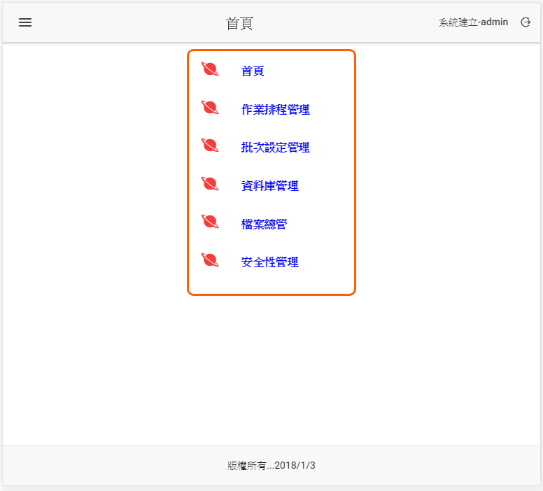

1. 點選資料庫管理

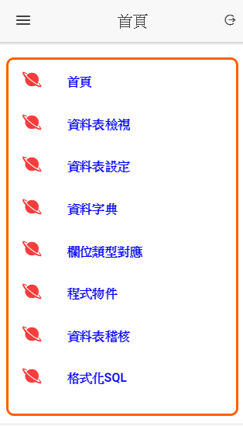

1. 點選資料表設定

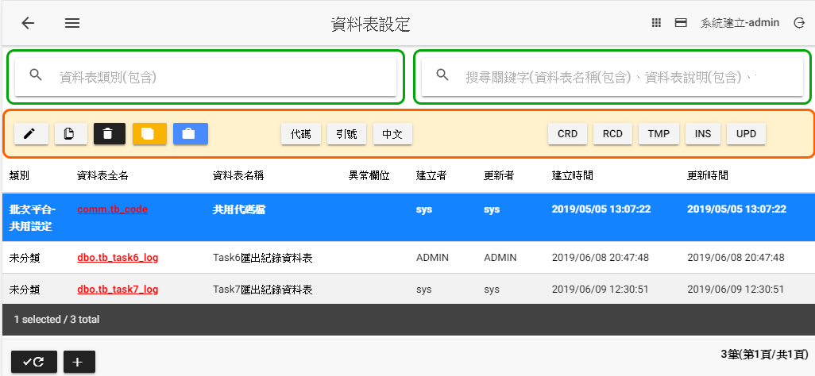

1. 按下進行新增資料表，欄位資訊如下，新增完畢後按下儲存。
   1. 資料表名稱：tb_job_exec_log
   2. 資料表說明：作業執行紀錄檔

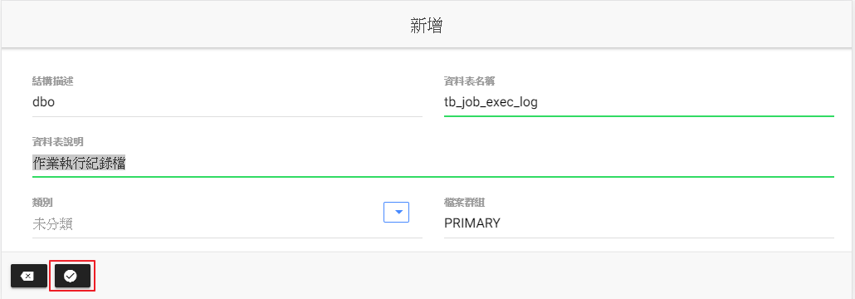

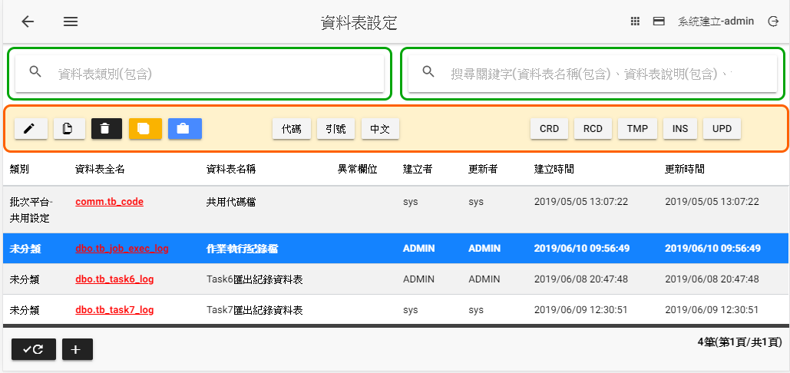

1. 點選批次設定管理

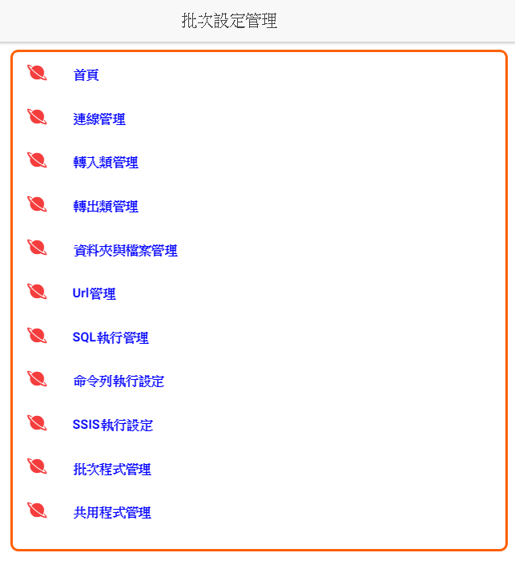

1. 點選連線管理

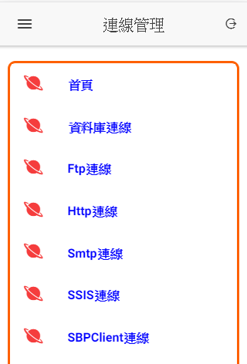

1. 點選資料庫連線

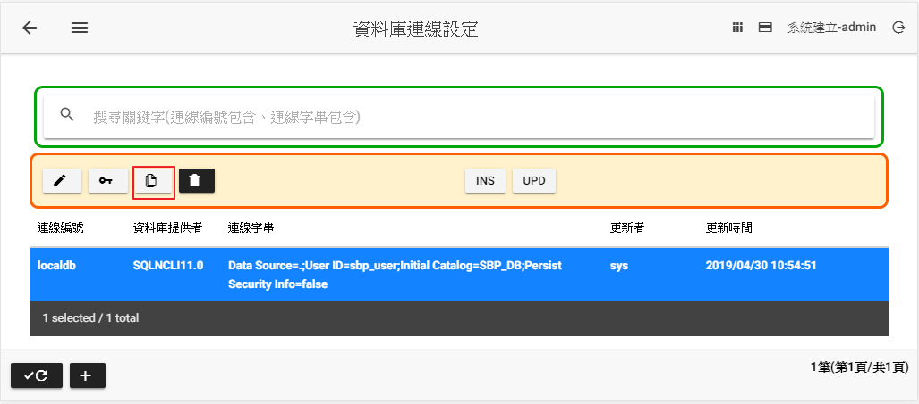

1. 按進行複製連線資訊

遠端連線編號：SBP_SRC_DB

連線字串:資料庫改為SBP_SRC

密碼：p@ssw0rd(預設，如安裝有修改時，請依照當時修改的設定)

確認密碼：同上

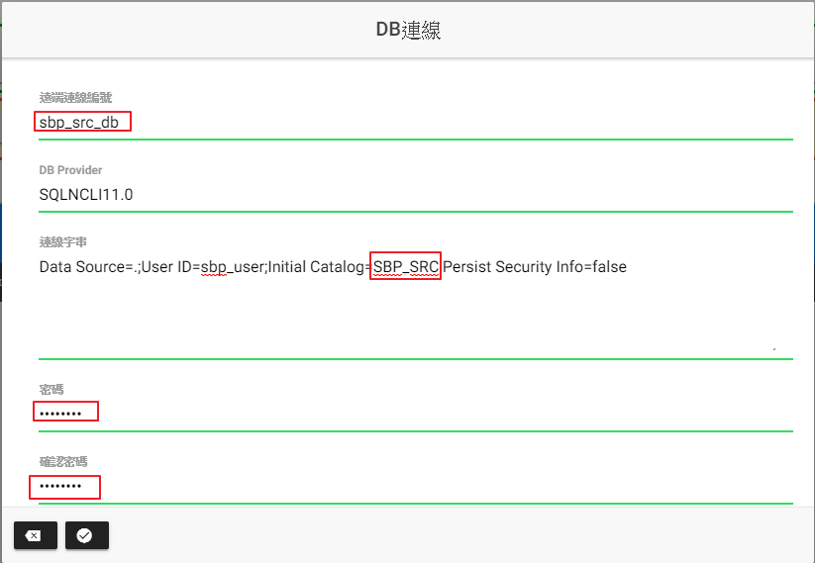

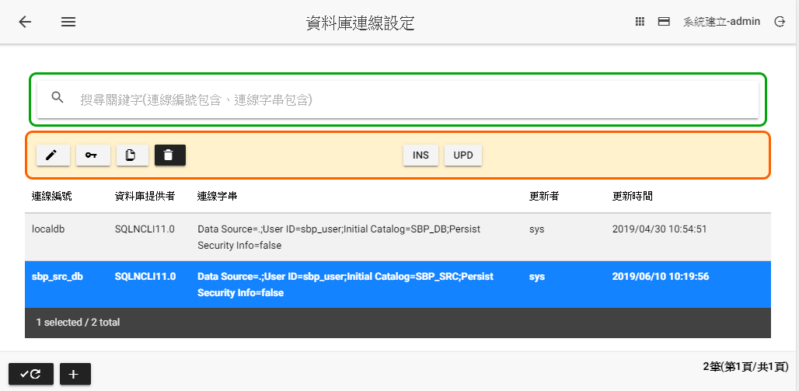

1. 點選轉出類管理

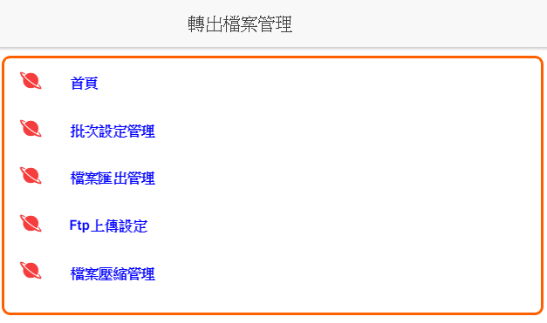

1. 點選檔案匯出管理

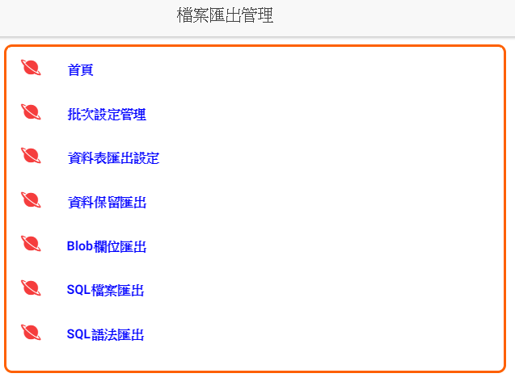

1. 點選**SQL語法匯出**

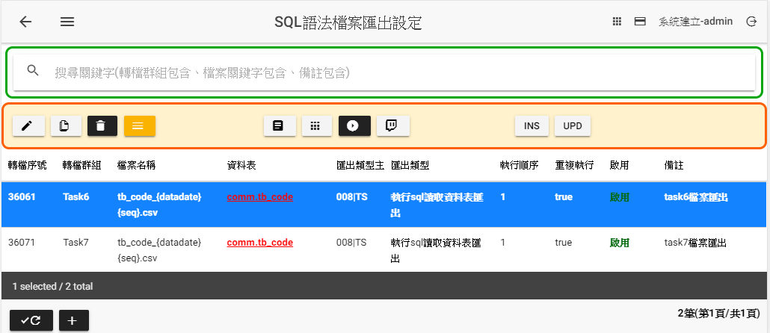

1. 點選新增設定，設定內容如下

**轉檔群組**：Task8(匯出檔案執行單位，同一群組可以有多個匯出檔案)

**轉檔序號**：30081

**結構描述**：dbo 資料表名稱：tb_job_exec_log

**執行順序**：1(點選，系統自動產生)

**連線編號：sbp_src_db**(點選，系統開啟視窗選擇sbp_src_db後按下帶回)

**參數群組**：001預設不變

**檔案名稱**：tb_job_exec_log_{datadate}{seq}.csv

**欄位分隔符號**：,

**輸出檔案路徑：**變更為005|9(C:\IBS\OUT)

**Sql_statement:**

|  |
| --- |
| SELECT [job_log_seq]  ,[batch_log_seq]  ,[ssis_job_no]  ,[exec_status_key]  ,[creator]  ,[create_time]  ,[modifier]  ,[last_update_time]  FROM [dbo].[tb_job_exec_log] |

**備註：**Task8跨伺服器檔案匯出

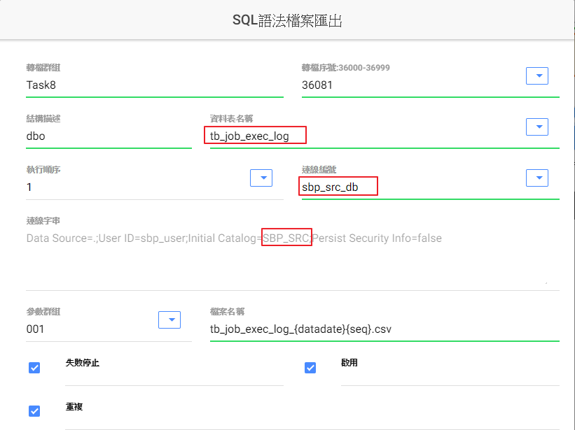

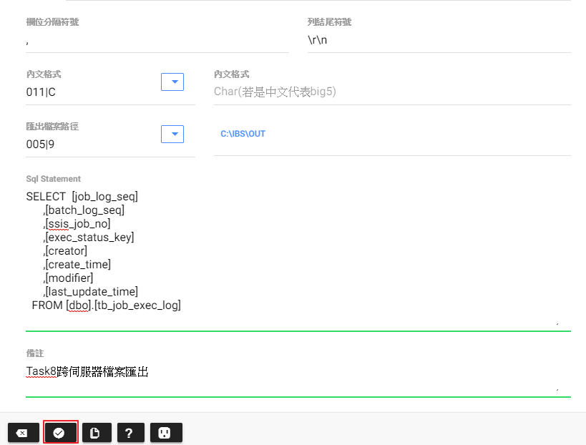

1. 點選 將資料儲存

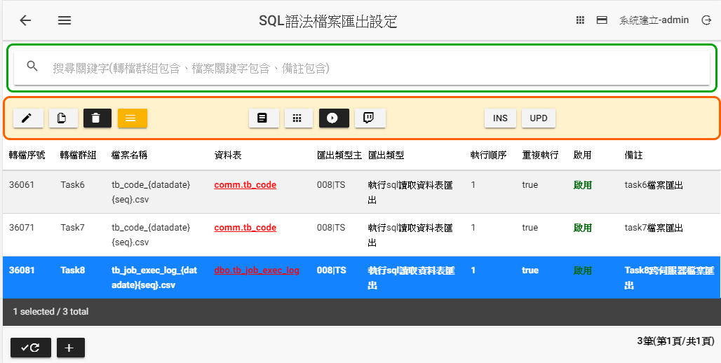

1. 點選 兩次回上上畫面

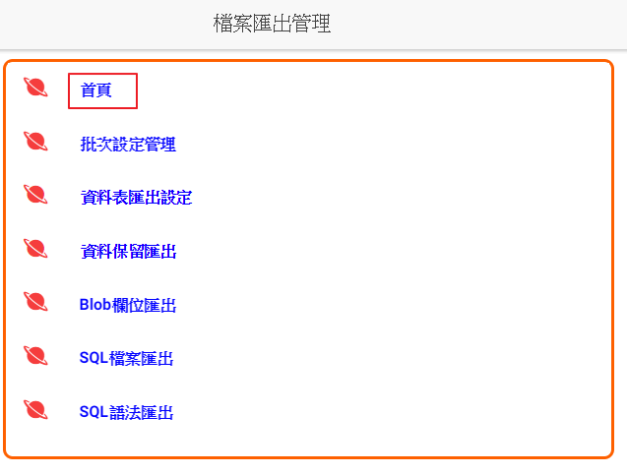

1. 點選首頁回首頁

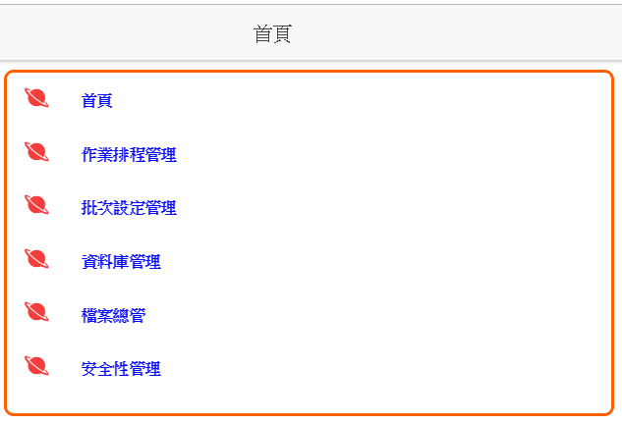

1. 點選作業排程管理

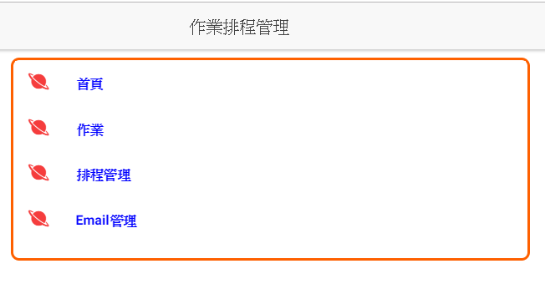

1. 點選作業

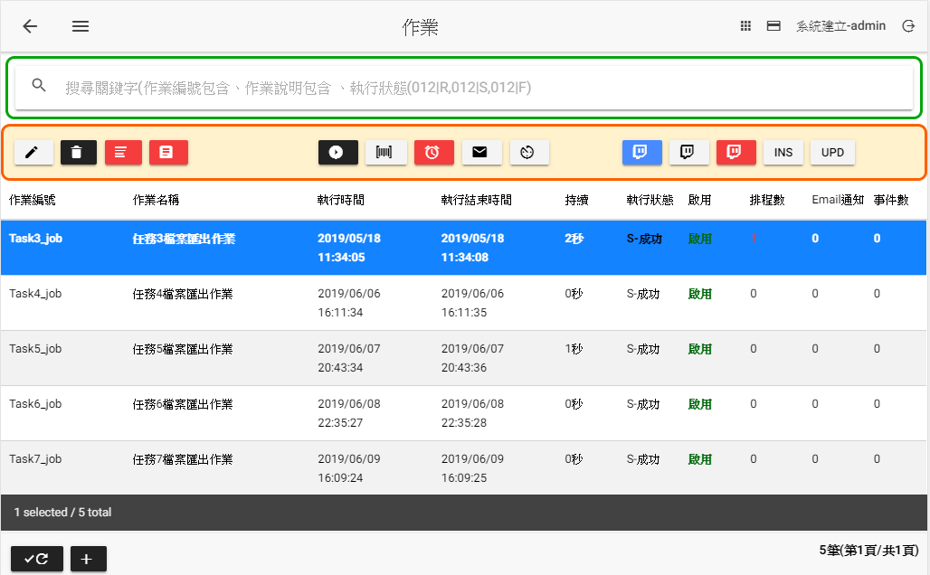

1. 點選命令區的新增作業

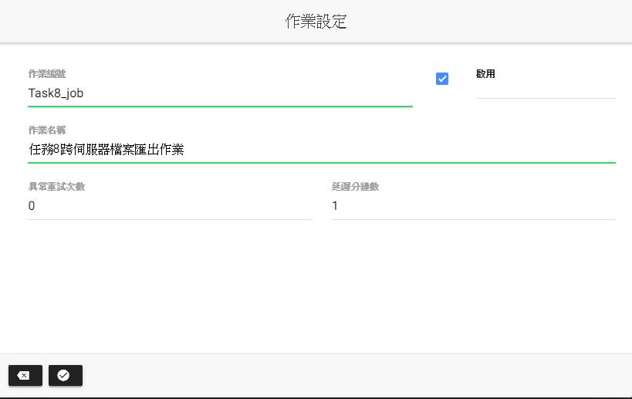

**作業編號：**Task8_job

**作業名稱：**任務8跨伺服器檔案匯出作業

1. 按 儲存後。

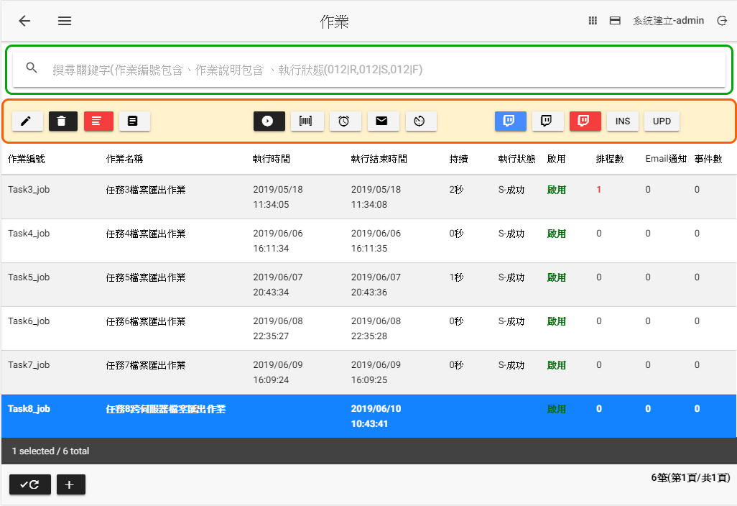

1. 點選功能列的進入作業步驟設定

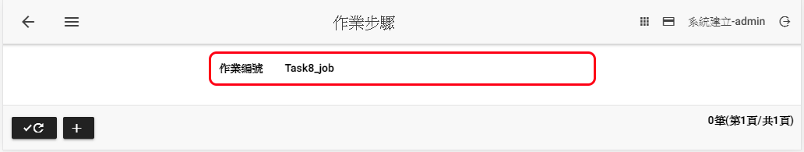

1. 點選命令區的新增作業步驟

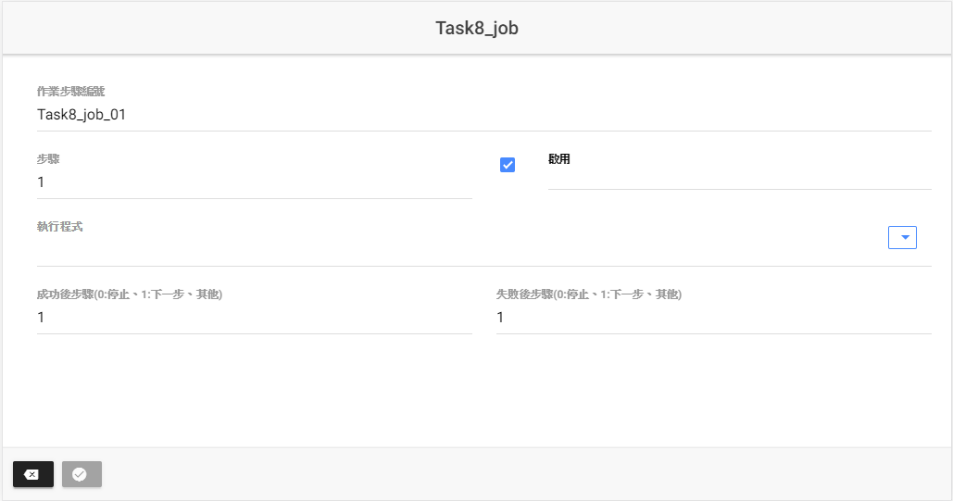

**執行程式：**Task8-Task8跨伺服器檔案匯出(點選右方的，系統會開啟一對話方框)，選取export_Task8後按下，系統代回填入。

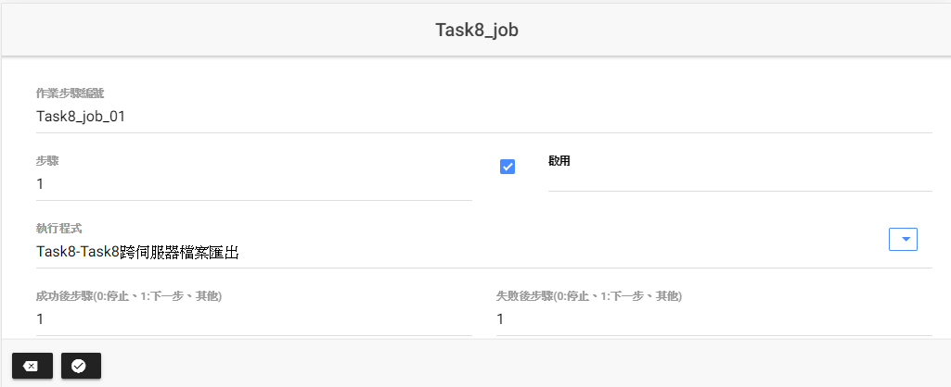

1. 點選儲存作業步驟，回到作業步驟畫面

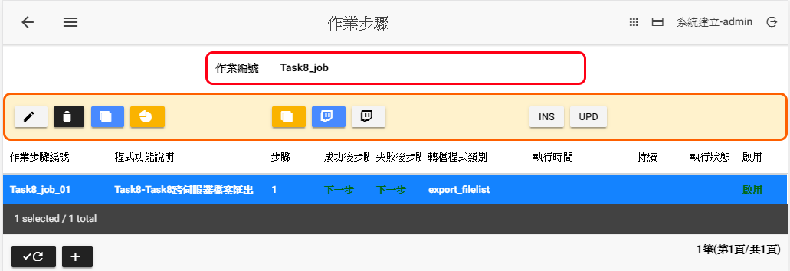

1. 點選 回作業設定畫面

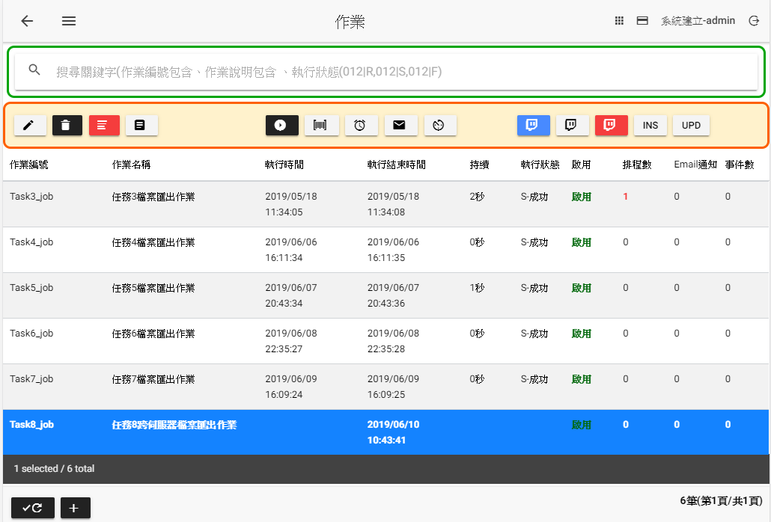

以上設定完畢

1. 點選進行執行作業



1. 點選 ，檢視歷史執行紀錄

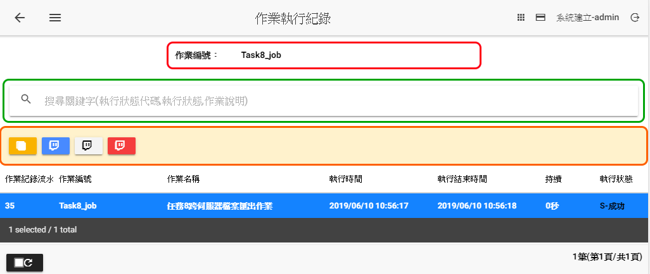

1. 點選檢視檔案執行紀錄

