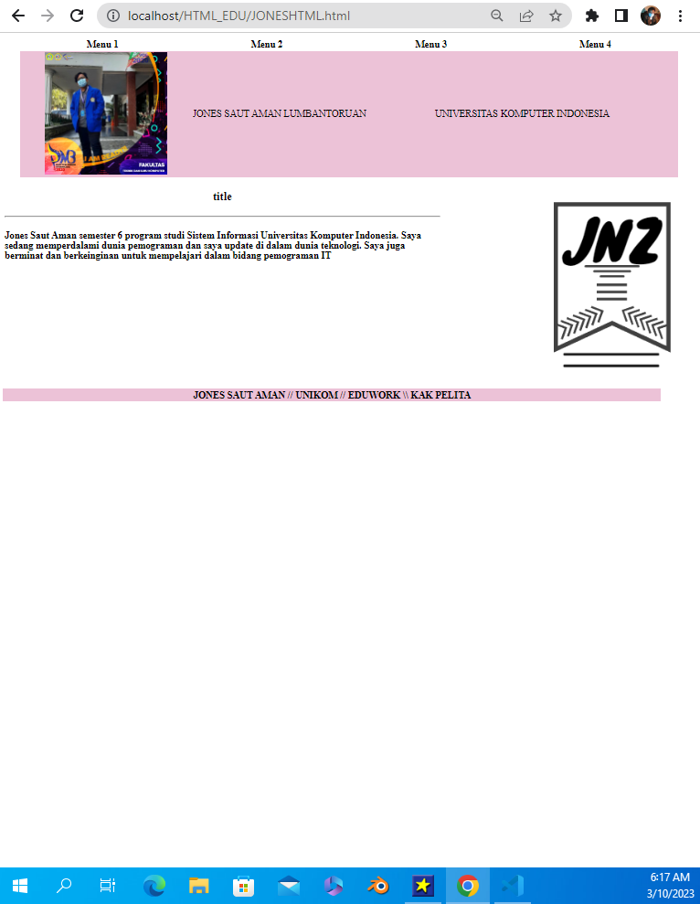

https://github.com/jonezSAL/Jones.git