SEN 602
Quizzicalicious
Ferdie Eugenio
Brandt Daniels
Heath Ivie
Jon Hancock

Use Cases with Activity Diagrams

Use Case: Begin Quiz
Description | The user, after accessing Quizzicalicious will be presented with three buttons labeled Level 1, Level 2, and Level 3. When the user wants to begin a level, he will click one of those buttons. The system will then show him the first question for that level, and if he has completed that level before, this previous score and time will be cleared so the scoring and time keeping can start fresh. If the user select Sudden Death Mode before clicking a level, they will be moved to the first question of the level, but the system will be operating in sudden death mode. If the user has completed a level before, their score and time will be shown as a link next to the button for that level. If the user clicks one of those links, they will not begin the quiz, but rather, they will be taken to the results page for that level where they can review their previous answers.
Id | UC_BQ

Version History
Date | Author | Description of Change
04/24/2011 | Jon Hancock | Initial

Screenshot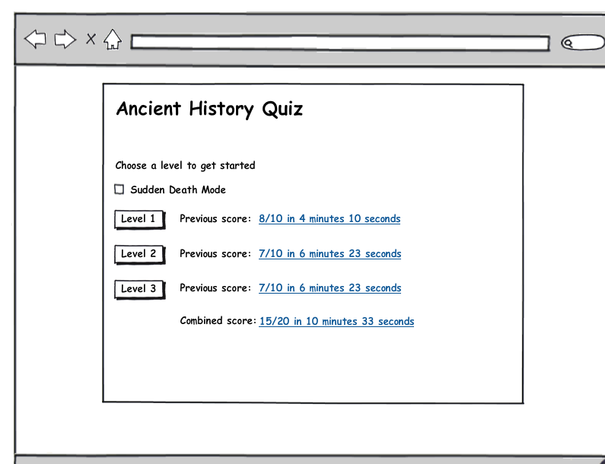

UML Diagram

Activity Diagram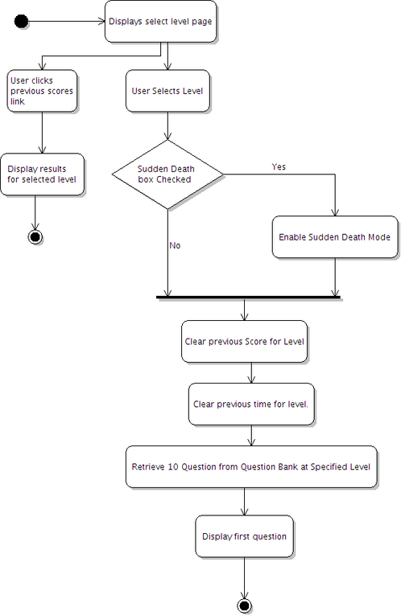
Class Diagram

Actors

Primary Actors
- User

Secondary Actors
- None

Trigger
User desires to begin a quiz

Pre-Conditions
- The user has accessed Quizzicalicious in a modern web browser.

Normal Flow (Happy Path)
Step # | Step Description
1 | The user clicks on the button to begin a selected level.
2 | The system clears any previous score for that level.
3 | The system clears any previous time for that level.
4 | The system selects 10 questions randomly from the Question Bank at the level selected.
5 | The system transitions to the first question for that level.

Alternative Paths
Alternative Path 1: Sudden Death Mode
Step # | Step Description
1 | The user checks the box for Sudden Death Mode
2 | The user clicks the button to begin a level.
3 | The system clears any previous score for that level.
4 | The system clears any previous time for that level
5 | The system transitions to the first question for that level

Post-Conditions
- The user is shown the first question for the chosen level.
- The previous score is cleared
- The previous time is cleared

Exception Paths
Exception Path 1: View Previous Score
Step # | Step Description
1 | The user clicks their previous score for any given level.
2 | The system transitions to the results page for that level.
3 | See use case View Results

Use Case: Answer Question
Description | The user is presented with one question at a time. To answer the question, the user will click the radio button to the left of their answer, then press Next. The system will display the running score in the upper left of the window, and the user’s progress will be represented with a progress bar in the upper middle of the window. The user will also be moved to the next question. If there are no more questions to answer, the user will be moved to the results page instead. If the user is playing in Sudden Death mode, and answers three questions incorrectly, they will be automatically sent to the results page when they click the Next button. If at any time the user wishes to exit the level, and go back to the main menu, they can press the Quit button.
Id | UC_AQ

Version History
Date | Author | Description of Change
04/24/2011 | Jon Hancock | Initial

Screenshot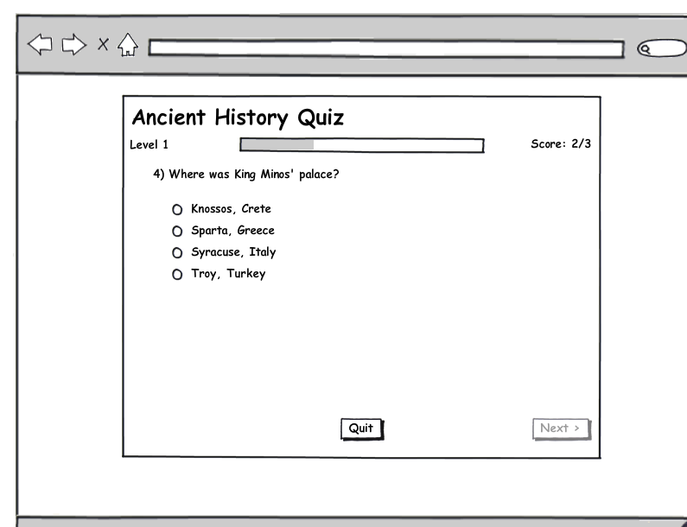

UML Diagram

Activity Diagram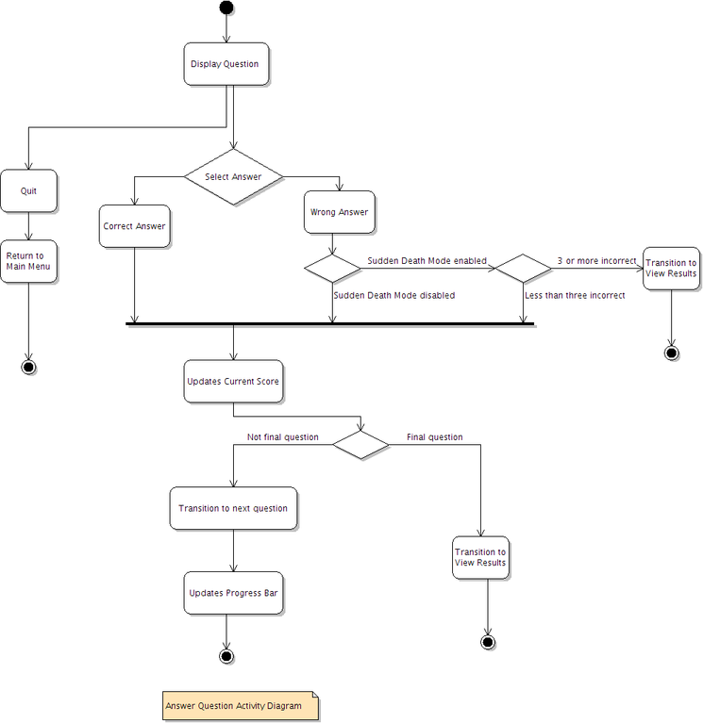

Class Diagram

Actors

Primary Actors
- User
Secondary Actors
- None

Trigger
The user is shown a question and wants to answer it.

Assumptions
- The user has accessed Quizzicalicious in a modern web browser.
Pre-Conditions
- The user has selected a level to work on, and began the quiz.

Normal Flow (Happy Path)
Step # | Step Description
1 | The user clicks the radio button to the left of an answer
2 | The user clicks the Next button. User is not able to click on the next button until an answer has been chosen.
3 | The system transitions to the next question
4 | The system updates the user’s current score in the running score display
5 | The system updates the user’s overall progress in the progress bar.

Alternative Paths
Alternative Path 1: Final Question
Step # | Step Description
1 | The user clicks the radio button to the left of an answer
2 | The user clicks the Next button
3 | The system transitions to the Results page
4 | See Use Case View Results

Alternative Path 2: Third Incorrect in Sudden Death Mode
Step # | Step Description
1 | The user clicks the radio button to the left of an answer
2 | The user clicks the Next button
3 | The system determines that the user has answered three questions incorrectly
4 | The system transitions to the results page
5 | See Use Case View Results

Post-Conditions
- The user’s answer is recorded to the system.
- The user’s score is updated
- The user’s progress is updated
- If the question is the final question, the user is shown the results page
- If the user has answered three questions incorrectly in Sudden Death mode, he is shown the results page.

Exception Paths
Exception Path 1: Path Name
Step # | Step Description
1 | The user presses the quit button
2 | The system discards the user’s score
3 | The system discards the user’s time
4 | The system transitions to the Main page.

Use Case: View Results
Description | Once the user has finished a level, he is taken to the results page. This page will show the user each question they answered along with whether the user answered correctly or incorrectly. If available, the user will be shown additional information about the correct answer. The page will display the total number of questions answered correctly over the total number of questions attempted. It will also show the amount of time in minutes and seconds that the user spent on the level. The user will be given the option to either restart the level, return to the main menu, or continue to the next level. If the user is playing Sudden Death mode, they will continue to play in that mode unless they change it in the main menu.
Id | UC_VR

Version History
Date | Author | Description of Change
04/24/2011 | Jon Hancock | Initial

Screenshot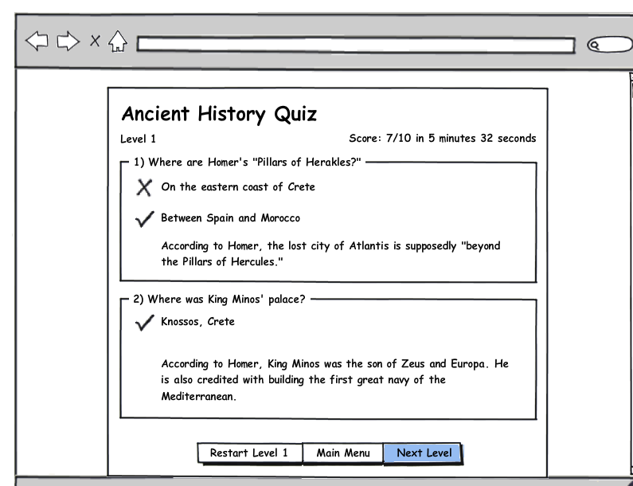

UML Diagram

Activity Diagram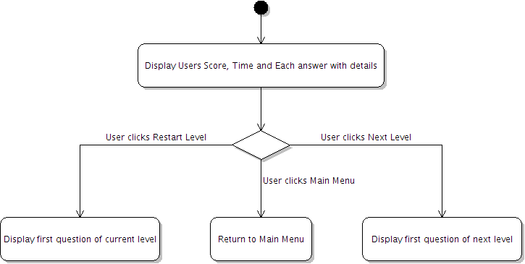
Class Diagram

Actors

Primary Actors
- User

Secondary Actors
- None

Trigger
The user finishes the last question of a level
The user answers three questions incorrectly in sudden death mode

The user clicks the previous results link from the main page

Assumptions
- The user has accessed Quizzicalicious in a modern web browser.

Pre-Conditions
- The user has completed the level for which the results are being displayed
- The user has clicked Next on the final question of a level OR
- The user has clicked Next after the third incorrect answer in Sudden Death mode OR
- The user has clicked the previous scores link for the level being displayed

Normal Flow (Happy Path)
Step # | Step Description
1 | The system will display the user’s score as the number of correct answers over the number of questions attempted
2 | The system will display the amount of time the user spent in the quiz in minutes and seconds
3 | The system will display each question with the correct answer, and if answered incorrectly, the user’s answer.
4 | With each question, the system will display additional information about the answer if it is available.
5 | The user will click Next level
6 | The system will transition to the first question of the next level. See Use case Begin Quiz

Alternative Paths
Alternative Path 1: User Restarts current level
Step # | Step Description
1 | The system will display the user’s score as the number of correct answers over the number of questions attempted
2 | The system will display the amount of time the user spent in the quiz in minutes and seconds
3 | The system will display each question with the correct answer, and if answered incorrectly, the user’s answer.
4 | With each question, the system will display additional information about the answer if it is available.
5 | The user will click Restart Level <current level>
6 | The system will transition to the first question of the current level. See Use case Begin Quiz

Alternative Path 2: User goes to the main menu
Step # | Step Description
1 | The system will display the user’s score as the number of correct answers over the number of questions attempted
2 | The system will display the amount of time the user spent in the quiz in minutes and seconds
3 | The system will display each question with the correct answer, and if answered incorrectly, the user’s answer.
4 | With each question, the system will display additional information about the answer if it is available.
5 | The user will click Main Menu
6 | The system will transition to the Main Menu

Post-Conditions
- The user will be shown their score
- The user will be shown their time
- The user will be shown each question with details
- The user will be transitioned to the next level OR
- The user will be transitioned to the first question of the current level OR
- The user will be transitioned to the main menu

