THERMO-TACTICS
Part I. Final System Architecture
Unity 2D turn-based strategy game · Android · fully offline · Capstone Project · revised 9 October 2026
This document presents the System Architecture Diagram the team uses from here on. It has been revised to match the game as it is actually built in the repository github.com/jonfranss221/CAPSTONE (11 commits; 22 runtime C# scripts plus one editor tool). Stage 1 (Baguio), Level 1 is playable: 3 waves, 10 animated units, Oxygen Points, the 1.5 °C loss rule, and a local SQLite results database. Components that are designed but not yet written are kept in the architecture and marked Planned, so the document shows both the target system and how much of it exists today.
The architecture reflects these confirmed design decisions:
- a battlefield of 6 lanes with 2 fixed slots each
- loss when the temperature reaches 1.5 °C
- a local SQLite database for player records
- a pre-quiz before every stage and a post-quiz after each stage's final level
- a local export of quiz results for the study
- script-level naming of every component (one script per system)

1. Inconsistencies Resolved in This Version
Each inconsistency found between the project overview, the earlier draft of this architecture and the working build is listed below with its resolution. Built means the resolution is in the repository now; Planned means it is the design the team will implement.
# | Inconsistency identified | Resolution in the final architecture
1 | The overview described a square grid with tile-by-tile movement and A* pathfinding, but the battlefield uses 6 lanes with 2 fixed slots each. | Built. GridManager.cs stores the 12 slots (one ally slot and one enemy slot per lane). BoardSlot.cs makes each painted slot tappable, and IsoBoardLayout.cs converts lane and slot to screen positions. There is no pathfinding. Enemies spawn into random free enemy slots and attack along their lane.  Planned. EnemyAI.cs will let an enemy move to another free enemy slot.
2 | The overview set the loss line at an in-game 1.6 °C while naming 1.5 °C as the target players must stay below. | Built. The game uses the real Paris Agreement value: the player loses as soon as the temperature reaches 1.5 °C, and wins by clearing every wave before that. The value is LevelData.lossThreshold (1.5), so it can be tuned per level without code changes. Pop-up thresholds stay at 1.2 °C and 1.4 °C, below the limit.
3 | The overview listed a second loss condition, "all player units destroyed", and an effect "below 1.0 °C", which conflict with the climate rules. | Built. Temperature is the only loss check (TurnManager.cs, after each enemy phase). With no allies left, every enemy attack hits an undefended lane (+0.10 °C), so the temperature reaches the limit anyway. The temperature cannot drop below the starting 1.0 °C (TemperatureSystem.cs), so a "below 1.0 °C" state never happens.
4 | Saving was described both as an "optional local JSON save" and as "Persistent save: Yes". The earlier draft used save.json and said the game had no database. | Built. Saving is automatic. Player records go in a local SQLite database file, thermo_tactics.db, in the app's private folder. ResultsDatabase.cs is the only script that opens it, using the bundled SQLite-net library. Every finished level is stored in the game_results table (name, WIN/LOSS, date created, final temperature, waves cleared) and shown in the Results panel.  Planned. The quiz_results and level_progress tables in the same file. There is no server; the database is a single file on the phone.
5 | Quiz timing conflicted: Game Flow listed one pre-game quiz before Stage 1 and one post-game quiz at the end, while Educational Features listed 5 questions per stage. | Planned. QuizManager.cs runs the pre-quiz as a pop-up before each stage begins and the post-quiz after that stage's final level (Level 10): five stages × 5 questions, each asked before and after.
6 | Quizzes and pop-up facts were said to use ScriptableObjects, but no data script existed for either. | Planned. QuizData.cs holds each stage's 5 questions. PopupData.cs holds the pop-up facts that both PopupManager.cs and ClimateCodex.cs read.
7 | The game is offline with no analytics, but the study needs pre/post scores from 20–30 testers, and no collection path was defined. | Planned. QuizResultExporter.cs reads quiz records through ResultsDatabase.cs and writes a CSV file to the phone's shared storage. The researcher copies it by USB or Android share. No network is used.
8 | The overview had no login, but each saved result needs a name. | Built. UIManager.cs shows a login panel with a username field (2–20 characters) before the level starts. The name is saved with each result, so several testers can share one phone. During the study, testers enter the code the researcher gives them as their username.
9 | Gameplay step 9 ("visual update reflects new temperature band") and the listed screen tints had no owning script. | Built. FogScroller.cs drifts the Baguio fog and thins it as the temperature rises. GameManager.cs passes each temperature change to it.  Planned. ClimateBackground.cs will crossfade three baked backgrounds (cool, warming, critical).
10 | Eleven UI screens and the music and SFX list had no owning script. | Built. UIManager.cs owns the Login, Gameplay HUD, End and Results screens. DeployCard.cs draws each unit card and ResultsPanel.cs lists saved records.  Planned. The remaining screens, and AudioManager.cs for music and SFX.
11 | Five scripts that the working game needs did not appear in the earlier architecture. | Built. Added to the diagram and component table:  • BoardSlot.cs: slot taps  • UnitFactory.cs: builds each unit's sprite, animator, shadow and health bar at runtime  • DeployCard.cs and ResultsPanel.cs: UI  • ThermoTacticsBuilder.cs: an editor-only tool that imports the art and builds the level; it is not part of the APK
12 | DOTween, Freesound and Claude were listed as "third-party assets" without separating what runs in the game from what is only used to build it. | Built. The only third-party library inside the APK is SQLite-net for Unity (MIT), with its native SQLite. DOTween is not used; UI motion uses Unity coroutines. The Unity Editor, GitHub, Claude (sprite art, code and documentation) and Freesound (planned SFX) are development-time only, outside the system boundary.
13 | The knowledge-gain formula ((post − pre) / pre) × 100 cannot be computed when a tester's pre-score is 0. | Planned. QuizManager.cs stores raw scores and shows gain as "N/A" when pre = 0. The study's ≥ 30% target is computed from group average scores in the exported CSV.
Table 1. Inconsistencies resolved in the final architecture.

2. System Architecture Diagram
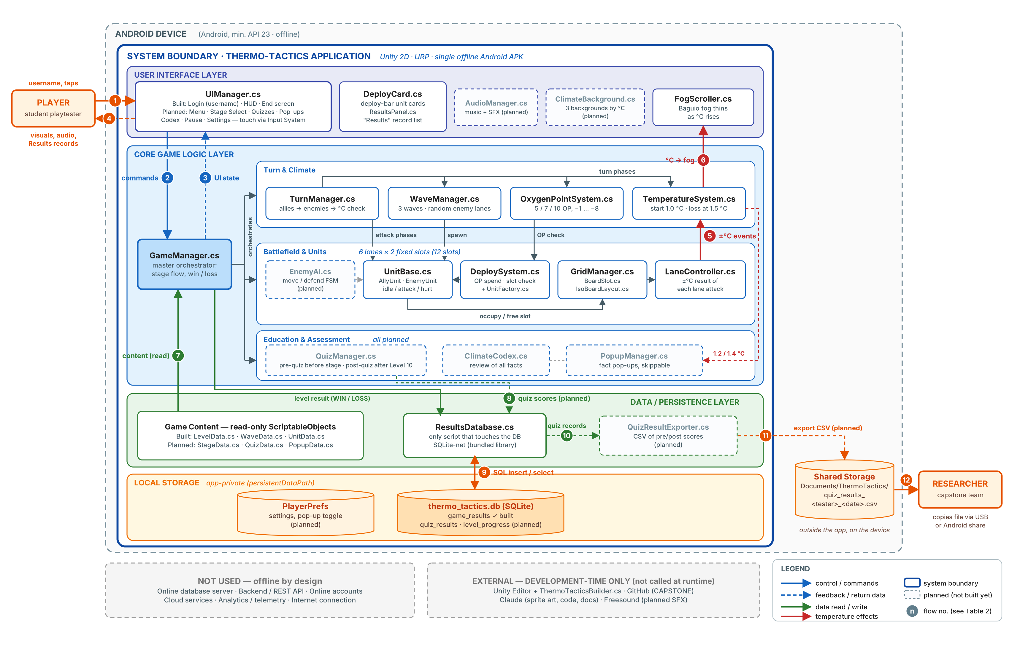
Figure 1. Thermo-Tactics system architecture. Everything inside the blue boundary runs on the player's phone. Solid boxes are built; dashed boxes are planned. Numbered arrows are explained in Table 2.

3. Major Communication Paths
Table 2 explains each numbered arrow in Figure 1. Paths 10–12 belong to planned components.
No. | Flow | Path | Data carried
1 | Player input | Player → UIManager.cs (uGUI through the Input System UI module) and → BoardSlot.cs (taps on the road through the EventSystem and a Physics 2D raycaster) | Username; unit-card taps; slot taps; End Turn; Results; Play Again / Menu
2 | Commands | UIManager.cs → GameManager.cs (start, restart, menu), → TurnManager.cs (End Turn); DeployCard.cs / BoardSlot.cs → DeploySystem.cs | Player name; selected unit; lane to deploy in
3 | UI state | Core logic → UIManager.cs through C# events (TemperatureSystem.Changed, OxygenPointSystem.Changed, DeploySystem.Deployed) and announcements | Temperature, OP (current / allowance), wave and turn, damage and °C floating text
4 | Feedback | UIManager.cs, unit animators, FogScroller.cs → Player | HUD, idle / attack / hurt animations, fog, Victory / Defeat screen, Results list
5 | Climate events | TurnManager.cs (an attack with no target) → LaneController.cs → TemperatureSystem.cs | +0.10 °C when an enemy attacks an undefended lane; −0.05 °C when an ally attacks an empty lane
6 | Temperature to visuals | TemperatureSystem.Changed → GameManager.cs → FogScroller.cs. Planned: → ClimateBackground.cs; → PopupManager.cs at 1.2 / 1.4 °C | Current °C; fog density (0.85 at 1.0 °C down to 0.15 at 1.5 °C)
7 | Content load | ScriptableObjects → GameManager.cs → subsystems; UnitData → UnitFactory.cs | Level climate rules, OP penalties, ally roster, waves; unit stats, sprites and animators
8 | Save request | GameManager.EndLevel() → ResultsDatabase.Insert(). Planned: QuizManager.cs → quiz records; GameManager.cs → level progress | Player name, WIN / LOSS, date created, final temperature, waves cleared
9 | Persist / retrieve | ResultsDatabase.cs ↔ thermo_tactics.db (SQL through SQLite-net); UIManager.OpenResults() → ResultsDatabase.GetAll() → ResultsPanel.cs | INSERT on level end; SELECT … ORDER BY id DESC for the Results panel
10 | Quiz records (planned) | ResultsDatabase.cs → QuizResultExporter.cs | All quiz_results rows; the exporter never opens the database itself
11 | Export (planned) | QuizResultExporter.cs → shared storage | quiz_results_<tester>_<date>.csv
12 | Collection (planned) | Shared storage → Researcher | CSV copied by USB or Android share
Table 2. Numbered communication paths in Figure 1.

Example end-to-end flows
- Deploy (built):
1. Player taps a card. DeployCard.cs → DeploySystem.Select().
2. Player taps a glowing ally slot. BoardSlot.cs → DeploySystem.TryDeploy(lane).
3. DeploySystem.cs checks the slot is free with GridManager.cs, then asks OxygenPointSystem.TrySpend().
4. UnitFactory.Spawn() builds the unit and GridManager.Place() records it.
5. UIManager.cs updates the OP counter.
- End turn (built):
1. Player taps End Turn. TurnManager.cs runs the ally phase: every ally attacks the enemy in its lane, or cools an empty lane through LaneController.cs.
2. If the wave is cleared, the enemy phase is skipped: after a short pause the next wave spawns at turn 1, or the level is won.
3. Otherwise the enemy phase runs: an undefended lane heats by 0.10 °C.
4. TemperatureSystem.HasReachedThreshold is checked; reaching 1.5 °C means a loss.
5. If not, the next turn starts with the OP penalty.
- Save and view results (built):
1. GameManager.EndLevel() → ResultsDatabase.Insert() → thermo_tactics.db.
2. UIManager.ShowEnd() shows Victory or Defeat with "Result saved · date".
3. The Results button → ResultsDatabase.GetAll() → ResultsPanel.cs lists Name / Result / Date.
- Quiz and export (planned):
1. Player submits a quiz in UIManager.cs (Post-Quiz). QuizManager.cs scores it and computes the gain.
2. ResultsDatabase.cs saves it to quiz_results.
3. On Export, QuizResultExporter.cs writes a CSV to shared storage for the researcher.

4. Architecture Explanation

4.1 Overall system structure
Thermo-Tactics is a single, fully offline Unity 6 (URP 2D) application installed as one Android APK. The system boundary is the app itself. Inside it, the code is split into four layers: User Interface, Core Game Logic, Data / Persistence, and Local Storage. Each system is one script in the ThermoTactics namespace, under Assets/ThermoTactics/Scripts/. GameManager.cs orchestrates the level, and each system owns one job. HUD values refresh through C# events; announcements and screen changes are direct calls to UIManager.cs. There is no server side: no online database, backend, account system or cloud service. The only database is a local SQLite file inside the app.

4.2 Where user interaction occurs
All player interaction happens in the User Interface layer:
- Screens: UIManager.cs owns the four screens built so far: Login (username), Gameplay HUD (temperature bar, OP, wave and turn, deploy bar, End Turn), the End screen (Victory or Defeat) and the Results panel.
- Road taps: taps on the road reach BoardSlot.cs through Unity's EventSystem, so they work with touch and mouse and are blocked when a panel covers the board.
- UI never changes rules: it sends commands and displays the state it receives.
- Planned screens: Main Menu, Stage Select, Pre-Quiz, Pop-Up Modal, Post-Quiz, Climate Codex, Pause, Settings and Credits.
- Researcher: their only interaction is outside the app, when copying the exported CSV file (planned).

4.3 Where major processing occurs
All processing happens on the phone, in the Core Game Logic layer:
- Turn and climate (built): TurnManager.cs runs each turn:
1. Ally phase.
2. Wave-cleared check.
3. Enemy phase.
4. Temperature check.
5. Next turn.
Around it, WaveManager.cs spawns 3 waves into random free enemy lanes, OxygenPointSystem.cs gives 5 / 7 / 10 OP per turn by wave, minus 1, 2, 4 or 8 on turns 2–5+, and TemperatureSystem.cs keeps the value from dropping below the starting 1.0 °C. The level is lost once it reaches 1.5 °C; it can go past 1.5 °C within one enemy phase, because the check runs after the phase.
- Battlefield (built): GridManager.cs, LaneController.cs, DeploySystem.cs, UnitFactory.cs and the unit scripts resolve placement, simultaneous lane attacks, damage, the hurt animation and death fade-out, and the climate result of each attack on the 12 slots.
- Planned: the EnemyAI.cs movement state machine, Burn / Cool / Shield effects, 10-wave boss levels, and education (QuizManager.cs, PopupManager.cs, ClimateCodex.cs).

4.4 Where persistent data is stored
Data is stored in four places, all on the device:
- Game content (read-only): ScriptableObject assets compiled into the APK.
• Built: LevelData, WaveData, UnitData (Baguio Level 1, 3 waves, 10 units).
• Planned: StageData, QuizData, PopupData.
- Player data (app-private): the SQLite file thermo_tactics.db in Application.persistentDataPath. Only ResultsDatabase.cs opens it.
• Built: the game_results table.
• Planned: quiz_results and level_progress.
- Settings (planned): PlayerPrefs for volume and the pop-up "don't show again" toggle.
- Exported results (planned): QuizResultExporter.cs writes Documents/ThermoTactics/quiz_results_<tester>_<date>.csv, with one row per stage.

4.5 How major components communicate
- References: components hold references to each other set in the scene. ThermoTacticsBuilder.cs wires them when it builds the level. GameManager and DeploySystem expose a single Instance for the UI.
- Downward: commands flow from the UI to GameManager.cs, TurnManager.cs or DeploySystem.cs, which call the responsible subsystem.
- Upward: subsystems raise events (Changed, Deployed, SelectionChanged) that UIManager.cs and GameManager.cs listen to for HUD values. For one-off feedback (announcements, floating numbers, the temperature flash, screen changes) the game scripts call UIManager.cs methods directly. Game logic never reads UI state; rules are decided only in the core scripts.
- Storage: all database access goes through ResultsDatabase.cs, a single point of persistence. Values are bound as SQL parameters (?), never pasted into the SQL text. Data leaves the app only through the planned export.

4.6 External services used
None at runtime. The game makes no network calls, needs no internet connection, and sends no telemetry. This matches the offline, privacy-first requirement, and students can play anywhere.
SQLite-net for Unity (com.gilzoide.sqlite-net 1.3.2, MIT licence) is a third-party library, but it is bundled inside the APK and runs locally, so it sits inside the system boundary.
The following are used only while building the game and have no connection to the running app:
- the Unity Editor, including the ThermoTacticsBuilder.cs editor tool
- GitHub
- Claude (sprite art, code and documentation assistance)
- Freesound (sound effects, planned)

5. Component Reference
Layer | Script | Responsibility | Status
User Interface | UIManager.cs | Screens and HUD; sends commands, displays state (Login, HUD, End, Results built; other screens planned) | Built (partly)
User Interface | DeployCard.cs, ResultsPanel.cs | Unit cards in the deploy bar; list of saved results | Built
User Interface | FogScroller.cs | Drifting Baguio fog whose density follows temperature | Built
User Interface | ClimateBackground.cs, AudioManager.cs | Cool / warming / critical backgrounds; music and SFX | Planned
Core Logic | GameManager.cs | Level flow: login → play → win / loss → save result | Built
Core Logic | TurnManager.cs | Ally phase → wave check → enemy phase → temperature check → next turn | Built
Core Logic | WaveManager.cs | Runs the level's waves (Level 1 has 3); spawns enemies; counts turns in a wave (10-wave boss levels planned) | Built
Core Logic | OxygenPointSystem.cs | Per-turn OP allowance (5 / 7 / 10) minus the long-wave penalty | Built
Core Logic | TemperatureSystem.cs | Global temperature from 1.0 °C; loss when it reaches 1.5 °C | Built
Core Logic | GridManager.cs, BoardSlot.cs, IsoBoardLayout.cs | 12-slot occupancy; tappable slots; lane / slot ↔ screen position | Built
Core Logic | LaneController.cs | Climate result of an attack on an undefended or empty lane | Built
Core Logic | DeploySystem.cs, UnitFactory.cs | Slot and OP checks; builds unit objects at runtime | Built
Core Logic | UnitBase.cs, AllyUnit.cs, EnemyUnit.cs | HP, damage, attack / hurt / death animation, lane | Built
Core Logic | EnemyAI.cs | Enemy movement between free enemy slots (state machine) | Planned
Core Logic | QuizManager.cs, PopupManager.cs, ClimateCodex.cs | Pre / post quizzes and gain; fact pop-ups; fact review | Planned
Data / Persistence | LevelData.cs, WaveData.cs, UnitData.cs | Read-only game content (ScriptableObjects) | Built
Data / Persistence | StageData.cs, QuizData.cs, PopupData.cs | Read-only stage, quiz and fact content | Planned
Data / Persistence | ResultsDatabase.cs | Only script that opens thermo_tactics.db; insert, read and delete records | Built
Data / Persistence | QuizResultExporter.cs | Writes the quiz-results CSV to shared storage | Planned
Local Storage | thermo_tactics.db (SQLite) | game_results (built); quiz_results, level_progress (planned) | Built (partly)
Local Storage | PlayerPrefs | Volume and pop-up toggle | Planned
Editor tool (not in APK) | ThermoTacticsBuilder.cs | Imports art, builds animations, data and the Baguio scene, and wires references | Built
Table 3. Components shown in Figure 1.

