THERMO-TACTICS
Parts III–VI. Data Design, Integration, Repository and Development Plan
Unity 2D turn-based strategy game · Android · fully offline · Capstone Project · revised 9 October 2026
These parts continue from Part I (Final System Architecture) and Part II (Component Responsibility Specification) and use the same script names. They describe the game as built in github.com/jonfranss221/CAPSTONE. Anything not yet written is labelled Planned.

PART III. DATA DESIGN (LOCAL STORAGE)
Thermo-Tactics is fully offline. It has no server or online database. Player records are kept in a local SQLite database: a single file, thermo_tactics.db, inside the app's private folder on the phone. The database is reached through the SQLite-net for Unity library, which bundles SQLite for Android and Windows. Each kind of storage has a single owner script, so no two components ever write the same data.

III.1 Storage overview
Storage | Mechanism / file | Data structure | Written by | Purpose | Status
Player records | thermo_tactics.db (SQLite 3) in Application.persistentDataPath (app-private folder) | Relational tables with typed columns, keys and CHECK constraints | ResultsDatabase.cs only | Keeps every level result: name, WIN / LOSS, date created, final temperature, waves cleared. Planned: quiz results and level progress | Built (game_results); other tables planned
Game content | ScriptableObject .asset files built into the APK | Typed Unity objects that reference each other | Designers in the Unity Editor (read-only in the game) | Climate rules, OP rules, waves and unit stats. Planned: stages, quiz questions, climate facts | Built (14 assets); more planned
Settings | Unity PlayerPrefs (Android SharedPreferences) | Key-value pairs | Settings screen | Volume and the pop-up "don't show again" setting | Planned
Exported results | quiz_results_<tester>_<date>.csv in Documents/ThermoTactics/ (shared storage) | CSV table, one row per player and stage | QuizResultExporter.cs only | Lets the researcher copy pre/post scores off each phone for the ≥ 30% knowledge-gain study | Planned
Table III-1. Where Thermo-Tactics stores data.

III.2 Data structure diagram
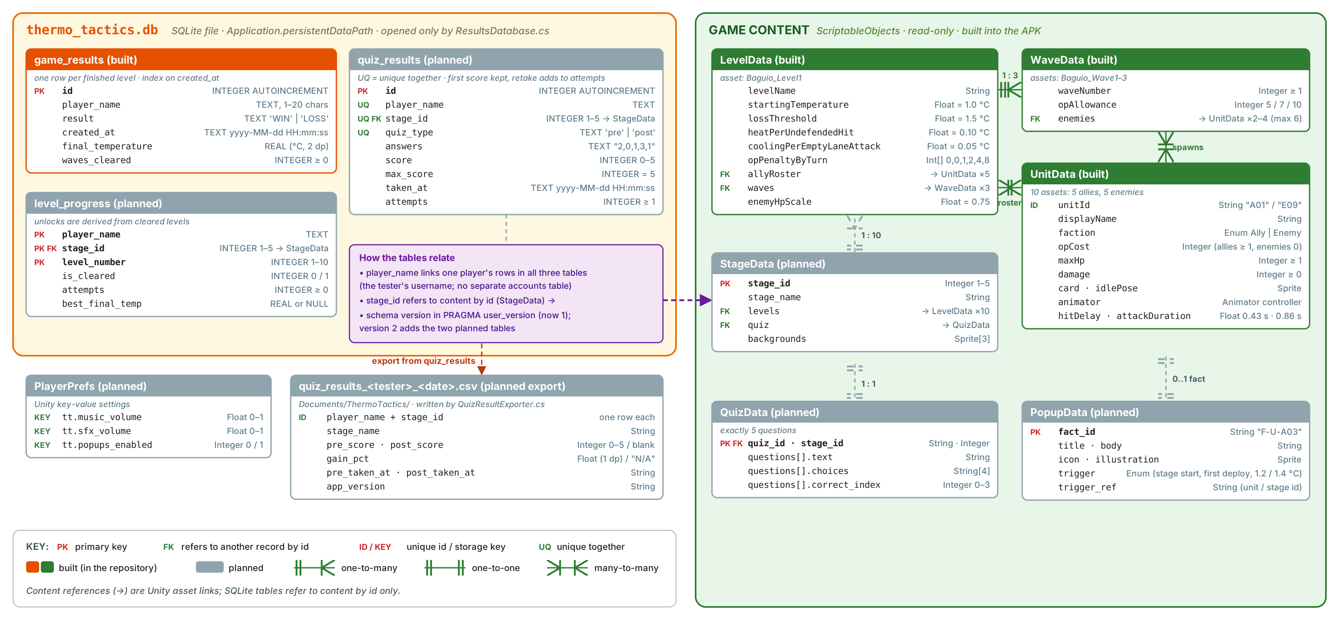
Figure 2. Data structure. Left: the SQLite database (orange = built table, grey = planned) and the planned settings and export. Right: read-only game content (green = built, grey = planned).

III.3 Schema and example records
The built table, exactly as ResultsDatabase.cs creates it on first launch (schema version 1, stored in PRAGMA user_version):
CREATE TABLE IF NOT EXISTS game_results (
id INTEGER PRIMARY KEY AUTOINCREMENT,
player_name TEXT NOT NULL CHECK (length(player_name) BETWEEN 1 AND 20),
result TEXT NOT NULL CHECK (result IN ('WIN','LOSS')),
created_at TEXT NOT NULL, -- yyyy-MM-dd HH:mm:ss, device local time
final_temperature REAL NOT NULL, -- °C when the level ended
waves_cleared INTEGER NOT NULL DEFAULT 0 CHECK (waves_cleared >= 0)
);
CREATE INDEX IF NOT EXISTS idx_game_results_created_at ON game_results(created_at);
The two records currently stored from playtesting (SELECT * FROM game_results ORDER BY id DESC):
id | player_name | result | created_at | final_temperature | waves_cleared
2 | Juan Dela Cruz | LOSS | 2026-10-07 22:48:53 | 1.60 | 0
1 | Playtest Bot | WIN | 2026-10-07 22:48:03 | 1.00 | 3
Record 2 ended at 1.60 °C, above the 1.5 °C line: two undefended lanes were hit in the same enemy phase (+0.10 °C each), and the loss check runs after the whole phase. This is expected behaviour.
Planned tables (schema version 2, added by the same script):
CREATE TABLE quiz_results (
id INTEGER PRIMARY KEY AUTOINCREMENT, player_name TEXT NOT NULL, stage_id INTEGER NOT NULL CHECK (stage_id BETWEEN 1 AND 5),
quiz_type TEXT NOT NULL CHECK (quiz_type IN ('pre','post')), answers TEXT NOT NULL, score INTEGER NOT NULL CHECK (score BETWEEN 0 AND 5),
max_score INTEGER NOT NULL DEFAULT 5, taken_at TEXT NOT NULL, attempts INTEGER NOT NULL DEFAULT 1,
UNIQUE (player_name, stage_id, quiz_type));
CREATE TABLE level_progress (
player_name TEXT NOT NULL, stage_id INTEGER NOT NULL, level_number INTEGER NOT NULL CHECK (level_number BETWEEN 1 AND 10),
is_cleared INTEGER NOT NULL DEFAULT 0, attempts INTEGER NOT NULL DEFAULT 0, best_final_temp REAL,
PRIMARY KEY (player_name, stage_id, level_number));
Planned export row (gain = (4 − 3) / 3 × 100 = 33.3%):
tester,stage_id,stage_name,pre_score,post_score,gain_pct,pre_taken_at,post_taken_at,app_version
TT-007,1,Baguio,3,4,33.3,2026-11-20 09:15:30,2026-11-20 10:02:40,1.0.0

III.4 Data dictionary
PK marks the field that uniquely identifies a record; FK marks a field that refers to another record. Content assets refer to each other through Unity asset links; database rows refer to content by id only. Built fields are exactly as named in the code.
Entity | Field | Data Type | Key / Identifier | Purpose | Status
thermo_tactics.db · game_results (one row per finished level)
game_results | id | INTEGER, auto-increment | PK | Unique record number; newest first in the Results panel | Built
game_results | player_name | TEXT, 1–20 characters | Links a player's rows | Username entered at login (the tester code during the study) | Built
game_results | result | TEXT 'WIN' or 'LOSS' |  | Outcome of the level | Built
game_results | created_at | TEXT yyyy-MM-dd HH:mm:ss | Indexed | Date and time the result was saved (device local time) | Built
game_results | final_temperature | REAL, °C, 2 decimals |  | Temperature when the level ended | Built
game_results | waves_cleared | INTEGER ≥ 0 |  | Waves fully cleared (3 on a win in Level 1) | Built
thermo_tactics.db · quiz_results (planned)
quiz_results | id | INTEGER, auto-increment | PK | Unique record number | Planned
quiz_results | player_name, stage_id, quiz_type | TEXT, INTEGER 1–5, TEXT 'pre' / 'post' | UNIQUE together; stage_id → StageData | One record per player, stage and quiz type | Planned
quiz_results | answers | TEXT, 5 indexes, e.g. "2,0,1,3,1" |  | Option chosen for each question (item analysis) | Planned
quiz_results | score, max_score | INTEGER 0–5, INTEGER = 5 |  | First-attempt score, shown as X / 5 | Planned
quiz_results | taken_at, attempts | TEXT date-time, INTEGER ≥ 1 |  | Time of the first attempt; retakes only add to attempts | Planned
thermo_tactics.db · level_progress (planned)
level_progress | player_name, stage_id, level_number | TEXT, INTEGER 1–5, INTEGER 1–10 | PK (all three); stage_id → StageData | Which level of which stage this row describes | Planned
level_progress | is_cleared, attempts, best_final_temp | INTEGER 0/1, INTEGER ≥ 0, REAL or NULL |  | Win flag, tries, lowest winning temperature; stage unlocks are derived from it | Planned
Game content · ScriptableObjects (read-only)
LevelData | levelName | String | Asset Baguio_Level1 | "Stage 1 · Baguio — Kennon Road" | Built
LevelData | startingTemperature, lossThreshold | Float (°C) |  | 1.0 °C start; the player loses on reaching 1.5 °C | Built
LevelData | heatPerUndefendedHit, coolingPerEmptyLaneAttack | Float (°C) |  | +0.10 °C and −0.05 °C climate effects | Built
LevelData | opPenaltyByTurn | Integer[] |  | OP removed by turn in a wave: 0, 0, 1, 2, 4, 8 (turn 5+ uses 8) | Built
LevelData | allyRoster, waves | UnitData[5], WaveData[3] | → UnitData, → WaveData | Units the player may deploy; the level's waves | Built
LevelData | enemyHpScale | Float 0.25–2 (now 0.75) |  | Multiplies enemy HP for this level (balance tuning) | Built
WaveData | waveNumber, opAllowance | Integer ≥ 1, Integer ≥ 1 | Assets Baguio_Wave1–3 | Order of the wave; OP given each turn (5, 7, 10) | Built
WaveData | enemies | UnitData[] (max 6) | → UnitData | Enemies that spawn when the wave starts (2, 3 and 4 in Level 1) | Built
UnitData | unitId | String "A01" / "E09" | Identifier (A = ally, E = enemy) | Matches the unit number in the overview's 30-unit roster | Built
UnitData | displayName, faction | String, Enum Ally / Enemy |  | Name and side | Built
UnitData | opCost, maxHp, damage | Integer, Integer ≥ 1, Integer ≥ 0 |  | Deploy cost (enemies 0) and combat stats (Table III-3) | Built
UnitData | card, idlePose, animator | Sprite, Sprite, Animator controller |  | Deploy-bar card; Idle / Attack / Hurt animations | Built
UnitData | hitDelay, attackDuration | Float (s) |  | 0.43 s until the hit lands; 0.86 s full attack | Built
StageData | stage_id, stage_name, levels, quiz, backgrounds | Integer 1–5, String, LevelData[10], QuizData, Sprite[3] | PK stage_id | One of the 5 stages | Planned
QuizData | quiz_id, stage_id, questions[] (text, choices[4], correct_index) | String, Integer, … | PK quiz_id | Exactly 5 multiple-choice questions per stage | Planned
PopupData | fact_id, title, body, icon, trigger, trigger_ref | String, …, Enum | PK fact_id | Climate facts for pop-ups and the Codex | Planned
PlayerPrefs and export (planned)
PlayerPrefs | tt.music_volume, tt.sfx_volume, tt.popups_enabled | Float 0–1, Float 0–1, Integer 0/1 | Storage keys | Settings | Planned
CSV export | tester, stage_id, pre_score, post_score, gain_pct, dates, app_version | String, Integer, … | One row per player + stage | Study data copied off the phone | Planned
Table III-2. Data dictionary.

III.5 Current unit data (Stage 1, Level 1)
Unit id | Name | Side | OP cost | Max HP | Damage | Appears in
A01 | Mangrove Guardian | Ally | 3 | 20 | 4 | Ally roster
A02 | Coral Defender | Ally | 3 | 18 | 4 | Ally roster
A06 | Wind Caller | Ally | 2 | 10 | 4 | Ally roster
A08 | Geothermal Sentinel | Ally | 4 | 22 | 6 | Ally roster
A14 | Reef Sentinel | Ally | 3 | 14 | 5 | Ally roster
E09 | Illegal Logger | Enemy | 0 | 12 (9 in play) | 5 | Waves 1 and 2
E12 | Methane Cloud | Enemy | 0 | 12 (9 in play) | 3 | Waves 1 and 3
E07 | Oil Slick | Enemy | 0 | 14 (10 in play) | 3 | Waves 2 and 3
E05 | Plastic Golem | Enemy | 0 | 24 (18 in play) | 4 | Waves 2 and 3
E10 | Quarry Colossus | Enemy | 0 | 22 (16 in play) | 7 | Wave 3
Table III-3. Unit stats from the UnitData assets. Enemy HP in play = max HP × 0.75, rounded by Mathf.RoundToInt (a .5 goes to the nearest even number).
Waves: Wave 1 (5 OP per turn) Illegal Logger and Methane Cloud · Wave 2 (7 OP) Oil Slick, Illegal Logger and Plastic Golem · Wave 3 (10 OP) Quarry Colossus, Plastic Golem, Methane Cloud and Oil Slick. The values were tuned with a balance simulation so that a level takes about 10–19 turns and can still be lost.

III.6 Data integrity and validation rules
# | Rule | Enforced by | When | Status
1 | A username is required. It is trimmed and must be 2–20 characters; longer input is cut to 20, an empty name is stored as "Player", and the database also rejects names outside 1–20 characters. | UIManager.cs (login check), ResultsDatabase.Sanitize(), CHECK on player_name | Start button; every insert | Built
2 | result can only be 'WIN' or 'LOSS'; waves_cleared can never be negative. | ResultsDatabase.cs; CHECK constraints | Every insert | Built
3 | created_at and the id are set by the system (current date-time and auto-increment), never typed by the player. | ResultsDatabase.Insert(); SQLite | Every insert | Built
4 | Exactly one result per played level: EndLevel runs only while the level is in the Playing state, so a level cannot be saved twice. | GameManager.cs | Level end | Built
5 | Values are passed as SQL parameters (?), never joined into the SQL text, so a name such as x'); DROP TABLE is stored as plain text. | ResultsDatabase.cs | Every query | Built
6 | Temperature is rounded to 2 decimals and never drops below the starting 1.0 °C. Reaching 1.5 °C ends the level. | TemperatureSystem.cs, TurnManager.cs | Gameplay | Built
7 | OP per turn is the wave allowance minus the penalty, never below 1; a deploy is refused unless the balance covers the unit's cost and the slot is free. | OxygenPointSystem.cs, DeploySystem.cs | Every turn and deploy | Built
8 | If the database cannot be opened or written, the error is logged and the game continues; the result is shown but not stored. Known issue: the End screen still says "Result saved" in that case (fix in VI-1). Tables are created with IF NOT EXISTS, so a missing file is simply recreated. | ResultsDatabase.cs | Open; insert | Built
9 | Results saved by the older JSON version (results_db.json) are imported once inside a transaction; the old file is then renamed .migrated so it is never imported twice. If the import fails, the file is left in place and tried again on the next launch. | ResultsDatabase.cs | First open | Built
10 | Content checks in the editor: the loss line is at least 0.05 °C above the start; allies cost ≥ 1 OP and enemies 0; attack duration ≥ hit delay; a warning if a wave has more than 6 enemies; HP ≥ 1, damage ≥ 0, OP allowance ≥ 1. | OnValidate() and [Min] in LevelData, UnitData, WaveData | In the Unity Editor | Built
11 | Only one quiz record per player, stage and quiz type; a retake adds to attempts but never replaces the first score. | UNIQUE constraint; ResultsDatabase.cs | Quiz save | Planned
12 | A quiz is submitted only with all 5 answers (each 0–3); the score is 0–5. | UIManager.cs, QuizManager.cs; CHECK on score | Submit | Planned
13 | Knowledge gain is never stored; it is computed from the two scores and shown as "N/A" when pre = 0 or missing. | QuizManager.cs, QuizResultExporter.cs | Results; export | Planned
14 | Stage N + 1 unlocks only when all 10 levels of Stage N are cleared; is_cleared never goes back to 0. | ResultsDatabase.cs (level_progress) | Level win | Planned
15 | Database upgrades are versioned. Today version 1 is written to PRAGMA user_version on every open; the upgrade code will read it first and add the planned tables when moving from 1 to 2, without touching existing results. | ResultsDatabase.cs | First open after an update | Planned
Table III-4. Data integrity and validation rules.

PART IV. END-TO-END INTEGRATION DESIGN
The two processes below connect the most components and carry the data the project depends on. Process 1 is built and can be demonstrated in the current game. Process 2 is planned and reuses the same database script. Both are local: the equivalent of a backend call is a SQL statement run by ResultsDatabase.cs on the phone. Neither process ever needs an internet connection.

IV.1 Process 1 — Save a level result and show it in the Results panel (built)
Workflow
Player taps End Turn → UIManager.cs → TurnManager.cs (phases, win / loss check) → GameManager.EndLevel() → ResultsDatabase.Insert() → thermo_tactics.db (INSERT) → Saved record → UIManager.ShowEnd()
Player taps Results → UIManager.cs → ResultsDatabase.GetAll() → thermo_tactics.db (SELECT) → List of records → ResultsPanel.cs
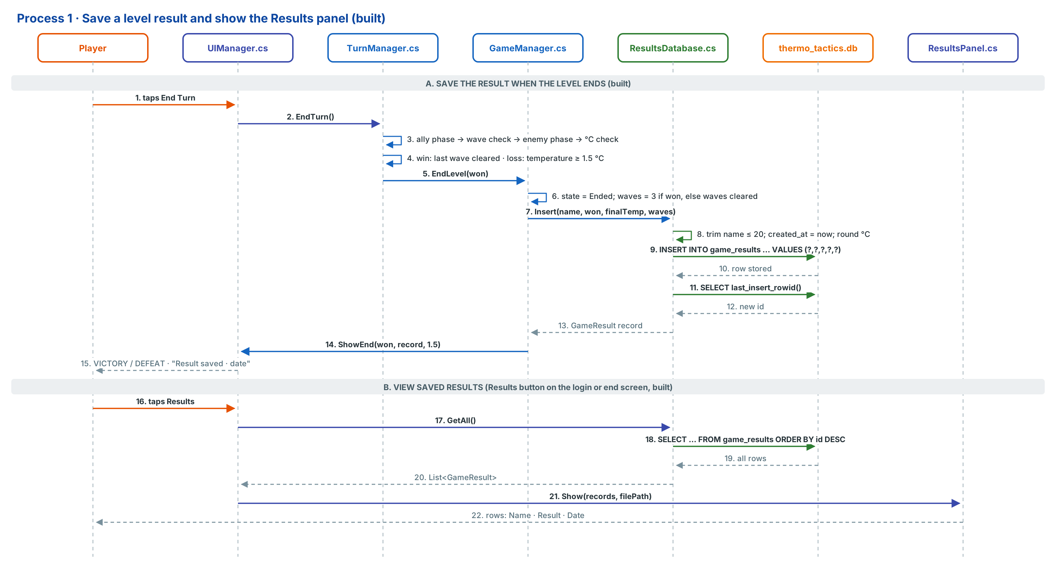
Figure 3. Sequence for Process 1 (save the result at the end of a level, then view all results).
Item | Description
Trigger | The level ends during a turn: win when the last enemy of Wave 3 is defeated in the ally phase; loss when the temperature has reached 1.5 °C after the enemy phase. For viewing: the player taps Results on the login or end screen.
Source Component | TurnManager.cs (detects the end) → GameManager.cs; UIManager.cs for the Results button
Data Generated / Sent | player_name (from login), won (true / false), final_temperature (TemperatureSystem.Current), waves_cleared (3 on a win, otherwise the waves fully cleared)
Processing Component | ResultsDatabase.cs trims the name to 20 characters, adds created_at (now) and runs a parameterised INSERT; then reads the new id. For viewing, it runs a SELECT ordered newest first
Destination | Table game_results in thermo_tactics.db (Application.persistentDataPath; on Windows AppData/LocalLow/DefaultCompany/TESTING CAPSTONE/)
Stored / Retrieved Data | Stores one row: id, player_name, result, created_at, final_temperature, waves_cleared. Retrieves all rows for the panel
Expected Response | A GameResult with its new id; for viewing, a list of GameResult (newest first)
User Output | End screen: "VICTORY — Baguio is safe, Jon! All 3 waves cleared and the temperature stayed at 1.20 °C, below the 1.5 °C limit. Result saved · 2026-10-09 20:45:10" or "DEFEAT — The temperature reached 1.60 °C …". Results panel: one row per game with Name, Result (green WIN / red LOSS) and Date, plus the record count and file location
Table IV-1. Process 1 integration details.
If the operation fails
Failure | How it is detected | System response (current code) | What the player sees
Empty or too-short username | UIManager.cs login check | The level does not start | "Please enter a username." / "Use at least 2 characters."
Database file missing (first launch, or deleted) | CREATE TABLE IF NOT EXISTS on open | Creates a new empty database and table | Nothing; the Results panel shows no records
Database cannot be opened (storage error, locked file) | Exception caught in ResultsDatabase.Open() | Logs the error; the game stays playable; later calls try to open again | The game plays normally. The End screen still says "Result saved" although nothing was stored (known issue; fix in VI-1)
Insert fails (constraint or write error) | Exception caught in ResultsDatabase.Insert() | Logs the error and returns the record with id 0 | End screen shows the result and "Result saved" (known issue); the game does not appear in Results
Same level ended twice (e.g. a double signal) | GameManager state is no longer Playing | Second call is ignored | Nothing; only one row is saved
No records yet | GetAll() returns an empty list | Shows the empty message | "No results yet. Finish a level to record one."
Old JSON results present | results_db.json exists on open | Imports them once in a transaction and renames the file | Old results appear in the Results panel
No internet connection | Not applicable | The process never uses the network | Nothing; works the same offline
Table IV-2. Process 1 failure handling.

IV.2 Process 2 — Record a quiz result and export it for the study (planned)
Workflow
Player submits quiz → UIManager.cs → QuizManager.cs (validate, score, gain) → ResultsDatabase.cs (one record per player, stage, type) → thermo_tactics.db → quiz_results → Save result → UIManager.cs quiz results
Player taps Export → UIManager.cs → QuizResultExporter.cs → ResultsDatabase.cs (SELECT quiz records) → Build CSV → Shared storage → Return path → UIManager.cs confirmation
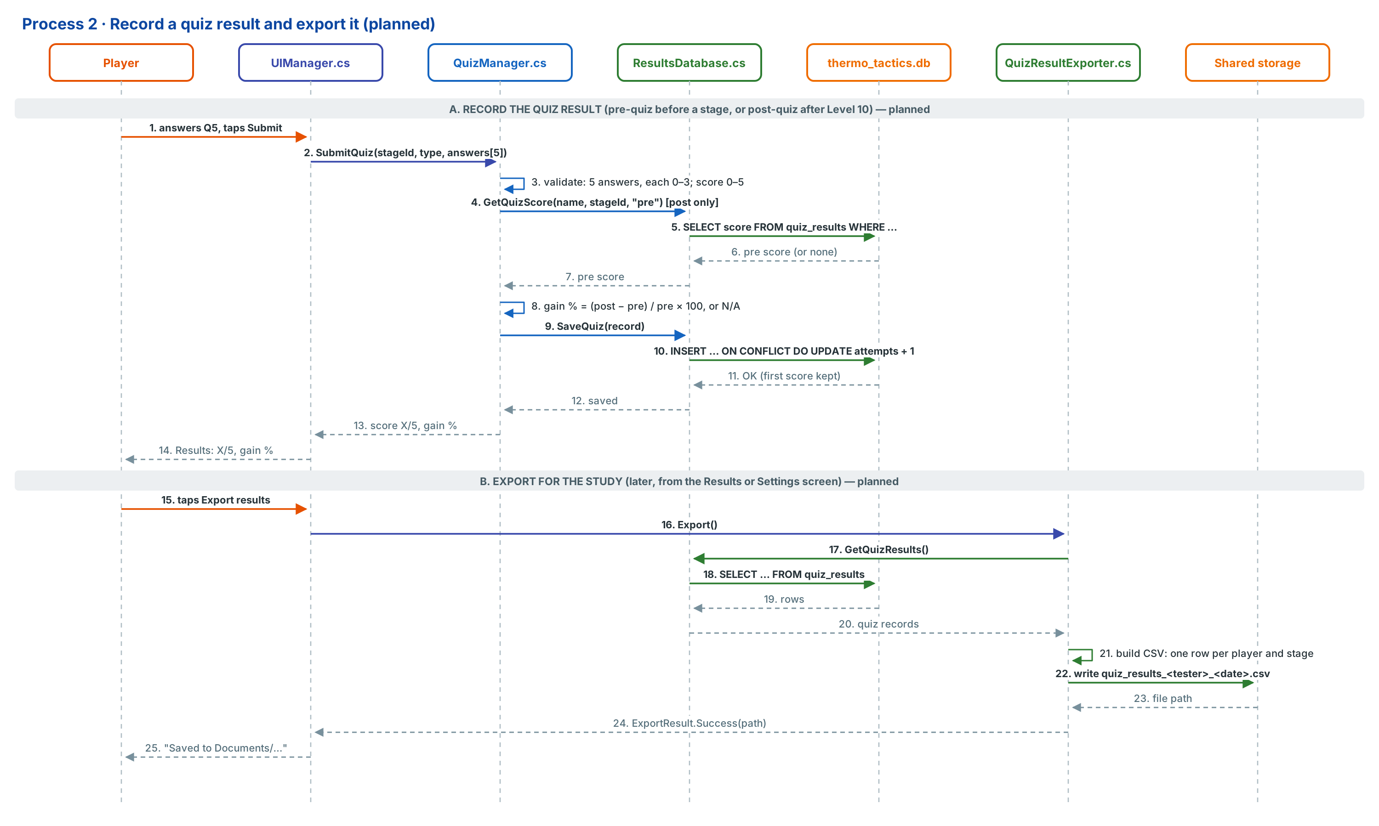
Figure 4. Sequence for Process 2 (record a quiz result, then export).
Item | Description
Trigger | The player submits the 5th answer of a pre-quiz (before a stage starts) or a post-quiz (after the stage's Level 10). For export: the researcher taps Export results.
Source Component | UIManager.cs (Quiz screen; Results or Settings screen for export)
Data Generated / Sent | player_name, stage_id, quiz_type, answers[5]; QuizManager.cs adds score, max_score = 5 and taken_at
Processing Component | QuizManager.cs validates, scores and computes gain; ResultsDatabase.cs stores the row (UNIQUE player + stage + type); QuizResultExporter.cs builds the CSV
Destination | quiz_results table in thermo_tactics.db. On export: Documents/ThermoTactics/quiz_results_<tester>_<date>.csv
Stored / Retrieved Data | Stores the quiz row. For a post-quiz, retrieves the same player's pre-quiz score for the stage. On export, retrieves all quiz rows
Expected Response | Saved record with score and gain; ExportResult.Success(path) on export
User Output | "Pre-quiz: 3 / 5" or "Post-quiz: 4 / 5 · Knowledge gain +33.3% (goal ≥ 30%)"; after export: "Saved to Documents/ThermoTactics/quiz_results_TT-007_2026-11-20.csv"
Table IV-3. Process 2 integration details.
If the operation fails
Failure | How it is detected | System response | What the player sees
Invalid input: a question unanswered or an index outside 0–3 | Submit stays disabled; QuizManager.cs rejects bad indexes | Nothing is saved; the quiz stays open | "Answer all 5 questions."
Duplicate: this quiz was already taken | UNIQUE (player_name, stage_id, quiz_type) conflict | Keeps the first score; adds 1 to attempts | "Practice round: your first score is kept."
Data missing: no pre-quiz at post-quiz time | SELECT returns no row | Saves the post-quiz; gain = N/A; pre column blank in the CSV | "Knowledge gain: N/A (no pre-quiz)"
Pre-quiz score is 0 | QuizManager.cs checks the divisor | Gain = N/A instead of dividing by zero | "Knowledge gain: N/A"
Database write fails | Exception in ResultsDatabase.cs | Keeps the result in memory and retries once; existing rows are untouched | "Couldn't save your result. Tap Retry."
Export: no records yet | SELECT returns 0 rows | No file is created | "No quiz results to export yet."
Export: shared folder not writable | Write exception | Writes to the app's own external folder (Android/data/<package>/files/Exports/) and reports that path | "Saved to Android/data/…/Exports"
No internet connection | Not applicable | The process never uses the network | Nothing; works the same offline
Table IV-4. Process 2 failure handling.

PART V. REPOSITORY AND IMPLEMENTATION STRUCTURE
Current state (9 October 2026): the Unity project is under Git and has been pushed to GitHub. The main branch holds 11 commits and 929 tracked files. It contains the playable Baguio Level 1 prototype: 22 C# scripts, 10 animated units, 3 waves, the Baguio scene and a SQLite results database. Unity's generated folders are excluded; 0 files from Library/ are tracked. Everything below was checked against the repository on GitHub. Folders marked (planned) do not exist yet.

V.1 Repository details
Item | Status | Detail
Repository name | Done | CAPSTONE
Repository link | Done | https://github.com/jonfranss221/CAPSTONE
Repository visibility | Public | Anyone with the link can view and clone it without signing in, so the adviser and panel need no invitation. Only invited collaborators can push.
Development platform / game engine | Done | Unity 6 (6000.0.84f1), Universal Render Pipeline 2D, C#; Unity Input System; uGUI.  Target: Android, IL2CPP, ARM64; the minimum API is currently 23 (Android 6.0). Active input handling: both the Input System and the old Input Manager.  The local project folder is "TESTING CAPSTONE". The product name in Player Settings is still "TESTING CAPSTONE" and should be renamed "Thermo-Tactics" before the first APK build.
Third-party package | Done | SQLite-net for Unity (com.gilzoide.sqlite-net 1.3.2, MIT licence). Unity installs it from GitHub through Packages/manifest.json, so every team member needs Git installed. It includes native SQLite for Android and Windows.
Commit history | 11 commits on main | 1 .gitignore + .gitattributes · 2 README · 3 project settings and packages · 4 gameplay scripts · 5 editor builder · 6 unit sprites and Baguio art · 7 animations · 8 unit, wave and level data · 9 Baguio Level 1 scene · 10 remaining assets and meta files · 11 move the results database to SQLite
README status | Present (README.md) | Covers the game summary and status; requirements (Unity version, packages); how to clone and open the project; how to play and the rule values; implemented features; the project structure; the SQLite schema and queries; and the version-control status. Corrected on 9 October 2026: target API 23, main as the only current branch, and the Version Control mode still to change. Commit this README change. Still to do: fill in the team member and role table.
.gitignore status | Present and working | Based on GitHub's Unity template. It excludes Library/, Temp/, Obj/, Build/, Builds/, Logs/, UserSettings/, IDE files (.vs/, .vscode/, *.csproj, *.sln, *.slnx), builds (*.apk, *.aab) and Unity Version Control files (.plastic/, ignore.conf), and keeps every Assets/**/*.meta file.  Verified: 0 tracked files under Library/.  Cleanup needed: .plastic/, ignore.conf and TESTING CAPSTONE.slnx were committed before their ignore lines were added, so they must be removed from tracking once (see V.4).
Git LFS | Configured, not yet in use | .gitattributes routes *.wav *.mp3 *.ogg *.psd *.aseprite *.mp4 to Git LFS. None of these files exist yet. All current art is small pixel-art PNG frames, stored as normal Git binaries (*.png binary). Before the first audio file is added, each member runs git lfs install.
.gitattributes | Present | * text=auto; Unity YAML files (.unity .prefab .asset .anim .controller .meta) use LF line endings so scenes and assets merge cleanly across Windows PCs.
Unity version-control settings | Partly set | Asset Serialization: Force Text (set). Version Control mode is still Unity Version Control (Plastic); change it to Visible Meta Files (Edit ▸ Project Settings ▸ Version Control) because the team uses Git and GitHub.
Current branch / branching approach | main only (current) | Current: everything is on main, which builds and plays.  Approach from the next milestone: main = stable, demo-ready; develop = integration; feature/<system> per task (e.g. feature/quiz-system, feature/stage2-boracay). Merge feature → develop through pull requests, and develop → main at each milestone.
Table V-1. Repository details (verified against github.com/jonfranss221/CAPSTONE).

V.2 Project structure (actual)
All game-specific work sits in Assets/ThermoTactics/. This keeps it apart from the files Unity's URP 2D template created (Assets/Scenes/SampleScene.unity, Assets/Settings/). Inside it the layout follows the example structure: Scenes, Scripts split by system, Art, plus Animations and GameData for Unity's animation and data assets.
CAPSTONE/ repository root = Unity project root
├── Assets/
│ ├── ThermoTactics/ ◄ all Thermo-Tactics game content
│ │ ├── Scenes/
│ │ │ └── Baguio_Level1.unity playable level (first scene in Build Settings)
│ │ ├── Scripts/ 22 C# scripts, namespace ThermoTactics
│ │ │ ├── Core/ GameManager, TurnManager, WaveManager, OxygenPointSystem, TemperatureSystem
│ │ │ ├── Board/ GridManager, BoardSlot, IsoBoardLayout, LaneController, DeploySystem, UnitFactory
│ │ │ ├── Units/ UnitBase, AllyUnit, EnemyUnit
│ │ │ ├── Data/ UnitData, WaveData, LevelData (ScriptableObject definitions)
│ │ │ ├── Persistence/ ResultsDatabase (SQLite: INSERT / SELECT / DELETE)
│ │ │ ├── UI/ UIManager, DeployCard, ResultsPanel
│ │ │ ├── Presentation/ FogScroller
│ │ │ └── Education/ (planned) QuizManager, PopupManager, QuizResultExporter
│ │ ├── Editor/
│ │ │ └── ThermoTacticsBuilder.cs menu: Thermo-Tactics ▸ Build Baguio Level
│ │ ├── GameData/ the content itself (ScriptableObject assets)
│ │ │ ├── Units/ A01_MangroveGuardian … E12_MethaneCloud (10 units)
│ │ │ ├── Waves/ Baguio_Wave1–3: OP allowance (5 / 7 / 10) and enemies
│ │ │ └── Baguio_Level1.asset climate rules, OP turn penalties, roster, waves
│ │ ├── Animations/<Unit>/ Idle, Attack, Hurt clips + Animator controller per unit
│ │ ├── Art/
│ │ │ ├── Units/<Unit>/ idle_00–11, attack_00–11, hurt_00–07, card.png
│ │ │ └── Environment/ Baguio background, fog, slot markers and highlights, shadow
│ │ ├── Prefabs/ (planned) units are currently assembled at runtime by UnitFactory
│ │ ├── Audio/ (planned) Music/, SFX/ → tracked with Git LFS
│ │ └── README.txt
│ ├── Scenes/SampleScene.unity Unity template scene, still enabled in Build Settings (to remove)
│ ├── Settings/ URP 2D renderer and pipeline assets
│ └── InputSystem_Actions.inputactions Input System actions
├── Packages/
│ ├── manifest.json Unity packages + com.gilzoide.sqlite-net (SQLite)
│ └── packages-lock.json
├── ProjectSettings/ Unity project settings (Force Text serialization)
├── README.md
├── .gitignore
└── .gitattributes line endings + Git LFS rules

Not in the repository (ignored or created at runtime):
Library/ Temp/ Logs/ UserSettings/ *.csproj
thermo_tactics.db → created on the device in Application.persistentDataPath
Tracked by mistake, to be removed (V.4): .plastic/ ignore.conf TESTING CAPSTONE.slnx
A (planned) folder does not exist yet; it shows where the next systems will go so the structure stays the same as the project grows. Every asset and folder has a .meta file committed next to it; these hold Unity's asset IDs, and without them scene references break on other computers.

V.3 Where each architecture component lives
The table maps the components from the Part I architecture to their place in the repository. Paths are relative to Assets/ThermoTactics/ unless they start with another root folder.
Architecture component | Script(s) | Repository / project location | Related assets / data
Game logic layer
Game state and flow (login → play → win/loss) | GameManager.cs | Scripts/Core/ | Scenes/Baguio_Level1.unity
Turn system (ally phase → enemy phase → temperature check) | TurnManager.cs | Scripts/Core/ | —
Wave system (3 waves, enemy spawning) | WaveManager.cs | Scripts/Core/ | GameData/Waves/
Oxygen Point (OP) system | OxygenPointSystem.cs | Scripts/Core/ | OP allowance in GameData/Waves/Baguio_Wave1–3.asset; turn penalties in GameData/Baguio_Level1.asset
Temperature system (1.5 °C loss threshold) | TemperatureSystem.cs | Scripts/Core/ | Climate values in GameData/Baguio_Level1.asset
Battlefield layer
Board: 6 lanes × 2 fixed slots | GridManager.cs, BoardSlot.cs, IsoBoardLayout.cs | Scripts/Board/ | Art/Environment/slot_*.png
Lane combat results (heating and cooling per lane) | LaneController.cs | Scripts/Board/ | —
Unit deployment | DeploySystem.cs, DeployCard.cs | Scripts/Board/, Scripts/UI/ | Art/Units/<Unit>/card.png
Unit creation at runtime | UnitFactory.cs | Scripts/Board/ | Animations/<Unit>/, Art/Environment/unit_shadow.png
Units (allies and enemies; idle, attack, hurt) | UnitBase.cs, AllyUnit.cs, EnemyUnit.cs | Scripts/Units/ | Art/Units/, Animations/, GameData/Units/
Data layer
Game data definitions | UnitData.cs, WaveData.cs, LevelData.cs | Scripts/Data/ | Content assets in GameData/
Results database (name, WIN/LOSS, date created) | ResultsDatabase.cs | Scripts/Persistence/ | SQLite file thermo_tactics.db on the device (not in the repo); package listed in Packages/manifest.json
Presentation layer
User interface (login, HUD, end screen, Results panel) | UIManager.cs, ResultsPanel.cs | Scripts/UI/ | UI canvas inside Scenes/Baguio_Level1.unity
Environment effects (fog follows temperature) | FogScroller.cs | Scripts/Presentation/ | Art/Environment/baguio_background.png, fog_drift_tileable.png
Game scenes | — | Scenes/ | Baguio_Level1.unity
Tooling and project configuration
Level builder (art import, animations, data, scene) | ThermoTacticsBuilder.cs | Editor/ | Menu Thermo-Tactics ▸ Build Baguio Level
Packages and project settings | — | Packages/, ProjectSettings/ (repository root) | Unity 6, URP 2D, Input System, SQLite-net
Planned (next milestones)
Pre-quiz / post-quiz, climate pop-ups, local quiz export | QuizManager.cs, PopupManager.cs, QuizResultExporter.cs | Scripts/Education/, Scripts/Persistence/ | GameData/Quizzes/, GameData/Popups/
Audio | AudioManager.cs | Scripts/Presentation/ | Audio/ (Git LFS)
Table V-2. Architecture components and their location in the repository.

V.4 Housekeeping still to do
- Remove the files committed before their ignore rules existed (the files stay on disk):
git rm -r --cached .plastic ignore.conf "TESTING CAPSTONE.slnx"
git commit -m "chore: stop tracking Plastic and IDE files"
git push
- In Unity, set Edit ▸ Project Settings ▸ Version Control ▸ Mode to Visible Meta Files, Player ▸ Product Name to Thermo-Tactics, and untick Assets/Scenes/SampleScene.unity in File ▸ Build Profiles so only Baguio_Level1 is built; commit the changed ProjectSettings/.
- Fill in the Team table in README.md.
- Create the develop branch: git checkout -b develop then git push -u origin develop.

PART VI. IMPLEMENTATION BASELINE AND DEVELOPMENT PLAN
This baseline reflects the project as of 9 October 2026, checked against the repository (main, 11 commits) and the Unity project. Stage 1 (Baguio), Level 1 is playable from login to Victory or Defeat, with results saved to SQLite. Fill in the Assigned Member/s column with your team members' names.

VI.1 Current technical baseline
Component / Feature | Current State | Evidence | Next Action | Assigned Member/s
Unity project (Unity 6000.0.84f1, URP 2D, Android) | Implemented | Assets/ThermoTactics/; Baguio_Level1.unity is the first scene in Build Settings; 0 console errors | Rename the product from "TESTING CAPSTONE" to Thermo-Tactics; set Version Control mode to Visible Meta Files; remove the template SampleScene from Build Settings; build and test an APK on a phone | [ name ]
GitHub repository jonfranss221/CAPSTONE | Implemented | Public; 11 commits on main; README, .gitignore (0 Library/ files tracked), .gitattributes with LFS rules | Stop tracking .plastic/, ignore.conf, *.slnx; create develop; fill in the README team table | [ name ]
System architecture and specifications (Parts I–VI) | Implemented (revised) | This document set and Figures 1–4, revised 9 October 2026 to match the build | Team review and adviser sign-off; add to the repository under Docs/ | [ name ]
Core loop: GameManager, TurnManager, WaveManager, OxygenPointSystem, TemperatureSystem | Implemented | Scripts/Core/. Playtest: a win in 11 turns with the OP penalty seen (7 → 6 → 5 → 3 → 1) and a loss at 1.60 °C | Add Levels 2–10 and the 10-wave boss levels (5 and 10) | [ name ]
Battlefield and units: GridManager, BoardSlot, IsoBoardLayout, LaneController, DeploySystem, UnitFactory, UnitBase, AllyUnit, EnemyUnit | Implemented | Scripts/Board/, Scripts/Units/. 6 lanes × 2 slots; deploy with OP; simultaneous lane attacks; ±°C per lane; hurt animation and death fade-out | Add Burn / Cool / Shield status effects in AllyUnit / EnemyUnit | [ name ]
EnemyAI.cs (enemy movement) | Planned | Enemies currently stay in their spawn lane | Implement the Idle → Move → Attack → Defend state machine | [ name ]
UI: UIManager, DeployCard, ResultsPanel | In Progress | Login (username), HUD, deploy bar, End screen and Results panel built; built by ThermoTacticsBuilder.cs | Main Menu, Stage Select, Pause, Settings and Credits screens | [ name ]
Results database: ResultsDatabase.cs + SQLite-net | Implemented | thermo_tactics.db, table game_results; insert and read used by the game; Delete() tested by hand in the editor (no UI uses it); 2 playtest records; JSON results migrated | Fix the known issue: show "Result not saved" when the insert fails (id 0) instead of "Result saved". Test on an Android phone; add quiz_results and level_progress (schema version 2) | [ name ]
Game content: LevelData, WaveData, UnitData | Implemented (Level 1) | GameData/: 1 level, 3 waves, 10 units (Table III-3) | Create Baguio Levels 2–10 and data for the other 20 units | [ name ]
Character art: 30-unit roster (12-frame idle and attack, cards) | In Progress | All 30 drawn (roster v3); 10 imported to Art/Units/ with 8-frame hurt animations and Animator controllers | Import the other 20 units when their levels need them | [ name ]
Baguio environment art | Implemented | Art/Environment/: Kennon Road board, background, fog, slot markers; three-temperature "Defend the Pines" concept exists outside the project | Import the three temperature backgrounds with ClimateBackground.cs | [ name ]
Education: QuizManager, QuizData, PopupManager, PopupData, ClimateCodex, QuizResultExporter | Planned | Part II and Part IV Process 2; sample questions in the project overview | Write 5 questions per stage and 15–20 facts; implement the quiz, pop-ups and CSV export | [ name ]
AudioManager.cs, music and SFX | Planned | Part II specification | Source SFX (Freesound) and implement | [ name ]
Stages 2–5 (content and art) | Planned | Project overview stage list | Produce after Stage 1 is complete | [ name ]
Table VI-1. Implementation baseline.

VI.2 Next three technical milestones
The order follows real dependencies. First, the build must run on a phone and the repository must be ready for team work. Then Stage 1 needs all 10 levels, because the post-quiz runs after Level 10. Finally, the quizzes and export rely on the stage flow and on the database tables added in the second milestone.
Order | Technical Milestone | Dependency / What Must Exist First | Expected Output
1 | Android build and repository workflow | The playable Level 1 and the repository (both exist now) | Product renamed; Version Control set to Visible Meta Files; SampleScene out of the build; Plastic and IDE files untracked; develop branch; the "Result saved" message fixed; an APK that runs on a test phone and saves results to SQLite
2 | Complete Stage 1 (Baguio) | Milestone 1; the built LevelData, WaveData, UnitData and ResultsDatabase | Levels 1–10 with boss Levels 5 and 10 (10 waves); StageData; Main Menu and Stage Select; level_progress table with level unlocking; remaining Baguio units imported
3 | Education and assessment | Milestone 2 (stage start and the end of Level 10 exist); quiz_results table | Pre-quiz before Stage 1 and post-quiz after Level 10 (5 questions each); knowledge gain; climate-fact pop-ups; CSV export of quiz results for the study
Table VI-2. Next three technical milestones.

