THERMO-TACTICS
How the Prototype Works: Data, Animation and Game States
Working prototype v0.2.0 · Stage 1 (Baguio) · Unity 6 · prepared 16 October 2026
This document explains three parts of the Thermo-Tactics prototype in plain language:
- Part 1. Data flow: how information moves from the game into the SQLite database, and exactly what is saved.
- Part 2. Animation: how the sprite pictures become moving characters, and how the animation tree reacts during a battle.
- Part 3. Game states: the state machines that control which screen is shown, whether the battle is running, and how a turn plays out.
Every name in this style is a real script, method or database column in the project, so each statement can be checked in the code.

Part 1. How data flows from the game to the database

1.1 The big picture
While you play, every number in the game (temperature, Oxygen, wave, units and their HP) lives in the phone's memory, owned by one script each. Memory is cleared when the app closes, so the game copies the important numbers into a database file on the phone. The data passes through four layers, as Figure 1 shows:
- The game systems hold the live numbers. TemperatureSystem owns the temperature, OxygenPointSystem owns the Oxygen, WaveManager owns the wave and turn, and GridManager knows which unit stands in which lane and how much HP it has.
- The collectors gather those numbers into one package. In battle this is GameManager; in the menu it is MainMenuController.
- The database layer is one script, ResultsDatabase.cs. It is the only script in the whole game that writes SQL. Every other script just calls its methods, such as SaveSession() or RecordAttempt().
- The database file thermo_tactics.db is stored in the app's private folder on the phone (Application.persistentDataPath). It is a normal SQLite file, so it works fully offline.
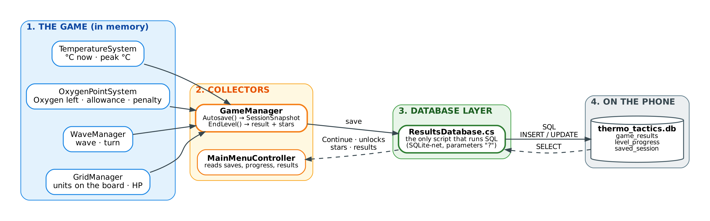
Figure 1. Data flow: game systems → GameManager → ResultsDatabase → SQLite file. Dashed arrows show data being read back.
Why one database script? Keeping all SQL in ResultsDatabase.cs means there is only one place to check for errors, one place to change if the tables change, and no risk of two scripts writing the same data in different ways. This is called the repository pattern.

1.2 Where each kind of data is kept
Not everything goes into the database. The game uses four storage places, each for a different job:
Place | What is kept there | Lasts until | Script
SQLite database  thermo_tactics.db | Results, level progress (unlocks, stars) and the saved game for Continue | The app is uninstalled or the player resets progress | ResultsDatabase
PlayerPrefs  (Unity's small key–value store) | Settings: volumes, battle speed, large text, high contrast, lane camera, boss warning, last player name (keys tt.*) | The app is uninstalled | SettingsStore
GameSession  (memory only) | The player's choice passed from the menu to the battle: name, stage, level, and the save to resume | The app closes (never written to disk) | GameSession
Game data assets  (ScriptableObjects, read-only) | Unit stats, waves, levels and the stage. These are the rules, not player data | Built into the app; never changed by playing | UnitData, WaveData, LevelData, StageData

1.3 What is saved: the three database tables
Table A: game_results. One row for every level that ends, whether won or lost. It is the history shown on the Results screen.
Column | Type | Meaning (example)
id | number | Automatic row number (1, 2, 3 …)
player_name | text | Who played, 1–20 characters ("Jon")
result | text | Only WIN or LOSS is allowed
created_at | text | Date and time the level ended ("2026-10-16 19:42:10")
final_temperature | decimal | Temperature when the level ended (1.15)
waves_cleared | number | How many waves were cleared (3 of 3)

Table B: level_progress. One row per player, per stage, per level. This table decides which levels are unlocked and how many stars are shown.
Column | Type | Meaning (example)
player_name + stage_id + level_number | key | Together they identify the row ("Jon", Stage 1, Level 4). Names ignore upper and lower case.
is_cleared | 0 or 1 | 1 once the level has been won; it never goes back to 0. Clearing Level N unlocks Level N + 1.
attempts | number | How many times the level was played (goes up by 1 every time)
best_final_temp | decimal | The lowest temperature the player has ever won this level with
best_stars | 0–3 | The most stars ever earned on this level; it can only go up

Table C: saved_session. One row per player: a snapshot of a level in progress, used by the Continue button. It is created from a SessionSnapshot object.
Column | Type | Meaning (example)
player_name | text (key) | Whose save this is; one save per player
stage_id, level_number | numbers | Which level (Stage 1, Level 7)
wave_number, turn_number | numbers | Where in the level (Wave 2, Turn 3)
oxygen_left, oxygen_allowance, oxygen_penalty | numbers | Unspent Oxygen and how it was calculated (4 left of 7, penalty 1)
temperature, peak_temperature | decimals | Temperature now and the highest it has been in this level (1.10, 1.25)
boss_turn | number | How many moves the boss has made (decides when the next Slam comes)
allies, enemies | text (JSON) | Every unit on the board with its lane, ID and HP, for example {"lane":2,"unitId":"A01","hp":14}
saved_at, app_version | text | When it was saved, and by which app version. A save from a different version is thrown away.

1.4 When the game writes to the database
The player never presses a Save button. The game saves by itself at these moments:
Moment in the game | Method that runs | Table written
Start of every player turn | GameManager.Autosave() | saved_session (replaced)
After every unit is deployed | Autosave() (listens to DeploySystem.Deployed) | saved_session (replaced)
Pause, or leaving to the menu | Pause(), ToMainMenu(), ToLevelSelect(), ToStageSelect() | saved_session (replaced)
Phone switches apps or the game closes | OnApplicationPause(), OnApplicationQuit() | saved_session (replaced)
A level ends (win or loss) | GameManager.EndLevel() | saved_session deleted, level_progress updated, game_results new row
Retry | GameManager.Restart() | saved_session deleted
Settings ▸ Reset my progress | ResultsDatabase.ResetProgress() | level_progress and saved_session rows of that player deleted (results stay)

Not saved mid-turn: while End Turn is playing out (IsResolving is true) the autosave is skipped on purpose. A half-finished turn would be an impossible state to resume, so the last save from the start of the turn stays in place.

1.5 When the game reads from the database
- Typing a name on the title screen: LoadSession() checks for a saved game. If one exists, the Continue button is shown. CountCleared() fills the Baguio progress strip.
- Stage Select and Level Select: GetProgress() returns every level row, which decides the locks, the stars on each node and the best temperature.
- Results screen: GetAll() returns every row of game_results, newest first.
- End of a level: right after saving, GetProgress() is read again to count the stage's stars for the end screen.

1.6 Example: one level from start to finish
- Jon types his name and picks Level 4. GameSession.Play() stores the choice in memory, and the battle scene loads.
- GameManager.StartLevel() sets the temperature to 1.00 °C, spawns Wave 1 and starts Turn 1. Autosave writes a saved_session row.
- Jon deploys a Mangrove Guardian in lane 2. Oxygen goes down by 3 and Autosave replaces the row, now with the new unit in the allies JSON.
- He presses End Turn. The lanes resolve; the temperature rises to 1.10 °C. Nothing is saved during the turn.
- Turn 2 starts and Autosave replaces the row again (Turn 2, 1.10 °C, peak 1.10 °C).
- Jon closes the app. OnApplicationQuit() saves one last time. Next time, Continue rebuilds the board from this row.
- Later he clears the last wave with a peak of 1.25 °C. EndLevel(true) deletes the save, then RecordAttempt() sets Level 4 to cleared with 2 stars, and Insert() adds a WIN row to game_results. Level 5 is now unlocked.

1.7 How the data is kept safe and correct
- Parameterized queries: values are passed with ? placeholders and never pasted into the SQL text, which blocks SQL injection.
- CHECK rules in the tables: the database itself refuses wrong data, for example a result that is not WIN or LOSS, stars outside 0–3, or a name longer than 20 characters.
- One-statement upsert: RecordAttempt uses INSERT … ON CONFLICT DO UPDATE, so a level row is created the first time and updated after that (attempts + 1, best stars kept with MAX).
- Schema versioning: the database version (now 3) is stored in PRAGMA user_version. An older file is upgraded with ALTER TABLE without losing any results.
- Transactions: multi-step changes (the upgrade, Reset progress) run inside RunInTransaction, so they happen completely or not at all.
- Errors never crash the game: every database call is wrapped in try/catch. If saving fails, the error is logged and the game keeps running.

Part 2. How the animations work

2.1 From picture files to a moving character
Every character is pixel art drawn as a series of separate pictures (frames), like a flip book. Showing the frames quickly one after another makes the character move. The pipeline has five steps:
- Frames (PNG files). Each unit has its own folder in Art/Units/, for example Art/Units/MangroveGuardian/, with idle_00–idle_11, attack_00–attack_11 and hurt_00–hurt_07. A unit frame is 144 × 96 pixels. The boss frames in Art/Bosses/ClearcutBehemoth/ are 384 × 320 and add enraged, cleave and slam sets.
- Import settings. Thermo-Tactics ▸ Steps ▸ 1. Import Art sets every frame to Point filtering (keeps pixels sharp), no compression, 64 pixels per world unit, and a pivot at the character's feet read from unit_pivots.json, so every character stands exactly on its slot.
- Animation clips. Steps ▸ 2. Build Animations turns each set of frames into a clip (.anim), for example MangroveGuardian_Attack.anim, with a fixed speed in frames per second (fps).
- Animator controller (the animation tree). The same step builds a controller per character (.controller in Animations/<Unit>/). It contains the states, the parameters (triggers) and the rules for moving between states.
- Attached at runtime. When a unit is deployed or a wave spawns, UnitFactory creates the character: a sprite, the Animator with its controller, a shadow and a health bar. From then on, the gameplay code only fires triggers, and the controller picks the right clip.
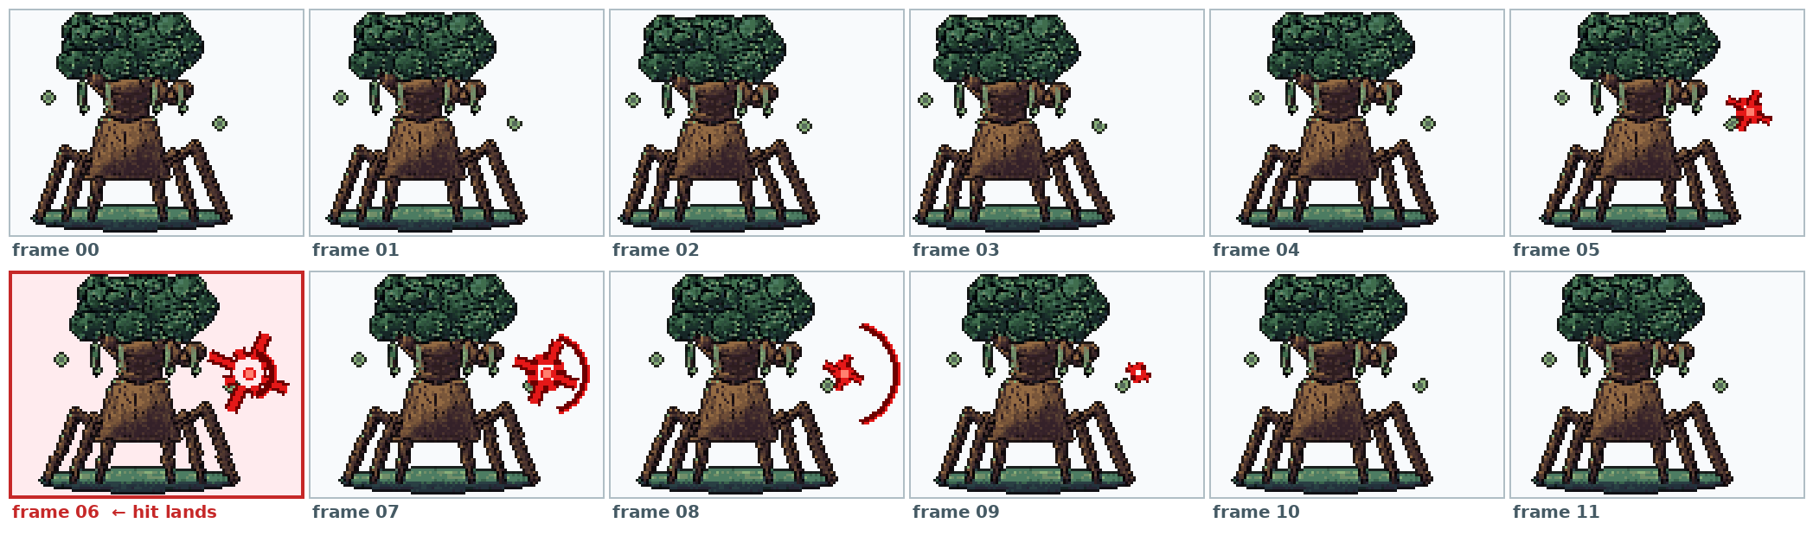
Figure 2. The 12 frames of the Mangrove Guardian's attack clip. The damage is applied on frame 6, when the blow lands.

2.2 The animation tree of a normal unit
All 13 normal units (5 allies, 8 enemies) and the 6 elites share the same simple tree. Idle is the resting loop. Any State means "from whatever is playing now": when the code fires a trigger, the character jumps straight to that action. When the action clip finishes, it returns to Idle by itself.
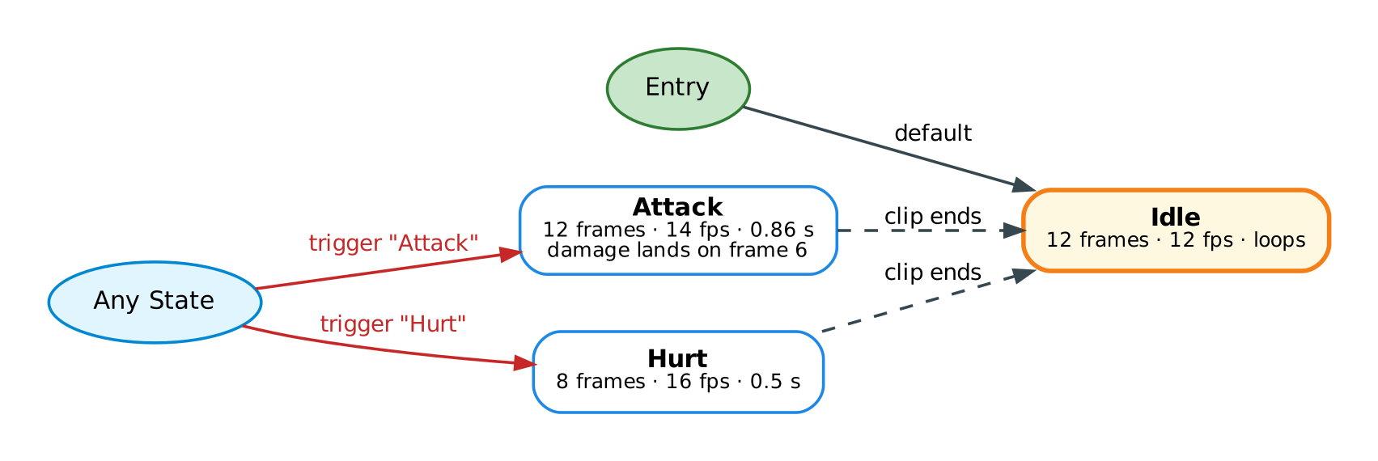
Figure 3. Animator controller of a unit: Idle by default; the Attack and Hurt triggers play one-shot clips that return to Idle.
Clip | Frames | Speed | Length | Loops? | Started by
Idle | 12 | 12 fps | 1.0 s | Yes | Default state (no trigger needed)
Attack | 12 | 14 fps | 0.86 s | No | Trigger Attack from UnitBase.AttackRoutine()
Hurt | 8 | 16 fps | 0.5 s | No | Trigger Hurt from UnitBase.TakeDamage()

2.3 The animation tree of the boss
The Clearcut Behemoth has a bigger tree with two resting loops and three actions. A bool parameter called Enraged works like a switch: once it is on, the boss rests in its angrier Enraged loop instead of Idle, and every action clip returns there.
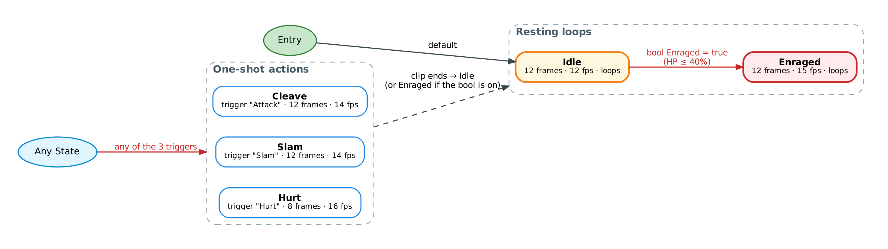
Figure 4. Boss Animator: Idle or Enraged as the resting loop; Cleave, Slam and Hurt as one-shot actions.
Clip | Frames | Speed | When it plays
Idle | 12 | 12 fps | Default resting loop
Enraged | 12 | 15 fps | Resting loop after Enraged is set to true (HP drops to 40% or less). The sprite also gets a red tint.
Cleave | 12 | 14 fps | Trigger Attack: the boss hits the strongest ally's lane and the lanes beside it
Slam | 12 | 14 fps | Trigger Slam: Landslide Slam on all 6 lanes
Hurt | 8 | 16 fps | Trigger Hurt: every time an ally damages it

2.4 What happens during one attack, second by second
The code and the animation are kept in step so the damage appears exactly when the blow lands on screen:
Time | What happens
0.00 s | TurnManager asks the attacker to attack. AttackRoutine() fires the Attack trigger and the Attack clip starts.
0.43 s | Frame 6 is showing (6 ÷ 14 fps). The code waits exactly this long (hitDelay), then applies the damage: the target's HP goes down, its health bar shrinks, a red "−4" floats up, and its Hurt trigger fires. If the lane was empty, LaneController changes the temperature instead (−0.05 °C or +0.10 °C) and shows it as floating text.
0.86 s | The Attack clip ends and the attacker returns to Idle. The target's Hurt clip (0.5 s) also ends and it returns to Idle.
If HP reaches 0 | The unit waits 0.45 s, fades out over 0.45 s and is removed. Its slot is freed immediately, so a new unit can be placed there.

Speed setting: the Battle speed option (1×, 1.5×, 2×) changes Time.timeScale. The animations, the hit timing and the camera all use the same game clock, so they speed up together and stay in sync.

2.5 Other visual details on the sprites
- Facing: all characters are drawn facing right. Enemies are flipped (flipX) so they face the allies.
- Elites: an elite uses the same frames and tree as its base enemy, with a red tint and higher stats.
- Depth: a sorting order is calculated from each slot's position (IsoBoardLayout.SortingOrderFor), so units in front are drawn over units behind.
- Extras around each unit: a shadow sprite under its feet and a two-part health bar (dark back plus a green or red fill) above its head.
- Camera: during End Turn, BattleCamera zooms into each lane so the attack animations are seen up close, then returns to the full board.

Part 3. The game state machines
A state machine is a list of situations (states) the game can be in, plus the rules for moving from one to another. At any moment the game is in exactly one state, and the state decides what the player is allowed to do. The prototype has three state machines working at different levels, from the outside in:
Level | Controlled by | Question it answers
1. Screen flow | MainMenuController, UIManager, scene loading | Which screen is the player looking at?
2. Battle state | GameManager.State | Is the battle running, paused or over?
3. Turn loop | TurnManager | Is it the player's turn, or is End Turn playing out?

3.1 Screen flow (the whole prototype)
The prototype has two Unity scenes. The MainMenu scene holds the Title, Stage Select and Level Select screens; the Baguio_Battle scene holds the battle and its end screens.
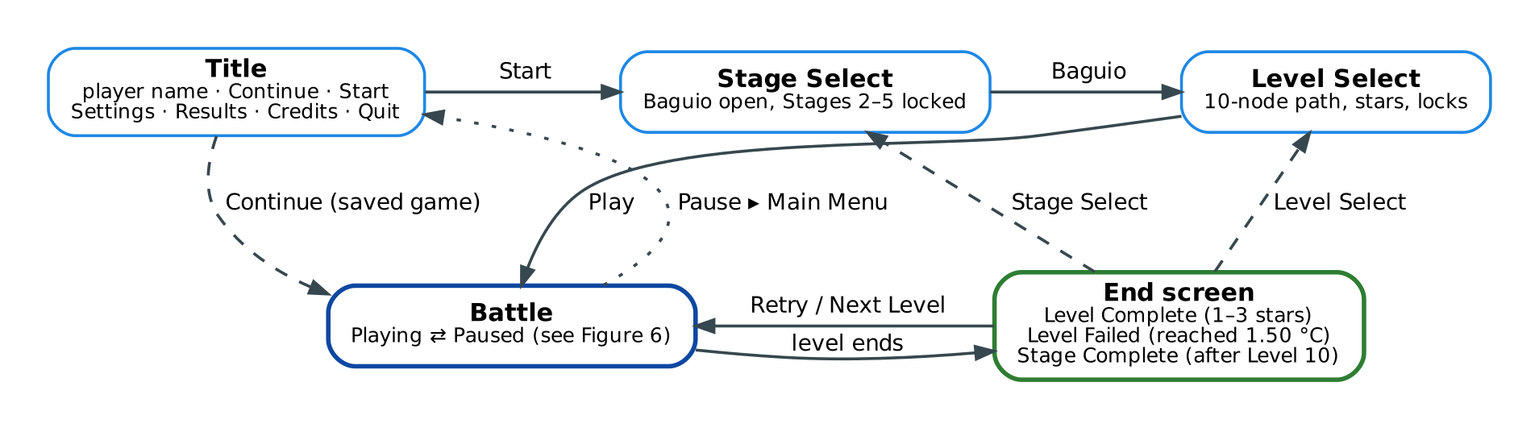
Figure 5. Screen flow. Solid arrows: normal path. Dashed: shortcuts. Dotted: leaving through the pause menu.
Screen | What the player can do | Goes to
Title | Type a name (2–20 characters), Continue, Start, Settings, Results, Credits, Quit | Stage Select (Start) or straight into the battle (Continue)
Stage Select | Pick Baguio (Stages 2–5 are shown locked) | Level Select
Level Select | Pick an unlocked level; see stars and best temperature | Battle (Play)
Battle | Deploy units, End Turn, Pause | End screen, or the menu through Pause
End screen | Level Complete (stars), Level Failed, or Stage Complete after Level 10 | Retry, Next Level, Level Select, Stage Select

Moving between the two scenes uses GameSession: before loading a scene, the game stores the player name, stage, level and (for Continue) the saved game there, and the new scene reads it when it starts. The flags OpenLevelSelect and OpenStageSelect tell the menu which screen to open when the player comes back from a battle.

3.2 Battle state (GameManager)
Inside the battle scene, GameManager keeps one value, Current, which is always one of four states:
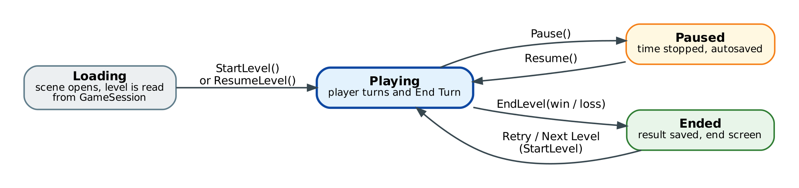
Figure 6. The four battle states in GameManager and the methods that move between them.
State | What it means | What is allowed
Loading | The battle scene has just opened. The level is read from GameSession. | Nothing yet. Moves on as soon as the level is built.
Playing | The level is running. Entered by StartLevel() (new level) or ResumeLevel() (Continue rebuilds the saved board). | Deploying and End Turn, but only when no turn is resolving (CanPlayerAct).
Paused | The pause menu is open. Time is stopped (Time.timeScale = 0) and the game is autosaved. | Resume, Retry or leave to the menu.
Ended | The level was won or lost. EndLevel() saved the result and showed the end screen. | Only the end-screen buttons. Retry or Next Level calls StartLevel() and returns to Playing.

3.3 The turn loop (TurnManager)
While the battle is Playing, the game repeats the turn loop in Figure 7. The flag IsResolving splits it into two halves: the player's turn (false: the player may deploy) and resolving (true: End Turn is playing out and input is blocked).
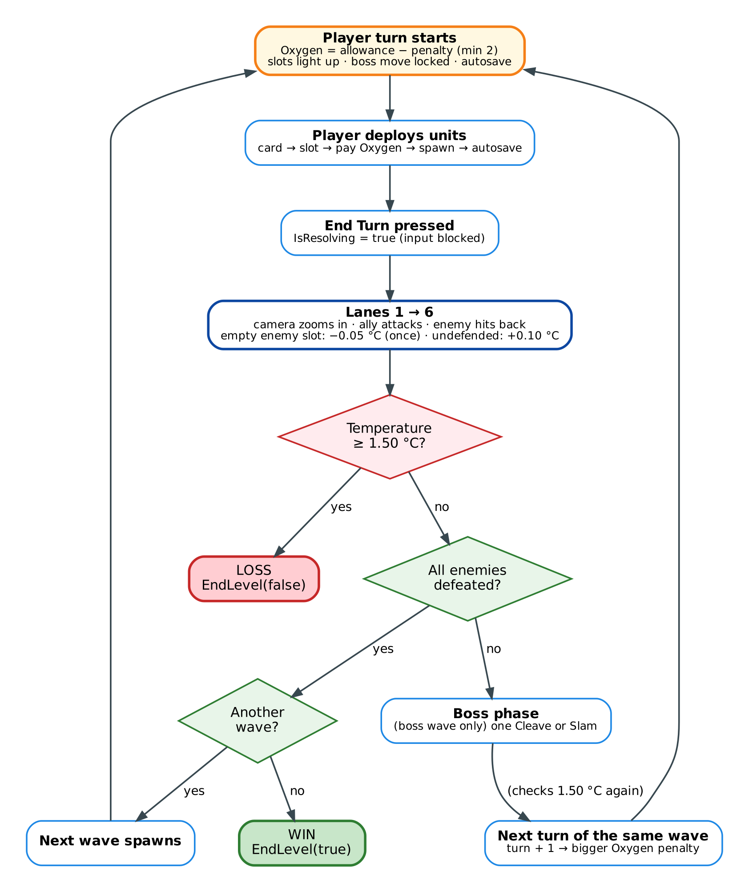
Figure 7. The turn loop: one player turn, then the lanes resolve in order, then the game checks for a loss, a cleared wave or another turn.
Step by step:
- Player turn starts (BeginPlayerTurn). Oxygen is reset to the wave's allowance minus the penalty for a long wave (−1 on turn 2, −2 on turn 3, −4 on turn 4, −8 from turn 5, never below 2). Free slots light up, the boss's next move is locked and shown, and the game autosaves.
- The player deploys as many units as the Oxygen allows, then presses End Turn. IsResolving becomes true.
- Lanes 1 to 6 resolve one at a time (ResolveLane). The camera zooms in. The ally attacks first (the enemy, or the empty slot to cool the planet by 0.05 °C, once per turn). Then the enemy, if still alive, hits back (the ally, or the undefended lane to heat the planet by 0.10 °C). If the temperature reaches 1.50 °C, the loop stops immediately.
- Checks after the lanes. At 1.50 °C or more: loss (EndLevel(false)). All enemies defeated: the next wave spawns, or if it was the last wave, win (EndLevel(true)). Otherwise, in the boss wave, the boss makes its one move (Cleave or Slam), then the temperature is checked again.
- Next turn of the same wave. The turn counter goes up (so the Oxygen penalty grows), IsResolving becomes false, and the loop returns to step 1.

3.4 Smaller state machines inside the battle
Thing | States | What changes it
Each unit | Alive → Dead | HP reaches 0 in TakeDamage(); it fades out and its slot is freed.
The boss | Normal → Enraged | HP drops to 40% or less (OnHpChanged): Cleave goes from 8 to 10 damage and Slam comes every 2nd boss turn instead of every 3rd.
The boss's next move | Cleave or Slam (locked) | Decided at the start of each player turn (LockNextMove) from the boss turn counter, so the warning shown to the player is always correct.
A wave | Active → Cleared | EnemyCount reaches 0 (IsCurrentWaveCleared).
A level in the database | Locked → Unlocked → Cleared (0–3 stars) | Clearing the level before it unlocks it; winning sets is_cleared and best_stars.

Summary
- Data: the game systems hold the live numbers, GameManager collects them, and only ResultsDatabase writes them to thermo_tactics.db: results, level progress with stars, and one saved game per player. It saves by itself every turn, after every deploy, and when the app is paused or closed.
- Animation: PNG frames become clips, the clips are arranged in an Animator controller, and the code only fires the Attack and Hurt triggers (plus Slam and Enraged for the boss). The damage is timed to land on frame 6.
- States: the screen flow decides which screen is shown, GameManager decides whether the battle is Loading, Playing, Paused or Ended, and TurnManager runs the turn loop until the level is won or the temperature reaches 1.50 °C.

