**SQL활용 – 홍길동**

**INSERT INTO MEMBER VALUES ('hong', '홍길동', 'hong1234', '010-1111-1111', 'hong@test.com');**

**INSERT INTO MEMBER VALUES ('kim', '김유신', 'kim1234', '010-2222-2222', 'kim@test.com');**

**INSERT INTO MEMBER VALUES ('kang', '강감찬', 'kang1234', '010-3333-3333', 'kang@test.com');**

**INSERT INTO MEMBER VALUES ('jong', '종대의', 'jong1234', '010-4444-4444', 'jong@test.com');**

**INSERT INTO MEMBER VALUES ('hiro', '히로', 'hiro1234', '010-5555-5555', 'hiro@test.com');**

**SELECT * FROM MEMBER;**

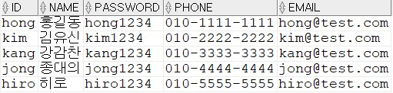

**INSERT INTO BOARD VALUES (0001, '제목1', '내용1', 'hong', SYSDATE);**

**INSERT INTO BOARD VALUES (0002, '제목2', '내용2', 'hong', SYSDATE);**

**SELECT * FROM BOARD;**

**C:\Users\bratio\AppData\Local\Microsoft\Windows\INetCache\Content.Word\홍길동 게시글 2개.jpg**

**UPDATE MEMBER SET PHONE = '010-2222-1234' WHERE ID = 'kim';**

**UPDATE MEMBER SET EMAIL = 'kim@mystudy.com' WHERE ID = 'kim';**

**SELECT * FROM MEMBER;**

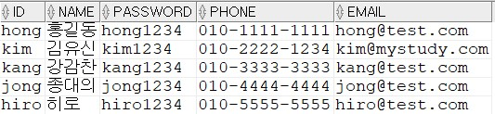

**DELETE FROM MEMBER WHERE ID = 'jong';**

**DELETE FROM MEMBER WHERE ID = 'hiro';**

**SELECT * FROM MEMBER;**

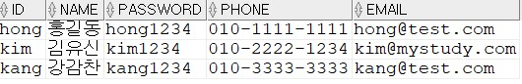

**/\*\*\*\*\*\*\*\*\*\*\*\*\*\*\*\*\*\*\*\*\*\*\*\*\*\*\*\*\*\*\*\*\***

**<MEMBER>**

**MEMBER_ID_PK Primary_Key**

**MEMBER_NAME_NN "NAME" IS NOT NULL**

**MEMBER_PASSWORD_NN "PASSWORD" IS NOT NULL**

**<BOARD>**

**BOARD_BNO_PK Primary_Key**

**BOARD_CONTENT_NN "CONTENT" IS NOT NULL**

**BOARD_ID_FK Foreign_Key**

**BOARD_ID_NN "ID" IS NOT NULL**

**BOARD_REGDATE_NN "REGDATE" IS NOT NULL**

**BOARD_TITLE_NN "TITLE" IS NOT NULL**

**\*\*\*\*\*\*\*\*\*\*\*\*\*\*\*\*\*\*\*\*\*\*\*\*\*\*\*\*\*\*\*\*\*\*\*\*\*\*\*\*\*\*\*/**

**CREATE INDEX MEMBER_IDX_NAME ON MEMBER (NAME);**



**CREATE OR REPLACE VIEW VIEW_MEMBER_BOARD**

**AS**

**SELECT M.ID, M.NAME, M.PHONE, M.EMAIL,**

**B.BNO, B.TITLE, B.CONTENT, B.REGDATE**

**FROM MEMBER M, BOARD B**

**WHERE M.ID = B.ID(+)**

**SELECT * FROM VIEW_MEMBER_BOARD;**

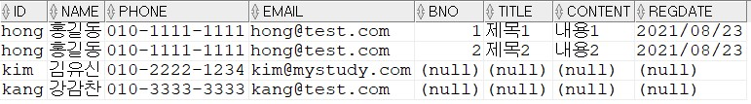

**SELECT NAME, TITLE, REGDATE**

**FROM VIEW_MEMBER_BOARD**

**WHERE ID = 'hong'**

**ORDER BY REGDATE**

**;**

