**CREATE INDEX MEMBER\_IDX\_NAME ON MEMBER (NAME);**

**NAME_INDEX 생성**

**CREATE OR REPLACE VIEW VIEW\_MEMBER\_BOARD**

**AS**

**SELECT M.ID, M.NAME, M.PHONE, M.EMAIL,**

**B.BNO, B.TITLE, B.CONTENT, B.REGDATE**

**FROM MEMBER M, BOARD B**

**WHERE M.ID = B.ID(+)**

**SELECT \* FROM VIEW\_MEMBER\_BOARD;**

**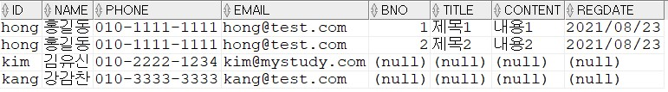**

**SELECT NAME, TITLE, REGDATE**

**FROM VIEW\_MEMBER\_BOARD**

**WHERE ID = 'hong'**

**ORDER BY REGDATE**

**;**

**홍길동 작성글**