1. **Kind testing: White box - Black Box**

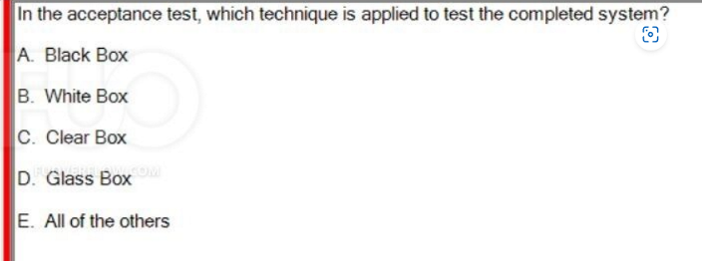

**A - Black Box là cu thường dùng nhất cho Acceptance Test**

**Còn white-box test cấu trức xử lí mã nguồn**

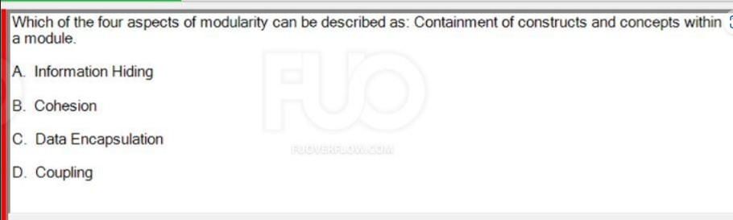

**C**

**Các dạng câu hỏi tương tự:**

**-Coupling : How well modules work together.**

**-Information Hiding : Abstracting away implementation details, Generate Random…, no detail….**

**-Cohesion : How well a module meets a single well-defined goal**

**-Data Encapsulation : Containment of constructs and concepts within a module**

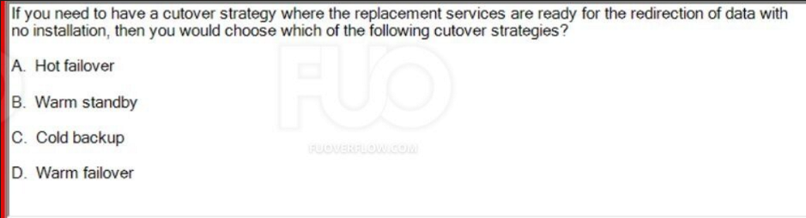

**A**

**Câu hỏi tương tự:  
- replacement machine is ready : Cold backup**

**- replacement services are ready :Hot failover**

**-replacement machine is running and ready :Warm standby**

**4.**

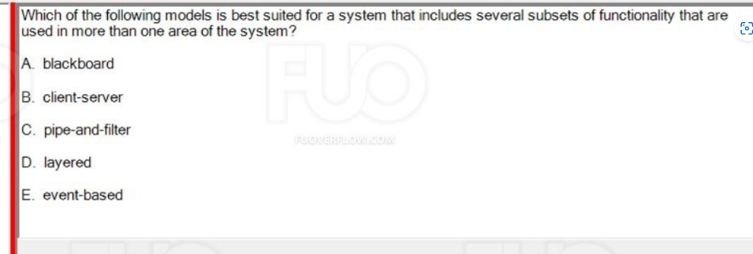

**C**

**Câu hỏi tương tự:  
-blackboard : use system with significant shared data that needs to be shared across a variety of components or sub-systems, somewhat like global variables, but with better data integrity**

**-pipe-and-filter : system includes several subsets of functionality that are used in more than one area of the system**

**-client-server : benefits from the separation of complexity and processing between work which can be done locally and that which should be completed on a shared, remote service**

**5.**

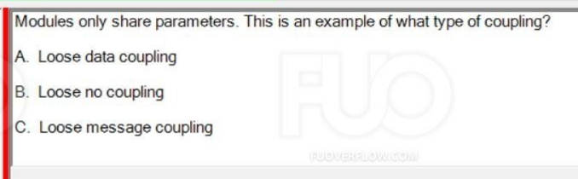

**-Loose message coupling :components only communicate through parameters or message passing.**

**-Loose data coupling : Modules only shareParameter**

**-Loose no coupling: The loosest type of coupling**

**6.**

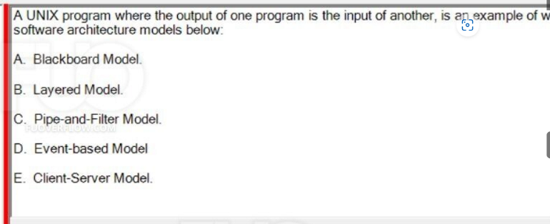

**A UNIX program -> Pipe-and-filter model**

**A vehicle identification and tracking system -> Blackboard Model**

**7.**

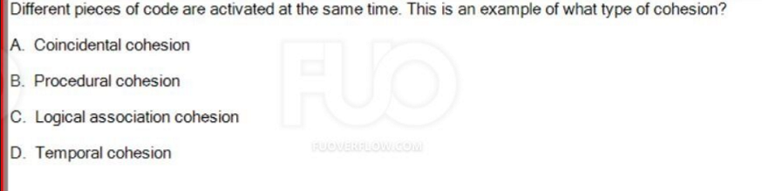

**-Coincidental cohesion : Parts of modules are together in the same file.**

**-Temporal cohesion : Different pieces of code are activated at the same time .**

**-Procedural cohesion : One piece of code run after another**

**-Logical association cohesion : Components do similar but separate things**

**8.**

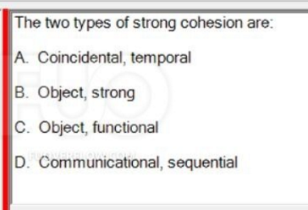

**medium coupling : 2types -> Control , Data Structure.**

**-tight coupling : 3 types ->Content , Common , External**

**-loose coupling : 3 types -> Data , Message , None**

**-Weak cohesion : 4 types -> Coincidental , temporal , procedural , logical association**

**-Medium cohesion : 2 types -> Communicational , sequential**

**-Strong cohesion : 2 types -> Object , functional**

**9.**

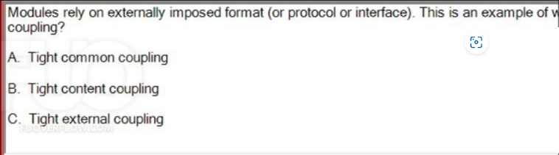

**Á**

**Câu hỏi tương tự:  
A relie B -> Content**

**Both A and B -> Conmon**