CREATE VIRTUAL QUANTUM COMPUTER

CREATE VIRTUAL QUANTUM COMPUTER FOR MAC OS

Table of Contents

1 SYNOPSIS 2

# PREREQUISITE

1. MacOS Mojave or newer.
2. Homebrew for MacOS has been installed and updated.
3. The latest **Anaconda** for Python 3.7 has been installed.
4. The latest **git** installed.

# INSTALL REQUIRED LIBRARIES

## XCODE

1. Install the latest Xcode from Apple AppStore:



1. After installing XCode, go to Terminal and run the following command. You will be prompted for password:

**$ sudo xcodebuild -license accept**

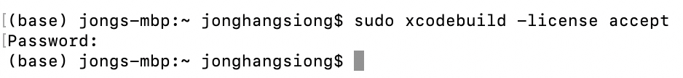

1. Install XCode Command Line Tool:

Download the command line tool from <https://developer.apple.com/download/more/>

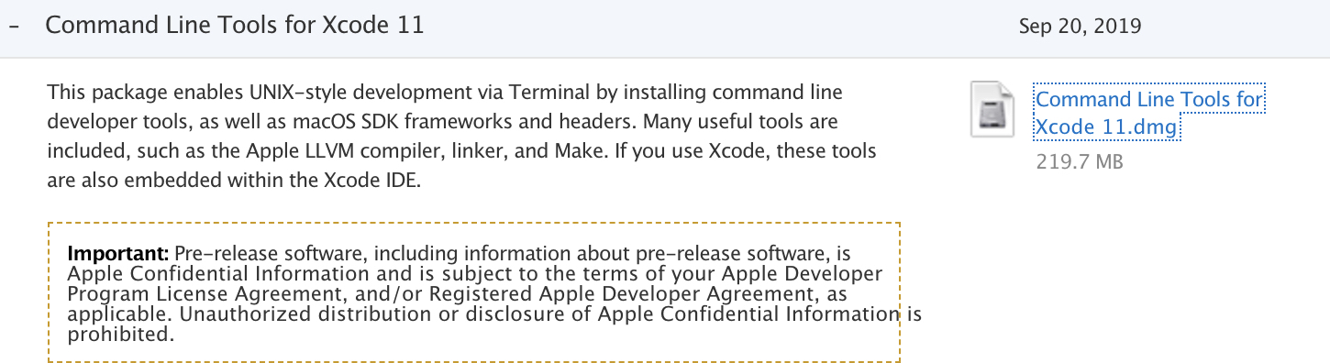

## UPDATE OS LIBRARIES

1. Update OS libraries using homebrew:

**$ brew update**

1. Install the latest gcc compiler:

**$ brew install gcc**

1. Install FFI:

**$ brew install libffi**

1. Install ZMQ:

**$ sudo chown -R $(whoami) /usr/local/share/man/man8**

**$ brew install zmq**

1. Install GNU GP:

**$ brew install gnupg**

## INSTALL SBCL

1. Download sbcl-1.2.11-x86-64-darwin-binary.tar.bz2 from http://www.sbcl.org/platform-table.html

## INSTALL QUICKLISP

1. In quantumvm directory, download quicklisp:

**$ curl -O** [**https://beta.quicklisp.org/quicklisp.lisp**](https://beta.quicklisp.org/quicklisp.lisp)

**$ curl -O** [**https://beta.quicklisp.org/quicklisp.lisp.asc**](https://beta.quicklisp.org/quicklisp.lisp.asc)

1. Verify using gpg:

$ gpg --verify quicklisp.lisp.asc quicklisp.lisp

Don’t worry about the following message:

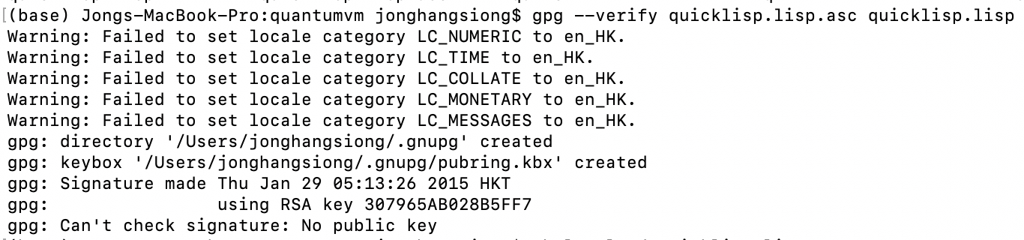

1. Run the following command:

$ sbcl --load quicklisp.lisp

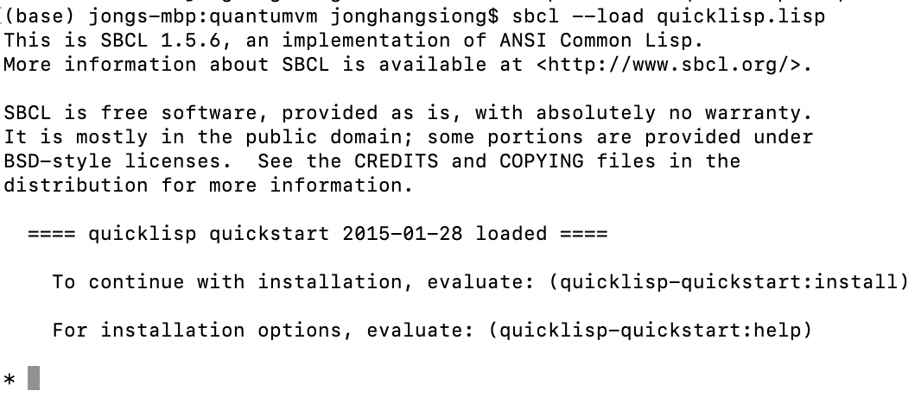

1. In SBCL console, run the following command in the following sequence:

(quicklisp-quickstart:install)

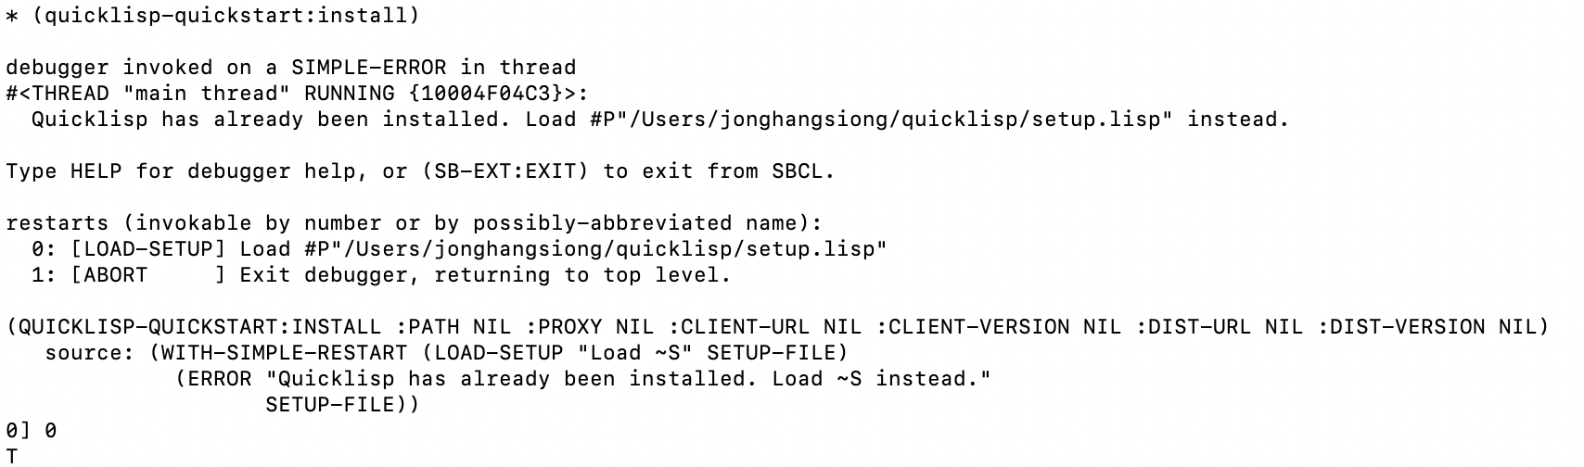

1. Command:

(ql:system-apropos "vecto")

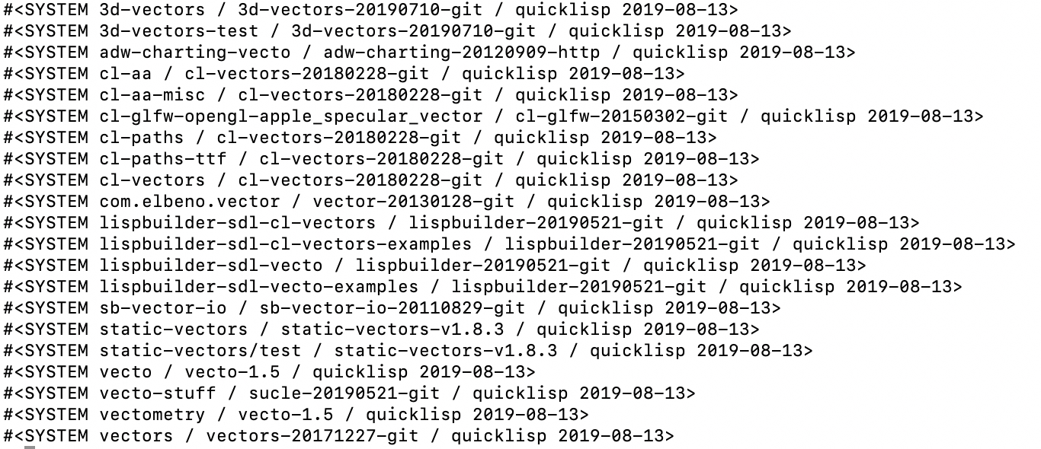

1. Df:

(ql:quickload "vecto")

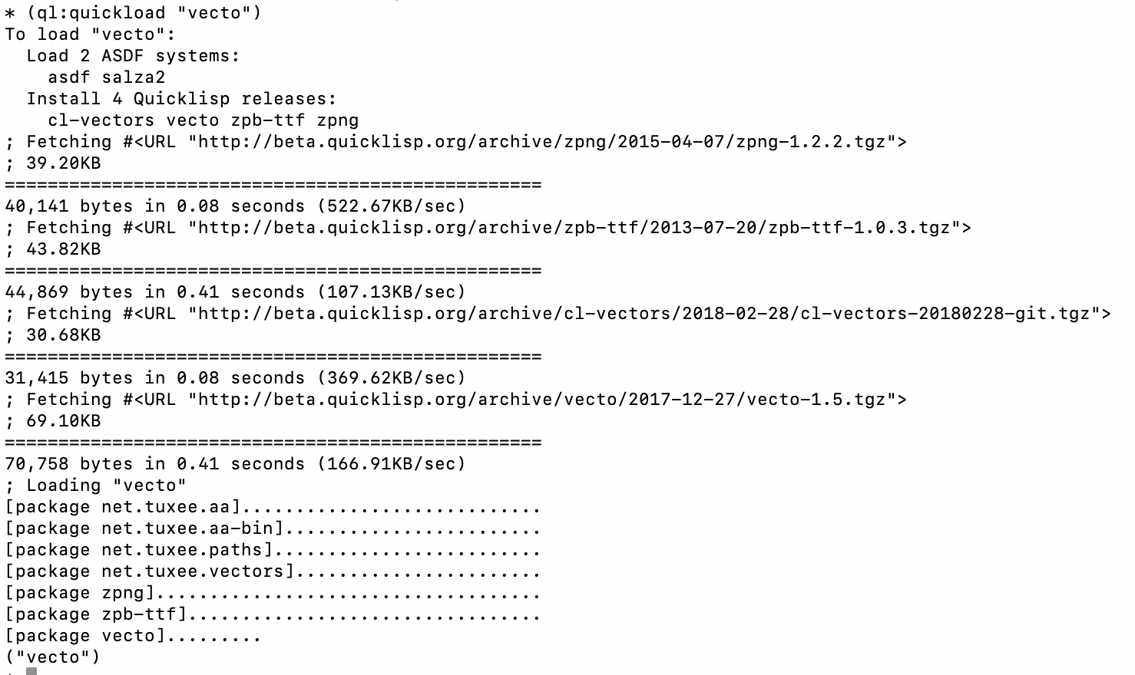

1. Command:

(ql:add-to-init-file)

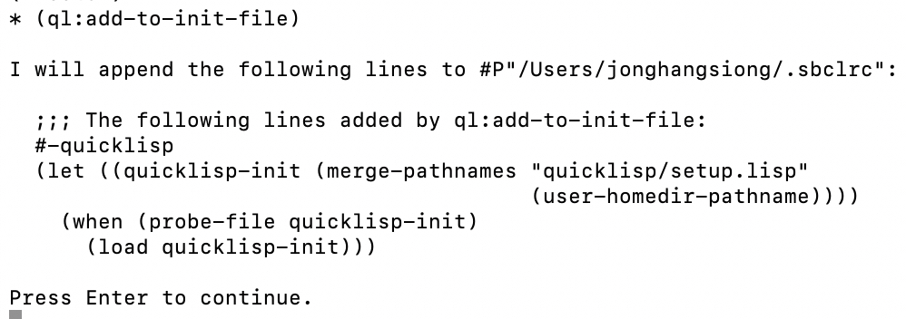

1. Command:

(ql:add-to-init-file)

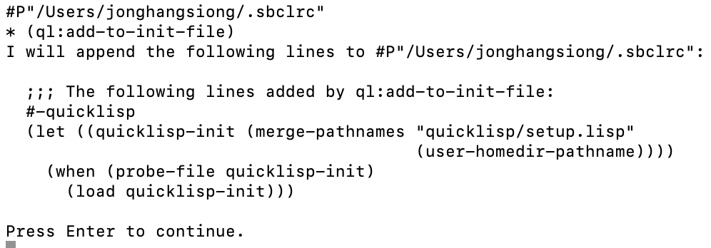

1. Command:

(quit)

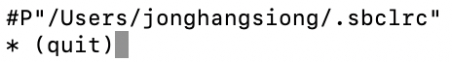

# INSTALL QVM AND QUILC

1. Create a directory to store Quantum Computer bundle in the Terminal.

**$ mkdir quantumvm**

1. Change to the newly created directory:

**$ cd quantumvm**

1. Git pull QVM

$ git clone https://github.com/rigetti/qvm.gi

1. Git pull the **QUILC** and its Submodules from git:

**$ git clone --recurse-submodules https://github.com/rigetti/quilc.git**

1. Change to the **quilc** directory which you have just pulled from github:

**$ cd quilc**

1. Issue the following command:

**$ make quilc**