CREATE VIRTUAL QUANTUM COMPUTER

CREATE VIRTUAL QUANTUM COMPUTER USING DOCKER

SIONG JONG HANG

Table of Contents

1 INSTALL DOCKER 2

2 SETUP QVM AND QUILC CONTAINERS 2

3 INSTALL AND UPDATE ANACONDA 4

4 PROGRAM THE VIRTUAL QUANTUM COMPUTER 6

# INSTALL DOCKER

1. Go to hub.docker.com and sign up for an account.
2. After signing up, login to download the latest **Docker for Desktop**.
3. Install Docker Desktop in your computer.
4. In Mac OS, Docker Desktop appears on the top bar:



1. Open a Terminal to test your installation:

$ docker version

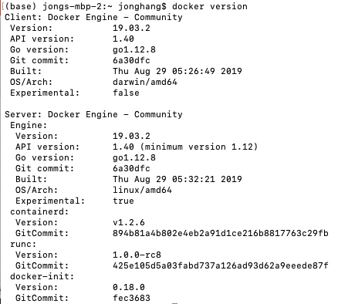

# SETUP QVM AND QUILC CONTAINERS

1. Go to hub.docker.com and search for **qvm**:

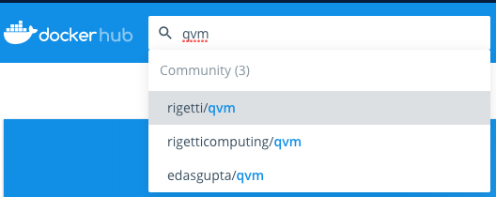

Select **rigetti/qvm** to review this docker image

1. Rigetti’s QVM is a virtual quantum computer. Open a Terminal to pull the **QVM docker image** from the repository:

**$ docker pull rigetti/qvm**

Upon completion:

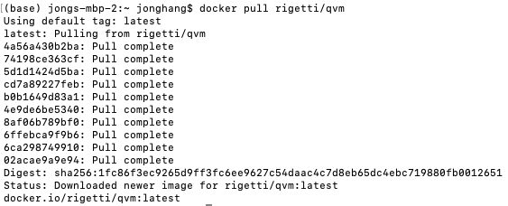

1. Verify the docker image has been downloaded into your computer:

**$ docker images**



1. Back to hub.docker.com, search for **quilc** which is a quantum compiler used in conjunction with QVM:

Select **rigetti/quilc** to review this docker image



1. Pull the image from repository:

**$ docker pull rigetti/quilc**

1. Verify quilc has been downloaded:

**$ docker images**



You now have 2 docker images of **QVM** and **QUILC**

# INSTALL AND UPDATE ANACONDA

1. Download and install the latest Anaconda from <https://www.anaconda.com/distribution/>
2. Launch Anaconda. Go to Environment:

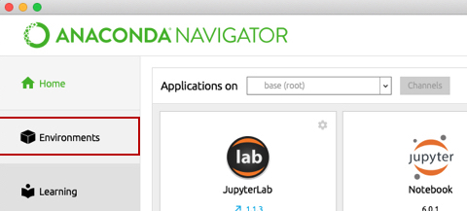

1. Open an Anaconda Terminal:

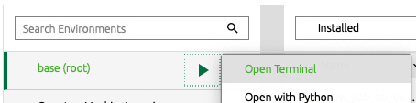

1. Update the Anaconda engine:

**$ conda update conda-build**

1. Update all packages:

**$ conda update --all**

1. Create a new **Python 3.7** environment, give it a name such as **QuantumMachineLearning**:

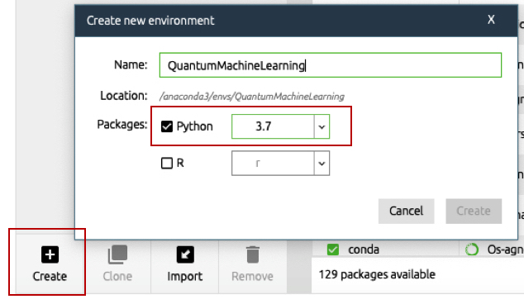

The new environment will be added to the list:

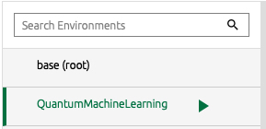

1. Launch a Terminal from the new environment. Install the essential python packages for data science:

**$ pip install numpy scipy matplotlib scikit-learn pandas**

1. Install packages for quantum computing:

**$ pip install pyquil qiskit**

1. Go to **Home**, select **QuantumMachineLearning**:

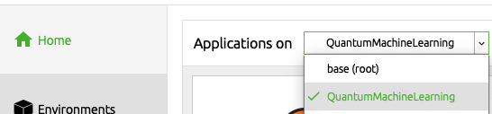

1. Launch **Jupyter Notebook** for **QuantumMachineLearning**:

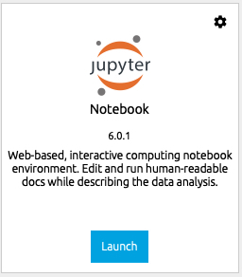

1. Proceed to completing QVM and QUILC setup.

# PROGRAM THE VIRTUAL QUANTUM COMPUTER

1. Launch a new Terminal, create a QVM **docker container** from the image:

**$ docker container run --rm -it -p 5000:5000 --name qvm rigetti/qvm -S**

You should see the following upon successful initialization of QVM virtual quantum computer:

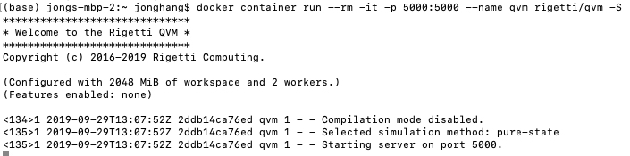

The docker command initialized a container (**container run**) from the docker image using interactive mode (**-it**). The name, **qvm** was assigned to the container (**--name qvm**) for identification and monitoring. The container can be stopped by simply Ctrl-C and it will be removed from disk accordingly (**--rm**) after exiting. Without **--rm**, the container will exit but not removed from disk so that it will not consume disk space. There are two port numbers specified (**5000:5000**). The first port number is on the host while the second is on the container.

1. Launch another Terminal, create a QUILC docker container from the image:

**$ docker container run --rm -it -p 5555:5555 --name quilc rigetti/quilc -R**

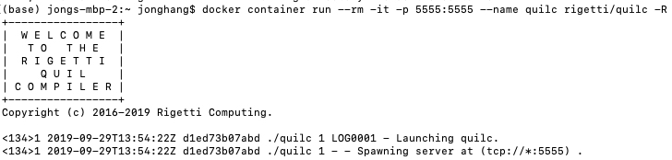

1. You can monitor QVM and QUILC using the following command in a new Terminal:

To see the list of running containers:

**$ docker container ls**

Or

**$ docker container ps**



To see the resources consumed by the containers:

**$ docker container stats**



Use **Ctrl-C** to exit

1. Go to your Jupyter Notebook which you launched in the previous Section.
2. In the Jupyter Notebook, execute the following Python codes:

Import the required libraries:

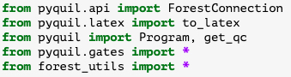

Use **ForestConnection** to connect to QVM virtual quantum computer via port **5000** and the QUILC compiler via port **5555**:

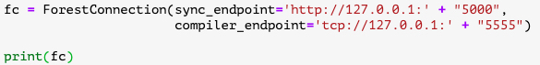

The output of the connection:



Initialize the qubit to



Output of results:

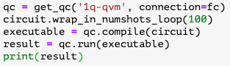



In the above code, the function get_qc connect to the virtual quantum computer to perform computation of 1 qubit. To perform computation of more than 1 qubit, use **2q-qvm** for 2 qubit, **3q-qvm** for 3 qubit , and so forth.

Transpose the results:

**result.T**

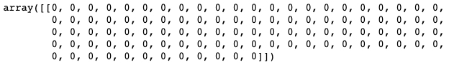

1. If you arrive at results similar to the above, you have successfully setup a virtual quantum computer and compiler. You are ready to program Quantum Machine Learning.
2. To shutdown QVM and QUILC, go to the terminals where you had them running, use **Ctrl-C** to stop them.
3. After stopping both QVM and QUILC, use **docker container ps** to ensure no containers are running:



