Lilian Liu
Editor-in-Chief
Sensors

February 16, 2016

Dear Dr. Liu,

Re: Manuscript reference No. sensors-113427

Please find attached a revised version of our manuscript “Fast Contour-Tracing Algorithm based on Pixel-Following Method for Image Sensors”, which we would like to resubmit for publication in Sensors.

First of all, we would like to thank the editorial board for the opportunity to revise our manuscript and we appreciate the positive and constructive comments made by reviewers. Their comments were highly insightful and enabled us to greatly improve the quality of our manuscript. In the following pages are our point-by-point responses to each of the comments of the reviewers.

The changes in the revised manuscript have been highlighted. In accordance with reviewer 1’s suggestion, we provided standard deviation results for speed experiment (table 8), made the figure caption more self-explaining and inserted discussion in conclusion. Also, in accordance with reviewer 2’s suggestion, we modified table number of Table 7 and caption of Figure 20. We hope that the revisions in the manuscript and our accompanying responses will be sufficient to make our manuscript suitable for publication in Sensors.

We would like to thank you once more for giving us the opportunity to revise our manuscript and look very much forward to the final decision.

Yours sincerely,

Jonghoon Seo
Software Platform R&D Lab., LG Electronics Advanced Research Institute,
19 Yangjae-daero 11 gil, Seocho-gu, Seoul 137-893, Korea
E-Mail: jonghoon.seo@lge.com

Responses to the comments of Reviewer #1
1. In the experimental results section (5.2), the performance of the proposed algorithm is compared to several other established algorithms. The measurement is repeated 10 times per image, but only the mean results are given in the corresponding table.
Either the algorithms are deterministic and always require the same proccessing time, or there is a random component (selection of starting points for contour tracing?) that might cause fluctuations. I suggest that you provide the variance / standard deviation in the tables or - if those are zero or neglectable - discuss in the text why it is not necessary to provide the variance.

Response: We added standard deviation into the speed table. Also, we described about standard deviation in the text as below:
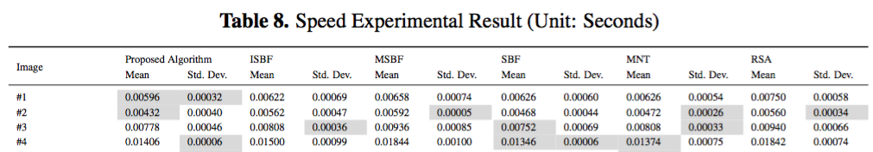
“Also, the proposed algorithm shows better standard deviation results than the conventional algorithms. “(Page 25, Line 423)
2. in general, the figure captions should be more self-explaining. Some of your figure captions are very short and hence can not be easily understood without first reading the text.
Response: We described more in detail as figure 2 and 15.
3. in the conclusion section, you should discuss that the proposed algorithm is (much?) more complex than older methods, but that this higher complexity is justified by improved quality , speed and compression as shown in your experimental results.
Response: Thanks, it was very important point which needed to be emphasized. We added discussion in conclusion as below:
“With these two tracing stages, the proposed algorithm extracts two contiguous contour pixels together. Because the proposed algorithm traces contiguous pixel pairs in a single step, there are more possible cases of the form a contour can take. Therefore the classification of the contour is more complicated than the conventional algorithms. On the other hand, this classification actually takes less time to compute, because it reduces duplicated detection of the background pixels.” (Page 31, Line 492)

4. L4: "The proposed algorithm distinguishes between different types of contour such as a local pattern-type based on its relative location among several contour pixels, and it then traces the next contour pixel using the previous one." <-- this is hard to understand please simplify / split it into two sentences.
Response: We split and changed the sentence as below:

“The proposed algorithm classifies the type of a contour pixel, based on its local pattern. Then, it traces the next contour using the previous pixel’s type.” (Page 1, Line 4)

5. L13: "In the experimental results, ..." <-- please split into two or more sentences.
Response: We split and changed the sentence as below:
“In the experimental results, the proposed algorithm shows better performance compared to the others. Also, it can provide compressed data of contour pixels and restore them accurately, including the inner-outer corner, which cannot be restored using conventional algorithms.” (Page 1, Line 13)
6. Keywords: the fact that your proposed algorithm can compress contour data is missing. please find a keyword that makes this clear - maybe "contour pixel compression" ?
Response: We changed ‘contour restoration’ as ‘contour data compression’. (Page 1, Line 17)

7. L30: change to "smart watches and smart glasses,"
8. L34: change to "they require simple and fast"
9. l43: change to "cannot restore the contour"
Response: Done
10. l50 to 56: "The paper is organized as follows. In the next section.. " alternatively, you could enumerate the sections: In section 2, ... In section 3, we describe.. and so on.
The sentence "Subsequently, we.." is very long with lots of commas. please split it up into two or more sentences to make it easier to read.
Response: We changed the paragraph as below:
“The paper is organized as follows. In section 2, we categorize conventional contour-tracing algorithms and introduce their characteristics. Then, in section 3, we analyze their performance based on the accuracy and speed. Subsequently, in section 4, the proposed algorithm is described and its contour tracing procedure, contour data compression technique, and restoration technique are presented. In section 5, we present a comparison of the conventional algorithms and the proposed algorithm on the basis of their performance, along with experimental results that include the number of traced pixels and the processing times for real-time large-sized images. Moreover, we compare the compressed data size and its restored results with the original traced contour pixels. Finally, in section 6, we summarize the characteristics and experimental results of the proposed algorithm.” (Page 2, Line 50)
11. L61: please delete "are used to”
Response: We deleted the part that you suggest to erase and changed as below:
“most of conventional contour-tracing algorithms process using 2D binary images that are consist of black and white pixels through binarization.” (Page 3, Line 60)
12. L78: please change to "These methods require a frame-size memory to trace the contour, and generate erroneous images when the contour image is enlarged [17] because they maintain only the pixel coordinates." (if that is true for all the cited pixel following methods)
Response: Yes, for the pixel following methods, it is true. They require frame-size memory to mark and save the traced pixels. Also, they may occur erroneous images because they basically handle pixel coordinates only. So, we changed as below:
“These methods require a frame-size memory to trace the contour, and generate erroneous images when the contour image is enlarged [17] because they maintain only the pixel coordinates.” (Page 3, Line 77)
13. L101: change to "The method uses only one or two line buffers, and therefore requires a smaller amount of memory compared to the pixel-following and vertex-following methods."
Response: Done
“The method uses only one or two line buffers, and therefore requires a smaller amount of memory compared to the pixel-following and vertex-following methods.” (Page 4, Line 100)
13. Figure 2: please describe not only in the text, but also in the figure caption what "O", "I" and "IO" means. for example: "Types of contour pixels: inner corner pixel (I), ..."
Response: We changed the caption for Figure 2 as below:
“Figure 2. Directions and types of contour pixels. (a) Absolute direction d (b) Relative direction r (c) Types of contour pixels: inner corner pixel(I), outer corner pixel(O), and inner-outer corner pixel(IO).” (Page 6, Figure 2)
14. Figure 4: please remove the text-shadow from the description-text on the right side ( "d: do not care .. " ) depending on the zoom level the pdf is viewed with, the shadow produces ugly artifacts.
Response: We eliminated the text-shadow of Figure 4 as below:
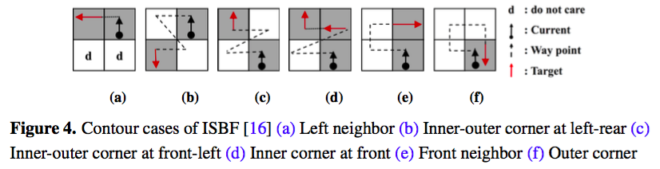
15. L214: change to "The pixel-following algorithm requires start- and stop-criteria to avoid incomplete or infinite contour tracing."
Response: Done (Page 12, Line 212)
16. Figure 10: the quality can be slightly improved by making sure that the text is not overlapping with lines / arrows (for example "B: black pixel" is overlapping with an arrow)
Response: We improved the quality of the figure and modified not to overlap between text and lines / arrows as below:
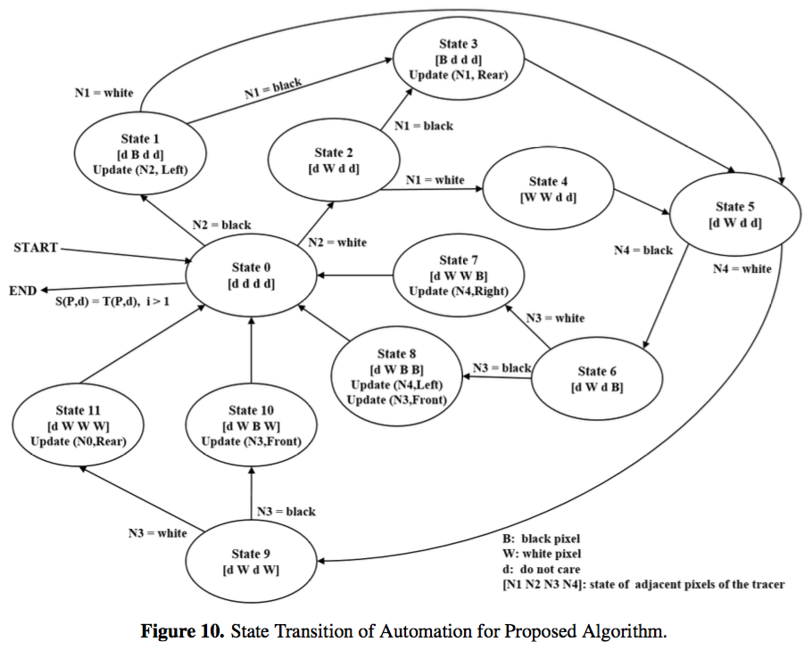

17. L316: please change to something like "The pseudocode of the proposed algorithm is shown in box 'Algorithm 3'."
Response: We changed as below:
“The pseudocode of the proposed algorithm is shown in Algorithm 3.” (Page 16, Line 314)
18. L340: please change to "we propose"
Response: We changed as below:
“For the restoration, we propose a restoration algorithm comprising two stages, namely, contour restoration and inner-outer corner restoration.” (Page 18, Line 338)

19. Figure 15: please shortly describe the problem at hand also in the figure caption, or refer to the text ("see text").
Response: We described the problem in brief in the figure caption as below:
“Figure 15. Problem with TPA. TPA must start with white left(L), left-rear(W), and right-rear(R) pixels. However, generic inner contours cannot satisfy this criteria.” (Page 23, Figure 15)
19. section 5.1 please describe, how the "Total Number" of contour pixels was obtained. Was this done by hand? or was that done by using some other algorithm and correcting errors made by that algorithm by hand ?
Response: The ground-truth contour pixels are the pixels that are adjacent with background pixels. So, we explained as below:
“In the table, “Total number” implies the total number of ground truth contour pixels, including the inner corner, outer corner, inner-outer corner, and straight-line pixels. The ground truth pixels are counted which are adjacent with background pixels.” (Page 23, Line 392)
20. Figure 16: please change to "Visual comparison of two Contour Tracing Methods. (a) MSBF (b) Proposed method."
21. Figure 17 - please change similarly to Fig. 16.
Response: Done (Page 24, Figure 16 and 17)
Figure 16. Visual Comparison of Two Contour Tracing Methods. (a) MSBF (b) Proposed method
Figure 17. Visual Comparison of Two Contour Tracing Methods. (a) MNT (b) Proposed method (without inner corners)
21. L404: please change to "As shown in figure 16a, MSBF was not able to trace some of the inner corner pixels, but our proposed method (figure 16b) was able to trace all the corner-pixel types without any inconsistency."
Response: We changed as below:
“As shown in figure 16a, MSBF was not able to trace some of the inner corner pixels, but our proposed method (figure 16b) was able to trace all the corner-pixel types without any inconsistency.” (Page 24, Line 403)
22. Figure 20: please change to: "Experimental Result for CCITT #1. Contour pixels are shown in black, original image pixels in grey".
Response: We changed as below:
“Figure 20. Result of Experiment for CCITT #1. Contour pixels are shown in black, original image pixels in grey. (a) Result of contour tracing (b) Result of contour restoration.” (Page 28, Figure 20)

Responses to the comments of Reviewer #2
1. In line 420, "... uses data from Tables 7-7", which table?
Response: We have miss-referenced table number, so we modified it as Table 7. (Page 25, Line 419)
2. In Figure 20, the authors said "Red Pixels are Contour Pixels", but I did not find red pixels in this Figure.
Response: The original image pixels are in grey, and contour pixels are in black. We modified the caption as below:
“Figure 20. Result of Experiment for CCITT #1. Contour pixels are shown in black, original image pixels in grey. (a) Result of contour tracing (b) Result of contour restoration.” (Page 28, Figure 20)

