Sensors 2015, 15, 1-x manuscripts; doi:10.3390/s150x0000x
OPEN ACCESS
sensors
ISSN 1424-8220
www.mdpi.com/journal/sensors
Type of the Paper (Article, Review, Communication, etc.)
Fast Contour-Tracing Algorithm based on Pixel-Following Method for Contour Representation
Cheolho Cheong ^{1,}*, Jonghoon Seo ^{2,†} and Tack-Don Han ^{3,†}
¹ Department of Computer Science, Yonsei University, 134, Shinchon-dong, Seodaemun-gu, Seolul, 120-749, Republic of Korea, and also with ColorZip Media Inc., 9th FL., KBL Center, 2, Nonhyoun-dong, Ganman-gu, Seoul, 135-811, Republic of Korea; Email: balgeum@yonsei.ac.kr
² Department of Computer Science, Yonsei University, 134, Shinchon-dong, Seodaemun-gu, Seolul, 120-749, Republic of Korea Full Affiliation; Emails: flamme4u@yonsei.ac.kr; hantack@kurene.yonsei.ac.kr
† These authors contributed equally to this work.
* Author to whom correspondence should be addressed; E-Mail: balgeum@yonsei.ac.kr; Tel.: +82-2-2123-2715.
Academic Editor:
Received: / Accepted: / Published:

Abstract: In this paper, we present a novel contour-tracing algorithm based on the pixel-following method for fast and accurate contour following. The proposed algorithm distinguishes between different types of contour such as a local pattern-type based on its relative location among several contour pixels, and it then traces the next contour pixel using the previous one. Therefore, it can classify the type of contour pixels as a straight line, inner corner, outer corner, and inner-outer corner, and it can extract pixels of a specific contour type. Moreover, it can trace contour pixels rapidly because it can determine the local minimal path using the contour case. In addition, the proposed algorithm is capable of compressing data of contour pixels using the representative points and inner-outer corner points, and it can accurately restore the contour image from the data. To compare the performance of the proposed algorithm with that of conventional techniques, we measure their processing time and accuracy. In the experimental results, the proposed algorithm shows better performance compared to the others, and it can provide compressed data of contour pixels and restore them accurately, including the inner-outer corner, which cannot be restored using conventional algorithms.
Keywords: Contour tracing; boundary following; pixel following; vertex following; contour restoration; contour representation

1. Introduction
Acontour is defined as a segment that is one pixel wide and one or more pixels in length, and a boundary is defined as an unbroken contour [1]. Contours and boundaries provide very important information for object representation and image recognition. For example, they are used to separate objects from their backgrounds, calculate the sizes of objects, classify shapes, and find the feature points of objects using the length and shape of their contour pixels [2,3]. Moreover, in the field of graphics and vision, it is possible to use the contour information to save the shape of objects and restore them to their original shapes for various applications. Therefore, there have been many studies on contour-tracing algorithms for extracting and tracing the contour of an object. Most of the algorithms are binary-image-based contour-tracing algorithms [2–9], which trace contours on digitized black-and-white images. Moreover, the focus is on contour-tracing algorithms that are based on color images and gray images []; further, the binary-image-based contour tracing algorithm can be easily applied to color and gray images.
In recent years, with the increasing popularity of camera-equipped mobile devices such as mobile phones and personal digital assistants (PDAs), various real-time applications such as image code recognition, face recognition, optical character recognition (OCR), logo recognition, augmented reality (AR), and mixed reality (MR) have emerged for mobile computing environments [], [], []. Because mobile devices possess limited hardware resources such as low-performance processors, small-sized memory, low-resolution displays, and low battery capacity, they require simpler and faster algorithms for image processing.
Generally, a contour tracing algorithm can be evaluated based on the following four criteria: (1) accuracy of contour tracing, (2) processing time, (3) data size to save the traced contour information, and (4) the ability to accurately restore and enlarge the original contour using the saved data. However, few studies on contour-tracing algorithms have sought to satisfy all of these criteria. Some of the conventional algorithms miss contour pixels that are at specific relative pixel locations, and others require considerable processing time to trace the pixels because shortcuts to the local patterns are not considered [6,10]. Moreover, most of the algorithms have no data-compression capabilities that enable them to save the contour information, and some of them cannot restore the image perfectly using the saved data [11].
In this paper, we propose a novel contour-tracing algorithm based on pixel following that overcomes the abovementioned problems, i.e., (1) it provides fast and accurate results for contour-pixel tracing, (2) contour information can be compressed to reduce the memory size, and (3) it accurately restores the compressed data to the original contour image. In order to achieve the objectives, the proposed algorithm initially distinguishes the local patterns made by adjacent contour pixels, and it then finds the next contour pixel that will be traced from the pattern.
The paper is organized as follows. In the next section, we categorize conventional contour-tracing algorithms and introduce their characteristics. Subsequently, we analyze their performance based on the accuracy and speed of the contour-tracing process, and we then describe the proposed algorithm, after which we present its contour-tracing procedure, data-compression technique, and restoration technique. Then,, we present a comparison of the conventional algorithms and the proposed algorithm on the basis of their performance, along with experimental results that include the number of traced pixels and the processing times for real-time large-sized images. Moreover, we compare the compressed data size and its restored results with the original traced contour pixels. Finally, we summarize the characteristics and experimental results of the proposed algorithm.
2. Related Works
To determine whether a pixel has a dark or light intensity, most conventional contour-tracing algorithms are used to process two-dimensional (2D) binary images that consist of black-and-white pixels that are obtained through binarization. In the digitized image, we can assume that the objects have black pixels and the background has white pixels; therefore, a contour pixel is black and it has at least one adjacent pixel that is white.
2.1. Overview
Figure 1 shows examples of contour traces that were obtained using the contour-tracing algorithms. The conventional contour algorithms can typically be categorized into three types as follows: pixel following, vertex following, and run-data-based following [11–13]. Of these, the pixel-following method is the most common.

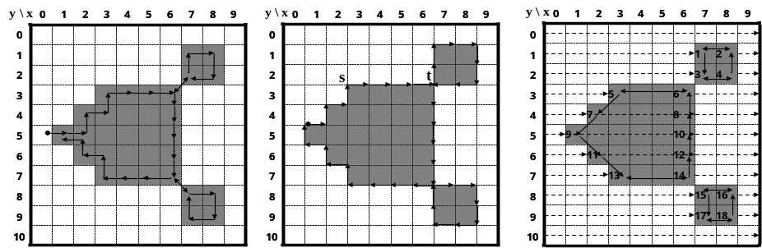
Figure 1: Contour tracer (a) Pixel-following algorithm; (b) Vertex-following algorithm; (c) Run-data-based following algorithm.

2.1.1. Pixel-following Method
The pixel-following method traces contour pixels in a predefined manner, and then saves their coordinates in memory according to the trace order. In Figure 1(a), the algorithm traces contour pixels along the clockwise direction from the current pixel, i.e., it sequentially searches adjacent black pixels of the current pixel using a relative directional order such as left, front-left, front, front-right, right, right-rear, and rear. pixel-following methods such as the simple boundary follower (SBF) [2,4,5], modified SBF (MSBF) [3], improved SBF (ISBF) [6], Moore-Neighbor tracing (MNT) [7], radial sweep algorithm (RSA) [7, 8], and Theo Pavlidis algorithm (TPA) [7], [9] have simple rules for tracing contour pixels based on a chain code. On the contrary, this method requires a frame-size memory to trace the contour, and it generates erroneous images when the contour image is enlarged [11] because it maintains only the pixel coordinates.
2.1.2. Vertex-following Method
The vertex-following method traces the vertices of the contour pixels that are located on the edges between the contour pixels and the background pixels [11]. Its procedure is similar to that of the pixel-following method because it uses a chain code and requires a frame-size memory for contour tracing; however, it traces the corners of the contour pixels and their connected edges. Moreover, it stores the corner points of the contour pixels in order to save the traced contour information, and the data can be compressed by reducing the number of points in a straight line. For example, in Figure 1(b), five points of the contour from s to t can be stored as there are only two corner points, i.e., (2.5, 2.5) and (6.5, 2.5) based on the (x, y) coordinate system. Moreover, when the contour images are enlarged, the vertex-following method can provide the correct image [11] because the traced points form the boundaries of the contour.
2.1.3. Run-data-based Following Method
The run-data-based following method, which involves the edge-point tracing of run data [11], [13], uses run data in pairs consisting of an object’s left and right edges, which are obtained using horizontal scan lines from left to right on an image. The object can have an outer contour and additional inner contours. Therefore, there are five types of run data: (left edge of outer contour, right edge of outer contour), (left edge of outer contour, left edge of inner contour), (right edge of inner contour, left edge of inner contour), (right edge of inner contour, right edge of outer contour), and (right edge of outer contour, left edge of outer contour). For contour following, the run-data-based following method constructs a run-following relationship between the edge points of two adjacent scan lines. In Figure 1(c), scan line #3 detects (left edge of 5, right edge of 6) and scan line #4 detects (left edge of 7, right edge of 8). Subsequently, the run-following relationships between 5 and 7 and between 8 and 6 are generated. The method uses only one or two line buffers, and therefore requires a smaller amount of memory when compared to the pixel-following and vertex-following methods because it uses only one or two scan lines. Examples of this method are the run-type direction code (RD code) method [11] and the PXY table-based method [13].
 | Pixel-following method | Vertex-following method | Run-data-based following method
Traced object | Contour pixel | Vertex of contour (pixel corner) | Run-data
Data construction | Coordinates of contour pixels obtained using traced sequence  (automatically) | Coordinates of vertices of contour pixels obtained using traced sequence  (automatically) | All run-data of image and run-following relationship data  (additive operation for calculating relationship between adjacent run-data horizontally)
Adaptive application [11] | Small-scale image  Slow trace is allowed | Small-scale image  Slow trace is allowed | Large-scale image such as document recognition

Table 1: Comparison of contour-following algorithms
Table 1 lists the characteristics of the contour-following methods. The pixel-following method and vertex-following method trace contours without scanning all the pixels of the image, and their transition data such as contour points and the tracing sequence are generated automatically by the contour-following process. Therefore, only a few pixels need to be scanned in order to obtain the first contour pixel representing the starting point of the object. Despite these merits, they are not suitable for large images with many objects because they require more operations and a larger memory when compared to the run-data-based following method. In other words, they scan all of the pixels with an image-buffer size memory in order to obtain all the objects, and they have several additional operations that enable them to detect whether to follow a contour pixel for all the contour pixels and their adjacent background pixels (see Figure 8).
On the contrary, the run-data-based following method searches the edge points with a smaller memory and constructs run-following relationships between edge points. Therefore, the traced run-following results are changed iteratively while the edge points are updated. This method is not simple, but it is faster than the other methods for large-scale images because it scans all of the pixels once, and it does not require any additional operations to be carried out on the pixels. Hence, it is suitable for large-scale image-based applications involving a large number of objects such as document recognition [11].
2.2. Conventional Contour-tracing Algorithms
Let I be a binary digital image with M × N pixels, where the coordinate of the top-leftmost pixel is (0, 0), and that of the bottom-rightmost pixel is (M – 1, N – 1). In I, a pixel can be represented as P = (x, y), x = 0, 1, 2,…., M – 1, and y = 0, 1, 2,…, N – 1. Most contour-tracing algorithms use a tracer T (P, d) with absolute directional information, and they have the following basic sequence:
- The tracer starts contour tracing at the contour of an object after it saves the starting point along with its initial direction.
- The tracer determines the next contour point using its specific rule of following paths according to the adjacent pixels, and then moves to the contour point and changes its absolute direction.
- If the tracer reaches the start point, then the trace procedure is terminated.

To determine the next contour point, which may be a contour pixel or pixel corner, the tracer detects the intensity of its adjacent pixel P_{r} and the new absolute direction d_{r} for P_{r} by using relative direction information r ∈ {front, front-left, left, left-rear, rear, right-rear, right, front-right}. For example, if the absolute direction of the current tracer T(P, d) is N, the left direction of the tracer d_{Left} is W. Similarly, the left pixel of tracer P_{Left} is (x – 1, y). Figures 2(a) and (b) show the directional information of the tracer, and Figure 2(c) shows the different types of contour pixels. The contour pixels can be classified into four types, namely, straight line, inner corner pixel, outer corner pixel, and inner-outer corner pixel. In Figure 2(c), “O” represents the outer corner, “I” represents the inner corner, and “IO” represents the inner-outer corner according to the local pattern of the contour.
In this study, we focus on a contour-tracing algorithm that is suitable for cases involving a relatively small number of objects, and which require real-time tracing such as augmented reality (AR), MR, and recognition image-based code in small-scale images, e.g., a mobile computing environment. Hence, we first introduce and briefly describe the conventional contour-tracing algorithms that are used in this environment, and analyze their tracing accuracy and characteristics.
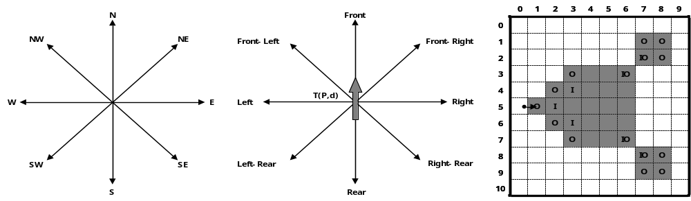
Figure 2: Directions and types of contour pixels (a) absolute direction d; (b) relative direction r; (c) Types of contour pixels.

2.2.1. Simple-boundary Follower
The simple-boundary follower (SBF) is also known as Papert’s turtle algorithm [4] and as a square-tracing algorithm [7], and it is the simplest contour-tracing algorithm. Initially, the location of tracer S is saved, and the tracer moves in a left or right direction. If the pixel tracer is located on a contour pixel, the tracer moves left; otherwise, it moves right. The procedure is as given below.
Procedure_SBF
T(P,d) ←S(P,d)
Do
If P = black then T(P,d) ←T(PLeft,dLeft)
Else T(P,d) ←T(PRight,dRight)
While T(P,d)≠S(P,d)
End_ SBF
2.2.2. Modified Simple-boundary Follower
SBF cannot trace an inner-outer corner pixel that is located at the left rear, and the modified SBF (MSBF) [3] was developed to trace these pixels. If the tracer is adjacent to the left-rear inner-outer corner, this condition implies that its left-rear pixel is black (object), and the left and rear pixels are white (background); the tracer will move to the left-rear pixel, and its direction is then changed toward the rear direction. After the movement, the tracer goes directly to the left pixel to avoid an infinite loop. Figure 3 shows examples of the SBF and MSBF paths for a left-rear direction inner-outer corner. In the case of the SBF, if the tracer is on pixel A with direction N, it misses pixel B. On the contrary, the MSBF can detour pixel B.
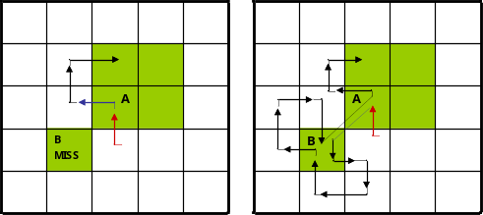
Figure 3: Detour of inner-outer corner at left-rear pixel (modified version of Ref. [3]). (a) SBF; (b) MSBF.
2.2.3. Improved Simple-boundary Follower
The SBF and MSBF require movement operations for both contour and background pixels; therefore, time is wasted during movement on the background pixel, and they cannot trace the inner-corner pixel in front of the tracer [6,7]. Hence, we propose an improved SBF (ISBF) [6] that is based on our previous research aimed at overcoming these limitations. The ISBF has six cases for following-contour pixels based on the local patterns of the contour pixels. the modified version of ref. [10] is as follows:

Procedure_ISBF
T(P,d)←S(P,d) where P is on black
Do
If PLeft = black then T(P,d)←T(PLeft,dLeft)
Else
If PLeft-Rear = black and PRear=white then T(P,d)←T(PLeft-Rear,dRear)
If PFront-Left = black
If PFront = black then T(P,d)←T(PFront,d) and T(P,d)←T(PLeft,d)
Else T(P,d)←T(PFront-Left,d)
Else If PFront = black then T(P,d)←T(PFront,dRight)
Else T(P,d)←T(P,dRear)
While T(P,d)≠S(P,d)
End_ISBF

Figure 4 represents the tracing path of the ISBF based on the local contour patterns. While the SBF cannot trace in cases (b) and (d), and the MSBF cannot follow in case (d), the ISBF successfully traces in all the cases. In the figure, the waypoint (dotted line) is subjected to a detection operation to determine whether it is black or white without employing a movement operation.
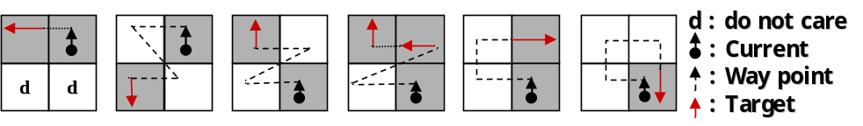
(a) Left neighbor (b) Inner-outer corner at left-rear (c) Inner-outer corner at front-left (d) Inner corner at front (e) Front neighbor (f) Outer corner
Figure 4: Contour cases of ISBF [cheong2].
2.2.4. Moore-neighbor Tracing
Moore-neighbor tracing (MNT) finds the next contour pixel using eight connected chain codes with a clockwise sequence starting from the rear pixel of the tracer, i.e., the tracer first moves toward the rear (T (P_{Rear}, d_{Rear})), and finds the next clockwise contour pixel such as the left-rear, left, font-left, front, front-right, right, and right-rear pixels [7].
2.2.5. Radial Sweep Algorithm
The radial sweep algorithm (RSA) [8] is similar to MNT, but its tracer has no directional information. Therefore, it maintains two points, namely, the previous pixel and current pixel for the initial tracing direction. Figure 5(b) illustrates an example of a tracing path obtained using RSA from P_{i} to P_{i+2}. In the figure, the direction vector from P_{i} to P_{i-1} is first generated, and the tracer then searches for the next contour pixel using the previous pixel P_{i-1} for the clockwise direction of the vector.
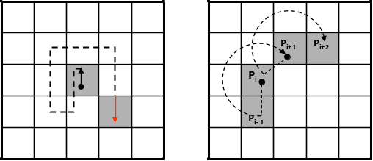
(a) MNT (b) RSA
Figure 5: Contour-following sequence of MNT and RSA.
2.2.6. Theo Pavlidis Algorithm
To determine the next contour pixel, the Theo Pavlidis algorithm (TPA) [9] considers only three adjacent pixels, e.g., front-left, front, and front-right. If all three pixels are white, the tracer turns right. Figure 6 describes the sequence of this algorithm.

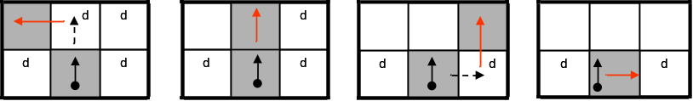
(a) Front-left contour (b) Front contour (c) Front-right contour (d) Rotation
Figure 6: Contour-following sequence of TPA [cheong2].
2.3. Conventional Data Compression and Restoration
The RD code method [11] comprises two major techniques. The first one traces the contour using a hybrid method that employs vertex following with run data, and it generates the corresponding RD codes. The other generates compressed contour data that can be used to restore the contour based on representative points and their corresponding RD codes. The representative points are selected from the vertices of contour pixels, and they are feature points of the contour. Moreover, the RD code can represent 10 local contour patterns and their corresponding following paths. Therefore, by saving the representative points and their corresponding RD codes instead of all the contour points, we can reduce the memory size used to store the contour data. Figure 7(a) [11] gives an example of representative points. There are four types of representative points in the RD method, namely, two outer corner points and two inner corner points, as shown in Figure 7(b). Although this technique can save data in small files, it does not consider the inner-outer corner pixel.

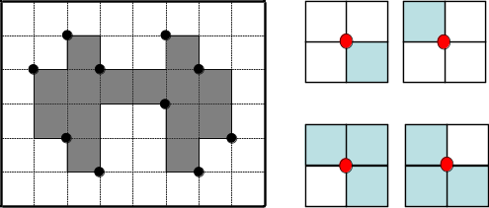
(a) Representative points [miyatake] (b) Cases of representative points
Figure 7: Representative points for data compression.
3. Analysis of Conventional Contour-following Algorithms
Figure 8 illustrates the tracing results of the pixel-following methods based on the contour shown in Figure 1. In the figure, the arrow with an anchor is the tracer at the starting pixel, the solid arrow shows the movement operation of the tracer, and the dotted line is the way point (detected pixel) for determining whether or not the pixel is a contour pixel for pixel following.
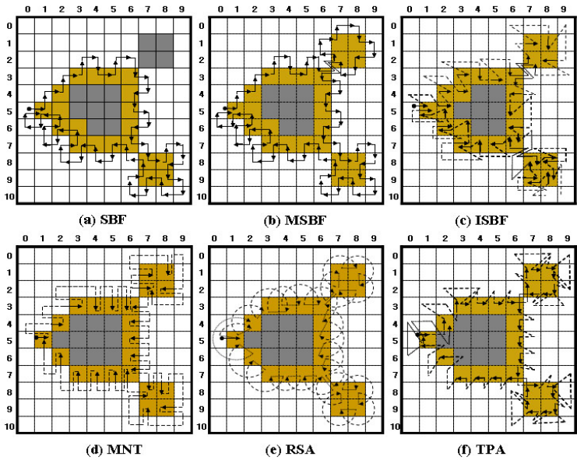
Figure 8: Comparison of Conventional Contour Pixel-following algorithms.
3.1. Pixel-following Cases
As shown in Figure 8, the ISBF traces most types of contour pixels such as the inner corner, outer corner, inner-outer corner, and straight-line pixels. In the case of the SBF, there are inconsistencies regarding tracing at the inner corner and inner-outer corner. For example, in the figure, the inner-corner pixel (3, 6) and inner-outer corner pixel (7, 8) are traced, but the inner corner (3, 4) and inner-outer corner (7, 9) pixels are missed. In the case of the MSBF, all the inner-outer corner pixels are traced, but it has inconsistencies with regard to tracing the inner-corner pixel. Moreover, the MNT, RSA, and TPA have no problems with consistency, but they cannot trace the inner corners. Among these algorithms, the TPA can be easily changed to trace an inner-corner pixel because it has waypoints on the inner corners, as shown in Figure 8(f).
3.2. Start-up Condition and Stopping Criteria
The pixel-following algorithm functions using the criteria of start-and-stop to avoid incompleteness of tracing and infinite tracing.
3.2.1. Assumption for Start
Commonly, tracing starts when the tracer enters a black pixel from a white pixel. Therefore, at the start of tracing, the tracer must be placed on a black pixel and its rear pixel P_{Rear} should be white. Moreover, in the case of the MSBF and ISBF, if the P_{Left-Rear} of the start pixel is an inner-outer corner pixel, it cannot trace all of the contour pixels using their stopping criteria [10]. In addition, TPA has to select a start pixel that has white pixels at the tracer positions P_{Left}, P_{Left-Rear}, and P_{Right-Rear} [7]; otherwise, it cannot trace the left pixel of the contour.
3.2.2. Stop Criterion
There are three methods for stopping the contour tracing [7]. The first method is Jacob’s stopping criterion [7], which terminates the trace when the tracer reenters the start pixel with an absolute direction that is the same as the start direction, i.e., if the current tracer T (P,d) is the same as the start tracer S (P,d), the pixel following is terminated. The SBF, MSBF, and ISBF use this criterion, and their tracing terminates at the start pixel, as shown in Figures 8(a)–(c). The second method uses the number of reentries to the start pixel. In Figures 8(d) and (f), the tracers of MNT and TPA revisit the start pixel (1, 5) with different directional information; therefore, they do not stop, but rather go to the next contour pixel if the first method is applied. For this reason, if a specified number of reentries, e.g., three or four times, is satisfied, the trace is terminated [7]. This method is sometimes not efficient because it requires unnecessary tracing to be performed one or more times. The final method checks the trace route that is traced by the previous pixel and current pixel of the tracer, and determines whether it has already been passed. This method is used for RSA [7,8] because its tracer has only pixel-location information, and no directional information. In other words, whenever the tracer enters the i-th contour pixel, the current pixel location P_{i} is appended sequentially into the traced contour path. Moreover, if the traced path of (P_{i-1}, P_{i}) appears twice, the tracing is terminated. This method can be applied for all pixel-following methods, and it is simpler than the second method; however, it requires more operations than Jacob’s stopping criterion.
3.3. Limitations of Conventional Pixel-following Methods
The abovementioned conventional pixel-following methods have certain limitations. First, some of the algorithms, such as SBF and MSBF, perform unnecessary movement operations on white pixels, as shown in Figures 8(a) and (b). Second, not all of the algorithms can define the contour in the case of contour pixels; therefore, they cannot be a descriptive feature of the object and determine connectivity among objects. For example, in Figure 8(b), the MSBF detects (2, 7) as the inner-outer corner pixel, but does not indicate (8, 7) as an inner-outer corner because the traced paths on the pixels are different. Moreover, the MSBF also cannot determine the inner corner, outer corner, and straight-line pixel, as is the case with the SBF. In the case of the ISBF, it determines the inner-outer corner, front-inner corner, and front-straight line pixels, but cannot determine the left-inner corner, left-straight line, and some of the outer-corner pixels, as shown in Figure 8(c). Similarly, MNT and RSA cannot determine and detect the inner corners, and TPA cannot classify the contour pixels into the different types of contour pixels. Finally, the data size of the traced contour must be considered. The pixel-following methods save all the pixel points; therefore, their data are larger than those of the RD code method.
4. Proposed Contour-tracing Algorithm
In this section, we propose a novel pixel-following algorithm that traces contour pixels by considering their local patterns. Therefore, it can classify the contour pixel as inner corner, outer corner, inner-outer corner, and straight-line contour types. Further, it can easily determine the next contour pixel. Moreover, it can determine and save representative points of an image, such as the RD code method, by using pixel following but not using run-data-based following. In addition, the data can be restored to the original contour pixels without the RD code data.
4.1. Contour Following
4.1.1. Assumptions for Start-up and Stopping Criteria
The proposed algorithm runs under two assumptions for starting. One is the general condition for pixel following, where the rear pixel of the tracer on the start pixel is white. The other is that there is no left-rear inner-outer corner for the tracer at the start position, i.e., if the rear and the left pixels are white and the rear-left pixel is black, the start pixel has to be changed. These are the same starting conditions as those used for the MSBF and ISBF. Moreover, the stop criteria of the proposed algorithm is Jacob’s stopping criterion, and the tracer is always on a contour pixel.
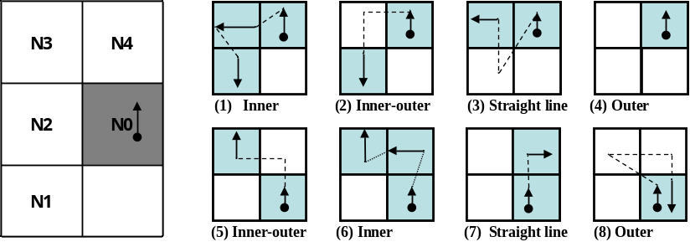
(a) Adjacent pixels (b) Contour cases
Figure 9: Contour Tracing Cases for Proposed Contour-following Algorithm.
4.1.2. Procedures
The proposed algorithm has two stages. First, the tracer follows the contour pixel based on the intensities of the left-rear and left pixels. After that, the tracer follows the contour pixels according to the intensities of the front and front-left pixels. Figure 9 shows the contour tracing cases for the proposed contour-following algorithm. In the figure, the tracer is first on N0 queries states of N1 and N2, as shown in Figure 9(a), and then the states determine the corresponding
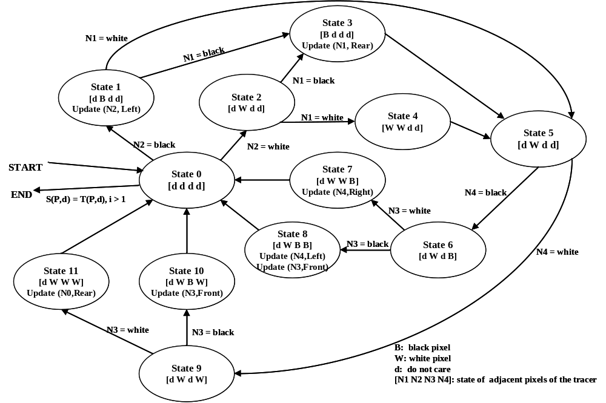
Figure 10: State Transition of Automation for Proposed Algorithm.

path to be traced from among cases (1)–(4), as shown in Figure 9(b). After stage 1, the moved tracer queries states N3 and N4, and it then traces contour pixels along the corresponding path using the states from among cases (5)–(8).
Hence, by using the proposed algorithm, the inner corners traced are considered as case (1) or case (6), the inner-outer corners are considered as case (2) or case (5), the outer corners are considered as case (4) or case (8), and the straight-line pixels are considered as the other cases. Therefore, all the cases are easily classified using the algorithm.
4.1.3. States
figure 10 describes the state transition for the automation of the proposed algorithm. In the figure, the start and termination occur at State 0. The first stage runs using States 1–4, and it then transits to state 5. the second stage continues from state 5 using states 6–11, and it then transits to state 0. For example, case (1) in Figure 9 can be executed using the transit sequence state 1, state 3, and state 5.
In Figure 10, [N1 N2 N3 N4] represents the intensity vector of the tracer’s four adjacent pixels shown in Figure 9(a). In the vector, d implies “do not care,” B represents a contour pixel (black), and W represents the background pixel (white). Moreover, Update (P,d) refers to the movement operation where P is the new contour-pixel location and d is the new directional information for the tracer. In states 1 and 3, the updates occur based on the tracer of state 0, and other updates are based on the tracer information in state 5.
4.1.4. Characteristics of Proposed Algorithm
We designed the proposed algorithm based on two stages with two major goals. First, the check operation for stopping occurs only at state 0; therefore, the number of checking operations on black pixels is reduced. In other words, the proposed algorithm verifies that the check operation occurs when only the tracer has a white rear pixel. this is more efficient when compared to the check operation that occurs for every contour pixel because its start condition and stop criterion also satisfy the condition that the rear pixel of the tracer on the start pixel should be white. Therefore, the transition of stage 2 to States 6–11 for processing cases (5) to (8) is designed such that it can be returned to state 0 only if the tracer has a white rear pixel, and it reduces any unnecessary operations that are required to stop the checking. Besides, the tracers of cases (2) and (4) have a white rear pixel after the movement, but their end conditions are not considered. In case (2), at the start, the tracer avoids the inner-outer corner pixels as the start and end pixel. Moreover, in case (4), the tracer has no update; therefore, it is unnecessary to perform the check operation twice.
Second, the proposed algorithm eliminates some of the redundant operations that are used to detect white pixels. The conventional algorithms do not consider white pixels in the previous path; therefore, they sometimes redetect white pixels on the previous tracing during the current tracing. For example, in Figure 8, the white pixel at (4, 2) is detected twice while determining contour pixels such as (4, 3) and (5, 3). Moreover, RSA detects (4, 2) three times while determining (4, 3), (5, 3), and (6, 3). On the contrary, the proposed algorithm has two stages, and its second stage avoids the previous path. Figure 11 shows the contour-tracing results obtained for the proposed algorithm, and it detects (4, 2) once for contour tracing. Moreover, the figure shows that the proposed algorithm has fewer operations on the white pixels when compared to conventional pixel-following methods, as shown in Figure 8, and it traces all types of contours.

The pseudocode of the proposed algorithm is given below:
Procedure_Proposed_Tracer

T(P,d)←S(P,d) where P is on black, P_{Rear} is on white and i←1
// Whenever T(P,d) is updated, i increases 1 and T(p’,d’) is saved automatically
Do
// Stage 1
IF P_{Left}-_{Rear}=black
IF P_{Left}=black then
T(P,d)←T(P_{Left},d_{Left}) and Code(i)←”Inner” and T(P,d)←T(P_{Left},d_{Left}) // case 1

ELSE Code(i)←”Inner-outer” and T(P,d)←T(P_{Left-Rear},d_{Rear}) and Code(i)←”Inner-outer” // case 2
ELSE
IF P_{Left}=black then T(P,d)←T(P_{Left},d_{Left}) and Code(i)←”Straight” // case 3
ELSE Code(i)←”Outer” // case 4

// Stage 2
IF P_{Front-Left}=black
IF P_{Front}=black then
T(P,d)←T(P_{Front},d_{Left}) and Code(i)←”Inner” and T(P,d)←T(P_{Front},d_{Right}) // case 6
ELSE Code(i)←”Inner-outer” T(P,d)←T(P_{Front-Left},d) and Code(i)←”Inner-outer” // case 5
ELSE IF P_{Front}=black then T(P,d)←T(P_{Front},d_{Right}) // case 7
ELSE T(P,d)←T(P,d_{Rear}) and i = i-1 and Code(i)←”Outer” // case 8
While T(P,d)≠S(P,d)

End_Proposed_Tracer

Table 2 describes the tracing results that were obtained by using the proposed algorithm up to the stage at which the tracer enters the 11th pixel. The code represents the contour pixel type, and it is classified automatically during tracing.

Table 2: Result Table for Proposed Contour Tracing.

In the table, Code (i) represents only one code, the contour pixel type per contour pixel, but it can have several codes. For example, there is an outer-corner pixel and an inner-outer corner pixel.

of
Sequence (i) | P |  | Code (i)
Sequence (i) | x | y | Code (i)
1 | 1 | 5 | Outer
2 | 2 | 5 | Inner
3 | 2 | 4 | Outer
4 | 3 | 4 | Inner
5 | 3 | 3 | Outer
6 | 4 | 3 | Straight
7 | 5 | 3 | Straight
8 | 6 | 3 | Inner-outer
9 | 7 | 2 | Inner-outer
10 | 7 | 1 | Outer
11 | 8 | 1 | -

4.2. Data compression and restoration
The proposed algorithm saves representation points and the inner-outer corner points in the form of compressed data in order to reduce the data size. The representation points are feature points that are used for storing and restoring contour pixels, while the inner-outer corner points are used for accurately restoring the inner-outer corner pixels.
4.2.1. Data Structure
The representative points and inner-outer corner points are represented as vertices of contour pixels. Figure 12(a) shows the point types of the proposed algorithm. There are seven types of representative point. They are two outer corners, two inner corners, and one inner-outer corner. In addition, there are two types of inner-outer corner point. Figure 12(b) illustrates all cases of contour tracing for the proposed algorithm and their corresponding representative points and inner-outer corner points.
These points are saved as a sequence during contour tracing. If the i-th representative point R_{i} is equivalent to (r_{i,x}, r_{i,y}), then the set of representative points R is given by {R₀, R₁, R₂,…, R_{n-1}} and R₀ = R_{n} because the starting and ending points are the same. Similarly, if C_{j} is the j-th inner-outer corner point, it can be represented using its coordinate and its type. The type of point C_{j},_{T} is assigned to be NW-SE or NE-SW, as shown in Figure 12(a). Table 3 shows the data structure for data compression and the restoration of the contour pixels using the proposed algorithm.
Figure 11: Representative points and inner-outer points in contour cases.
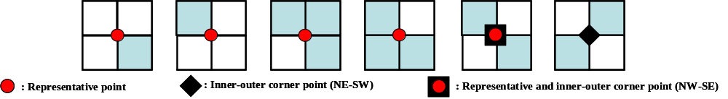
(a) Representative points and inner-outer corner points
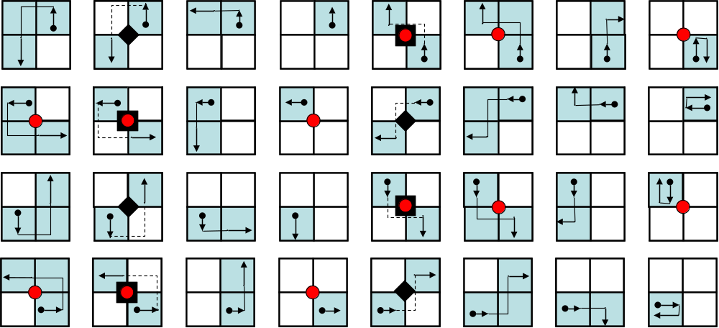
(b) Cases of the proposed algorithm

Table 3: Data Structure of Proposed Contour Tracer.

Representative Points (R_{i}) |  | Inner-outer Corner (C_{j})
x | y | x | y | Type
r_{1,x} | r_{1,y} | c_{1,x} | c_{1,y} | c_{1,T}
r_{2,x} | r_{2,y} | c_{2,x} | c_{2,y} | c_{2,T}
… | … | … | … | …

4.2.2. Contour Pixel Restoration
For the restoration, we proposed a restoration algorithm comprising two stages, namely, contour restoration and inner-outer corner restoration.
4.2.2.1. Contour Restoration with Representation Points
The sequence of representative points is important for the reconstruction of the contour pixels because it represents the contour-tracing sequence. Hence, by using the sequence of representative points and the relative location between adjacent representative points in the representative point table, the contour can be restored easily. If there are two sequential representative points R_{i} and R_{i+1}, 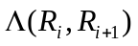, which is the relative position classifier from R_{i} to R_{i+1}, can be described as
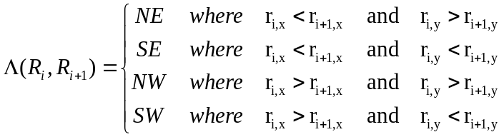. (1)
Figure 13 shows the contour-pixel reconstruction methods using the relative positions from R_{i} to R_{i+1}. In the case of SE or NW, the contour pixels are filled in a clockwise manner, while in the other cases, these pixels are filled in a counterclockwise manner.

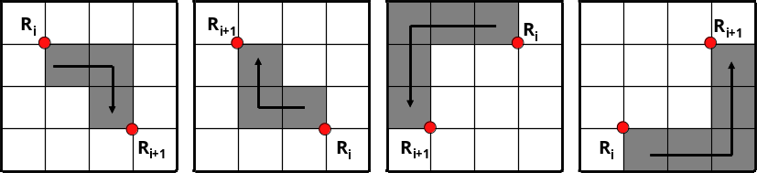
(a) SE (b) NW (c) SW (d) NE
Figure 12: Contour Pixel Reconstruction.

Table 4: Examples of Inner Corner Missing.

Case | 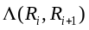 | 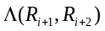
1 | SE | NE
2 | SE | SE
3 | NE | SW
4 | NE | NW
5 | NW | NW
6 | NW | SW
7 | SW | SE
8 | SW | NE

The methods in Figure 13 are the basic methods employed to restore the contour, but they are problematic when used to reconstruct the inner-corner pixel using three or more representative points. Table 4 and Figure 14 show cases of the missing inner-corner pixels using sequential representative points R_{i}, R_{i+1}, and R_{i+2}.

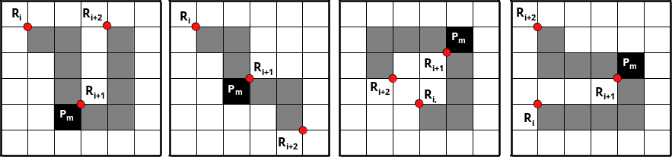
(a) Case 1 (b) Case 2 (c) Case 3 (d) Case 4
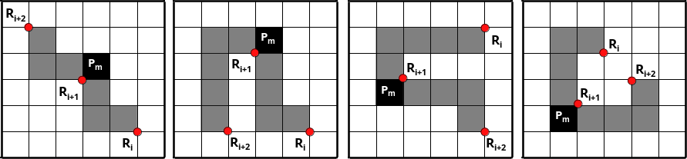
(e) Case 5 (f) Case 6 (g) Case 7 (h) Case 8
Figure 13: Restoration Cases for Different Sequences of Representation Points.

As shown in the figure, the three representative points cannot restore the inner-corner pixel P_{m}. Therefore, if the three sequential points form one of the cases in table 4, P_{m} of the middle representative point R_{i+1} must be filled with black.
This reconstruction method is different from the restoration approach in the RD code method because the proposed method does not need the RD code, but requires only representative points, and their saved sequence naturally replaces the RD code. Therefore, it requires a smaller memory size when compared to the RD code method.
4.2.2.2. Inner-outer Corner Restoration
The restored contour obtained using only the representative points has no inner-outer corners because the inner-outer corner is not considered. For this reason, if there are inner-outer corner points in the data table, as shown in Table 3, the inner-outer corners are generated using the data C_{j} with their point coordinates and types. If a pixel restored using the representative points is o(x, y), and O is the restored contour, the function of the inner-outer corner restoration, R_{IO}, can be obtained as
. (2)

5. Experimental Result
To compare the proposed algorithm with conventional algorithms, we perform an experiment to determine their accuracy, speed, and stored data size. Table 5 shows the experimental environment.
Table 5: Experimental Environment.

 | Desktop | Notebook (Samsung Sens V20)
CPU | Intel® Core™2 CPU 6300 1.86 GHz | Intel® Pentium® 4 1.80 GHz
Memory | 512 MB | 256 MB (PC133 SDRAM)
HDD | Samsung UDMA 133 7200 RPM 8 MB Buffer | Hitachi UDMA 100 4200 RPM 2 MB Buffer
O/S | Microsoft Windows XP SP2
Development | Microsoft Visual Studio 6.0 C++

We experimented on nine CCITT standard fax images with 200 dots per inch (dpi) [14]. All of these images have 1,728 × 2,339 pixels and a file size of 11,842 KB. Table 6 shows the document type of these images and the total number of contour pixels. We used these large-sized images because they have various types of contours, which is useful when comparing the efficiencies with regard to parameters such as processing time and the accuracy of the trace results of the contour-tracing algorithms.
In order to compare the proposed algorithm with conventional algorithms, we used the experimental method described in Ref. [12] to determine the start pixels of the outer and inner contours of the images. In other words, whenever any untraced contour pixel is searched using a raster scan from the left top to the right bottom of the images, this pixel is regarded as the start pixel, and the tracer starts contour tracing. If the contour is an outer contour, the tracer’s initial direction is assigned as East (“E”). On the contrary, in the case of the inner contour of an object, e.g., “e,” “p,” “q,” “R,” and “o,” the tracer’s initial direction is assigned as West (“W”), as shown in Figure 2(a).
In the experiments, we did not consider the TPA because the initial condition of the TPA [7,9]

Table 6: CCITT Fax Standard Images.

Index | Type | Total number of contour pixels
#1 | Business letter | 81,189
#2 | Circuit diagram | 50,825
#3 | Sales order table | 152,489
#4 | French document | 312,812
#5 | Technical paper | 157,377
#6 | Technical graph | 98,579
#7 | Japanese document | 283,717
#8 | Handwritten memo | 97,031
#9 | Facsimile test chart | 453,721

is that it must start with white left (“L”), left-rear (“W”), and right-rear (“R”) pixels, which is not satisfied in some of the inner contours. Figure 15 shows an example of this violation. In our experiments, there were many cases for which these conditions were not satisfied. Therefore, we could not perform identical experiments, and meaningful data were not obtained for comparing the trace results with those of the other methods.
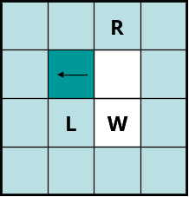
Figure 14: Problem with TPA.
5.1. Accuracy
Table 7: Comparison of Traced Contour Pixels.
he accuracy of contour tracing involves determining how accurately the tracing algorithm traces, and we measure it by counting the number of pixels traced. First, we apply each algorithm to the test images and mark the tracing on the images. Then, we count all the marked contour pixels in the images. Therefore, even if a pixel is traced several times, it is counted only once. Table 7 shows the results of the comparison between the proposed algorithm and the conventional ones. In the table, “total number” implies the total number of contour pixels, including the inner corner, outer corner, inner-outer corner, and straight-line pixels. In this result, the MNT and RSA traced the least number of pixels as contours because they could not trace the inner-corner pixels. the SBF has inconsistencies with regard to the inner-outer corner and inner-corner types. Therefore, it traced fewer pixels when compared to the ISBF and proposed algorithm. Further, the MSBF has inner-corner inconsistencies that are similar to those of the

Image | Total  Number | Proposed |  | ISBF |  | MSBF |  | SBF |  | MNT |  | RSA
Image | Total  Number | Number | % | Number | % | Number | % | Number | % | Number | % | Number | %
#1 | 81,189 | 81,188 | 100.0 | 81,188 | 100.0 | 73,743 | 90.8 | 73,613 | 90.7 | 65,503 | 80.7 | 65,503 | 80.7
#2 | 50,825 | 50,824 | 100.0 | 50,824 | 100.0 | 45,003 | 88.5 | 45,003 | 88.5 | 38,819 | 76.4 | 38,819 | 76.4
#3 | 152,489 | 152,487 | 100.0 | 152,487 | 100.0 | 139,589 | 91.5 | 139,589 | 91.5 | 126,414 | 82.9 | 126,414 | 82.9
#4 | 312,812 | 312,812 | 100.0 | 312,812 | 100.0 | 283,709 | 90.7 | 283,712 | 90.7 | 253,169 | 80.9 | 253,169 | 80.9
#5 | 157,377 | 157,374 | 100.0 | 157,374 | 100.0 | 142,447 | 90.5 | 142,453 | 90.5 | 127,306 | 80.9 | 127,306 | 80.9
#6 | 98,579 | 98,566 | 100.0 | 98,566 | 100.0 | 91,176 | 92.5 | 91,174 | 92.5 | 82,239 | 83.4 | 82,239 | 83.4
#7 | 283,717 | 283,551 | 99.9 | 283,551 | 99.9 | 264,108 | 93.1 | 264,067 | 93.1 | 238,533 | 84.1 | 238,533 | 84.1
#8 | 97,031 | 97,015 | 100.0 | 97,015 | 100.0 | 86,822 | 89.5 | 86,822 | 89.5 | 76,251 | 78.6 | 76,251 | 78.6
#9 | 453,721 | 445,975 | 98.3 | 445,972 | 98.3 | 417,687 | 92.1 | 417,735 | 92.1 | 361,439 | 79.7 | 361,439 | 79.7
Total | 1,687,740 | 1,679,792 | 99.5 | 1,679,789 | 99.5 | 1,544,284 | 91.5 | 1,544,168 | 91.5 | 1,369,673 | 81.2 | 1,369,673 | 81.2

SBF, and the MSBF traced fewer pixels when compared to the proposed algorithm and ISBF. The proposed algorithm shows that 99.5% of the total contour pixels were found to be the same as those in the case of the ISBF, and it has the maximum total number of traced contour pixels. In conclusion, the proposed algorithm produced the best results with regard to tracing accuracy.
Figure 16 shows the traced images resulting from the MSBF and proposed algorithm. In this figure, in (a), it was not possible to trace some of the inner corner pixels, but in (b), it was possible to trace all the corner-pixel types without any inconsistency. Moreover, as the proposed algorithm can classify each corner type, it can trace the selected type of contour pixels by omitting some cases, as shown in Figure 9(b). For example, if we remove the tracing cases (1) and (6) from the other cases, we can obtain a result without inner-corner tracing, and it is the same as the result of the MNT and RSA. Figure 17(b) shows an image that was traced using the proposed algorithm without inner corners, and it shows that the image is consistently traced without inner corners.
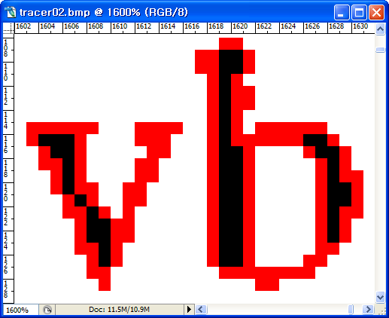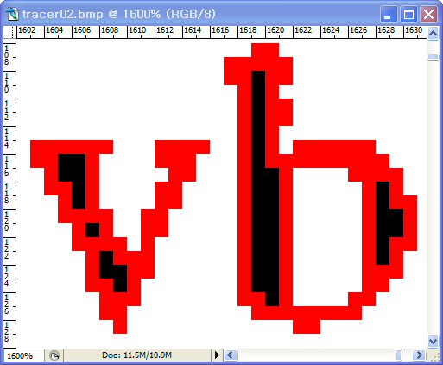
(a) MSBF (b) Proposed method

Figure 15: Comparison with Contour Tracing.

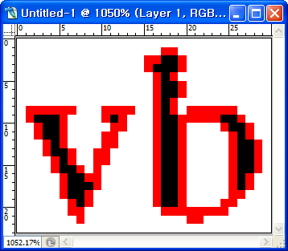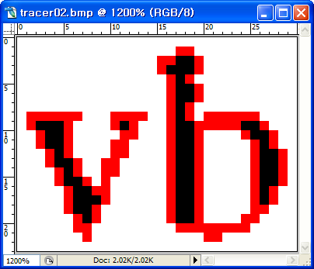
(a) MNT (b) Proposed method (without inner corners)
Figure 16: Comparison with Contour Tracing.
5.2. Speed
In order to measure the tracing time for each algorithm, we performed each algorithm 10 times per image and calculated the average time. We used the GetTickCount() function supported by Microsoft Visual C++ 6.0 to measure the processing time. Tables 8 and 9 show the average processing time of each algorithm used for tracing the images, and a linear model for estimating the process time as the number of traced pixels increases using the least-square estimation (LSE) method. In the tables, we obtain the average processing time per traced contour pixel by dividing the total processing time by the total number of traced contour pixels. They were separately measured on a desktop PC and notebook.

Image | Proposed Algorithm | ISBF | MSBF | SBF | MNT | RSA
#1 | 0.0298 | 0.0311 | 0.0329 | 0.0313 | 0.0313 | 0.0375
#2 | 0.0216 | 0.0281 | 0.0296 | 0.0234 | 0.0236 | 0.0280
#3 | 0.0389 | 0.0404 | 0.0468 | 0.0376 | 0.0404 | 0.0470
#4 | 0.0703 | 0.0750 | 0.0922 | 0.0673 | 0.0687 | 0.0921
#5 | 0.0424 | 0.0454 | 0.0500 | 0.0433 | 0.0421 | 0.0500
#6 | 0.0296 | 0.0342 | 0.0375 | 0.0329 | 0.0312 | 0.0343
#7 | 0.0654 | 0.0735 | 0.0952 | 0.0688 | 0.0672 | 0.0874
#8 | 0.0312 | 0.0344 | 0.0392 | 0.0311 | 0.0311 | 0.0328
#9 | 0.0828 | 0.0937 | 0.1314 | 0.0889 | 0.0875 | 0.1094
Average | 0.0458 | 0.0506 | 0.0616 | 0.0472 | 0.0470 | 0.0576
Average time per traced contour pixel | 2.4510⁻⁰⁷ | 2.7110⁻⁰⁷ | 3.5910⁻⁰⁷ | 2.7510⁻⁰⁷ | 3.0910⁻⁰⁷ | 3.7910⁻⁰⁷
LSE | 1.62  10⁻⁰⁷ + 0.0156 | 1.79  10⁻⁰⁷ + 0.0173 | 2.87  10⁻⁰⁷ + 0.0124 | 1.79  10⁻⁰⁷ + 0.0164 | 2.03  10⁻⁰⁷ + 0.0161 | 2.77  10⁻⁰⁷ + 0.0155
R-square | 0.956 | 0.958 | 0.983 | 0.958 | 0.964 | 0.966
* Results of best or faster than the proposed algorithm are marked as shadow.

Table 8: Experimental Result from Desktop (Unit: Second).
Table 9: Experimental Result from Notebook (Unit: Second).
Image | Proposed Algorithm | ISBF | MSBF | SBF | MNT | RSA
#1 | 0.0470 | 0.0520 | 0.0531 | 0.0450 | 0.0510 | 0.0541
#2 | 0.0380 | 0.0380 | 0.0390 | 0.0350 | 0.0412 | 0.0401
#3 | 0.0670 | 0.0700 | 0.0751 | 0.0611 | 0.0752 | 0.0820
#4 | 0.1171 | 0.1250 | 0.1412 | 0.1061 | 0.1293 | 0.1454
#5 | 0.0680 | 0.0740 | 0.0780 | 0.0631 | 0.0731 | 0.0832
#6 | 0.0532 | 0.0531 | 0.0581 | 0.0501 | 0.0561 | 0.0600
#7 | 0.1142 | 0.1250 | 0.1441 | 0.1091 | 0.1330 | 0.1432
#8 | 0.0521 | 0.0521 | 0.0581 | 0.0490 | 0.0530 | 0.0591
#9 | 0.1593 | 0.1703 | 0.2031 | 0.1455 | 0.1731 | 0.2005
Average | 0.0795 | 0.0844 | 0.0944 | 0.0738 | 0.0872 | 0.0964
Average per contour pixel | 4.2610⁻⁰⁷ | 4.5210⁻⁰⁷ | 5.5010⁻⁰⁷ | 4.3010⁻⁰⁷ | 5.7310⁻⁰⁷ | 6.3310⁻⁰⁷
LSE | 3.10  10⁻⁰⁷ + 0.0217 | 3.39  10⁻⁰⁷ + 0.0210 | 4.46  10⁻⁰⁷ + 0.0179 | 3.01  10⁻⁰⁷ + 0.0221 | 4.26  10⁻⁰⁷ + 0.0223 | 5.00  10⁻⁰⁷ + 0.0203
R-square | 0.997 | 0.994 | 0.995 | 0.993 | 0.993 | 0.999
* Results of best or faster than the proposed algorithm are marked as shadow.

Figure 17. Comparison of contour tracing

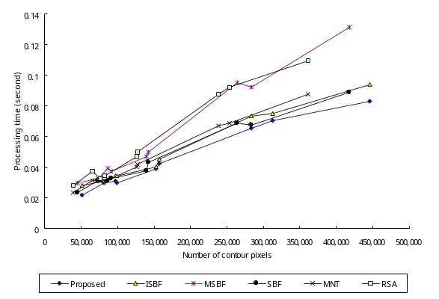 | 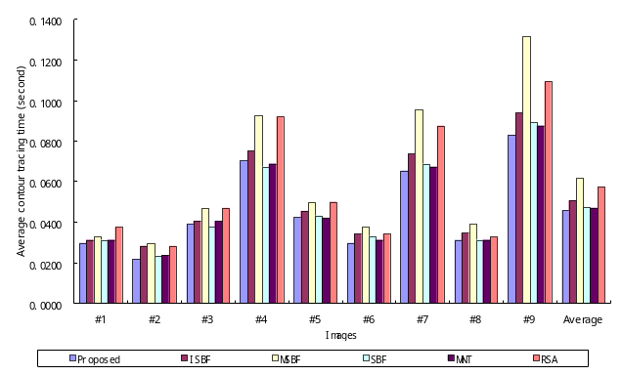
(a) Processing time vs. the number of contour pixels (desktop) | (b) Average contour tracing time vs. images (desktop)
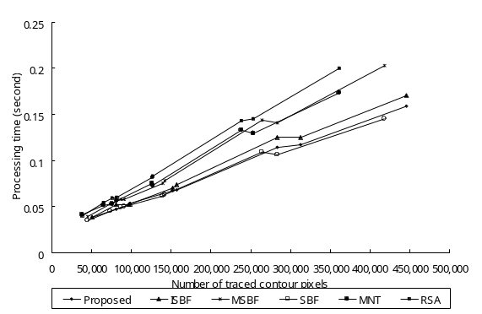 | 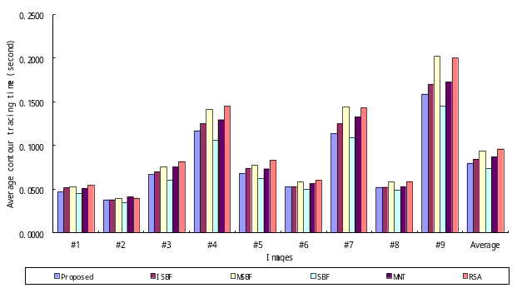
(c) Processing time vs. the number of contour pixels (notebook) | (d) Average contour tracing time vs. images (notebook)

Figure 17: Comparison of Tracing Times of Contour-tracing Algorithms.

Figure 18 illustrates a graph that uses data from tables 7–9. As shown in Figures 18(a) and (b), the proposed algorithm has the best performance in the case of the desktop PC, i.e., it had the least average processing time and showed the smallest increase in the ratio of the process time to the number of traced contour pixels, as shown in the LSE. In particular, although the proposed algorithm traced most of the contour pixels in each image, it has the best or a good performance when compared to the conventional algorithms. On the contrary, for the notebook PC, the SBF had the smallest average processing time for images and the smallest ratio from the LSE. In addition, the proposed algorithm is ranked second based on the average processing time and LSE. from these experimental results, the SBF algorithm is not ideal for the notebook PC because the ratio of the number of traced contour pixels is only approximately 92% of the value of the proposed algorithm. Therefore, the proposed algorithm has a better performance than the other algorithms for the number of traced contour pixels and the processing time.
5.3. Reduced Memory
The proposed algorithm does not save all of the contour pixels, but it saves only the representative points and the inner-outer corner pixels. Table 10 shows the data size acquired from the above experiments performed using CCITT standard fax images. It shows the data sizes of traced contour pixels and their compressed data. The number of traced contour pixels (A), which are the same results from Table 7, and C and D in the table indicate the number of representative points and inner-outer corner points of the traced contour pixels. A and C are the number of (x, y) coordinates, and D represents the number of inner-outer corners that comprise (x, y) coordinates and the type of inner-outer corner. The benefit of storing only the representative points based on the vertex of the contour pixel is that it can
Table 10: Comparison Between Total Contour Pixels and Representative Points.
 | Entire contour pixels |  | Compressed data |  |  | Ratio (%)  (E / B100)
 | Number of contour pixels  (A) | Data size  (B = A2) | Number of representative points  (C) | Number of Inner-outer corner points  (D) | Data size  (E = C2+D3) | Ratio (%)  (E / B100)
#1 | 81,188 | 162,376 | 21,206 | 61 | 42,595 | 26.23
#2 | 50,824 | 101,648 | 12,695 | 21 | 25,453 | 25.04
#3 | 152,487 | 304,974 | 30,181 | 53 | 60,521 | 19.84
#4 | 312,812 | 625,624 | 86,953 | 442 | 175,232 | 28.01
#5 | 157,374 | 314,748 | 37,386 | 113 | 75,111 | 23.86
#6 | 98,566 | 197,132 | 18,464 | 104 | 37,240 | 18.89
#7 | 283,551 | 567,102 | 84,484 | 1,539 | 173,585 | 30.61
#8 | 97,015 | 194,030 | 21,928 | 104 | 44,168 | 22.76
#10 | 445,975 | 891,950 | 158,529 | 75,425 | 543,333 | 60.92

Figure 18: Example of Restoration of Contour Pixels.

significantly reduce the data size. The experimental results obtained show that the proposed algorithm reduced the data size to 19~60% of the memory used when all of the contour pixels were stored, as shown in Table 10.
5.4. Restoration
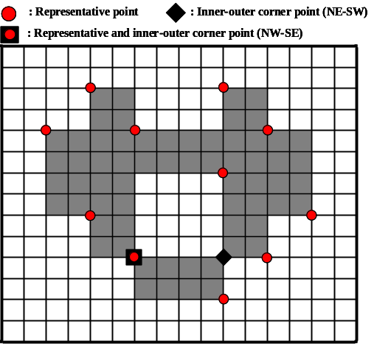
(a) Original image and its saved points for restoration (b) restoration by saved data

Figure 19 shows an example of the retrieval points and a restoration result obtained using the proposed restoration algorithm. Figure 19(a) is an example image that has all of the contour pixel types, and it depicts the representative points and inner-outer corner points for contour description and restoration. This image has two contours, namely an outer contour and an inner contour that includes two inner-outer corners. Table 11 describes these data and Figure 18 (b) shows the restoration results, which were retrieved using the data from table 11. In the figure, the restored contour accurately represents the original contour pixels.
Table 11: Saved Data.
i | Contour #1. (outer contour) |  |  |  |  | Contour #2. (inner contour)
i | R_{i} |  | C_{i} |  |  | R_{i} |  | C_{i}
i | x | y | x | y | type | x | y | x | y | type
1 | 3.5 | 1.5 | 9.5 | 9.5 | NE-SW | 5.5 | 9.5 | 5.5 | 9.5 | NW-SE
2 | 5.5 | 3.5 | 5.5 | 9.5 | NW-SE | 9.5 | 5.5 | 9.5 | 9.5 | NE-SW
3 | 9.5 | 1.5
4 | 11.5 | 3.5
5 | 13.5 | 7.5
6 | 11.5 | 9.5
7 | 9.5 | 11.5
8 | 5.5 | 9.5
9 | 3.5 | 7.5
10 | 1.5 | 3.5

Figure 20 shows the result obtained for the CCITT #1 image using the proposed restoration algorithm. Figure 20(a) represents the contour-tracing result, and (b) depicts the result of restoration from the compressed contour data. To verify the identity, we compared the contour pixels of the two images, and found that they are identical with regard to the number of contour pixels and the pixel coordinates, i.e., the contour pixels in the restoration result are the same as the original contour pixels. As shown in Figures 19 and 20, these experiments proved that the proposed algorithm could trace the inner and outer contours. Further, it was able to store the results using less memory by storing only the representative points and
 
(a) Result of contour tracing (b) Result of contour restoration
Figure 19: Result of Experiment for CCITT #1. Red Pixels are Contour Pixels.

inner-outer corner points instead of all the contour pixels; moreover, it could correctly restore all the contour pixels from the compressed data. Besides, as shown in Ref. [11], compressed data based on vertex contours guarantee precise enlarging.
5.5. Limitations
In the experiments, there were missing contour pixels that did not satisfy the experimental conditions described in Ref. [12]. In Figures 21(b) and (c), there are eight untraced contour pixels because the horizontal scan line cannot find a starting pixel for the contour under certain conditions. In other words, because the scan line seeks an untraced black pixel with an adjacent white pixel on the horizontal line, if the untraced contour pixel that is between two black pixels in the horizontal direction has an adjacent white pixel in the vertical and/or diagonal direction, the untraced contour pixel cannot be considered as the starting pixel. Therefore, as shown in Table 7, the missing contour pixels remain after running the proposed algorithm, and the untraced contour pixels of other algorithms are included in the missing contour pixels for the same reason. In particular, image #9 has the largest number of missing contour pixels because it has many one-pixel-sized chessboard patterns that comprise inner-outer corner pixels. The chessboard pattern consists of one-pixel-sized inner-outer corner pixels, which tend to cause the missing start-pixel problem.
To overcome the problem, we applied an eight-connection mask to the images to obtain the starting pixel, but the mask required many operations. In other words, we attempted to measure the performance of multidirection scanning in order to eliminate the missing contour-pixel problem by using vertical and horizontal scans instead of an eight-connection mask operation. Table 12 shows the increase in the number of pixels traced using bidirectional scanning, and Table 13 describes the processing time for this method. Moreover, Figure 22 shows the tracing result that was obtained using the proposed algorithm based on bidirectional scanning, and it shows that seven of the missing pixels are traced, but one diagonal connective-contour pixel (A) remained untraced.
Table 12: Increases of Pixels Traced by Bidirectional Scan From One-directional Scan.
 | Total | Proposed |  | ISBF |  | MSBF |  | SBF |  | MNT |  | RSA
 | Number | Number | % | Number | % | Number | % | Number | % | Number | % | Number | %
#1 | 81,189 | 1 | 0.001 | 1 | 0.001 | 1 | 0.001 | 1 | 0.001 | 0 | 0.000 | 0 | 0.000
#2 | 50,825 | 0 | 0.000 | 0 | 0.000 | 0 | 0.000 | 0 | 0.000 | 0 | 0.000 | 0 | 0.000
#3 | 152,489 | 2 | 0.001 | 2 | 0.001 | 3 | 0.002 | 3 | 0.002 | 1 | 0.001 | 1 | 0.001
#4 | 312,812 | 0 | 0.000 | 0 | 0.000 | 0 | 0.000 | 0 | 0.000 | 0 | 0.000 | 0 | 0.000
#5 | 157,377 | 3 | 0.002 | 3 | 0.002 | 0 | 0.000 | 0 | 0.000 | 0 | 0.000 | 0 | 0.000
#6 | 98,579 | 7 | 0.007 | 7 | 0.007 | 8 | 0.008 | 8 | 0.008 | 1 | 0.001 | 1 | 0.001
#7 | 283,717 | 120 | 0.042 | 120 | 0.042 | 67 | 0.024 | 67 | 0.024 | 92 | 0.032 | 92 | 0.032
#8 | 97,031 | 12 | 0.012 | 12 | 0.012 | 15 | 0.015 | 15 | 0.015 | 1 | 0.001 | 1 | 0.001
#9 | 453,721 | 7,075 | 1.559 | 7,076 | 1.560 | 433 | 0.095 | 444 | 0.098 | 3,414 | 0.752 | 3,414 | 0.752
Total | 1,687,740 | 7,220 | 0.428 | 7,221 | 0.428 | 527 | 0.031 | 538 | 0.032 | 3,509 | 0.208 | 3,509 | 0.208

Figure 20: Example of Untraed Contour Pixels Caused by Missing Starting Pixel CCITT Image #9 From (1093, 1766) to (1108, 1780).
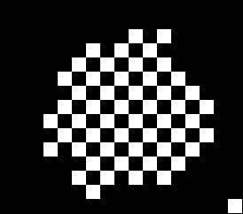 | 
(a) original image | (b) traced by ISBF | (c) traced by the proposed algorithm


Figure 22. Result of the proposed algorithm by using bidirectional scanning.

Not found pixel despite of bi-directional scanning
Figure 21: Result of Proposed Algorithm by using Bidirectional Scanning.

In the above tables, bidirectional scanning slightly increases the number of traced contour pixels, but their processing time increases significantly. Moreover, the proposed algorithm shows acceptable performance in terms of accuracy (99.5%), although we performed only unidirectional scanning. Hence, unidirectional scanning based on the proposed algorithm is sufficient for application to contour tracing under the condition that relatively few objects are present, and we performed real-time tracing such as AR, MR, and recognition-image-based code on small-scale images such as those in a mobile computing environment.
Table 13. Computational Time Traced Bidirectionally.
 | Proposed |  | ISBF |  | MSBF |  | SBF |  | MNT |  | RSA
Image | Processing  time | Ratio* | Processing  time | Ratio* | Processing  time | Ratio* | Processing  time | Ratio* | Processing  time | Ratio* | Processing  time | Ratio*
#1 | 0.064 | 2.1 | 0.067 | 2.2 | 0.074 | 2.2 | 0.064 | 2.0 | 0.067 | 2.1 | 0.069 | 1.8
#2 | 0.061 | 2.8 | 0.063 | 2.2 | 0.061 | 2.1 | 0.056 | 2.4 | 0.061 | 2.6 | 0.067 | 2.4
#3 | 0.072 | 1.9 | 0.083 | 2.1 | 0.084 | 1.8 | 0.077 | 2.0 | 0.077 | 1.9 | 0.083 | 1.8
#4 | 0.11 | 1.6 | 0.116 | 1.5 | 0.131 | 1.4 | 0.109 | 1.6 | 0.111 | 1.6 | 0.135 | 1.5
#5 | 0.078 | 1.8 | 0.084 | 1.9 | 0.089 | 1.8 | 0.078 | 1.8 | 0.078 | 1.9 | 0.089 | 1.8
#6 | 0.065 | 2.2 | 0.073 | 2.1 | 0.075 | 2.0 | 0.064 | 1.9 | 0.07 | 2.2 | 0.072 | 2.1
#7 | 0.108 | 1.7 | 0.111 | 1.5 | 0.134 | 1.4 | 0.11 | 1.6 | 0.113 | 1.7 | 0.125 | 1.4
#8 | 0.069 | 2.2 | 0.07 | 2.0 | 0.074 | 1.9 | 0.067 | 2.2 | 0.067 | 2.2 | 0.075 | 2.3
#9 | 0.128 | 1.5 | 0.139 | 1.5 | 0.172 | 1.3 | 0.127 | 1.4 | 0.13 | 1.5 | 0.147 | 1.3
Total | 0.755 | 1.8 | 0.806 | 1.8 | 0.894 | 1.6 | 0.752 | 1.8 | 0.774 | 1.8 | 0.862 | 1.7
* ratio = processing time by bi-directional scanning / processing time by one-directional scanning of Table 8.
6. Conclusion
In this paper, we proposed a contour-tracing algorithm to trace contours in low-performance devices such as mobile phones, PDAs, and embedded devices that have a processor with limited computational capability and a small memory capacity. The proposed algorithm traces contour pixels based on the pixel-following method, and it can also convert the contour information to compressed data and accurately restore it to the original contour using the vertex-following method. The proposed algorithm repeatedly executes the two tracing stages. first, the tracer moves to the next pixel based on its left and left-rear pixels. Next, it moves based on the front and front-left pixels. With these pixel pairs, the contour pixels can be classified as four types, namely, inner corner, outer corner, inner-outer corner, and straight line, and we used these classifications to reduce the computational time required for tracing the next contour pixel without duplicated detection of the background pixel. Moreover, based on the classified cases, we can determine the representative points and the inner-outer corner points that are based on the coordinates of the vertices, and we can store the contour data as points in order to reduce the data size. In addition, we proposed a restoration algorithm to retrieve all of the contour pixels from the representative points and the inner-outer corner points. The proposed algorithm performs accurate restoration, and it can restore the inner-outer corners that were not considered in conventional algorithms such as the RD code method and the PXY method. Another characteristic of the proposed algorithm is that it can trace the desired type of connectivity because it is able to distinguish between the different types of connections of the contour pixels. For example, the proposed algorithm may trace without inner corners, which is similar to the performances of MNT and RSA.
We performed experiments with regard to three aspects—accuracy, speed, and saving data. From the experiment results, the proposed algorithm had the best performance with regard to the accuracy of contour tracing, i.e., of all the algorithms, it traced the largest number of contour pixels. Moreover, it had the smallest average processing time per contour pixel and good performance with respect to the processing time of each image and the LSE. For this reason, it is considered to have reasonable performance, and based on its accuracy and processing time, it is regarded as the best of the different algorithms. In addition to the accuracy and speed, the proposed algorithm exhibited good performance with regard to the memory consumption. It stored only the representative points and inner-outer corner points, thus reducing the memory consumption. Besides, the proposed restoration algorithm successfully retrieved all the contour pixels from the compressed data. Therefore, the proposed algorithm shows improved accuracy and fast processing of contour tracing, low memory consumption for saving the contour, and good restoration ability.
References
- McQueen, W. A. “Contour tracing and boundary detection for object” U.S. Patent No. 6,674,904, Jan. 6, 2004.
- Pitas, I. Digital Image Processing Algorithms and Applications, John Wiley & Sons, 2000, pp 275–329.
- Gose, E.; Johnsonbaugh, R.; Jost, S. Pattern recognition and image analysis, Upper Saddle River, NJ: Prentice Hall, 1996, pp 338–346.
- Das, M.; Paulik, M. J.; Loh, N. K. "A bivariate autoregressive modeling technique for analysis and classification of planar shapes," IEEE Trans. on Pattern Analysis and Machine Intelligence, Jan. 1990, Vol. 12, no. 1, pp 97–103.
- Papert, S. Uses of Technology to Enhance Education, AI memo 298, AI Lab., MIT, 1973: ftp://publications.ai.mit.edu/ai-publications/pdf/AIM-298.pdf, Apr., 2007.
- Cheong, C.; Han, T. -D. “Improved simple boundary following algorithm” Journal of Korea Information Science Society: Software and Applications, Apr. 2006, Vol. 33, no. 4, pp 427–439.
- Ghuneim, A. G. “Contour tracing,”
http://www.imageprocessingplace.com/DIP/dip_downloads/tutorials/contour_tracing_Abeer_George_Ghuneim/index.html, Apr. 2007.
- Mirante, A.; Weingarten, N. “The radial sweep algorithm for constructing triangular irregular networks,” IEEE Computer Graphics and Applications, 1982, pp 11–21.
- Pavlidis, T. Algorithms for Graphics and Image Processing, Rockville, Maryland: Computer Science Press Inc., 1982.
- Cheng, C.; Seo, J.-H.; Han, T.-D. "Advanced contour tracing algorithms based on analysis of tracing conditions," in Proc. of the 33rd KISS Fall Conference, Vol. 33, no. 2, Seoul, Korea: Korea Information Science Society, Oct. 2006, pp 431-436.
- Miyatake, T.; Matsushima, H.; Ejiri, M. “Contour representation of binary images using run-type direction codes,” Machine Vision and Applications, 1997, pp 193-200, Springer-Verlag.
- Danielsson, P.-E. “An improvement of Kruses’s segmentation algorithm,” Computer Graphics and Image Processing, 1981, Vol. 17, Academic Press, pp 394–396.
- Shoji, K.; Miyamich, J.; Hirano, K. “Contour following and reconstruction of binary image stored in run format,” System and Computers in Japan, 1999, Vol. 30, no. 11, Scripta Technica, pp. 1–11.
- Image Power, Inc. “Image power compression efficiencies”, http://www.imagepower.com/compress/, Apr. 2007
- [Stelldinger] Peer Stelldinger, Ullrich Köthe, Hans Meine, Topologically correct image segmentation using alpha shapes, in: A. Kuba, L. Nyul, K. Palagyi (Eds.): Discrete Geometry for Computer Imagery, Proc. DGCI 2006, Lecture Notes in Computer Science 4245, pp 542–554, Berlin: Springer, 2006.
- Marchand-Maillet, S.; Sharaiha, Y. M. Binary Digital Image Processing, Academic Press, 2000, pp 173–180.
- Chang, F.; Chen, C.-J.; Lu, C.-J. Lu, "A linear-time component-labeling algorithm using contour tracing technique," Comput. Vis. Image Underst. 93(2), pp 206-220, 2004.
- [Johnson] Johnson, W.; Jellinek, H.; Klotz, L.; Rao, R.; Card, S. "Bridging the paper and electronic worlds: the paper user interface," in Proceedings of Interact ’93 and CHI’93 Conference on Human Factors in Computing Systems, S. Ashlund, K. Mullet, A. Henderson, E. Hollnagel, and T. White, Eds. New York: Association for Computing Machinery Press, 1993, pp 507-512.
- [Hecht ] Hecht, D. L. “Printed embedded data graphical user interfaces,” IEEE Computer, Vol. 34, no.3, pp 47-55, 2001.
- [Nelson] Nelson, L.; Ichimura, S.; Pedersen, E. R.; Adams, L. “Palette: a paper interface for giving presentations,” in Proceedings of ACM SIGCHI Conference on Human Factors and Computing Systems, M. G. William and M. W. Altom, Eds. New York: Association for Computing Machinery Press, 1999, pp 354-361.
- [Hautala ] Hautala, T.; Kallenbach, J.; Nuutinen, M.; Salo, L.; Venho, T.; Bäck, A.; Bäckström, C.; Hakola, L.; Järvinen, T.“PrintAccess,” http://www.media.hut.fi/GTTS/GAiF/GAiF2_2005.htm#PrintAccess — Final Report.
- [Usuda] Usuda, H.; Suzuku, M.; Maeda, Research Result Report on Creation and Transmission of Digital Contents Using Image Recognition Technology (Summary Version), Project Code IMS 0359, Japan: Sony Corporation, 2004.
- [Hunter] Hunter, K. D. “Automatic access of internet content with a camera-enabled cell phone,” US6993573, United States Patent and Trademark Office, 2006.
- [Rekimoto] Rekimoto, J.; Ayatsuka, Y. "Cyber code: Designing augmented reality environments with visual tags,” in Proceedings Designing Augmented Reality Environments, W. E. Mackay, Ed. New York: Association for Computing Machinery Press, 2000, pp. 1–10.
- [vallino] Vallino, J. R. “Interactive Augmented Reality,” Ph.D. Dissertation, New York: University of Rochester, 1998.
- [anuma] Azuma, R.; Baillot, Y.; Behringer, R.; Feiner, S.; Julier, S.; MacIntyre, B. “Recent advances in augmented reality,” IEEE Computer Graphics and Applications, 2001, Vol. 21, no. 6, pp 34–47.
- [ARTOOLKIT] HITLab, ”ARToolKit,” http://www.hitl.washington.edu/artoolkit.
- [Fiala] Fiala, M. “ARTag, a fiducial marker system using digital techniques,” in Proceedings of IEEE Computer Vision and Pattern Recognition, C. Schmid, S. Soatto, and C. Tomasi, Eds. Vol. 2, Los Angeles, CA: IEEE Computer Society, 2005, pp 590–596.
- [colorzip] ColorZip Media, http://www.colorzip.co.jp/en.

Cheolho Cheong (M’02) received the B.S. degrees in Statistics and Computer Science from Yonsei University, Seoul, Korea, in 1994 and 1998, respectively, and the M.S. degree in Computer Science from Yonsei University in 2001. He is now a Ph.D. student at the Yonsei University, and a senior engineer at ColorZip Media Inc. in Seoul, Korea. His research interests include vision, pattern recognition, and human-computer interaction (HCI).

Jonghoon Seo (M’07) received the B.S. degree in computer science, from Yonsei University, Seoul, Korea in 2006. He is an M.S. student in the Department of Computer Science at Yonsei University in Seoul, Korea. His research interests are in vision and graphics.

Tack-Don Han received the B.S. degree in electronic engineering from Yonsei University, Seoul, Korea, in 1978, and the M.S. degree in computer engineering from Wayne State University in 1983. In 1987, he received the Ph.D. degree in computer engineering from the University of Massachusetts at Amherst. He is a professor in the Department of Computer Science at the Yonsei University, Korea. His research interests include high-performance computer architecture, 3D graphics, and vision.

 

