

SAP Integration Developer Workshop

Hands-on Lab Step-by-Step Guide
July 2025

Contents
SAP Integration Developer Workshop 1
Exercise 8: Import Additional Flows for Approvals in Teams and Auto create of Vendor Invoice. 3
Exercise 11: Adding a field to a canvas app and updating the flows. 5
Exercise 12: Create and Add AI Builder Model 20
Exercise 13: Create Vendor Invoice using AI Builder and use Teams for Approval. 34

Overview and Extending the Procurement Templates

The next set of exercises will be focused on an overview and extending the Procurement templates. We will import another solution that has flows for PO Approval in Teams and a flow that uses AI Builder to create the vendor invoice based on incoming email. We will walk through the Vendor Management, Purchase Requisitions, Purchase Order, Goods Receipt, Vendor Invoices and Vendor Payment applications and the cloud flows associated with them. We will then customize both a canvas app and a cloud flow, so you are comfortable extending the Procurement template for your customer.

SAP procurement solution template for Power Platform - Power Platform | Microsoft Learn

Exercise 8: Import Additional Flows for Approvals in Teams and Auto create of Vendor Invoice.
In this exercise, we will import an unmanaged solution that has cloud flows to route approvals through Teams and a cloud flow that uses an AI Builder model that will gather information from an emailed invoice to create the vendor invoice in SAP.
- In the main Power Automate menu, click on Import solution.
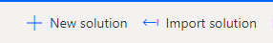

- Click on Browse and select the AskSAP from the workshop resources and then click on Next.

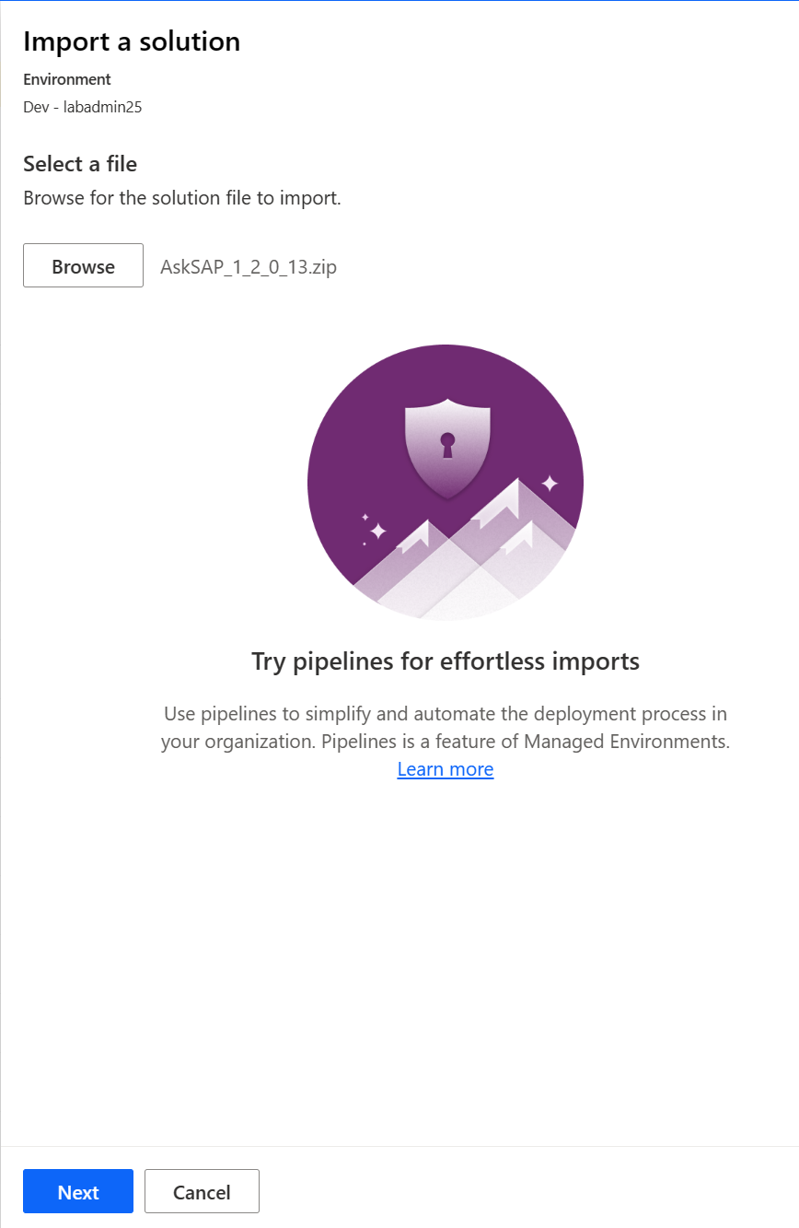

- Set up any Connections needed using your lab credentials using the same process as before and then click on Import.

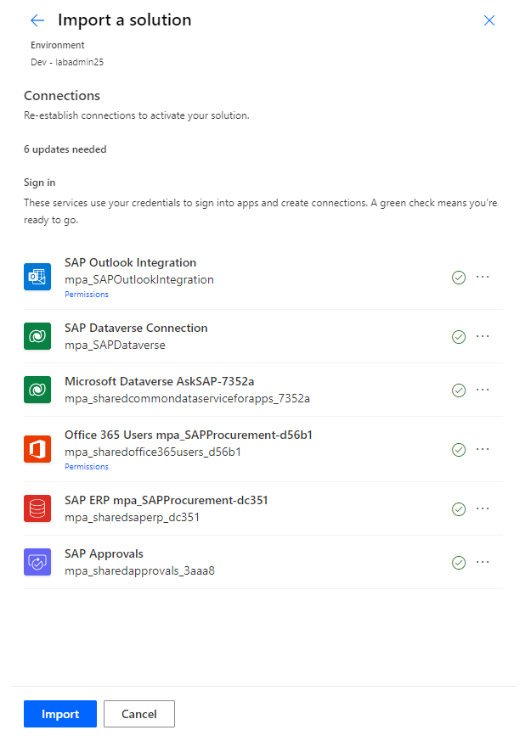

- Ensure all the flows are turned on. If not, turn them on. Specifically, check CreateRequisition and UpdateRequisition flows are turned on.

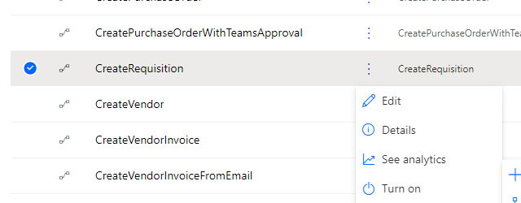

- Publish all customizations. Back out of the specific solution. Click on Publish all customizations.

Exercise 11: Adding a field to a canvas app and updating the flows.
In this exercise, we will add a new field to the Purchasing app and update the cloud flows to send and bring the data for that field back from SAP. We will be working in the SAP Procurement Approval and AI Builder flows solution.
- Open the solution. In the main Power Automate menu, open the SAP Procurement Approval and AI Builder flows solution.

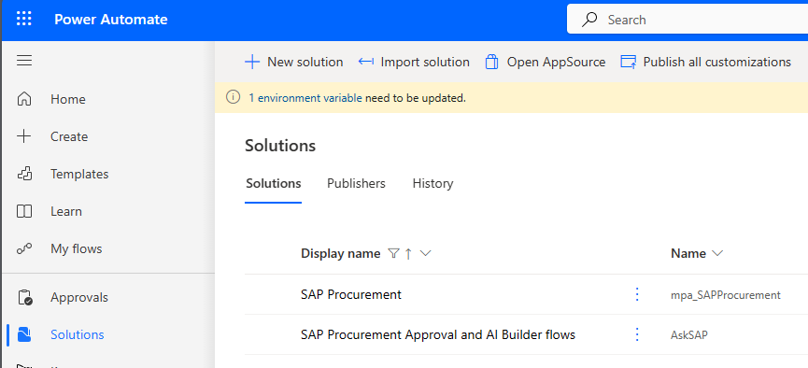

- We are going to directly edit the canvas app and cloud flows for the sake of simplicity in the labs. If you import an update and choose to remove the unmanaged layer, any customization will be overwritten. Alternatively, you can make a copy of the app and flow that is specific for each customer. These will be in the unmanaged layer and would not be affected with an update. Also, if you change the name of the flow, you will need to update that in the canvas app.

Solution layers - Power Apps | Microsoft Learn

Select the SAP Purchase Orders canvas app. Click on the 3 dots and then select Edit and Edit in new tab.
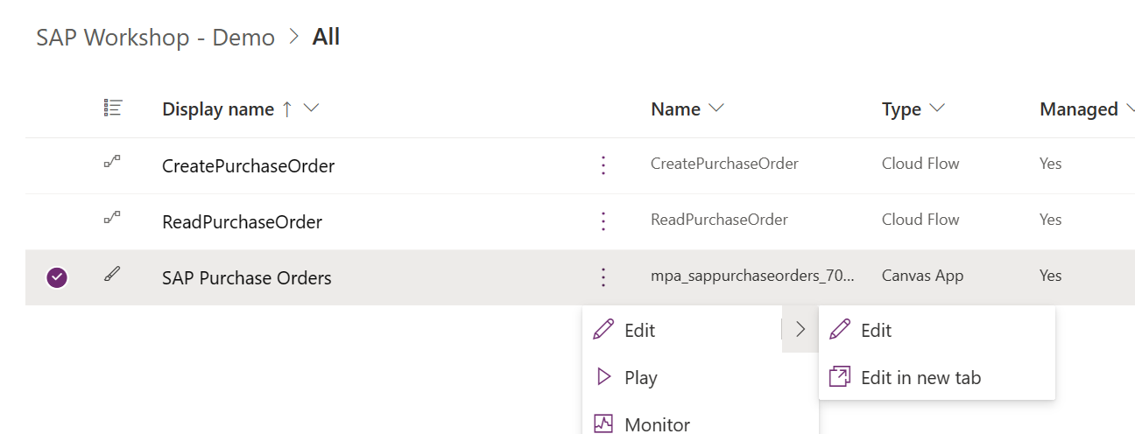

- We will be adding a new field to the Purchase Orders Details Screen. In the left-hand navigation, expand the Purchase Orders Detail Screen to see the various items on the screen.
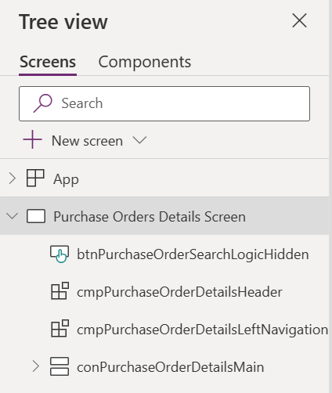
- The app was built with the best practice of using containers to enable the app to be responsive. We are going to copy the Currency container and modify it to display the new field Company Code. Click on the Currency field on the canvas app and then select the conPurchaseOrderDetailsCurrency contaniner in the left-hand navigation. Click on the ellipse (…) and then Copy.

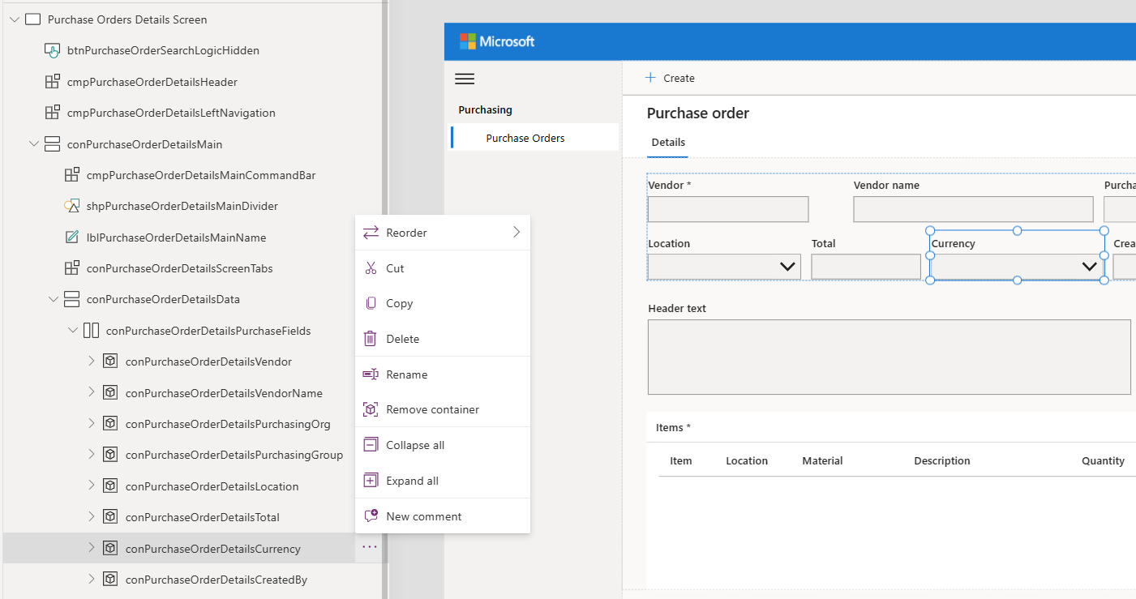

- Select the conPurchaseOrderDetailsPurchaseFields container and then paste the fields next to the Approved by field. We now have a 2nd currency field in our details container.

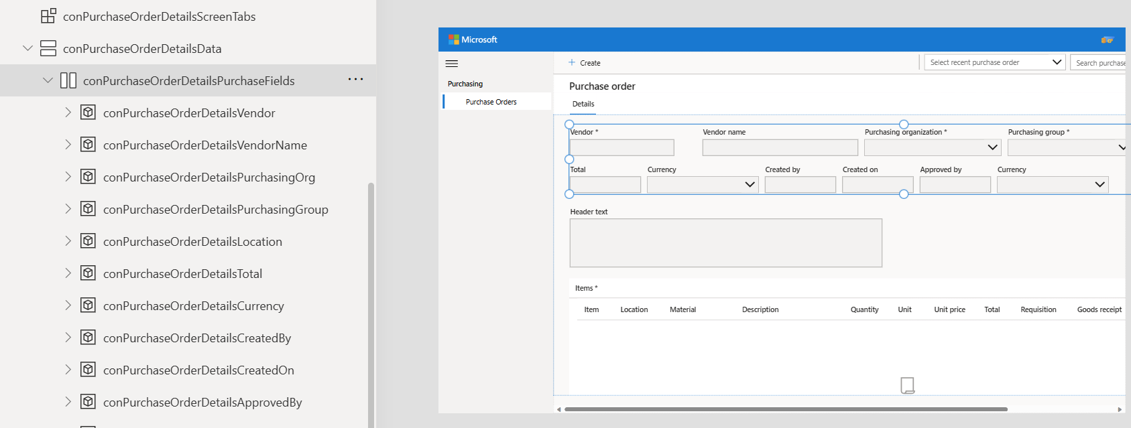

- Update the container, label and combo box. We need to rename the container. Select the conPurchaseOrderDetailsCurrency_1 container, then click on the ellipse (…). Select Rename and rename to conPurcahseOrderDetailsCompanyCode.

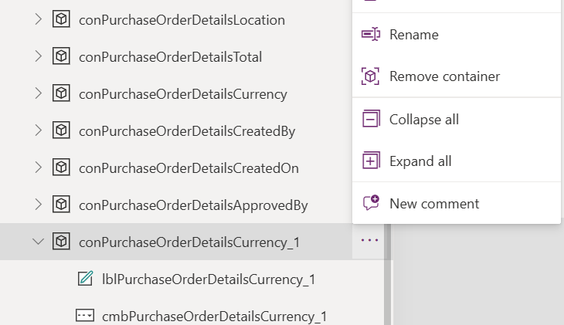

- Rename and update the label. Select the label in the container. Rename to lblPurchaseOrderDetailsCompanyCode and update the Text property to “Company Code”. You can leave the rest of the text property the same.

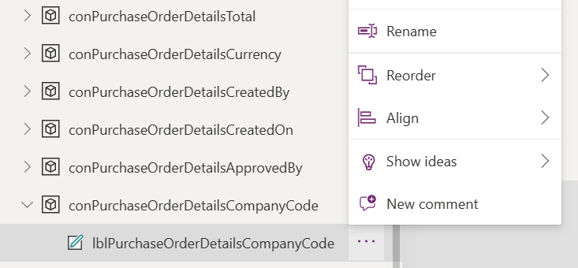
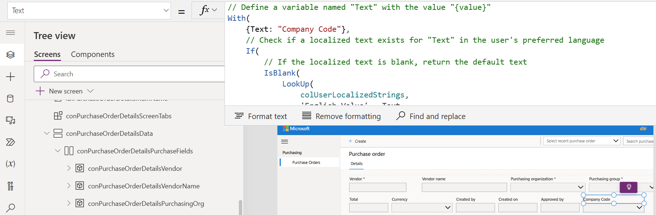

- Rename the combo box. Select the combo box in the container. Using the same steps, Rename to cmbPurchaseOrderDetailsCompanyCode.
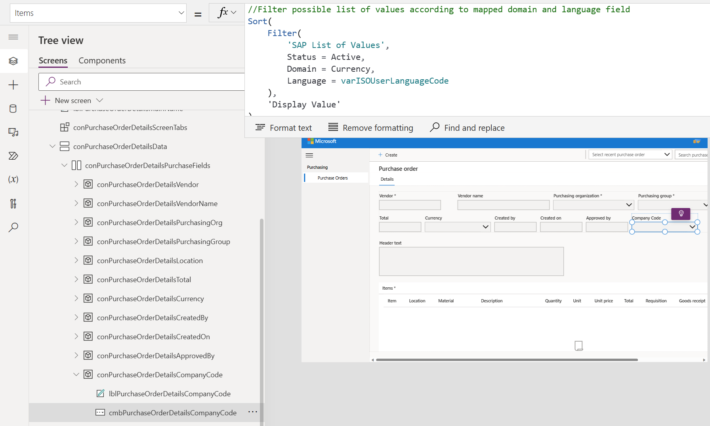

- Update the Items property. In the Domain, click on ‘Currency’ and update to ‘Company Code’. Intellisense will pop up the options.

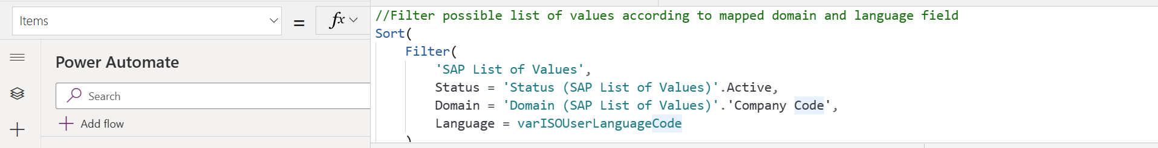

- Update the Tooltip. Select AccessibleLabel in the Property drop down and change “Select currency” to “Select Company Code”.

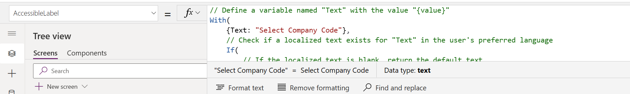

- Update the DefaultSelectedItems. Click on Advanced in the right-hand pane. In the DefaultSelectedItems, change the Domain and Value Code to be ‘Company Code’
Ensure you have a comma at the end of the line after replacing the text.

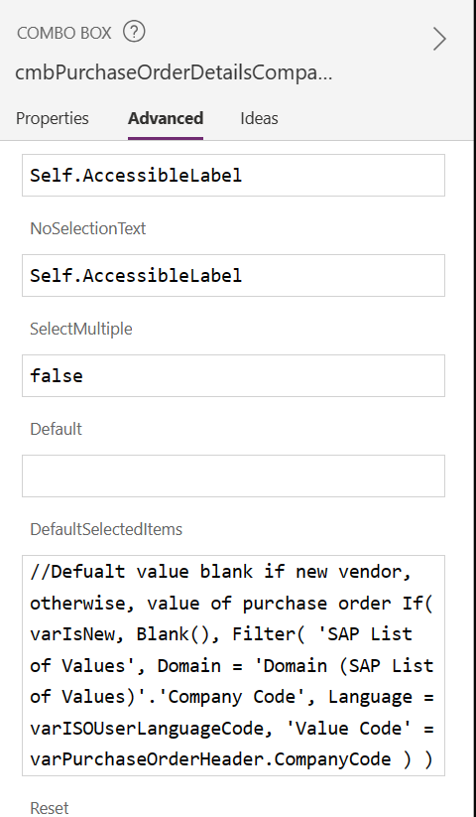

- Update the Save button. We need to add the Company Code as part of the information we send back to SAP when we click on the Save button. In the Tree view in the left-hand navigation, click on Components tab. Expand the CommandBar component, then the conCommandBar container and finally the conCommandBarButtonsSave container. Select the btnCommandBarButtonsSave.

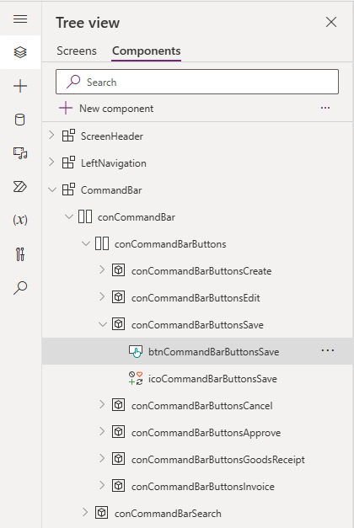

- Change the OnSelect property. Ensure the OnSelect property is showing in the property bar. We need to add the Company Code to Purchase Order JSON that is being created. Scroll down until you see the comment //Build the purchase order JSON. Add the following text to the Header section.
CompanyCode:cmbPurchaseOrderDetailsCompanyCode.Selected.'Value Code',

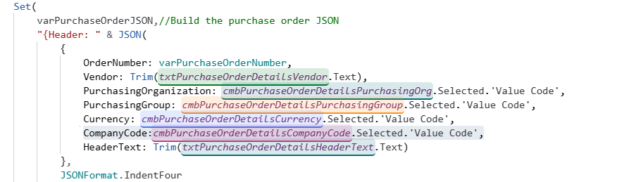

- Save the app. Click on the Save button in the upper ribbon to save the app.

- Click back to the tab that is open to your SAP Workshop Solution. Edit the CreatePurchaseOrder cloud flow. Click on the ellipse (…) for the CreatePurchaseOrder cloud flow and select Edit then Edit in a new tab.

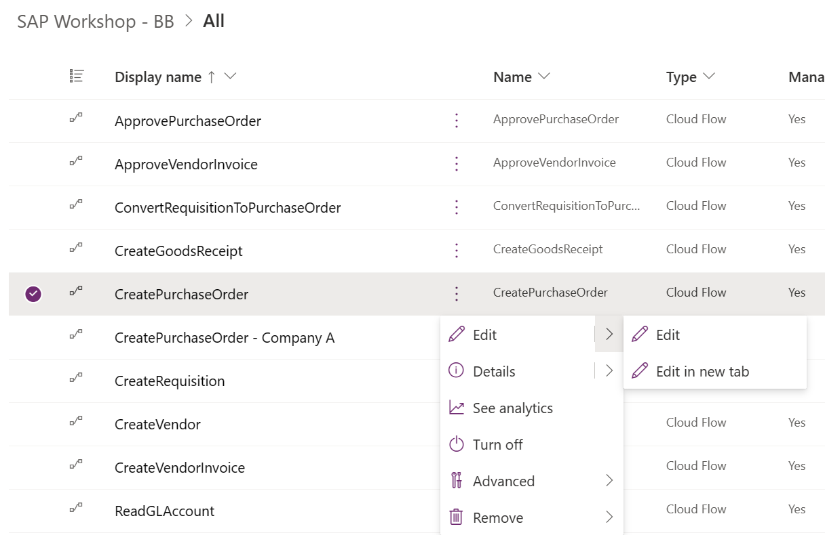

- Update the schema to include the Company Code. Expand the Try section and then the Parse JSON section. In the Header section, copy the HeaderText piece of the JSON code from the comma to the closing bracket.

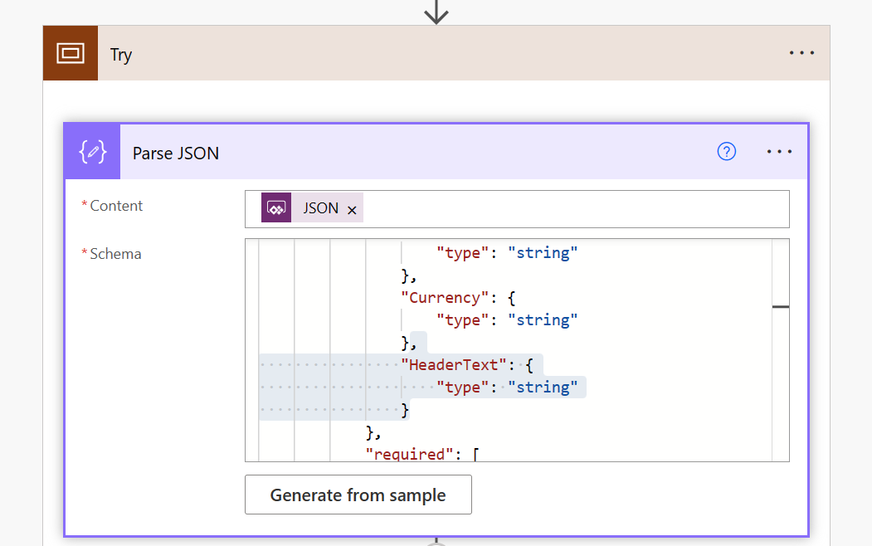
- Paste after the closing bracket for the HeaderText section.

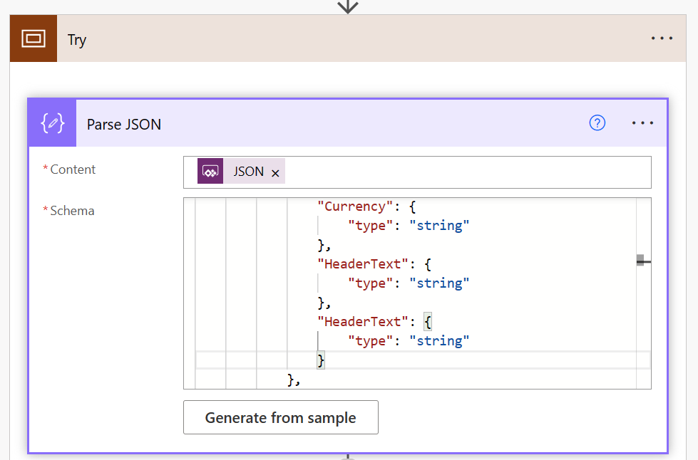

- Change the text to “CompanyCode”.

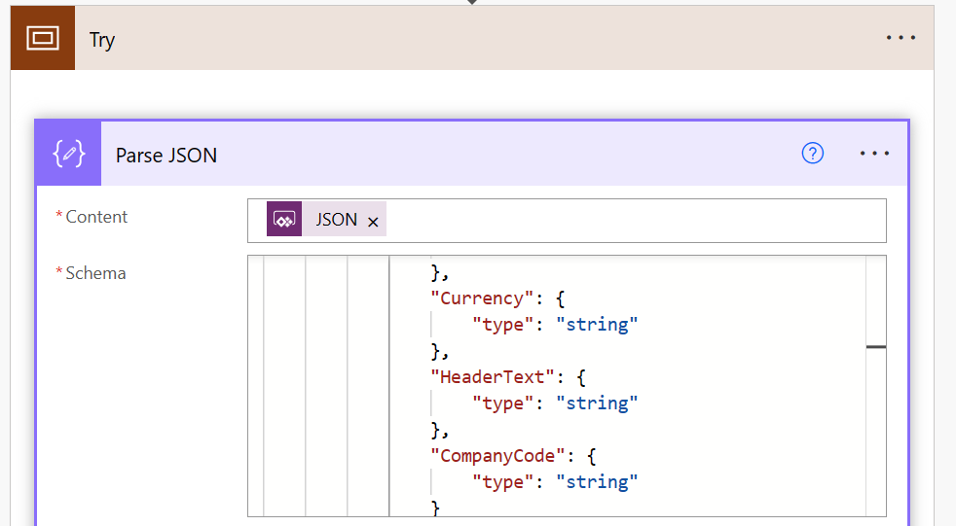

- Update the POHEADER Variable. Expand the POHEADER Variable action. After Vendor, add the key for the key value pair. “COMP_CODE”: “”,
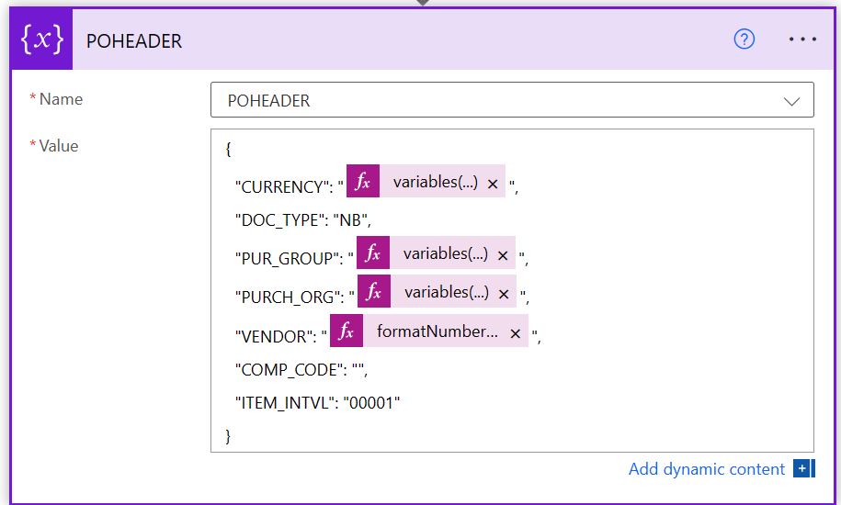
- Add the value by creating an expression. Click inside the pair of quotes on the right-hand side of the key value pair. Select the Expression tab in the Dynamic content pop-up. Enter the following expression: variables(‘Header’)?[‘CompanyCode’] and then click on OK.

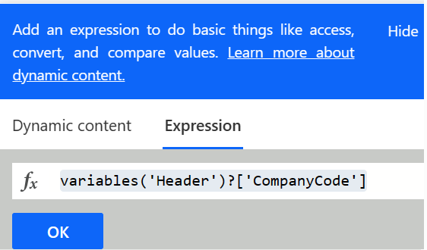
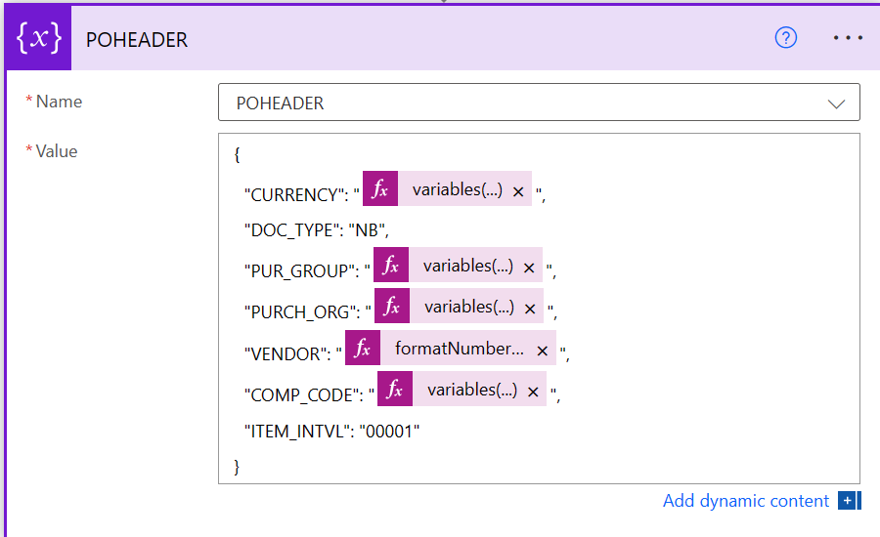

- Update the POHEADERX variable. Expand the POHEADERX variable action. After Vendor, add the key value pair to indicate SAP should send back the Company Code.
“COMP_CODE”: “X”,
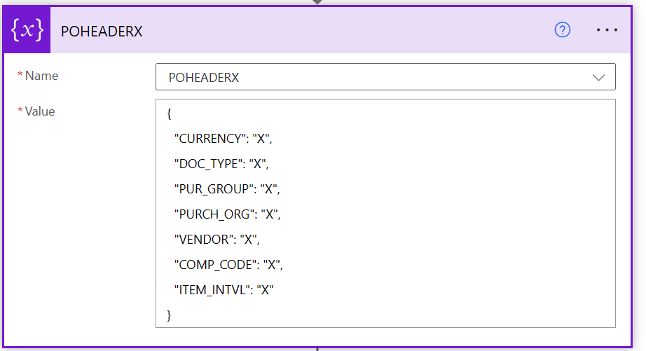

- Save the flow. Click on the Save button in the upper ribbon.

- Edit the ReadPurchaseOrder cloud flow. We also want to edit the ReadPurchaseOrder cloud flow so we bring back the Company Code from SAP in addition to adding it to new orders. Click on the ellipse (…) for the ReadPurchaseOrder cloud flow and select Edit then Edit in a new tab.

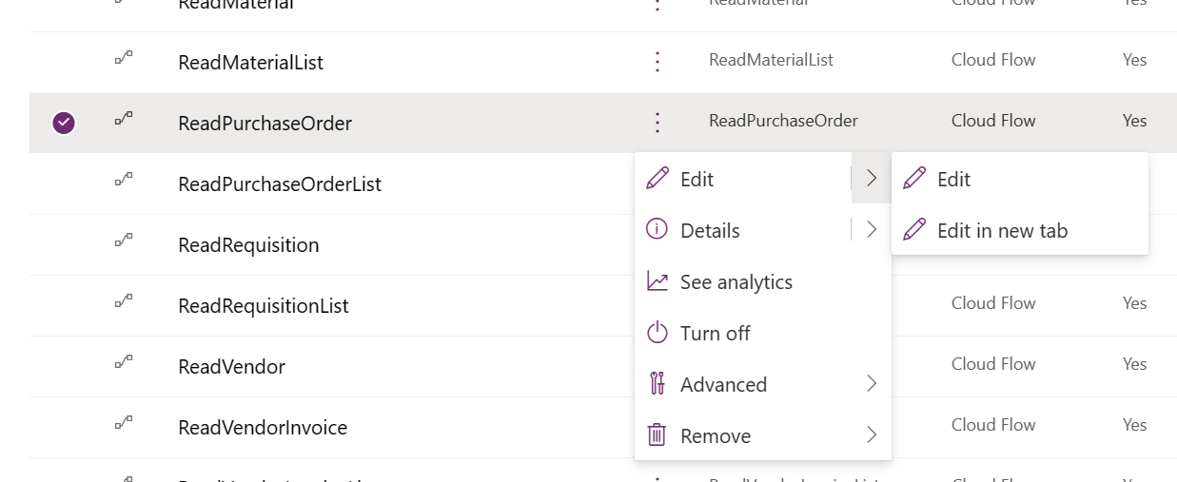

- We are already bring back the Company Code in the ReadPurchaseOrder cloud flow, but want to call out this may be a step you need to take for any other customizations. To see where we are bringing this back, expand the Try section and then expand the Existence Check section. Scroll down on the Yes side and expand the Parse Header section.
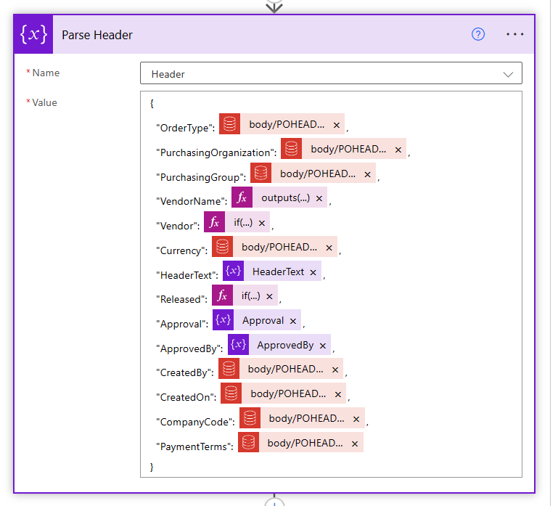
- If deploying this for customers, you would also want to modify the UpdatePurchaseOrder cloud flow but we are skipping that step in the interest of time.

- Our last step is to refresh our cloud flows in our canvas app and test to ensure our changes are working. Click back to the tab that had our SAP Purchase Orders canvas app open or edit it again from the solution. On the left-hand navigation, click on the Power Automate icon.
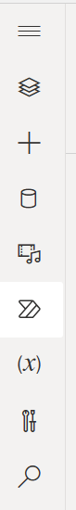

- Click on the ellipse (…) for the CreatePurchaseOrder flow and select Refresh. Do the same for ReadPurchaseOrder.
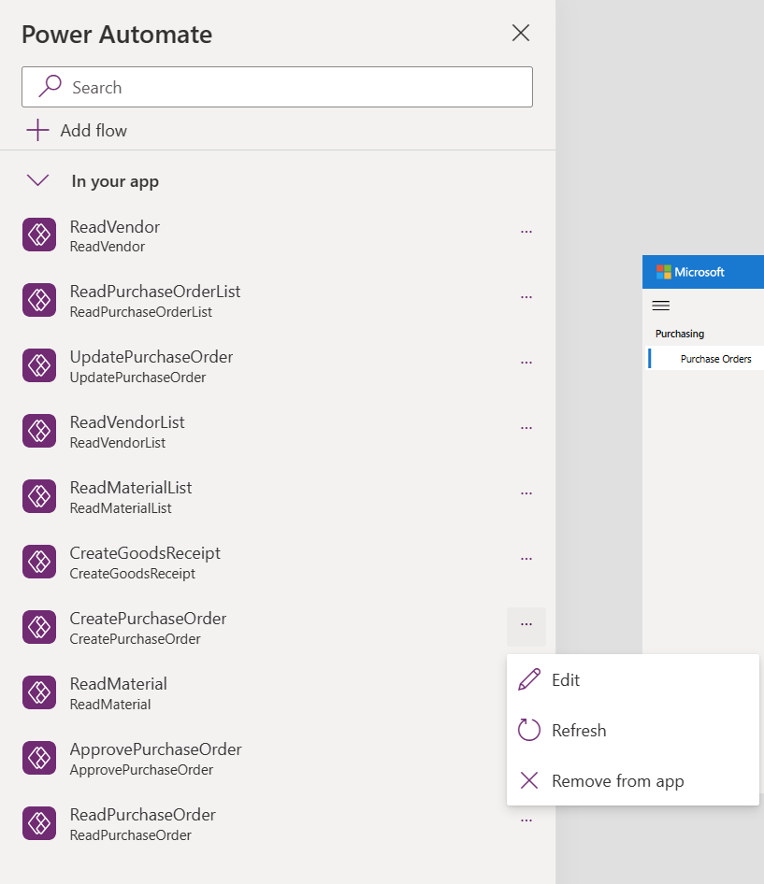

- Test the app. Click on the Play button in the upper ribbon. Click on + Create to start a new purchase order and verify you have a drop-down selection for the Company Code.

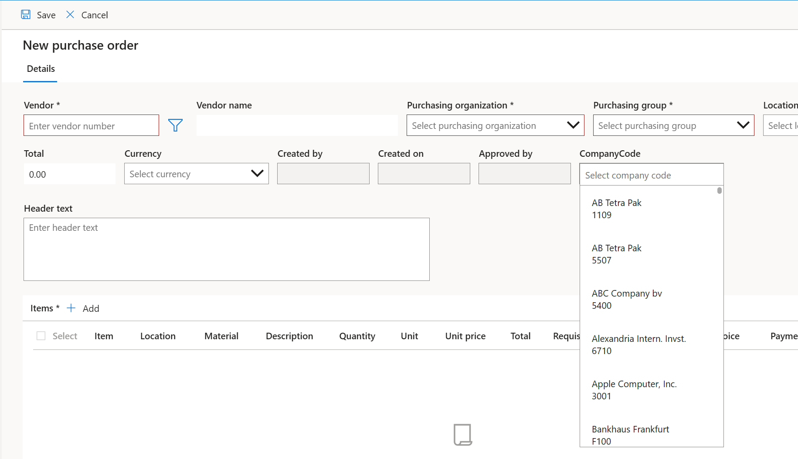

Exercise 12: Create and Add AI Builder Model
In the next exercise, we will create and train an AI Builder model to capture information from our vendor invoices so we can have them automatically created in SAP.

- Browse to https://make.powerautomate.com and confirm you are still signed in with the credentials supplied by the instructor and you are in the correct environment.

- On the left-hand side, expand the AI Builder section and click on + New AI Model.

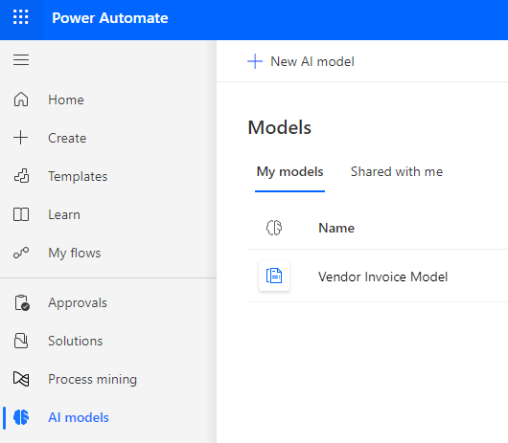

- Select the Extract custom information from documents.

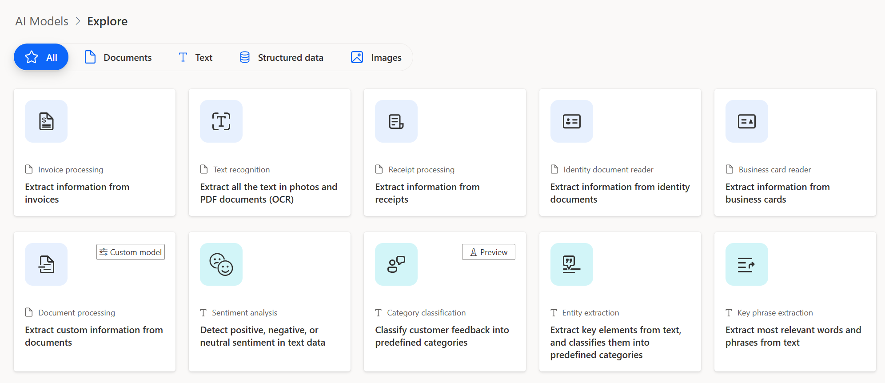

- Click on Create Custom Model in the bottom right-hand corner. 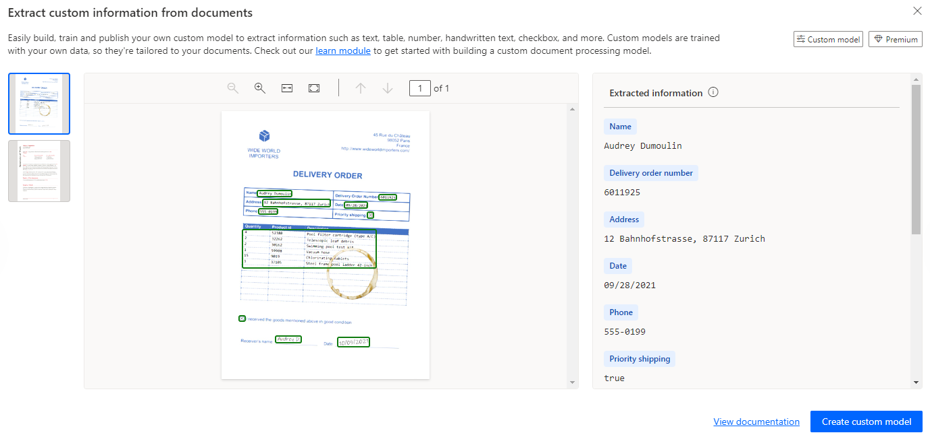
- Rename the model. In the upper right-hand corner click on the pencil icon to rename the model. Rename the model Vendor Invoice Model-XX where XX are your initials. Click on Rename.

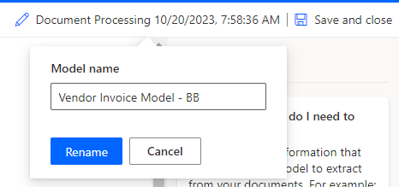

- Select Invoices (preview) for the document type and then click Next.

. 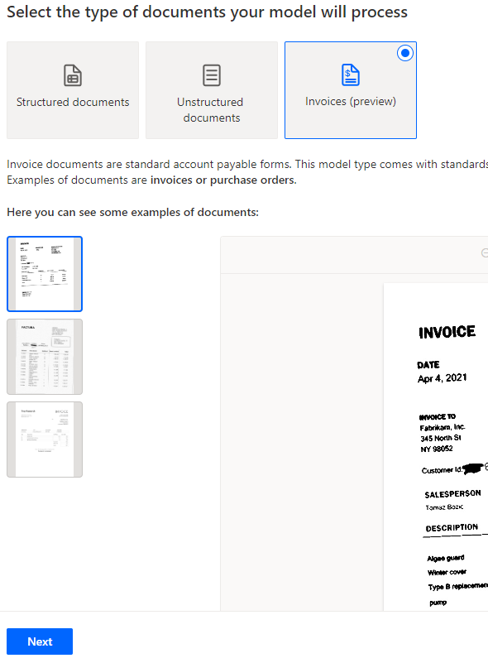

- Add the Fields for Extraction. The invoice model has all the fields we need for our vendor invoice, but we will add a new line item table so we can collect the line item number. Click on the drop-down menu in the + Add box and select Table.
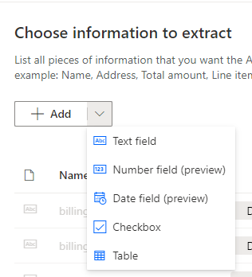

- Type Line Items as the Name for the table and click on Column 1 and select Edit column.

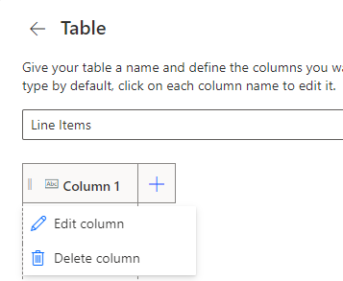

- Change the Name to Line Item and Type to Number with Format as dot (.) for decimal separator and then click on Confirm.
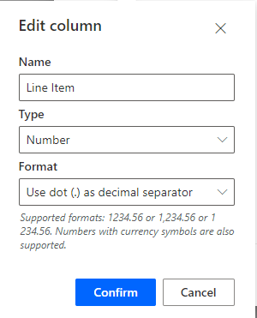

- Click on the plus sign to add more columns based on the information in the table below and then click on Done.

Name | Type | Format
Description | Text
Quantity | Number | Use dot (.) as decimal separator
Unit | Text
Unit Price | Number | Use dot (.) as decimal separator
Total Price | Number | Use dot (.) as decimal separator

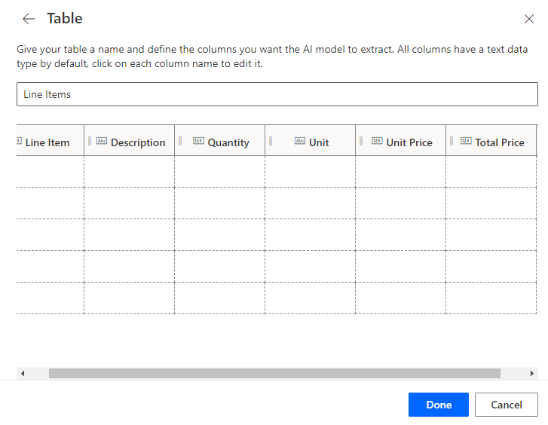
- Click on Next.
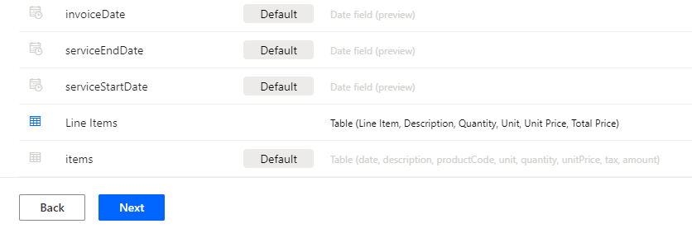
- Train the model. We are now ready to train the mode with some sample invoices. Click on New collection and then the + in Collection 1.
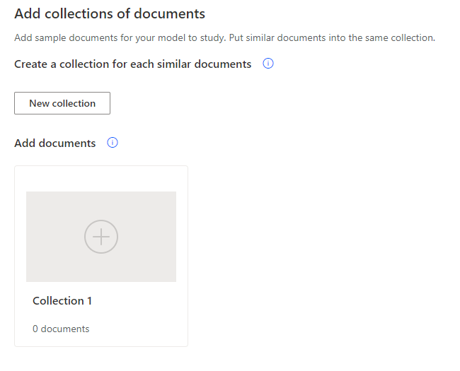
- Click on Add documents.
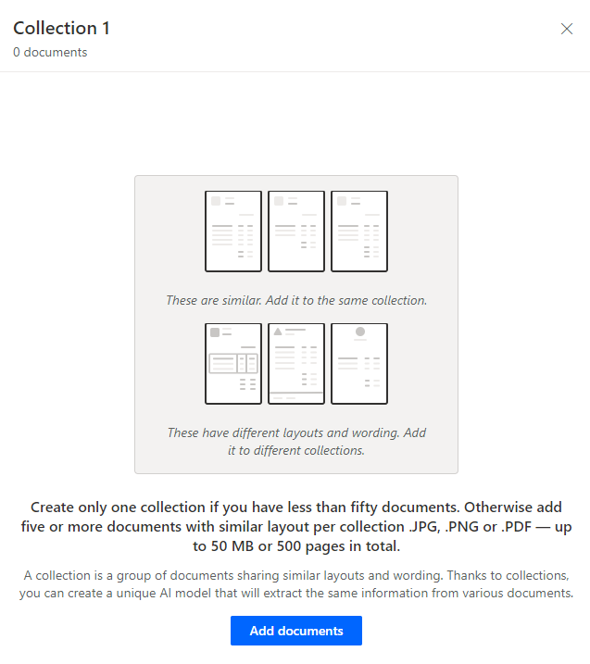

- Select the source for your documents. Click on My device and browse to where you downloaded the documents at the beginning of the workshop.

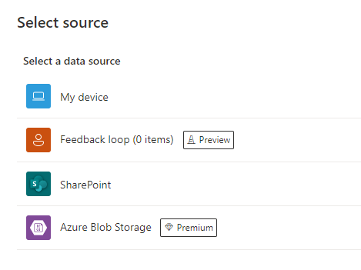

- Select all 5 Vendor Invoices from the Train folder.
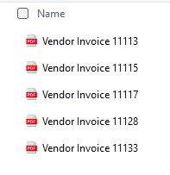
- Click on Upload 5 documents and then click on Done.

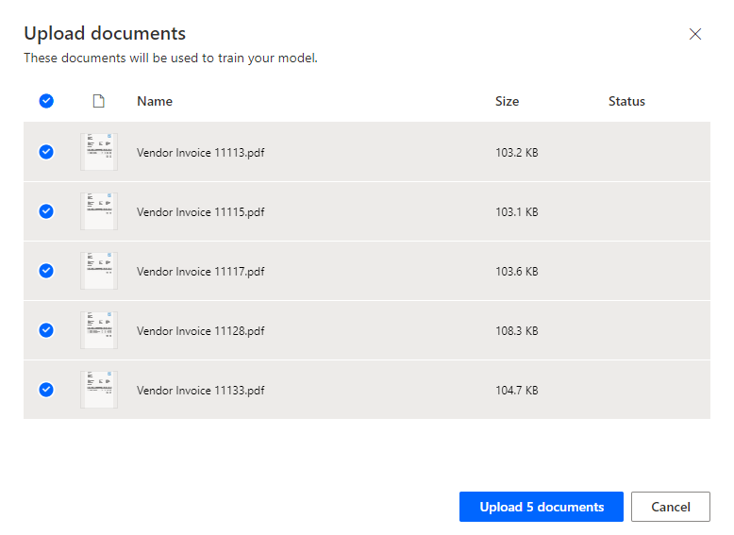

- Click on Next.

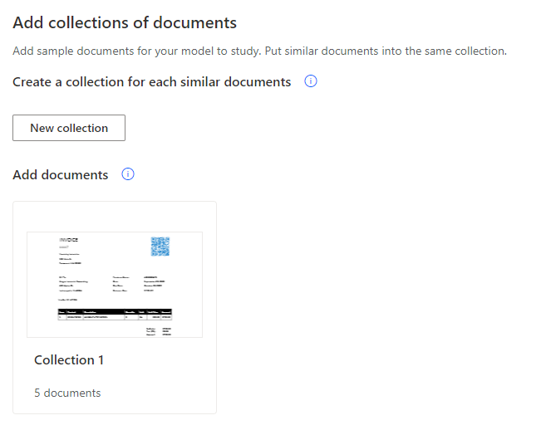
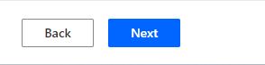
- Tag the Documents. Next, we will tag the areas on the invoice and associate them with our fields. The first document has been selected. You can see all the default fields have been selected and mapped. On the right-hand side under the text fields, you can hover over purchaseOrder. You will see on the invoice which field has been mapped.

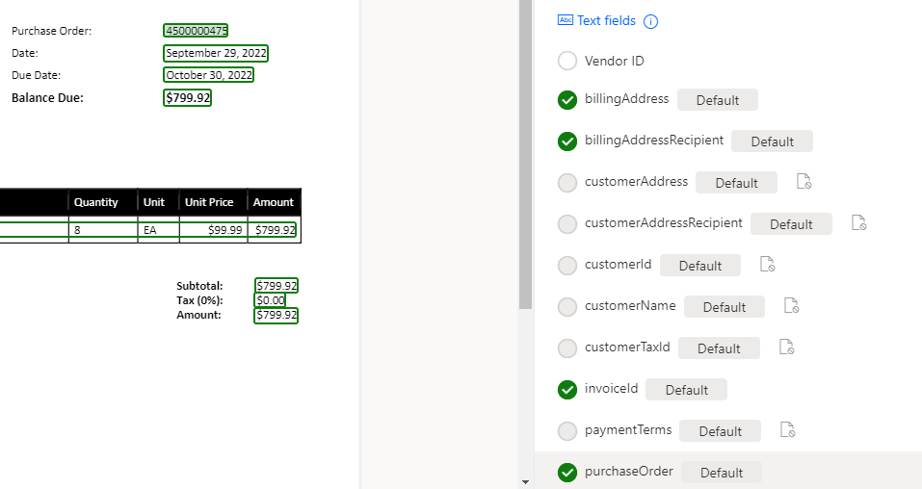

- Remove the items tag from the Line Items table. Select the blue icon for the items table on the invoice and then select Remove Tag.

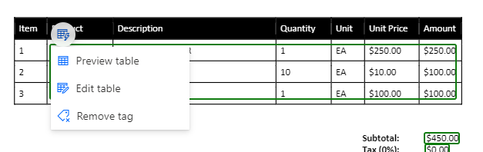
- Confirm you want to remove the tag. Click on Remove.

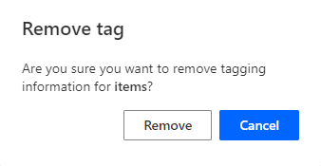
- Re-select the Line Items table using your cursor and select the Line Items table.

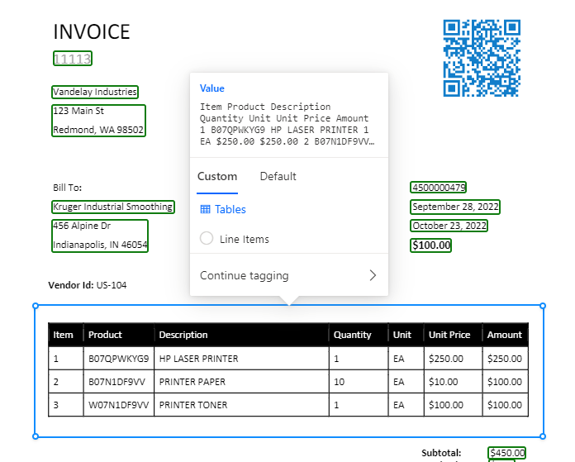
- We can now map the Line Items table. There are blue pop-ups with guidance on how to tag the table. When you mouse over the table, your cursor will turn to a plus sign with a blue horizontal line. Click to create lines separating the header and the 3 line items.
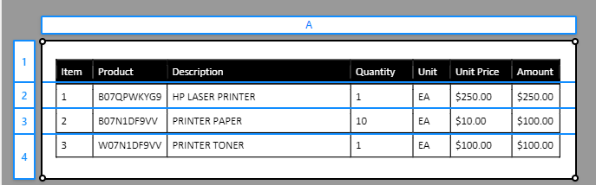

- Map the columns. Hold down the Crtl key and click to change the mapping to a vertical line and map out the columns.
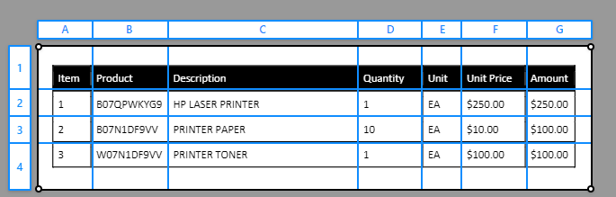

- Label the columns. Click on the letters for the columns and map to the correct field.
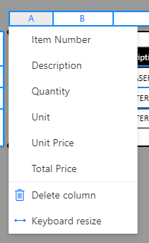
A – Item Number
B – Not mapped
C – Description
D – Quantity
E – Unit
F – Unit Price
G – Total Price

- Turn on the Ignore first row to remove the header line. On the right-hand side, toggle on the Ignore first row and confirm the table is mapped properly and click on Done.

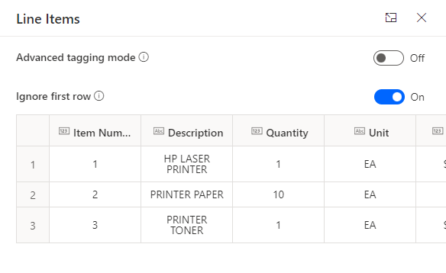
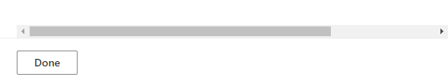

If you can’t get the last document to save. On the right-hand side, select ellipse (…) of the items table and remove from document.

- Repeat the same steps for mapping the Line Item table for the remaining 4 documents and then click Next. The model should automatically map the column names after you complete the first invoice, so you only need to map the rows and turn on the Ignore First Row.

- Train the model. We are now ready to train the model. Click on Train. It may take a few minutes to finish training.
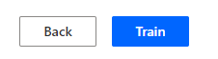

- Test your model. When the model is finished training, you can see the results of accuracy with more details on the specific items we are extracting. We are now ready to Publish the Model. Click on Publish.

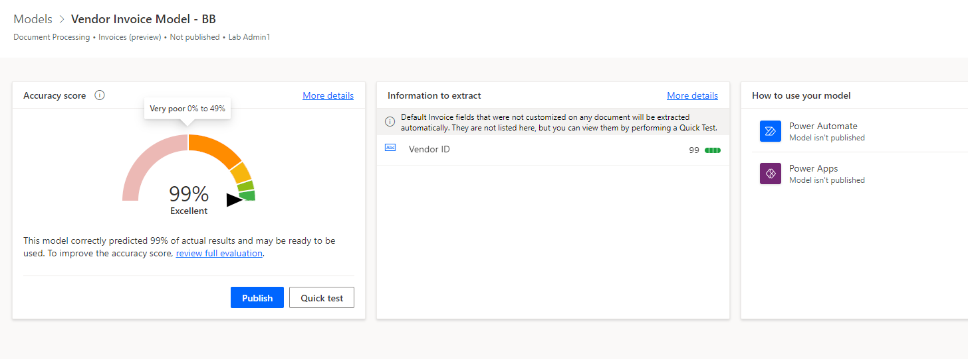

- Add AI Builder Model to our solution. Click on Solutions, select the SAP Procurement Approval and AI Builder Flows solution, click on the ellipse (…) and click on Edit.

The next steps will update the cloud flow to use the AI Model you just built and update the dynamic content to pull from this new model. If you did not finish your AI Builder model or don’t want to update the flow, you can skip the rest of this exercise and move onto the next one.

- Edit the cloud flow. Select the CreateVendorInvoiceFromEmail cloud flow, click on the ellipse (…) and then Edit and Edit in new tab.

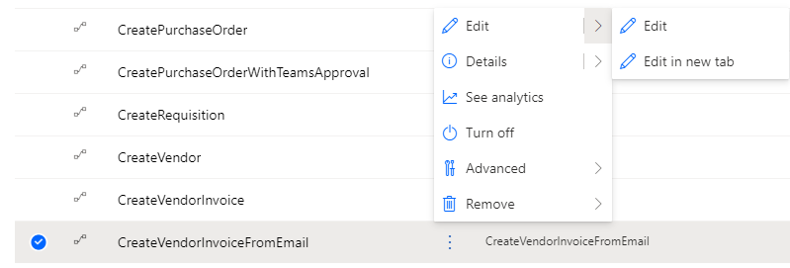

Overview of Cloud Flow. This flow is triggered when an email arrives in the Inbox. We use variables to capture information about each invoice that comes from the data extracted with our AI Builder Model. In the interest of time, we will update only certain parts of this flow.

- Expand the Apply to each ATTACHMENT action. Expand the Extract Information from documents action. Add your new AI Model. In the AI Model field, select the Vendor Invoice Model-XX you just created.

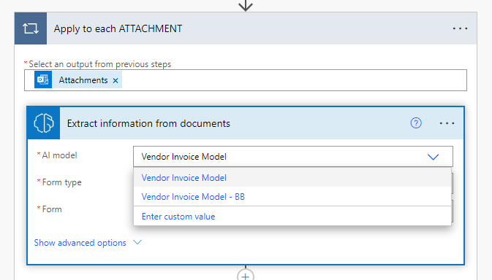

- Expand the Set Header Action. Update the schema in the Value section to pull data from our AI model. In the Order name/value pair, remove the existing dynamic content and insert purchaseOrder value from Dynamic Content. In the Total Price name/value pair, insert invoiceTotal value from Dynamic Content.

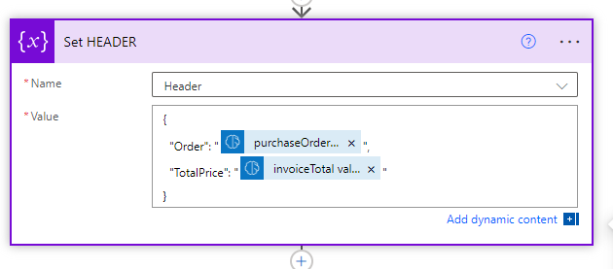

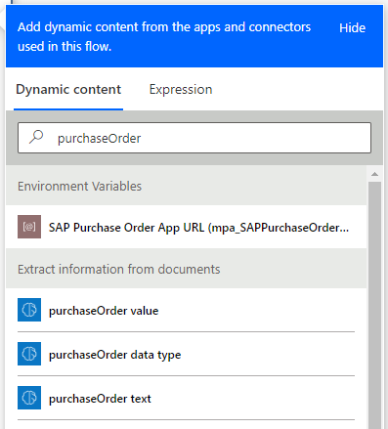

- Expand the Apply to each item action and then expand the Append to ExtractedItems action. We will update the name/value pair the same way as the step above. Using the table below, update values with the following Dynamic Content from the AI Model.

Name | Dynamic Content
Description | Line Items Description value
Quantity | Line Items Quantity value
Item | Line Items Line Item value
Unit | Line Items Unit Value
TotalPrice | Line Items Total Price Value

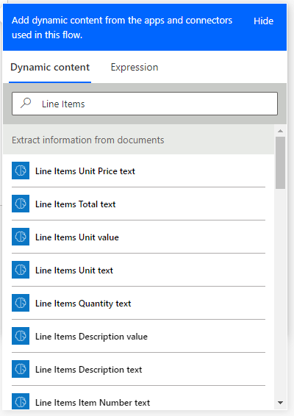
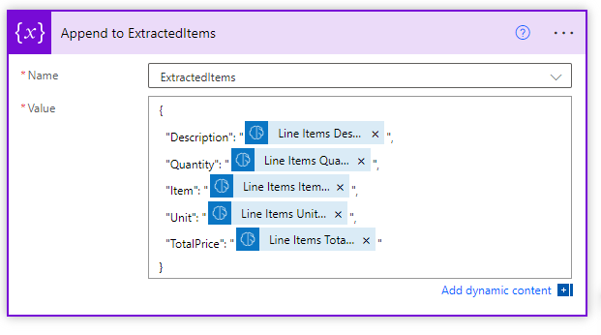

- Save the Cloud flow. Click on Save.

We have now finished updating the cloud flow that will use the AI Builder model to extract data from invoice that are received via email.

Exercise 16: Create Vendor Invoice using AI Builder and use Teams for Approval.

We are now going to modify the Purchase Order app to send an approval through Teams when created. We will then create a new Purchase Order that we can use to test our creation of the vendor invoice using the AI Builder Model and use Teams for approval. We will simulate the vendor sending us an email with the invoice as an attachment. This will kick off our cloud flow to run our AI Builder Model to pull the information from the invoice. This information is returned to SAP and a vendor invoice is created in SAP. We will then go back into our Power App and refresh the screen to see the vendor invoice number listed in our app.

- Edit the SAP Procurement Approval and AI Builder flows solution.

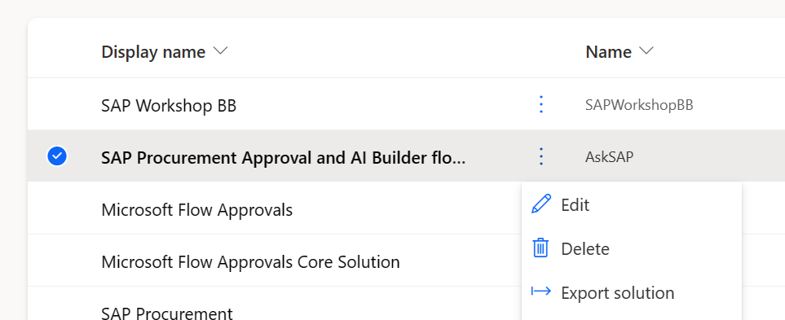

- Add the flow that will submit an approval in Teams into the SAP Purchase Order app. Select the SAP Purchase Orders app and Edit in new tab.
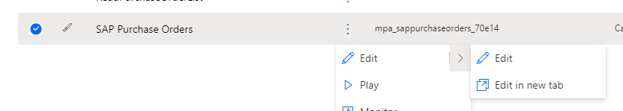

- Modify the Save Button to use the new cloud flow. In the Tree View, click on the Components tab and navigate to the Save button in the Command Bar container.

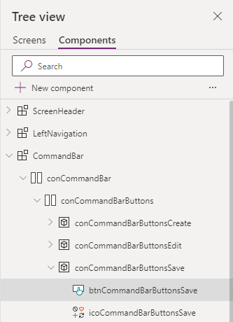

- Expand the OnSelect formula bar.

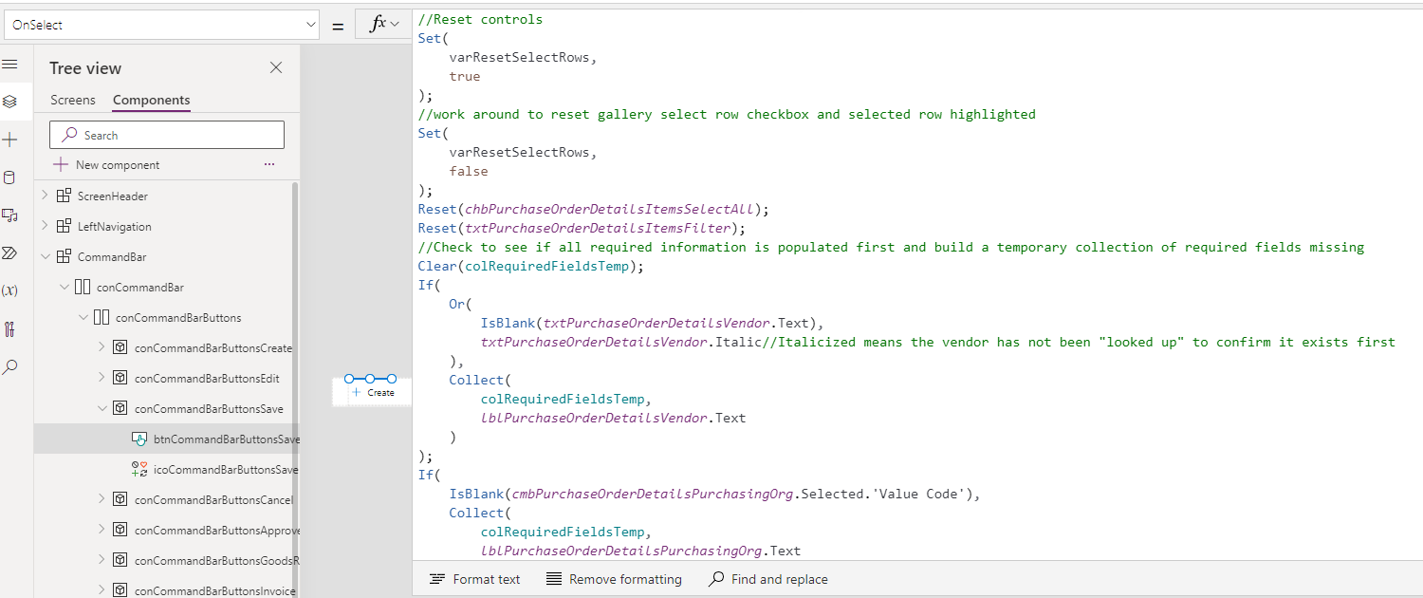

- Scroll down to where we are calling the Power Automate flow and replace CreatePurchaseOrder.Run with CreatePurchaseOrderWithTeamsApproval.Run. Now when we click on the Save button in the Purchase Order app, we will send an Approval through Teams.

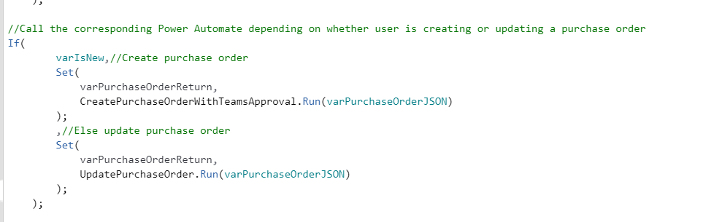

- Save the App. In the Tree View, click on Screens then click on Save Icon.

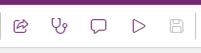
- Publish the App. Click the Publish App Icon.

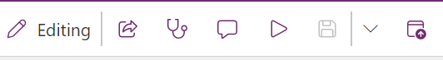

- Create a new purchase order. In the upper ribbon, click on the Play Button and then + Create.

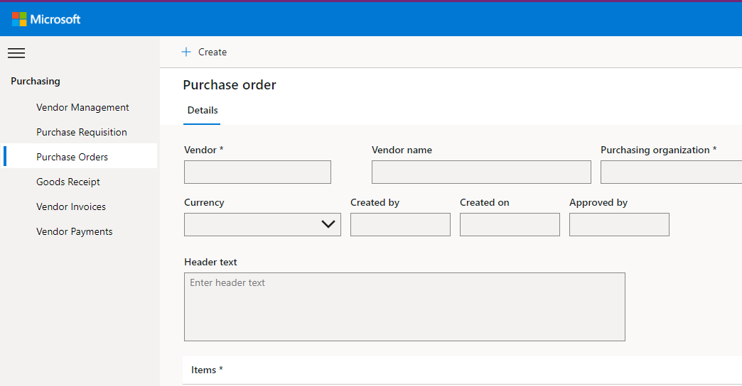

- Create the purchase order with the following information and then click on Save.

Vendor – 3000 Contoso Pharmaceuticals
Purchasing Organization – 3000 Best Run USA
Purchasing Group – 300 PG US
Location – 3000 – New York Plant
Currency – United States Dollars

Line Items

Material | Description | Qty | Unit Price
938 | Laser Printer | 1 | $250.00
938 | Printer Paper | 10 | $ 10.00
938 | Printer Toner | 1 | $ 100.00

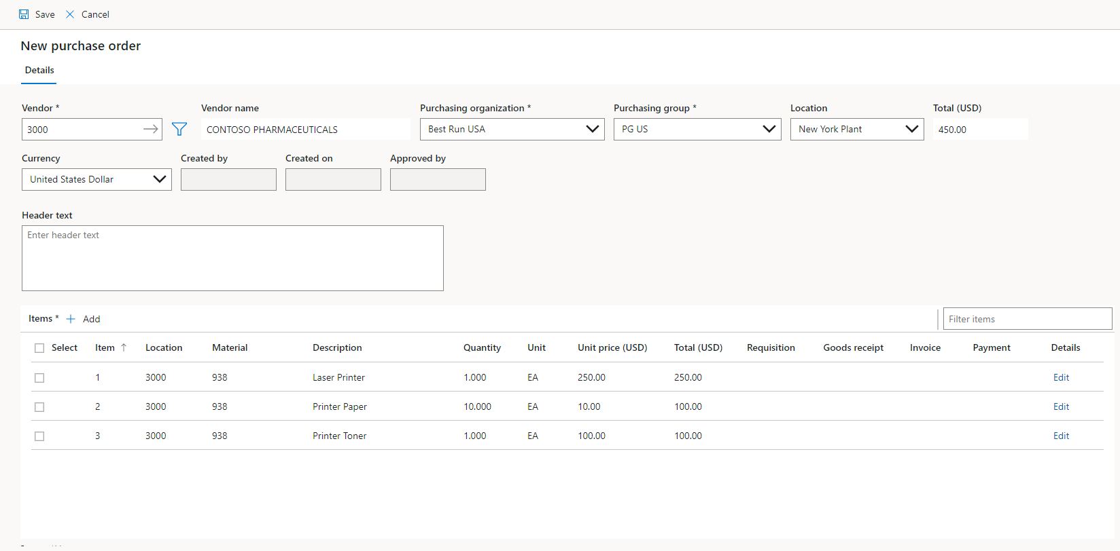

- Check for our Approval in Teams. Browse to www.office.com using your lab credentials and click on Teams.
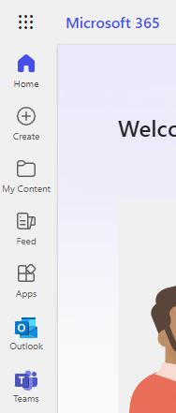

- Open the Approvals app. Click on the ellipse …. and select the Approvals app.

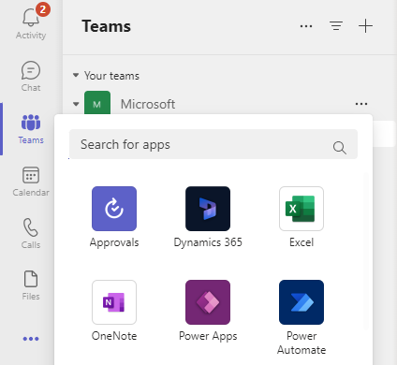

- In the upper right corner, select your lab environment.

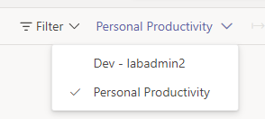

- Select the latest Approval Request for the PO you just created.

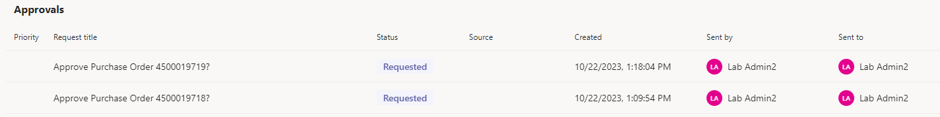

- You will see the list of all the items on the PO with the ability to click on the link and access the PO in the Purchase Order app. Click on Approve to approve the PO.

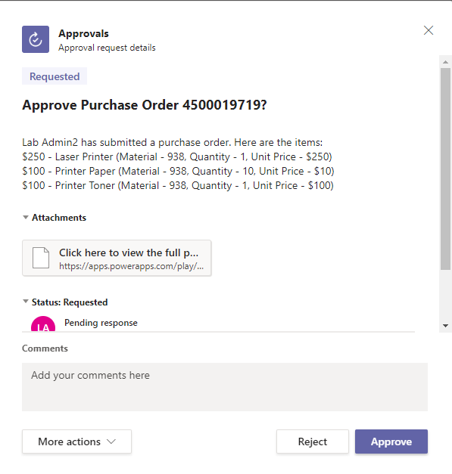
- Click back over to the tab with the Purchase Order app. Click on the Refresh button in the app and you will see that the Approval button is gone, our Approved By field is populated and the New Goods Receipt and New Invoice buttons are now available.

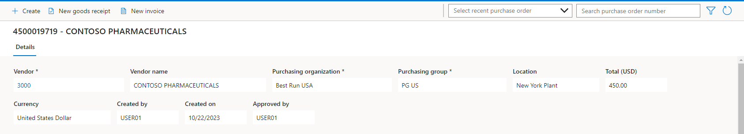

- Create a new Goods Receipt. Click on the New Goods Receipt.

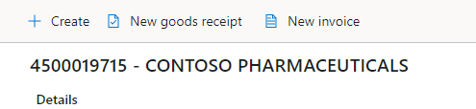
- Edit all 3 line items and select Warehouse 0001 for the Storage Location and then Save.

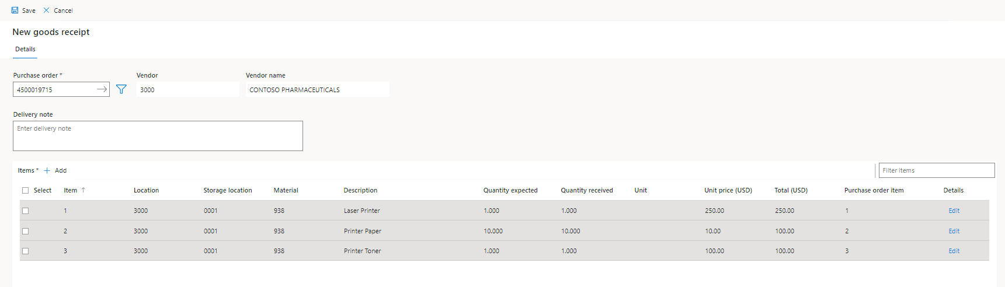

- Copy the new PO number and paste it onto the Vendor Invoice Template in your Workshop Resources.
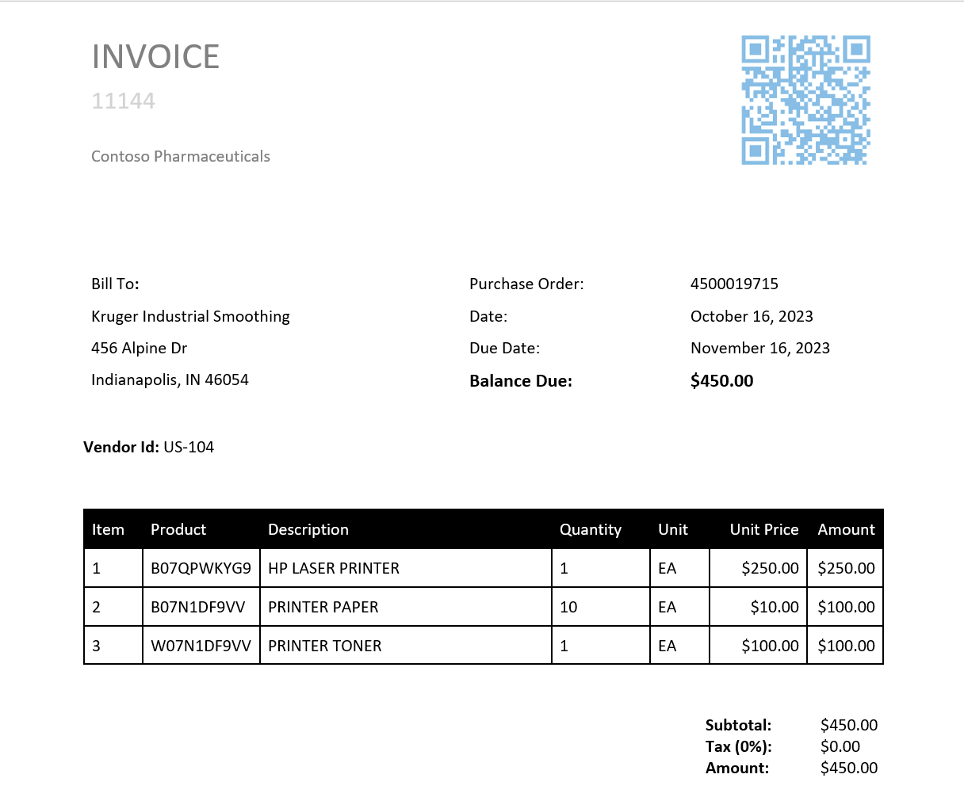
- Save as a PDF on your desktop so you can insert into an email. I usually add the PO number in place of the word Template.
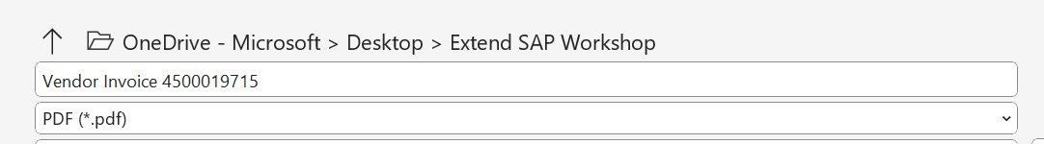

- Open the O365 portal to access Outlook. In the same browsers session, browse to https://www.office.com. Ensure you are still using the credentials supplied by the instructor. Click on Outlook.

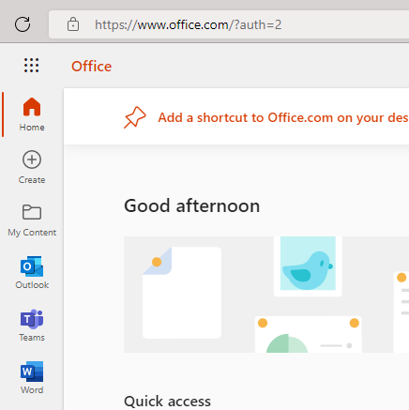
- Click on New Message.

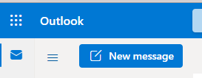

- Compose email message. Send the message to yourself using the credentials supplied by the instructor, fill out the subject line and attach the vendor invoice we created in the previous exercise. Click on Send.
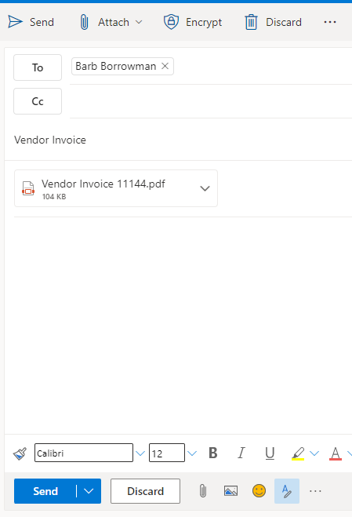

- Go back to the Power App. Click on the tab that has the Purchase Order canvas app open. Click on the Refresh button in the upper right-hand corner and you should now see the invoice as a hyperlink in the Items section.

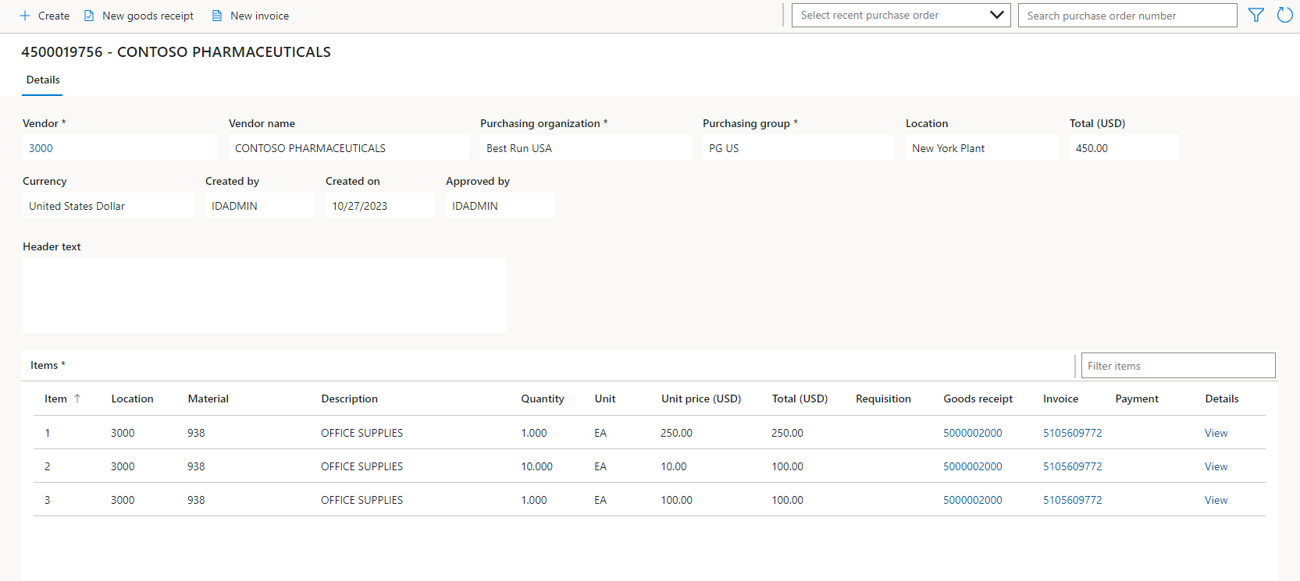

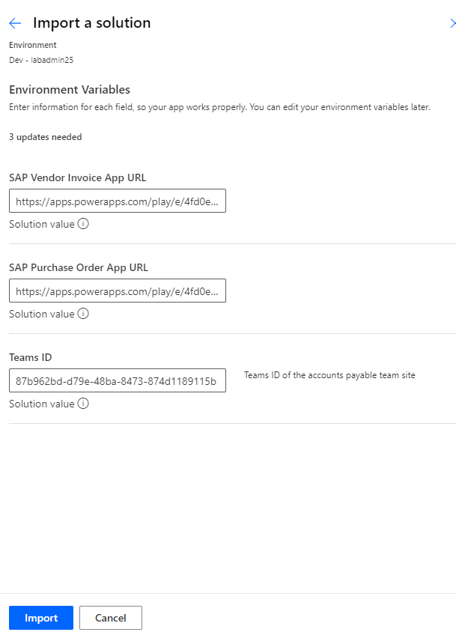

We can get details on the activities or the steps between activities by clicking on the activity or the lines connecting activities.
By clicking on the activity or the lines that link activities, we can see information about the actions or the processes between actions.

