STUDENT RESEARCH REPORT / 01

How Light Affects Seedling Growth
  - Science investigation • Year 7
Student: Avery Kim Class: Year 7 Science Teacher: Jo Lee Date: 21 June 2027

Question and Prediction
How does daily light exposure affect bean seedling height over two weeks? I predict that the group receiving more light will show healthier leaf growth. Height alone may not capture plant health.

Variables
Type | What is measured or controlled
Independent | Daily light exposure: 4 hours or 8 hours
Dependent | Seedling height in centimeters; leaf appearance
Controlled | Seed type, soil, container, water and measurement time

Materials and Method
- Prepare six similar seedlings in identical containers; label three A and three B.
- Place group A in 4 hours of light and group B in 8 hours. Keep other conditions consistent.
- Water each container with the same measured amount daily.
- Measure height from soil level at the same time on days 0, 7 and 14. Record observations.

Care and Safety
Ask a teacher before using lamps. Keep water away from electrical equipment. Wash hands after handling soil.
RECORD HONESTLY
The next page contains example data to demonstrate the layout. Replace it with your own measurements; do not present it as an experiment you performed.

STUDENT RESEARCH REPORT / 02

Results and Reflection

Mean Height at Day 14
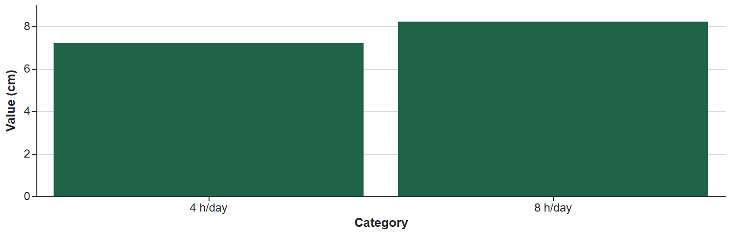
Plant | Light hours | Day 0 cm | Day 7 cm | Day 14 cm
A1 | 4 | 2.0 | 4.3 | 7.1
A2 | 4 | 2.1 | 4.4 | 7.2
A3 | 4 | 2.2 | 4.5 | 7.3
B1 | 8 | 2.0 | 4.9 | 8.1
B2 | 8 | 2.1 | 5.0 | 8.2
B3 | 8 | 2.2 | 5.1 | 8.3

What the Example Suggests
Group A grew from 2.1 to 7.2 cm on average. Group B grew from 2.1 to 8.2 cm. The difference in growth is 1.0 cm. With only three plants per group, this does not establish a general rule.
BETTER EVIDENCE
Height can increase when a seedling stretches for light. Add leaf count, color observations and more plants before interpreting health. These measurements are synthetic, not an experiment performed by a student.
Design notes: Traceable synthetic observations, chart and uncertainty. Original Dazzler template, Apache-2.0. All sample facts are fictional.

