CREATIVE BRIEF 04 / 01

Make the first visit easy
  - Campaign brief • Juniper neighborhood launch
Owner: Lena Ortiz Campaign: 1–31 July 2027 Review: 18 June 2027
120 | $3,000 | 31 days
inquiry target | sample budget | launch window

PRIMARY OBJECTIVE
Generate 120 qualified reservation inquiries during the launch month. This is a sample target, not a forecast or an achieved result.

Who we are speaking to
People living or working within the local neighborhood who want a relaxed place for a midweek dinner. They need to understand the menu, typical spend and how to book before deciding.

Message and response
Main message | Supporting content | Call to action
A seasonal dinner close to home | Menu highlights, room details, service hours and booking instructions | View the menu and request a table

Creative direction
Warm food-led photography, short ingredient descriptions and readable menu typography. Show the actual space when photographs are supplied. Avoid invented reviews, awards or claims about local sourcing.

Required information
- Approved menu and prices; service dates and hours.
- A clear booking route and accurate location information.
- Confirmed dietary and accessibility guidance from the operator.

Approval route
Chef reviews menu descriptions. Operations confirms hours and booking information. Campaign owner approves final copy before publication.

CREATIVE BRIEF 04 / 02

Channels and measurement

Allocate by the job to be done
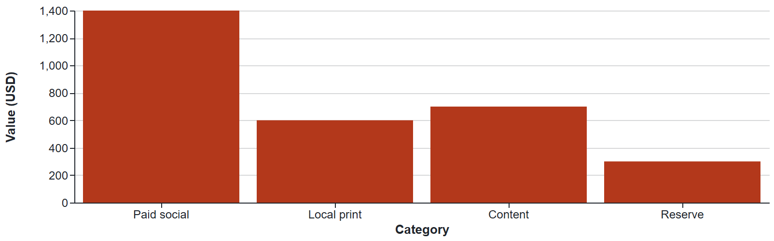
Week | Asset | Decision signal
01 | Menu story and launch email | Are people reaching the menu?
02 | Chef interview and neighborhood card | Are inquiry starts increasing?
03 | Midweek creative variation | Which message produces qualified interest?
04 | Retrospective and follow-up | What should be retained?

Measure the actual journey
Synthetic funnel: 8,000 landing visits → 1,200 menu opens → 180 inquiry starts → 120 completed inquiries. Completion is 1.5% of visits and 66.7% of starts. An inquiry is not a confirmed booking.
SPEND WITH A QUESTION
If the menu attracts attention but the form loses people, improve the form before buying more traffic. Targets and illustrative funnel values are not forecasts.
Design notes: Editorial emphasis, reconciled budget and funnel semantics. Original Dazzler template, Apache-2.0. All sample facts are fictional.

