ALDER STUDIO / 01

Approve the onboarding pilot
  - Decision brief • Leadership review • 18 June 2027
20 | 4 weeks | $6,000
pilot customers | learning window | spend ceiling

THE ASK
Approve a limited onboarding pilot with Maya Chen accountable for delivery. Keep the existing platform; test a clearer welcome sequence and one checklist.

A small bet with a visible exit
The team needs evidence before committing to a full rollout. The pilot tests completion, time to first value and support handoffs. It does not promise a revenue result.
Today | Pilot change | Decision gate
3 separate setup emails | 1 sequenced checklist | Review after four weeks
Ownership is unclear | Named success owner | No scope expansion without review

ALDER STUDIO / 02

Compare the options

Sample baseline and pilot target
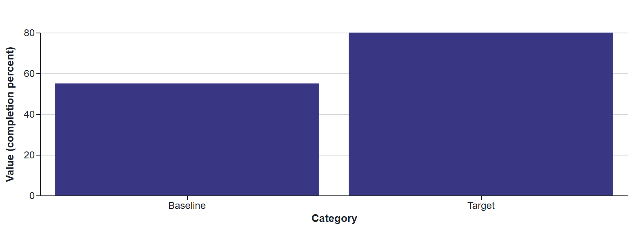
Option | Benefit | Trade-off
Keep the current process | No near-term delivery cost | Existing handoffs remain
Pilot with 20 customers | Tests the approach before a broad change | Requires four weeks and a dedicated owner
Rebuild immediately | Moves directly to a single experience | Commits more resources before learning

Recommended option
Run the limited pilot. Use the current system, rewrite the welcome sequence and add one checklist; defer any platform migration.
Measure | Pilot target | Source
Setup completed within 7 days | At least 16 of 20 participants | Checklist event log
Support contacts in first week | Record per participant; compare with baseline | Support ticket report
Serious account issues | Zero unresolved at closeout | Incident log

Presenter note: targets are proposed thresholds for this sample, not reported results.

ALDER STUDIO / 03

Make the next month measurable
Week | Work | Accountable owner
1 | Finalize copy and baseline measures | Maya • Customer success
2 | Invite participants and start the pilot | Sam • Operations
3 | Review exceptions and fix copy gaps | Alex • Product
4 | Report findings and recommend next step | Maya • Customer success

Guardrails
- Pause new invitations if account access is affected.
- Keep the existing onboarding path available during the test.
- Do not expand the pilot without reviewing the final evidence.
RECORD THE DECISION
Sponsor: Avery Kim Outcome: Pilot proposal for review
Owner confirmed: Avery Kim Review meeting: 21 June 2027
Design notes: Large type, strong contrast and decision-centered storytelling. Original Dazzler template, Apache-2.0. All sample facts are fictional.

