DELIVERY OFFICE / 01

Launch with confidence
  - Weekly delivery report
PORTAL RELEASE / WEEK 24 / 14–18 JUNE 2027
75% | $18k | 24
scope complete | budget remaining | days to launch

DECISION / 21 JUNE
Approve the 20-customer pilot. Identity integration is three days late; a reviewed password fallback protects the 12 July launch.

Cumulative accepted deliverables
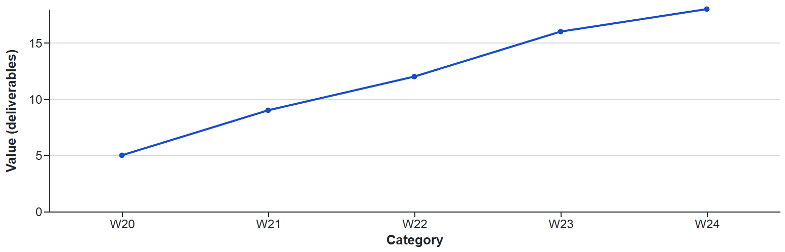
Workstream | Accepted / planned | Owner
Account setup | 6 / 6 | Alex Rivera
Invoice history | 5 / 6 | Sam Okafor
Identity | 3 / 6 | Maya Chen
Help and training | 4 / 6 | Lena Ortiz

DELIVERY OFFICE / 02

Protect the launch window
3 | 0 | 25 Jun
tracked risks | new funding requested | pilot review

Risk / owner | Trigger | Response
Identity / Maya | Access arrives after 22 June | Reviewed password fallback
Content / Lena | Help copy not signed off | Limit pilot to reviewed flows
Support / Sam | More than 5 pilot incidents | Pause new invitations

What success looks like
Invite 20 customers, observe setup completion and review support handoffs. The sponsor receives a recorded go / revise / pause recommendation after the 25 June acceptance review.

Risks and response
R-03 • Identity provider access. If credentials arrive after 22 June, the pilot will use password sign-in. Maya owns the fallback; security review is booked for 23 June.

Decision for the sponsor
Approve the 20-customer pilot with password sign-in, subject to security review. No additional budget is requested. Priya Shah to confirm by 21 June, 15:00.

Next week
- Finance: approve invoice totals and download wording by 21 June.
- Engineering: complete pilot deployment and rollback rehearsal by 24 June.
- Customer success: confirm pilot participants and support coverage by 25 June.
Design notes: Decision hierarchy, measured progress and owner-led action. Original Dazzler template, Apache-2.0. All sample facts are fictional.

