
FILM + TV PRIVATE CREDIT INSIGHTS

The 2026 Guide to Film & Television Tax Incentives
A state-by-state guide to U.S.
film and television tax incentives
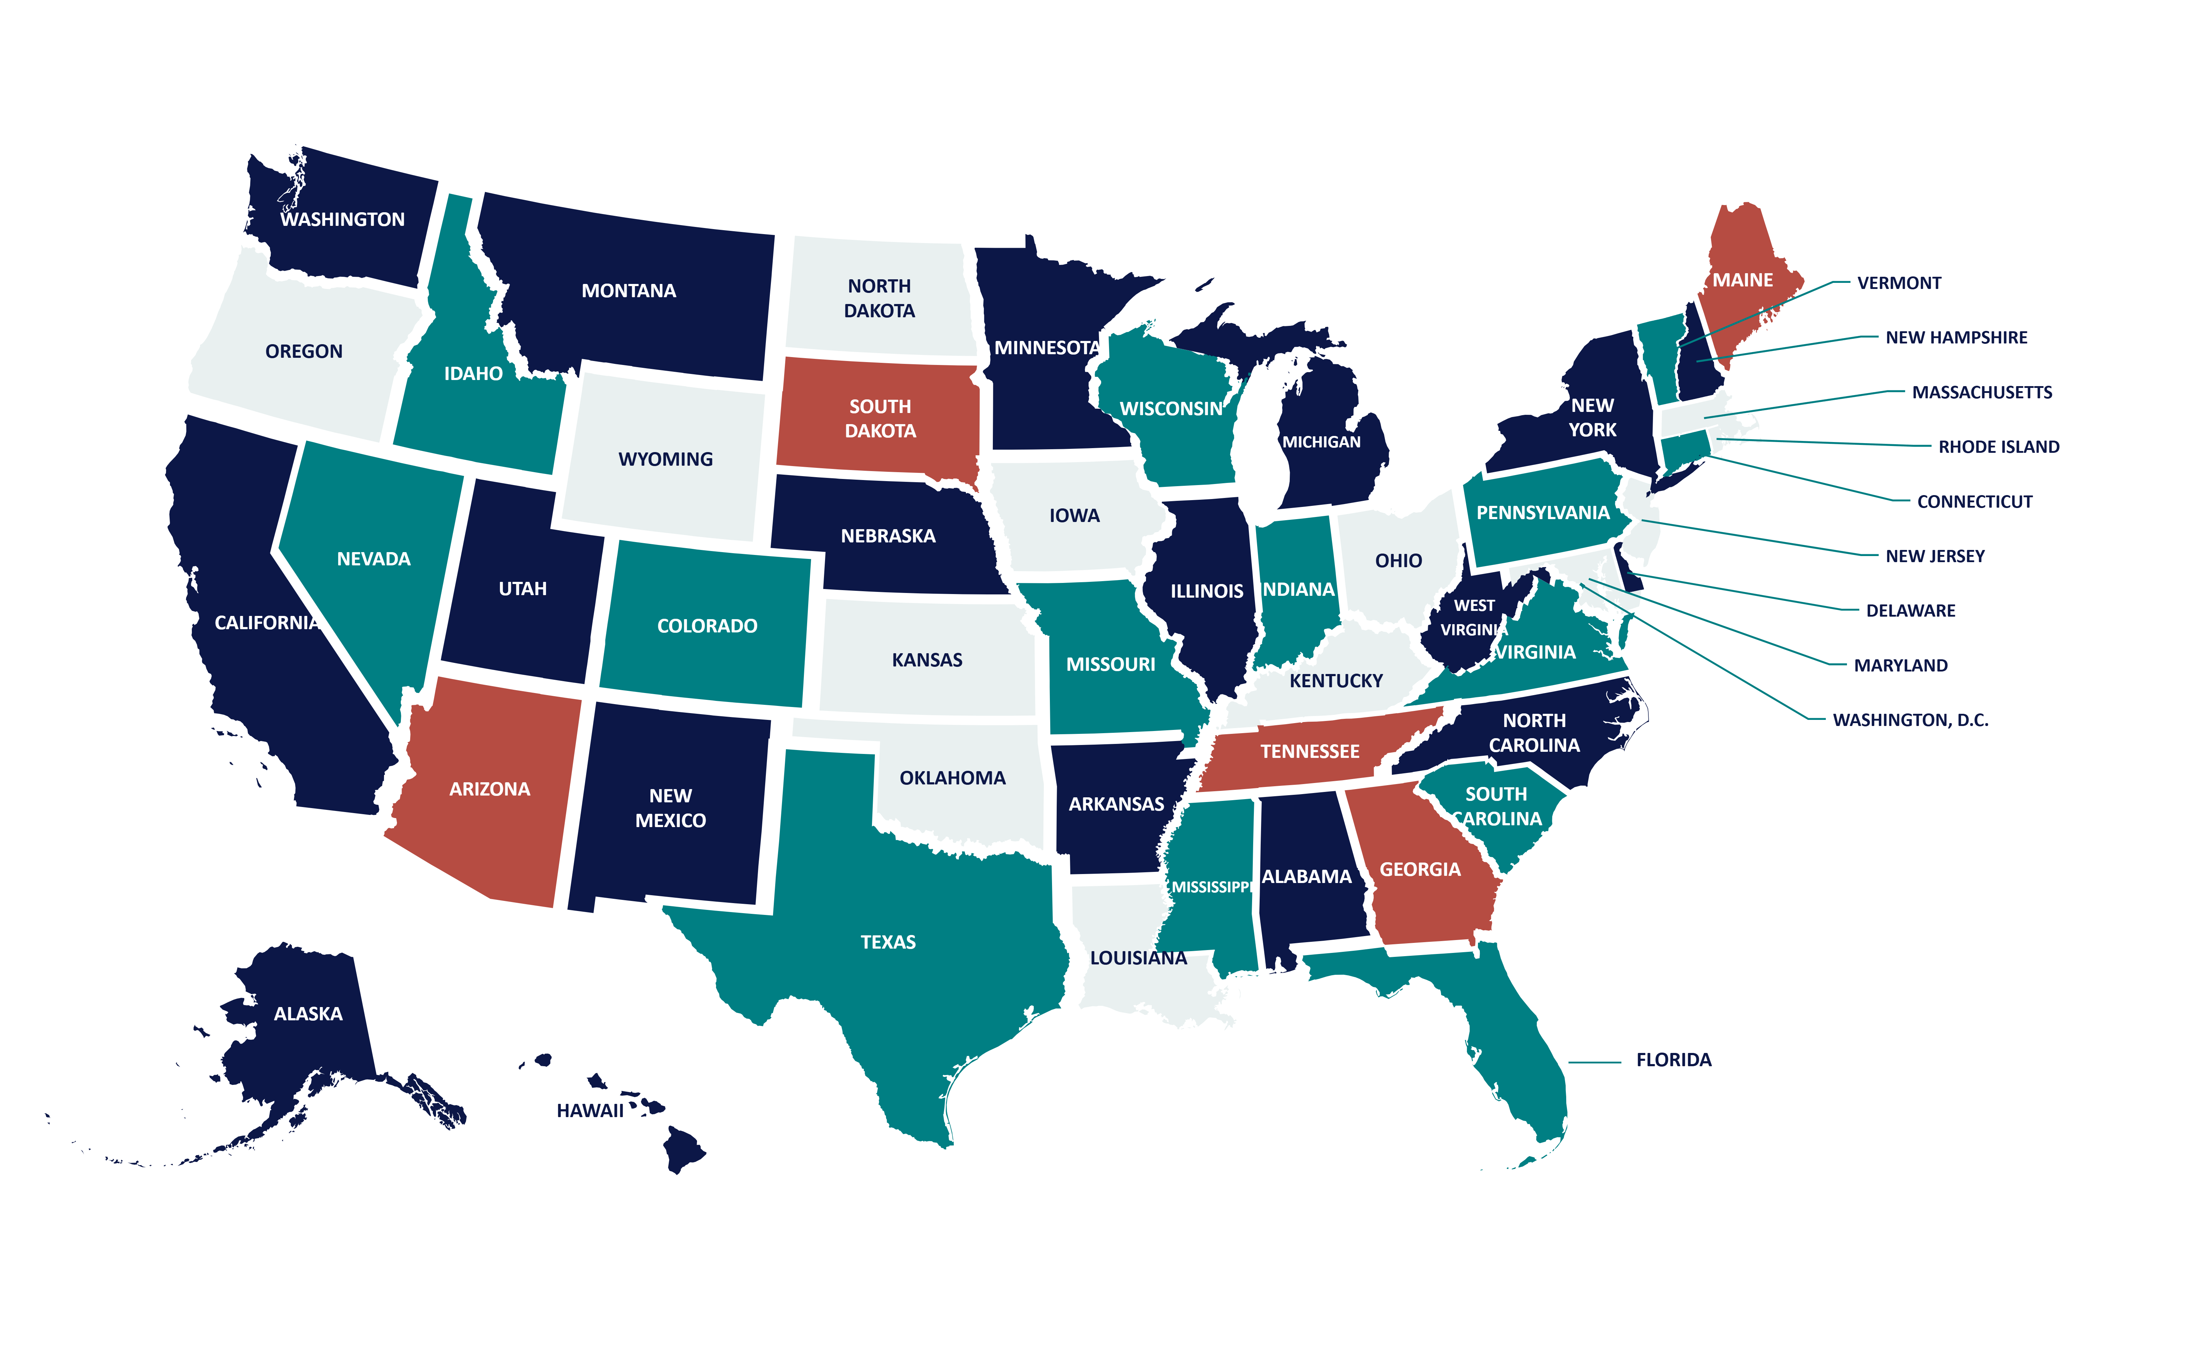
Your first investor is
your location

CONTENTS

Your Guide
04 Introduction  05 The Incentive Constellation  06 Film and TV Incentives at a Glance  08 Show Me the Money  10 The Fine-Print Ladder  11 United States  12 Hollywood’s Other Map  13 Alabama  14 Arizona  15 Arkansas  16 California  17 Colorado  18 Connecticut | 19 Florida  20 Georgia  21 Hawaii  22 Illinois  23 Indiana  24 Kentucky  25 Louisiana  26 Maine  27 Maryland  28 Massachusetts

CONTENTS

State Profiles
29 Minnesota  30 Mississippi  31 Missouri  32 Montana  33 Nebraska  34 Nevada  35 New Jersey  36 New Mexico  37 New York  38 North Carolina  39 Ohio  40 Oklahoma | 41 Oregon  42 Pennsylvania  43 Rhode Island  44 South Carolina  45 Tennessee  46 Texas  47 Utah  48 Virginia  49 Washington  50 West Virginia  51 State Benefits at a Glance  52 Notes and Sources

FROM FILMHEDGE

Introduction
Welcome to the latest Film + TV Private Credit Insights report from the research team at FilmHedge.
FilmHedge (http://filmhedge.com), a MediaHedge company, originates, underwrites, structures, closes, and services film and television production loans. We connect producers and capital providers around identifiable repayment sources, including tax credits, distribution receivables, pre-sales, and minimum guarantees.

Overview
Film budgets have a way of outrunning their plans. Few line items move the numbers as much as a tax incentive, which can return millions of dollars to a production, or nothing at all, depending on where the cameras roll and how the paperwork is filed.
This report is a working guide to the 38 U.S. states profiled here. It sets credits, rebates, grants, spending thresholds, and program caps side by side, so producers can see what each incentive is worth in a real budget.
The best location pairs a good incentive with the right crew, facilities, schedule, and overall cost. A headline percentage is only where the arithmetic starts. What counts as eligible spending, and how the money reaches the production, decide what an incentive is worth.
A deeper dive into tax credits.
Below, each state profile examines funding availability, the route to cash, entry requirements, and payout rates. The At a Glance panels put those facts side by side. The charts compare selected rates on their stated expense categories, making it easier to see which parts of a budget earn an incentive.

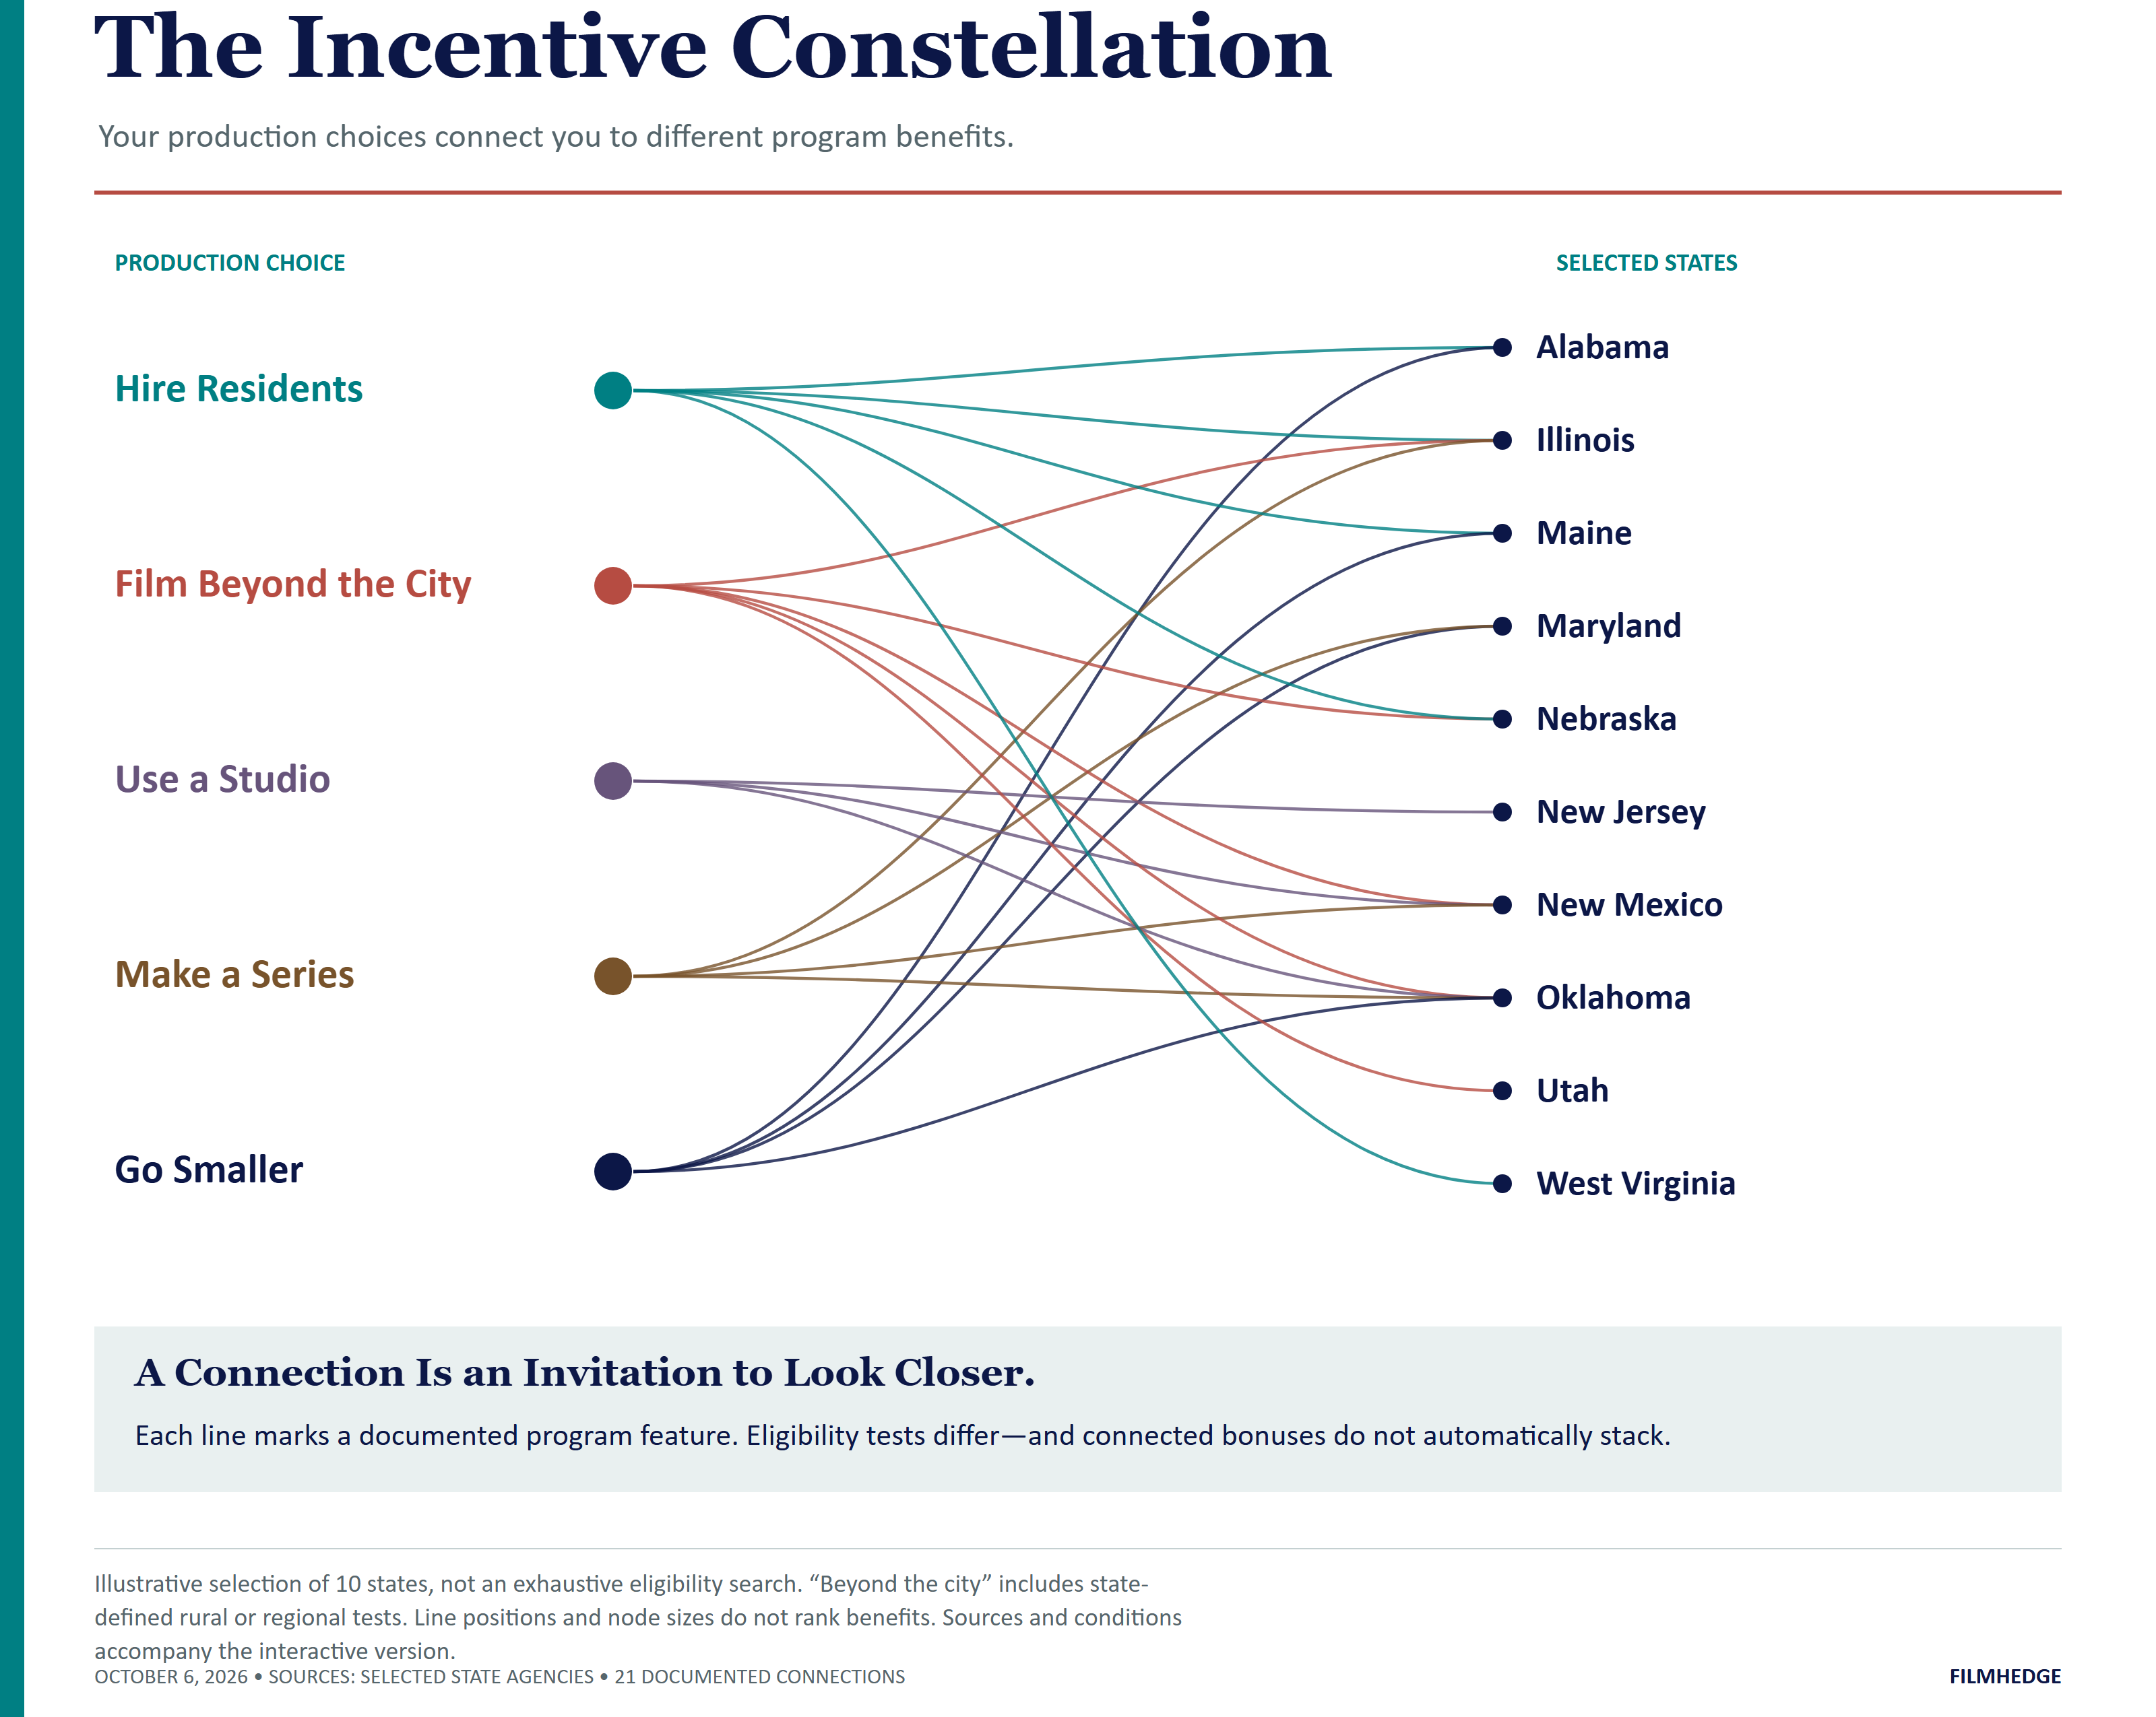
THE ESSENTIALS

Film and TV Incentives at a Glance
Governments at every level use film incentives to attract production spending, create local jobs, and build their screen industries. This guide covers U.S. production incentives and the different ways producers turn eligible spending into money.

Follow the Money

Tax Credits
A tax credit reduces the tax a production company owes to the issuing jurisdiction. Transfer and refund provisions determine how a company with little local tax liability converts the credit into cash.

Rebates
A rebate pays a production company cash based on approved, documented expenditures. The production earns payment by meeting the program’s spending, application, and completion requirements. Payment follows the required review or audit.

Grants
Grants provide funding for qualifying production activities under an award agreement. Producers earn the grant by meeting its spending, hiring, delivery, and reporting requirements.

Exemptions
Exemptions remove specified taxes from qualifying purchases or stays, such as production equipment rentals or eligible lodging. They lower costs when the production satisfies the exemption’s registration and use requirements.

FILM AND TV INCENTIVES

Glossary of Terms

Transferable Tax Credits
Productions sell or assign eligible credits to taxpayers that can use them. The sale creates cash for the production. Sale price, fees, certification, and permitted transfer dates determine the amount and timing of the proceeds.

Refundable Tax Credits
The issuing government pays the eligible unused credit after applying the program’s tax-offset and refund rules. The refund percentage and payment schedule determine the cash the production receives.

Non-Refundable / Non-Transferable Tax Credits
These credits offset the production company’s own eligible taxes. Carryforward rules determine whether the company can use an unused balance in a later year.

Know the Limits

Capped Programs
A program cap limits credits or funding over a defined period. An annual cap and a two-year appropriation cover different periods. A project cap limits the award to one production; a qualified-spending cap limits the expense base used to calculate it.

Uncapped Programs
An uncapped program has no aggregate statutory ceiling on credits. Productions still earn the incentive through eligible spending, timely applications, certification, and compliance. Having no cap does not mean the money arrives on any particular date.

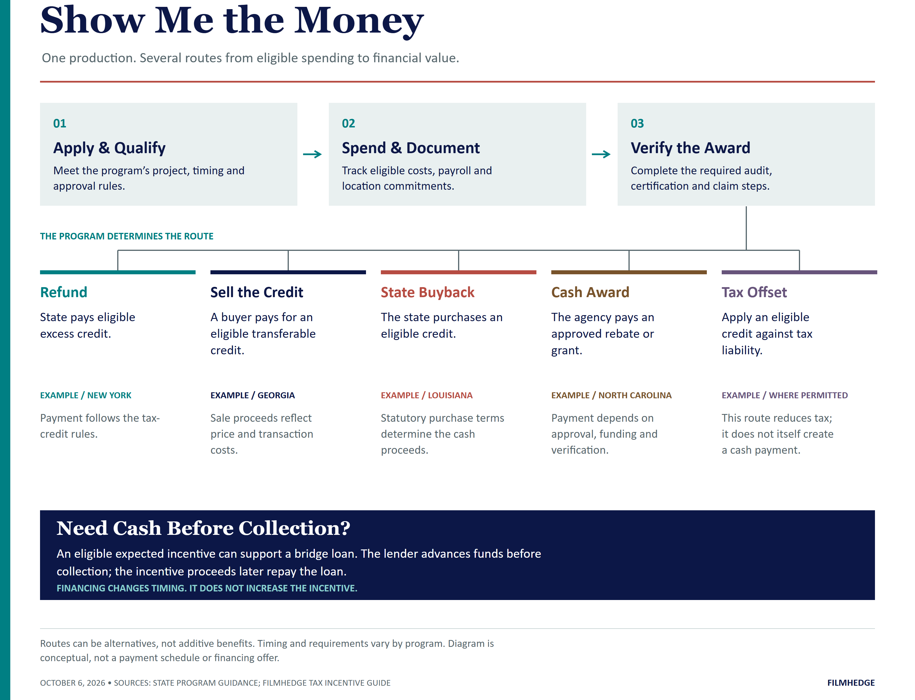
FILM AND TV INCENTIVES

Annual Availability
Published funding describes a program’s capacity. Remaining availability reflects awards already made and funds reserved for other projects. Producers should secure the required allocation or approval before counting the incentive in their financing plan.

Above-the-Line (ATL)
Above-the-line costs cover the principal creative talent, including writers, producers, directors, and lead cast. Incentive programs often apply separate eligibility rules or compensation limits to these costs.

Below-the-Line (BTL)
Below-the-line costs cover the crew and physical production: cinematography, editing, costumes, sets, equipment, locations, and related services. Resident hiring, local vendors, and approved facilities often increase the incentive on these expenses.

Sunset
A sunset provision sets the end of a program or an eligibility period. The law determines which applications, expenditures, awards, and claims remain eligible. Producers should match their production schedule to those dates.

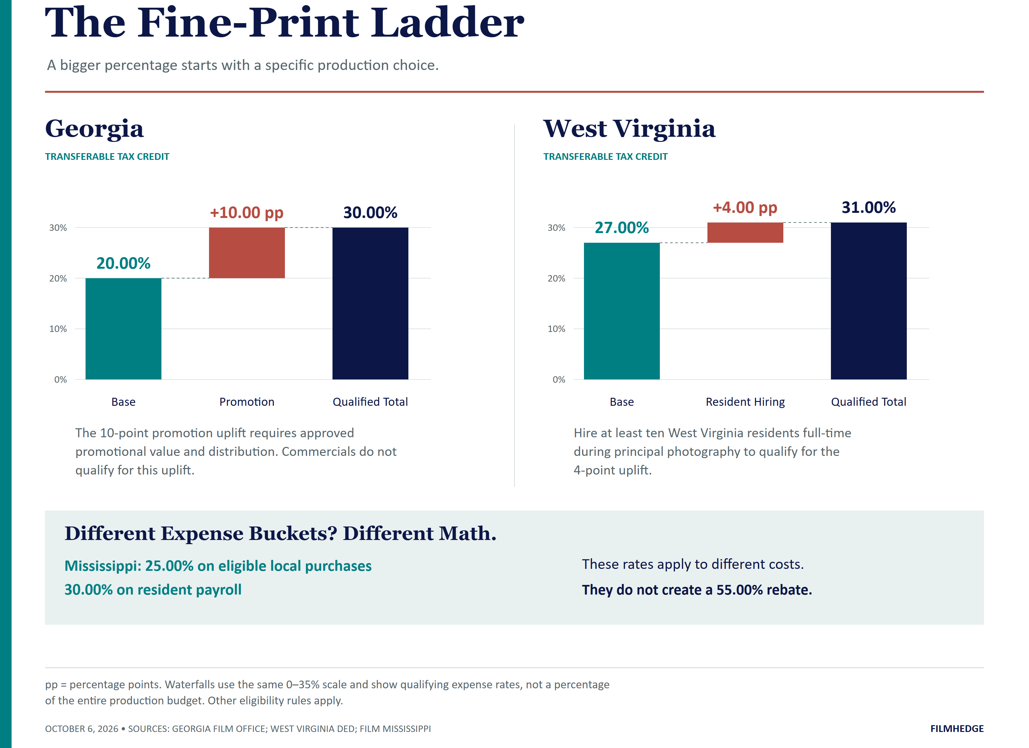
THE PRODUCTION LANDSCAPE

United States
State incentives are a major part of U.S. film and television finance, and states compete hard for productions: on rates, hiring bonuses, refundability, transfer rights, and funding commitments. A sound location strategy weighs the incentive against the costs and practical demands of shooting in each state.

Standout Programs

Georgia
Georgia pairs a 20.00% production credit with a 10.00% promotional uplift and no annual program cap. Its transferable credit and established production infrastructure make it a strong location to evaluate for projects that meet the $500,000 spending threshold.

Illinois
Illinois offers a 35.00% credit on qualified local spending and resident wages, with separate bonuses for eligible hiring, regional filming, relocation, and certified green productions. Its uncapped program and relatively low spending thresholds give producers several ways to build a competitive budget.

More Locations to Watch
California offers $750 million annually under Program 4.0. New York combines its $700 million program with a separate $100 million independent-film allocation. New Jersey, New Mexico, Louisiana, and Massachusetts also offer substantial incentives. Match the project to each program’s expense rules, award availability, and route to cash before choosing a location.
38 states. Different ways
to make a budget work.
The alphabetical profiles that follow pair each program’s rules with its funding limits, entry requirements, route to cash, and selected incentive rates.

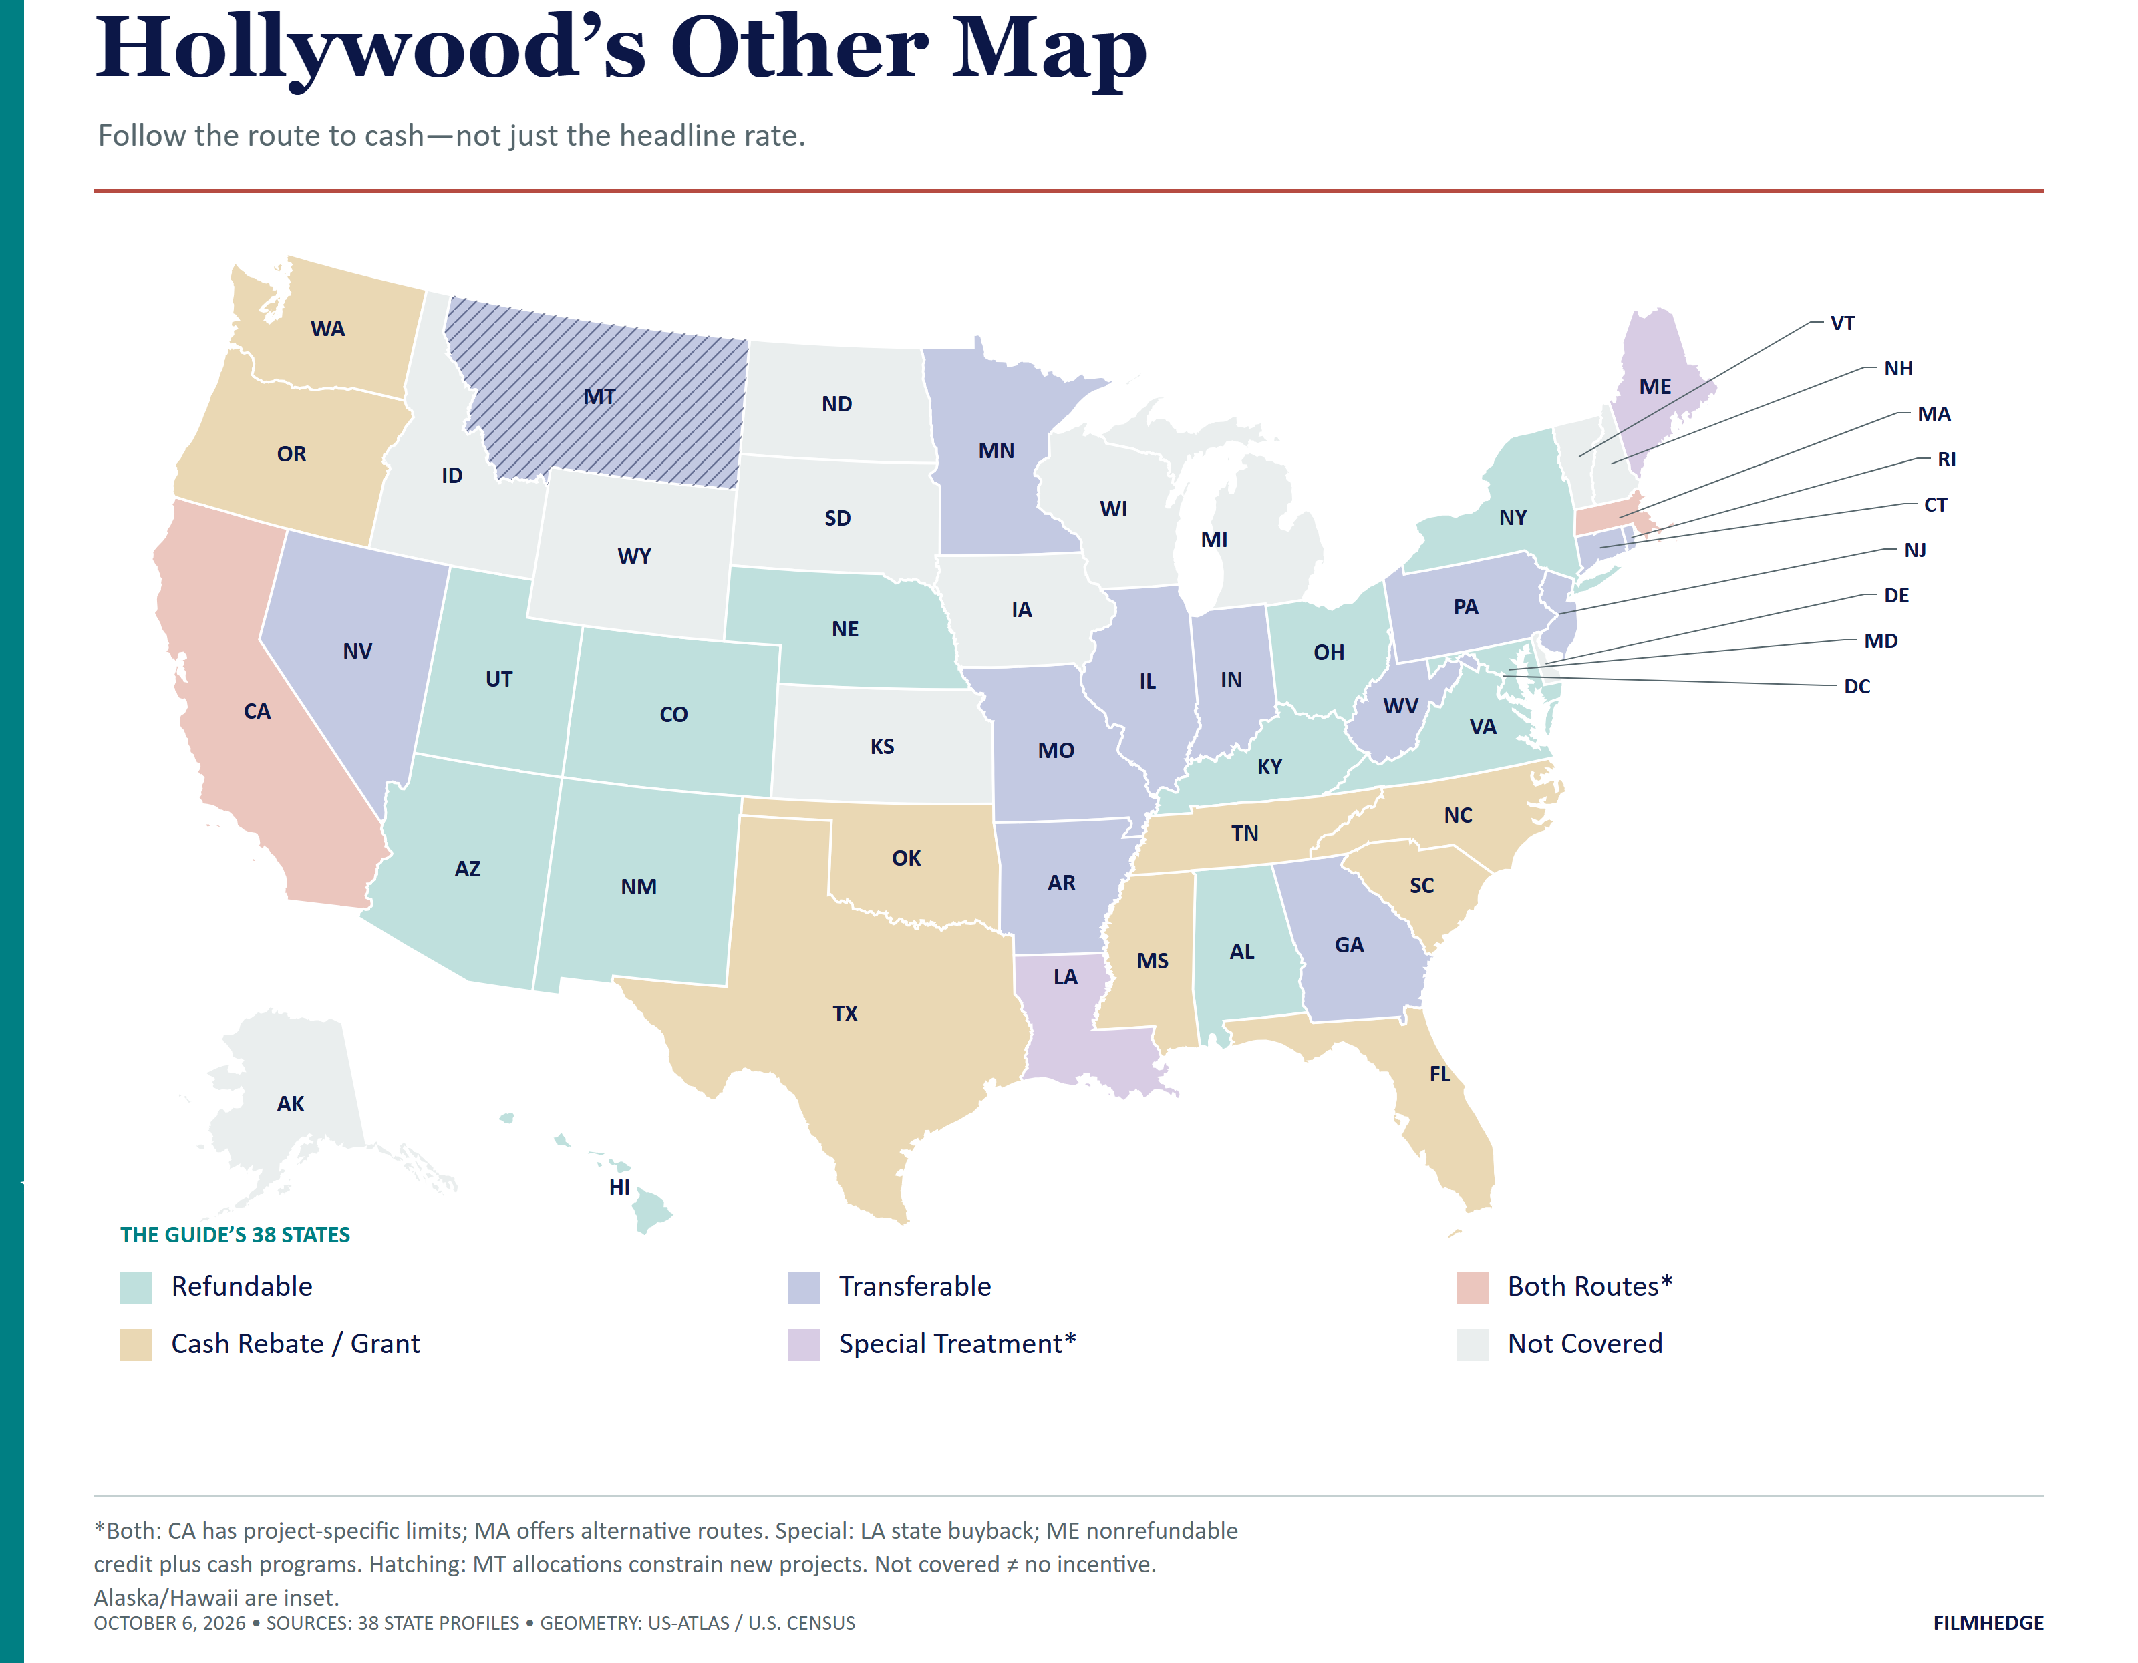
STATE PROFILE 01 / 38

Alabama
THE ROUTE TO CASH
Refundable, Non-Transferable Income Tax Rebate
Alabama’s entertainment incentive rewards local spending and resident hiring. Its annual allocation is $22 million, and productions earn the rebate on the first $20 million of qualifying expenditure.
How It Works  The rebate pays 25.00% on eligible nonresident payroll, goods, and services, and 35.00% on Alabama-resident payroll. These are separate expense categories. A separate small-budget rebate pays 45.00% of resident payroll for productions with $100,000–$499,999 in total production expenditures. Loan-out companies must meet the withholding or estimated-payment requirements that took effect October 1, 2026. | AT A GLANCE  PROGRAM FUNDING  $22 million annually  PROJECT LIMIT  First $20 million of qualifying production expenditures  MINIMUM SPEND  $500,000 standard; $100,000 small-budget route

SELECTED INCENTIVE RATES

Gross rate on each labeled expense category. Program rules and additional incentives appear above.
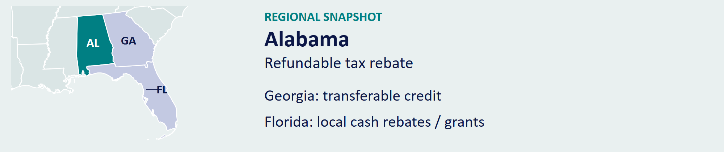
Official program source [1] / Back to contents

STATE PROFILE 02 / 38

Arizona
THE ROUTE TO CASH
Refundable, Non-Transferable Tax Credit
Arizona’s Motion Picture Production Program reserves $100 million annually for qualified production-facility projects and $25 million for practical-location projects. It requires pre-approval, production-start notification, and final certification.
How It Works  Base credits equal 15.00% on production costs up to $10 million, 17.50% above $10 million but below $35 million, and 20.00% above $35 million. A 2.50% uplift applies to qualifying resident below-the-line labor; another 2.50% applies to production costs that meet the facility-use conditions. A separate 2.50% uplift rewards productions associated with a qualifying long-term studio tenant. Practical-location projects must meet Arizona’s filming and in-state preproduction, postproduction, and editing rules. | AT A GLANCE  PROGRAM FUNDING  $125 million annually through 2043  PROJECT LIMIT  $25 million per production  MINIMUM SPEND  No minimum qualifying spend

SELECTED INCENTIVE RATES

Gross rate on each labeled expense category. Program rules and additional incentives appear above.
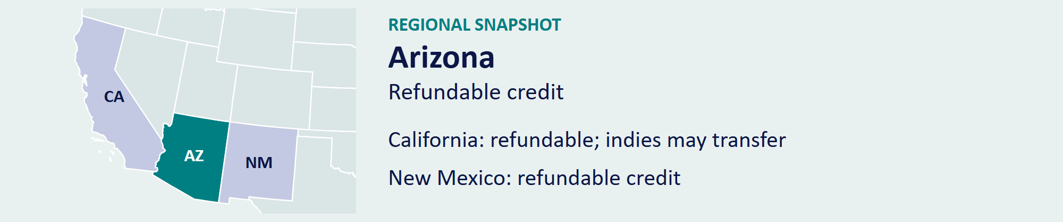
Official program source [2] / Back to contents

STATE PROFILE 03 / 38

Arkansas
THE ROUTE TO CASH
Transferable, Non-Refundable Tax Credit or Cash Rebate
Arkansas offers parallel tax-credit and cash-rebate routes under its Digital Motion Picture Incentive. The program runs through June 30, 2031, and supports eligible production and post-production spending.
How It Works  The base incentive is 25.00%. Qualifying resident or veteran below-the-line payroll, veteran-owned vendors, designated counties, and multi-project productions receive additional incentives under the program’s rules. The administering agency states a 30.00% maximum per expenditure. Eligible compensation includes the first $500,000 per resident or nonresident worker, subject to Arkansas income tax. | AT A GLANCE  PROGRAM FUNDING  $4 million annually for tax credits; rebates use available funding  PROJECT LIMIT  Award set by approval and available funds  MINIMUM SPEND  $200,000 production; $50,000 post-production

SELECTED INCENTIVE RATES

Gross rate on each labeled expense category. Program rules and additional incentives appear above.
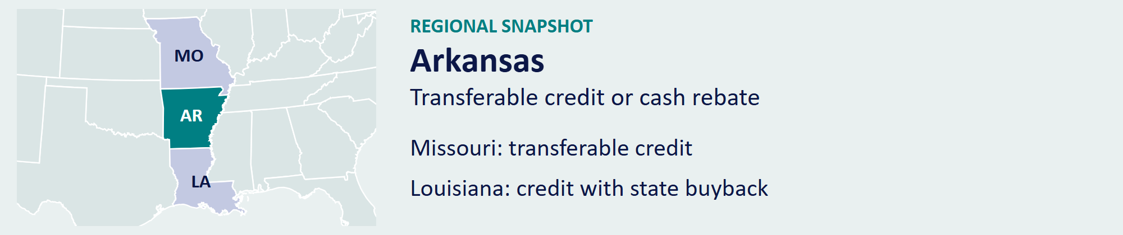
Official program source [3] / Back to contents

STATE PROFILE 04 / 38

California
THE ROUTE TO CASH
Independent Films: Transferable or Refundable; Others: Refundable, Non-Transferable
California’s Film and Television Tax Credit Program 4.0 runs through June 30, 2030, with $3.75 billion across five years. It allocates funding among television, relocating series, independent features, and non-independent features.
How It Works  The base rate is 35.00%, with 40.00% for the first California season of a qualifying relocating series. Eligible spending outside the Los Angeles zone, qualifying visual effects, and local hiring earn specified uplifts. Independent credits apply to the first $20 million of qualified expenditure; non-independent feature allocations apply to the first $120 million, plus uplifts. Program 4.0 offers an election to refund 90.00% of eligible excess credit over the statutory payment period and permits independent-film credit transfers. | AT A GLANCE  PROGRAM FUNDING  $750 million annually under Program 4.0  PROJECT LIMIT  Qualified-spending limits: $20 million independent; $120 million non-independent features  MINIMUM SPEND  $1 million minimum budget for features

SELECTED INCENTIVE RATES

Gross rate on each labeled expense category. Program rules and additional incentives appear above.
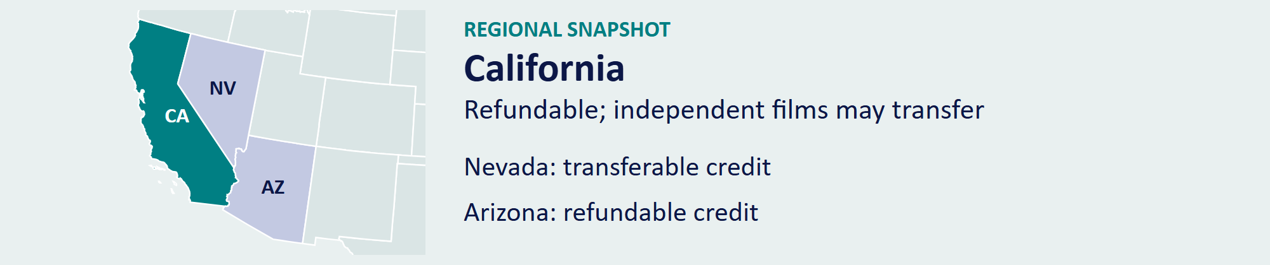
Official program source [4] / Back to contents

STATE PROFILE 05 / 38

Colorado
THE ROUTE TO CASH
Refundable, Non-Transferable Tax Credit
Colorado offers a performance-based credit for qualifying local production expenditure. The program rewards Colorado spending and employment, with approval required through the state’s film office.
How It Works  The standard incentive reaches 20.00%, with a further 2.00% for qualifying activity outside the Denver metropolitan area. Out-of-state television commercials and video games use a $250,000 spending threshold; the $1 million threshold applies to other out-of-state productions. At least half the workforce must be Colorado residents. | AT A GLANCE  PROGRAM FUNDING  $5 million annual credit authorization  PROJECT LIMIT  Award set by approval  MINIMUM SPEND  $100,000 local companies; $1 million out-of-state films

SELECTED INCENTIVE RATES

Gross rate on each labeled expense category. Program rules and additional incentives appear above.
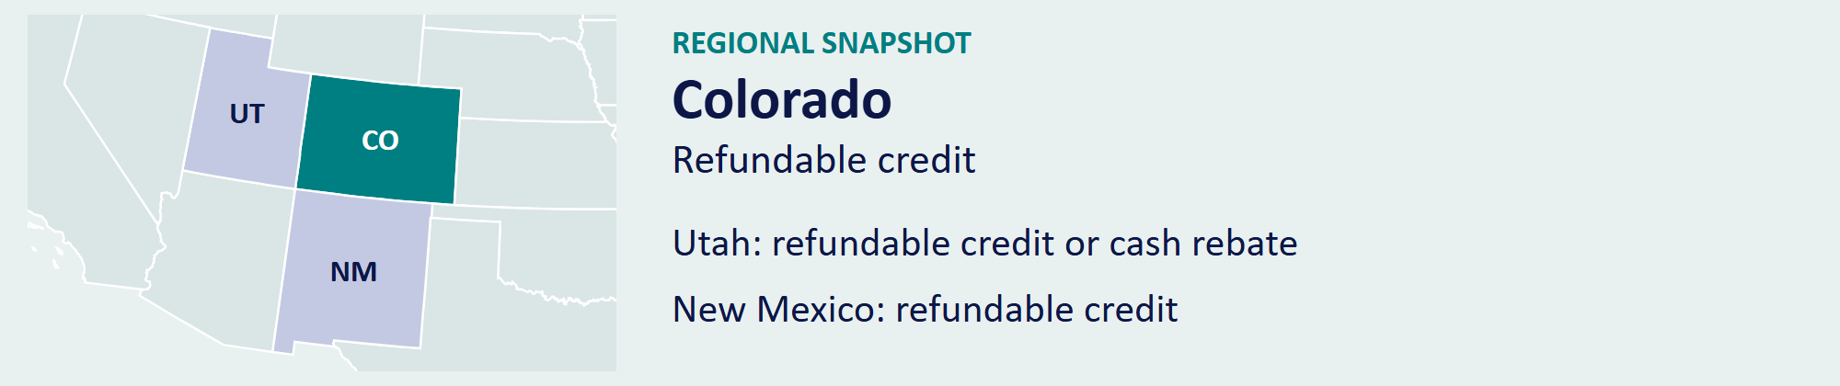
Official program source [5] / Back to contents

STATE PROFILE 06 / 38

Connecticut
THE ROUTE TO CASH
Transferable, Non-Refundable Tax Credit
Connecticut’s Digital Media and Motion Picture Tax Credit offers three spending tiers without an annual program cap. Producers qualify through in-state principal photography or post-production activity.
How It Works  The credit is 10.00% for qualifying costs from $100,000 through $500,000, 15.00% above $500,000 through $1 million, and 30.00% above $1 million. Eligibility requires at least 50.00% of principal-photography days in Connecticut, at least 50.00% of post-production costs in Connecticut, or at least $1 million of in-state post-production costs. Aggregate star-talent compensation is limited to $20 million and must be subject to Connecticut income tax. | AT A GLANCE  PROGRAM FUNDING  No annual statutory cap  PROJECT LIMIT  No general project cap  MINIMUM SPEND  $100,000

SELECTED INCENTIVE RATES

Gross rate on each labeled expense category. Program rules and additional incentives appear above.
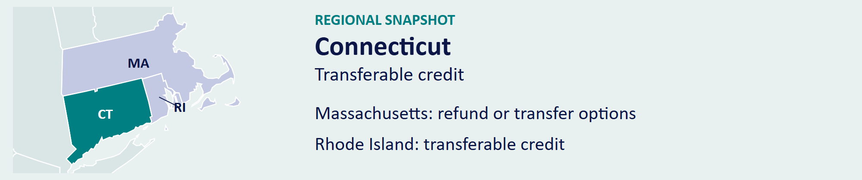
Official program source [6] / Back to contents

STATE PROFILE 07 / 38

Florida
THE ROUTE TO CASH
Cash Rebate / Grant; Not a Tax Credit
Florida combines a statewide sales-tax exemption for qualifying productions with county-level incentives. Broward, Duval, Hillsborough, and Miami-Dade offer distinct programs with their own local spending and hiring requirements.
How It Works  Broward’s Film & TV Program offers 20.00% on qualifying spending, a $400,000 minimum, and an $800,000 project ceiling. Jacksonville offers film and television rebates up to 20.00%. Hillsborough offers a 10.00% rebate for qualifying productions with at least $100,000 of local spending. Miami-Dade’s High Impact Film Fund offers up to 20.00% for qualifying major productions. Broward’s Multiple Project Guarantee offers 30.00%, capped at $2.5 million per project, for at least two scripted projects within three years, each spending at least $4 million locally. | AT A GLANCE  PROGRAM FUNDING  Local allocations; no statewide production-credit pool  PROJECT LIMIT  Varies by county and program  MINIMUM SPEND  Varies by county and program

Think local.
Florida’s incentives operate through local programs. Compare each location’s award structure and requirements.
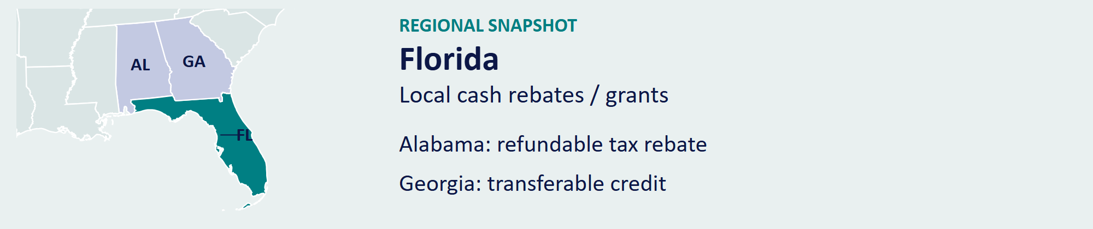
Official program source [7] / Back to contents

STATE PROFILE 08 / 38

Georgia
THE ROUTE TO CASH
Transferable, Non-Refundable Tax Credit
Georgia’s production incentive combines an uncapped credit with a substantial local production industry. The Georgia Film Office certifies eligible projects, and the Department of Revenue reviews the expenditures and credit claim.
How It Works  The base credit is 20.00% of qualified Georgia expenditure. A further 10.00% applies when a production meets the Georgia Entertainment Promotion requirements. The minimum is $500,000 of qualifying expenditure in a tax year. Producers must meet certification, mandatory audit, payroll, and promotional conditions before monetizing the earned credit. | AT A GLANCE  PROGRAM FUNDING  No annual cap  PROJECT LIMIT  No project cap  MINIMUM SPEND  $500,000 in qualifying annual expenditure

SELECTED INCENTIVE RATES

Gross rate on each labeled expense category. Program rules and additional incentives appear above.
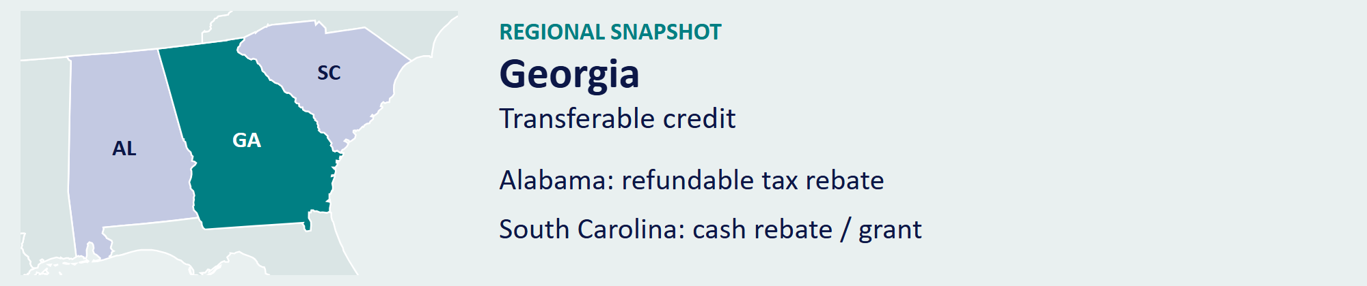
Official program source [8] / Back to contents

STATE PROFILE 09 / 38

Hawaii
THE ROUTE TO CASH
Refundable, Non-Transferable Tax Credit
Hawaii’s 2026 program offers refundable credits on qualifying island production spending. The statewide cap is $60 million, and the standard production ceiling is $20 million. Productions with at least $60 million of qualified costs have no per-production credit cap.
How It Works  The credit equals 22.00% on Oahu and 27.00% on the Neighbor Islands. A production with at least 80.00% local hires earns an additional 5.00% on qualifying costs incurred after December 31, 2025, bringing those rates to 27.00% and 32.00%. Each claimant must submit an independent CPA certification under the prescribed procedures. | AT A GLANCE  PROGRAM FUNDING  $60 million annually  PROJECT LIMIT  $20 million; no cap with at least $60 million of qualified costs  MINIMUM SPEND  $100,000

SELECTED INCENTIVE RATES

Gross rate on each labeled expense category. Program rules and additional incentives appear above.

Official program source [9] / Back to contents

STATE PROFILE 10 / 38

Illinois
THE ROUTE TO CASH
Transferable, Non-Refundable Tax Credit
Illinois offers a 35.00% credit on qualified local vendor spending and Illinois-resident wages. Eligible nonresident wages receive 30.00%. The program extends through 2038 and applies a $500,000 compensation limit per eligible worker.
How It Works  A 15.00% wage uplift rewards hiring from qualifying economically disadvantaged areas. Separate 5.00% uplifts cover eligible resident wages outside the six-county Chicago region, relocating television series, and certified green productions. Nonresident crew and cast eligibility follows the program’s role and production-spending limits. The chart shows base rates and the resident-wage rate with the disadvantaged-area uplift. | AT A GLANCE  PROGRAM FUNDING  No annual cap  PROJECT LIMIT  No general project cap  MINIMUM SPEND  $50,000 under 30 minutes; $100,000 at least 30 minutes

SELECTED INCENTIVE RATES

Gross rate on each labeled expense category. Program rules and additional incentives appear above.
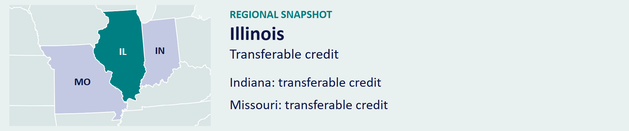
Official program source [10] / Back to contents

STATE PROFILE 11 / 38

Indiana
THE ROUTE TO CASH
Transferable, Non-Refundable Tax Credit
Indiana’s Film and Media Production Tax Credit became transferable effective January 1, 2026. Its $250,000 project cap and $2 million statewide limit make award size a central part of the financing decision.
How It Works  The base credit is 20.00% of qualified production expenditure. Productions earn a further 5.00% for meeting the Indiana workforce requirement and 5.00% for including an approved Indiana brand or logo, for a total of up to 30.00%. Applicants must obtain approval and document the qualified activity. | AT A GLANCE  PROGRAM FUNDING  $2 million statewide credit limit  PROJECT LIMIT  $250,000  MINIMUM SPEND  No published general minimum

SELECTED INCENTIVE RATES

Gross rate on each labeled expense category. Program rules and additional incentives appear above.
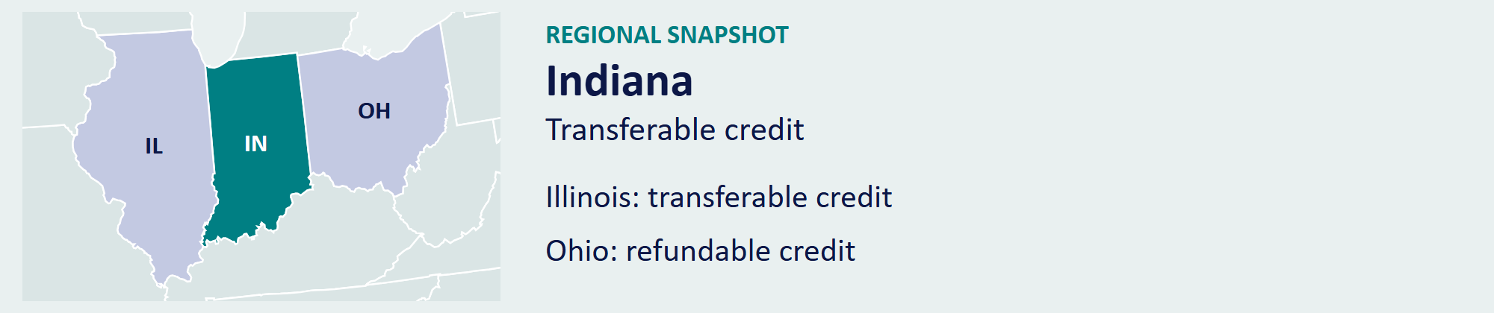
Official program source [11] / Back to contents

STATE PROFILE 12 / 38

Kentucky
THE ROUTE TO CASH
Refundable, Non-Transferable Tax Credit
Kentucky’s Entertainment Incentive combines a 30.00% standard rate with 35.00% treatment for qualifying resident payroll or eligible enhanced-county spending. Its 2026 rules raise the film and television spending thresholds to $200,000 for Kentucky-based companies and $400,000 for out-of-state companies.
How It Works  Documentaries use lower thresholds of $10,000 and $20,000, respectively. The program reviews applications through the Kentucky Film Office and Film Leadership Council and requires a certified audit after production. Producers should build the applicable review window, award agreement, and audit timetable into their financing schedule. | AT A GLANCE  PROGRAM FUNDING  $75 million annually, with statutory carryforward provisions  PROJECT LIMIT  $10 million per production  MINIMUM SPEND  $200,000 Kentucky companies; $400,000 out-of-state film/TV

SELECTED INCENTIVE RATES

Gross rate on each labeled expense category. Program rules and additional incentives appear above.
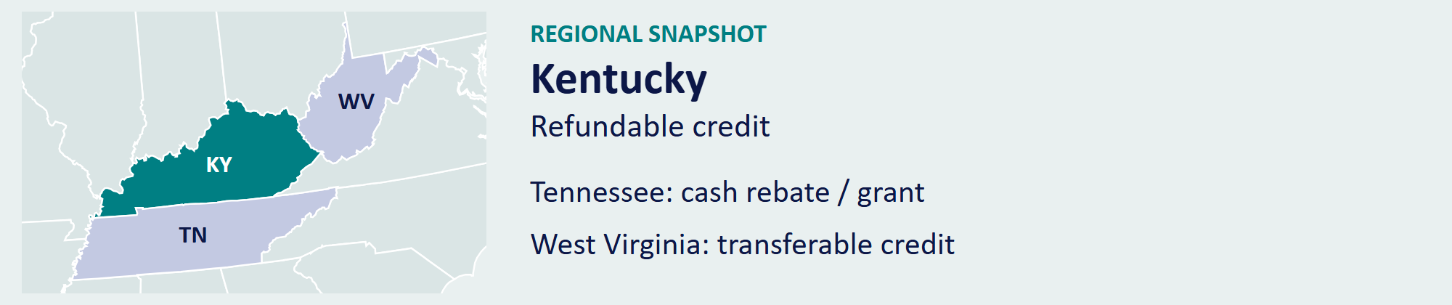
Official program source [12] / Back to contents

STATE PROFILE 13 / 38

Louisiana
THE ROUTE TO CASH
Non-Refundable Credit; Transfer Back to State for Cash
Louisiana’s Motion Picture Production Program offers a 25.00% base credit and eligible uplifts. The issuance and claim caps are each $125 million for the periods covered by the July 1, 2025, changes.
How It Works  Eligible Louisiana-screenplay productions receive a 10.00% increase, and qualifying production outside the New Orleans metropolitan area receives 5.00%. Resident-payroll and visual-effects rules provide additional benefits, with the program’s combined limit applying. Producers can use the credit against eligible Louisiana income tax or transfer it back to the state at a net 88.00% of face value after the transfer fee. | AT A GLANCE  PROGRAM FUNDING  $125 million annual issuance cap and $125 million claim cap  PROJECT LIMIT  Approval-specific award  MINIMUM SPEND  $300,000; $50,000 qualifying Louisiana-screenplay productions

SELECTED INCENTIVE RATES

Gross rate on each labeled expense category. Program rules and additional incentives appear above.

Official program source [13] / Back to contents

STATE PROFILE 14 / 38

Maine
THE ROUTE TO CASH
Neither Refundable nor Transferable Credit; Separate Wage Rebate
Maine’s Visual Media Production Incentive combines a payroll reimbursement with a separate credit on eligible non-wage expenses. The program serves productions that spend at least $75,000 in the state.
How It Works  Maine reimburses 12.00% of qualifying resident wages and 10.00% of qualifying nonresident wages, using the first $50,000 of wages per individual. The separate 5.00% production-expense credit is non-refundable and non-transferable. The wage and non-wage rates apply to different costs; they do not form a single 17.00% rebate. A separate pilot offers 25.00% on resident labor and non-payroll costs and 20.00% on nonresident labor, with a $350,000 grant ceiling and $1 million spending threshold. | AT A GLANCE  PROGRAM FUNDING  Core program uncapped; anticipated $700,000 pilot pool  PROJECT LIMIT  Core program uncapped; pilot grants up to $350,000  MINIMUM SPEND  $75,000 core; $1 million pilot

SELECTED INCENTIVE RATES

Gross rate on each labeled expense category. Program rules and additional incentives appear above.
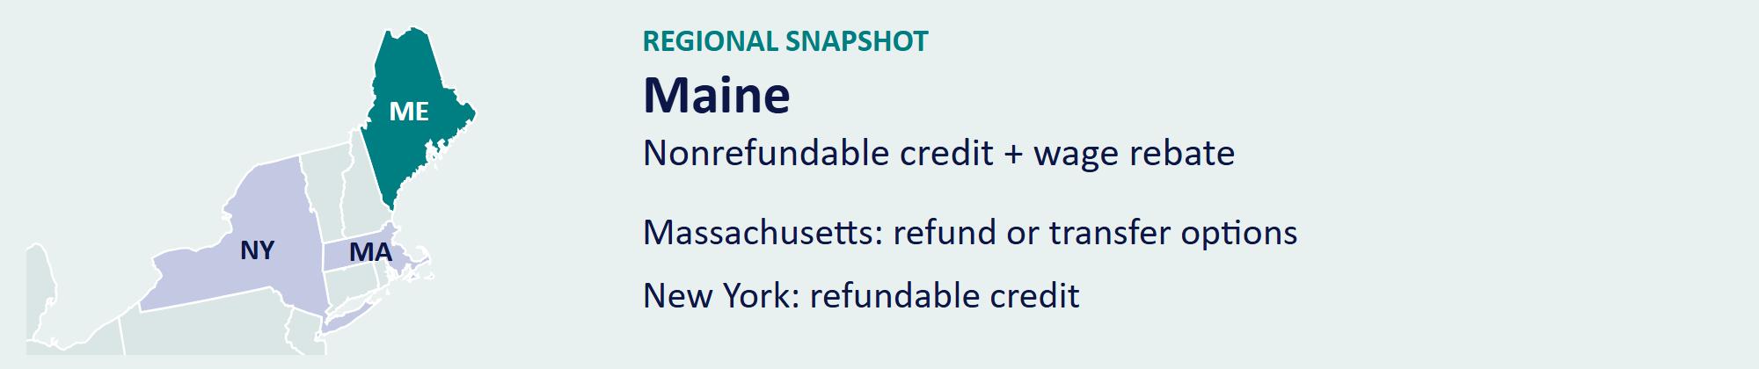
Official program source [14] / Back to contents

STATE PROFILE 15 / 38

Maryland
THE ROUTE TO CASH
Refundable, Non-Transferable Tax Credit
Maryland’s Film Production Activity Tax Credit provides $12 million for fiscal year 2027, July 1, 2026, through June 30, 2027. The state accepts qualification applications on a first-come, first-served basis.
How It Works  Qualified feature films and Maryland small or independent films receive 28.00% of eligible direct costs. Television series receive 30.00%. The program caps standard awards at $10 million and small or independent-film awards at $125,000. Producers must meet Maryland’s activity, spending, application, and verification requirements. | AT A GLANCE  PROGRAM FUNDING  $12 million for FY 2027  PROJECT LIMIT  $10 million standard; $125,000 small/independent films  MINIMUM SPEND  $250,000 standard; $25,000 small/independent films

SELECTED INCENTIVE RATES

Gross rate on each labeled expense category. Program rules and additional incentives appear above.
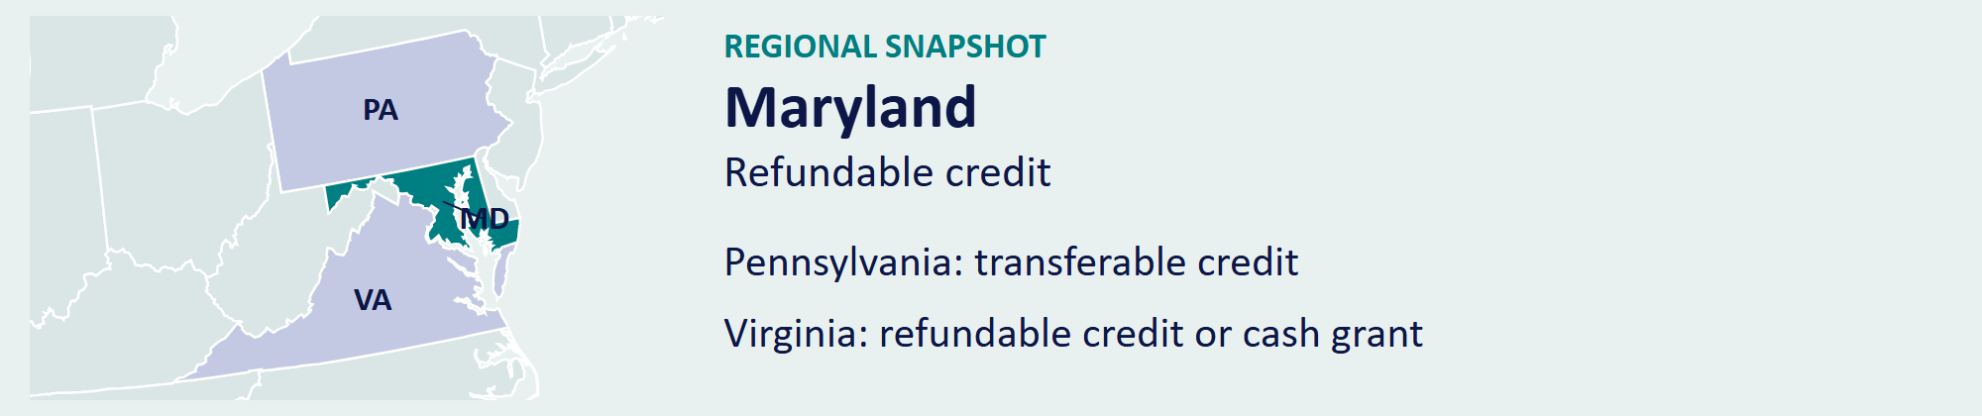
Official program source [15] / Back to contents

STATE PROFILE 16 / 38

Massachusetts
THE ROUTE TO CASH
Both Transfer and Refund Routes; Refund at 90.00% of Eligible Excess
Massachusetts combines a 25.00% payroll credit, a 25.00% production-expense credit, and a qualifying sales-tax exemption. The state made the program permanent in 2021.
How It Works  The production-expense credit requires more than 75.00% of total production expenses in Massachusetts or at least 75.00% of principal-photography days in the state. Payroll paid to an individual earning $1 million or more is excluded from the payroll credit, but can qualify under the production-expense rules. Producers can transfer credits or elect a 90.00% refund of eligible unused credits after tax offsets. The two credits do not double-count the same payroll expense. | AT A GLANCE  PROGRAM FUNDING  No annual cap  PROJECT LIMIT  No project cap  MINIMUM SPEND  $50,000 in a consecutive 12-month period

SELECTED INCENTIVE RATES

Gross rate on each labeled expense category. Program rules and additional incentives appear above.
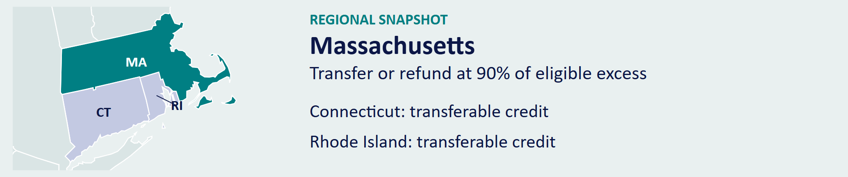
Official program source [16] / Back to contents

STATE PROFILE 17 / 38

Minnesota
THE ROUTE TO CASH
Transferable, Non-Refundable Tax Credit
Minnesota’s Film Production Tax Credit offers 25.00% of eligible production costs to companies that spend at least $1 million within 12 consecutive months. Explore Minnesota Film allocates credits on a first-come, first-served basis.
How It Works  Productions secure a Credit Allocation Letter before incurring the eligible expenditure. The credit is assignable, allowing the production to transfer it to another taxpayer. The spending threshold, allocation date, qualified-cost rules, and required Minnesota tax reporting determine the final award. | AT A GLANCE  PROGRAM FUNDING  $25 million annual maximum  PROJECT LIMIT  Award set by allocation  MINIMUM SPEND  $1 million in 12 consecutive months

SELECTED INCENTIVE RATES

Gross rate on each labeled expense category. Program rules and additional incentives appear above.
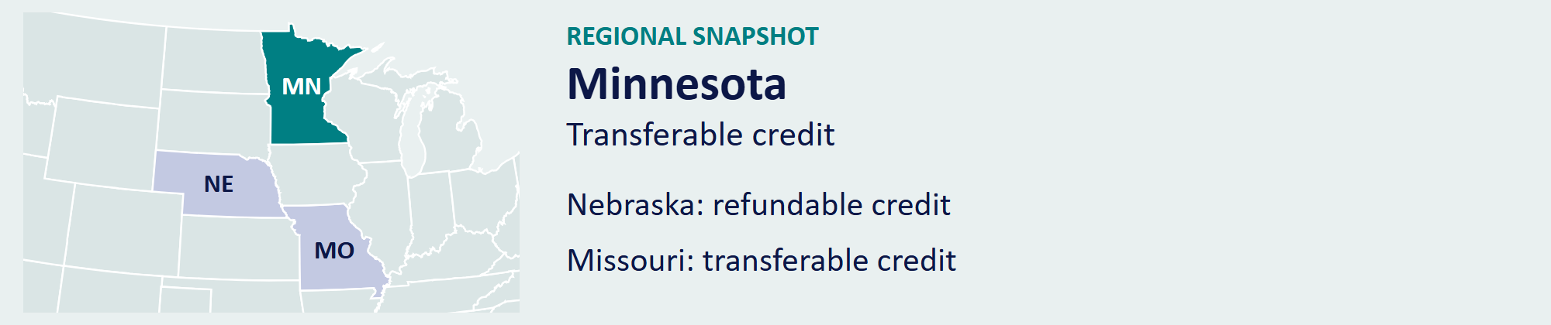
Official program source [17] / Back to contents

STATE PROFILE 18 / 38

Mississippi
THE ROUTE TO CASH
Cash Rebate / Grant; Not a Tax Credit
Mississippi’s Motion Picture Incentive uses a cash rebate to reward local spending and employment. A separate episodic-television program supports qualifying series; its award rules and funding are distinct.
How It Works  The motion-picture rebate pays 25.00% on qualifying local purchases and eligible nonresident payroll, and 30.00% on resident payroll, plus 5.00% for eligible resident veterans. Eligible compensation reaches the first $5 million per person. The separate episodic-TV program pays 35.00% on resident payroll, capped at $3 million per person. At least 20.00% of the production crew must be Mississippi residents. Producers must obtain approval and document the qualified spending. | AT A GLANCE  PROGRAM FUNDING  $20 million annually for the motion-picture program  PROJECT LIMIT  $10 million  MINIMUM SPEND  $50,000

SELECTED INCENTIVE RATES

Gross rate on each labeled expense category. Program rules and additional incentives appear above.
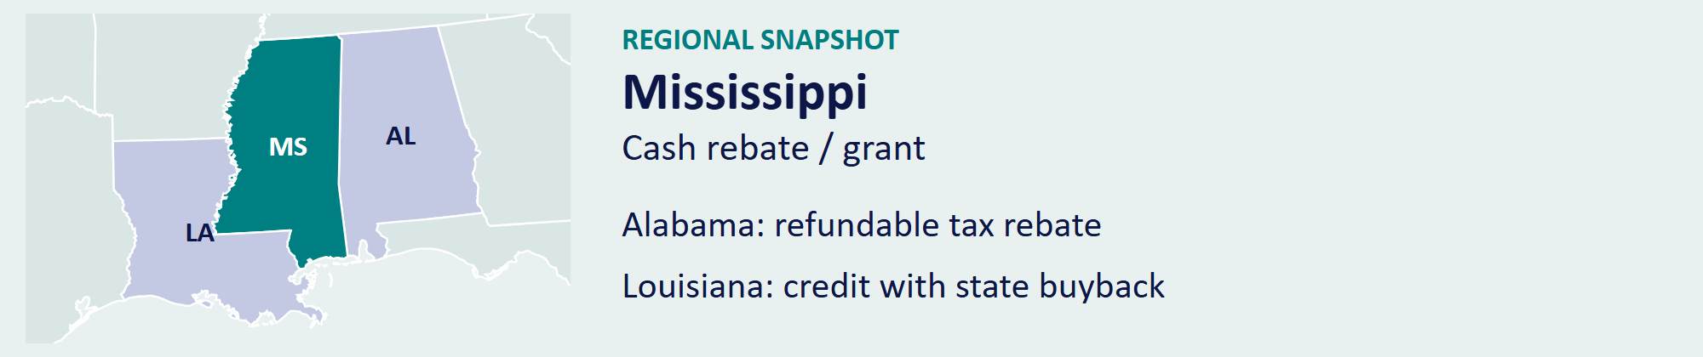
Official program source [18] / Back to contents

STATE PROFILE 19 / 38

Missouri
THE ROUTE TO CASH
Transferable, Non-Refundable Tax Credit
Missouri’s Show MO incentive offers a 20.00% base credit and bonuses that raise the rate to 42.00%. The annual allocation separates film and episodic productions into two $8 million pools.
How It Works  The bonus structure rewards Missouri filming, rural or blighted locations, career advancement for Missouri crew, positive portrayal of the state, and an eligible county production office. Projects must employ two to eight registered apprentices or veterans who are Missouri residents, according to budget. Producers calculate the award using each qualifying expense and the bonuses the project actually earns. | AT A GLANCE  PROGRAM FUNDING  $16 million annually: $8 million film and $8 million episodic  PROJECT LIMIT  Awards draw from the applicable program pool  MINIMUM SPEND  $50,000 up to 30 minutes; $100,000 over 30 minutes

SELECTED INCENTIVE RATES

Gross rate on each labeled expense category. Program rules and additional incentives appear above.
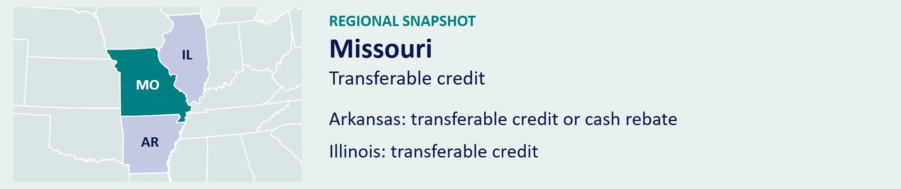
Official program source [19] / Back to contents

STATE PROFILE 20 / 38

Montana
THE ROUTE TO CASH
Transferable, Non-Refundable Tax Credit
Montana’s MEDIA credit is not currently available to productions filming after 2024. The Department of Revenue has allocated the annual credit capacity to approved 2024 productions under its implementation of Senate Bill 326.
How It Works  The department reports that credit through 2030 and part of 2031 will serve those earlier productions. It identifies 2031 as the first potential year for new expenditure claims after those commitments. Producers planning a new Montana shoot should budget no current MEDIA credit. The chart shows current availability for new productions, rather than the historical incentive rate. | AT A GLANCE  PROGRAM FUNDING  $12 million annually; committed to earlier approved productions  PROJECT LIMIT  No current credit for new productions  MINIMUM SPEND  New productions have no current credit availability

CURRENT CREDIT AVAILABILITY

No current credit is available for new productions. This chart does not show the statutory incentive rate.
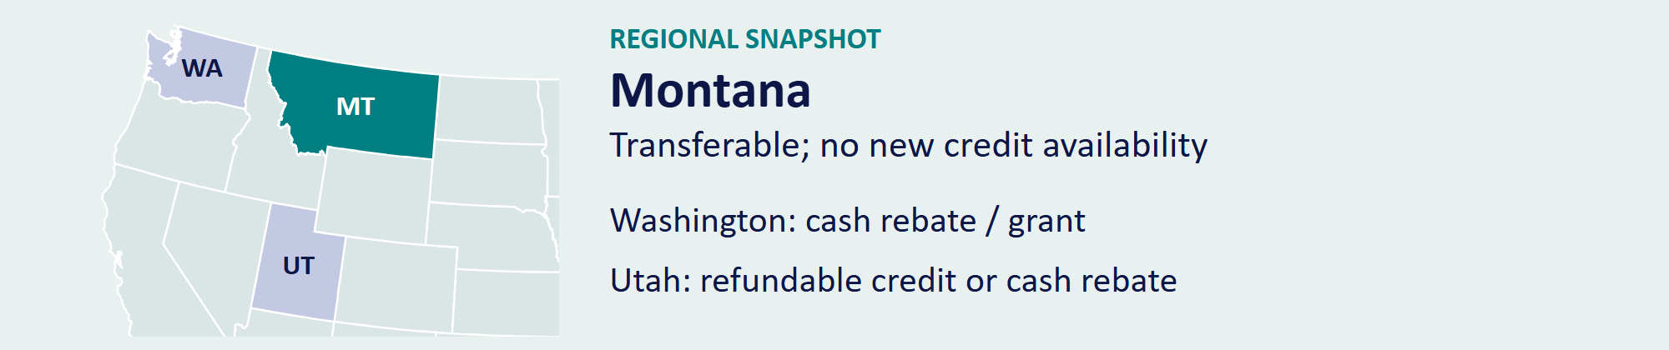
Official program source [20] / Back to contents

STATE PROFILE 21 / 38

Nebraska
THE ROUTE TO CASH
Refundable, Non-Transferable Tax Credit
Nebraska’s Cast and Crew Nebraska Act provides a 20.00% refundable credit. Current law limits total credits to $500,000 per fiscal year and caps a qualifying long-form production’s credit at $500,000.
How It Works  Qualifying full-length productions earn an additional 5.00% for a Nebraska-based story and 5.00% for the specified rural filming commitment. A separate 5.00% applies to qualifying wages for up to ten first-time Nebraska actors or below-the-line employees. The program also requires Nebraska production days, resident hiring, and advance application. The wage uplift applies only to the eligible wages. | AT A GLANCE  PROGRAM FUNDING  $500,000 per fiscal year  PROJECT LIMIT  $500,000 per qualifying long-form production  MINIMUM SPEND  $500,000 long-form; $25,000 qualifying short-form

SELECTED INCENTIVE RATES

Gross rate on each labeled expense category. Program rules and additional incentives appear above.
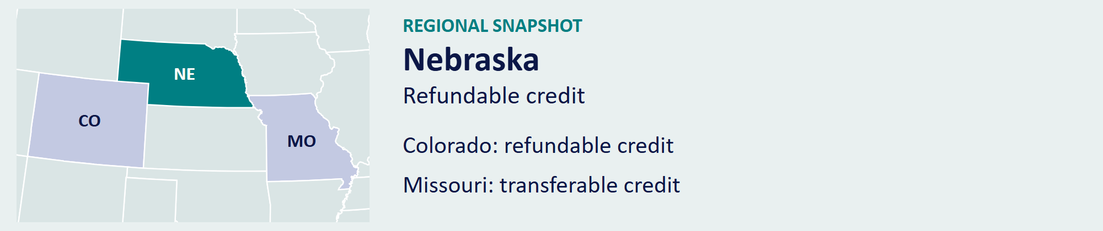
Official program source [21] / Back to contents

STATE PROFILE 22 / 38

Nevada
THE ROUTE TO CASH
Transferable, Non-Refundable Tax Credit
Nevada’s transferable credit offers a 15.00% base incentive on eligible local spending and resident compensation. Eligible nonresident above-the-line compensation receives 12.00%. The program has $10 million in annual funding.
How It Works  A 5.00% uplift rewards a below-the-line crew with more than 50.00% Nevada residents. Another 5.00% rewards qualifying filming in counties with limited prior production spending. At least 60.00% of the production budget must meet Nevada’s in-state expenditure test. Compensation limits and project approval determine the eligible expense base. | AT A GLANCE  PROGRAM FUNDING  $10 million annually, plus eligible carryforward  PROJECT LIMIT  $6 million  MINIMUM SPEND  $500,000

SELECTED INCENTIVE RATES

Gross rate on each labeled expense category. Program rules and additional incentives appear above.
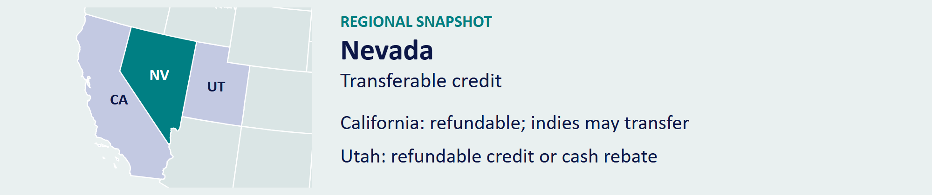
Official program source [22] / Back to contents

STATE PROFILE 23 / 38

New Jersey
THE ROUTE TO CASH
Transferable, Non-Refundable Credit; Eligible State Purchase Route
New Jersey’s film credit offers 30.00% on eligible activity within the defined 30-mile New York zone and 35.00% outside it. Studio-partner, film-lease, and hiring provisions provide additional benefits under separate rules.
How It Works  Projects qualify through more than $1 million of New Jersey expenditure or the 60.00% spending test. NJEDA currently directs approved applications to future fiscal-year allocations. For original applications approved from January 1, 2026, qualifying studio-partner credits receive a 95.00% state purchase price once the certificate has been held for at least one year. Other eligible credits retain the transfer route. | AT A GLANCE  PROGRAM FUNDING  Separate legacy, studio-partner, and film-lease allocations  PROJECT LIMIT  Award set by program category and approval  MINIMUM SPEND  Over $1 million, or the 60.00% eligible-spending test

SELECTED INCENTIVE RATES

Gross rate on each labeled expense category. Program rules and additional incentives appear above.
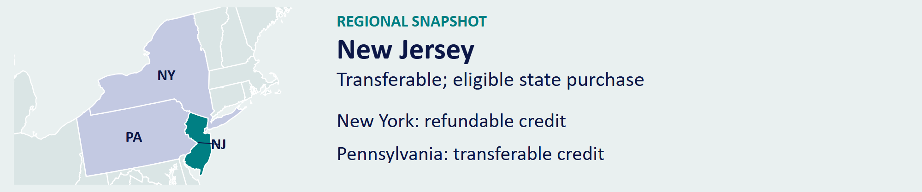
Official program source [23] / Back to contents

STATE PROFILE 24 / 38

New Mexico
THE ROUTE TO CASH
Refundable, Non-Transferable Tax Credit
New Mexico offers a 25.00% refundable production credit. Its annual payment cap rises to $150 million in fiscal year 2027 and $160 million in fiscal year 2028. Qualifying film-partner expenditures receive separate statutory treatment.
How It Works  A 5.00% uplift applies to eligible television series or qualified production-facility use; those two uplifts do not stack. A further 10.00% applies to eligible spending in the rural uplift zone, producing a potential 40.00% rate on qualifying expenses. Resident and nonresident labor follow separate eligibility and limitation rules. Producers should calculate the credit by expense category and location. | AT A GLANCE  PROGRAM FUNDING  $150 million FY 2027 payment cap; qualifying partners excluded  PROJECT LIMIT  No general project cap  MINIMUM SPEND  No general minimum spend

SELECTED INCENTIVE RATES

Gross rate on each labeled expense category. Program rules and additional incentives appear above.
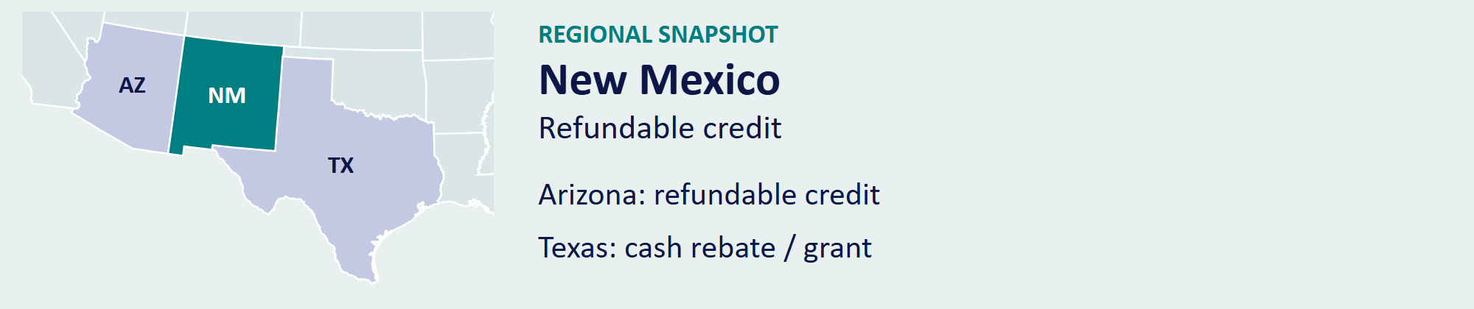
Official program source [24] / Back to contents

STATE PROFILE 25 / 38

New York
THE ROUTE TO CASH
Refundable, Non-Transferable Tax Credit
New York’s main production program provides $700 million annually through 2036. A separate $100 million independent-film program expands access for eligible independent projects. A production uses one of those routes for the same project.
How It Works  The standard production credit is 30.00%. Qualifying work in designated counties earns a 10.00% uplift under the regional rules. Production Plus offers additional 5.00% or 10.00% benefits for qualifying companies that meet multi-production spending thresholds. Qualified-facility, location-spending, application, and production requirements determine eligibility; producers should model the rate on the costs that meet those tests. | AT A GLANCE  PROGRAM FUNDING  $700 million annually; separate $100 million independent-film program  PROJECT LIMIT  No general production-credit cap  MINIMUM SPEND  $1 million in specified downstate counties; $250,000 elsewhere

SELECTED INCENTIVE RATES

Gross rate on each labeled expense category. Program rules and additional incentives appear above.

Official program source [25] / Back to contents

STATE PROFILE 26 / 38

North Carolina
THE ROUTE TO CASH
Cash Rebate / Grant; Not a Tax Credit
North Carolina’s Film and Entertainment Grant provides a base cash rebate of up to 25.00% of qualifying in-state expenditure. The legislature added $15 million for FY 2026–27 to the $31 million recurring annual allocation.
How It Works  Feature films must spend at least $1.5 million in North Carolina. Television series use a $500,000 per-episode threshold, and made-for-television movies use $500,000. The award cap is $20 million for a feature or unscripted streaming season and $25 million for a scripted streaming or television season. Qualifying compensation is limited to $4 million per person. A separate micro-budget program authorizes a 20.00% base grant, capped at $100,000, for qualifying spending of $50,000–$1,499,000, plus limited bonuses. | AT A GLANCE  PROGRAM FUNDING  $31 million recurring; $15 million extra for FY 2026–27  PROJECT LIMIT  $20 million feature; $25 million scripted/TV season  MINIMUM SPEND  $1.5M features; $500K TV; $50K micro-budget route

SELECTED INCENTIVE RATES

Gross rate on each labeled expense category. Program rules and additional incentives appear above.
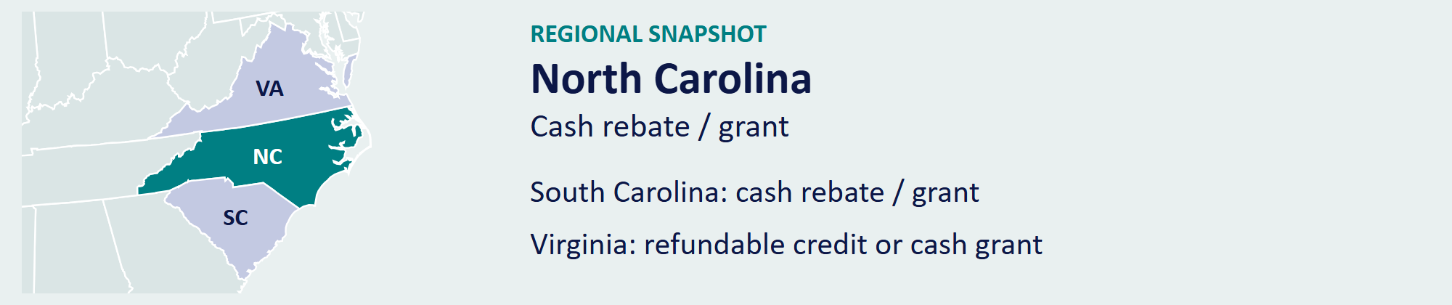
Official program source [26] / Back to contents

STATE PROFILE 27 / 38

Ohio
THE ROUTE TO CASH
Refundable, Non-Transferable Tax Credit
Ohio’s Motion Picture Tax Credit offers a 30.00% refundable credit on eligible production expenditure. The program allocates $50 million annually, including a $5 million reservation for eligible Broadway and theatrical productions.
How It Works  Qualifying projects must spend at least $300,000 in Ohio. Production costs and qualifying cast and crew wages form the expense base. Applicants compete in the published allocation rounds and must document financing, production activity, and qualified costs. The production must include the required Ohio acknowledgment and complete the final review. | AT A GLANCE  PROGRAM FUNDING  $50 million annually; $5 million reserved for Broadway/theatrical  PROJECT LIMIT  No general project cap  MINIMUM SPEND  $300,000

SELECTED INCENTIVE RATES

Gross rate on each labeled expense category. Program rules and additional incentives appear above.
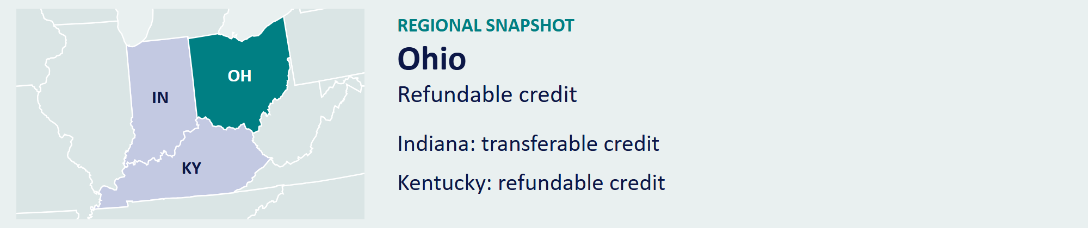
Official program source [27] / Back to contents

STATE PROFILE 28 / 38

Oklahoma
THE ROUTE TO CASH
Cash Rebate / Grant; Not a Tax Credit
The Filmed in Oklahoma Act offers a 20.00% base rebate and qualifying uplifts up to 30.00%. Its $30 million annual pool reserves $7.5 million for projects with budgets below $7.5 million and $22.5 million for larger projects. Those are funding pools, not individual project awards.
How It Works  Uplifts reward rural counties, small municipalities, soundstage use, television production, multi-film commitments, local post-production, and Oklahoma music. Each has its own spending or filming test. Producers select the bonuses their production qualifies for and apply the program’s combined limit. | AT A GLANCE  PROGRAM FUNDING  $30 million annually  PROJECT LIMIT  No general project cap; funding reserved by budget category  MINIMUM SPEND  $50,000 Oklahoma spend; $50,000 minimum project budget

SELECTED INCENTIVE RATES

Gross rate on each labeled expense category. Program rules and additional incentives appear above.
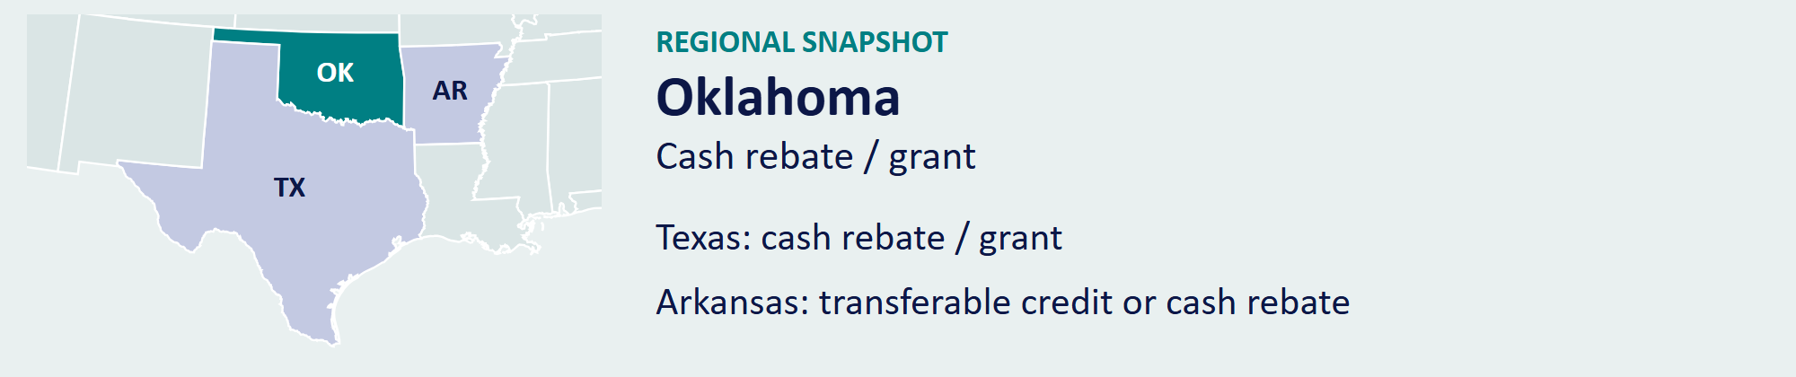
Official program source [28] / Back to contents

STATE PROFILE 29 / 38

Oregon
THE ROUTE TO CASH
Cash Rebate / Grant; Not a Tax Credit
Oregon combines the Oregon Production Investment Fund with the Greenlight Oregon Labor Rebate. OPIF pays 25.00% on qualifying Oregon goods and services and 20.00% on eligible payroll.
How It Works  The Greenlight program adds up to 6.20% on qualifying Oregon payroll, bringing combined payroll support to 26.20%. Regional and local-production programs provide separate benefits. Commercial production became eligible for OPIF on July 1, 2026, under its specific requirements. Producers must arrange an allocation and meet the program’s spending, hiring-policy, and reporting conditions. | AT A GLANCE  PROGRAM FUNDING  $21.2 million OPIF annually; separate Greenlight labor program  PROJECT LIMIT  No more than 50% of the annual OPIF fund per project  MINIMUM SPEND  $1 million standard; lower thresholds for local programs

SELECTED INCENTIVE RATES

Gross rate on each labeled expense category. Program rules and additional incentives appear above.
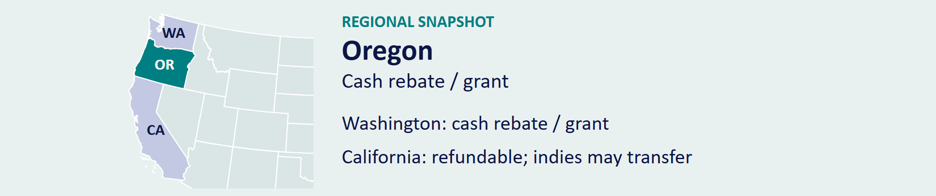
Official program source [29] / Back to contents

STATE PROFILE 30 / 38

Pennsylvania
THE ROUTE TO CASH
Transferable, Non-Refundable Tax Credit
Pennsylvania’s Film Production Tax Credit offers 25.00% of qualifying in-state production expenses. A further 5.00% applies when an eligible production meets the qualified-production-facility requirements.
How It Works  The principal access test requires at least 60.00% of total production expenses in Pennsylvania. Awards draw from the annual program allocation, with a general project limit equal to 20.00% of that allocation. Producers must apply, receive approval, and document eligible spending and required screen acknowledgment. | AT A GLANCE  PROGRAM FUNDING  $100 million annually  PROJECT LIMIT  Generally 20.00% of the annual allocation  MINIMUM SPEND  60.00% of total production expenses in Pennsylvania

SELECTED INCENTIVE RATES

Gross rate on each labeled expense category. Program rules and additional incentives appear above.
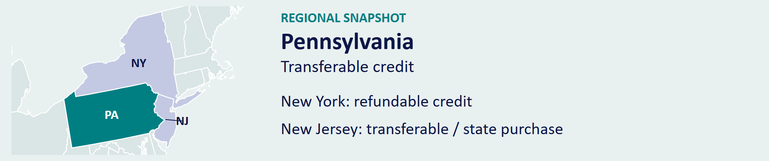
Official program source [30] / Back to contents

STATE PROFILE 31 / 38

Rhode Island
THE ROUTE TO CASH
Transferable, Non-Refundable Tax Credit
Rhode Island provides a 30.00% credit on state-certified production costs. Current statute sets the annual pool at $20 million, shared with musical and theatrical credits. The $7 million production cap has a waiver process for qualifying features and television series.
How It Works  Eligibility requires primary Rhode Island locations and at least a $100,000 production budget, or at least $10 million of state-certified production costs paid within 12 months. The production earns the credit in its completion year after certification. Unused credits have a three-year carryforward. | AT A GLANCE  PROGRAM FUNDING  $20 million annually, shared with musical/theatrical credits  PROJECT LIMIT  $7 million; qualifying waivers available  MINIMUM SPEND  $100,000 budget with primary in-state locations, or $10 million in-state spend

SELECTED INCENTIVE RATES

Gross rate on each labeled expense category. Program rules and additional incentives appear above.

Official program source [31] / Back to contents

STATE PROFILE 32 / 38

South Carolina
THE ROUTE TO CASH
Cash Rebate / Grant; Not a Tax Credit
South Carolina pays cash rebates on qualifying supplier and payroll spending. The Film Commission cites a general minimum of $15.5 million in annual rebate funding, with the fund replenished each July 1.
How It Works  The supplier rebate is 30.00% for qualifying South Carolina suppliers and 25.00% for other qualifying suppliers. Resident wages receive 25.00%; eligible nonresident wages receive 20.00%. Wage payments must meet South Carolina withholding rules. Productions must secure approval before filming. A separate sales-tax exemption route begins at $250,000 of qualifying spending. | AT A GLANCE  PROGRAM FUNDING  Annual rebate fund; agency cites a general $15.5 million minimum  PROJECT LIMIT  Award set by approved rebate agreement  MINIMUM SPEND  $1 million for production rebates

SELECTED INCENTIVE RATES

Gross rate on each labeled expense category. Program rules and additional incentives appear above.
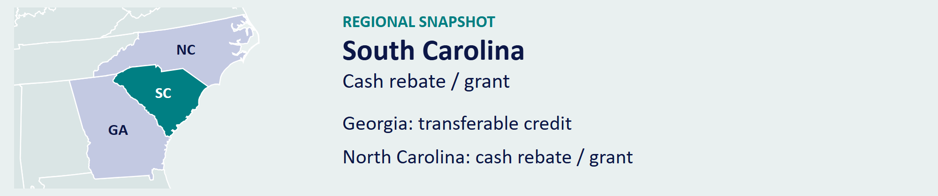
Official program source [32] / Back to contents

STATE PROFILE 33 / 38

Tennessee
THE ROUTE TO CASH
Cash Rebate / Grant; Not a Tax Credit
Tennessee’s production incentive offers a 25.00% grant on qualified Tennessee spending. Production companies enter a grant contract before production and earn reimbursement by meeting the award’s conditions.
How It Works  The grant rebate pays 25.00% of qualifying Tennessee expenditures. Eligible resident compensation includes the first $500,000 per worker. The state requires a grant contract, a defined effective date, and a CPA audit. Spending before the contract’s effective date does not qualify. | AT A GLANCE  PROGRAM FUNDING  Annual appropriation and available grant funding  PROJECT LIMIT  Award set by grant contract  MINIMUM SPEND  $500,000 per project

SELECTED INCENTIVE RATES

Gross rate on each labeled expense category. Program rules and additional incentives appear above.
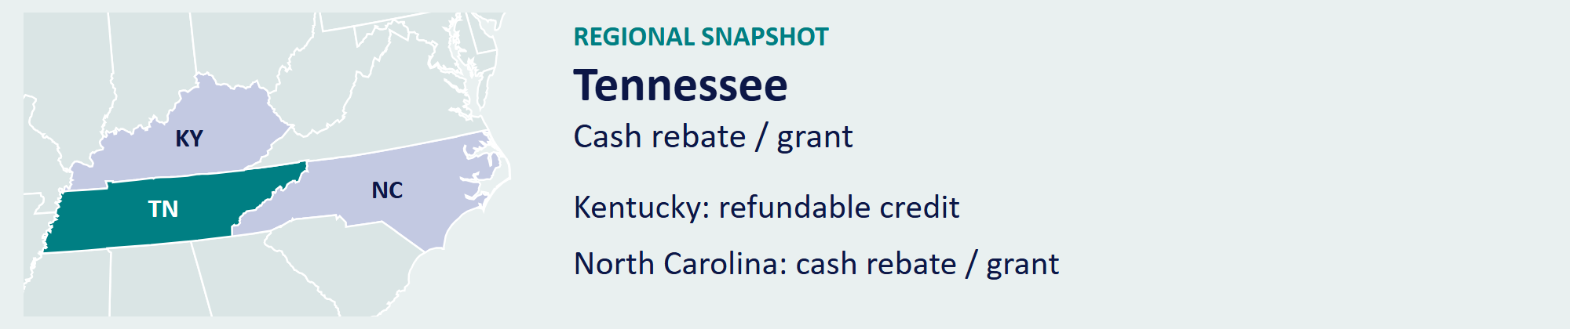
Official program source [33] / Back to contents

STATE PROFILE 34 / 38

Texas
THE ROUTE TO CASH
Cash Rebate / Grant; Not a Tax Credit
Texas funds its Moving Image Industry Incentive Program with $300 million per biennium. The 2026 rules provide a base rate up to 25.00% and qualifying additional grants up to a combined 31.00%.
How It Works  Film and television projects must spend at least $250,000 in Texas and complete at least 60.00% of production in the state. Through August 31, 2027, at least 35.00% of paid crew and 35.00% of paid cast, including extras, must be Texas residents. Eligible spending includes Texas vendors and resident wages; nonresident wages do not qualify. | AT A GLANCE  PROGRAM FUNDING  $300 million each biennium through 2035  PROJECT LIMIT  Award set by approved grant  MINIMUM SPEND  $250,000 for film or television

SELECTED INCENTIVE RATES

Gross rate on each labeled expense category. Program rules and additional incentives appear above.
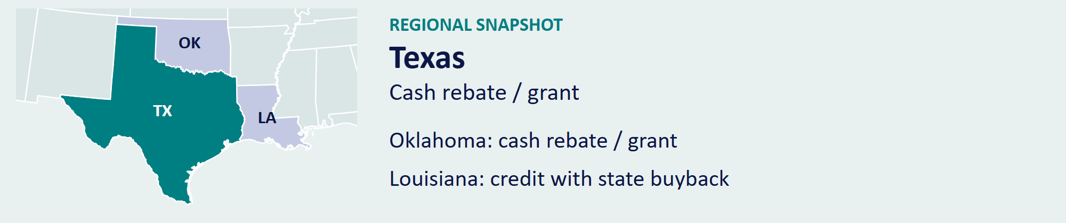
Official program source [34] / Back to contents

STATE PROFILE 35 / 38

Utah
THE ROUTE TO CASH
Refundable, Non-Transferable Tax Credit or Cash Rebate
Utah offers post-performance production incentives and a separate rural program. In 2026, the legislature allocated $3 million in ongoing rural-program funding. Productions qualify through their Utah spending, hiring, and filming commitments.
How It Works  The standard Motion Picture Incentive Program offers 20.00%, with qualifying projects reaching 25.00%. Rural-program productions spend at least 75.00% of their production days in eligible rural counties. The state’s approval determines the award and funding source; local programs and equipment or lodging exemptions offer additional production savings. | AT A GLANCE  PROGRAM FUNDING  Annual state allocation; separate rural funding  PROJECT LIMIT  Award set by approval  MINIMUM SPEND  $500,000 standard program; separate community-film route

SELECTED INCENTIVE RATES

Gross rate on each labeled expense category. Program rules and additional incentives appear above.
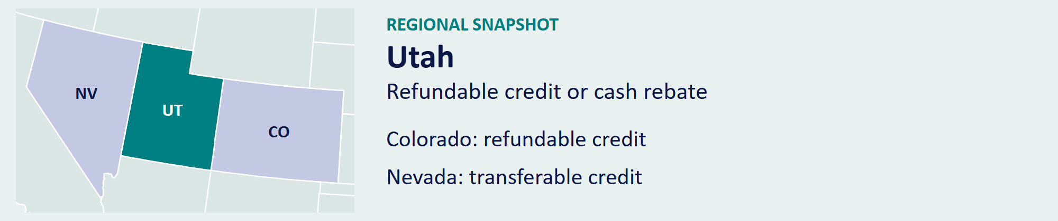
Official program source [35] / Back to contents

STATE PROFILE 36 / 38

Virginia
THE ROUTE TO CASH
Refundable, Non-Transferable Tax Credit or Cash Grant
Virginia combines the Motion Picture Production Tax Credit with the Governor’s Motion Picture Opportunity Fund. The tax-credit program has a $6.5 million annual cap. The grant fund makes separate discretionary awards.
How It Works  The base credit is 15.00% of qualifying spending, or 20.00% for eligible production in economically distressed areas. Additional credits reward Virginia-resident payroll and first-time Virginia film workers. Those payroll bonuses apply to eligible wages, not the entire budget. The grant program awards funding through individual production agreements. Producers apply before production and document their spending and hiring commitments. | AT A GLANCE  PROGRAM FUNDING  $6.5 million annual tax-credit cap; separate appropriated grant fund  PROJECT LIMIT  Award set by approval  MINIMUM SPEND  $250,000 for tax credits; grant terms vary

SELECTED INCENTIVE RATES

Gross rate on each labeled expense category. Program rules and additional incentives appear above.
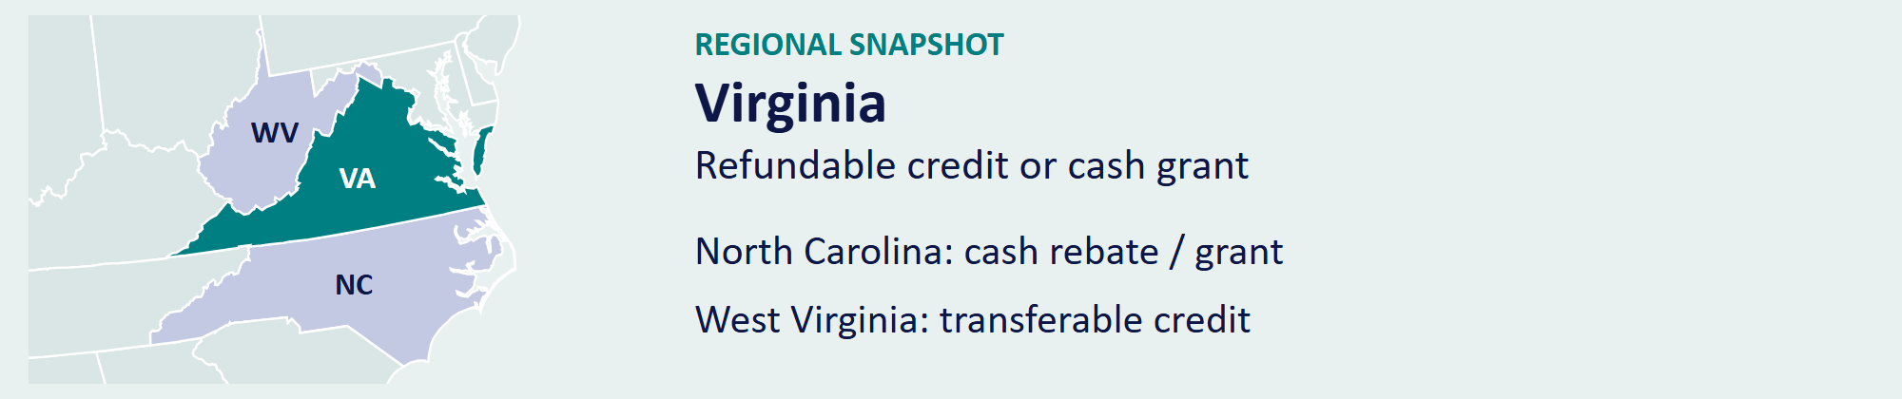
Official program source [36] / Back to contents

STATE PROFILE 37 / 38

Washington
THE ROUTE TO CASH
Cash Rebate / Grant; Not a Tax Credit
Washington Filmworks administers the state’s production incentive and separate small-budget support. Its standard program offers 30.00% cash back for eligible features and 30.00%–35.00% for episodic series.
How It Works  Qualifying rural filming or stories about historically underrepresented communities earn an additional 10.00%, bringing eligible episodic support to 45.00%. Commercials use a $150,000 spending threshold. Nonresident labor and small-budget projects follow separate workforce and reimbursement rules. Producers must secure a funding commitment and complete the required expenditure review. | AT A GLANCE  PROGRAM FUNDING  $15 million annual contribution-credit cap supporting the program  PROJECT LIMIT  Award set by Washington Filmworks  MINIMUM SPEND  $500,000 features; $300,000 per television episode

SELECTED INCENTIVE RATES

Gross rate on each labeled expense category. Program rules and additional incentives appear above.

Official program source [37] / Back to contents

STATE PROFILE 38 / 38

West Virginia
THE ROUTE TO CASH
Transferable, Non-Refundable Tax Credit
West Virginia’s Film Production Tax Credit offers a 27.00% base credit without annual, project, or talent caps. Producers qualify by accumulating at least $50,000 of eligible in-state spending in a calendar year.
How It Works  A further 4.00% applies when the production hires at least ten West Virginia residents full-time during principal photography. Eligible hires include talent and above- or below-the-line crew. The resulting credit reaches 31.00%. Producers register the business, obtain approval, and submit the required CPA report and credit-voucher application. | AT A GLANCE  PROGRAM FUNDING  No annual cap  PROJECT LIMIT  No project or talent cap  MINIMUM SPEND  $50,000 accumulated in a calendar year

SELECTED INCENTIVE RATES

Gross rate on each labeled expense category. Program rules and additional incentives appear above.
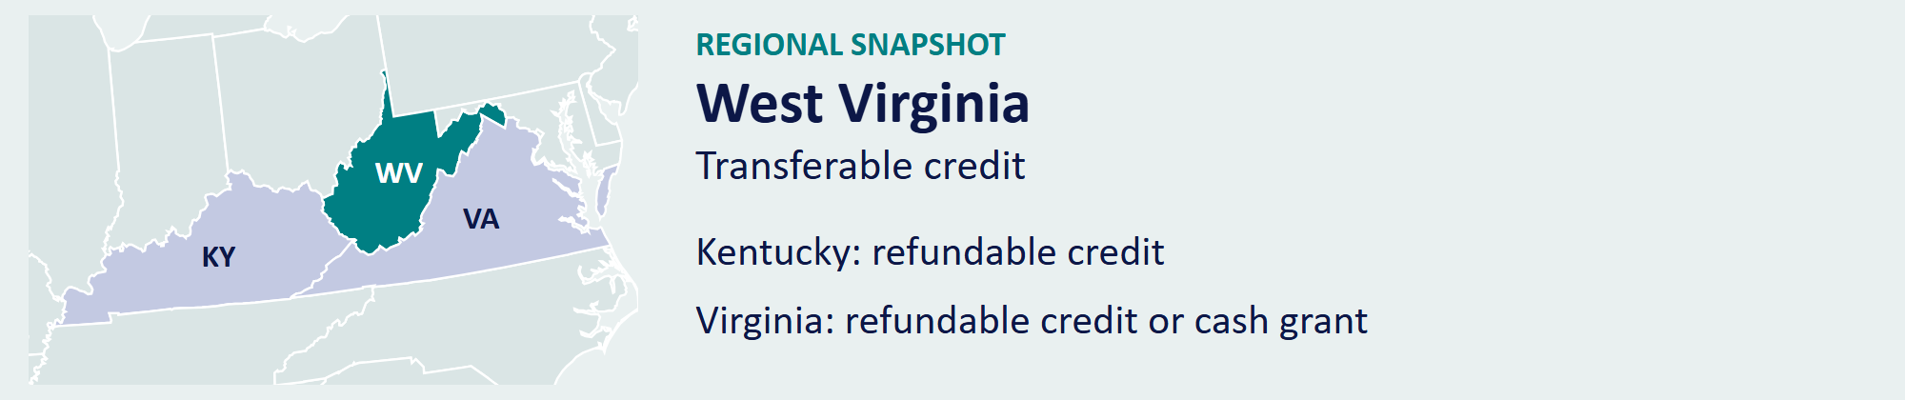
Official program source [38] / Back to contents

THE COMPARISON / OCTOBER 6, 2026

State Benefits at a Glance
State | Selected Incentive Benefit | Transfer | Refund | What the Program Offers
Alabama | 25–35%; 45% small-budget pay | No | Yes | $22M annual pool; standard rebate covers first $20M of qualifying spending.
Arizona | 15–20% base; eligible uplifts | No | Yes | $125M annual pool; separate allocations for facilities and practical locations.
Arkansas | 25–30% per eligible expense | Yes | No | Credit or cash-rebate route; supports production and post-production.
California | 35% base; 40% relocating TV | Indies | 90% | $750M annually; independent films can transfer credits or elect refunds.
Colorado | 20% standard; 22% regional | No | Yes | $5M authorization; qualifying activity outside Denver earns the uplift.
Connecticut | 10%, 15%, or 30% by spend | Yes | No | No annual cap; principal photography or qualifying post-production opens access.
Florida | Local rebates up to 30% | — | — | County programs plus a statewide production sales-tax exemption.
Georgia | 20% base; 30% with promotion | Yes | No | No annual cap; established production infrastructure; $500,000 spend threshold.
Hawaii | 22–27% base; +5% hiring | No | Yes | $60M annual pool; no project cap at $60M or more in qualified costs.
Illinois | 30% nonresident; 35% resident | Yes | No | Uncapped; separate hiring, regional, relocation, and green-production uplifts.
Indiana | 20% base; up to 30% | Yes | No | Transferable from 2026; $250,000 project cap and $2M statewide limit.
Kentucky | 30% standard; 35% enhanced | No | Yes | $75M annual pool; enhanced treatment for eligible resident/county spending.
Louisiana | 25% base; 40% combined limit | State | No | State buyback nets 88% of face value; separate screenplay and location uplifts.
Maine | 5% non-wage; 10–12% wages | No | No | Uncapped core; separate pilot: up to $350K, $1M minimum spend.
Maryland | 28% films; 30% TV series | No | Yes | $12M for FY 2027; $25,000 small-film entry threshold; higher TV-series rate.
Massachusetts | 25% eligible payroll/spending | Yes | 90% | Permanent, uncapped program; transfer or refund routes; sales-tax exemption.
Minnesota | 25% eligible costs | Yes | No | $25M annual maximum; assignable credits; $1M spending threshold.
Mississippi | 25%; 30–35% resident pay | — | — | $20M annual motion-picture pool; a separate episodic-TV program operates.
Missouri | 20% base; up to 42% | Yes | No | $8M film and $8M episodic pools; resident, rural, and other qualifying bonuses.
Montana | No current new-production credit | Yes | No | Current allocations serve earlier productions; 2031 is the first potential new year.
Nebraska | 20% base; 30% story + rural | No | Yes | Separate 5% eligible-wage uplift; $500,000 annual and long-form project caps.
Nevada | 15% local base; up to 25% | Yes | No | $10M annual pool; resident-hiring and qualifying-county uplifts.
New Jersey | 30% within zone; 35% outside | Yes | No | Eligible studio-partner credits have a 95% state-purchase route under 2026 rules.
New Mexico | 25% base; selected rates to 40% | No | Yes | TV/facility and rural uplifts; payment cap rises to $150M in FY 2027.
New York | 30% base; 40% with regional uplift | No | Yes | $700M main program plus $100M independent-film pool; Production Plus benefits.
North Carolina | 25% base on eligible costs | — | — | $31M recurring + $15M FY27; $20M film / $25M scripted-TV caps; funds constrained.
Ohio | 30% eligible costs | No | Yes | $50M annual allocation includes a $5M Broadway/theatrical reservation.
Oklahoma | 20% base; up to 30% | — | — | $30M annual pool; no general project cap; rural, facility, and other uplifts.
Oregon | 25% goods; payroll up to 26.2% | — | — | OPIF plus Greenlight payroll support; separate regional and local-production benefits.
Pennsylvania | 25% base; 30% with facility uplift | Yes | No | $100M annual allocation; qualified-facility bonus; general project cap is 20% of pool.
Rhode Island | 30% certified costs | Yes | No | $20M annual shared pool; $7M project cap has a qualifying waiver process.
South Carolina | 20–25% wages; 30% SC suppliers | — | — | Supplier and payroll cash rebates; separate production sales-tax exemption.
Tennessee | 25% qualified Tennessee spending | — | — | Cash grant; resident compensation eligible up to $500,000 per worker.
Texas | Top base 25%; up to 31% | — | — | $300M each biennium through 2035; eligible additional grants supplement the base.
Utah | 20% standard; 25% enhanced | No | Yes | Credit or cash-rebate route; separate rural and community-film programs.
Virginia | 15% base; 20% distressed area | No | Yes | Credit plus separate grant program; eligible payroll and first-time-worker bonuses.
Washington | 30–35% base; selected rates to 45% | — | — | Cash reimbursement; rural and historically underrepresented-community uplifts.
West Virginia | 27% base; 31% resident hiring | Yes | No | No annual, project, or talent caps; $50,000 accumulated spend threshold.
Transfer / Refund describe tax credits. — = cash program. Indies = independent films. State = transfer back to the state. 90% = refund of eligible excess credit.
Rates apply to the labeled expenses. Program caps, eligibility, available allocations, additional uplifts, and payment rules appear in the state profiles and source notes.

REFERENCE

Notes and Sources
INFORMATION DATE: OCTOBER 6, 2026.

Scope and Comparison Method
This report profiles 38 U.S. states and selected local programs. Each state profile compares published funding, monetization, access, and payout terms. These are program facts, not credit ratings or rankings of investment performance.

Chart Method
Charts compare selected incentive rates on the labeled expense categories. A payroll bonus applies only to qualifying payroll. Rates for different expense categories must not be added together. The figures show gross incentive rates before taxes, financing costs, transfer discounts, fees, and collection timing. Montana’s chart shows the current absence of credit availability for new productions.

Funding and Effective Dates
A statutory cap or appropriation is not an uncommitted balance. Annual and biennial amounts cover different periods. Project approvals, reserved funding, fiscal-year allocations, expenditure dates, and claim dates control access. New Jersey currently assigns approvals to future-year allocations. Montana’s revenue department reports no current credit for productions filming after 2024.

Source Reconciliation
The Rhode Island cap follows R.I. Gen. Laws § 44-31.2-5, rather than older film-office summaries. Nebraska’s cap follows the current statute, including the 2025 amendment. Louisiana’s $125 million caps follow the Department of Revenue’s July 1, 2025, rules rather than the older amounts still displayed on its general program page. Kentucky’s access thresholds follow its 2026 application and audit guidance.

Tax and Financing
Grants and rebates are not automatically tax-free. Federal and state income-tax treatment depends on the applicable law and the recipient. Credit transferability does not create immediate liquidity, and refundability does not promise a full-face-value or immediate payment. FilmHedge evaluates tax-credit collateral through eligible spending, legal rights, audit risk, collection timing, monetization discounts, and collection controls.

OFFICIAL SOURCES

State by State
1. Alabama
www.revenue.alabama.gov
2. Arizona
www.azcommerce.com
3. Arkansas
dev.arkansasedc.com
4. California
cdn.film.ca.gov
5. Colorado
www.advancecolorado.com
6. Connecticut
portal.ct.gov
7. Florida
filmflorida.org
8. Georgia
georgia.org
9. Hawaii
filmoffice.hawaii.gov
10. Illinois
dceo.illinois.gov

OFFICIAL SOURCES
11. Indiana
www.filmindy.com
12. Kentucky
cedky.com
13. Louisiana
www.opportunitylouisiana.gov
14. Maine
filminmaine.com
15. Maryland
commerce.maryland.gov
16. Massachusetts
www.mass.gov
17. Minnesota
www.revenue.state.mn.us
18. Mississippi
filmmississippi.org
19. Missouri
mofilm.org
20. Montana
revenue.mt.gov

OFFICIAL SOURCES
21. Nebraska
nebraskalegislature.gov
22. Nevada
film.nv.gov
23. New Jersey
www.njeda.gov
24. New Mexico
www.tax.newmexico.gov
25. New York
esd.ny.gov
26. North Carolina
www.filmnc.com
27. Ohio
dam.assets.ohio.gov
28. Oklahoma
www.okfilmmusic.org
29. Oregon
oregonfilm.org
30. Pennsylvania
dced.pa.gov

OFFICIAL SOURCES
31. Rhode Island
webserver.rilegislature.gov
32. South Carolina
www.scprt.com
33. Tennessee
www.createtn.com
34. Texas
gov.texas.gov
35. Utah
film.utah.gov
36. Virginia
www.film.virginia.org
37. Washington
www.washingtonfilmworks.org
38. West Virginia
westvirginia.gov

OFFICIAL SOURCES

Legislation and Supporting Guidance
Alabama — Entertainment Rebate and October 2026 Withholding
www.revenue.alabama.gov
Indiana — 2025 Legislative Synopsis, Effective January 2026
www.in.gov
Kentucky — 2026 SB 324 Enacted Summary
apps.legislature.ky.gov
Louisiana — Current Issuance and Claim Caps
revenue.louisiana.gov
New Jersey — Director’s Tax Credit Purchase Program
www.nj.gov
Texas — July 2026 Adopted Incentive Rules
www.sos.texas.gov
Utah — March 2026 Rural Funding Announcement
film.utah.gov
Virginia — Motion Picture Credit Cap
www.tax.virginia.gov
Washington — Program Funding Cap
dor.wa.gov
Federal Tax Treatment — IRS Taxable and Nontaxable Income
www.irs.gov
California — Program 4.0 Refund Election
www.ftb.ca.gov
Louisiana — Transfer Restrictions and State Buyback
www.legis.la.gov
New York — Independent Film Credit Program
www.esd.ny.gov

SOURCES AND SUPPORTING REPORTING
Broward — Screen Industry Incentive Programs
filmlauderdale.org
Jacksonville — Incentive Program
www.filmjax.com
Hillsborough — Film Tampa Bay Incentive FAQ
news.filmtampabay.com
Miami-Dade — High Impact Film Fund
www.miamidade.gov
Arizona — Statutory Spending Tiers
www.azleg.gov
Alabama — Small-Budget Rebate and October 2026 Rules
www.revenue.alabama.gov
Maine — Reimbursement Grant Pilot
filminmaine.com
North Carolina — 2026 Grant Rules, Sections 11.4–11.5
www.ncleg.gov
North Carolina — FY 2026–27 Funding, Section 5.8A
library.ncleg.gov
North Carolina — Current Funding Commitments
www.wilmingtonbiz.com
FilmHedge
Company description and tax-credit financing approach checked against Company Overview (September 26, 2026) and Collateral Types (September 25, 2026).

DISCLAIMER
This report provides general production-planning information and is not legal, tax, accounting, or investment advice, an offer of financing, or a guarantee of eligibility or payment. Before committing a budget, confirm the applicable rules, available funding, approval, and payment schedule with the administering agency and the production’s advisers. As of October 6, 2026, Maine’s pilot page lists its next application deadline as forthcoming. North Carolina’s enacted 2026 award limits supersede older program-page figures; local reporting quotes state officials describing grant commitments through 2029. Its new micro-budget authorization does not establish an open application round. Qualifying multi-production packages can earn a bonus equal to 5.00% of the calculated North Carolina grant, subject to the statutory spending and timing tests. Laws, funding, program guidance, and application windows can change.

ABOUT
If you’d like to learn more about media credit, private credit in media, media production lending (MPL), or other opportunities in the film finance space, contact our team at FilmHedge:
- Lenders and investors interested in learning more about opportunities in the space can contact: lender@filmhedge.com
- TV/Film producers can email: producer@filmhedge.com
- If you have a question about the data in this report or want to consult our data team, contact: data@filmhedge.com
For more reports and research like this, please visit: http://filmhedge.com/reports

Written and Researched by: Joshua Paulose
Edited by: Jon Gosier, CEO, FilmHedge + MediaHedge
Phone: (770) 268-3006
Email: jon@filmhedge.com

