**10/22/17 2:00pm Sparh 2326**

Jon, Kate, Ryan

Brainstorming ideas

**2:15pm Sparh 2326**

Bisher, Jon, Kate, Ryan

Brainstorming ideas

Game

App

Interaction with other users

**2:45pm Sparh 2326**

Bisher, Jon, Kate

Brainstorming

QR codes

QR codes on for example a fridge. Users can scan code and then view lists and information about object. Targeted for shared living.

App

Website maybe

Maybe nfc rather than QR codes

**END 3:15pm**

**10/23/17**

**10/24/17 1:15 - 2:00pm Sparh Study area**

Bisher, Jon, Kate, Ryan

What do we want

NFC last

Start off with lists

Then add schedules (7 day)

Maybe bill paying

Login - maybe use Facebook log in

Check list

Who added what item(s)

Downloading development environment

Assigning tasks

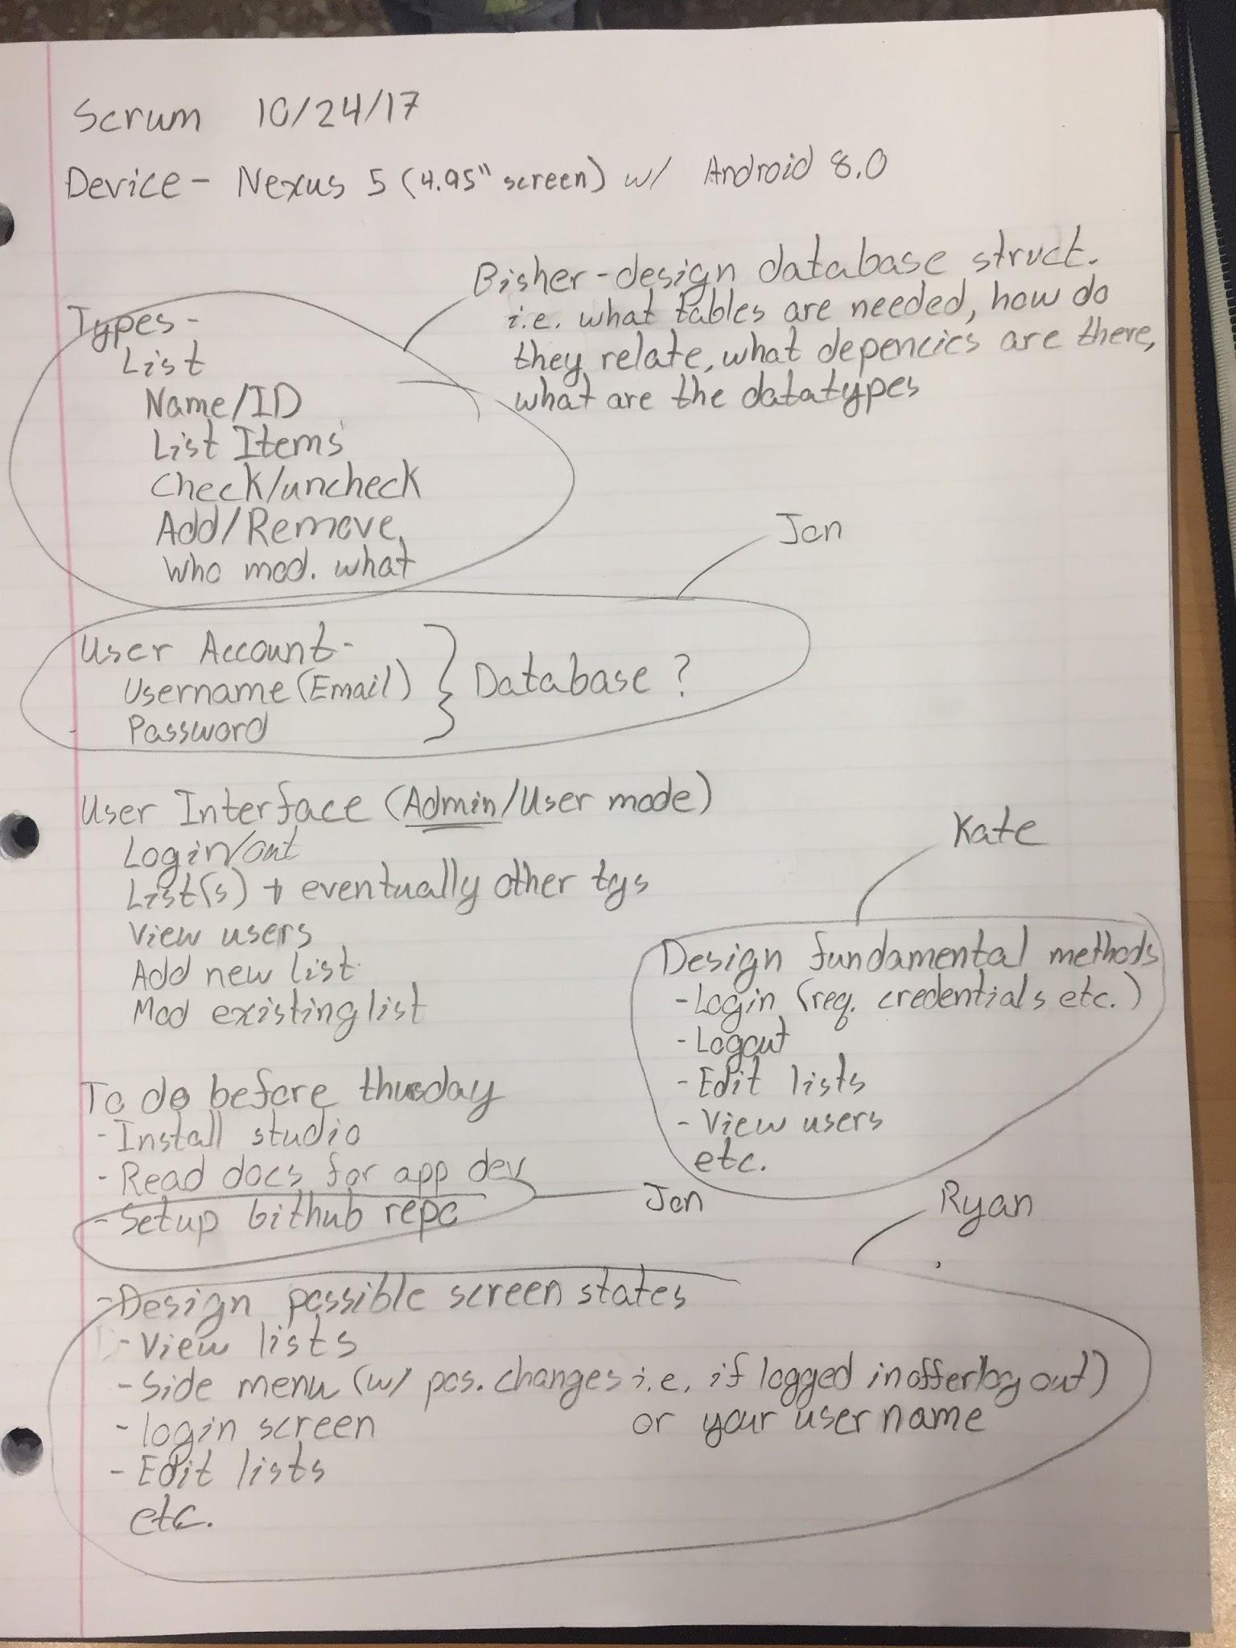

**10/24/17 11:45 - 11:50am Class**

Bisher, Jon, Kate, Ryan

Meeting tomorrow

**10/26/17 5:30 - 8:00pm Sparh 2326**

Bisher, Jon, Kate, Ryan

Practicing app devel

Getting the initial project running

Timeline

Next meeting

Learning goals

**10/29/17 1:15 - 4:40pm Ryan’s place**  
 Bisher, Jon, Kate, Ryan

Push, merge, pull

Figuring out why files are being angry

Updating android studios

Various states of fixing software, coding, and pushing pulling and merging

Bisher, Jon, Ryan **3:10pm**

Coding

**10/30/17 11:40 - 11:50am Class**

Bisher, Jon, Kate, Ryan

Database structure

List of groups

Group

Users

Items

ID

Users

ID

Name

Email

List of Group IDs

Where is everyone at in the project

Documentation realization

**11/02/17 1:00 - 3:00pm Sparh**

Bisher, Jon, Kate, Ryan

Making sure our required documentation is in order

**11/05/17 12:30 - 3:30 Ryan’s place**

Bisher, Jon, Kate, Ryan

Polishing documentation

Different behaviour for user log in states

Working on scheduling

Database stuff

**5:30 - 9:30 Ryan’s place**

Bisher, Jon, Kate, Ryan

Polishing documentation

Working on scheduling

Real time list updates

Merge error fixing

Time spent outside of class on project 3 as a group: about 17 hours

**----------------------Project 4------------------------**

**11/12/17 1:00 - 4:30 Ryan’s place**

Bisher, Jon, Kate, Ryan

NFC research

New logo discussion

New naming convention

Schedule data for future database work

Making chip list page

Being able to delete things

How to do tests in android studios

**11/14/17 1:10 - 3:00 LEEP2**

Jon, Kate, Ryan

What are fragments

How to use fragments

Using fragments

**11/19/17 2:10 - 4:00 Sparh**

Bisher, Jon, Kate, Ryan

Project allocation

**11/28/17 1:15 - 9:00 LEEP2**

Bisher, Jon, Kate, Ryan

Group Programming

Project re-allocated (minor)

**11/29/17 6:30 - 10:30 LEEP2**

Bisher, Jon, Kate, Ryan

Group Programming

Working on assigned parts

**11/30/17 1:00pm - 12/01/17 12:45am LEEP2**

Bisher, Jon, Kate, Ryan

Group Programming

Working on assigned parts

**12/02/17 1:00 - 8:00pm Ryan’s Place and Sparh**

Bisher, Jon, Kate, Ryan

Group Programming

Testing

Major Bug Fixing

**12/03/17 2:00 - 11:30 Sparh**

Bisher, Jon, Kate, Ryan

Group Programming

Testing

Major Bug Fixing

Integrating Schedule with database and project

Documentation

Time spent outside of class on project 4 as a group: about 46.75 hours