

THE OKLAHOMA PIPELINE ENERGY STORAGE SYSTEM (OPESS) REQUIRMENT ANALYSIS REPORT

By Jonathan Grinnell

FALL 2022



EN.645.800

Mentor Robert Krzystan

|  |  |
| --- | --- |
| Document Name | Reason for Change |
| Grinnell Final_Report | Initial Document |

Table of Contents

1 Final Report Description 4

2 OPESS ConOps 5

2.1 System Need 5

2.2 System Block Diagram 5

2.2.1 OPESS Block Diagram 5

2.2.2 ESS Block Diagram 6

2.2.3 CaCS Block Diagram 7

3 OPESS Proposal 9

4 Requirement Analysis Report 10

5 Functional Analysis Report 11

6 Trade Study 13

7 Conceptual Design Report 15

8 Test Plan 17

9 A-Spec Report 19

10 Risk Report 20

11 Follow on Activities 22

12 Lessons Learned 23

13 Class Evaluation 24

14 Earned Value Management 25

14.1 Schedule 25

14.2 Milestones 25

14.3 EVM 26

14.4 CPI and SPI Index 27

14.5 EVM Analysis 27

15 References 28

**Table of Figures**

Figure 1: OPESS Block Diagram End of Risk Version 6

Figure 2:ESS Block Diagram End Risk Version 7

Figure 3: CaCS Block Diagram End of Risk Version 8

Figure 4: OPESS Functional Hierarchy Diagram 11

Figure 5: Functional Flow Block Diagram Example 12

Figure 6: N2 Diagram Example 12

Figure 7: URL Filtering Utility Graph 13

Figure 8: OPESS Physical Block Diagram 15

Figure 9: Build Schedule 17

Figure 10: OPESS Schedule 25

**Table of Tables**

Table 1: MOE Summary 4

Table 2 List of Solution Needs 5

Table 3: Scenario Summary 9

Table 4: MOP Summary 9

Table 5: Requirements Metric RAR 10

Table 6: Requirements Metric FAR 11

Table 7: Requirements Metric TS 14

Table 8: Requirements Metric CDR 16

Table 9: Requirements Metric TP 17

Table 10: Requirements Metric A-Spec 19

Table 11: Program Risk Summary 20

Table 12: Requirements Metric Final 22

Table 13: Milestones 25

Table 14: EVM 26

Table 15:CPI/SPI 27

# 1 Final Report Description

The **Final Report** will be delivered as the Ninth and final delivery of the **Oklahoma Pipeline Energy Storage System (OPESS)**. This report will be composed of an overview of all the other eight deliveries of the OPESS development life cycle. Follow on activities, schedule, EVM and lesions learned will also be discussed during this project.

The concept of operations will provide a description of the functional need that the OPESS aims to fill. It will focus on spelling out the current makeup of the Oklahoma power grid, its increasing reliance on renewable sources of energy and why a new energy solution will be needed to meet future demand. After that, the ConOps will dive further into the design of the OPESS system through the use of block diagrams in an attempt to flesh out the two subsystems that compose the OPESS.

This paper will primarily consist of a summary of what effort each of the other deliveries covered, what reasoning was used to develop each of these deliveries and provide an attempt to describe the evolution of the OPESS as it was developed. Each of these deliveries will be attached as an appendix in the final delivery.

This document will also provide an update of the final EVM. Schedule updates, deliveries, the WBS and SPI/CPI will be discussed in this section.

Since this is also the final delivery, all lessons learned will be delivered in this paper as well as a class evaluation. Follow on activities will also be discussed. Additional effort will be required by a team of expert and developmental engineers to actually bring the work presented here to fruition.

All KPP’s listed in section 3 trace to MOE 2 through MOE 4. These MOEs can be found in the table below. These remain unchanged from the RAR.

Table 1: MOE Summary

| MOE Number | Summary |
| --- | --- |
| MOE 1 | The energy efficiency of the OPESS must be high enough to be of worth to the market. |
| MOE 2 | The ESS must be able to store energy on the time span of months to years. |
| MOE 3 | The OPESS much adhere to proper cyber security standards. |
| MOE 4 | The ESS should be able to stand up to the elements. |
| MOE 5 | The OPESS must not produce carbon emissions. |

MOE 1 was left was not referenced by the KPPs since that particular MOE is really more of a market and financial requirement. This MOE is still an important one to have listed and reference as this requirement will ultimately be what decides the viability of the OPESS system.

# 2 OPESS ConOps

## 2.1 System Need

In 2010 Oklahoma mandated that 15% of the state’s energy needs be provided by some form of renewable energy source. As early as 2012 the state surpassed that goal (Popovich & Plumer, 2020). In 2021, the amount of energy produced by renewable sources accounted for 45% of the state’s energy needs. That number continues to increase as new wind projects are stood up and roof top solar becomes more popular. Unfortunately, wind and solar are not a source of consistent power. When the sun goes down homeowners are forced to either pull power from a grid that still produces energy primarily from dirty sources or from an expensive battery pack. High pressure systems can also move in, causing time periods of low wind energy production or worse yet, strong winds can come in during storm season and produce an excess of wind energy, forcing wind turbines offline.

The solution is to install large amounts of grid level energy storage. This will help even out the peaks and valleys of energy production, allowing energy produces on high energy days to be used on low energy days. Batteries are expensive and will compete with electric cars as their demands rises and pumped hydro can’t really be used in Oklahoma as the state neither gets the required amount of rain or has enough in the way of mountains to make it practical.

What the state does have in abundance are natural gas wells. It is through the use of this resource common to the state that a form of green energy storage can be developed. A list of solution needs can be found is table 2.

Table 2 List of Solution Needs

|  |  |  |
| --- | --- | --- |
| Number | Name | Description |
| 1 | Extra Storage | The OPESS needs to be able to store extra energy from renewable sources during times of over production. |
| 2 | Low-Cost Storage | The OPESS needs to be able to store energy produced on the grid during low rates for use during times of high rates |
| 3 | Long Term Storage | The OPESS needs to be able to store energy for a significant amount of time with minimal loss. This will be measured on the timeframe of months to years. |
| 4 | Grid Scale Storage | The OPESS needs to be able to provide an energy storage solution that can be maintained on a grid level. |

## 2.2 System Block Diagram

The system block diagrams were produced during the RAR. They have been modified a bit as the design of the OPESS has changed though they have remained relatively intact for the most part. The block diagrams can be found in the sections below.

### 2.2.1 OPESS Block Diagram

The OPESS is composed of two major subsystems. The first is the Energy Storage Subsystem (ESS). The ESS is the actual storage system of the OPESS system. Functionally, it pulls power off the grid, compressed air for storage in spend natural gas wells, and then used that gas to spin a turbine for use on the grid. Since this device is outside, it is exposed to the elements and will thus need to be protected.

The second major subsystem is the Command-and-Control Subsystem (CaCS). As its name suggests, it performs the command-and-control functionality of the OPESS system. The CaCS allows communication between the OPESS and other utility companies and plants that might be powering the grid at the time. The CaCS communicated with the ESS over a secured internet connection.

Figure 1: OPESS Block Diagram End of Risk Version

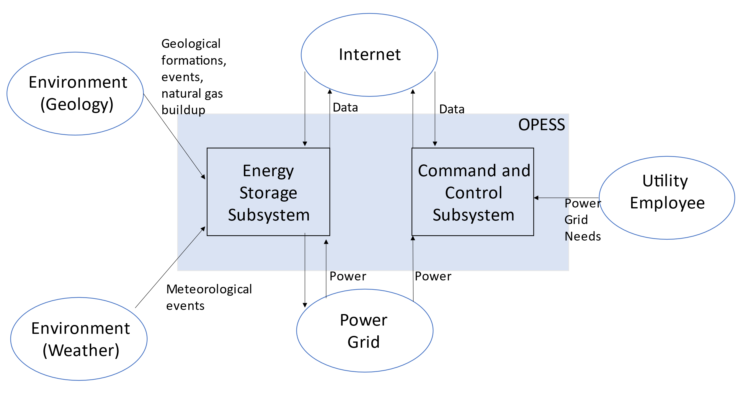

### 2.2.2 ESS Block Diagram

The ESS is the heart of the OPESS. It is composed of 5 functions, receive power, store power, generate power, a control node and weather protection. The primary function of the ESS is to act as a battery, hence the first three functions, however, unlike a batter, this is a complicated piece of equipment with lots of moving parts. A localized control note will have to be included in order to tell the individual components of the ESS how to behave. Additionally, this node will communicate with the CaCS and report and health and status issues the ESS might be experiencing.

Additionally, per risk 1, the ESS will be exposed to the elements on a regular bases and Oklahoma is famous for its bad weather. The final function, weather protection, is a risk reduction function meant to protect the ESS.

Figure 2:ESS Block Diagram End Risk Version

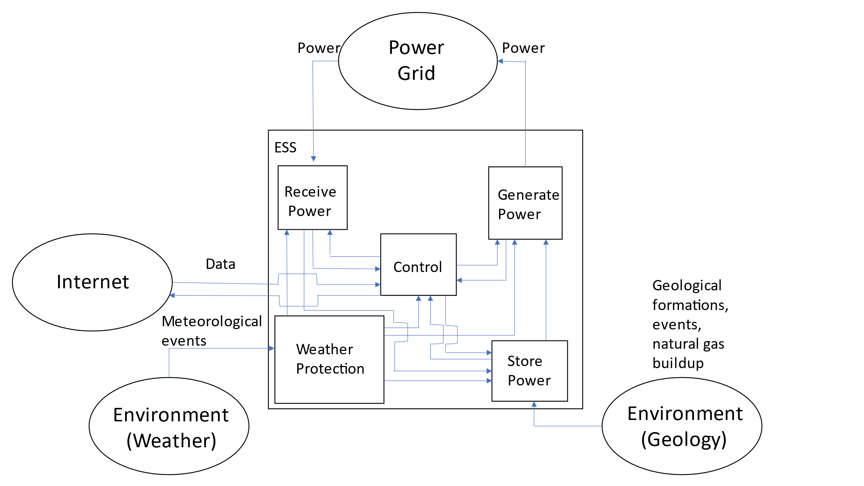

### 2.2.3 CaCS Block Diagram

The CaCS is the brains of the OPESS system. It exists primarily as an office space that allows utility workers, economists and engineers to communicate with other facilities both locally and across state lines in an effort to figure out what the future and current electrical needs will be. The CaCS will be able to allow employees access to modeling software in an effort of predict the future needs of the OPESS system on the grid. The CaCS will also allow employees to log into the ESS from their desk, monitor health and status and even control the ESS without having to go into the field. This will be helpful as issues can be diagnosed and handled without sending out technicians into the field.

Figure 3: CaCS Block Diagram End of Risk Version

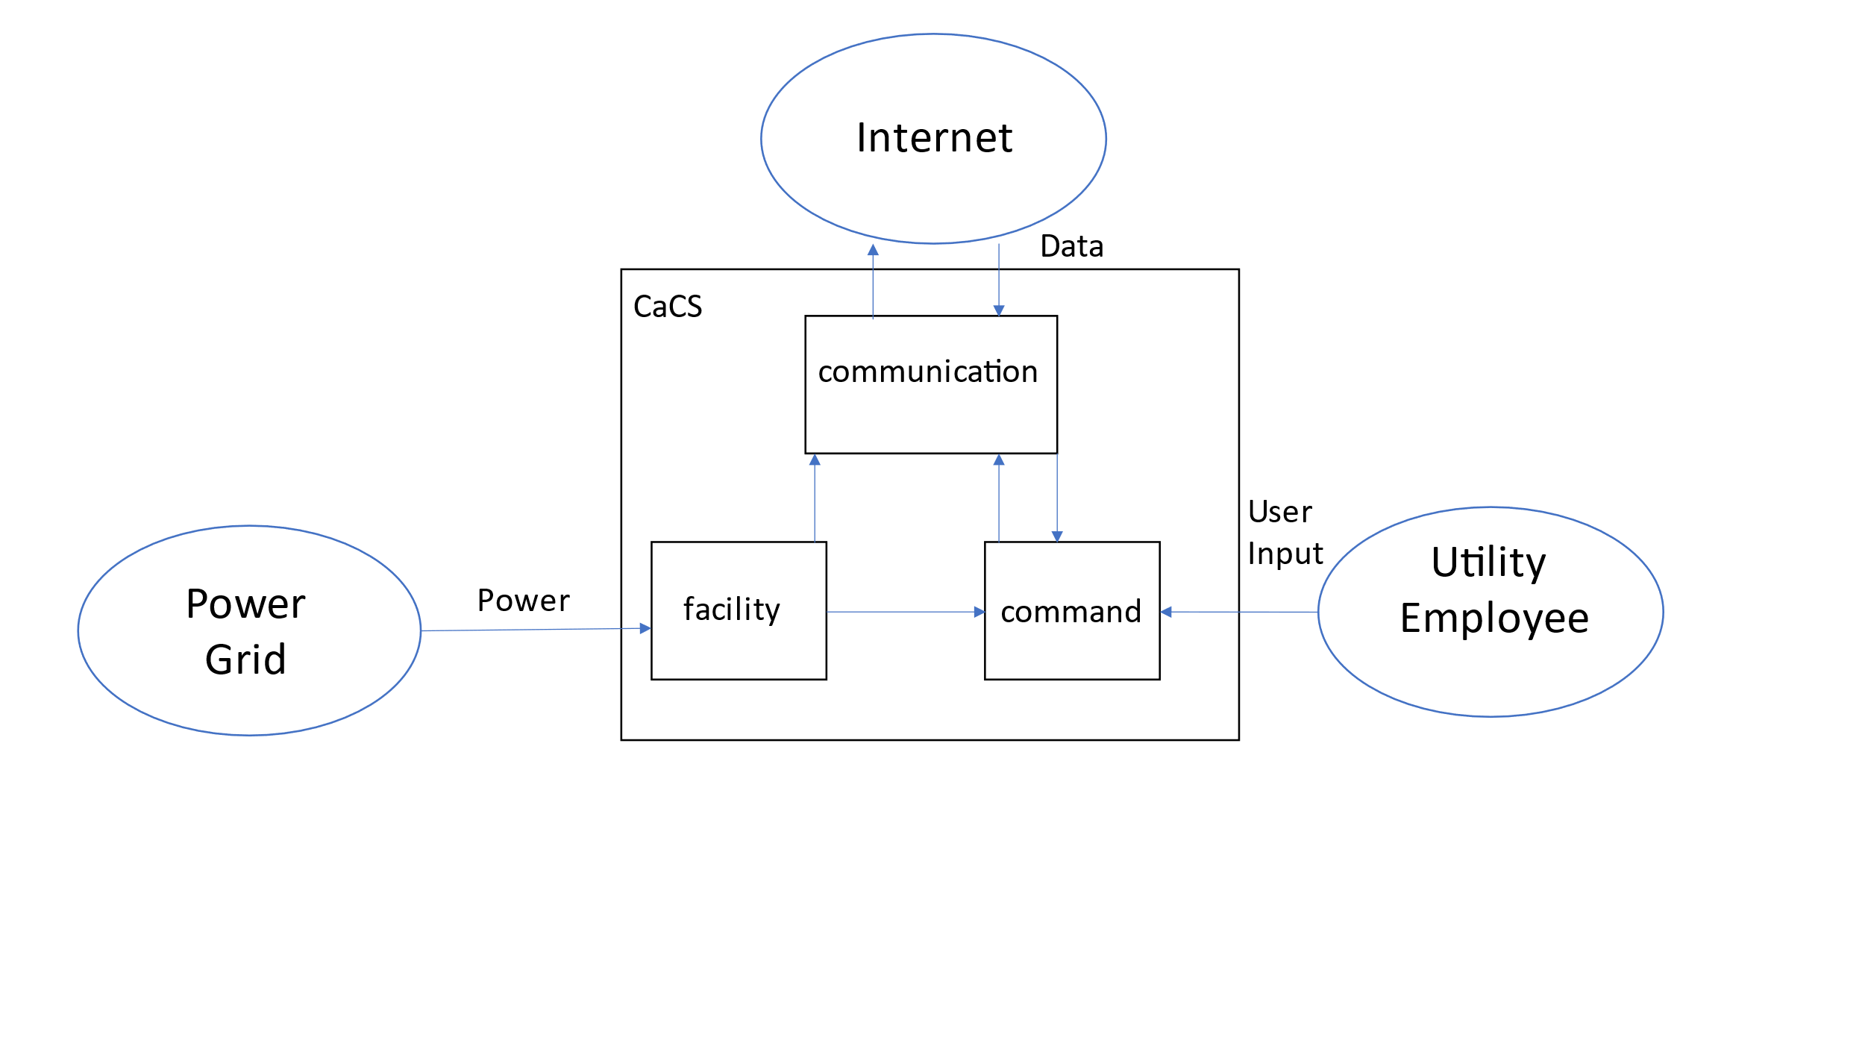

# 3 OPESS Proposal

The project proposal was the first delivery of the OPESS developmental life cycle. This delivery detailed the initial system description with a high level break down of the OPESS into the ESS and CaCS subsystems. At the time of the proposals development, the ESS and CaCS were not broken down further into the individual components and functions that they would later have. With that said, as a part of the initial proposal, all external interactions with the OPESS and the surrounding environment were mapped out and documented.

This was also the document where the system need was first defined. Research was done into the makeup of the Oklahoma energy sector which has become increasingly reliant on wind over the last decade. During this research, a gap was noticed in the needed energy storage capability that is usually need when relying heavily on most green sources of energy. This gas was the initial motivation for the OPESS and inspired a lot of what of initial design as well as serving to help identify stakeholders. These stakeholders would later go on to become interviewees during the requirements analysis report and help with the initial set of requirements for the OPESS system.

It was also during the proposal that the initial WBS, milestones and schedule were developed. These products, along with the EVM spreadsheet that was based on the schedule, were used and updated in every delivery as a way to track the progress in a detailed and timely fashion. CPI/SPI was also updated in the proposal, though since it was the first delivery, it consisted of just a single point.

Finally, the Measures of Effectiveness mentioned in table 1 were also developed here. Three operational scenarios and Measures of Performance (MOP) were also developed during the proposal. These can be found in the tables below.

Table 3: Scenario Summary

| Scenario Number | Summary |
| --- | --- |
| Scenario 1 | An overgeneration of power has led to a surplus of electricity on the grid. The OPESS store that power to keep the grid from being overloaded. |
| Scenario 2 | An under generation of power has led to a potential brownout situation. The OPESS will generate power using it’s stored reserves. |
| Scenario 3 | The OPESS system both generates and stores power on the grid at the same time. This smooths out the variates in the demand curve allowing for a better maintained grid. |

Table 4: MOP Summary

| MOP Number | Summary |
| --- | --- |
| MOP 1 | Efficiency of Air Pump |
| MOP 2 | Efficiency of the Generator |
| MOP 3 | Long Term Energy Storage Potential |

The proposal can found listed in the final repository as Appendix 10.

# 4 Requirement Analysis Report

The Requirements Analysis Report (RAR) was the delivery where the requirements were first developed. This process started with the gathering of an much technical information as possible. In this vane, several interviews were conducted with some of the steak holders identified in the proposal. Specifically, a economist for the Tacoma electric company was interviewed in an effort to better understand how utility companies plan their power needs and how that might effect storage and use of the OPESS. This information was important in the development of requirements for the CaCS since utility workers would be the ones running the device.

Additionally, since cyber crime is on the rise and both the ESS and CaCS are connected to the internet, it was thought the opinion of a cyber security expert might be needed. As such, a professor from John Hopkins University was interviewed and asked what might be necessary for creating a secure network. The advice given proved to be quite valuable and was important in developing requirements that went directly to addressing some of the risk on the program.

During this time, block diagrams were created as a way of mapping out the behavior of the OPESS, ESS and CaCS. Once these block diagrams were created, requirements could be pulled from them.

Finally, since the ESS necessitates the use of old natural gas wells, a petroleum engineer was looked for in an effort to understand the geology of the region. However, of the several engineers that were contacted, none were willing to respond. However, several studies and documents pertaining to the relevant information were found online. These resources aided in the development of critical safety measures that helped to also further lower risk on the program.

A summary of the requirements developed during the RAR can be found below.

Table 5: Requirements Metric RAR

|  |  |  |  |  |  |  |  |  |
| --- | --- | --- | --- | --- | --- | --- | --- | --- |
| Report | Requirements | KPP’s | Qualitative | Quantitative | Inspection | Analysis | Demonstration | Test |
| RAR | 104 | 12 | 50 | 54 | 29 | 14 | 37 | 24 |

The RAR can found listed in the final repository as Appendix 20.

# 5 Functional Analysis Report

The block diagrams mentioned in section 4 came back during the Functional Analysis Report. These diagrams provided a convenient method of looking at the OPESS at a high level in an effort to create functions. Since the block diagram was broken down to level 4 or 5 depending on what the diagram was modeling, functions of equal level could be created relatively easily with decent traceability to the requirements. There are too many functions to be listed in this paper, but see the figure below for a summary of the high-level ones. You’ll note they fit fairly well with the block diagrams presented in section 2.

Figure 4: OPESS Functional Hierarchy Diagram

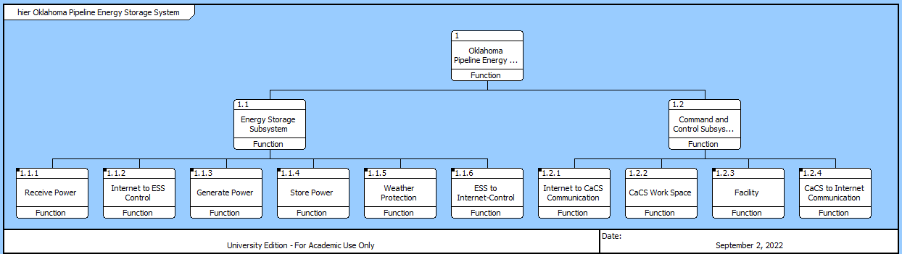

Once the functions were produced, requirements needed to be traced. Since both the requirements and functions come from the same block diagram, it was expected that they would match up one to one. It was however noticed that a lot of the lower-level requirements were performance requirements and not functional requirements. While this is naturally fine, it was felt that each function needed a functional requirement to define with performance requirements given for added detail into the working of the function. It was here that a bunch of requirements were added to the design.

Table 6: Requirements Metric FAR

|  |  |  |  |  |  |  |  |  |
| --- | --- | --- | --- | --- | --- | --- | --- | --- |
| Report | Requirements | KPP’s | Qualitative | Quantitative | Inspection | Analysis | Demonstration | Test |
| RAR | 104 | 12 | 50 | 54 | 29 | 14 | 37 | 24 |
| FAR | 129 | 12 | 75 | 54 | 37 | 16 | 48 | 28 |

Both requirements and functions were kept in CORE so as to allow for added traceability and to allow for the use of MBSE. A by product of this what the use of functional flow block diagrams and N2 diagrams. These helped to further link functions to each other as well as provide functional logic. Examples of these can be found below.

Figure 5: Functional Flow Block Diagram Example



Figure 6: N2 Diagram Example



The FAR can found listed in the final repository as Appendix 30.

# 6 Trade Study

As a part of the development of the OPESS, a trade study had to be performed. There were many trade study topics that could be considered and for a while, it was expected that a trade study would be performed on the generators that will make up one of the larger components of the ESS. However, due to cyber being a major risk attached to the system, it was decided that a trade study should be performed on network protection software.

Based on the interview with the cyber security expert, several detailed requirements were written that could easily provide detail on what needed to be looked for. These requirements specifically called out URL filtering, TLS and an Antivirus. Several of the packages examined also included DDOS protection so that became a part of the selection criteria as well.

Each of these selection criteria were assigned a wait based on their relative importance to each other. Once that calculation was done, utility cures were developed. These curves came out a little different from what was expected. The criteria were allowed four values; not in package, partially in package, an extra add on or completely in package. Since these options are more a chouse then a value that can gradually change, the utility curve should look like a stair case. However, Excel has issues producing a stair case type graph. As such, the utility curve is a strait line with the middle of the criteria representing the value assigned to that choice. An example can be found below.

Figure 7: URL Filtering Utility Graph

At this point, the score of each software product was calculated based on the utility curve and weighted based on the selection criteria based on its calculated weight. These weights were added together to find a final score of the individual software packages being studied and a winner was chosen. Normally, the final score (total utility) can be divided by the cost to get a score of utility per dollars. This can help in picking the most efficient package. However, all of these products charge based on a fee negotiated with the company they are doing business with. Because of this I was never able to find a cost and was prevented from doing this calculation.

Finally, a sensitivity analysis was performed so as to check to see if one of the individual selection criteria was over weighting all the others. It was found that URL filtering did seem to have an effect on the study but all other selection criteria were unaffected.

An unexpected change in the design of the OPESS that came out of the trade study was the change from a server farm type set up to one based on modern cloud computing. This changed deleted a number of requirements and function developed in the RAR and FAR and replace them with new, more modern requirements. A requirement for DDoS protection was also included since it sounded like a good idea and seemed to be offered. For a quick breakdown of the requirements as they exist at the end of the trade study, see the table below.

Table 7: Requirements Metric TS

|  |  |  |  |  |  |  |  |  |
| --- | --- | --- | --- | --- | --- | --- | --- | --- |
| Report | Requirements | KPP’s | Qualitative | Quantitative | Inspection | Analysis | Demonstration | Test |
| RAR | 104 | 12 | 50 | 54 | 29 | 14 | 37 | 24 |
| FAR | 129 | 12 | 75 | 54 | 37 | 16 | 48 | 28 |
| TS | 131 | 12 | 79 | 52 | 43 | 16 | 44 | 28 |

Is was at this point the requirements assumed a form they would hold throughout the totality of the rest of the OPESS development. The TS Report can found listed in the final repository as Appendix 40.

# 7 Conceptual Design Report

Much like the FAR, the Conceptual Design Report (CDR) begins with the block diagrams developed in the RAR. From this the OPESS is broken down into physical components allowing the hardware of the OPESS to be defined. These components were spelled out and numbered in CORE along with the functions and requirements. Since the components are kept in the same database, they can be linked together with the functions developed in the FAR. Since those functions are already linked to requirements, full traceability between hardware, functions and requirements can be established.

Further block diagrams were created for CDR. The block diagrams take any subcomponent that might exist with a component and plot it on a chart. Then connections are drawn that demonstrate what physical element, whether it be a cable, pipe or even rain, interacts between those two components. One of these block diagrams can be found below.

Figure 8: OPESS Physical Block Diagram

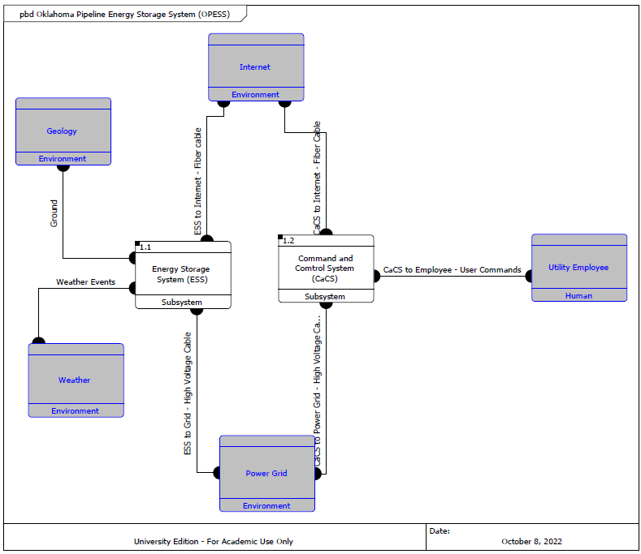

Figure 8 actually corresponds to figure 1 mentioned in section 2. Here we can see the ESS and CaCS mentioned as subsystems. Then the external stimuli are intorduces and connection in such a way that their hardware components are called one. Some like “weather events” are vague since there a lot of ways weather could interact with the ESS. The power grid however, connects directly to the ESS through a high voltage cable. This specification is what the CDR brings to the table.

No requirements were changed during the CDR, See the below table to an analysis.

Table 8: Requirements Metric CDR

|  |  |  |  |  |  |  |  |  |
| --- | --- | --- | --- | --- | --- | --- | --- | --- |
| Report | Requirements | KPP’s | Qualitative | Quantitative | Inspection | Analysis | Demonstration | Test |
| RAR | 104 | 12 | 50 | 54 | 29 | 14 | 37 | 24 |
| FAR | 129 | 12 | 75 | 54 | 37 | 16 | 48 | 28 |
| TS | 131 | 12 | 79 | 52 | 43 | 16 | 44 | 28 |
| CDR | 131 | 12 | 79 | 52 | 43 | 16 | 44 | 28 |

The CDR can found listed in the final repository as Appendix 50.

# 8 Test Plan

The next delivery delivered as a part of the OPESS developmental lifecycle is the Test Plan Report (TP). The TP begins by performing a requirements analysis. This might seem a bit odd since the requirements could potentially change as a part of the TP effort but this needed to be done in an effort to better understand the requirements and assign them to builds later on in the paper. Since the TP begins with requirements analysis, this section will present the obligatory requirements analysis below.

Table 9: Requirements Metric TP

|  |  |  |  |  |  |  |  |  |
| --- | --- | --- | --- | --- | --- | --- | --- | --- |
| Report | Requirements | KPP’s | Qualitative | Quantitative | Inspection | Analysis | Demonstration | Test |
| RAR | 104 | 12 | 50 | 54 | 29 | 14 | 37 | 24 |
| FAR | 129 | 12 | 75 | 54 | 37 | 16 | 48 | 28 |
| TS | 131 | 12 | 79 | 52 | 43 | 16 | 44 | 28 |
| CDR | 131 | 12 | 79 | 52 | 43 | 16 | 44 | 28 |
| TP | 131 | 12 | 79 | 52 | 43 | 16 | 44 | 28 |

From here builds were developed. Each builds covers a subcomponent of either the ESS or the CaCS. There are currently five ESS builds, which focus on things like power generation and storage, as well as CaCS builds which focus on things like an office space and a secure connection for those employees. There is also one integration build present in the development. This is done to make sure the ESS and CaCs play nice with each other. The build schedule can be found in the figure below.

Figure 9: Build Schedule

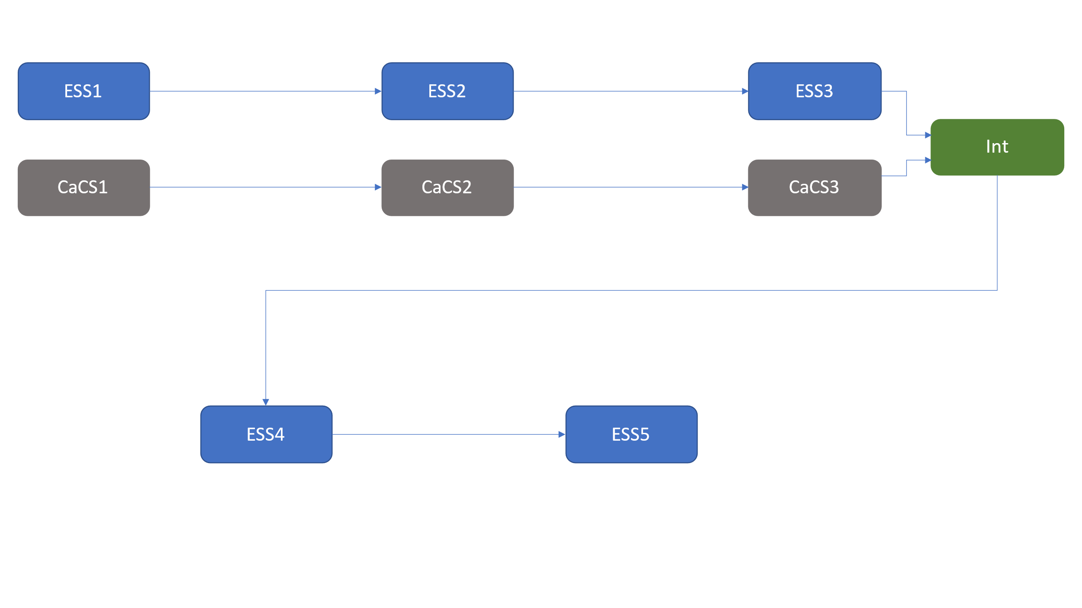

Since each build covers a specific subsystem of either the ESS or CaCS, the requirements for those subsystems are mapped to each individual build. These requirements serve as the backbone of the individual build and give them true meaning. A change to any of the builds would require a change to the requirements.

The TP can found listed in the final repository as Appendix 60.

# 9 A-Spec Report

The A-Spec represents the final document documenting the development of the OPESS. Here final requirements are gathered and organized but as they were with the RAR but this time with a final set of requirements that takes into account impacts from multiple other sources.

You can see a summary of the final requirements analysis below.

Table 10: Requirements Metric A-Spec

|  |  |  |  |  |  |  |  |  |
| --- | --- | --- | --- | --- | --- | --- | --- | --- |
| Report | Requirements | KPP’s | Qualitative | Quantitative | Inspection | Analysis | Demonstration | Test |
| RAR | 104 | 12 | 50 | 54 | 29 | 14 | 37 | 24 |
| FAR | 129 | 12 | 75 | 54 | 37 | 16 | 48 | 28 |
| TS | 131 | 12 | 79 | 52 | 43 | 16 | 44 | 28 |
| CDR | 131 | 12 | 79 | 52 | 43 | 16 | 44 | 28 |
| TP | 131 | 12 | 79 | 52 | 43 | 16 | 44 | 28 |
| A-Spec | 131 | 12 | 79 | 52 | 43 | 16 | 44 | 28 |

This paper also delved into the system engineering tools a bit more then the other. The core file used in the OPESS development can be found listed at Appendix A of the A-Spec.

The A-Spec can found listed in the final repository as Appendix 70.

# 10 Risk Report

The Risk Report is unique in that it is the only paper that was written in parallel with the whole of the OPESS project. During the proposal four risks were identified. Those risks were tracked during the other reports mentioned and typically presented at the bottom of every paper. The risk report is the culmination of all that work, allowing the risk to be presented in such that the sum totality of the risk analysis can be presented. A summery of the risks evolution can be found in the table below.

Table 11: Program Risk Summary

|  |  |  |  |  |  |  |  |  |
| --- | --- | --- | --- | --- | --- | --- | --- | --- |
| Risk ID | Risk Name | Risk Definition | Original Consequence | Original Likelihood | Original Score | Final Consequence | Final Likelihood | Final Score |
| Risk 1 | Weather | If severe weather arrives, like large hail or a tornado, then the ESS could be at risk of damage or compressed air leakage. | 2 | 5 | 10 | 1 | 2 | 2 |
| Risk 2 | Earthquake | If an earthquake were to occur, then the ESS could be damaged and potentially leak compressed air. | 3 | 1 | 3 | 3 | 1 | 3 |
| Risk 3 | Residual Natural Gas | If natural gas is able to seep back into the well, then at pressure, the gas might react with the oxygen in the compressed air and explode. | 4 | 5 | 20 | 5 | 1 | 5 |
| Risk 4 | Cyber Security | If an adversarial group were to attack and infiltrate the OPESS network, then they would gain access to proprietary OPESS files as well as potentially damage the ESS. | 5 | 5 | 25 | 5 | 1 | 5 |

As you can see, each risk was assigned a number, name and descriptor. Additional risk levels ranging from 1 (good) to 5 (very bad) are also assigned to the values of likelihood and consequence. Further risk analysis can be found of the rick charts presented in the Risk Report which can be found in the final repository as Appendix 80.

# 11 Follow on Activities

Since the high-level developmental effort is currently done, the requirements much be reanalyzed for the purposes of the final report.

Table 12: Requirements Metric Final

|  |  |  |  |  |  |  |  |  |
| --- | --- | --- | --- | --- | --- | --- | --- | --- |
| Report | Requirements | KPP’s | Qualitative | Quantitative | Inspection | Analysis | Demonstration | Test |
| RAR | 104 | 12 | 50 | 54 | 29 | 14 | 37 | 24 |
| FAR | 129 | 12 | 75 | 54 | 37 | 16 | 48 | 28 |
| TS | 131 | 12 | 79 | 52 | 43 | 16 | 44 | 28 |
| CDR | 131 | 12 | 79 | 52 | 43 | 16 | 44 | 28 |
| TP | 131 | 12 | 79 | 52 | 43 | 16 | 44 | 28 |
| A-Spec | 131 | 12 | 79 | 52 | 43 | 16 | 44 | 28 |
| Final | 131 | 12 | 79 | 52 | 43 | 16 | 44 | 28 |

The first thing that would need to be done is some form of prototyping. The OPESS is a great idea in theory but the execution involves working with one of the most complicated systems used in the modern world (the power grid) and working closely with unpredictable natural elements (natural gas wells). It would be wise if, during the development build cycle, prototypes were made in an effort to better understand how each component worked. Performing a trade analysis updated several requirements as mentioned earlier, it is safe to say that doing so with other components might have a similar effect on high level components.

On a smaller scale, a team of engineers with diverse backgrounds will need to be organized so as to help in the OPESS development as well as in writing system and software requirement specifications (SRS’s) and other lower-level physical specifications (p-specs). Additionally wiring schematics will need to be drawn up and software written. All these things will need to be done and are beyond the scope of this project. However, a good prototype would help with providing technical direction for these efforts.

The first thing that would need to be prototyped is the network connection between the ESS and the CaCS. There really is no point in continuing on with the project if the two subsystems can’t communicate with each other securely. These are also the first two builds mentioned in the TP report. Continuing to follow that build schedule will be the key to success.

# 12 Lessons Learned

Lesson one was a simple one. Don’t take a new job during the same time period as the RAR development. It’s like drinking from two firehoses at once.

Lesson two had to do with the block diagram that kept getting talked about during this report. They’re extremely valuable. Originally, I was planning to do a functional block diagram as a part of the FAR but found it helped too much with requirement development to not do. This added quite a bit of extra time onto the RAR and is something that I wish I had thought about in the beginning.

Lesson three is all about requirements as it pertains to the FAR. Originally, I mapped all my functional requirements to the necessary functions and left the qualitative requirements to get mapped to components. After giving it some thought and watching those CORE tutorials, I realized that all the requirements needed to be traced to functions regardless of requirement type in order for the full system traceability work. This led to some new requirements, some rework and some more delay of the part of the FAR.

Lesson four is really almost more a philosophical one. Going into the trade study, I expected it to just be this quick thing to show I new how to perform one. And it kind of was because I’ve always found them to be pleasantly logical. However, I was not expecting it to have a design impact of the system. My lesson here is all about system knowledge and how much you can get by doing product research much like what is needed in a trade study.

Lesson five is really about the risk report and how nothing was really done about the earthquake risk. I still feel like it is a small risk or else you would hear more about wells having issues in earthquake dense regions but not getting an expert to weigh in on that is something that I regret. The lesson here is just the importance of SME’s and the need for expert advice in engineering development.

# 13 Class Evaluation

This class was one of the more difficult classes I’ve taken. It was not technically difficult the way E&M 1 was in my undergrad or the way my networking class was as one of my electives for this program, but this class was extremely difficult in terms of just what all had to be done. Developing an idea from something floating around in the back of your head to something so detailed it requires a test plan is not small feet and something I am personally proud of completing regardless of how this project gets graded.

One thing I might mention in terms of class improvement is more focus on just how much work will be required of a student to complete this project. More emphasis needs to be placed on students in the Test and Evaluation course to get them to fine an advisor and get the ball rolling on a proposal. I feel I only succeeded because I had the summer to work ahead. Again, the technical push of this class isn’t too bad and there was definably a lot of help in this class from professors and easily obtainable research, but the development cycle was a lot.

Core was also something that surprised me. I had not ever taken a MBSE class before as my electives were all cyber classes so MBSE software was a learning experience for me. The use of this software in a class or even a mandated MBSE class in the program would be useful and helpful for some one new to MBSE.

With all this said, the program was solid. There was a lot of support on this project from both professors current and past as well as a host of example projects to look to. I referenced the example papers constantly to figure out organization and what it was that the graders (you) were looking for in a research project. They were quite helpful.

All in all, there really isn’t that much about this class I would change. It was a good learning experience.

# 14 Earned Value Management

## 14.1 Schedule

Right now, the schedule has an expected due date of mid to late December, near when the semester ends. However, with a presentation date of December 2nd, the schedule had to be compressed. As such, we are currently showing ahead of schedule.

Figure 10: OPESS Schedule

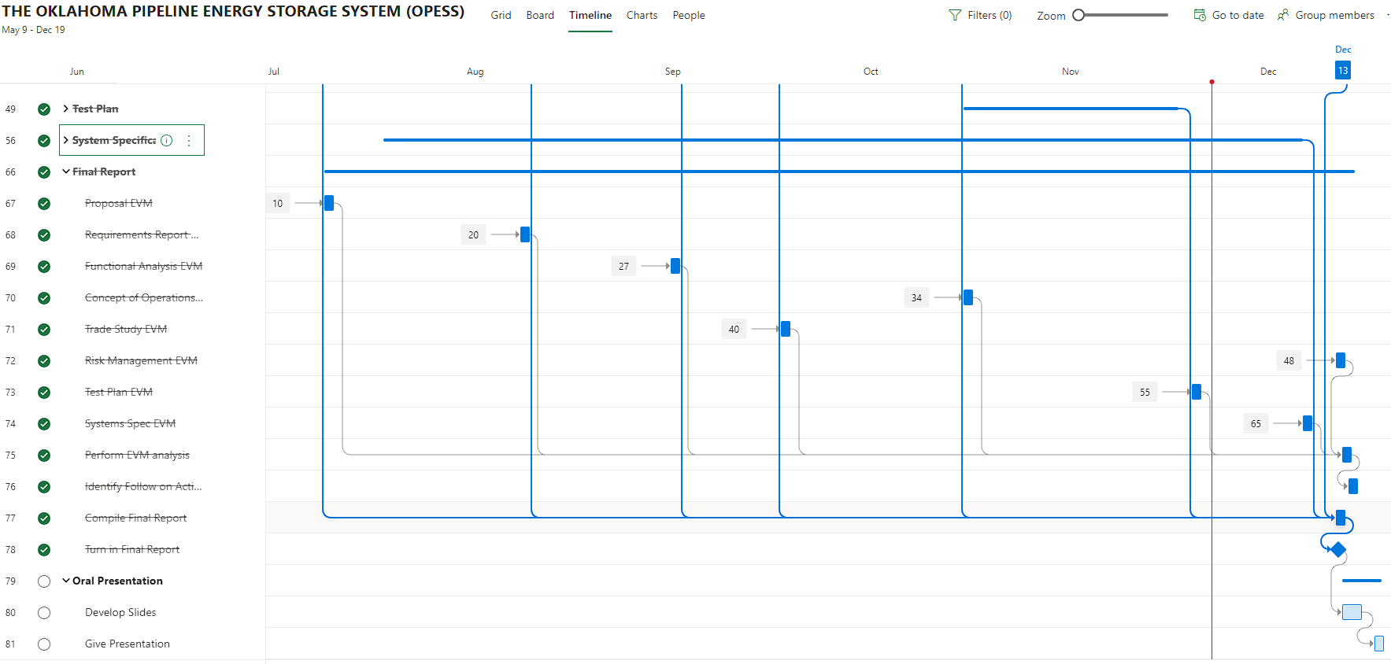

## 14.2 Milestones

Milestones Items in red were turned in late per the original due date. Green have been turned in ahead of schedule. While the Oral Presentation is not done has of the writing of this report, it’s due date is 11/30, which is two weeks before the original expected due date of 12/14. As such, it is showing green as this is the last update expected.

Table : Milestones

| **Milestone** | **Date** |
| --- | --- |
| Project Proposal | 7/8/2022 |
| Requirements Report | 8/12/2022 |
| Functional Analysis | 9/2/2022 |
| Trade Study | 9/7/2022 |
| Concept of Operations | 10/8/2022 |
| Test Plan | 11/5/2022 |
| System Specifications | 11/17/2022 |
| Risk Management Report | 11/22/2022 |
| Final Report | 11/24/2022 |
| Oral Presentation | 11/30/22 |

## 14.3 EVM

Table : EVM

|  |  |  |  |  |  |  |  |
| --- | --- | --- | --- | --- | --- | --- | --- |
| WBS number | Name | % Complete | Budget | BCWP | ACWP | SPI | CPI |
| **10** | **Final Report** | **91.67%** |  |  |  |  |  |
| 10.1 | Proposal EVM | 100.00% | 0.5 | 0.50 | 1 | 1 | 0.5 |
| 10.2 | Requirements Report EVM | 100.00% | 0.5 | 0.50 | 1 | 1 | 0.5 |
| 10.3 | Functional Analysis EVM | 100.00% | 0.5 | 0.50 | 1 | 1 | 0.5 |
| 10.4 | Concept of Operations EVM | 100.00% | 0.5 | 0.50 | 1 | 1 | 0.5 |
| 10.5 | Trade Study EVM | 100.00% | 0.5 | 0.50 | 1 | 1 | 0.5 |
| 10.6 | Risk Management EVM | 100.00% | 0.5 | 0.50 | 1 | 1 | 0.5 |
| 10.7 | Test Plan EVM | 100.00% | 0.5 | 0.50 | 1 | 1 | 0.5 |
| 10.8 | Systems Spec EVM | 100.00% | 0.5 | 0.50 | 1 | 1 | 0.5 |
| 10.9 | Perform EVM analysis | 100.00% | 3 | 3.00 | 1 | 1 | 3 |
| 10.1 | Identify Follow on Activities | 100.00% | 3 | 3.00 | 1 | 1 | 3 |
| 10.11 | Compile Final Report | 100.00% | 3 | 3.00 | 2 | 1 | 1.5 |

## 14.4 CPI and SPI Index

Table :CPI/SPI

## 14.5 EVM Analysis

The EVM was honestly, not done well. There was not historical reference to really pull from and going in, there wasn’t really a strong understanding of what effort needed to be accomplished. A lot of what was required involved a detailed look at some of the example projects and a better understanding of CORE then was present at the time of the baselining.

This can pretty easily be seen in the CPI/SPI graph. They both look to be close to 1 for the most part but a closer examination reveals that they are actually just below one, showing constantly behind schedule and over budget. It can also be observed that at the end of the program there is a spike. This demonstrates two things. The first, is that it was crunch time and the reports had to come out in a hurry. The other, however, was that the project should have been front loaded. Most of the effort of the project seemed to live in the RAR and the FAR. Then distribution of effort was not known at the time of the baselining so the EVM was spread out more or less evenly. This lead to a huge spike at the end when deliveries got put out much faster than expected.

It can also be noticed that the CPI took a hit in the last week. This is because the budget for the final paper mostly consisted on performing EVM checks on the other papers and expected that effort to be done during their development. Since this paper is far more detailed then a simple EVM analysis, a lot of extra time went into developing it that wasn’t budgeted for. As such, you can see the schedule got further ahead but at the expense of cost.

# 15 References

Cisco Umbrella Packages. (2022). *Cisco Umbrella*. Retrieved from Cisco: https://umbrella.cisco.com/products/umbrella-enterprise-security-packages

Cloud Flare. (2022). *Application Services*. Retrieved from Cloud Flare : https://www.cloudflare.com/plans/application-services/#overview

*Electricity explained: How electricity is delivered to consumers.* (2022, August 11). Retrieved from US Energy Information Administration: https://www.eia.gov/energyexplained/electricity/delivery-to-consumers.php

Grubelich, M. C., Bauer, S. J., & Cooper, P. W. (2011, September). *Potential Hazards of Compressed Air Energy Storage in Depleted Natural Gas Reservoirs.* Retrieved from Sandia Report: https://www.osti.gov/servlets/purl/1029814/

Popovich, N., & Plumer, B. (2020, 10 28). *How Does Your State Make Electricity?* Retrieved from The New York Times: https://www.nytimes.com/interactive/2020/10/28/climate/how-electricity-generation-changed-in-your-state-election.html

*The Basics of Underground Natural Gas Storage* . (2015, 11 16). Retrieved from US Energy Information Administration: https://www.eia.gov/naturalgas/storage/basics/

U.S. Energy Information Administration. (2022, May 19). *Oklahoma State Profile and Energy Estimates*. Retrieved from U.S. Energy Information Administration: https://www.eia.gov/state/analysis.php?sid=OK