Website Build — SDLC Summary
A brief account of how the Jon Grorud personal website was built, framed around the Software Development Life Cycle (SDLC).

Timeline at a glance
Date | Phase | What happened
Jun 6 | Requirements & planning | Defined goals, audience, and a no-build tech stack (HTML/CSS/vanilla JS)
Jun 6 | Implementation (V1) | Initial site scaffold; Home/About/Contact; rebranded to Jon Grorud
Jun 8 | Design iteration (V2) | “Executive Ink” redesign sourced from the CV
Jun 8–9 | Design iteration (V3) | Seller-first positioning, refined hero/typography, added Track Record page, copy refinements
Jul 5 | Change management | Renamed customer boxes; made dark mode the default
Jul 5 | Testing / QA | Local + end-to-end visual test, recording and report on the PR
Jul 5 | Deployment | Published static site; re-deployed for each change

Phases

1. Requirements & planning
- Goal: a fast, dependency-free personal site for Jon Grorud, Strategic Enterprise Software Executive, with Home, About, and Contact.
- Tech decision: plain HTML, CSS, and vanilla JavaScript — no build step, no framework, zero runtime dependencies — for simplicity and easy hosting.

2. Design & implementation (iterative versioning)
Each design direction lived on its own branch so it could be reviewed independently instead of overwriting the previous one: - V1 (devin/1780776875-personal-website) — first working site, then rebranded to Jon Grorud. - V2 (jon-profile-v2) — “Executive Ink” redesign sourced from the CV. - V3 (jon-profile-v3) — final direction: seller-first positioning, refined hero and typography, added a Track Record page, plus several copy-refinement commits.

3. Version control & code review
- Every version was a feature branch with its own Pull Request (PR #1, #2, #3), producing a reviewable diff and full history.
- The latest work is PR #4, branched off V3 to keep new changes isolated from the reviewed baseline.

4. Change management (recent enhancements)
Two scoped changes, each an atomic commit on PR #4: - Renamed 5 customer boxes → Mercedes, Deutsche Bank, AstraZeneca, Nokia, Ericsson. - Made dark mode the default for first-time visitors, while still respecting a returning visitor’s saved preference.

5. Testing / QA
- Verified locally (served the site, inspected the rendered DOM).
- Ran an end-to-end visual test with a screen recording and a test report attached to the PR.

6. Deployment & release
- Published as a static deployment at https://devin-demo-fgwlpfki.devinapps.com.
- The deploy is a static snapshot, so each release is an explicit re-deploy.

7. Maintenance & feedback loop
- Iterating on feedback (label corrections, dark-mode default, URL handling).
- Each round follows the same loop: change → commit → verify → redeploy.

Process diagram
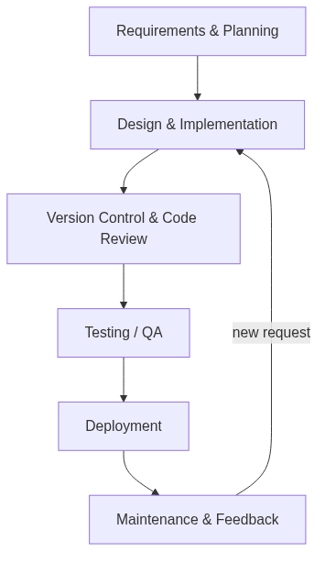
SDLC process flow
flowchart TD
A[Requirements & Planning] --> B[Design & Implementation]
B --> C[Version Control & Code Review<br/>feature branch + PR]
C --> D[Testing / QA<br/>local + E2E visual test]
D --> E[Deployment<br/>static re-deploy]
E --> F[Maintenance & Feedback]
F -->|new request| B
subgraph Versions[Iterative design versions]
V1[V1: initial site] --> V2[V2: Executive Ink]
V2 --> V3[V3: seller-first + Track Record]
end
B -.-> Versions

Feedback loop (simplified)
flowchart LR
Req[Request] --> Change[Change] --> Commit[Commit / PR] --> Verify[Verify] --> Deploy[Deploy] --> Req

