1. Cherrypick

Cherrypick is one of the easily creatable but hard to catch misleading visualization. It basically takes the data that the creator prefer and cut off both edges that have the data that is not preferable.

Below is my game record of a video game league of legends.

By this image, I had been playing extremely well most games and win rate will be 87.5%.

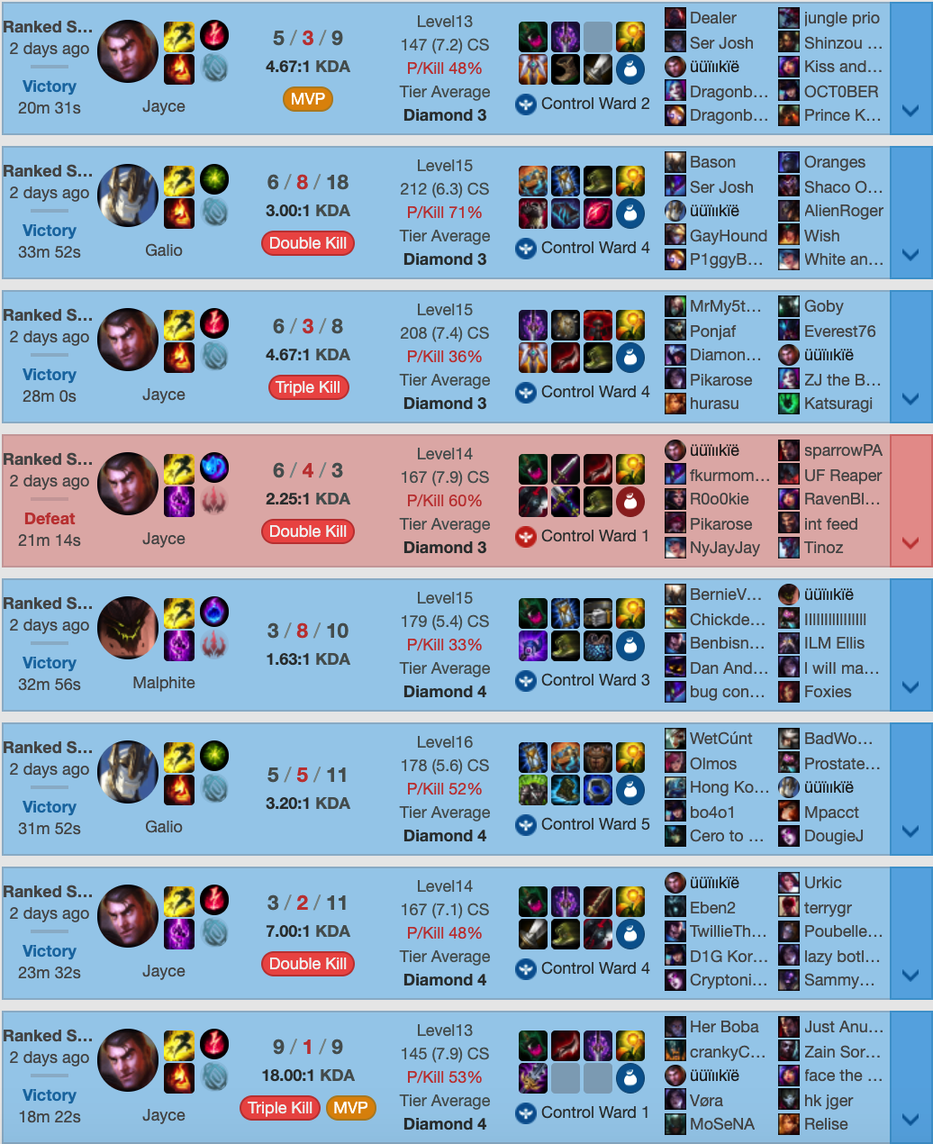

However, if I get 3 more data from each edge, it looks like the following.

The win rate is 0.58, and I have been playing in comparison, really bad, in the game I have lost.

I am actually not a good player.

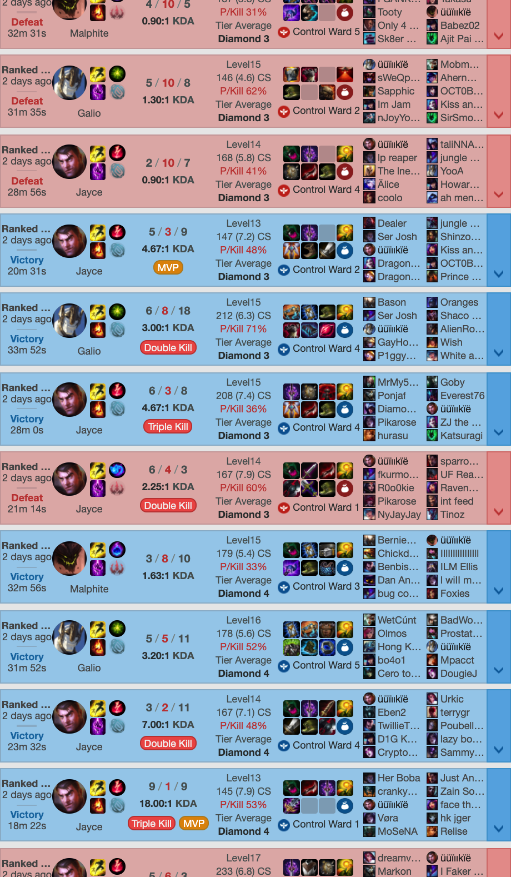

1. Starting from non-0.

If a line graph or a histogram dose not start from 0, a small difference can be felt like a large change of data.

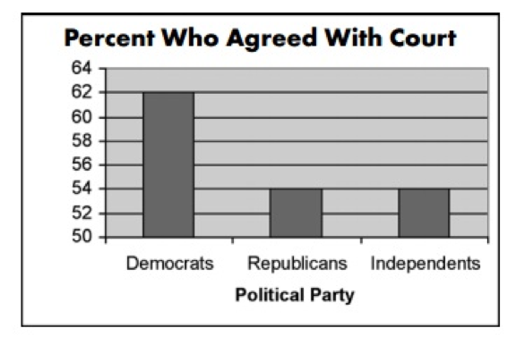

This Looks much better which represents well 8% difference.

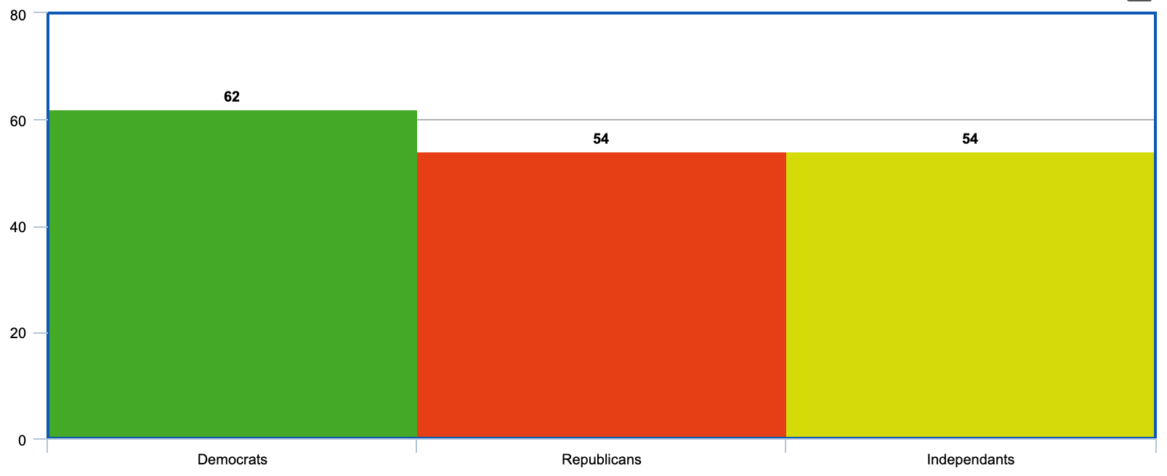

1. No Label

Sometimes, there will be no label but just show a random graph to show that a product is “scientifically proven” effective but does not tell you anything.

