**VNC Connect**

**1. Install VNC to raspberry pi**

Command : sudo apt-get install tightvncserver

**2. Excute VNC server**

Command: vncserver

If the password field appears, enter the long password

**3.Check VNC port in Raspberry Pi**

Command: sudo netstat-tulpn

**4. Installing the VNC program in Windows**

**4.1 To install the VNC program, connect to** [**http://www.tightvnc.com/**](http://www.tightvnc.com/)**.**

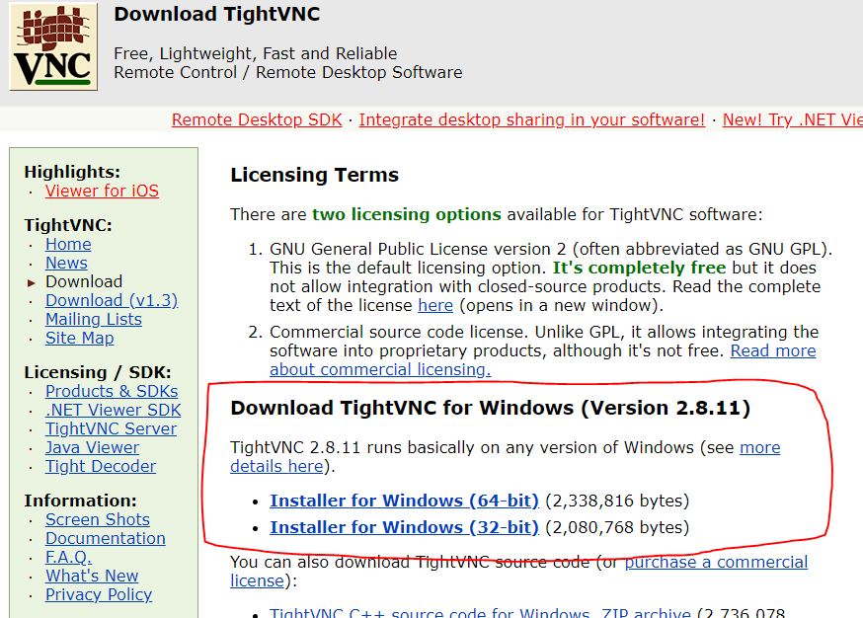

**5. Run VNC program in windows**

