NAME: JONH ROGIEL M. TUMANDA BSIT 3-A

Activity1_Lab_Report

Introduction:
This activity focuses on setting up a complete development environment using Laragon and the Laravel Framework. The main goal is to prepare a smooth and efficient workspace for building web applications. First, I installed Laragon, which serves as a local server environment that includes Apache, MySQL, and useful developer tools. After verifying that the services were running properly, I proceeded to install Laravel through the Laragon terminal. Creating a new Laravel project and opening it in Visual Studio Code allowed me to explore the basic structure of the framework. Finally, I tested the setup by creating a simple route in web.php to confirm that Laravel was working correctly. Overall, this activity helps beginners build a solid foundation for web development using modern tools and frameworks.

Screenshots of:

Laragon
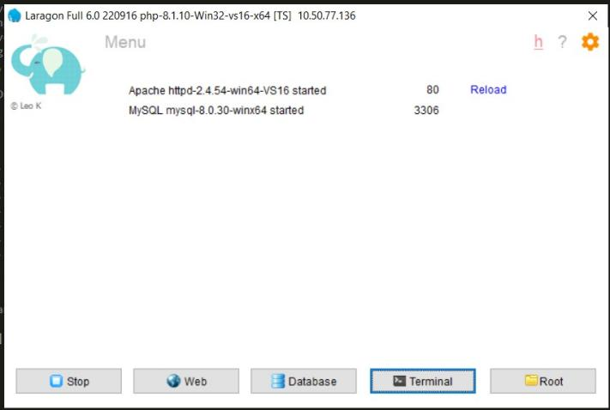

Laravel installation

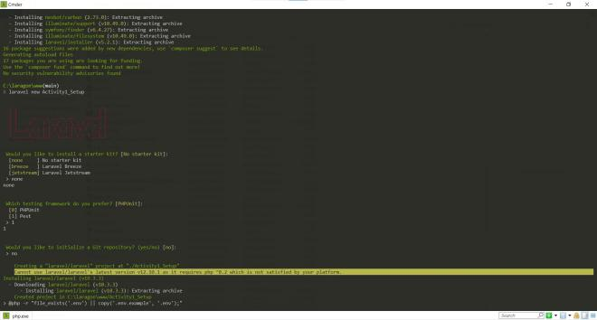
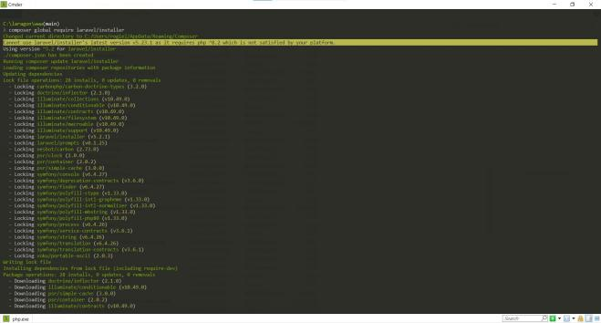

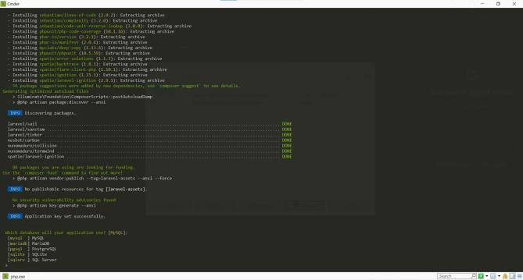

VS Code environment
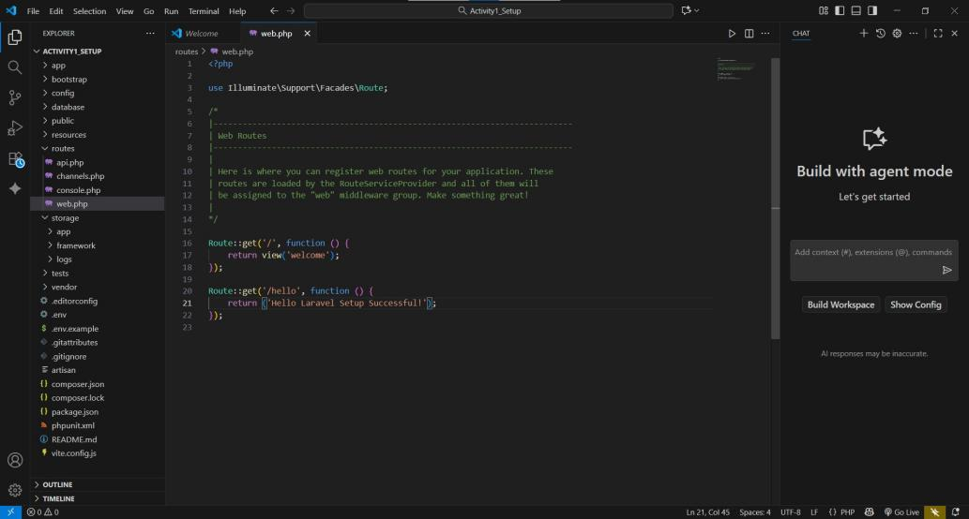

"Hello" route output
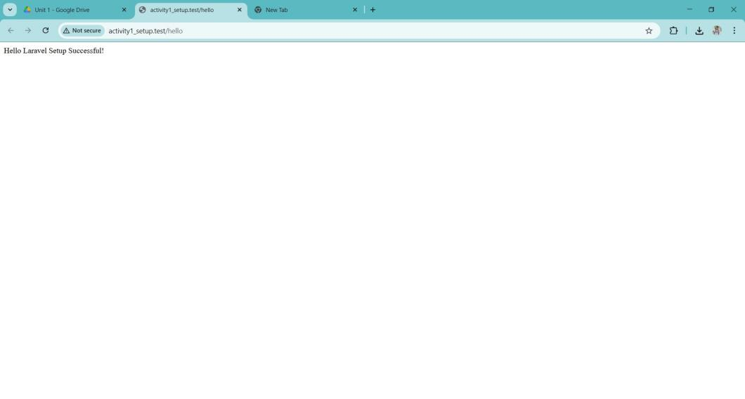

Reflection:

This activity taught me how important it is to set up my tools correctly before I start coding. Installing Laragon was easy, and it helped me run Apache and MySQL without any problems. Setting up Laravel was also simple, and I was happy to see the welcome page appear in my browser. When I added a test route, I learned how Laravel shows output on a webpage. Overall, this activity made me feel more confident in using Laragon and Laravel. Now I know how to start a new project and I am ready to move on to more lessons in web development.

