|  |  |
| --- | --- |
| Name  NIM  Class  Semester  Subject  Lecturer | JONI  L200134020  X  04  Rekayasa Perangkat Lunak  Bana Handaga |

**CLIENT’S PROBLEM STATEMENT**

Need to have you develop a website system which enables to create, edit, delete, and update as many web pages as possible with easy to administrate dashboard. Website system should also have ability to protect some of web page and the website can be access more than one users like a student, lecturer, and staff. Each user different access, staff can create, edit , delete, update data. Lecturer just can input data, and than student just can read data. and than i will also need ability to manage widget that apears on sidebar areas of website.

From pessage above :

1. Create a document requirements specification ?
2. Create DVD level-0 and description and the description for the diagram ?
3. Create an USE-case diagram and the discription for the diagram ?
4. Creae an architecture of system and descript how the system work ?

Take on items from use case and then create a activity diagram for th

1. at item ?

**Answers :**

1. REQUIREMENTS OF DOCUMENT:
2. **Website** (Web based application).
3. Users are able to **create, read, update, and delete** **many web pages** using dashboard easily.
4. Users are able to **access control** pages to all pages.
5. Users are ablt to show some widgets in the **sidebar** of the website.
6. Users are able to **change themes** of the pages anytime.
7. DFD 0

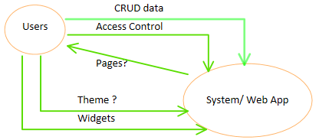

1. USE CASE

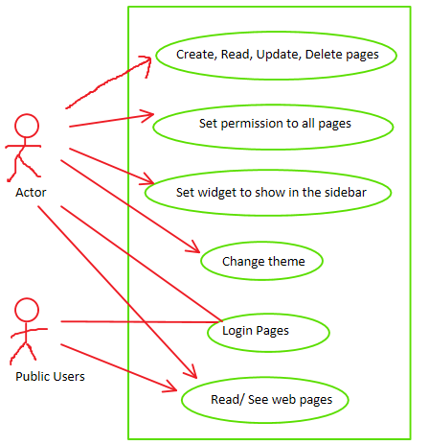

1. ARCHITECTURE SYSTEM

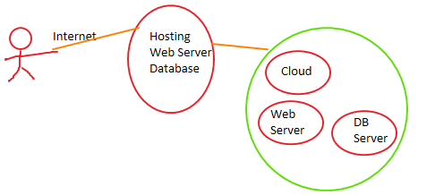

1. ACTIVITY DIAGRAM (Login Activity)

