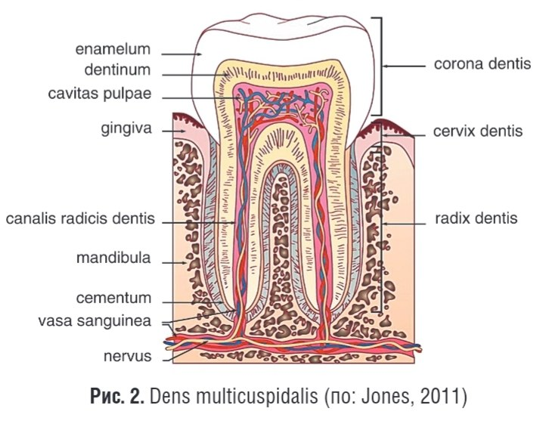
• dens – tish
• corona dentis – tish toji
cervix dentis-tish bo’yni
• radix dentis – tish ildizi
• pulpa dentis – tish pulpası
• dentinum – dentin
• enamelum – emal
• cementum – sement qavati
• apex radicis – ildiz uchi
• canalis radicis – ildiz kanali
• ligamentum periodontale – periodont boylami
gingiva –milk
nervus-nerv
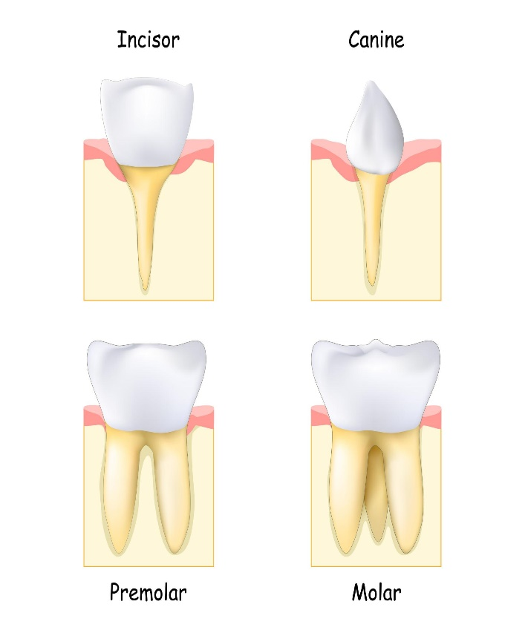
dens incisivus – kurak tish
dens caninus – qoziq tish
dens premolaris – kichik oziq tish
dens molaris – katta oziq tish
dens deciduus – sut tishi
dens permanens – doimiy tish
dens serotinus-kech chiqadigan tish(aql tish)
arcus dentalis – tish yoyi
Dens molaris tertius – uchinchi molyar tish(aql tish)

