1. **Portfolio sayt**

<https://jonibek-portfolio.netlify.app/>



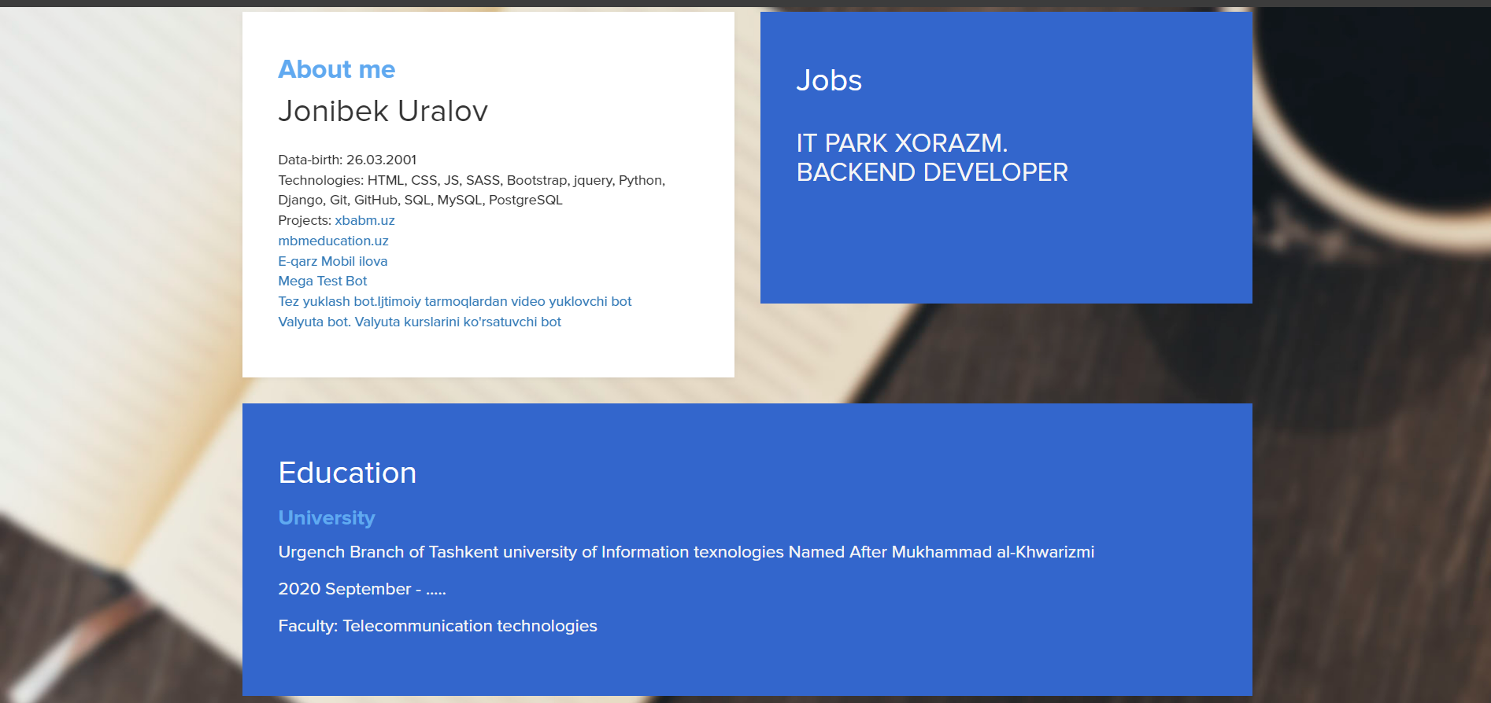

1. **Shaxsiy sayt**

<https://jonibekdev.netlify.app/>

