**O’ZBEKISTON RESPUBLIKASI RAQAMLI TEXNOLOGIYALARI VAZIRLIGI MUHAMMAD AL-XORAZIMIY NOMIDAGI TOSHKENT AXBOROT TEXNOLOGIYALARI UNIVERSITETI **

**KIBERXAVFSIZLIK FAKULTETI 711-21AXO` GURUHI TALABASINING “MASHINALI O’QITISHGA KIRISH” FANIDAN**

**AMALIY ISHI**

**BAJARDI:**Ziyadullayev Mehrojiddin

**QABUL QILDI:**Qobilov Sirojiddin

**Toshkent-2023**

**4-AMALIY TOPSHIRIQ**

**Mashinali o‘qitishda o‘qituvchisiz o‘qitish algoritmlarini o‘rganish va ularni dasturlash**

1. Datasetni shakllantirish. Bunda o‘zgaruvchilar soni kamida 10 tani va qatorlar soni 20 tani tashkil etishi lozim.

2. K-means klasterlash modeli orqali shakillantirilgan datasetni klasterlash algoritmini va dasturini ishlab chiqish.

3. Natijalarni vizual va jadval ko‘rinishda taqdim etish.

import numpy as np

import pandas as pd

import matplotlib.pyplot as plt

dataset_2 = np.array([

    [10, 4, 6, 6], [15, 7, 8, 10], [12, 5, 7, 9], [9, 4, 5, 5], [11, 5, 6, 7],

    [20, 8, 12, 15], [6, 1, 5, 4], [19, 9, 10, 14], [9, 4, 5, 6], [15, 5, 10, 12],

    [15, 7, 8, 15], [14, 6, 8, 10], [21, 10, 11, 12], [24, 14, 10, 20], [9, 4, 5, 6],

    [11, 5, 6, 6], [20, 9, 11, 16], [12, 5, 7, 9], [22, 10, 12, 10], [25, 12, 13, 15],

    [15, 10, 5, 10], [22, 15, 7, 15], [20, 12, 8, 10], [8, 4, 4, 4], [10, 5, 5, 7],

    [8, 4, 4, 5], [16, 10, 6, 8], [10, 5, 5, 6], [18, 10, 8, 12], [14, 8, 6, 15],

    [14, 7, 7, 10], [6, 4, 2, 4], [17, 9, 8, 14], [13, 7, 6, 13], [17, 9, 8, 15],

    [20, 10, 10, 8], [11, 7, 4, 6], [22, 12, 10, 18], [24, 16, 8, 16], [14, 8, 6, 12]

])

X = dataset_2

Y = np.array([0, 0, 0, 0, 0, 0, 0, 0, 0, 0, 0, 0, 0, 0, 0, 0, 0, 0, 0, 0, 1, 1, 1, 1, 1, 1, 1, 1, 1, 1, 1, 1, 1, 1, 1, 1, 1, 1, 1, 1])

df = pd.DataFrame({

    'Daromad': X[:, 0],

    'Xarajat': X[:, 1],

    'Sof foyda': X[:, 2],

    'Shartnoma': X[:, 3],

    'Class': Y[:]

})

X_train = df.iloc[:, [1, 3]].values

Y_train = df.iloc[:, [4]].values

plt.figure(figsize=(6, 6))

plt.scatter(*X_train.T, s=50, alpha=0.8, label='dataset', color='blue')

plt.title('Dataset')

plt.xlabel('Xarajat')

plt.ylabel('Shartnoma')

plt.legend()

plt.grid()

plt.show()

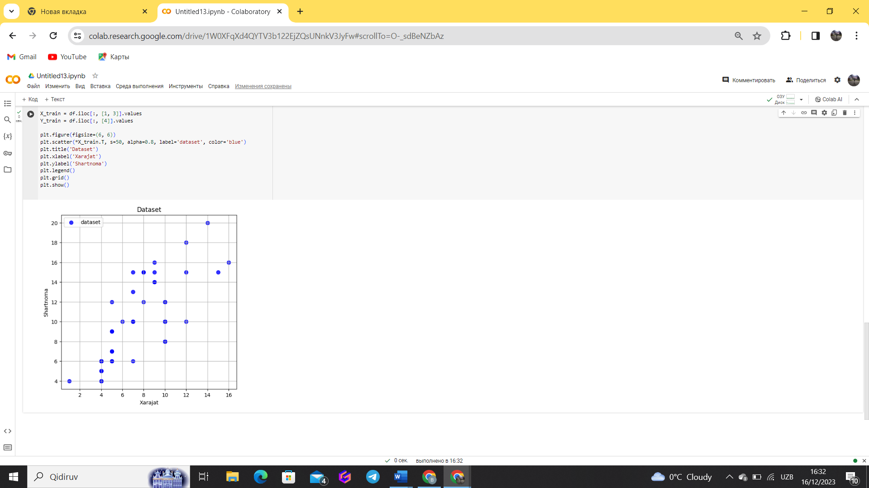

import matplotlib.pyplot as plt

from sklearn.cluster import KMeans

# ... Sizning avvalgi kodlar ...

# K-means klasterlash modelini yaratish

num_clusters = 2

kmeans = KMeans(n_clusters=num_clusters, random_state=42)

kmeans.fit(X_train)

Y_kmean = kmeans.labels_

center = kmeans.cluster_centers_

plt.figure(figsize=(12, 6))

# Asl ma'lumotlar

plt.subplot(1, 2, 1)

plt.title('Orginal')

plt.xlabel('Xarajat')

plt.ylabel('Shartnoma')

plt.scatter(*X_train[Y == 0].T, s=50, alpha=0.8, label='sinf-0')

plt.scatter(*X_train[Y == 1].T, s=50, alpha=0.8, label='sinf-1')

plt.legend()

# K-means natijalari

plt.subplot(1, 2, 2)

plt.title('KMeans')

plt.xlabel('Xarajat')

plt.ylabel('Shartnoma')

plt.scatter(*X_train[Y_kmean == 0].T, s=50, alpha=0.8, label='Cluster-0')

plt.scatter(*X_train[Y_kmean == 1].T, s=50, alpha=0.8, label='Cluster-1')

plt.legend()

# Markazlar (centroidlar)

for i in center:

    plt.scatter(i[0], i[1], s=50, c='k', marker='o')

plt.show()

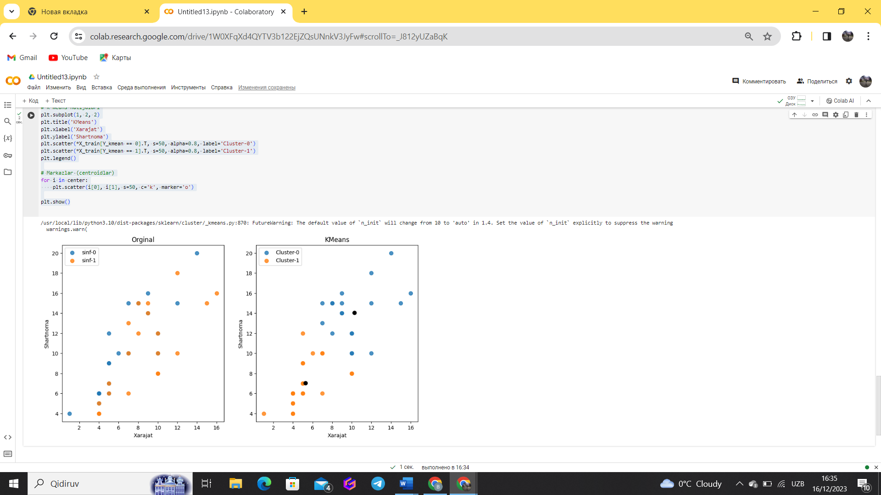

import numpy as np

import pandas as pd

# Random dataset yaratish

np.random.seed(42)

rows = 20

columns = 10

dataset = pd.DataFrame(np.random.rand(rows, columns), columns=[f'Feature_{i}' for i in range(1, columns + 1)])

from sklearn.cluster import KMeans

# K-means modelini yaratish

k = 3  # Klasterlar soni

kmeans_model = KMeans(n_clusters=k, random_state=42)

dataset['Cluster'] = kmeans_model.fit_predict(dataset)

import matplotlib.pyplot as plt

# Klasterlar bo'yicha natijalarni vizualizatsiya qilish

plt.scatter(dataset['Feature_1'], dataset['Feature_2'], c=dataset['Cluster'], cmap='viridis', s=50)

plt.title('K-means Klasterlash Natijalari')

plt.xlabel('Feature 1')

plt.ylabel('Feature 2')

plt.show()

# Jadval ko‘rinishida natijalarni chiqarish

print(dataset[['Feature_1', 'Feature_2', 'Cluster']])

