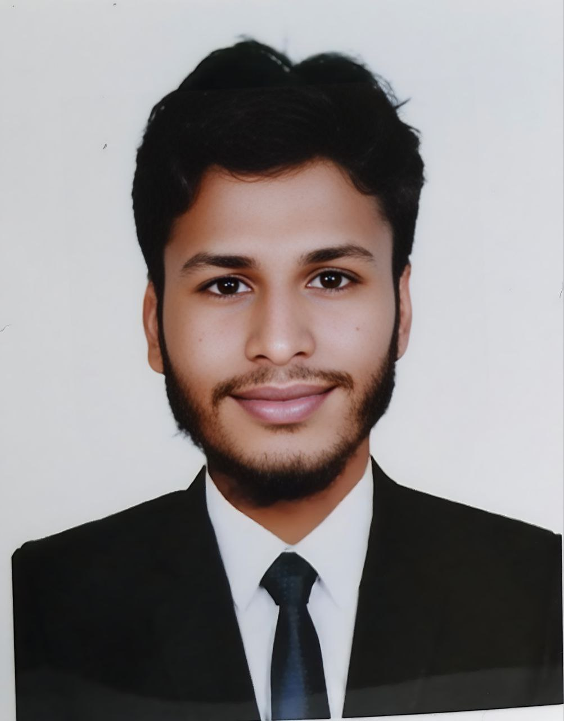

# 1. Personal Information

Full Name: Md. Joni Hasan

Father’s Name: Md. Jalal Uddin

Mother’s Name: Most Aleya Begum

Date of Birth: 11-11-200

National ID (NID):2862142938

Present Address: Park More, Rangpur

Permanent Address: Jagadish,Itakumari ,Pirgachha, Rangpur

Mobile Number: 01787135431

Email Address: eco1903050brur@gmail.com

Marital Status: Unmarried

Religion: Islam

Nationality:Bangladeshi

# 2. Career Objective

To build up a challenging career in a dynamic and reputed organization where I can utilize my academic knowledge, improve my skills, and contribute to the success of the organization.

# 3. Academic Qualifications

|  |  |  |  |  |  |
| --- | --- | --- | --- | --- | --- |
| Exam Name | Board/Universit | Group/Subject | Result (GPA/CGPA) | Year | Duration |
| SSC / Equivalent | Dinajpur |  | 4.59 |  |  |
| HSC / Equivalent | Dinajpur |  | 4.33 |  |  |
| Honours/Degree | Begum Rokeya University,Rangpur |  | 3.33 |  |  |
|  |  |  |  |  |  |

# 4. Computer Skills

- Microsoft Word, Excel, PowerPoint

- Internet Browsing

- Basic Troubleshooting

# 5. Language Proficiency

- Bengali: Native

- English: Good (Speaking, Writing, Reading)

# 6. Extra-Curricular Activities

- Participated in Debate/Quiz/Cultural Program

- Voluntary work (if any)

# 7. Personal Strengths

- Hardworking and sincere

- Quick learner

- Ability to work under pressure

- Strong communication skills